MA-374 Financial Lab – 09

Santosh Reddy Banda
140123010

1)
For Call Option
The plot of option price, maturity and strike price
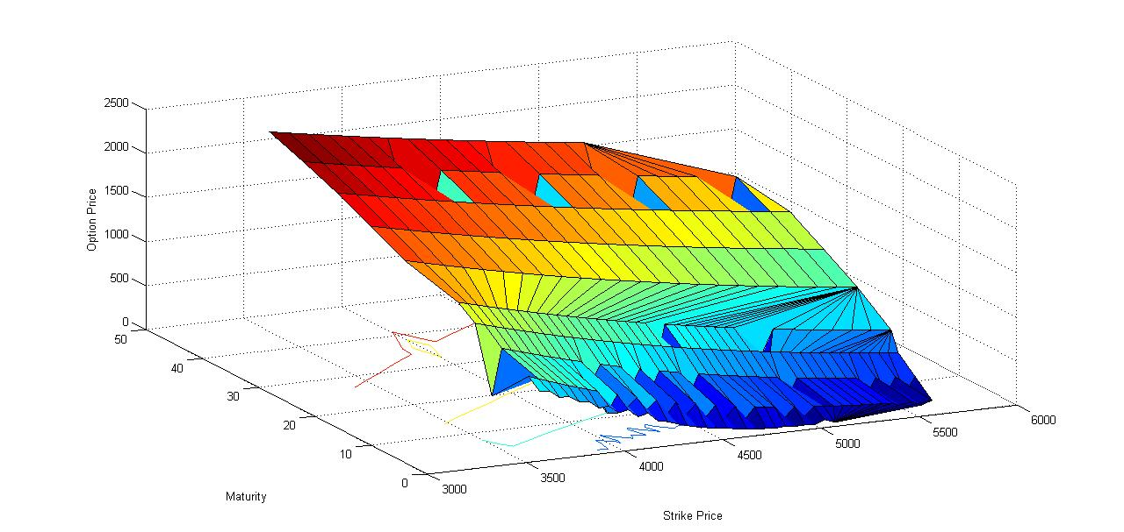

Plot of Option Price vs Strike Price for various maturities
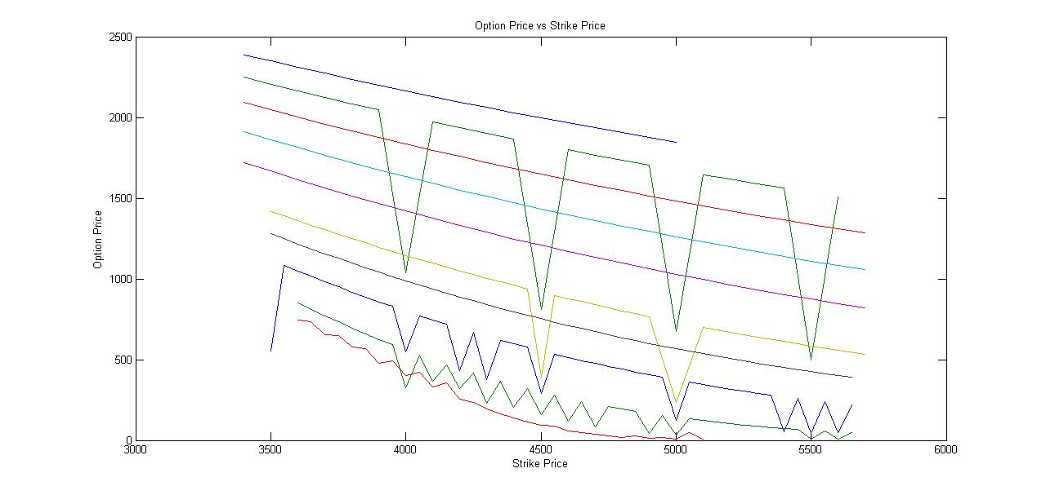
Plot of Option price vs maturities
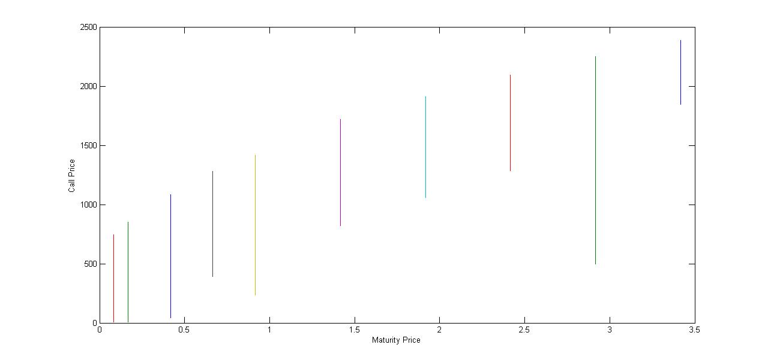

For Put
The plot of option price, maturity and strike price
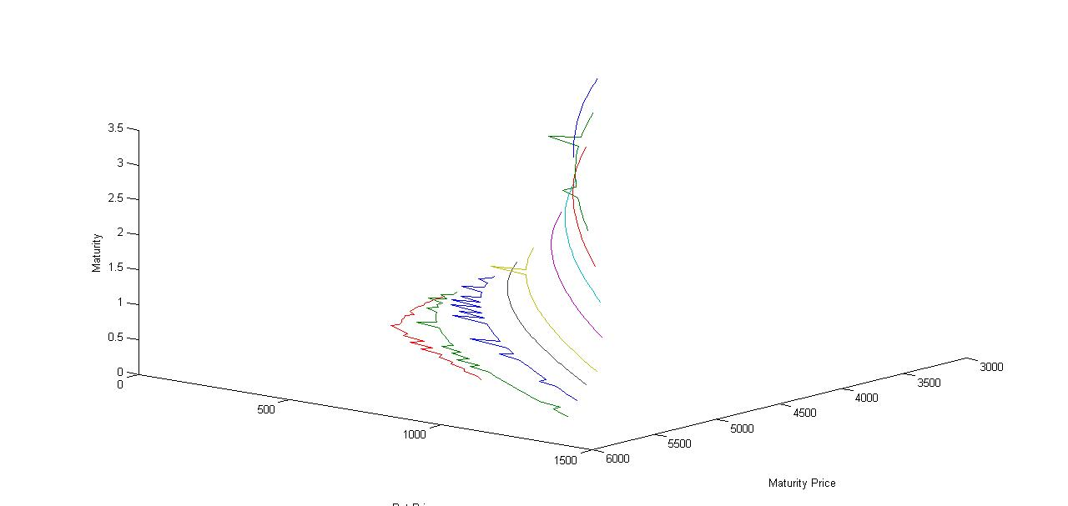
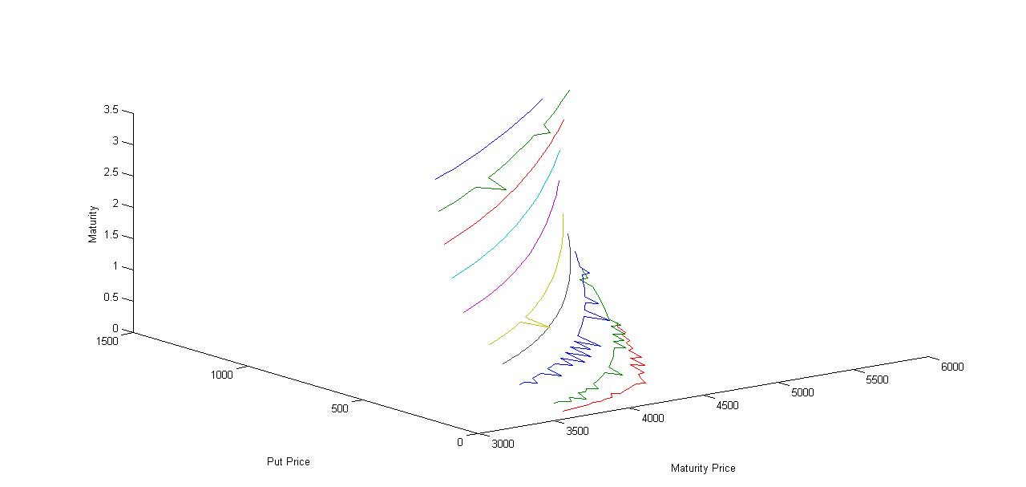

Plot of Option price vs Strike Price
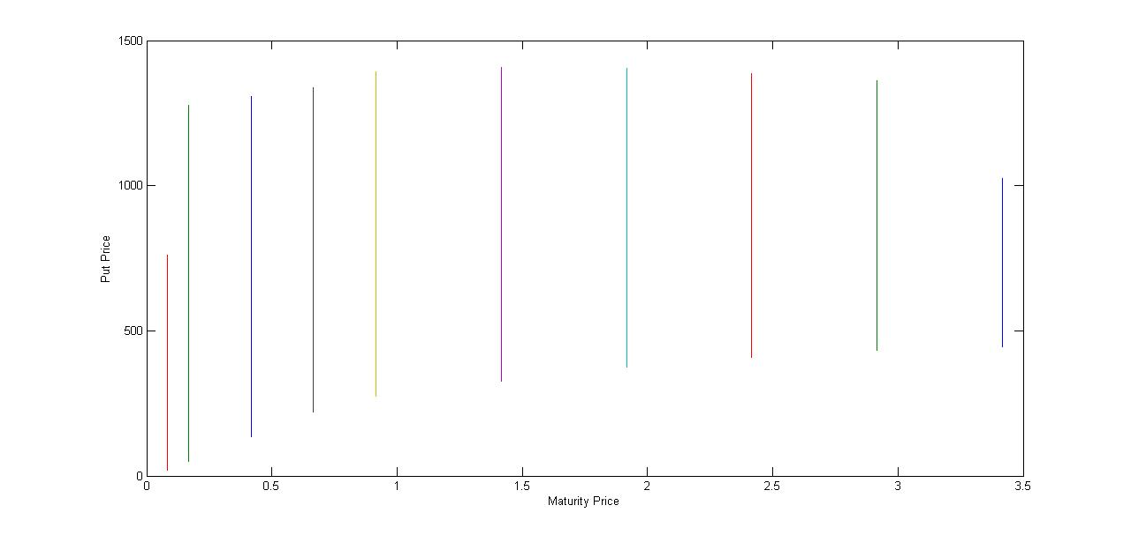
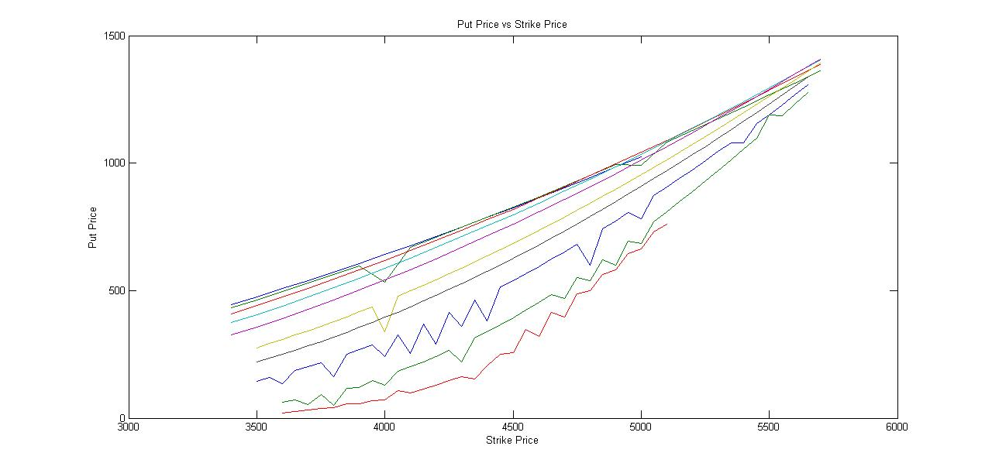

Ans.2)
For Call
Plot of option price vs implied volatility vs strike
price
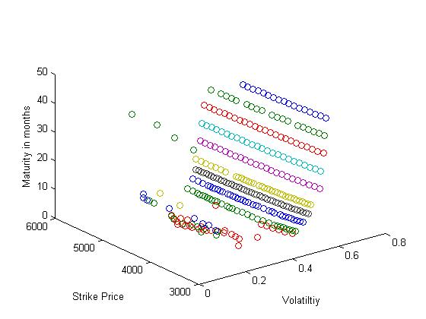

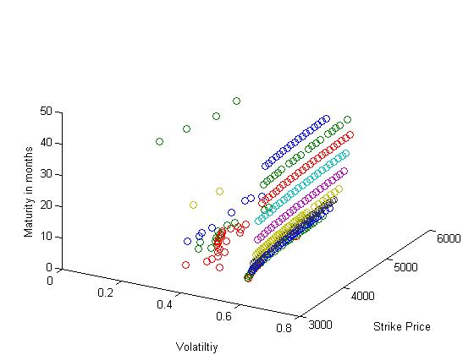

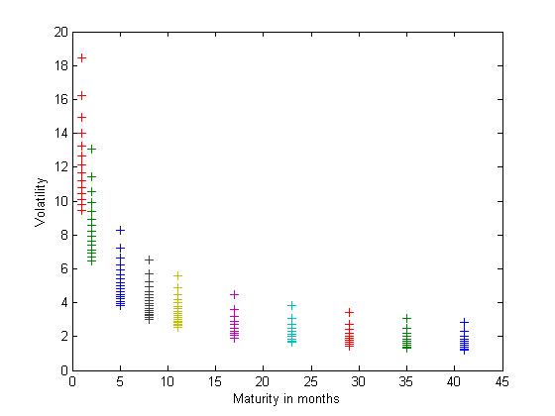

For Call
Plot of option price vs implied volatility vs strike price
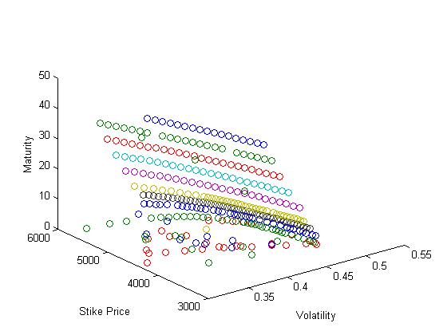

For Call
Plot of Implied Volatility vs Strike Price
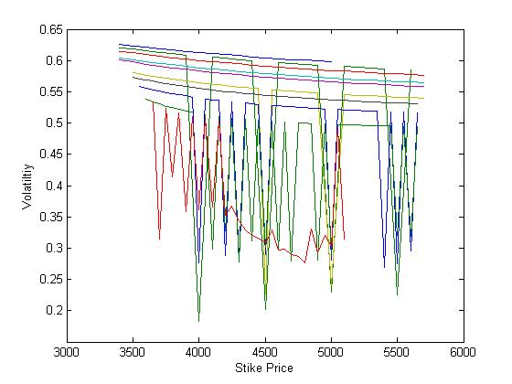

Plot of Implied Volatility vs Maturity
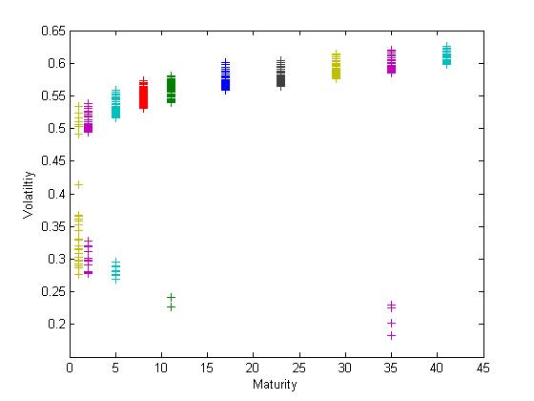

For Put
Plot of Implied Volatility vs Strike Price
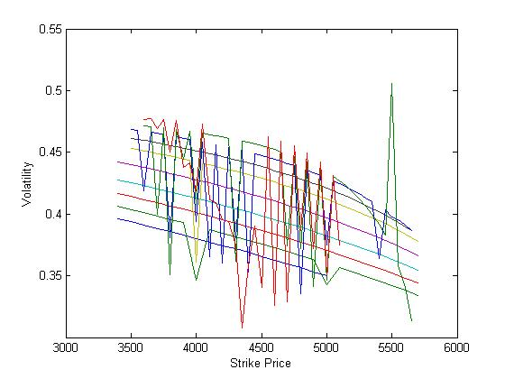
Plot of Implied Volatility vs Maturity
