MA 374
Financial Engineering Lab-10
Santosh Reddy Banda
140123010

Part 1:
Simulation of 10 paths in real and risk neutral world : Set 1: Real world

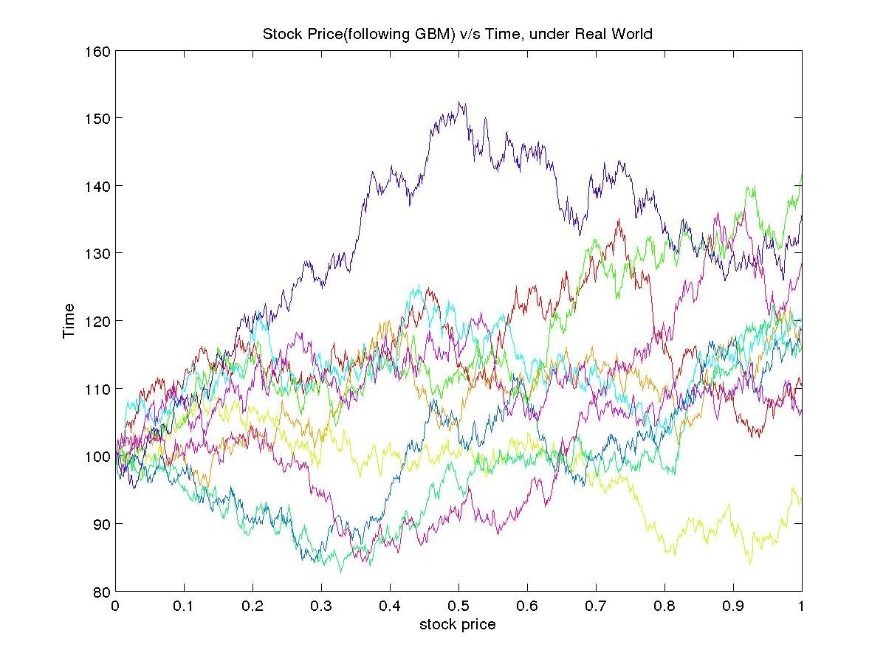

Simulation of 10 paths in real and risk neutral world : Set 2: Risk Neutral world

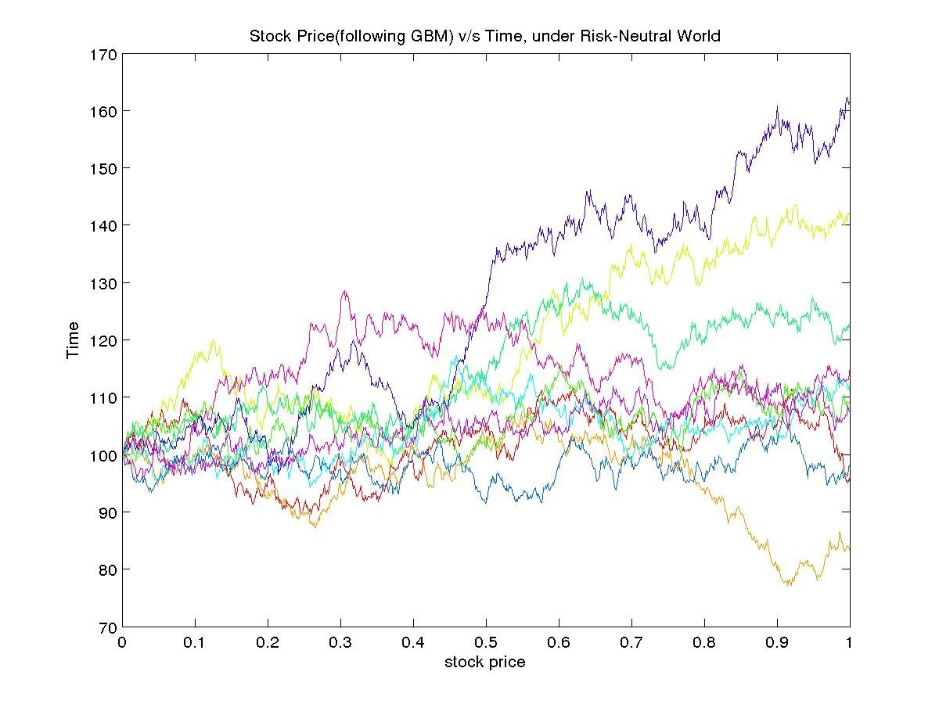

Part 2:
Calculation of Asian Call and Put option with strike = 105, 100, 90 by simulation of paths in risk neutral world :

Confidence interval for call option with strike=90: (11.167855 11.262790) with mean=11.215322
Confidence interval for put option with strike=90: (0.232708 0.246733) with mean=0.239721

Confidence interval for call option with strike=105: (1.760957 1.809022) with mean=1.784989
Confidence interval for put option with strike=105: (5.376679 5.446483) with mean=5.411581

Confidence interval for call option with strike=110: (0.680188 0.708681) with mean=0.694434
Confidence interval for put option with strike=110: (9.180578 9.265141) with mean=9.222859

Part 3:
Sensitivity of Option prices w.r.t. Different parameters
