# MA471:Stochastic Analysis of Financial Data

# Lab Assignment – 2

# Banda Santhosh Reddy : 140123010

## Question a:

Kurtosis for the dataset is obtained as follows :

Kurtosis for C-return is 75.04089

Kurtosis for SP_return is 13.235

Observation: Distribution of both C_return and SP-return are heavy tailed with respect to Normal distribution whose Kurtosis is 3. C_return is heavy tailed with respect to the distribution of SP_return

Question b:

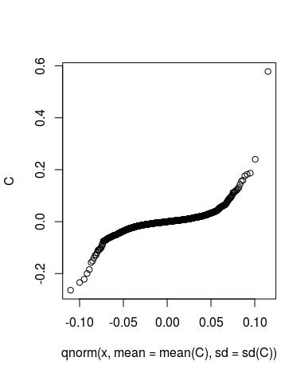

## 

## Question c:

The random samples for Weibull distribution are generated and There is a unique maximum for the Likelihood function as the Hessian matrix for the likelihood with respect to shape and scale parameters is negative definite.

## Question d:

From the 2 dimensional surface plot, I chose the initial value of parameters as shape = 2.2 and scale = 1.0 and after the Newton Raphson method, the value of the parameters converged to

Shape = 2.7175871

Scale= 0.9810205