Code Base: I don’t have an account in Git hence I am sharing the source code here.



Database Creation Screen shot:

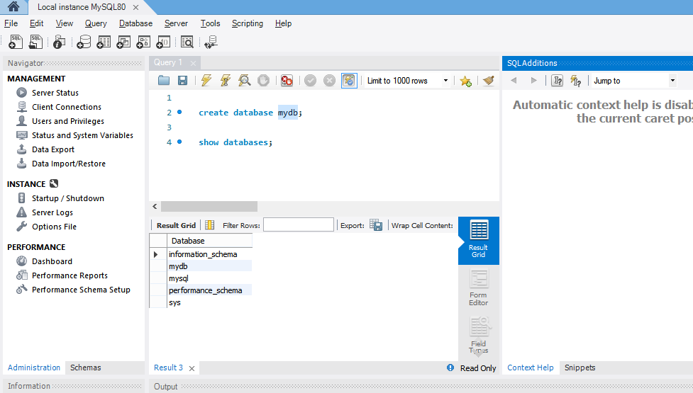

Application Started Screen shot:

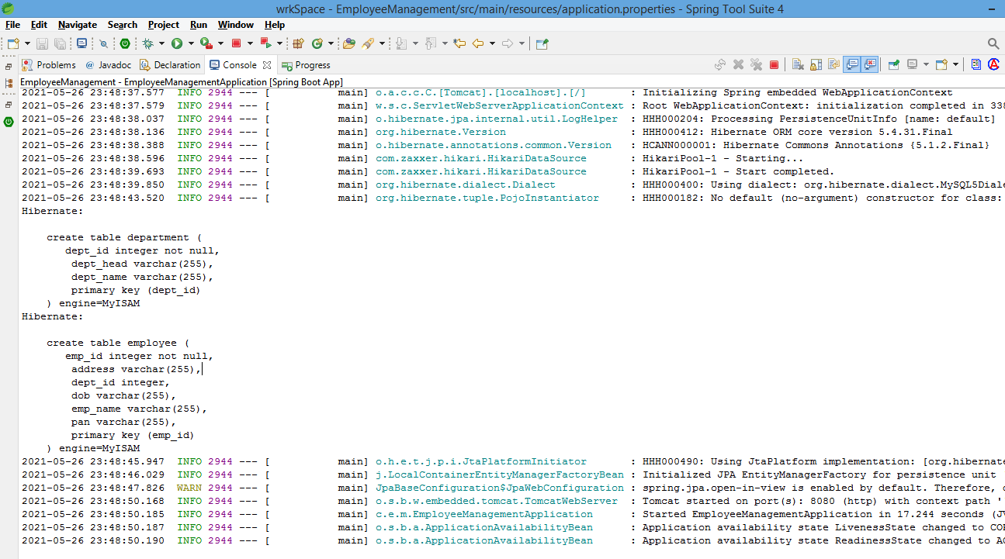

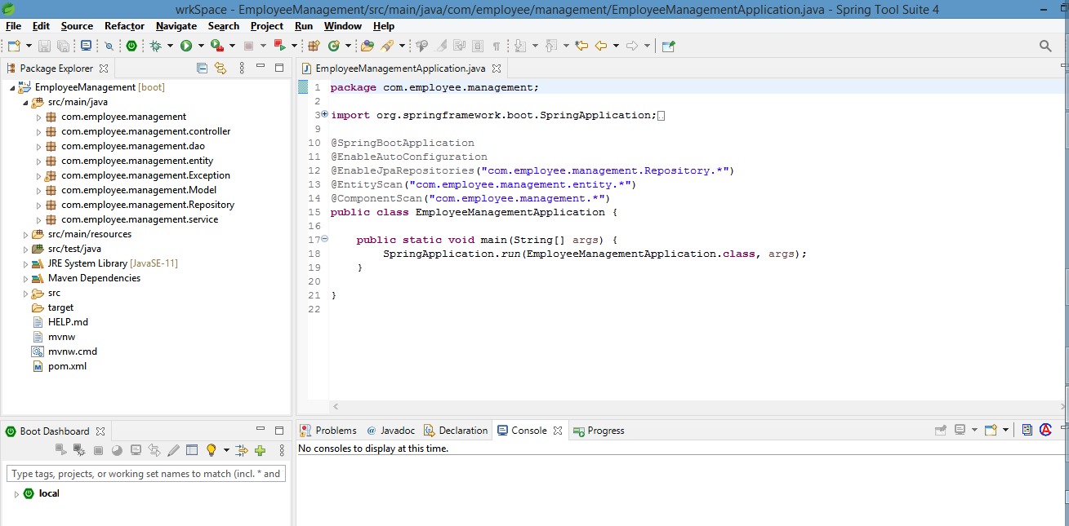

I have tried to my level best to come up with Success results, but due to tight timelines, I couldn’t trouble shoot the issues I had while API development. But I was able to create the REST service and could start the app in local STS.