**INTERNSHIP REPORT**

**ON**

**WEB DEVELOPMENT**

**A report submitted in partically fulfillment of the requirements of the Award of the**

**Degree of**

**MASTER OF SCIENCE**

**in**

**COMPUTER SCIENCE**

**by**

**SANTHOSH M**

**(Reg.No.2313112078017)**

**DEPARTMENT OF COMPUTER SCIENCE**



**GOVERNMENT ARTS COLLEGE FOR MEN (AUTONOMOUS), NANDANAM, CHENNAI-600 035.**

**2024-2025**

**DEPARTMENT OF COMPUTER SCIENCE GOVERNMENT ARTS COLLEGE FOR MEN(AUTONOMOUS), NANDANAM, CHENNAI-600 035.**



**CERTIFICATE**

**This is to certify that the "Internship report" submitted by SANTHOSH M(Reg.No.2313112078017)is work done by him and submitted during the academic year 2024-2025, in partial fulfillment of the requirements for the award of the degree ofMASTER OF SCIENCE IN COMPUTER SCIENCE, in Government Arts College (Men), (Autonomous), Nandanam, Chennai - 600 035.**

**Internship CoordinatorHead of the department**



|  |  |  |
| --- | --- | --- |
| **S.NO** | **CONTENTS** | **PAGE.NO** |
| 1 | INTRODUCTION | 1 |
| 2 | WEB DEVELOPMENT USING HTML,CSS,JS | 3 |
| 3 | INTERNSHIP PROJECT | 23 |
| 4 | CONCLUSION | 37 |

**WEBDEVELOPMENT**

* **Introduction**

**Web development** refers to the creating, building, and maintaining of websites. It includes aspects such as web design, web publishing, web programming, and database management. It is the creation of an application that works over the internet i.e. websites.



The word Web Development is made up of two words, that is:

* **Web:** It refers to websites, web pages or anything that works over the internet.
* **Development:** It refers to building the application from scratch.

**Web Development can be classified into two ways:**

* [Frontend Development](https://www.geeksforgeeks.org/web-development/#front_dev)
* [Backend Development](https://www.geeksforgeeks.org/web-development/#back_dev)
* **Frontend Development:**

The part of a website where the user interacts directly is termed as frontend. It is also referred to as the ‘client side’ of the application.

### **Popular Frontend Technologies**

* **HTML**
* **CSS**
* **JAVA SCRIPT**
* **BOOTSTRAP**

## **Backend Development**

Backend is the server side of a website. It is part of the website that users cannot see and interact with. It is the portion of software that does not come in direct contact with the users. It is used to store and arrange data.

### **Popular Backend Technologies**

* **PHP**
* **JAVA**
* **PYTHON**
* **NODE.JS**

**WEB DEVELOPMENT USING HTML,CSS,JS**

* **HTML** stands for **HyperText Markup Language.**It is the standard language used to create and design web pages on the internet.
* It was introduced by **Tim Berners-Lee** in **1991**at **CERN**as a simple markup language.
* Since then, it has evolved through versions from **HTML 2.0** to **HTML5**.
* HTML is a **combination of Hypertext and Markup language**.
* Hypertext defines the link between the web pages and Markup language defines the text document within the tag.

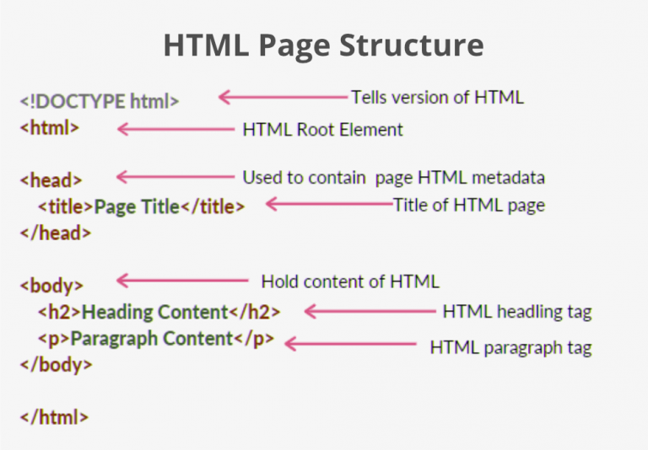

**SIMPLE HTML CODING:**

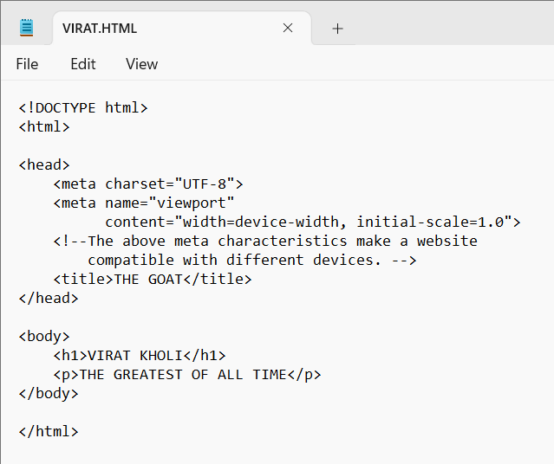

**OUTPUT:**

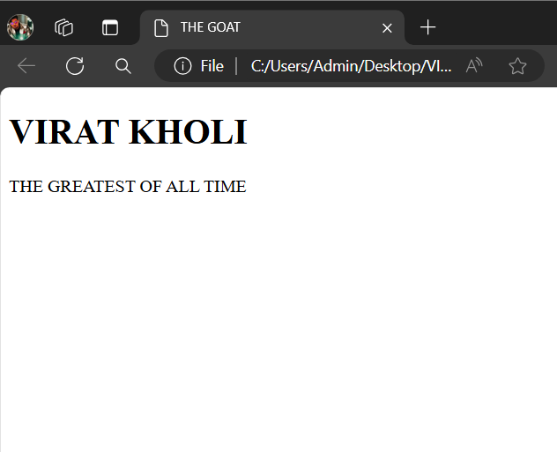

**HTML Tags:**

* HTML tags are the building blocks of any website.
* They are keywords used to create web pages in various formats. These tags come in pairs, with opening and closing tags, although some tags don’t need to be closed.
* **For example**, the HTML document structure is defined using tags like *<!DOCTYPE html>*,*<html>*,*<head>*, and *<body>*.
* There are 142 HTML tags within the latest HTML version, HTML 5.2. Only 115 tags are deemed functional and usable within any HTML code.
* There are two types of tags in HTML,
* **CONTAINER TAG**
* **EMPTY TAG**

## **Container tags**

* Container tags are generally divided into three parts, i.e., opening tag, content(which will display on the browser), and closing tag. In the content part, they can also contain some other tags.
* These opening and closing tags are used in pairs which are start tag and end tag, which are often called ON and OFF tags.
* If you forget to close the container tag, the browser applies the effect of the opening tag until the end of the page.
* So be careful while working with container tags. The majority of tags present in HTML are container tags.

**SYNTAX :**

**<tag_name> . . . </tag_name>**

Some commonly used container tags are:

**1. Essential Tags:**Following tags are used to create the structure of the webpage:

* ***<html>….</html>****: This marks the beginning and ending of the webpage also it tells that the document is an HTML document. This contains all other tags in between these tags which are considered for making a webpage.*
* ***<head>…</head>****: This tag is used to define the head part of the document which contains the information related to the webpage.*
* ***<title>…</title>****: This tag stores the description of the web page, whatever given in these tags appears on the tab name while opened by the browser. It is described in the head tag.*
* ***<body>….</body>:****This tag is used to display all the information or data, i.e, text, images, hyperlinks videos, etc., on the webpage to the user.*

**2. Headings:**Following tags are used for headings:

***<h1>….</h1> to <h6>…</h6>:****It is used for including headings of different sizes ranging from 1 to 6.*

**3. Text formatters:**Following tags are used for text formatting:

* ***<p>….</p>****: When paragraphs are needed to be included, this tag is used*
* ***<b>….</b>****: Makes the contained text to bold.*
* ***<i>…</i>****: Makes the contained text to italic.*

**4. HyperLinks:**Following tag is used to define a hyperlink in the webpage:

***<a href=”link.com”>…</a>:****When we link some other webpages we add the hyper links to other webpages using this <a …>…</a>tag.*

**5. Button tag:**Following  tag is used to create a click button:

***<button>…</button>:****This is used in many ways but mainly used to manipulate done by adding events and many more.*

**6. Division tag:**Following tag is used to create a division:

***<div>….</div>:****This defines a section in a document. The webpage can be divided to different sections using the <div>….</div> tag.*

**7. Iframe tag:**Following tag is used for inline framing:

***<iframe src=”link.com></iframe>****: When some other document is to be embedded like some video or image into HTML we use this tag.*

**8. Navigation tag:**Following tag is used to set a navigation link:

***<nav>…</nav>:****Defines a navigation bar that contains a set of menu or a menu of hyperlinks.*

**9. Script tag:**Following  tag is used to add JavaScript code to the webpage:

***<script>…</script>****: This contains the javascript code that adds interactivity to the webpage.*

**10. Lists:**Following tags are used to write data in the form of ordered and unordered lists:

* ***<ol>…</ol>:****This tag is used to create ordered lists.*
* ***<ul>…</ul>:****This tag is used to create unordered lists.*
* ***<li>…</li>:****This tag is used to add list items.*

## **Empty Tags**

* The tags that do not contain any closing tags are known as empty tags.
* Empty tags contain only the opening tag but they perform some action in the webpage.

| **Empty Tags** | **Description** |
| --- | --- |
| **<br>** | Inserts a line break in a webpage wherever needed. |
| **<hr>** | Inserts a horizontal line wherever needed in the webpage. |
| **<img>** | This tag is used to display the images on the webpage which were given in the src attribute of the tag. |
| **<input>** | This is mainly used with forms to take the input from the user and we can also define the type of the input. |
| **<link>** | When we store our CSS in an external file this can be used to link external files and documents to the webpage and it is mainly used to link CSS files. |
| **<meta>** | Contains all metadata of the webpage. Metadata is the data about data and is described in the head tag. |
| **<source>** | source tag is used to insert any media source like audio, video etc… in our webpage. |

* **HEADING TAG**

<h1>This is heading 1</h1>  
<h2>This is heading 2</h2>  
<h3>This is heading 3</h3>  
<h4>This is heading 4</h4>  
<h5>This is heading 5</h5>  
<h6>This is heading 6</h6>

These are the six different **HEADING TAGS** in HTML.

## **TEXT FORMATTING TAGS**

|  |  |
| --- | --- |
| **Tag** | **Description** |
| [<abbr>](https://www.w3schools.com/tags/tag_abbr.asp) | Defines an abbreviation or an acronym |
| [<address>](https://www.w3schools.com/tags/tag_address.asp) | Defines contact information for the author/owner of a document/article |
| [<b>](https://www.w3schools.com/tags/tag_b.asp) | Defines bold text |
| [<center>](https://www.w3schools.com/tags/tag_center.asp) | Not supported in HTML5. Use CSS instead. Defines centered text |
| [<del>](https://www.w3schools.com/tags/tag_del.asp) | Defines text that has been deleted from a document |
| [<font>](https://www.w3schools.com/tags/tag_font.asp) | Not supported in HTML5. Use CSS instead. Defines font, color, and size for text |
| [<i>](https://www.w3schools.com/tags/tag_i.asp) | Defines a part of text in an alternate voice or mood |
| [<q>](https://www.w3schools.com/tags/tag_q.asp) | Defines a short quotation |
| [<small>](https://www.w3schools.com/tags/tag_small.asp) | Defines smaller text |
| [<strike>](https://www.w3schools.com/tags/tag_strike.asp) | Not supported in HTML5. Use <del> or <s> instead. Defines strikethrough text |
| [<strong>](https://www.w3schools.com/tags/tag_strong.asp) | Defines important text |
| [<sub>](https://www.w3schools.com/tags/tag_sub.asp) | Defines subscripted text |
| [<sup>](https://www.w3schools.com/tags/tag_sup.asp) | Defines superscripted text |
| [<var>](https://www.w3schools.com/tags/tag_var.asp) | Defines a variable |

## **FORMS AND INPUT TAGS**

|  |  |
| --- | --- |
| **Tag** | **Description** |
| [<form>](https://www.w3schools.com/tags/tag_form.asp) | Defines an HTML form for user input |
| [<input>](https://www.w3schools.com/tags/tag_input.asp) | Defines an input control |
| [<button>](https://www.w3schools.com/tags/tag_button.asp) | Defines a clickable button |
| [<label>](https://www.w3schools.com/tags/tag_label.asp) | Defines a label for an <input> element |

## **FRAME TAG**

|  |  |
| --- | --- |
| **Tag** | **Description** |
| [<frame>](https://www.w3schools.com/tags/tag_frame.asp) | Not supported in HTML5. Defines a window (a frame) in a frameset |
| [<iframe>](https://www.w3schools.com/tags/tag_iframe.asp) | Defines an inline frame |

## **IMAGES TAG**

|  |  |
| --- | --- |
| **Tag** | **Description** |
| [<img>](https://www.w3schools.com/tags/tag_img.asp) | Defines an image |
| [<map>](https://www.w3schools.com/tags/tag_map.asp) | Defines a client-side image map |

## **AUDIO / VIDEO TAGS**

|  |  |
| --- | --- |
| **Tag** | **Description** |
| [<audio>](https://www.w3schools.com/tags/tag_audio.asp) | Defines sound content |
| [<source>](https://www.w3schools.com/tags/tag_source.asp) | Defines multiple media resources for media elements (<video>, <audio> and <picture>) |
| [<track>](https://www.w3schools.com/tags/tag_track.asp) | Defines text tracks for media elements (<video> and <audio>) |
| [<video>](https://www.w3schools.com/tags/tag_video.asp) | Defines a video or movie |

## **LINKS TAG**

|  |  |
| --- | --- |
| **Tag** | **Description** |
| [<a>](https://www.w3schools.com/tags/tag_a.asp) | Defines a hyperlink |
| [<link>](https://www.w3schools.com/tags/tag_link.asp) | Defines the relationship between a document and an external resource (most used to link to style sheets) |
| [<nav>](https://www.w3schools.com/tags/tag_nav.asp) | Defines navigation links |

## **LISTS TAG**

|  |  |
| --- | --- |
| **Tag** | **Description** |
| [<ul>](https://www.w3schools.com/tags/tag_ul.asp) | Defines an unordered list |
| [<ol>](https://www.w3schools.com/tags/tag_ol.asp) | Defines an ordered list |
| [<li>](https://www.w3schools.com/tags/tag_li.asp) | Defines a list item |

## **TABLES TAG**

|  |  |
| --- | --- |
| **Tag** | **Description** |
| [<table>](https://www.w3schools.com/tags/tag_table.asp) | Defines a table |
| [<caption>](https://www.w3schools.com/tags/tag_caption.asp) | Defines a table caption |
| [<th>](https://www.w3schools.com/tags/tag_th.asp) | Defines a header cell in a table |
| [<tr>](https://www.w3schools.com/tags/tag_tr.asp) | Defines a row in a table |
| [<td>](https://www.w3schools.com/tags/tag_td.asp) | Defines a cell in a table |
| [<thead>](https://www.w3schools.com/tags/tag_thead.asp) | Groups the header content in a table |
| [<tbody>](https://www.w3schools.com/tags/tag_tbody.asp) | Groups the body content in a table |
| [<tfoot>](https://www.w3schools.com/tags/tag_tfoot.asp) | Groups the footer content in a table |

## **STYLE TAG**

|  |  |
| --- | --- |
| **Tag** | **Description** |
| [<style>](https://www.w3schools.com/tags/tag_style.asp) | Defines style information for a document |
| [<div>](https://www.w3schools.com/tags/tag_div.asp) | Defines a section in a document |
| [<span>](https://www.w3schools.com/tags/tag_span.asp) | Defines a section in a document |
| [<search>](https://www.w3schools.com/tags/tag_search.asp) | Defines a search section |

## **CSS**

CSS stands for Cascading Style Sheets. CSS describes how HTML elements are to be displayed on screen, paper, or in other media. CSS saves a lot of work. It can control the layout of multiple web pages all at once.External stylesheets are stored in CSS files.

**Types of CSS:**

There are three types of CSS

* **Inline css**
* **Internal css**
* **External css**

## **Inline CSS:**

Inline CSS involves applying styles directly to individual HTML elements using the style attribute. This method allows for specific styling of elements within the HTML document, overriding any external or internal styles.

* **Internal CSS:**

[Internal or Embedded CSS](https://www.geeksforgeeks.org/internal-css/) is defined within the HTML document’s <style> element. It applies styles to specified HTML elements, The CSS rule set should be within the HTML file in the head section i.e. the CSS is embedded within the <style> tag inside the head section of the HTML file.

* **External CSS:**

[External CSS](https://www.geeksforgeeks.org/external-css/) contains separate CSS files that contain only style properties with the help of tag attributes (For example class, id, heading, … etc). CSS property is written in a separate file with a .css extension and should be linked to the HTML document using a **link** tag. It means that, for each element, style can be set only once and will be applied across web pages.

**PROJECT : CREATING A WEB PAGE FOR BOOK MY SHOW APPLICATION USING HTML ,CSS And JS**

**HTML CODING:**

<!DOC html>

<head>

<title>book my show

</title>

<link href="https://cdn.jsdelivr.net/npm/bootstrap@5.0.2/dist/css/bootstrap.min.css" rel="stylesheet" integrity="sha384-EVSTQN3/azprG1Anm3QDgpJLIm9Nao0Yz1ztcQTwFspd3yD65VohhpuuCOmLASjC" crossorigin="anonymous">

</head>

<body bgcolor="black">

<style>

body {

background-image: url("theatre.jpg");

background-size:cover;

background-position:center;

background-repeat: repeat;

font-family:Arial,sans-serif;

color:white;

text-align:center;

}

</style>

<img src="logo.png"width="1700" height="150">

<br>

<br>

<button type="button" class="btn btn-Movies"><style color="white"></style>Movies</button>

<button type="button" class="btn btn-Stream"><style color="white"></style>Stream</button>

<button type="button" class="btn btn-Event"><style color="white"></style>Event</button>

<button type="button" class="btn btn-Plays"><style color="white"></style>Plays</button>

<button type="button" class="btn btn-Activities"><style color="white"></style>Activities</button>

<div class="rightnav">

<input type="text"

name="search"

id="search"

font color="white">

<button class="btn btn-sm"><style color="white"></style>Search</button>

</div>

</nav>

<div class="toast" role="alert" aria-live="assertive" aria-atomic="true">

<div class="toast-header">

<strong class="me-auto"></strong>

<small class="text-muted"></small>

<button type="button" class="btn-close" data-bs-dismiss="toast" aria-label="Close"></button>

</div>

<div class="toast-body">

Welome to Book my show,Enjoy your show with your loved ones.

</div>

</div>

<button type="button" class="btn btn-lg btn-danger" data-bs-toggle="popover" title="Popover title" data-bs-content="And here's some amazing content. It's very engaging. Right?">Book My Show</button>

<div id="carouselExampleCaptions" class="carousel slide" data-bs-ride="carousel">

<div class="carousel-indicators">

<button type="button" data-bs-target="#carouselExampleCaptions" data-bs-slide-to="0" class="active" aria-current="true" aria-label="Slide 1"></button>

<button type="button" data-bs-target="#carouselExampleCaptions" data-bs-slide-to="1" aria-label="Slide 2"></button>

<button type="button" data-bs-target="#carouselExampleCaptions" data-bs-slide-to="2" aria-label="Slide 3"></button>

</div>

<div class="carousel-inner">

<div class="carousel-item active">

<img src="garudan-poster2.webp" class="d-block w-100" alt="HOUSEFULL">

<div class="carousel-caption d-none d-md-block">

<p style="color:white"

<h4><b>GARUDAN</b></h4>

<br>

(DRAMA)

</div>

</div>

<div class="carousel-item">

<img src="ghilli2.jpg" class="d-block w-100" alt="HOUSEFULL">

<div class="carousel-caption d-none d-md-block">

<p style="color:white"

<h5><b>GHILLI</b></h5>

<br>

(ACTION/DRAMA)

</div>

</div>

<div class="carousel-item">

<img src="pokiri2.webp" class="d-block w-100" alt="HOUSEFULL">

<div class="carousel-caption d-none d-md-block">

<p style="color:white"

<h5><b>POKIRI</b></h5>

<br>

(ACTION/DRAMA)

</div>

</div>

</div>

<button class="carousel-control-prev" type="button" data-bs-target="#carouselExampleCaptions" data-bs-slide="prev">

<span class="carousel-control-prev-icon" aria-hidden="true"></span>

<span class="visually-hidden">Previous</span>

</button>

<button class="carousel-control-next" type="button" data-bs-target="#carouselExampleCaptions" data-bs-slide="next">

<span class="carousel-control-next-icon" aria-hidden="true"></span>

<span class="visually-hidden">Next</span>

</button>

</div>

<script src="https://cdn.jsdelivr.net/npm/bootstrap@5.0.2/dist/js/bootstrap.bundle.min.js" integrity="sha384-MrcW6ZMFYlzcLA8Nl+NtUVF0sA7MsXsP1UyJoMp4YLEuNSfAP+JcXn/tWtIaxVXM" crossorigin="anonymous"></script>

</body>

</html>

**OUTPUT:**

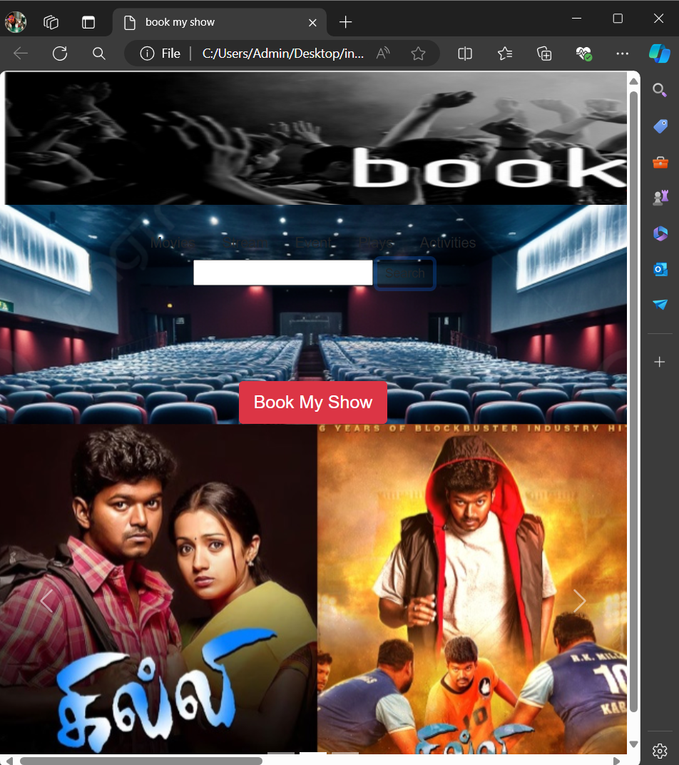

* **JAVA SCRIPT**
* **JavaScript** is the most powerful and versatile web programming language.
* It is used for making the websites interactive.
* JavaScript helps us add features like animations, interactive forms and dynamic content to web pages.
* JavaScript is a **programming language used for creating dynamic content on websites**.
* It is a **lightweight**, **cross-platform** and **single-threaded** programming language.
* JavaScript is an **interpreted**language that executes code line by line providing more flexibility.
* It is a commonly used programming language to**create dynamic and interactive elements in web applications**.
* It is easy to learn.

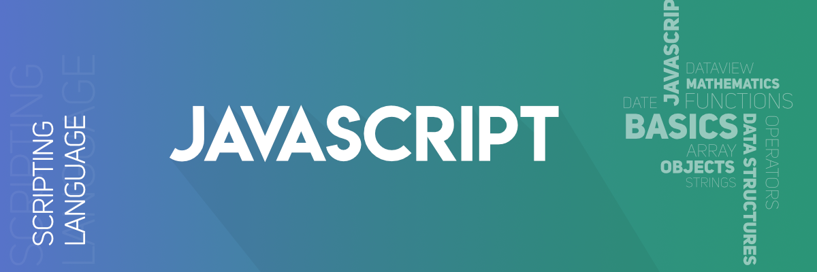

### **Key Features of JavaScript:**

* **Versatility**: JavaScript can be used to develop websites, games, mobile apps, and more.
* **Client and Server-Side**: With frameworks like [Node.js](https://www.geeksforgeeks.org/nodejs/)and [Express.js](https://www.geeksforgeeks.org/express-js/), JavaScript is now used for building server-side applications.
* **End-to-End Solutions**: JavaScript enables developers to create complete solutions for various problems.
* **Constant Evolution**: JavaScript continually evolves with new features and standards.
* **Vibrant Community**: A large community of users and mentors actively contributes to JavaScript’s growth.



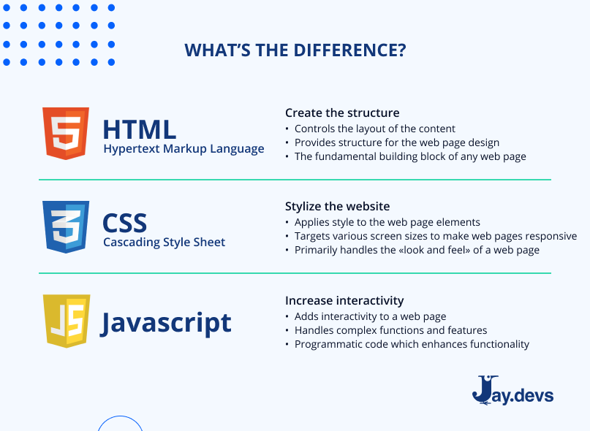

**For Example:**

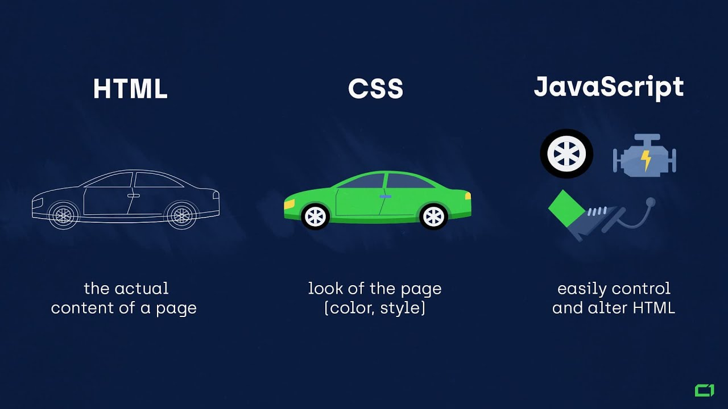

**Here we can able to clearly understand that How does HTML, CSS and JS used for web designing and Development.**

# **Python as Back-end Development**

* Python allows you to create innovative backend solutions. This versatile language is swiftly becoming a go-to for developers seeking to create powerful server-side components for web applications.
* But its simplicity and versatility are just the beginning. Python enables you to design solutions that make real-world impacts, bringing efficiency and innovation to various industries.
* Python is a popular programming language.
* It was created by Guido van Rossum, and released in 1991.
* Python can be used on a server to create web applications.
* High Level Language
* Open Source
* It is used for:
* web development (server-side),
* software development,
* mathematics.

**PYTHON:**

* Python works on different platforms (Windows, Mac, Linux, Raspberry Pi, etc.)
* Python has a simple syntax similar to the English language.
* Python runs on an interpreter system, meaning that code can be executed as soon as it is written. This means that prototyping can be very quick.
* Basic Syntax:Print(“Hello Word”)
* **Advantages and Disadvantages of python:**

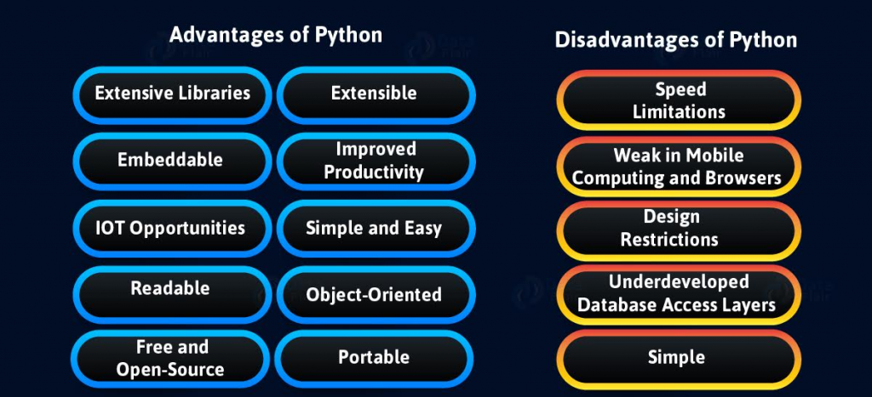

**CONCLUSION:**

In today's Web development, a good page design is essential. A bad design will lead to the loss of visitors and that can lead to a loss of business. In general, a good page layout has to satisfy the basic elements of a good page design. This includes color contrast, text organization, font selection, style of a page, page size, graphics used, and consistency.

In order to create a well-designed page for a specific audience. The developer needs to organized and analyze the users' statistics and the background of the users. Although it can be hard to come up with a design that is well suited to all of the users, there will be a design that is appropriate for most of the audience. The better the page design, the more hits a page will get. That implies an increase in accessibility and a possible increase in business.