Innovation For Air Quality Analysis

# Data Analysis And Innovation:

Data is an emerging resource for organizations, enabling value creation and the development of new industries, products, and processes. The use of data to create value and reach new horizons is called data-driven innovation.

This type of innovation is based on three growth-catalyzing practices: collecting data, using data analysis techniques and methodologies, and leveraging data in decision-making. Adopting these practices and moving to a new data paradigm streamlines companies’ innovation efforts, resulting in more innovation and reduced time to time market.

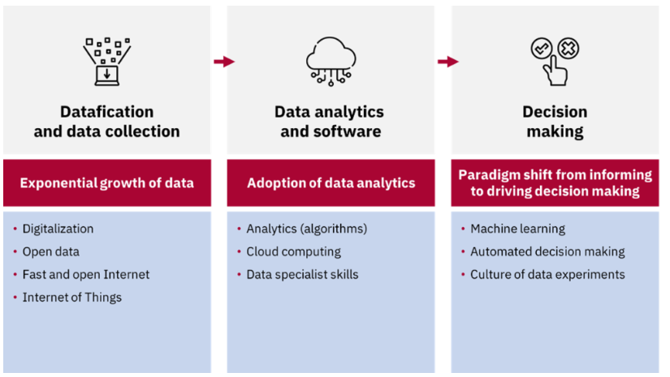

# Introduction:

As part of our Air Quality Analysis project, we are considering the incorporation of machine learning algorithms to enhance the accuracy of the predictive model. The primary objective is to develop a more robust and precise model for estimating RSPM/PM10 levels based on SO2 and NO2 levels. By leveraging machine learning techniques, we aim to improve the model's predictive capabilities and provide more accurate insights into air pollution trends in Tamil Nadu.

# Current Predictive Model:

Our current approach involves building a predictive model based on traditional regression algorithms. While these models provide a good starting point for estimating pollutant levels, there is room for improvement in terms of accuracy and robustness. Factors such as non-linearity, interactions between pollutants, and temporal variations may not be fully captured by conventional regression methods.

### ****Integration of data analytics throughout the innovation process****

The innovation process entails testing and adjustments culminating in developing a profitable product or service. It is critical to ensure that data is integrated throughout the process, not just at the beginning of the innovation development. Whether it’s through audience testing, MVP(Minimum Viable Product) creation, or process improvement,dataanalysis process.

Now, let’s get started with the task of Air Quality Index Analysis by importing the necessary Python libraries and the dataset:

* import pandas as pd
* import plotly.express as px
* import plotly.io as pio
* import plotly.graph_objects as go

# Proposed Innovation

To address the limitations of our current predictive model, we propose the following innovations:

# 

# 1. Feature Engineering

* Polynomial Features: We will explore the creation of polynomial features to capture non-linear relationships between pollutants (e.g., SO2^2, NO2^2, SO2 * NO2). This can help the model better represent complex interactions.
* Temporal Features: Introduce temporal features such as time of day, day of the week, and seasonal indicators to account for time-dependent variations in air quality.

# 2. Advanced Regression Techniques

* Ridge and Lasso Regression: Implement Ridge and Lasso regression, which introduce regularization terms to mitigate overfitting and improve model stability.
* Elastic Net Regression: Utilize Elastic Net regression, which combines the advantages of both Ridge and Lasso regression, to handle multicollinearity and feature selection.

# 3. Ensemble Learning

* Random Forest Regression: Implement Random Forest regression, an ensemble learning technique that can capture complex relationships between features and improve prediction accuracy.
* Gradient Boosting: Explore Gradient Boosting algorithms like XGBoost or LightGBM, which can optimize model performance through boosting.

# 4. Cross-Validation and Hyperparameter Tuning

* Employ cross-validation techniques such as k-fold cross-validation to assess model performance robustness.
* Perform hyperparameter tuning to find the best set of parameters for each algorithm, optimizing model accuracy.

## Expected Benefits

By incorporating these innovations, we anticipate several benefits:

* Improved Accuracy: Machine learning algorithms can capture complex relationships in the data, leading to more accurate estimates of RSPM/PM10 levels.
* Robustness: Regularization techniques and ensemble learning methods can enhance model stability and reduce overfitting.
* Better Feature Representation: Feature engineering will enable the model to capture non-linear and temporal dependencies.
* Enhanced Insights: A more accurate model will provide more valuable insights into air pollution trends in Tamil Nadu, aiding in policy-making and pollution control efforts.

## Implementation Plan

Our implementation plan involves the following steps:

* Data Preparation: Ensure the dataset is ready for modeling, including feature engineering and encoding categorical variables.
* Algorithm Selection: Choose the appropriate machine learning algorithms for experimentation, including Ridge and Lasso regression, Elastic Net regression, Random Forest regression, and Gradient Boosting.
* Model Training: Train each selected algorithm on the preprocessed data.
* Cross-Validation: Evaluate the models using cross-validation techniques to assess their performance and robustness.
* Hyperparameter Tuning: Fine-tune hyperparameters to optimize each model's accuracy.
* Model Comparison: Compare the performance of different models and select the best-performing one for estimating RSPM/PM10 levels.

# From The Given Dataset:

In this section We design a innovation to solve the problem. Consider incorporating machine learning algorithms to improve the accuracy of the predictive model.

**Dataset Link: [https://tn.data.gov.in/resource/location-wise-daily-ambient-air-quality-tamil-nadu-year-2014](https://tn.data.gov.in/resource/location-wise-daily-ambient-air-quality-tamil-nadu-year-2014" \t "https://survey.zohopublic.in/zs/_blank)**

# To List The Given dataset Fields:

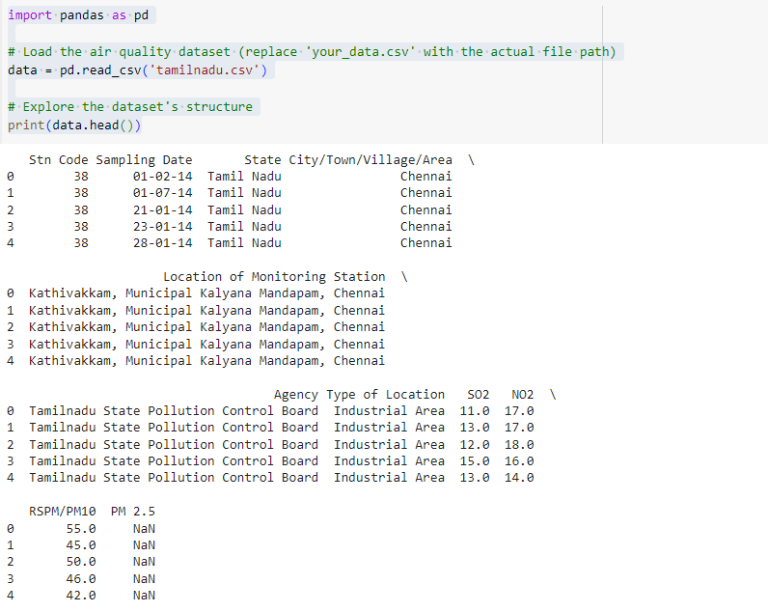

# Conclusion:

Incorporating machine learning algorithms into our Air Quality Analysis project is a promising innovation that has the potential to significantly enhance the accuracy and reliability of our predictive model. By addressing the limitations of traditional regression methods and introducing advanced techniques, we aim to provide more accurate insights into air pollution trends in Tamil Nadu, ultimately contributing to better environmental management and public health.

We will proceed with the implementation plan outlined above and closely monitor the progress and results to ensure the successful integration of machine learning into our project.