**Q1. Describe the main differences between the CSS Flexbox layout model and the CSS Grid layout model. When would you choose to use one over the other?**

| **Feature** | **Flexbox** | **CSS Grid** |
| --- | --- | --- |
| Axis | One-dimensional (row or column) | Two-dimensional (rows and columns) |
| Layout Control | Best for content in a single row or column | Better for overall page layout |
| Content Flow | Content-driven | Layout-driven |
| Alignment | Easier vertical and horizontal centering | More complex alignment control |
| Use Case | Navigation bars, card layouts, centering elements | Web page layouts, dashboards, forms |

**Flexbox-** when layout is primarily linear (row or column).  
**Grid-** when need to control both dimensions of your layout.

**Q2. Explain the role of the following key properties in the Flexbox layout mode**

**justify-content**

**align-item**

**gap**

**flex-direction**

**flex-wrap**

Ans :  
justify-content:

Aligns items horizontally along the main axis.

Values: flex-start, flex-end, center, space-between, space-around, space-evenly.

align-items:

Aligns items vertically (along the cross axis) in a flex container.

Values: flex-start, flex-end, center, baseline, stretch.

gap:

Adds spacing between flex items (like margin but cleaner).

Example: gap: 20px;

flex-direction:

Defines the direction of the main axis.

Values: row, row-reverse, column, column-reverse.

flex-wrap:

Allows items to wrap onto multiple lines.

Values: nowrap (default), wrap, wrap-reverse.

**Q3. Write the code to center a div using CSS Flexbox. Reference Image given below**

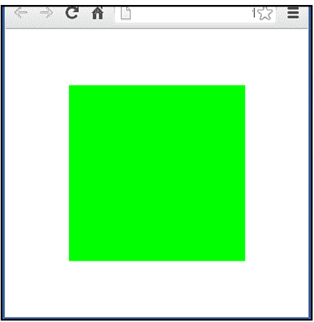

Ans:

html

<!DOCTYPE html>

<html lang="en">

<head>

    <meta charset="UTF-8">

    <meta name="viewport" content="width=device-width, initial-scale=1.0">

    <title>Document</title>

    <link rel="stylesheet" href="style.css">

</head>

<body>

    <div class="container">

        <div class="centered-box"></div>

    </div>

</body>

</html>

Css:  
* {

    margin: 0;

    padding: 0;

    box-sizing: border-box;

}

.container {

    display: flex;

    justify-content: center;

    align-items: center;

    height: 100vh;

}

.centered-box {

    padding: 20px;

    background-color: #ddd;

    height: 300px;

    width: 300px;

    background-color: greenyellow;

}

**Q4. A client of yours wants to add a pricing section on their website to showcase their newly introduced premium plans.**

Ans:

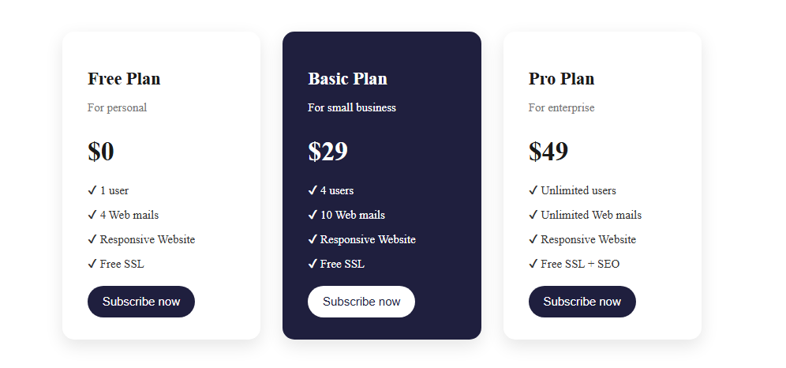

<!DOCTYPE html>

<html lang="en">

<head>

    <meta charset="UTF-8">

    <meta name="viewport" content="width=device-width, initial-scale=1">

    <title>Pricing Plans</title>

    <link rel="stylesheet" href="plans.css">

</head>

<body>

    <section class="pricing-section">

        <div class="card">

            <h2>Free Plan</h2>

            <p class="subheading">For personal</p>

            <h1>$0</h1>

            <ul>

                <li>✔ 1 user</li>

                <li>✔ 4 Web mails</li>

                <li>✔ Responsive Website</li>

                <li>✔ Free SSL</li>

            </ul>

            <button>Subscribe now</button>

        </div>

        <div class="card featured">

            <h2 class="text-white">Basic Plan</h2>

            <p class="subheading text-white">For small business</p>

            <h1 class="text-white">$29</h1>

            <ul>

                <li>✔ 4 users</li>

                <li>✔ 10 Web mails</li>

                <li>✔ Responsive Website</li>

                <li>✔ Free SSL</li>

            </ul>

            <button class="featured-btn">Subscribe now</button>

        </div>

        <div class="card">

            <h2>Pro Plan</h2>

            <p class="subheading">For enterprise</p>

            <h1>$49</h1>

            <ul>

                <li>✔ Unlimited users</li>

                <li>✔ Unlimited Web mails</li>

                <li>✔ Responsive Website</li>

                <li>✔ Free SSL + SEO</li>

            </ul>

            <button>Subscribe now</button>

        </div>

    </section>

</body>

</html>

Css:  
.pricing-section {

    display: flex;

    gap: 30px;

    padding: 40px;

    flex-wrap: wrap;

    margin: 0 auto;

    justify-content: center;

}

.card {

    background-color: white;

    border-radius: 16px;

    box-shadow: rgba(0, 0, 0, 0.1) 0px 8px 24px;

    padding: 30px 34px;

    text-align: start;

    flex: 1 1 221px;

    max-width: 200px;

}

.card h2 {

    margin-bottom: 5px;

    color: #1a1a1a;

}

.subheading {

    color: #777;

    margin-bottom: 20px;

}

.card h1 {

    font-size: 36px;

    margin-bottom: 20px;

    color: #1a1a1a;

}

.card ul {

    list-style: none;

    padding: 0;

    margin-bottom: 20px;

}

.card ul li {

    margin: 12px 0;

    color: #333;

    font-weight: 500;

}

.card button {

    background-color: #1f1f3e;

    color: white;

    border: none;

    padding: 12px 20px;

    font-size: 16px;

    border-radius: 25px;

    cursor: pointer;

}

.card.featured {

    background-color: #1f1f3e;

    color: white !important;

}

.card.featured ul li {

    color: white;

}

.featured-btn {

    background-color: white !important;

    color: #1f1f3e !important;

}

.text-white {

    color: white !important;

}

.bg-white {

    background-color: white !important;

}

**Q5. build a clone of the IRCTC Ticket booking page.**