***1 Introduction:***

*The project Hospital Management system includes registration of patients, storing their details into the system. The software has the facility to give a unique id for every patient and stores the details of every patient and the staff automatically.*

*The details of a patient using the id “Hospital” can be entered using a username and password. The data are well protected for personal use and makes the data processing very fast. Hospital Management System is powerful, flexible, and easy to use and is designed and developed to deliver real conceivable benefits to hospitals. To cover a wide range of hospital administration and management processes.*

*It is an integrated end-to-end Hospital Management System that provides relevant information across the hospital to support effective decision making for patient care. Hospital Management System is a software Hospital Management System enables you to develop your organization and improve its effectiveness and quality of work.*

***Scope of the project :***

* *Information about Patients is done by just writing the Patients name, age and gender. Whenever the Patient comes up his information is stored freshly.*
* *Daily functions like patient registration, managing admission and overall management of various departments can be easily performed with higher accuracy by using our application.*
* *The modules of hospital management software are user-friendly and easy to access. It has a common user friendly interface having several modules. The officials can utilize these modules in their processes without any hassle and make the best possible use of hospital management system.*
* *This tool is a comprehensive solution that integrates all the departments by creating a common platform. In brief, hospital management system has all the modules that serve purpose of all the departments of healthcare institute. In fact, these modules have been competitively designed to make all the operations simplified.*

***Objective:-***

* + *Define hospitals and related branches.*
  + *Recording information about the Patients that come.*
  + *Recording information related to the diagnosis given to Patients.*
  + *Tracking End-to-End information about Patients.*
  + *Providing respective accessibility based on their roles.*

***MODULES:***

*The project consist of modules are mentioned below:*

* *Admin module*
* *Staff module*
* *User module (patient)*

***Admin module :***

1. *Admin is responsible for establishing the hospital with the respective branch.*
2. *Admin is eligible to modify the hospital and branch.*
3. *Admin is responsible for control over the staff’s for the respective hospital of the branch.*
4. *Admin is responsible for control over the Room’s for the respective Floor of the Budlings.*
5. *Admin can add, remove, view and modify the beds.*

***Staff module :***

1. *Manage patient, account opening and updating*
2. *Create encounter for patient*
3. *Staff can allocate the bed for the patient*
4. *View admit history. like bed, ward icu etc*

***user module(patient) :***

1. *View prescription details*
2. *View encounter details.*

***Admin module features :***

* *Creating the hospital .*
* *Modifying the hospital details.*
* *Removing the hospital.*
* *Specific hospital can be viewed.*
* *Viewing all hospitals.*
* *Creating the branch for hospital.*
* *Modifying the branch details.*
* *Removing the branch.*
* *Viewing all branches.*
* *Specific branch can be viewed.*
* *Creating the building for branch.*
* *Modifying the building details.*
* *Removing the building.*
* *Viewing all buildings.*
* *Specific building can be viewed.*
* *Creating the floor for building.*
* *Modifying the floor details.*
* *Removing the floor.*
* *Viewing all floors.*
* *Specific floor can be viewed.*
* *Creating the Room for building.*
* *Modifying the Room details.*
* *Removing the room.*
* *Viewing all rooms.*
* *Specific room can be viewed.*
* *Creating the beds for room.*
* *Modifying the bed details.*
* *Removing the bed.*
* *Viewing all beds.*
* *Specific bed can be viewed.*
* *Creating the Staff for hospital .*
* *Modifying the Staff details.*
* *Removing the Staff.*
* *Viewing all staff.*

***Staff module features :***

* *Creating the patient .*
* *Modifying the patient details.*
* *Can view patient information .*
* *Can discharge the patient from bed.*
* *Viewing of all patients****.***
* *Bed can be viewed.*
* *Room can be viewed.*

***User(Patient) module features :***

* *Can view the encounters.*

***Flow-Diagram :***

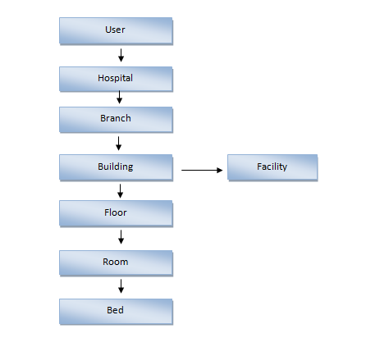

**DTO’s  ( ALL ENTITYS’s )**

***User***

|  |  |  |  |  |  |  |  |
| --- | --- | --- | --- | --- | --- | --- | --- |
| Id | Name | Email | Password | Phone | Age | Gender | Role_discription |

**Hospital**

|  |  |  |  |  |  |  |
| --- | --- | --- | --- | --- | --- | --- |
| Id | Name | website | Phone | Email | Gst | User |

**Branch**

|  |  |  |  |  |  |  |  |
| --- | --- | --- | --- | --- | --- | --- | --- |
| Id | Branch_name | Country | State | City | Branch_number | Pincode | Hospital |

**Building**

|  |  |  |
| --- | --- | --- |
| Id | Building Name | Branch |

**Floor**

|  |  |  |  |
| --- | --- | --- | --- |
| Id | Floor Number | Type | Building |

**Room**

|  |  |  |  |
| --- | --- | --- | --- |
| Id | Room Number | Type | Floor |

**Bed**

|  |  |  |  |
| --- | --- | --- | --- |
| Id | Bed number | Type | Room |

**Facility**

|  |  |  |  |
| --- | --- | --- | --- |
| Id | Diagnostic type | Cost | Building |