SRI LANKA INSTITUTE OF INFORMATION TECHNOLOGY


PROPWISE AI
Agentic Property Discovery, Home Planning and Construction Budget Decision-Support System

FINAL GROUP TECHNICAL REPORT
IT3041 - Information Retrieval and Web Analytics
Academic Year 2026

Team Member | Registration Number
Jayathunga B A A U | IT23689626
Kariyawasam H T S D | IT23762954
Samaraweera S A H K | IT23664326
Jayathilake J M S P | IT23778726

Source Evidence Note
This revised report was checked against the official IT3041 group-assignment brief, the project documentation, and the current PropWise AI develop branch. The earlier report snapshot pre-dated the completed Agent 4 work; this version therefore updates the implementation, LLM, integration, evaluation and contribution sections to reflect the accepted final Agent 4 implementation while preserving unresolved production/security limitations.
The current repository contains working implementations for Agents 1-4, a FastAPI API layer, a browser frontend, structured property retrieval, conceptual floor-plan generation, construction budget estimation, and final recommendation/decision support. Agent 4 is implemented as a deterministic decision layer with an optional grounded Gemini explanation path. Production authentication/authorization and rate limiting are still not implemented and remain explicit gaps rather than completed capabilities.
The project documentation states that the original property dataset contains approximately 203,874 rows and the cleaned dataset approximately 202,309 rows. In the supplied ZIP, the raw, cleaned and local large CSV files are Git LFS pointer stubs; only the 500-row Git sample is directly inspectable. Dataset statistics in this report therefore distinguish documented full-dataset size from verified sample-level observations.
Final acceptance evidence records 305 Agent 4 Phase 1-3 tests passing and 398 full backend tests passing with no failures; these suites overlap and must not be added together. The latest frontend Agent 4 smoke run completed 290 assertions per fixture set, with JavaScript syntax and git diff checks also passing. The existing non-failing warnings concern the PlanFileSet.json Pydantic field name and Starlette TestClient/httpx setup/deprecation behavior [3], [4].

Executive Summary
PropWise AI is an agentic decision-support prototype designed for Sri Lankan property discovery, house concept planning and construction budget estimation. It addresses a practical problem: a person who wants to buy or rent property, acquire land, or evaluate a combined land-and-house project must normally reconcile natural-language preferences, property listings, spatial constraints and construction cost assumptions across separate sources. PropWise AI brings these tasks into one guided workflow.
The verified implementation contains four functioning logical agents. Agent 1 converts English, Sinhala and Singlish-style property requests into structured requirements and identifies the intended route. Agent 2 performs information retrieval over property listings using hard filters, weighted relevance scoring and controlled fallback relaxation. Agent 3 converts house requirements and selected-land context into deterministic conceptual plans and preliminary budget estimates. Agent 4 consumes validated Agent 2/3 outputs and confirmed requirements to enforce hard constraints, assess eligibility, compute a final decision-support ranking, retain alternatives and uncertainty, compare options, and produce the final recommendation state. Optional Gemini output explains this deterministic result but cannot change it.
The strongest implementation qualities are typed contracts, deterministic ranking and constraint enforcement, transparent retrieval and final decision-support scoring, multilingual requirement extraction, explicit uncertainty and candidate-coverage reporting, no-invention behavior for missing land dimensions, bounded grounded LLM explanations, strict explanation guardrails, deterministic provider fallback and strong responsible-use disclaimers. Final acceptance recorded 305 Agent 4 Phase 1-3 tests and 398 full backend tests passing, plus a dedicated frontend smoke suite for recommendation presentation [3], [4].
The major remaining compliance and production-readiness risks are now concentrated mainly in security and evaluation rather than missing Agent 4/LLM functionality. The current project still lacks production authentication, authorization/RBAC, rate limiting and deployment-grade transport controls. Formal individual red-team/security audits, broader retrieval-quality evaluation, full-dataset validation, fairness evaluation and professional/user studies also remain necessary. These gaps are retained explicitly so the report does not overstate production readiness.
The commercialization proposal positions PropWise AI as a staged consumer and business SaaS product for home buyers, renters, land buyers, property professionals and small development teams. The recommended path is to retain the implemented four-agent decision-support and grounded-explanation architecture, then strengthen security, listing freshness/provenance, production data ingestion, professional review and real-user validation before commercial launch.

Contents
Source Evidence Note 2
Executive Summary 2
Abbreviations 5
1. Introduction 6
1.1 Background 6
1.2 Problem Statement 6
1.3 Aim 6
1.4 Objectives 6
1.5 Scope 7
1.6 Target Users 7
2. Technology and Domain Background 7
2.1 Agentic Decomposition 7
2.2 Natural-Language Requirement Understanding 8
2.3 Information Retrieval for Property Search 8
2.4 Conceptual Planning and CAD Output 8
2.5 Preliminary Cost Estimation 8
3. System Overview 9
3.1 User Scenarios 9
3.2 Verified Architecture 9
3.3 End-to-End Land + House Flow 10
3.4 Capability Classification 10
4. Requirements and Assignment Compliance 11
4.1 Functional Requirements 11
4.2 Non-Functional Requirements 11
4.3 Assignment Requirement Mapping 12
4.4 Critical Compliance Gap Analysis and Closure Evidence 13
5. System Architecture and Design 14
5.1 Backend Architecture 14
5.2 Agent Responsibilities 14
5.3 Agent Contracts and Data Flow 14
5.4 Property Retrieval Scoring 14
5.5 Upstream Land + House Combination Scoring (Agent 3) 15
5.6 Planning Knowledge Base 15
5.7 Generated Artifact Model 15
6. Development and Evaluation Methodology 15
6.1 Development Approach 15
6.2 Evidence-Driven Verification Cycle 16
6.3 Test Environment 16
6.4 Evaluation Dimensions 16
7. NLP and Information Retrieval Methodology 16
7.1 Intent Classification 16
7.2 Requirement Extraction 16
7.3 Retrieval Filtering 17
7.4 Ranking Explainability 17
7.5 Dataset Evidence 17
8. Home Planning and Budget Methodology 18
8.1 Site Analysis and No-Invention Rule 18
8.2 Room Program and Candidate Generation 18
8.3 Layout Scoring 18
8.4 Cost Model 18
8.5 Responsible Planning Boundary 18
9. Implementation 19
9.1 Technology Stack - Verified vs Planned 19
9.2 API Endpoints 19
9.3 Frontend Workflow 19
9.4 Representative Verified Run 20
9.5 LLM Integration - Implemented Grounded Explanation Layer 21
9.6 Security Architecture - Minimum Assignment-Ready Baseline 21
9.7 Agent 4 - Recommendation & Decision Support Implementation 22
10. Responsible AI, Security and Privacy 23
10.1 Accuracy and Reliability 23
10.2 Explainability and Transparency 23
10.3 Human Oversight 23
10.4 Prompt Injection 24
10.5 Privacy and Data Leakage 24
10.6 Security Controls and Gaps 24
10.7 Fairness and Bias 25
10.8 Responsible AI Risk Register 25
11. Evaluation and Results 25
11.1 Automated Test Result 25
11.2 Evaluation Coverage 25
11.3 Retrieval Evaluation Interpretation 26
11.4 Planning Evaluation Interpretation 26
11.5 Evaluation Against Individual Audit Themes 26
11.6 Summary of Strengths and Gaps 27
12. Discussion 27
13. Limitations 28
14. Future Work and Mitigation Roadmap 28
14.1 P0 - Assignment Completion and Safety 28
14.2 P1 - Retrieval and Data Quality 28
14.3 P1 - Planning Quality 29
14.4 P2 - Production Readiness 29
15. Commercialization Plan 29
15.1 Commercial Positioning 29
15.2 Customer Segments 29
15.3 Proposed SaaS Pricing 29
15.4 Value Proposition 30
15.5 Commercial Roadmap 30
15.6 Cost and Feasibility Framework 30
16. Conclusion 30
References 31
Appendix A - Verification Registry 31
Appendix B - Assignment Requirement Traceability 32
Appendix C - Submission Compliance Checklist 33
Appendix D - Team Contribution Record 34

Abbreviations
Abbreviation | Meaning
AI | Artificial Intelligence
API | Application Programming Interface
CAD | Computer-Aided Design
CORS | Cross-Origin Resource Sharing
DXF | Drawing Exchange Format
HTTP | Hypertext Transfer Protocol
IR | Information Retrieval
LLM | Large Language Model
NLP | Natural Language Processing
PII | Personally Identifiable Information
RAI | Responsible Artificial Intelligence
REST | Representational State Transfer
SaaS | Software as a Service
SVG | Scalable Vector Graphics

1. Introduction

1.1 Background
Property decisions are inherently multi-stage. A user may know a preferred area and total budget but not know how to translate that into a valid listing search, whether a land parcel is financially compatible with a planned house, or whether a conceptual room program can fit a site. Conventional property portals focus mainly on listing discovery, while planning and cost estimation are usually handled separately. PropWise AI is intended to bridge those stages through specialized agents and shared structured data.
The IT3041 group assignment requires a real-world multi-agent AI system that integrates one or more LLMs, NLP, information retrieval, security features, defined agent communication, Responsible AI practices and a commercialization strategy. The final report must include system design, methodology, Responsible AI implementation, commercialization with pricing and evaluation results [1].

1.2 Problem Statement
The problem addressed by PropWise AI is the fragmentation of property discovery and early home-planning decisions. Users express requirements in natural language, property datasets contain heterogeneous fields and incomplete values, land suitability depends on constraints that are often not fully known, and construction cost information changes over time. A useful system must therefore translate requirements, retrieve evidence, expose assumptions, avoid fabricating missing site details, estimate costs cautiously, and support a final decision without presenting conceptual outputs as professional construction documents.

1.3 Aim
To design and implement a transparent multi-agent property decision-support prototype that interprets natural-language requirements, retrieves and ranks suitable property listings, generates conceptual house plans and preliminary construction budget estimates, and combines these outputs into an explainable decision workflow for Sri Lankan users.

1.4 Objectives
ID | Objective
O1 | Interpret natural-language property and house-planning requests, including tested English, Sinhala and Singlish-style inputs.
O2 | Classify the request into a supported intent and extract budget, location, property, room and planning constraints.
O3 | Retrieve and rank property listings using explicit filters, scoring signals and transparent score breakdowns.
O4 | Support buy, rent, land-only, house-planning and combined land-and-house workflows through to final recommendation/decision support.
O5 | Generate multiple conceptual house-layout candidates and validate hard spatial/room constraints before selection.
O6 | Estimate preliminary construction and total project cost using configured Sri Lankan planning rates while exposing assumptions and exclusions.
O7 | Generate reusable planning artifacts in JSON, SVG, PNG, DXF and ZIP formats.
O8 | Apply Responsible AI controls such as deterministic authority, bounded grounded LLM explanations, disclaimers, explicit uncertainty, no-invention behavior, safe fallback and transparent scoring.
O9 | Evaluate the implementation with automated tests and clearly document current gaps against the assignment brief.
O10 | Define a realistic commercialization and pricing concept for future deployment.

1.5 Scope
Verified scope includes the local FastAPI backend, static HTML/JavaScript/CSS frontend, Agent 1 requirement parser, Agent 2 property retrieval and analysis pipeline, Agent 3 planning/budget pipeline, Agent 4 Recommendation & Decision Support, the POST /api/v1/recommendation integration endpoint, optional grounded Gemini explanations, local file-based planning artifacts, project knowledge files and automated tests. The implementation uses the project dataset/sample configuration described in the repository documentation.
Outside the verified current scope are production authentication and authorization, rate limiting, production database persistence, Supabase migration, LangGraph orchestration, production cloud deployment, formal end-user/accessibility studies, quantitative latency/load benchmarks, professional architectural validation and statutory planning approval. OpenAI remains supported by the provider adapter, but the recorded controlled live acceptance evidence in this report is for Gemini.

1.6 Target Users
- Home buyers and renters who want structured property shortlists.
- Land buyers who want to compare a purchase with a planned house within a total budget.
- Homeowners who already have land and want an early conceptual house layout and cost range.
- Property agents or small developers who need explainable shortlist and feasibility support.
- Architectural, engineering and quantity-surveying professionals as future review partners - not as a replacement for professional judgment.

2. Technology and Domain Background

2.1 Agentic Decomposition
PropWise AI decomposes the user journey into four specialized responsibilities rather than using one monolithic chatbot. Agent 1 interprets requirements, Agent 2 retrieves and analyzes property evidence, Agent 3 performs deterministic conceptual planning and budget estimation, and Agent 4 provides final Recommendation & Decision Support over validated upstream outputs. The separation keeps retrieval relevance distinct from final decision-support ranking, exposes assumptions and uncertainty, and makes each stage independently testable.

2.2 Natural-Language Requirement Understanding
Agent 1 uses rule-based NLP: regular expressions, Sinhala and English keyword patterns, number-word parsing, intent rules, district inference and field extraction. Supported structured fields include location, district, several budget types, property/listing type, bedrooms, bathrooms, land size, house size, floors, parking, preferred style, finish level and optional room flags. Validation then calculates missing-information fields and a bounded confidence score.

2.3 Information Retrieval for Property Search
Agent 2 treats property search as a retrieval-and-ranking problem over a structured dataset. It first applies hard filters such as listing type, property type, location, budget, bedrooms and size. If strict filtering returns no rows, a second pass relaxes selected constraints to avoid a dead-end and explicitly warns the user. Matching rows are ranked using a weighted relevance score combining budget fit, location, bedrooms, verified-listing status, size and recency.

2.4 Conceptual Planning and CAD Output
Agent 3 uses deterministic geometry rather than an unconstrained generative model. It builds a room program from knowledge files, analyzes available site context, allocates rooms across floors, generates multiple candidates, validates hard constraints, scores valid candidates and renders the selected plan. This produces machine-readable and visual outputs suitable for academic prototyping while preserving a clear boundary from professional architectural documentation.

2.5 Preliminary Cost Estimation
The construction-cost configuration defines Basic and Standard low/expected/high rates per square foot and deliberately leaves Premium rates unavailable where the project source notes that a bounded range could not be supported. The default Standard profile is LKR 16,000 / 19,000 / 22,000 per sq ft for low/expected/high planning estimates. The system classifies combined projects as WITHIN_BUDGET, POTENTIALLY_FEASIBLE, TIGHT_BUDGET or ABOVE_BUDGET. These are planning labels, not guarantees.

3. System Overview

3.1 User Scenarios
Scenario | Implemented route | Current status
Buy property | Agent 1 -> Agent 2 -> Agent 4 | Implemented and tested
Rent property | Agent 1 -> Agent 2 -> Agent 4 | Implemented and tested
Buy land | Agent 1 -> Agent 2 -> Agent 4 | Implemented as land retrieval plus final assessment
Plan a house on known land | Agent 1 -> Agent 3 -> Agent 4 | Implemented and tested
Land + house within total budget | Agent 1 -> Agent 2 -> Agent 3 -> Agent 4 | Implemented and tested
Compare / final decision support | Agent 1 -> Agent 2 -> Agent 4 | Implemented and tested

3.2 Verified Architecture
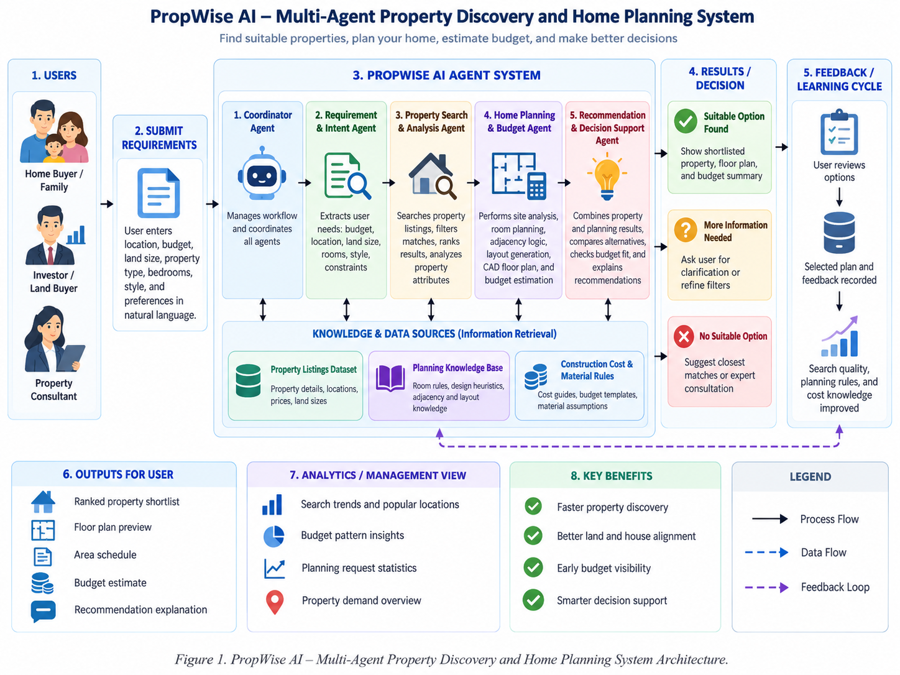
The current deployment is a local modular monolith: the agents run inside one Python/FastAPI application and communicate through typed in-process calls and HTTP API contracts rather than independent microservices. Agent 1 parses and confirms requirements; POST /api/v1/recommendation then orchestrates existing Agent 2 and/or Agent 3 Python entry points and passes their server-obtained evidence to Agent 4. Current implemented routes are Agent 1 -> Agent 2 -> Agent 4 for property search, Agent 1 -> Agent 3 -> Agent 4 for owned-land planning, and Agent 1 -> Agent 2 -> Agent 3 -> Agent 4 for land-and-house decisions.

3.3 End-to-End Land + House Flow
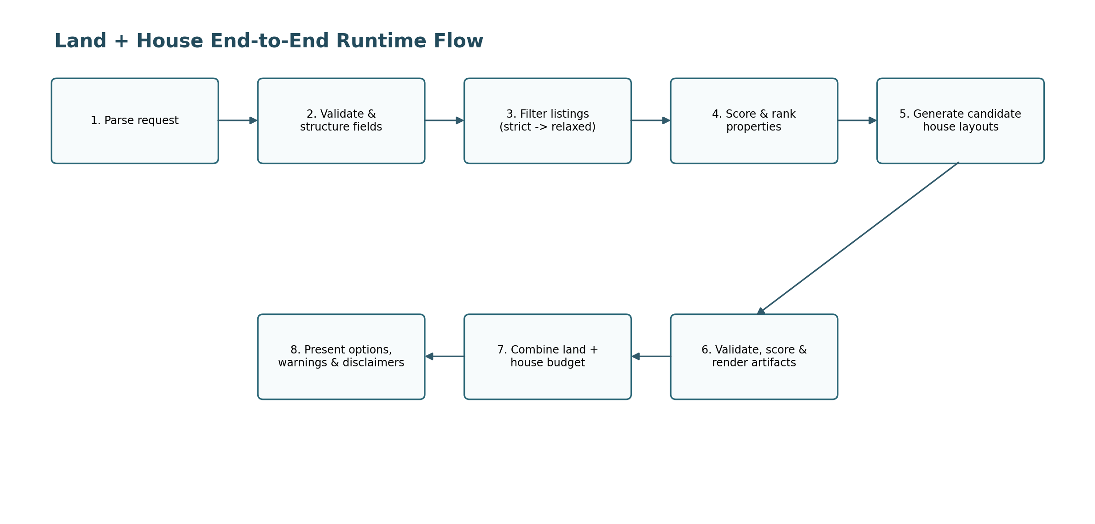
Figure 2. Upstream land + house retrieval/planning flow; Agent 4 performs the final deterministic recommendation and explanation stage after these validated outputs are produced.

3.4 Capability Classification
Classification | Capability summary
Verified implementation | FastAPI APIs; static web frontend; Agents 1-4; property retrieval; planning/budget generation; Recommendation API; optional grounded Gemini explanation; sample/knowledge data; automated tests.
Verified behavior | Multilingual requirement parsing; strict/relaxed retrieval; transparent upstream scoring; deterministic Agent 4 hard-constraint eligibility and final ranking; alternatives/comparisons/coverage; missing-site warnings; no-invention behavior; plan exports; guarded LLM explanation with deterministic fallback.
Partially implemented / production gap | Security includes request validation, bounded model evidence, output guardrails, sanitized provider errors and local CORS, but production authentication, authorization/RBAC, rate limiting and deployment transport controls remain incomplete.
Planned / not implemented | LangGraph orchestration; Next.js frontend; Supabase PostgreSQL/pgvector/Auth/RLS migration; production hosting, monitoring and enterprise controls.

4. Requirements and Assignment Compliance

4.1 Functional Requirements
ID | Requirement
FR-01 | Accept a natural-language user request and reject blank or over-length request bodies.
FR-02 | Classify the request into BUY_PROPERTY, RENT_PROPERTY, BUY_LAND, PLAN_HOUSE, LAND_AND_HOUSE, COMPARE_PROPERTIES, ESTIMATE_BUDGET, GENERAL_PROPERTY_QUERY or UNKNOWN.
FR-03 | Extract structured property, budget and house-planning constraints.
FR-04 | Retrieve properties using hard filters and return a bounded ranked set.
FR-05 | Apply fallback relaxation when strict filters return zero matches and disclose the relaxation.
FR-06 | Return per-property score and score breakdown for transparency.
FR-07 | Generate a conceptual house plan with required rooms, geometry and constraint validation.
FR-08 | Estimate construction/total project costs only when configured rate data is available.
FR-09 | Export planning artifacts as JSON, SVG, PNG, DXF and ZIP.
FR-10 | Expose assumptions, warnings, exclusions and a professional-verification disclaimer.
FR-11 | Evaluate multiple land + house options and rank combinations using property, budget, land-size and house-program signals.
FR-12 | Provide a final Recommendation & Decision Support stage over validated upstream outputs, including deterministic eligibility/ranking, alternatives, comparisons, uncertainty/coverage and an optional grounded explanation with safe fallback.

4.2 Non-Functional Requirements
ID | Requirement
NFR-01 Reliability | Deterministic validation and tests should prevent invalid geometry and malformed cost configuration.
NFR-02 Explainability | Expose parsed requirements, retrieval score breakdowns, final Agent 4 rank/decision-support score, candidate coverage, budgets, planning evidence, warnings, explanation source and professional-use limitations.
NFR-03 Maintainability | Keep agent responsibilities, schemas, retrieval functions and planning modules separated and testable.
NFR-04 Data safety | Do not invent exact land dimensions or professional approvals when values are unavailable.
NFR-05 Security | Validate request lengths, avoid accidental secret disclosure and add production authentication/authorization before deployment.
NFR-06 Portability | Run locally through Python/FastAPI and browser frontend with environment-based dataset and LLM configuration.
NFR-07 Performance | Use vectorized pandas scoring for dataset ranking; no formal latency/load benchmark is supplied.
NFR-08 Auditability | Use deterministic inputs, score components, constraint checks, evidence references, warnings, provider/fallback status and artifact files to make outputs inspectable.
NFR-09 Accessibility | A browser UI exists, but formal accessibility testing is not supplied.
NFR-10 Scalability | Full cleaned dataset support is documented; the supplied ZIP verifies only the 500-row sample due LFS pointer files.

4.3 Assignment Requirement Mapping
Assignment requirement | Evidence in PropWise AI | Status
Real-world domain | Sri Lankan property discovery, house planning and construction budget estimation. | Met
At least two interacting agents | Agents 1-4 participate in implemented workflows; typed outputs from retrieval/planning stages are consumed by Agent 4 for final decision support. | Met
One or more LLMs | Gemini is operational for optional grounded Agent 4 explanations. Deterministic Python remains authoritative and a validated fallback is used when the provider is unavailable or rejected. | Met
NLP techniques | Rule-based intent classification, field extraction, number-word parsing, Sinhala/Singlish handling. | Met
Information Retrieval | Hard filtering, relaxed fallback, weighted scoring, ranking and market analysis over property listings. | Met
Security features | Pydantic input validation, bounded/allowlisted LLM evidence, redaction, strict provider-output validation/guardrails, sanitized errors and local CORS are implemented; production auth/RBAC and rate limiting remain absent. | Partial / P0
Agent communication protocol | HTTP REST API endpoints, typed JSON/Pydantic contracts and direct in-process Python orchestration between implemented agent stages. | Met
Responsible AI | Deterministic decision authority, warnings, uncertainty/coverage, no-invention checks, grounded evidence references, safe LLM fallback, cost/site disclaimers and human-readable source transparency. Formal fairness/privacy studies remain pending. | Partial
Commercialization + pricing | Proposed in Section 15. | Met in report

4.4 Critical Compliance Gap Analysis and Closure Evidence
The official assignment requires at least two interacting intelligent agents and explicitly requires one or more LLMs, NLP, information retrieval, security features and a defined communication protocol. The final repository now closes the earlier operational-LLM and Agent 4 implementation gaps: four agents are implemented, Gemini is used for optional bounded explanations, and final recommendation orchestration is exposed through a typed API. The principal remaining compliance risk is production security/authentication and completion of the formal individual audit/evaluation evidence.
Compliance area | Current verified state | Why it matters | Status / remaining evidence
Operational LLM integration | Gemini gemini-3.1-flash-lite is used for optional Agent 4 grounded explanations through a bounded provider layer. Prompt v5, strict schema validation, guardrails and deterministic fallback are implemented. | The group brief explicitly requires one or more LLMs; the LLM must contribute without controlling high-stakes numeric/constraint decisions. | Met for the academic prototype. Controlled live Kandy and Kottawa runs returned validated LLM explanations; provider failure/malformed-output paths are covered by offline tests.
Security controls | Pydantic request validation, bounded evidence, output guardrails, secret/contact/path redaction, sanitized provider errors and restricted local CORS are present; authentication, RBAC/ownership checks and rate limiting are absent. | Security features are an explicit system requirement, and production user/saved-result data would require identity and access control. | Partial / P0: add authentication, role/ownership authorization, rate limiting, deployment TLS/security headers, and complete the individual security audit scenarios.
Agent 4 - Decision Support | Implemented with typed input/output contracts, upstream adapters, hard-constraint eligibility, versioned deterministic policy/ranking, comparisons, alternatives, candidate coverage, owned-land assessment, API integration and frontend presentation. | It provides the final synthesis layer without duplicating Agent 2 retrieval or Agent 3 planning and makes the decision path traceable. | Met. 305 Agent 4 Phase 1-3 tests passed in the accepted snapshot; the full backend suite recorded 398 passing tests.
Submission interpretation: Agent 4 and the optional Gemini explanation path can now be presented as implemented because reproducible code, automated tests and controlled live-provider evidence exist. Security should remain labelled Partial until authentication/authorization/rate-limiting and the required individual audits are completed. Planned technologies such as LangGraph, Supabase/pgvector and Next.js must remain clearly separated from the current demo implementation.

5. System Architecture and Design

5.1 Backend Architecture
The FastAPI application mounts a versioned /api/v1 router containing requirement parsing, property search, planning generation/evaluation and the final recommendation endpoint. Generated planning artifacts are exposed through a restricted /plans static-file mount. The backend remains modular: schemas define contracts; Agents 1-4 coordinate domain logic; retrieval modules handle data search; planning modules handle geometry/budget logic; and the Agent 4 explanation layer isolates provider access, evidence construction and guardrails.

5.2 Agent Responsibilities
Agent | Verified responsibilities
Agent 1 - Requirement & Intent Understanding | Cleans the query, classifies intent, extracts structured fields, validates required fields and produces confidence/missing-information metadata. It currently uses deterministic fallback parsing and does not invoke the LLM service.
Agent 2 - Property Search & Analysis | Loads and normalizes the property dataset, applies strict filters, optionally relaxes selected constraints, computes weighted relevance signals, ranks results and summarizes market price statistics.
Agent 3 - Home Planning & Budget Estimation | Adapts selected land context, builds room program, analyzes site assumptions, generates candidates, validates constraints, scores layouts, estimates cost, renders files and returns warnings/disclaimers.
Agent 4 - Recommendation & Decision Support | Consumes confirmed requirements plus server-obtained Agent 2/3 outputs; applies hard-constraint eligibility and deterministic final decision-support scoring/ranking; retains alternatives, comparisons, warnings, uncertainty and candidate coverage; assesses owned-land plans without inventing property ranks; and optionally attaches a grounded Gemini explanation or deterministic fallback.

5.3 Agent Contracts and Data Flow
Agent 1 outputs confirmed structured requirements. Agent 2 returns relevance-ranked retrieved properties; this ranking is upstream retrieval evidence, not the final Agent 4 decision rank. Agent 3 returns conceptual planning and budget evidence for land/house or owned-land workflows. RecommendationContext pairs the requirements with these server-obtained Agent 2/3 outputs. Agent 4 then produces RecommendationResponse/RecommendationAPIResponse with final deterministic recommendation items, criterion assessments, alternatives, comparisons, coverage, optional owned-land assessment and explanation status. Public clients cannot submit trusted candidate scores, prices, eligibility, planning outcomes or ranks.

5.4 Property Retrieval Scoring
Signal | Weight | Interpretation
Budget fit | 0.35 | Rewards listings with more headroom below the configured budget ceiling.
Location | 0.20 | Exact location match receives the strongest signal; district-only match is weaker.
Bedrooms | 0.15 | Exact count is preferred, then +/-1 where applicable.
Verified listing | 0.12 | Adds a positive signal for verified listings.
Size fit | 0.10 | Rewards properties meeting the requested minimum size.
Recency | 0.08 | More recent listings receive a higher signal.

5.5 Upstream Land + House Combination Scoring (Agent 3)
Signal | Weight
Agent 2 land-match score | 0.35
Budget feasibility | 0.35
Land-size suitability | 0.15
House-program fit | 0.15

The Agent 3 combination score shown above remains upstream planning evidence. Agent 4 does not simply add Agent 2 and Agent 3 composite scores, which would double-count correlated signals. Instead, its versioned deterministic policy evaluates final criteria such as budget, location, planning feasibility and evidence quality from their underlying evidence; upstream relevance may be retained as provenance/tie-breaking evidence. Hard-constraint violations cannot enter the final recommendation shortlist, regardless of a high upstream score.

5.6 Planning Knowledge Base
Agent 3 reads explicit JSON/CSV knowledge files rather than embedding key assumptions in prompts. The room-size file defines minimum, preferred and maximum areas for spaces such as bedrooms, living room, kitchen, bathrooms, office, utility, balcony and staircase. The adjacency file defines preferred distances and weights for pairs such as entrance-living, dining-kitchen and master-bedroom-bathroom. Construction costs define Basic and Standard rate bands and source metadata. This design makes core planning assumptions inspectable and testable.

5.7 Generated Artifact Model
When a valid plan is selected, the canonical plan JSON records units, site assumptions, conceptual envelope, footprint, zones, floors, rooms, walls, doors, windows, circulation graph, stairs, parking, fixtures, dimensions, space metrics, warnings and score breakdown. The same canonical model drives SVG, PNG and DXF output to reduce inconsistencies between representations.

6. Development and Evaluation Methodology

6.1 Development Approach
The repository reflects an incremental modular approach: establish typed contracts, implement and test Agent 1, build retrieval modules and Agent 2, add deterministic planning/budget modules for Agent 3, then implement Agent 4 in three layers: deterministic recommendation logic, bounded grounded explanations/guardrails, and API/frontend integration. The final browser workflow reuses existing upstream Python entry points rather than copying their algorithms. Because the project files do not document a formal Scrum process, this report does not claim a named methodology that cannot be verified.

6.2 Evidence-Driven Verification Cycle
- Inspect source modules and configuration rather than relying on planned architecture documents.
- Execute the complete automated test suite in the supplied environment.
- Use actual sample data for dataset-level observations.
- Run representative property, land-and-house and owned-land requests through the implemented Agent 1 -> upstream agent(s) -> Agent 4 workflow and compare deterministic outputs with explanation-disabled/enabled behavior.
- Generate real planning artifacts where applicable and inspect the resulting PNG/DXF/JSON files, final recommendation cards, alternatives, budget/planning evidence and coverage information.
- Exercise the LLM explanation layer with offline fake-provider/transport tests and controlled live Gemini checks, verifying unchanged deterministic ranks, scores, eligibility, budgets and planning outcomes.
- Separate implemented, partially implemented and planned functionality in every section; record limitations and assignment gaps explicitly so the report does not overstate maturity.

6.3 Test Environment
- Python/FastAPI backend using the repository requirements and current Agent 4 integration.
- Automated acceptance snapshot: 305 Agent 4 Phase 1-3 tests passed; 398 full backend tests passed with no failures (overlapping suites, not additive). Two existing non-failing setup/dependency warnings are documented in the Agent 4 acceptance notes.
- Frontend validation: V8 JavaScript syntax checks plus a dependency-free mock-DOM/mock-fetch Agent 4 smoke suite; the latest presentation pass completed 290 assertions per fixture set without live provider calls.
- Property retrieval and planning knowledge/data paths follow the current repository configuration; large production/full-dataset handling remains a separate data-quality/deployment concern.
- Generated planning artifacts are written under the configured storage/plans/{plan_id}/ area and projected to the frontend through restricted safe artifact URLs.
- Representative end-to-end query: "I have a total budget of 40 million LKR. I want to buy land in Kottawa and build a 3 bedroom house with 2 bathrooms and 2 floors."

6.4 Evaluation Dimensions
Evaluation covers functional correctness, NLP extraction, retrieval behavior, geometry/artifact generation, budget logic, deterministic Agent 4 eligibility/ranking, candidate coverage, API/orchestration, explanation grounding, provider failure/fallback, prompt-injection-style text, privacy filtering and frontend presentation. The individual assignment brief additionally identifies prompt injection, privacy/data leakage, Responsible AI/bias, and IR/security as formal specialization areas [2]. Dedicated individual audit reports remain separate deliverables and are not invented here.

7. NLP and Information Retrieval Methodology

7.1 Intent Classification
Intent classification is deterministic and pattern-based. The classifier recognizes comparison, land + building combinations, planning, rent, budget estimation, land purchase, property purchase and general property queries using English and Sinhala patterns. Combined land-and-house routing is deliberately checked before generic house planning so that a request such as buying land and building a house is not misrouted.

7.2 Requirement Extraction
The extractor handles numeric and word-based Sri Lankan money expressions, including million/lakh-style forms and tested Sinhala terms, and captures location, district, bedroom/bathroom counts, floors, parking, land size, house size, property/listing types and selected preferences. A validator checks intent-specific required fields and produces missing_information plus a confidence score capped at 0.95.

7.3 Retrieval Filtering
The retrieval pipeline normalizes numeric, boolean and string columns with pandas. Hard filters are applied to listing type, property type, location, maximum/minimum budget, bedrooms and size fields. When strict filtering returns zero results, a controlled relaxed pass drops bedroom restrictions and expands the budget ceiling by 20%, then returns a warning so the user can see that the results no longer meet the original constraints exactly.

7.4 Ranking Explainability
Agent 2 returns both a composite score and score_breakdown for each listing. This is an important transparency feature: the user or developer can inspect whether a property ranked highly because of budget, location, bedrooms, verification, size or recency rather than treating the rank as an opaque AI judgment.

7.5 Dataset Evidence
Project documentation describes approximately 203,874 raw rows and 202,309 cleaned rows. Only the 500-row Git sample is available as real CSV content in the supplied ZIP. That sample contains 354 sale and 146 rental listings. Property-type counts are 219 land, 156 house, 48 commercial, 34 apartment, 23 room/annex and 20 holiday rental records. The sample is heavily concentrated in Colombo (217 rows), so sample-level evaluation should not be interpreted as national representativeness.
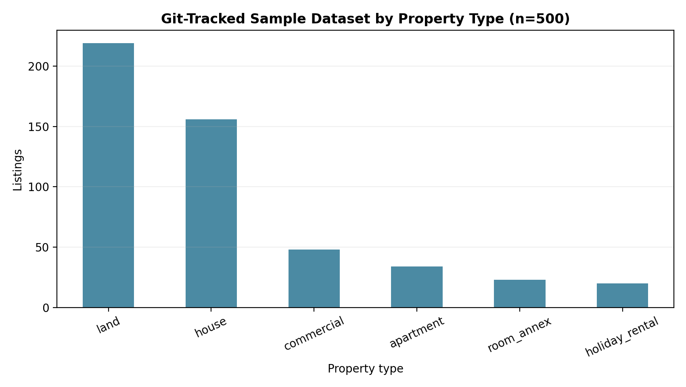
Figure 3. Property-type distribution in the verified 500-row sample.
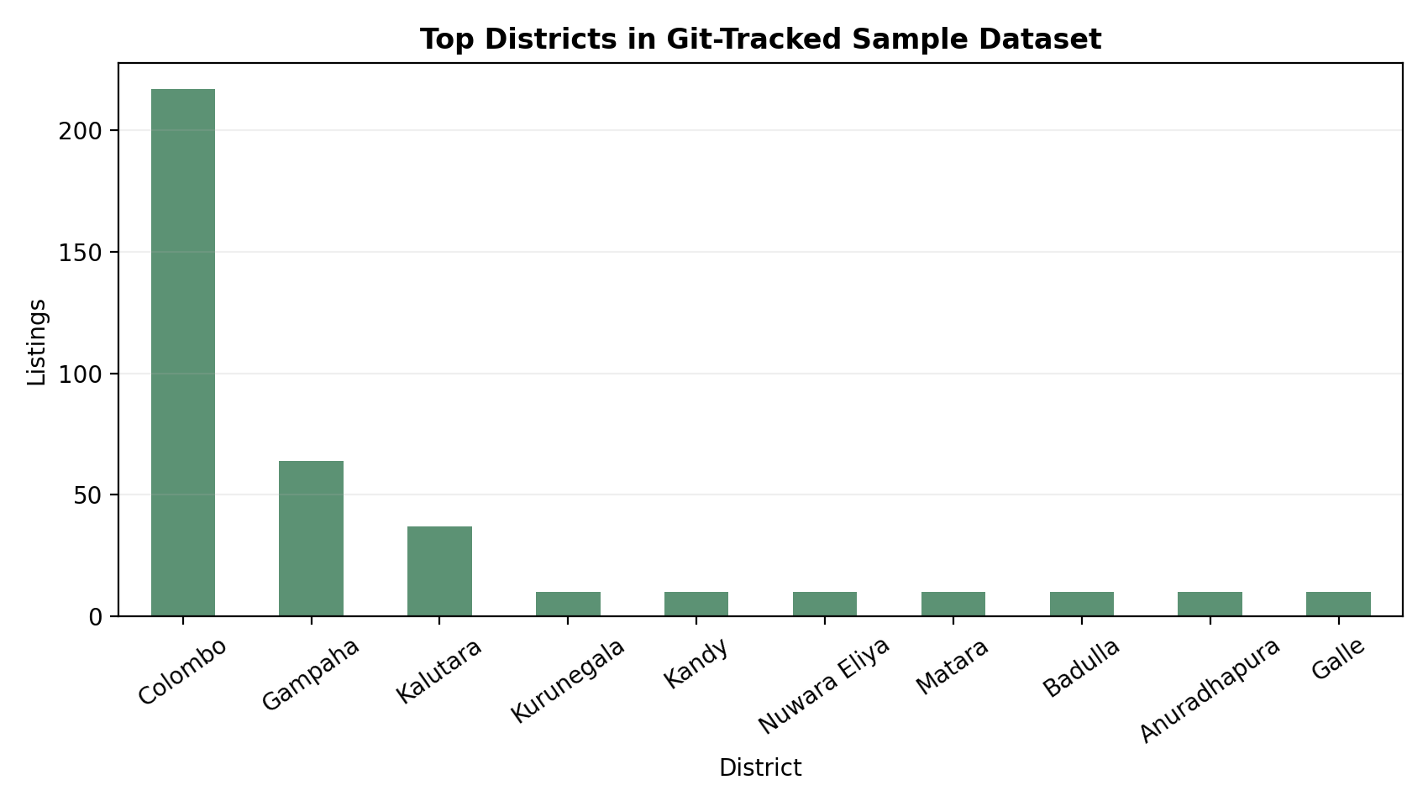
Figure 4. Top district distribution in the verified 500-row sample.

8. Home Planning and Budget Methodology

8.1 Site Analysis and No-Invention Rule
When exact land width/length are unavailable, the planner does not fabricate them as factual values. It creates a conceptual planning envelope from land area and marks exact_site_fit_verified as false, with warnings that the real plot shape and dimensions are unknown. This behavior is explicitly covered by tests and is one of the most important Responsible AI safeguards in the current implementation.

8.2 Room Program and Candidate Generation
The planner builds required/optional room requirements from the request and room-size knowledge base. Floor allocation, candidate generation and architectural enrichment then create rooms, walls, access graph, doors, windows, fixtures, dimensions and parking. Multiple candidates are produced using deterministic geometry variations, then each candidate is checked against hard constraints such as non-overlap, footprint containment and required room accessibility.

8.3 Layout Scoring
Valid candidates are scored using factors including adjacency, circulation quality, privacy, natural-light proxies, compactness and parking/entrance relationship. The optimizer selects the highest-scoring valid candidate rather than returning the first generated geometry. Tests confirm that overlapping candidates are rejected and that the highest valid score is selected.

8.4 Cost Model
Construction estimate = estimated floor area x configured rate per square foot. Three rate points (low, expected and high) produce a range rather than one exact figure. Combined land-and-house evaluation adds land price, compares the range with total project budget, and exposes expected/high margins. The system also lists major exclusions such as land transfer costs, professional fees, approval fees, utility connections, furniture and landscaping.

8.5 Responsible Planning Boundary
Every planning response includes a disclaimer that PropWise AI provides AI-assisted conceptual planning and preliminary decision support only and that generated layouts are not approved architectural, structural, engineering, quantity-surveying, legal, planning or construction documents. Final design, cost, site suitability, approvals and regulatory compliance must be verified by qualified professionals and authorities.

9. Implementation

9.1 Technology Stack - Verified vs Planned
Area | Verified in supplied ZIP | Planned in project documentation
Frontend | Static HTML, JavaScript and CSS. | Next.js + TypeScript.
Backend | Python + FastAPI + Pydantic. | Python + FastAPI.
Orchestration | Frontend/API sequence and internal Python calls. | LangGraph.
Data | CSV + pandas; local knowledge JSON/CSV. | Supabase PostgreSQL + pgvector.
Authentication | Not implemented. | Supabase Auth + Row Level Security.
LLM | Operational optional Agent 4 explanation provider: Gemini gemini-3.1-flash-lite with Prompt v5 and deterministic fallback; OpenAI adapter remains supported. | Provider abstraction retained; other models/providers may be evaluated later.
CAD | ezdxf plus SVG/PNG renderers. | Python + ezdxf.
Testing | pytest + httpx/mock transports; JavaScript V8 syntax checks and mock-DOM/mock-fetch frontend smoke tests. | Not separately specified.

9.2 API Endpoints
Method / endpoint | Purpose
GET /api/v1/health | Backend health/status check.
POST /api/v1/requirements/parse | Run Agent 1 requirement parsing.
POST /api/v1/property-search | Run Agent 2 search, ranking and analysis.
POST /api/v1/planning/generate | Generate a conceptual house plan through Agent 3.
POST /api/v1/planning/evaluate-land-house | Evaluate property results and generate combined land/house options.
GET /plans/... | Serve generated planning artifacts.
POST /api/v1/recommendation | Run Agent 4 final Recommendation & Decision Support orchestration over server-obtained Agent 2/3 evidence; optionally attach a grounded LLM explanation.

9.3 Frontend Workflow
The browser UI submits natural-language text to Agent 1, displays interpreted fields and follow-up requirements, and then sends confirmed user requirements to POST /api/v1/recommendation. The server performs the required Agent 2/Agent 3 work and Agent 4 returns the final deterministic shortlist/assessment. The UI shows Top Pick/Pick N, final rank, decision-support score, eligibility, concise budget/planning evidence, alternatives, unmet constraints, verification qualification, candidate/search coverage, deterministic option comparisons and an optional grounded explanation source. Dynamic explanation/listing text is rendered safely as text rather than injected HTML.

9.4 Representative Verified Run
For the representative Kottawa land + house request (LKR 40,000,000 total budget; Kottawa; 3 bedrooms; 2 bathrooms; 2 floors), the accepted Agent 4 run recorded 106 matching candidates, 8 retrieved and 8 planning-assessed. Agent 4 produced 2 final recommendations plus 6 alternatives. The top recommendation had a final decision-support score of approximately 85.1/100, land price LKR 9,500,000, expected project total LKR 37,955,730 and expected remaining budget LKR 2,044,270. The second recommendation scored approximately 84.6/100 with expected project total LKR 39,455,730. Retrieval coverage was explicitly marked limited rather than implying market-wide coverage.
With grounded explanation enabled, the same deterministic result was preserved while Gemini generated a validated explanation. The expanded model evidence package (103,674 bytes) was compacted to 58,453 bytes under the 64,000-byte limit while preserving 776 authoritative scalar facts. Only the explanation subset was bounded (up to 5 recommendations + 2 alternatives); the deterministic response remained unchanged.
Figure 5. Actual ground-floor PNG generated by the supplied Agent 3 implementation during verification.
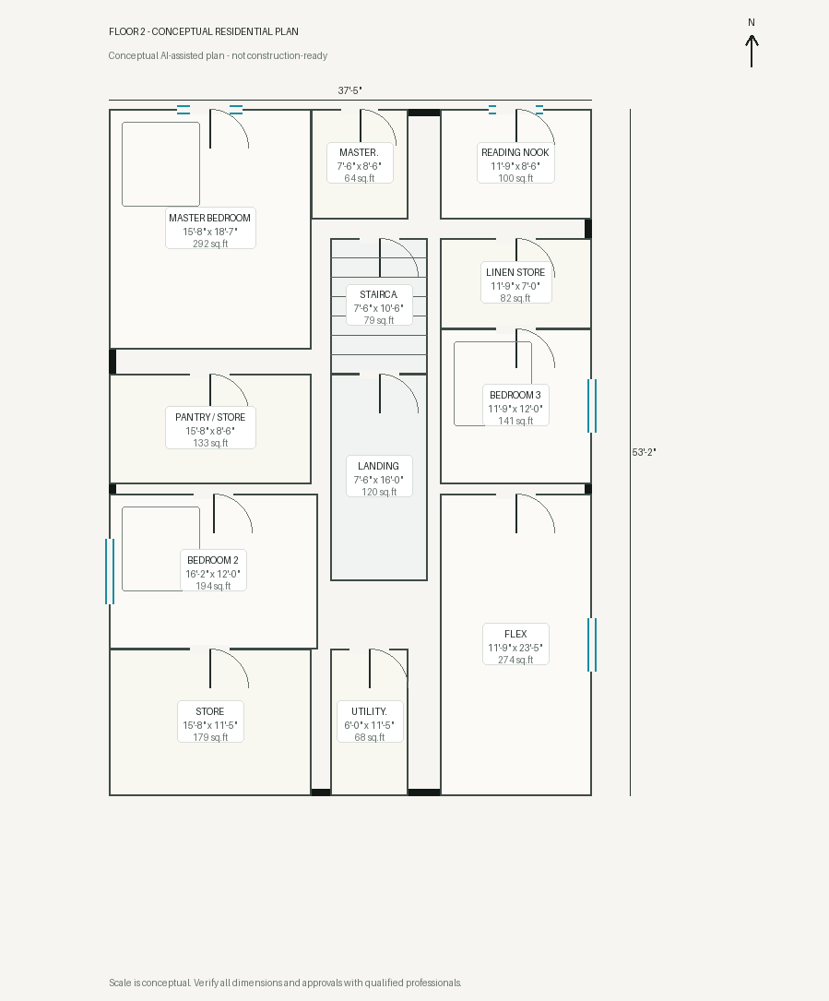
Figure 6. Actual upper-floor PNG generated by the supplied Agent 3 implementation during verification.

9.5 LLM Integration - Implemented Grounded Explanation Layer
Agent 4 now includes an operational optional LLM explanation layer. The accepted live configuration uses Gemini gemini-3.1-flash-lite with prompt version propwise-agent4-explanation-v5. Deterministic Python remains authoritative for candidate identity, hard constraints, eligibility, budget/planning assessment, final scores, rank order, alternatives and comparisons. The LLM can explain those results but cannot alter them.
- Authoritative boundary: Agent 4 Phase 1 computes the decision first. Phase 2 receives a copy of that result and attaches explanation text only; model output is never written into deterministic decision fields.
- Bounded provider/evidence layer: the model receives an allowlisted evidence package containing confirmed requirements and selected deterministic facts, with at most five recommendations and two alternatives and a 64,000-byte model-facing limit. Contacts, URLs, local paths, provider settings and secret-like values are excluded/redacted; original query/listing-description excerpts are untrusted and non-citable.
- Structured output and guardrails: strict Pydantic validation checks candidate identity/order, rank, final score, eligibility, budget and planning echoes, exact evidence references, numeric placeholders and factual-domain ownership. Duplicate-key/nonfinite JSON, invented IDs, unsupported approval/availability guarantees, unknown facts presented as known, violations used as strengths and decision reordering claims are rejected.
- Provider isolation and safety: Gemini/OpenAI access uses fixed endpoints, environment-based keys, no tools/actions, no redirects, no environment proxy inheritance, bounded timeout/output/response sizes and sanitized error codes. Credentials and provider bodies are not returned in public recommendation responses.
- Failure handling: missing configuration, timeout/transport error, refusal, oversized output, invalid JSON/schema or guardrail failure returns DETERMINISTIC_FALLBACK while preserving the usable deterministic recommendation. There is at most one synthesis request and one bounded repair attempt for invalid structured output; transport failures are not retried.
Evaluation evidence includes fake-provider/MockTransport coverage for normal completion, malformed/schema-invalid output, timeout/provider failure, prompt-injection-style content, unsupported claims, privacy filtering, numeric integrity and fallback. Controlled live Gemini verification succeeded for the Kandy no-suitable-option case and the Kottawa land-and-house case with explanation_status=LLM, no fallback and one provider attempt [3], [4].

9.6 Security Architecture - Minimum Assignment-Ready Baseline
The implemented prototype now contains meaningful AI/prompt-safety controls around Agent 4: public requests cannot provide trusted upstream scores/planning outcomes, model evidence is bounded and allowlisted, obvious contact/secret/path data is filtered, provider output is strictly validated, model errors are sanitized and the model has no tools/actions. These controls protect decision integrity but do not provide user identity or access control. Production authentication, authorization/RBAC, rate limiting and deployment TLS/security controls therefore remain required.
Control | Assignment-ready behavior | Verification evidence
Authentication | Issue a signed session/token after successful login and require it for protected property, planning, saved-result and administrative routes. | Unauthenticated calls to protected routes return 401; valid sessions succeed.
Authorization / RBAC | Separate ordinary users from privileged/admin or professional-review functions; enforce ownership for saved searches/plans. | Cross-user and wrong-role requests return 403 without disclosing protected data.
Input and prompt safety | Implemented for Agent 4: Pydantic request bounds/extra-field rejection; client cannot submit trusted Agent 2/3 evidence; bounded untrusted model context; no model tools/actions; strict structured-output/grounding guardrails. | Automated tests reject fabricated trusted inputs, injection-like explanation text, malformed/unsupported model output and decision-field tampering while preserving deterministic results.
Rate limiting | Throttle repeated authentication and expensive AI/planning requests. | Burst/repeated requests are limited with a controlled error response.
Sensitive data and secrets | Return only necessary presentation data, keep API keys in environment variables, redact/exclude contact/URL/path/secret-like evidence from the model, and sanitize provider errors. | Repository/configuration and response tests should confirm no committed keys or provider request/response bodies; production field-minimization/privacy policy still required.
Transport/deployment | Use HTTPS/TLS and secure headers/cookies in deployed environments. | Production-like configuration or deployment evidence documents TLS and secure settings.
The table below distinguishes implemented AI/input safety from production security controls that are still missing. The report should keep overall security status Partial until the identity/access-control and formal individual-audit requirements are completed.

9.7 Agent 4 - Recommendation & Decision Support Implementation
Agent 4 is the implemented final synthesis layer. It does not repeat property retrieval or regenerate floor plans. It consumes confirmed requirements plus server-obtained Agent 2/3 evidence, applies original hard constraints, classifies eligibility, assesses budget/planning evidence, computes a transparent final decision-support score/rank, retains alternatives and uncertainty, compares shortlisted options, reports candidate coverage and supports owned-land assessment. A hard-constraint violation cannot enter the recommendation shortlist regardless of its upstream score.
Input | Implemented processing responsibility | Output
Confirmed requirements + server-obtained Agent 2/Agent 3 outputs | Validate upstream context; preserve original user constraints; determine ELIGIBLE / CONDITIONAL / HARD_CONSTRAINT_VIOLATION / INSUFFICIENT_EVIDENCE; assess budget, location, planning and evidence quality; apply versioned deterministic policy; rank eligible/conditional candidates; retain alternatives, warnings and coverage. | RecommendationResponse/RecommendationAPIResponse with final recommendations, rank, 0-100 decision-support index, criterion assessments, alternatives, comparisons, CandidateCoverage, warnings and optional explanation attachment.
Ambiguous or incomplete required evidence | Do not force a recommendation; preserve unknown evidence and identify required clarification fields/questions. | NEEDS_CLARIFICATION or INSUFFICIENT_EVIDENCE with clarification/uncertainty information.
No candidate satisfies original hard constraints | Keep violated candidates outside the shortlist; preserve them only as clearly labelled alternatives where useful, with unmet reasons and no fabricated rank. | NO_SUITABLE_OPTION with alternatives, constraint reasons, coverage and next-step guidance.
Integration is exposed through POST /api/v1/recommendation. Property purchase/rental/land requests use Agent 2 -> Agent 4; land-and-house uses Agent 2 -> existing Agent 3 evaluator -> Agent 4; owned-land planning uses Agent 3 -> Agent 4 assessment. Agent 4 calls existing Python entry points directly, does not duplicate upstream algorithms and does not create internal HTTP round-trips. Provider availability never changes deterministic scores or rank order.
- Decision semantics: final_recommendation_score is a 0-100 decision-support index, not a probability or confidence percentage. Agent 2 retrieval relevance and Agent 3 combination scores remain upstream provenance rather than being blindly summed into the final score.
- Explanation/presentation: when enabled, a validated Gemini explanation is preferred; if model text is unavailable, unsafe or merely machine-like, the system retains deterministic source transparency and can present a concise human-readable explanation from structured Agent 4 evidence. The frontend keeps recommendations, alternatives, final ranks, budget/planning evidence, comparison and coverage separate from supplementary retrieval results.
- Coverage semantics: retrieved_count, total_matching_candidates, planning_assessed_count, ranked_count and coverage-limit flags are returned so the UI can state that recommendations are based on evaluated candidates rather than implying coverage of the entire property market.

10. Responsible AI, Security and Privacy

10.1 Accuracy and Reliability
Reliability is supported by typed schemas, deterministic parsing/retrieval/planning, hard geometric and recommendation constraints, explicit cost-data validation, Agent 4 decision preservation checks and automated tests. Gemini is intentionally restricted to explanation after the deterministic decision exists, and invalid/provider-failure cases fall back safely. These controls do not prove real-world listing truth: property data may be stale or incomplete, construction rates may change, and conceptual geometry is not survey-based site design.

10.2 Explainability and Transparency
Explainability is provided at several levels: parsed requirements, retrieval filters/score breakdowns, whether fallback relaxation was used, Agent 4 final rank and 0-100 decision-support score, eligibility/constraint checks, budget/planning evidence, strengths/trade-offs, alternatives, comparisons, uncertainty, candidate/search coverage and explanation source (LLM, deterministic fallback or deterministic only). This exposes the decision state and supporting evidence without requiring private chain-of-thought.

10.3 Human Oversight
Professional human verification is explicitly required for architectural, engineering, quantity-surveying, legal, regulatory, listing-availability and final cost decisions. Agent 4 preserves this boundary by presenting recommendations as decision support, keeping high-cost/site-fit/listing-verification limitations visible, and preventing the LLM from overriding hard constraints or claiming professional approval.

10.4 Prompt Injection
Prompt-injection risk is reduced by architectural separation rather than relying only on wording. User/listing text is treated as untrusted data, arbitrary descriptions are non-citable, the model receives no tools/actions, and only allowlisted evidence references may support factual explanation. Strict validation rejects identity/order/rank/score/eligibility/budget/planning changes, invented facts and unsupported availability/approval guarantees. Automated Agent 4 tests exercise injection-like content and malformed outputs; however, the formal individual prompt-injection/jailbreak audit remains a separate required assessment and should not be claimed complete here.

10.5 Privacy and Data Leakage
The property schema and source dataset may contain addresses/contact information. Agent 4 deliberately excludes contact fields, addresses, artifact paths, URLs, provider settings and secret-like strings from the model-facing evidence package and sanitizes provider failures. This reduces unnecessary LLM data exposure but is not a complete privacy/access-control system. The public API still lacks production authentication/RBAC; future persisted searches/plans and sensitive listing fields therefore require explicit access policy, minimization, retention and logging controls.

10.6 Security Controls and Gaps
Area | Current evidence | Assessment
Input validation | Pydantic validates public request types/ranges and forbids client-supplied trusted Agent 2/3 scores, ranks, eligibility and planning outcomes. | Implemented baseline
LLM / prompt-output safety | Bounded allowlisted evidence; contact/secret/path filtering; exact evidence references; strict structured-output/authority guardrails; no tools/actions; deterministic fallback. | Implemented for Agent 4; formal red-team audit still pending
CORS | Backend development allow-list is restricted to configured local frontend origins. | Development control; production origin/TLS alignment required
Authentication | No login/token middleware in supplied backend. | High-priority gap
Authorization | No RBAC / ownership checks. | High-priority gap
Rate limiting | Not implemented. | Gap
Secrets | API keys/settings are environment-based; provider keys are not placed in URLs; provider bodies/credentials are excluded from public fallback/error text. | Implemented provider hygiene; production secret-management review still required
Transport security | No production HTTPS/reverse-proxy configuration in project. | Deployment gap

10.7 Fairness and Bias
No completed fairness or bias evaluation was supplied. The parser includes Sinhala and Singlish-oriented cases, which improves linguistic inclusion, but this is not evidence of demographic fairness. Formal Responsible AI assessment should evaluate language variation, location coverage, price-band effects, listing verification bias, missing-data behavior and whether ranking systematically disadvantages underrepresented districts or property types.

10.8 Responsible AI Risk Register
Risk | Impact | Likelihood | Current/required control
LLM prompt injection / unsupported explanation claims | High | Medium | Implemented bounded evidence, no tools/actions, exact reference validation, decision-authority guardrails and deterministic fallback; complete formal red-team regression audit before submission/production.
Unauthenticated API access | High | High | Implement authentication, authorization and rate limiting before production.
Stale/inaccurate property listings | High | Medium | Freshness checks, source provenance, listing verification and user-visible dates.
Misleading conceptual plan treated as construction-ready | High | Medium | Existing disclaimer + stronger UI watermark + professional review gate.
Outdated construction rates | High | Medium | Effective dates, source governance, scheduled review and fail-closed behavior for stale profiles.
Sample/data geographic imbalance | Medium | High | Evaluate on full dataset and report coverage by district/property type.
Contact/address exposure | Medium | Medium | Field minimization, licensing/privacy policy and access controls.

11. Evaluation and Results

11.1 Automated Test Result
Final acceptance records 305 Agent 4 Phase 1-3 tests passing and 398 full backend tests passing with no failures; the Agent 4 suite is included in the full backend total and the counts are not additive. Automated provider tests are offline/mock-based and block live HTTP. Two existing non-failing warnings concern the PlanFileSet.json Pydantic field name and Starlette TestClient/httpx setup/deprecation behavior. The latest frontend Agent 4 smoke suite completed 290 assertions per fixture set, alongside successful JavaScript syntax and git diff checks.

11.2 Evaluation Coverage
Area | Representative verified tests / evidence | Result
Agent 1 | Buy/rent/property planning; Sinhala/Singlish; word budgets; combined land + house; prompt-secret regression. | Pass
Agent 2 | Default top N, buy/rent search, fallback relaxation, land + house retrieval. | Pass
Intent + extraction | 11 classifier tests + 12 extractor tests across English/Sinhala forms. | Pass
Filters + scoring | Strict/relaxed filters, land intent, budget/verification/location signals. | Pass
Agent 3 geometry | Room counts/sizes, multi-storey staircase, multiple candidates, overlap rejection, containment, parking, access, windows, doors, fixtures. | Pass
Artifacts | Canonical JSON, SVG, PNG, DXF; DXF reopen; architecture layers. | Pass
Budget engine | Floor-area basis, configured rates, feasibility labels, option ranking, missing/malformed cost handling. | Pass
API / orchestration | Requirements, property search, planning generate/evaluate and POST /api/v1/recommendation; public request rejects fabricated trusted upstream evidence. | Pass
Agent 4 deterministic decision support | Hard constraints/eligibility, ranking, alternatives, comparisons, budget/planning consistency, owned-land assessment, candidate coverage and no-suitable/insufficient-evidence behavior. | Pass
Grounded explanation + guardrails | Valid LLM explanation; identity/order/rank/score preservation; evidence references; malformed/duplicate/nonfinite JSON; unsupported claims; timeouts/429/5xx; deterministic fallback; privacy filtering. | Pass
Frontend Agent 4 presentation | V8 syntax + mock-DOM/mock-fetch smoke coverage for human-readable explanations, alternatives, coverage, safe text rendering, top_k=10 and API-object immutability; latest run 290 assertions per fixture set. | Pass

11.3 Retrieval Evaluation Interpretation
Agent 2 behavior remains transparent and testable as the structured information-retrieval/relevance stage. Its ranking is upstream retrieval evidence, not the final recommendation. Agent 4 applies a separate multi-factor decision-support assessment over the retrieved/planning evidence and preserves hard user constraints. The current IR implementation is still structured/pandas-based rather than semantic/vector retrieval; planned pgvector should not be claimed as implemented.

11.4 Planning Evaluation Interpretation
The planning suite provides unusually strong deterministic coverage for an academic prototype: required room count/size, non-overlap, containment, circulation, adjacency, parking, windows, doors, fixtures, CAD layers and renderer geometry are all exercised. The limitations remain equally important: exact site shape is not available unless dimensions are provided, room-size and adjacency rules are conceptual heuristics, and no architect/engineer validation study is supplied.

11.5 Evaluation Against Individual Audit Themes
Audit theme from individual brief | Evidence currently available | What remains for formal individual assessment
Prompt Injection / Jailbreak | Agent 4 has bounded evidence, no model tools/actions, strict authority/grounding guardrails, deterministic fallback and injection-like regression cases; controlled live Gemini explanation is operational. | Complete the formal individual prompt-injection/jailbreak/prompt-leakage audit with at least 15 dedicated scenarios and document results.
Privacy / Data Leakage | Agent 4 excludes/redacts contact/address/path/URL/secret-like model evidence and sanitizes provider errors; public API still has no auth/RBAC. | 15 privacy scenarios covering PII exposure, auth, session handling, logging and access control.
Responsible AI / Bias | No-invention and professional disclaimers plus Agent 4 deterministic authority, uncertainty/coverage, guarded grounded explanation and fallback transparency. | 15 hallucination, fairness, harmful-content, transparency and explainability cases.
IR / Security | Agent 2 filter/ranking tests plus Agent 4 hard-constraint preservation, coverage/source warnings, trusted-input rejection, evidence ownership and API/orchestration security regression tests. | Complete the Member 4 IR/Security audit with at least 15 dedicated cases covering retrieval manipulation/accuracy, hallucination from retrieval, source reliability, authentication, authorization, API and protocol security and observed limitations.

11.6 Summary of Strengths and Gaps
Strengths demonstrated | Gaps requiring completion
398 full backend tests and 305 Agent 4 Phase 1-3 tests passed in the accepted snapshot; four typed modular agents; multilingual parsing; transparent retrieval scoring; deterministic planning; deterministic final recommendation; bounded grounded Gemini explanations with guardrails/fallback; multiple output formats; explicit uncertainty, coverage and professional-use limitations. | Production authentication/RBAC/rate limiting; formal individual red-team/audit reports; full-dataset and retrieval-quality evaluation; semantic/vector retrieval only if later implemented; production CORS/TLS/secret/monitoring controls; user study, fairness evaluation and professional plan validation.

12. Discussion
The main engineering value of PropWise AI is the traceable progression from natural-language requirements through retrieval/planning evidence to final decision support. Agent 2 supplies retrieval relevance, Agent 3 supplies conceptual feasibility/budget evidence, and Agent 4 combines the validated evidence without pretending that upstream relevance alone equals a final recommendation. Candidate coverage and alternatives remain visible so a shortlist is not presented as the entire property market.
A particularly strong design choice is deterministic authority around high-impact facts. Geometry, cost calculations, hard constraints, eligibility and final ranks are explicit code rather than LLM decisions. Gemini is restricted to bounded explanation after the decision exists, and strict guardrails/fallback prevent provider output from changing identity, rank, score, budget or planning outcomes. This improves reproducibility and makes hallucination failures containable.
The remaining architecture-to-production gap is now mainly between the implemented demo stack (FastAPI, pandas/CSV, vanilla frontend, direct Agent 4 orchestration and optional Gemini explanations) and the historical roadmap technologies (LangGraph, Supabase/pgvector, Supabase Auth/RLS, Next.js and production hosting). These roadmap technologies should not be described as deployed capabilities. Production security, full-dataset quality, formal audits and user/professional evaluation remain more important than adding framework complexity.

13. Limitations
- The supplied full raw, cleaned and local property CSVs are Git LFS pointer files, so only the 500-row sample could be inspected directly.
- The 500-row sample is geographically imbalanced toward Colombo and is not evidence of national retrieval quality.
- Optional grounded explanations depend on an external LLM provider; provider/validation failures deliberately fall back to deterministic explanation. Guardrails are conservative and may reject benign prose, and schema/reference validation does not prove that an upstream listing itself is true.
- Property listings are historical/source data and current availability or listing claims are not independently verified by PropWise. Agent 4 therefore qualifies source verification and avoids treating source-data verification flags as independent platform verification.
- No authentication, authorization, rate limiting or production transport-security configuration is implemented.
- No vector search/pgvector retrieval is implemented despite being present in planned architecture documentation.
- No formal user study, usability benchmark or accessibility study was supplied.
- No formal performance/load benchmark was supplied for the 202k-record full dataset.
- Construction rates are preliminary planning data and may become outdated; Premium rates are intentionally unavailable.
- Conceptual planning does not establish exact site fit without real dimensions and is not a professional architectural/engineering design.
- Completed individual security audit reports were not supplied; this report does not invent their findings.

14. Future Work and Mitigation Roadmap

14.1 P0 - Assignment Completion and Safety
- Complete the formal individual security/red-team specializations, including the Member 4 IR/Security audit with at least 15 documented test cases.
- Add authentication, authorization/RBAC and rate limiting to protected APIs; define public versus private listing fields and ownership rules for any saved searches/plans.
- Add production provider observability, quota/error monitoring and secure deployment controls while retaining deterministic Agent 4 fallback and decision authority.
- Align frontend/backend production origins and deploy behind HTTPS/TLS with secure headers, environment secret management and controlled logging.
- Capture the final integrated demo evidence on the merged develop branch and keep live-provider credentials/configuration out of the report, video and repository.

14.2 P1 - Retrieval and Data Quality
- Restore and test the complete cleaned dataset through Git LFS or environment-managed storage.
- Add semantic/vector retrieval only if it is actually needed and evaluate it against the current deterministic ranking baseline.
- Add listing freshness, duplicate detection, source provenance and data-quality scoring.
- Calibrate ranking weights using held-out relevance judgments rather than treating manually chosen weights as final.
- Separate sensitive contact fields from ranking responses unless the user is authorized to view them.

14.3 P1 - Planning Quality
- Add explicit site dimensions/shape upload and road/access information before claiming site fit.
- Add local planning-rule configuration with professional/legal review rather than treating conceptual room rules as statutory standards.
- Introduce cost profile expiry dates and fail closed when price data is stale.
- Add plan-versioning and reproducible seeds so users can compare alternatives.
- Have qualified architects/quantity surveyors review generated outputs and evaluation criteria.

14.4 P2 - Production Readiness
- Deploy behind HTTPS/TLS with secure headers, environment secret management, logging, monitoring, backups and incident response.
- Move persistence to a production database if user accounts, saved searches, plans and audit records are introduced.
- Automate regression suites covering prompt injection, privacy, RAI and retrieval-security findings before releases.
- Run performance testing on the full 202k+ cleaned dataset and measure latency/throughput objectively.
- Conduct user studies with buyers/renters and professional reviewers before commercial claims.

15. Commercialization Plan

15.1 Commercial Positioning
Proposed positioning: "PropWise AI is an explainable property-and-home feasibility assistant that turns a natural-language goal into a property shortlist, conceptual house plan, preliminary budget range and decision-support summary - while keeping professional verification in the loop." The product should differentiate on end-to-end traceability rather than claiming to replace property agents, architects, engineers or quantity surveyors.

15.2 Customer Segments
- Individuals searching for homes, apartments or land.
- First-time home builders comparing land purchase and construction affordability.
- Property agents who want structured requirement capture and shortlist explanation.
- Small developers and design/build firms that want preliminary lead qualification and concept feasibility.
- Banks, insurers or property platforms as possible future API/partnership channels, subject to governance and professional validation.

15.3 Proposed SaaS Pricing
Feature | Free Explorer | Home Planner | Professional | Business / API
Indicative price | Free | LKR 1,490 / month | LKR 4,990 / month | From LKR 49,900 / month
Property searches | Limited | Higher monthly allowance | High allowance | Custom / API
Explainable ranking | Basic | Included | Included | Included
Conceptual plans | 1 demo / month | Up to 5 / month | Up to 25 / month | Custom
Budget reports | Basic | Included | Detailed export | Custom workflows
DXF / ZIP export | - | Limited | Included | Included
Saved projects | - | Included | Included | Team workspace
Professional collaboration | - | Roadmap | Roadmap | Optional integration
API access | - | - | - | Proposed
Support | Community | Standard | Priority | Custom SLA roadmap

Table note: pricing is a proposed commercialization model for validation, not a statement of implemented subscription entitlements or proven willingness to pay.

15.4 Value Proposition
- Consumer: reduce the effort required to translate a vague property goal into a structured shortlist and preliminary house-feasibility view.
- Professional: standardize early requirement capture and provide transparent, reproducible planning artifacts for discussion.
- Platform partner: expose property-search and feasibility capabilities through a governed API after security and data licensing are resolved.

15.5 Commercial Roadmap
Phase | Focus
Phase 1 - Academic MVP | Complete remaining production security controls and individual audits; validate the full dataset/report claims; retain the implemented Agent 4 and grounded-LLM acceptance baseline.
Phase 2 - Closed pilot (0-6 months) | Small controlled user group, professional reviewers, refreshed data, retrieval relevance benchmark, plan/cost usability testing.
Phase 3 - Consumer SaaS (6-12 months) | Hosted accounts, saved projects, secure plans, controlled monthly limits, updated construction-rate governance.
Phase 4 - Professional / API (12-24 months) | Team workspaces, agent/developer integrations, audit logs, enterprise authentication, contract/licensing controls and SLA-backed support.

15.6 Cost and Feasibility Framework
No infrastructure or LLM operating-cost measurements were supplied, so this report does not invent margins. Before launch, the team should measure hosting/database cost, LLM token/API cost, data licensing/refresh cost, storage for generated plans, monitoring/security overhead and professional support/review cost. Pricing should then be validated using measured usage rather than assumed profitability.

16. Conclusion
PropWise AI now demonstrates a four-agent property decision-support prototype. The verified code can parse multilingual property requirements, retrieve and rank listings, generate constrained conceptual house layouts, calculate preliminary cost ranges, export planning artifacts, and produce a final deterministic recommendation/assessment through Agent 4. Optional Gemini explanations are grounded in bounded authoritative evidence and cannot change the underlying decision. The accepted snapshot records 305 Agent 4 tests and 398 full backend tests passing, with separate frontend smoke validation.
The remaining work for strict assignment completion and production readiness is no longer the Agent 4 or LLM implementation itself. The report instead retains genuine gaps: authentication/authorization/RBAC and rate limiting, formal individual security audits, broader/full-dataset retrieval evaluation, fairness/user studies, production deployment controls and professional validation of planning/cost outputs. Responsible AI controls such as deterministic authority, no-invention behavior, evidence grounding, uncertainty/coverage reporting, fallback transparency and professional-use disclaimers should remain central as the system evolves.
With those security/evaluation gaps closed, refreshed data and professional/user validation, PropWise AI could provide a credible bridge between property discovery and early home-feasibility planning while keeping human judgment, market-data uncertainty and regulatory responsibility explicit.

References
[1] Sri Lanka Institute of Information Technology, "Assignment Brief - Agentic AI-Based System Development," IT3041 Information Retrieval and Web Analytics, 2026.
[2] Sri Lanka Institute of Information Technology, "Assignment Brief - Individual AI Security Audit and Vulnerability Assessment," IT3041 Information Retrieval and Web Analytics, 2026.
[3] PropWise AI current develop branch and project documentation: README.md, docs/architecture.md, docs/agent-contracts.md, docs/agent4-phase2.md, docs/agent4-phase3.md, backend/app/, backend/tests/, frontend/, 2026.
[4] PropWise AI Agent 4 final acceptance evidence: 305 Agent 4 Phase 1-3 tests and 398 full backend tests passing; controlled Gemini Kandy/Kottawa verification and frontend smoke/regression checks, 3-5 Oct. 2026.
[5] PropWise AI construction-cost configuration, data/knowledge/construction_costs.json, effective date 18 Sep. 2026.
[6] Supplied reference report: "KnowGap AI - Final Technical Report | IT3041," used for structure and presentation reference only; no project-specific technical claims were copied into this report.

Appendix A - Verification Registry
Evidence ID | Verification item | Observed result
EV-01 | Full backend pytest run | 398 full backend tests passed; no failures. Agent 4 Phase 1-3 subset: 305 passed (overlapping, not additive).
EV-02 | Agent 1 representative combined request | LAND_AND_HOUSE; Kottawa/Colombo; LKR 40m total budget; 3 bedrooms; 2 floors; confidence 0.71.
EV-03 | Agent 2 representative search | 106 matching candidates; 8 retrieved in the accepted Kottawa Agent 4 example; retrieval coverage limitation disclosed.
EV-04 | Top sample land result | Kottawa; 11 perches; LKR 9.5m; relevance score 0.625.
EV-05 | Agent 3 representative plan | Valid two-floor plan; 3,473.04 sq ft; layout score 93.05; POTENTIALLY_FEASIBLE.
EV-06 | Site uncertainty | Warning correctly states exact plot dimensions unavailable and exact fit not verified.
EV-07 | Generated files | plan.json, ground/floor SVG and PNG, propwise_plan.dxf, all_floor_plans.zip, summary.json.
EV-08 | Sample data inspection | 500 rows; 354 sale/146 rent; 219 land/156 house; Colombo 217 records.
EV-09 | Operational LLM implementation review | Gemini gemini-3.1-flash-lite + Prompt v5 provide optional grounded Agent 4 explanations; deterministic Python remains authoritative; provider failures fall back safely.
EV-10 | Agent 4 final acceptance | Typed contracts/adapters, hard constraints, deterministic final ranking, alternatives/comparisons/coverage, owned-land assessment, recommendation API and frontend integration implemented; 305 Agent 4 tests passed.
EV-11 | Security implementation review | Input validation, bounded evidence, LLM guardrails/redaction and sanitized provider errors exist; authentication/RBAC/rate limiting remain absent.
EV-12 | Controlled live Gemini verification | Kandy NO_SUITABLE_OPTION and Kottawa land+house both produced validated LLM explanations with no fallback; deterministic decision fields remained unchanged.
EV-13 | Frontend Agent 4 smoke/regression | Latest presentation run completed 290 assertions per fixture set with safe text rendering, human-readable fallback/explanation behavior and unchanged API objects.

Appendix B - Assignment Requirement Traceability
Brief item | Report location | Implementation status
System design | Sections 3-5 | Documented from verified source
Methodology | Sections 6-8 | Documented and evidence-based
Responsible AI implementation | Section 10 | Implemented controls + limitations documented
Commercialization plan with pricing | Section 15 | Proposed model included
Evaluation results | Section 11 + Appendix A | 398 full backend acceptance + 305 Agent 4 Phase 1-3 acceptance + frontend smoke evidence (overlapping suites appropriately distinguished).
At least two interacting agents | Sections 3 and 5 | Agents 1-4 implemented in supported workflows.
LLM | Sections 4, 9-11, Appendix A | Implemented: optional grounded Gemini explanation with guardrails and deterministic fallback.
NLP | Section 7 | Implemented rule-based NLP
Information Retrieval | Sections 5 and 7 | Implemented structured retrieval/ranking
Security features | Section 10 | Partial: strong input/LLM-output safety controls exist; production authentication/RBAC/rate limiting remain gaps.
Communication protocol | Sections 3, 5, 9 | HTTP/REST + typed JSON contracts
Responsible AI | Sections 8, 10, 11 | Deterministic authority, no-invention, evidence grounding, warnings/uncertainty/coverage, fallback transparency and professional-use limits; formal fairness/individual audits pending.

Appendix C - Submission Compliance Checklist
Item | Current evidence | Before claiming complete
Multi-agent behavior | Agents 1-4 implemented and used in supported workflows, including final Recommendation & Decision Support. | Keep representative end-to-end evidence.
LLM | Operational Gemini explanation path in Agent 4 with Prompt v5, strict structured validation/guardrails and deterministic fallback. | Retain controlled live evidence and provider-failure regression coverage; do not expose credentials or claim the LLM controls ranking.
NLP | Intent classification, extraction and Sinhala/Singlish-oriented parsing tests. | Retain evidence and limitations.
Information Retrieval | Structured filters, fallback relaxation and weighted ranking. | Retain evaluation; do not call it vector/semantic retrieval unless added.
Security | Pydantic validation/local CORS plus Agent 4 trusted-input rejection, bounded model evidence, redaction, output guardrails and sanitized errors. | Add authentication, authorization/RBAC, rate limiting and sensitive-field protection.
Agent communication | FastAPI HTTP/REST + typed Pydantic/JSON contracts and in-process orchestration. | Retain endpoint and contract evidence.
Responsible AI | No-invention rule, professional disclaimers, deterministic Agent 4 authority, candidate coverage/uncertainty, grounded LLM evidence and deterministic fallback. | Complete formal individual Responsible AI/security audits and fairness evaluation; retain user-visible limitations.
Agent 4 | Implemented deterministic final synthesis/decision logic, recommendation API, grounded explanation layer, guardrails/fallback, frontend presentation and automated tests. | Retain acceptance evidence; do not overclaim market-wide coverage or production security.
Commercialization | Pricing and staged roadmap included. | Keep proposed features clearly separated from current implementation.
This checklist is intended to prevent overclaiming in the report and viva. A feature should move from planned/partial to implemented only when the corresponding source code and reproducible evidence are present in the final repository.

Appendix D - Team Contribution Record

Team Member | Primary Technical Responsibility | Implementation Contribution | Testing, Integration & Evaluation Contribution
Jayathilake J.M.S.P- IT23778726 | Agent 1 – Requirement & Intent Understanding | Developed the requirement-processing component responsible for interpreting user natural-language requests. Implemented intent classification, requirement extraction, field validation, normalization, and structured requirement generation. Supported identification of user requirements such as budget, location, property type, land size, room requirements, and request type. | Contributed to Agent 1 unit and API testing, including requirement parsing, intent-classification, extraction, validation, and malformed/ambiguous input handling. Supported evaluation of NLP robustness and prompt/input-related risks.
Samaraweera S.A.H.K- IT23664326 | Agent 2 – Property Search & Analysis | Developed the property retrieval and analysis pipeline. Contributed to property dataset loading, filtering, requirement-based matching, ranking and scoring, property attribute analysis, and preparation of ranked property candidates for downstream agents. | Contributed to information-retrieval testing including filter accuracy, ranking behaviour, scoring logic, dataset quality checks, and property-search API validation. Supported assessment of retrieval relevance and consistency of search results.
Jayathunga B.A.A.U- IT23689626 | Agent 3 – Home Planning & Budget Estimation | Developed the house-planning and budget-estimation subsystem. Implemented selected-property adaptation, site analysis, room-program generation, adjacency rules, floor allocation, geometric constraint handling, candidate generation, scoring and optimization. Also contributed to generation of conceptual SVG, PNG and DXF floor-plan outputs, area schedules, and construction-budget estimation logic. | Contributed to planning-engine validation, geometric and constraint testing, budget-engine testing, planning API testing, and verification of generated planning artifacts. Supported Responsible AI considerations by defining planning limitations, assumptions, warnings, and conceptual-design disclaimers.
Kariyawasam H.T.S.D- IT23762954 | Agent 4 – Recommendation & Decision Support / System Integration | Implemented Agent 4, combining confirmed requirements with server-obtained Agent 2/3 outputs. Built typed contracts/adapters; hard-constraint eligibility; versioned deterministic scoring/ranking; recommendations, alternatives, comparisons and coverage; budget/planning evidence; owned-land assessment; and recommendation API orchestration for property, land-and-house and owned-land workflows. Added optional grounded Gemini explanations using bounded allowlisted evidence, Prompt v5, strict schema validation, grounding and authority guardrails, sanitized provider handling and deterministic fallback, so the LLM cannot alter candidate identity/order, rank, score, eligibility, budget or planning decisions. Integrated Agent 4 into the redesigned frontend with user-friendly reasons, alternatives, budget/planning details, verification qualification, comparisons and coverage transparency. | Developed Agent 4 Phase 1-3 tests covering hard constraints, eligibility/ranking, alternatives, no-suitable/insufficient-evidence cases, comparisons, budget/planning consistency, owned-land assessment, API integration, provider/malformed failures, injection-style text, unsupported claims, evidence references, privacy filtering and fallback. Final acceptance: 305 Agent 4 and 398 full backend tests passed. Performed controlled live Gemini checks for Kandy/Kottawa and frontend V8/mock-DOM regression testing (290 assertions per fixture set). Contributed to end-to-end integration, UI presentation, documentation and Responsible AI/security review; the formal Member 4 IR/Security audit remains a separate assessment.

