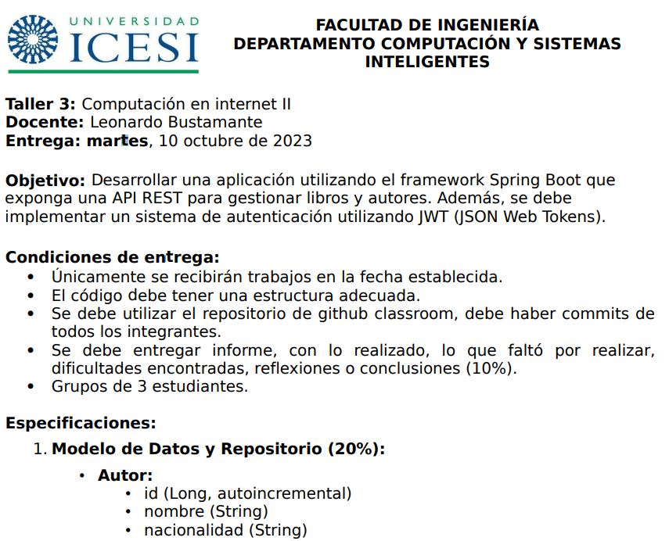

**By:**

**- Jesús Garces**

**- Santiago Arboleda**

**- Juan Pablo Acevedo**

**NOTE: IMPORTANTE REVISAR LA RAMA IMPLEMENTACION 1-6, NO PUDIMOS REALIZAR MERGE A LA RAMA PRINCIPAL.**

**Introduction:**

The Spring MVC workshop "Task 3" is about developing an application using the Spring Boot framework to create a REST API that manages books and authors. Creating various types of models for both Author and Book

**Step by Step:**

The development of the system was divided into the following stages:

* **Data Model and Repository:** Defining the Author and Book entities along with their relationships in the database.
* **Endpoints:** Creating a series of endpoints to interact with authors and books, including operations such as listing, getting details, creating, updating, and deleting both authors and books. Like, implementing an endpoint to list books by a specific author.
* **Authentication:** Implementing a JWT-based authentication system. This includes creating a login endpoint, which validates user credentials and will return a valid JWT token if they are correct. All other endpoints require a valid JWT token to access.

**Achievements:**

This project was an opportunity to apply our knowledge of Spring Boot, pushing ourselves to the limit of effort when working and developing a functional application that meets the specifications provided.

**Difficulties encountered:**

* The import of various classes was not read by the IDE. Both from Jakarta and Nimbdus, that is, from JWT.
* Error when executing, we did not know how to log in with JWT.
* In postman, a 401 not authorized error appeared.
* Error with Spring versions and other dependencies delayed our development a lot
* It serves, but within the login, the management of the authors as they had been doing in the previous appointments, obviously with the specifications of this assignment.

**Conclusion:**

We feel that it was a great challenge, the result was not what we expected. This is what we learn to improve for future deliveries.