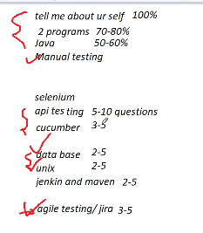

What is Jenkins?

Jenkins is an open source automation tool written in Java programming language that allows continuous integration.

Jenkins **builds** and **tests** our software projects which continuously making it easier for developers to integrate changes to the project, and making it easier for users to obtain a fresh build.

It also allows us to continuously **deliver** our software by integrating with a large number of testing and deployment technologies.

With the help of Jenkins, organizations can speed up the software development process through automation. Jenkins adds development life-cycle processes of all kinds, including build, document, test, package, stage, deploy static analysis and much more.

Jenkins achieves CI (Continuous Integration) with the help of plugins. Plugins is used to allow the integration of various DevOps stages.

**For example:** If any organization is developing a project, then **Jenkins** will continuously test your project builds and show you the errors in early stages of your development.

Possible steps executed by Jenkins are for example:

* Perform a software build using a build system like Gradle or Maven Apache
* Execute a shell script
* Archive a build result
* Running software tests

**Jenkins pipeline**

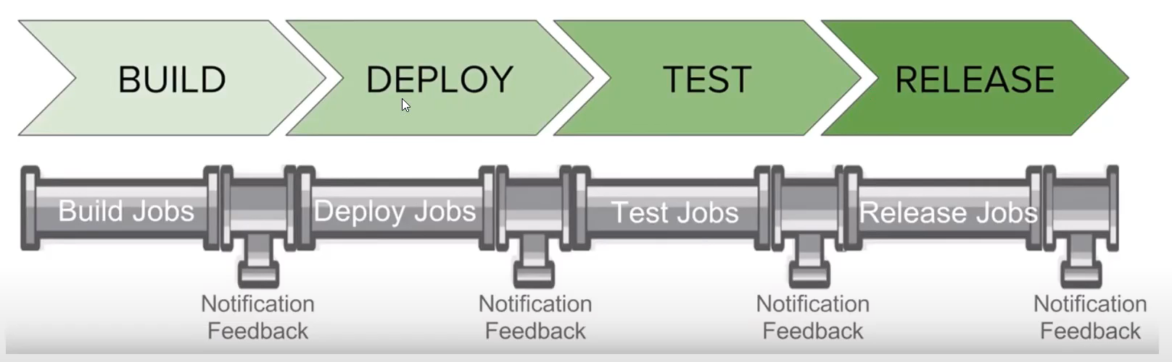

**Setup build pipeline in jenkins**

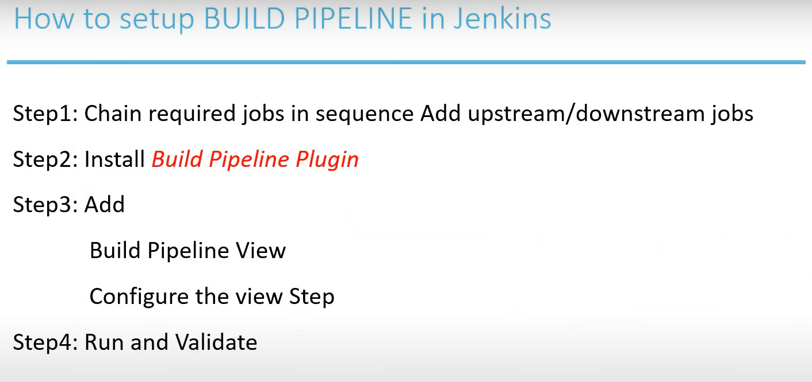

Copy Jenkins job from one server to another

C:\Users\TISHAN1KA\AppData\Local\Jenkins\.jenkins\jobs