Cellular response before challenge: E2-stimulated PBMC cytokines
Generated on 2026-09-27 with R version 4.6.0 (2026-04-24 ucrt).

Analysis
Net cytokine concentrations (E2-stimulated minus unstimulated) were log10(x + 1)-transformed and analyzed with linear mixed-effects models (nlme::lme, REML) including time, group and their interaction as fixed effects and animal as a random intercept. Day 56 was compared with day 0 within each group, and groups were compared within each day with Tukey's adjustment (emmeans).

Negative net values set to 0
Cytokine | Values set to 0
IFN-γ | 0
IL-17 | 0
TNF-α | 0

Draft text for Section 3.3
IFN-γ: group × time interaction, F4,18 = 1.43, p = 0.266. Day 56 vs day 0 — Control, p = 0.262; 25 µg, p = 0.001; 50 µg, p = 0.004; 100 µg, p = 0.026; Comm., p = 0.858.
TNF-α: group × time interaction, F4,18 = 1.89, p = 0.156. Day 56 vs day 0 — Control, p = 0.771; 25 µg, p = 0.001; 50 µg, p < 0.001; 100 µg, p = 0.062; Comm., p = 0.141.
IL-17: group × time interaction, F4,18 = 6.68, p = 0.002. Day 56 vs day 0 — Control, p = 0.533; 25 µg, p < 0.001; 50 µg, p < 0.001; 100 µg, p = 0.008; Comm., p = 0.098.

IFN-γ

Fixed effects
Effect | numDF | denDF | F_value | p
Time | 1 | 18 | 28.06 | < 0.0001
Group | 4 | 18 | 1.11 | 0.3810
Group × time | 4 | 18 | 1.43 | 0.2659

Day 56 vs day 0 within each group
Group | Estimate (log10) | SE | df | t | Fold change | p
Control | 0.374 | 0.323 | 18 | 1.16 | 2.37 | 0.2616
25 µg | 0.675 | 0.173 | 18 | 3.91 | 4.73 | 0.0010
50 µg | 0.765 | 0.228 | 18 | 3.35 | 5.83 | 0.0035
100 µg | 0.417 | 0.173 | 18 | 2.42 | 2.61 | 0.0264
Comm. | 0.048 | 0.264 | 18 | 0.18 | 1.12 | 0.8580

TNF-α

Fixed effects
Effect | numDF | denDF | F_value | p
Time | 1 | 18 | 32.04 | < 0.0001
Group | 4 | 18 | 1.59 | 0.2187
Group × time | 4 | 18 | 1.89 | 0.1562

Day 56 vs day 0 within each group
Group | Estimate (log10) | SE | df | t | Fold change | p
Control | 0.149 | 0.505 | 18 | 0.30 | 1.41 | 0.7709
25 µg | 1.051 | 0.270 | 18 | 3.89 | 11.25 | 0.0011
50 µg | 1.515 | 0.357 | 18 | 4.24 | 32.72 | 0.0005
100 µg | 0.538 | 0.270 | 18 | 1.99 | 3.45 | 0.0617
Comm. | 0.635 | 0.412 | 18 | 1.54 | 4.32 | 0.1409

IL-17

Fixed effects
Effect | numDF | denDF | F_value | p
Time | 1 | 18 | 26.52 | < 0.0001
Group | 4 | 18 | 3.08 | 0.0425
Group × time | 4 | 18 | 6.68 | 0.0018

Day 56 vs day 0 within each group
Group | Estimate (log10) | SE | df | t | Fold change | p
Control | -0.154 | 0.243 | 18 | -0.64 | 0.70 | 0.5333
25 µg | 0.544 | 0.130 | 18 | 4.18 | 3.50 | 0.0006
50 µg | 0.833 | 0.172 | 18 | 4.84 | 6.80 | 0.0001
100 µg | 0.386 | 0.130 | 18 | 2.97 | 2.43 | 0.0082
Comm. | -0.347 | 0.198 | 18 | -1.75 | 0.45 | 0.0979

Figure 4
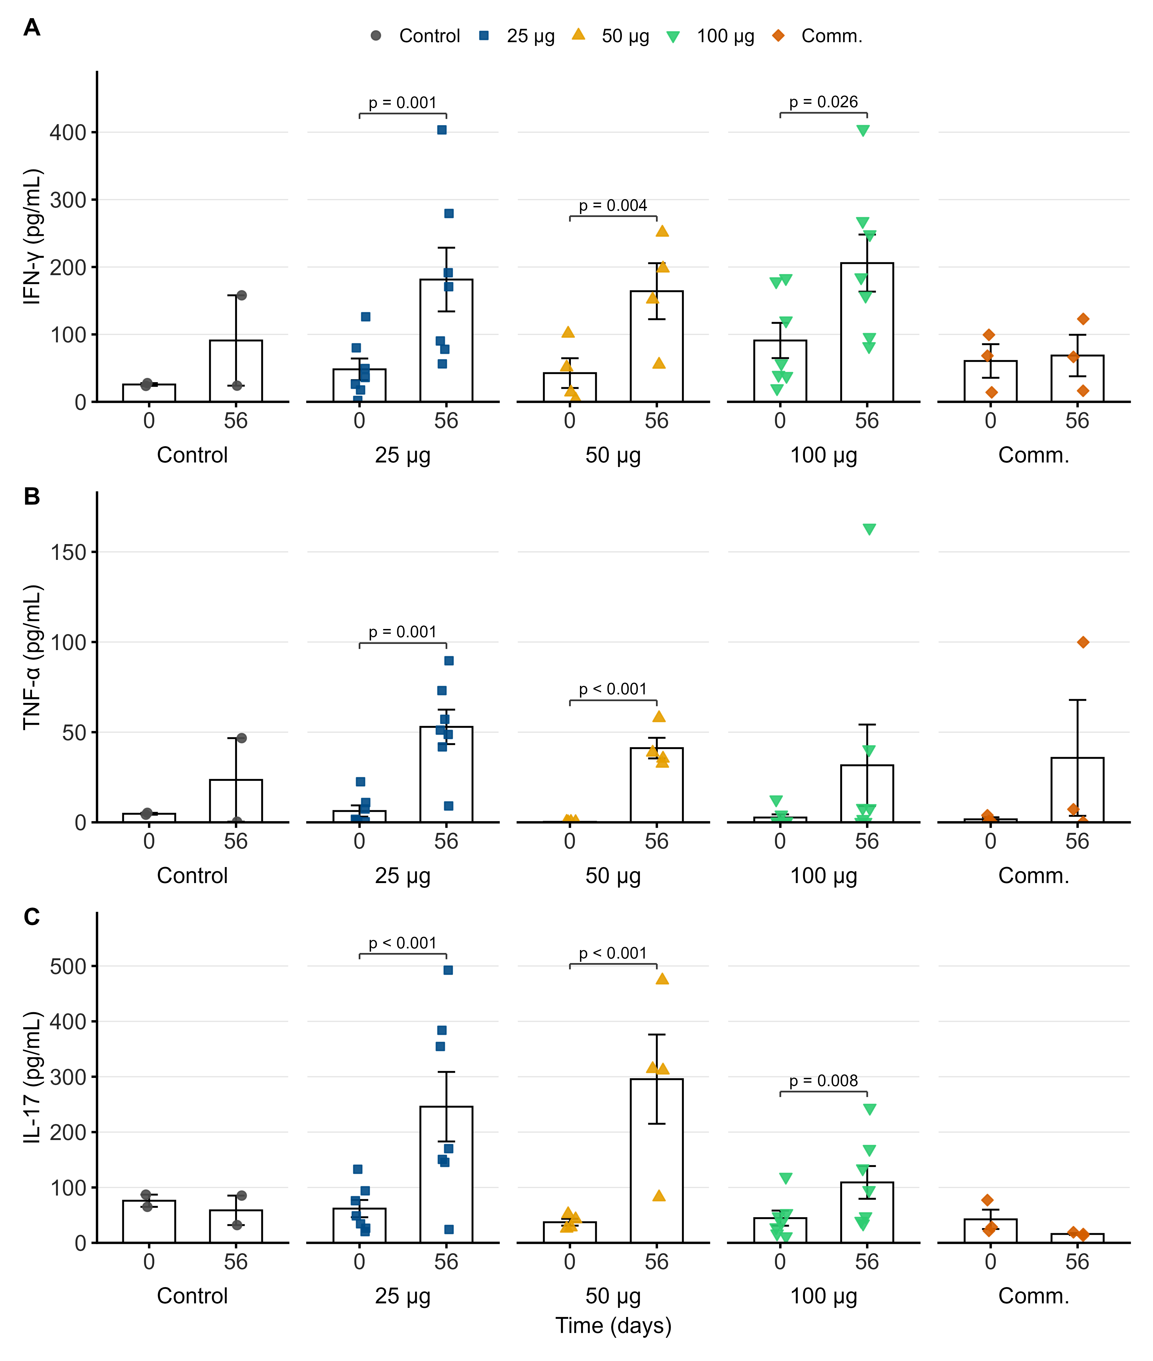
Cytokine secretion by E2-stimulated PBMCs at day 0 and day 56. Bars show mean ± SEM (pg/mL); symbols show individual animals. p-values: day 56 vs day 0 from the linear mixed model on log10(x + 1)-transformed data (shown when p < 0.05).

