Serum cytokines after challenge
Generated on 2026-09-27 with R version 4.6.0 (2026-04-24 ucrt).

Analysis
Serum cytokine concentrations were log10(x + 1)-transformed and analyzed with linear mixed-effects models (lmerTest::lmer, REML) including group, time and their interaction as fixed effects and animal as a random intercept. Fixed effects were tested with type III F tests and Satterthwaite's degrees of freedom; groups were compared within each day with Tukey's adjustment (emmeans). Cumulative exposure (trapezoidal AUC) and peak concentration per animal were compared with the Kruskal–Wallis test followed by Dunn's test with Benjamini–Hochberg adjustment.

Draft text for Section 3.5
IFN-γ: time, F4,72 = 0.29, p = 0.882; group, F4,18 = 1.29, p = 0.313; group × time, F16,72 = 1.14, p = 0.335.
IL-17: time, F4,72 = 12.52, p < 0.001; group, F4,18 = 1.06, p = 0.403; group × time, F16,72 = 1.25, p = 0.254.
TNF-α: time, F4,72 = 62.09, p < 0.001; group, F4,18 = 2.75, p = 0.060; group × time, F16,72 = 2.90, p = 0.001.
IL-6: time, F4,72 = 0.69, p = 0.599; group, F4,18 = 0.77, p = 0.556; group × time, F16,72 = 0.91, p = 0.562.
IL-4: time, F4,72 = 39.91, p < 0.001; group, F4,18 = 1.26, p = 0.321; group × time, F16,72 = 1.65, p = 0.077.
IFN-γ, day 6: 25ug - 100ug, p = 0.039.
TNF-α, day 14: 25ug - Commercial, p = 0.018.
TNF-α, day 14: 50ug - Commercial, p = 0.016.
TNF-α, day 21: 25ug - Commercial, p = 0.008.
TNF-α, day 21: 50ug - Commercial, p = 0.003.
TNF-α, day 21: 100ug - Commercial, p = 0.008.

Fixed effects of the mixed models
Cytokine | Effect | NumDF | DenDF | F_value | p
IFN-γ | Group | 4 | 18 | 1.29 | 0.3125
IFN-γ | Time | 4 | 72 | 0.29 | 0.8817
IFN-γ | Group × time | 16 | 72 | 1.14 | 0.3347
IL-17 | Group | 4 | 18 | 1.06 | 0.4026
IL-17 | Time | 4 | 72 | 12.52 | < 0.0001
IL-17 | Group × time | 16 | 72 | 1.25 | 0.2544
TNF-α | Group | 4 | 18 | 2.75 | 0.0602
TNF-α | Time | 4 | 72 | 62.09 | < 0.0001
TNF-α | Group × time | 16 | 72 | 2.90 | 0.0011
IL-6 | Group | 4 | 18 | 0.77 | 0.5563
IL-6 | Time | 4 | 72 | 0.69 | 0.5987
IL-6 | Group × time | 16 | 72 | 0.91 | 0.5620
IL-4 | Group | 4 | 18 | 1.26 | 0.3214
IL-4 | Time | 4 | 72 | 39.91 | < 0.0001
IL-4 | Group × time | 16 | 72 | 1.65 | 0.0768

Significant between-group comparisons (Tukey)
Cytokine | Day | Contrast | Estimate (log10) | t | p
IFN-γ | 6 | 25ug - 100ug | 0.274 | 2.94 | 0.0395
TNF-α | 14 | 25ug - Commercial | -0.683 | -3.43 | 0.0178
TNF-α | 14 | 50ug - Commercial | -0.768 | -3.48 | 0.0158
TNF-α | 21 | 25ug - Commercial | -0.754 | -3.78 | 0.0078
TNF-α | 21 | 50ug - Commercial | -0.939 | -4.26 | 0.0026
TNF-α | 21 | 100ug - Commercial | -0.752 | -3.78 | 0.0080

AUC and peak: Kruskal–Wallis
Cytokine | Metric | n | H | df | p
IFN-γ | auc | 23 | 2.96 | 4 | 0.5640
IFN-γ | peak | 23 | 4.83 | 4 | 0.3050
IL-17 | auc | 23 | 1.97 | 4 | 0.7410
IL-17 | peak | 23 | 0.70 | 4 | 0.9520
TNF-α | auc | 23 | 7.42 | 4 | 0.1150
TNF-α | peak | 23 | 7.58 | 4 | 0.1080
IL-6 | auc | 23 | 3.97 | 4 | 0.4110
IL-6 | peak | 23 | 2.89 | 4 | 0.5760
IL-4 | auc | 23 | 3.64 | 4 | 0.4560
IL-4 | peak | 23 | 3.74 | 4 | 0.4430

AUC and peak by group (mean ± SD)
Cytokine | Group | n | AUC | Peak
IFN-γ | Control | 2 | 129.03 ± 4.69 | 9.84 ± 2.03
IFN-γ | 25 µg | 7 | 204.67 ± 100.49 | 14.05 ± 8.84
IFN-γ | 50 µg | 4 | 129.25 ± 40.53 | 8.22 ± 2.37
IFN-γ | 100 µg | 7 | 126.51 ± 44.62 | 7.49 ± 2.30
IFN-γ | Comm. | 3 | 163.00 ± 62.13 | 13.82 ± 8.22
IL-17 | Control | 2 | 66.72 ± 19.89 | 6.10 ± 4.28
IL-17 | 25 µg | 7 | 81.79 ± 14.40 | 5.27 ± 1.05
IL-17 | 50 µg | 4 | 90.42 ± 33.89 | 5.56 ± 1.92
IL-17 | 100 µg | 7 | 74.20 ± 17.67 | 5.74 ± 2.03
IL-17 | Comm. | 3 | 92.14 ± 38.90 | 6.80 ± 3.17
TNF-α | Control | 2 | 2603.11 ± 2045.43 | 207.18 ± 143.46
TNF-α | 25 µg | 7 | 1611.99 ± 728.35 | 107.55 ± 38.43
TNF-α | 50 µg | 4 | 1502.35 ± 956.28 | 101.20 ± 67.15
TNF-α | 100 µg | 7 | 2285.82 ± 2008.04 | 159.35 ± 138.15
TNF-α | Comm. | 3 | 7320.94 ± 3703.95 | 726.71 ± 571.79
IL-6 | Control | 2 | 12350.52 ± 6816.13 | 1009.45 ± 443.08
IL-6 | 25 µg | 7 | 10172.06 ± 11319.20 | 683.77 ± 728.50
IL-6 | 50 µg | 4 | 4706.25 ± 3414.07 | 409.80 ± 316.84
IL-6 | 100 µg | 7 | 12075.56 ± 13989.65 | 823.92 ± 835.80
IL-6 | Comm. | 3 | 14824.30 ± 5721.58 | 1158.88 ± 481.15
IL-4 | Control | 2 | 1327.76 ± 1093.37 | 172.57 ± 164.17
IL-4 | 25 µg | 7 | 539.04 ± 360.70 | 45.15 ± 26.62
IL-4 | 50 µg | 4 | 784.61 ± 829.35 | 76.42 ± 69.62
IL-4 | 100 µg | 7 | 614.16 ± 694.75 | 58.78 ± 50.88
IL-4 | Comm. | 3 | 1641.76 ± 1358.69 | 122.28 ± 86.18

Figure 6
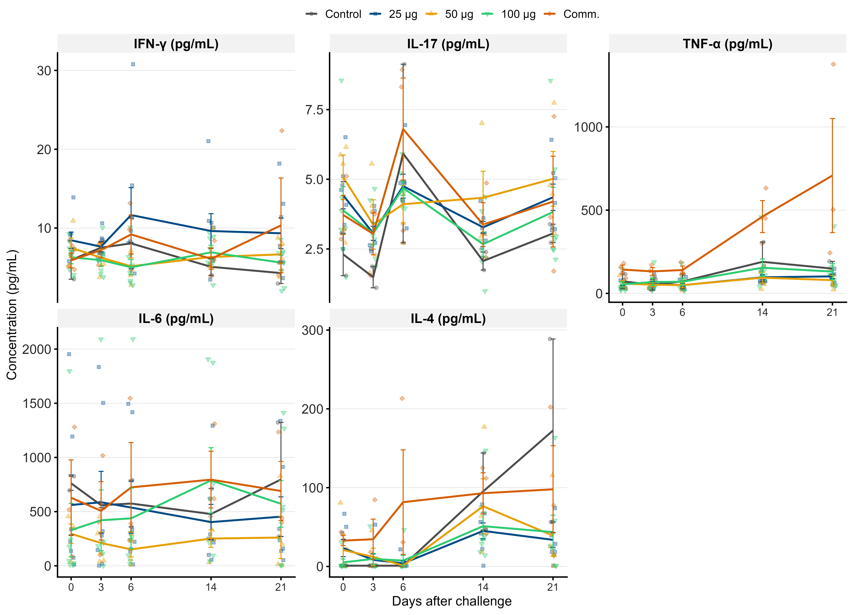
Kinetics of serum cytokines after challenge. Symbols show individual animals, lines show group means and error bars show SEM. Each panel has an independent y-axis.

Figure 7
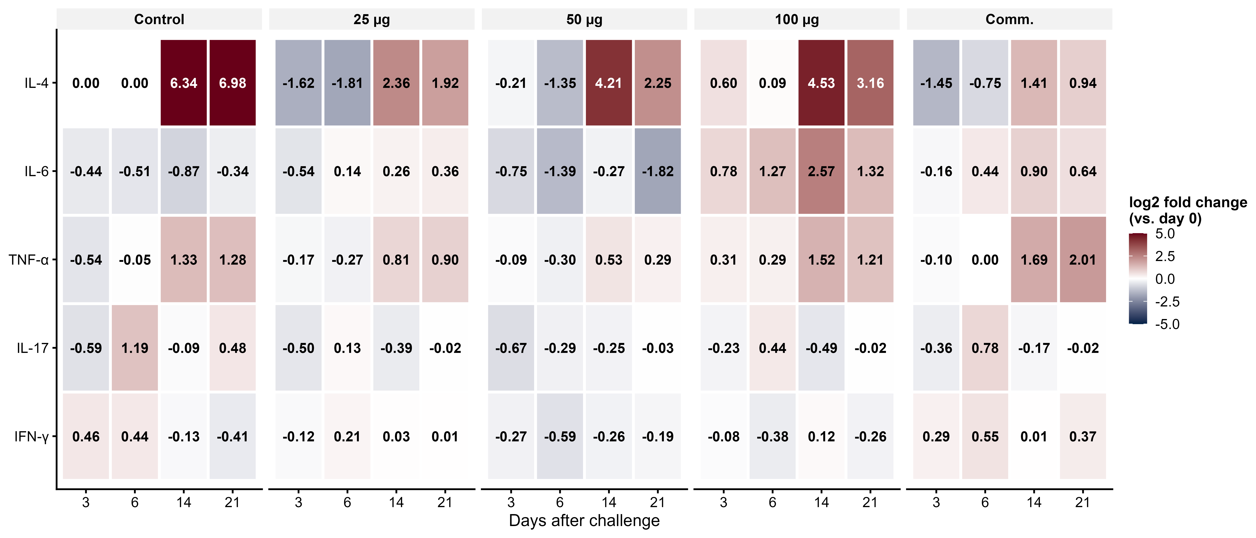
Relative change in serum cytokine concentration at 3, 6, 14 and 21 days after challenge. Values are the mean of individual log2 fold changes relative to day 0, equivalent to the log2 of the geometric mean fold change.

