Viremia after challenge
Generated on 2026-09-27 with R version 4.6.0 (2026-04-24 ucrt).

Analysis
Viral load was analyzed as log10(copies/mL + 1). Cumulative exposure (trapezoidal AUC, days 0–21) was compared with one-way ANOVA and Tukey's test, with the Kruskal–Wallis test as a sensitivity analysis. Peak viral load and the number of positive sampling days were compared with the Kruskal–Wallis test followed by Dunn's test with Benjamini–Hochberg adjustment. The prevalence of viremia (days 3, 6 and 14) was analyzed with a penalized binomial generalized linear mixed model (blme::bglmer) including group, day and their interaction as fixed effects and animal as a random intercept; pairwise odds ratios averaged over days are reported with Tukey-adjusted 95% confidence intervals.

Draft text for Section 3.4
AUC (ANOVA): One-way ANOVA, F4,18 = 4.81, p = 0.008.
AUC vs commercial (Tukey): Control - Commercial, p = 0.111; 25ug - Commercial, p = 0.017; 50ug - Commercial, p = 0.007; 100ug - Commercial, p = 0.206.
AUC (sensitivity): Kruskal–Wallis, H = 9.8, p = 0.044; Control vs Commercial, Dunn-BH p = 0.270; 25ug vs Commercial, Dunn-BH p = 0.056; 50ug vs Commercial, Dunn-BH p = 0.055; 100ug vs Commercial, Dunn-BH p = 0.270.
Peak: Kruskal–Wallis, H = 9.47, p = 0.050; Control vs Commercial, Dunn-BH p = 0.557; 25ug vs Commercial, Dunn-BH p = 0.159; 50ug vs Commercial, Dunn-BH p = 0.058; 100ug vs Commercial, Dunn-BH p = 0.384.
Days positive: Kruskal–Wallis, H = 10.17, p = 0.038; Control vs Commercial, Dunn-BH p = 0.120; 25ug vs Commercial, Dunn-BH p = 0.068; 50ug vs Commercial, Dunn-BH p = 0.036; 100ug vs Commercial, Dunn-BH p = 0.190.
Daily prevalence (Fisher): Smallest BH-adjusted p = 0.333 (day 14, 25ug 1/7 vs Commercial 3/3).

Metrics by group (mean ± SD)
Group | n | AUC (log10 copies/mL × days) | Peak (log10 copies/mL) | Peak (copies/mL) | Days positive
Control | 2 | 25.36 ± 3.84 | 4.61 ± 0.70 | 70,304 ± 80,883 | 1.00 ± 0.00
25 µg | 7 | 24.25 ± 12.53 | 3.84 ± 0.83 | 15,380 ± 15,262 | 1.14 ± 0.38
50 µg | 4 | 14.91 ± 12.40 | 2.75 ± 1.87 | 4,755 ± 5,737 | 0.75 ± 0.50
100 µg | 7 | 38.74 ± 23.38 | 4.04 ± 1.94 | 166,755 ± 260,650 | 1.57 ± 0.98
Comm. | 3 | 63.94 ± 4.14 | 5.26 ± 0.43 | 239,112 ± 193,882 | 2.67 ± 0.58

AUC: ANOVA assumptions
Test | p_value
Shapiro–Wilk (residuals) | 0.4949
Levene | 0.1608

Kruskal–Wallis tests
Metric | n | H | df | p
auc_log10 | 23 | 9.80 | 4 | 0.0440
peak_log10 | 23 | 9.47 | 4 | 0.0504
viremic_days | 23 | 10.17 | 4 | 0.0377

Table 3. Pairwise odds ratios of viremia (days 3, 6 and 14)
Comparison | OR | 95% CI | Adjusted p
Control vs 25 µg | 3.528 | 0.170–73.389 | 0.7891
Control vs 50 µg | 5.634 | 0.261–121.685 | 0.5397
Control vs 100 µg | 1.356 | 0.090–20.464 | 0.9981
Control vs Commercial | 0.129 | 0.003–6.470 | 0.6100
25 µg vs 50 µg | 1.597 | 0.086–29.574 | 0.9924
25 µg vs 100 µg | 0.384 | 0.030–4.973 | 0.8468
25 µg vs Commercial | 0.037 | 0.001–2.146 | 0.1735
50 µg vs 100 µg | 0.241 | 0.018–3.207 | 0.5622
50 µg vs Commercial | 0.023 | 0.000–1.384 | 0.0880
100 µg vs Commercial | 0.095 | 0.002–4.223 | 0.4389

Figure 5
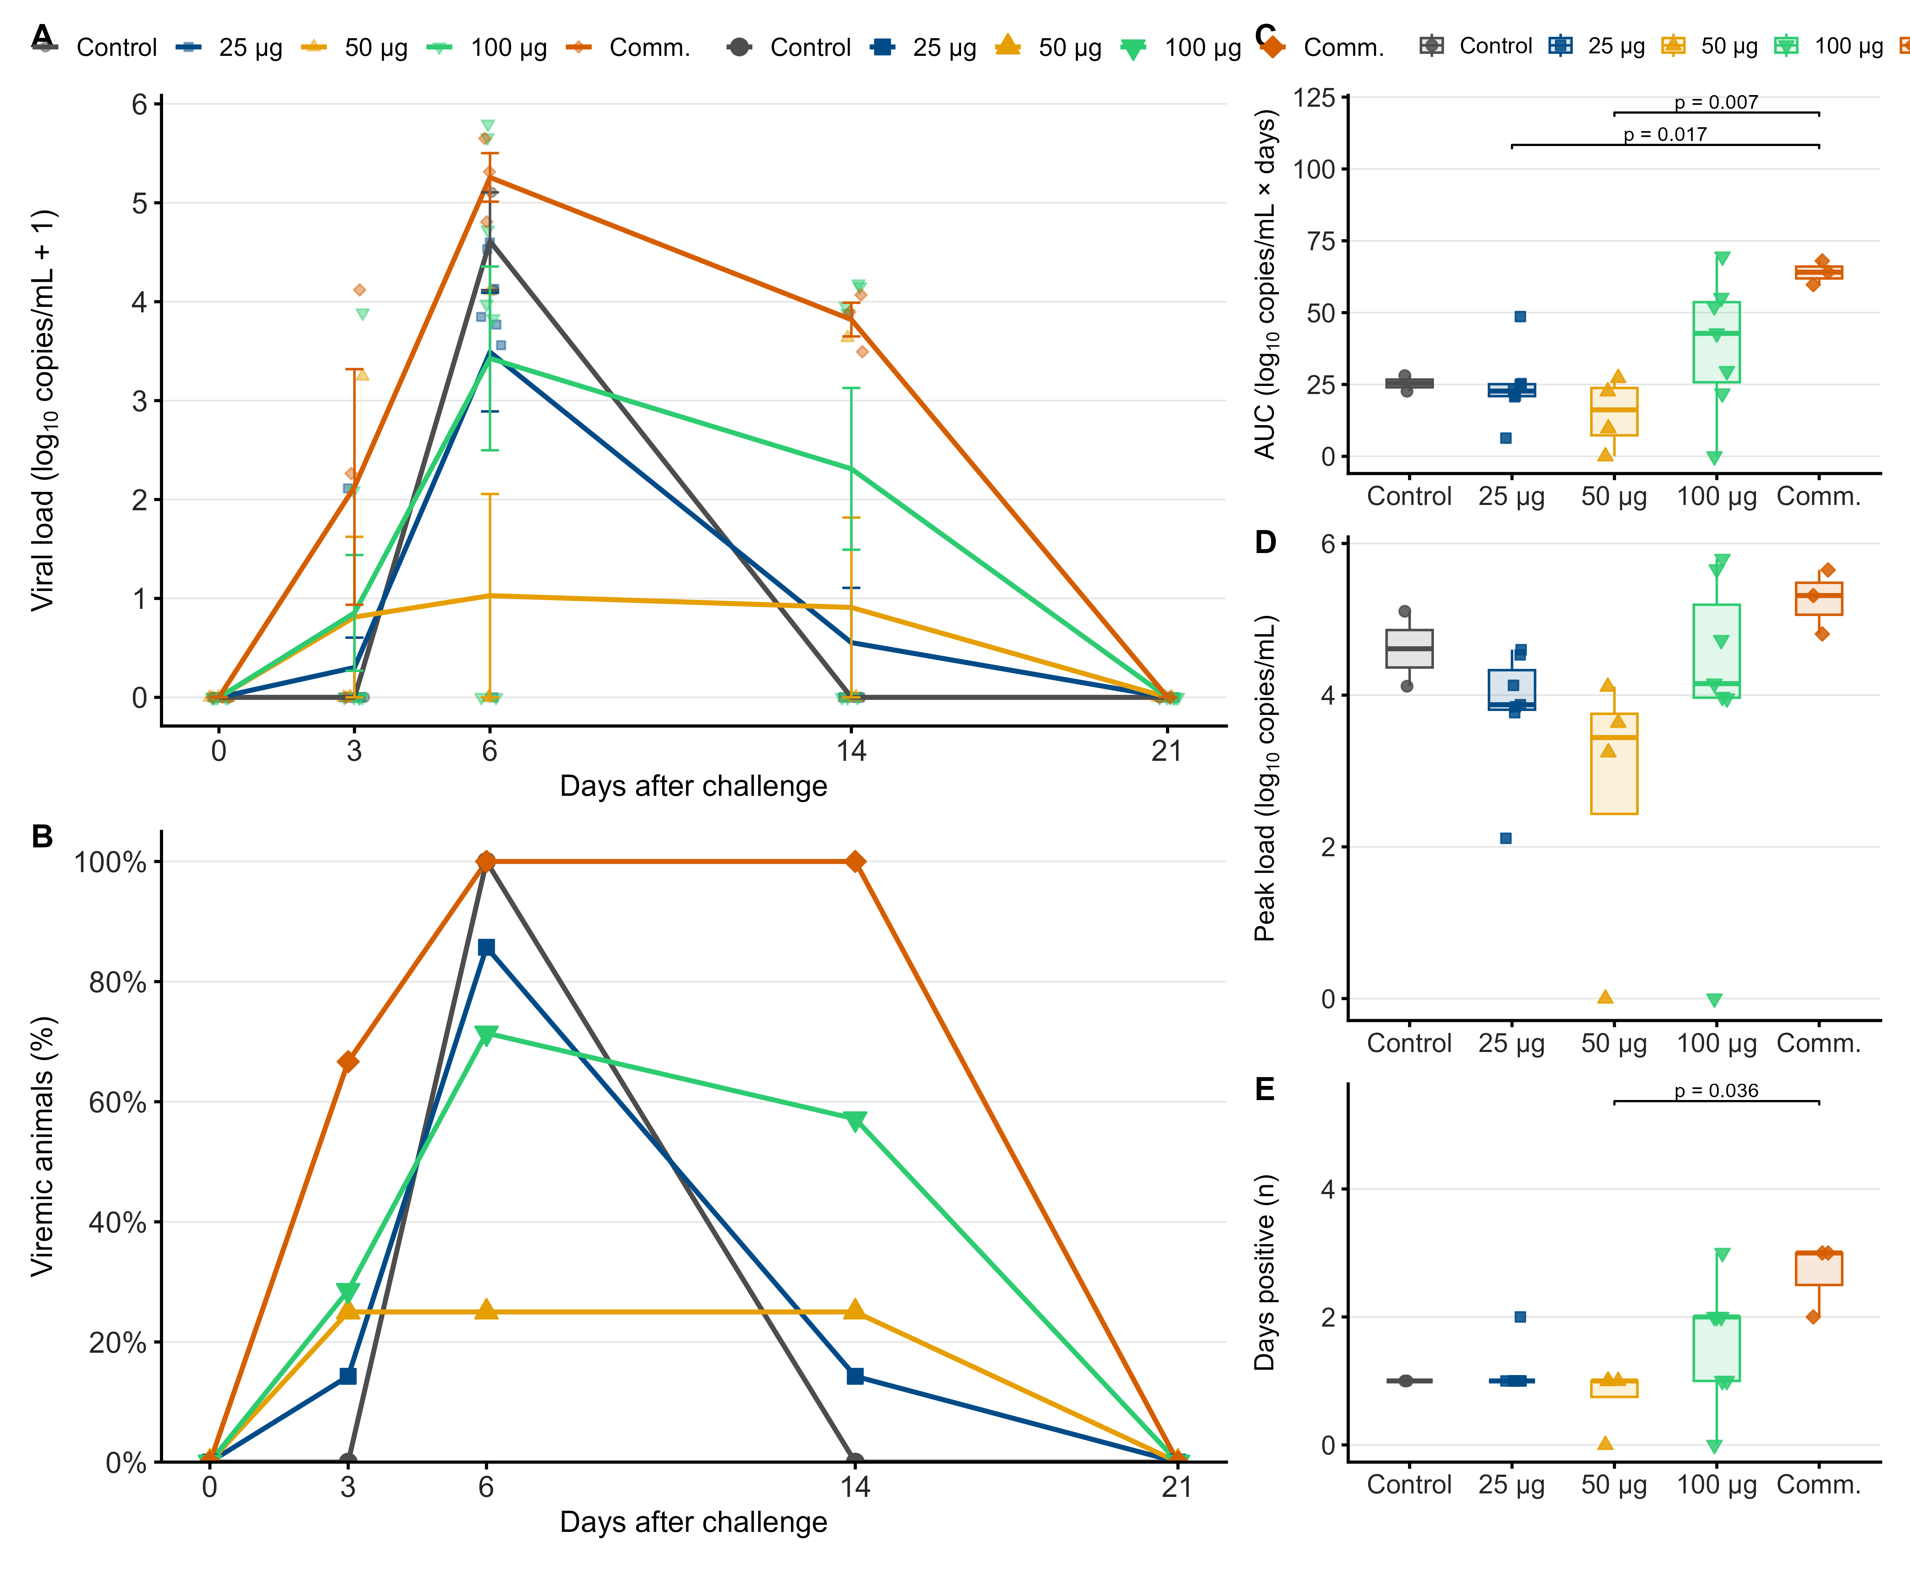
Viremia kinetics after challenge. (A) Serum viral load (log10 copies/mL + 1); lines and error bars show group means and SEM. (B) Prevalence of viremia. (C) Cumulative exposure (AUC), (D) peak viral load and (E) number of sampling days with detectable viremia. Boxplots show median and IQR. Brackets show adjusted p < 0.05 (Tukey for AUC; Dunn-BH for peak and days).

