Associations among immune responses, viremia and clinical outcomes
Generated on 2026-09-27 with R version 4.6.0 (2026-04-24 ucrt).

Draft text (Sections 3.4 and 3.7)
NT (mean) vs viral load AUC: ρ = -0.49, 95% CI -0.79 to -0.08, p = 0.017; adjusted p = 0.029
NT (mean) vs peak viral load: ρ = -0.64, 95% CI -0.83 to -0.32, p < 0.001; adjusted p = 0.004
NT by subgenotype vs viral load AUC (range): ρ from -0.46 to -0.43 (1b ρ = -0.45; 1c ρ = -0.43; 1d ρ = -0.46; 1e ρ = -0.44)
IL-17 recall vs viral load AUC: ρ = -0.71, 95% CI -0.88 to -0.36, p < 0.001; adjusted p < 0.001
IL-17 recall vs viral load AUC, adjusted for NT titer: partial ρ = -0.58, p = 0.004
IL-17 recall vs viral load AUC, recombinant groups: ρ = -0.64, p = 0.004; adjusted p = 0.015
IL-17 recall vs viral load AUC, adjusted for group: partial ρ = -0.56, p = 0.013
IFN-γ recall vs viral load AUC: ρ = -0.23, 95% CI -0.57 to 0.18, p = 0.288; adjusted p = 0.288
TNF-α recall vs viral load AUC: ρ = -0.47, 95% CI -0.73 to -0.07, p = 0.025; adjusted p = 0.038
Recall vs serum cytokine AUC (smallest adjusted p): All adjusted p ≥ 0.61
Viral load AUC vs serum TNF-α AUC: ρ = 0.52, 95% CI 0.07 to 0.79, p = 0.010; adjusted p = 0.061
Viral load AUC vs serum TNF-α AUC, excluding control: ρ = 0.59, p = 0.005; adjusted p = 0.030
Viral load AUC vs serum TNF-α AUC, recombinant groups: ρ = 0.40, p = 0.101; adjusted p = 0.452
Viral load AUC vs serum TNF-α AUC, adjusted for group: partial ρ = 0.28, p = 0.247
Fever vs diarrhea: ρ = 0.32, 95% CI -0.10 to 0.66, p = 0.142; adjusted p = 0.337
Fever vs viral load AUC: ρ = -0.06, 95% CI -0.53 to 0.39, p = 0.782; adjusted p = 0.782
Fever vs serum TNF-α AUC: ρ = -0.12, 95% CI -0.56 to 0.31, p = 0.583; adjusted p = 0.699
Diarrhea vs viral load AUC: ρ = 0.30, 95% CI -0.17 to 0.64, p = 0.169; adjusted p = 0.337
Diarrhea vs serum TNF-α AUC: ρ = 0.20, 95% CI -0.24 to 0.60, p = 0.357; adjusted p = 0.535
Other Section 3.7 pairs (smallest adjusted p): All adjusted p ≥ 0.34
Same-day correlation (TNF-α): TNF-α: n = 115, ρ = 0.12, p = 0.194; partial (group) ρ = 0.01, p = 0.939
Same-day correlation (IL-4): IL-4: n = 115, ρ = -0.03, p = 0.747; partial (group) ρ = -0.09, p = 0.323
Preceding-day correlation (TNF-α): TNF-α: n = 92, ρ = 0.43, p < 0.001; partial (group) ρ = 0.34, p = 0.001
Preceding-day correlation (IL-4): IL-4: n = 92, ρ = 0.43, p < 0.001; partial (group) ρ = 0.40, p < 0.001
TNF-α, day 0 to day 3: median change -0.9 pg/mL, p = 0.520
TNF-α, day 0 to day 6: median change -2.1 pg/mL, p = 0.754
TNF-α, day 6 to day 14: median change +44.6 pg/mL, p < 0.001
TNF-α, day 6 to day 21: median change +61.8 pg/mL, p < 0.001

Data available per variable
Label | n_available | missing_animals
Neutralizing titer, BVDV-1b (log2) | 23
Neutralizing titer, BVDV-1c (log2) | 23
Neutralizing titer, BVDV-1d (log2) | 23
Neutralizing titer, BVDV-1e (log2) | 23
Neutralizing titer (mean log2) | 23
IFN-γ recall (day 56 − day 0) | 23
IL-17 recall (day 56 − day 0) | 23
TNF-α recall (day 56 − day 0) | 23
IFN-γ recall (log2 fold change, day 56 vs day 0) | 23
IL-17 recall (log2 fold change, day 56 vs day 0) | 23
TNF-α recall (log2 fold change, day 56 vs day 0) | 23
IFN-γ recall (day 56) | 23
IL-17 recall (day 56) | 23
TNF-α recall (day 56) | 23
Serum IFN-γ AUC | 23
Serum IL-17 AUC | 23
Serum IL-4 AUC | 23
Serum IL-6 AUC | 23
Serum TNF-α AUC | 23
Composite clinical score AUC | 23
Diarrhea score AUC | 23
Fever score AUC | 23
Viral load AUC | 23
Peak viral load | 23

Table S2. Neutralizing antibodies vs viremia
Variable | Outcome | n | ρ (95% CI) | p | Adjusted p (BH)
Neutralizing titer (mean log2) | Viral load AUC | 23 | -0.49 (-0.79 to -0.08) | 0.0171 | 0.0285
Neutralizing titer (mean log2) | Peak viral load | 23 | -0.64 (-0.83 to -0.32) | 0.0010 | 0.0039
Neutralizing titer, BVDV-1b (log2) | Viral load AUC | 23 | -0.45 (-0.77 to -0.02) | 0.0292 | 0.0366
Neutralizing titer, BVDV-1b (log2) | Peak viral load | 23 | -0.63 (-0.83 to -0.31) | 0.0013 | 0.0039
Neutralizing titer, BVDV-1c (log2) | Viral load AUC | 23 | -0.43 (-0.73 to -0.01) | 0.0428 | 0.0428
Neutralizing titer, BVDV-1c (log2) | Peak viral load | 23 | -0.58 (-0.80 to -0.27) | 0.0037 | 0.0073
Neutralizing titer, BVDV-1d (log2) | Viral load AUC | 23 | -0.46 (-0.76 to -0.03) | 0.0270 | 0.0366
Neutralizing titer, BVDV-1d (log2) | Peak viral load | 23 | -0.63 (-0.82 to -0.31) | 0.0014 | 0.0039
Neutralizing titer, BVDV-1e (log2) | Viral load AUC | 23 | -0.44 (-0.77 to -0.02) | 0.0365 | 0.0406
Neutralizing titer, BVDV-1e (log2) | Peak viral load | 23 | -0.62 (-0.82 to -0.30) | 0.0016 | 0.0039

Table S3. Recall responses vs viremia and serum cytokines
Variable | Outcome | n | ρ (95% CI) | p | Adjusted p (BH)
IFN-γ recall (log2 fold change, day 56 vs day 0) | Viral load AUC | 23 | -0.23 (-0.57 to 0.18) | 0.2883 | 0.2883
IFN-γ recall (log2 fold change, day 56 vs day 0) | Peak viral load | 23 | -0.29 (-0.61 to 0.10) | 0.1725 | 0.2070
TNF-α recall (log2 fold change, day 56 vs day 0) | Viral load AUC | 23 | -0.47 (-0.73 to -0.07) | 0.0252 | 0.0378
TNF-α recall (log2 fold change, day 56 vs day 0) | Peak viral load | 23 | -0.58 (-0.83 to -0.19) | 0.0041 | 0.0082
IL-17 recall (log2 fold change, day 56 vs day 0) | Viral load AUC | 23 | -0.71 (-0.88 to -0.36) | 0.0002 | 0.0005
IL-17 recall (log2 fold change, day 56 vs day 0) | Peak viral load | 23 | -0.76 (-0.90 to -0.46) | < 0.0001 | 0.0001
IFN-γ recall (log2 fold change, day 56 vs day 0) | Serum IFN-γ AUC | 23 | -0.22 (-0.58 to 0.22) | 0.3175 | 0.9694
IFN-γ recall (log2 fold change, day 56 vs day 0) | Serum IL-17 AUC | 23 | 0.02 (-0.48 to 0.49) | 0.9299 | 0.9694
IFN-γ recall (log2 fold change, day 56 vs day 0) | Serum TNF-α AUC | 23 | -0.05 (-0.47 to 0.44) | 0.8337 | 0.9694
IFN-γ recall (log2 fold change, day 56 vs day 0) | Serum IL-6 AUC | 23 | 0.04 (-0.37 to 0.44) | 0.8407 | 0.9694
IFN-γ recall (log2 fold change, day 56 vs day 0) | Serum IL-4 AUC | 23 | -0.02 (-0.50 to 0.45) | 0.9358 | 0.9694
TNF-α recall (log2 fold change, day 56 vs day 0) | Serum IFN-γ AUC | 23 | -0.01 (-0.44 to 0.40) | 0.9694 | 0.9694
TNF-α recall (log2 fold change, day 56 vs day 0) | Serum IL-17 AUC | 23 | 0.03 (-0.51 to 0.48) | 0.9012 | 0.9694
TNF-α recall (log2 fold change, day 56 vs day 0) | Serum TNF-α AUC | 23 | -0.21 (-0.60 to 0.26) | 0.3358 | 0.9694
TNF-α recall (log2 fold change, day 56 vs day 0) | Serum IL-6 AUC | 23 | -0.14 (-0.59 to 0.32) | 0.5185 | 0.9694
TNF-α recall (log2 fold change, day 56 vs day 0) | Serum IL-4 AUC | 23 | -0.12 (-0.56 to 0.32) | 0.5977 | 0.9694
IL-17 recall (log2 fold change, day 56 vs day 0) | Serum IFN-γ AUC | 23 | 0.15 (-0.33 to 0.60) | 0.4980 | 0.9694
IL-17 recall (log2 fold change, day 56 vs day 0) | Serum IL-17 AUC | 23 | 0.09 (-0.38 to 0.58) | 0.6725 | 0.9694
IL-17 recall (log2 fold change, day 56 vs day 0) | Serum TNF-α AUC | 23 | -0.43 (-0.77 to 0.00) | 0.0408 | 0.6126
IL-17 recall (log2 fold change, day 56 vs day 0) | Serum IL-6 AUC | 23 | -0.30 (-0.66 to 0.11) | 0.1649 | 0.9694
IL-17 recall (log2 fold change, day 56 vs day 0) | Serum IL-4 AUC | 23 | -0.14 (-0.53 to 0.29) | 0.5379 | 0.9694

Recall response vs viral load AUC: alternative definitions
Definition | Cytokine | Subset | n | rho | p | Adjusted p (BH) | Partial ρ (NT) | p (partial NT)
log2 fold change vs day 0 (primary) | IFN-γ | All animals | 23 | -0.23 | 0.2883 | 0.2883 | -0.23 | 0.3090
log2 fold change vs day 0 (primary) | TNF-α | All animals | 23 | -0.47 | 0.0252 | 0.0378 | -0.30 | 0.1714
log2 fold change vs day 0 (primary) | IL-17 | All animals | 23 | -0.71 | 0.0002 | 0.0005 | -0.58 | 0.0044
Change from day 0 | IFN-γ | All animals | 23 | -0.10 | 0.6423 | 0.6618 | -0.09 | 0.7025
Change from day 0 | TNF-α | All animals | 23 | -0.43 | 0.0411 | 0.0617 | -0.43 | 0.0447
Change from day 0 | IL-17 | All animals | 23 | -0.61 | 0.0021 | 0.0063 | -0.42 | 0.0542
Day 56 net value | IFN-γ | All animals | 23 | -0.03 | 0.9002 | 0.9002 | 0.07 | 0.7687
Day 56 net value | TNF-α | All animals | 23 | -0.53 | 0.0097 | 0.0146 | -0.51 | 0.0147
Day 56 net value | IL-17 | All animals | 23 | -0.54 | 0.0075 | 0.0146 | -0.31 | 0.1550
log2 fold change vs day 0 (primary) | IFN-γ | Recombinant groups | 18 | 0.04 | 0.8675 | 0.8675
log2 fold change vs day 0 (primary) | TNF-α | Recombinant groups | 18 | -0.39 | 0.1103 | 0.1655
log2 fold change vs day 0 (primary) | IL-17 | Recombinant groups | 18 | -0.64 | 0.0042 | 0.0147
Change from day 0 | IFN-γ | Recombinant groups | 18 | 0.24 | 0.3384 | 0.3384
Change from day 0 | TNF-α | Recombinant groups | 18 | -0.48 | 0.0459 | 0.0826
Change from day 0 | IL-17 | Recombinant groups | 18 | -0.46 | 0.0551 | 0.0826
Day 56 net value | IFN-γ | Recombinant groups | 18 | 0.33 | 0.1834 | 0.1878
Day 56 net value | TNF-α | Recombinant groups | 18 | -0.58 | 0.0116 | 0.0347
Day 56 net value | IL-17 | Recombinant groups | 18 | -0.33 | 0.1878 | 0.1878

Section 3.7. Virological and clinical outcomes
Variable | Outcome | n | ρ (95% CI) | p | Adjusted p (BH)
Viral load AUC | Serum TNF-α AUC | 23 | 0.52 (0.07 to 0.79) | 0.0102 | 0.0613
Viral load AUC | Fever score AUC | 23 | -0.06 (-0.53 to 0.39) | 0.7822 | 0.7822
Viral load AUC | Diarrhea score AUC | 23 | 0.30 (-0.17 to 0.64) | 0.1687 | 0.3374
Serum TNF-α AUC | Fever score AUC | 23 | -0.12 (-0.56 to 0.31) | 0.5826 | 0.6991
Serum TNF-α AUC | Diarrhea score AUC | 23 | 0.20 (-0.24 to 0.60) | 0.3567 | 0.5350
Fever score AUC | Diarrhea score AUC | 23 | 0.32 (-0.10 to 0.66) | 0.1422 | 0.3374

Section 3.7 by subset
Subset | Pair | n | rho | p | Adjusted p (BH)
All animals | Viral load AUC vs Serum TNF-α AUC | 23 | 0.52 | 0.0102 | 0.0613
All animals | Viral load AUC vs Fever score AUC | 23 | -0.06 | 0.7822 | 0.7822
All animals | Viral load AUC vs Diarrhea score AUC | 23 | 0.30 | 0.1687 | 0.3374
All animals | Serum TNF-α AUC vs Fever score AUC | 23 | -0.12 | 0.5826 | 0.6991
All animals | Serum TNF-α AUC vs Diarrhea score AUC | 23 | 0.20 | 0.3567 | 0.5350
All animals | Fever score AUC vs Diarrhea score AUC | 23 | 0.32 | 0.1422 | 0.3374
Excluding control | Viral load AUC vs Serum TNF-α AUC | 21 | 0.59 | 0.0050 | 0.0297
Excluding control | Viral load AUC vs Fever score AUC | 21 | -0.04 | 0.8600 | 0.8600
Excluding control | Viral load AUC vs Diarrhea score AUC | 21 | 0.33 | 0.1456 | 0.4368
Excluding control | Serum TNF-α AUC vs Fever score AUC | 21 | -0.18 | 0.4389 | 0.5267
Excluding control | Serum TNF-α AUC vs Diarrhea score AUC | 21 | 0.20 | 0.3758 | 0.5267
Excluding control | Fever score AUC vs Diarrhea score AUC | 21 | 0.27 | 0.2306 | 0.4611
Recombinant groups | Viral load AUC vs Serum TNF-α AUC | 18 | 0.40 | 0.1014 | 0.4523
Recombinant groups | Viral load AUC vs Fever score AUC | 18 | -0.23 | 0.3526 | 0.5289
Recombinant groups | Viral load AUC vs Diarrhea score AUC | 18 | -0.04 | 0.8607 | 0.8607
Recombinant groups | Serum TNF-α AUC vs Fever score AUC | 18 | -0.35 | 0.1508 | 0.4523
Recombinant groups | Serum TNF-α AUC vs Diarrhea score AUC | 18 | -0.16 | 0.5248 | 0.6297
Recombinant groups | Fever score AUC vs Diarrhea score AUC | 18 | 0.28 | 0.2690 | 0.5289

Partial rank correlations
Adjusted_for | Pair | n | rho | p
Group | IFN-γ recall (log2 fold change, day 56 vs day 0) vs Viral load AUC | 23 | 0.16 | 0.5079
Group | IFN-γ recall (log2 fold change, day 56 vs day 0) vs Peak viral load | 23 | 0.05 | 0.8418
Group | TNF-α recall (log2 fold change, day 56 vs day 0) vs Viral load AUC | 23 | -0.31 | 0.2000
Group | TNF-α recall (log2 fold change, day 56 vs day 0) vs Peak viral load | 23 | -0.40 | 0.0872
Group | IL-17 recall (log2 fold change, day 56 vs day 0) vs Viral load AUC | 23 | -0.56 | 0.0126
Group | IL-17 recall (log2 fold change, day 56 vs day 0) vs Peak viral load | 23 | -0.58 | 0.0086
Group | Viral load AUC vs Serum TNF-α AUC | 23 | 0.28 | 0.2471
Group | Viral load AUC vs Fever score AUC | 23 | -0.13 | 0.5995
Group | Viral load AUC vs Diarrhea score AUC | 23 | 0.06 | 0.8214
Group | Serum TNF-α AUC vs Fever score AUC | 23 | -0.27 | 0.2573
Group | Serum TNF-α AUC vs Diarrhea score AUC | 23 | -0.18 | 0.4531
Group | Fever score AUC vs Diarrhea score AUC | 23 | 0.23 | 0.3515
Neutralizing titer (mean log2) | IFN-γ recall (log2 fold change, day 56 vs day 0) vs Viral load AUC | 23 | -0.23 | 0.3090
Neutralizing titer (mean log2) | IFN-γ recall (log2 fold change, day 56 vs day 0) vs Peak viral load | 23 | -0.33 | 0.1370
Neutralizing titer (mean log2) | TNF-α recall (log2 fold change, day 56 vs day 0) vs Viral load AUC | 23 | -0.30 | 0.1714
Neutralizing titer (mean log2) | TNF-α recall (log2 fold change, day 56 vs day 0) vs Peak viral load | 23 | -0.40 | 0.0649
Neutralizing titer (mean log2) | IL-17 recall (log2 fold change, day 56 vs day 0) vs Viral load AUC | 23 | -0.58 | 0.0044
Neutralizing titer (mean log2) | IL-17 recall (log2 fold change, day 56 vs day 0) vs Peak viral load | 23 | -0.56 | 0.0067

Serum cytokines vs viral load by sampling day
Cytokine | Comparison | n | rho | p | rho_partial | p_partial
TNF-α | Same sampling day | 115 | 0.12 | 0.1940 | 0.01 | 0.9388
TNF-α | Preceding sampling day | 92 | 0.43 | < 0.0001 | 0.34 | 0.0011
IL-4 | Same sampling day | 115 | -0.03 | 0.7468 | -0.09 | 0.3233
IL-4 | Preceding sampling day | 92 | 0.43 | < 0.0001 | 0.40 | 0.0001

Serum TNF-α: paired comparisons (Wilcoxon)
Comparison | n | median_from | median_to | median_change | V | p
Day 0 to day 3 | 23 | 61.8 | 50.8 | -0.9 | 116 | 0.5202
Day 0 to day 6 | 23 | 61.8 | 43.9 | -2.1 | 127 | 0.7540
Day 6 to day 14 | 23 | 43.9 | 124.1 | 44.6 | 276 | < 0.0001
Day 6 to day 21 | 23 | 43.9 | 105.7 | 61.8 | 268 | < 0.0001
Day 0 to day 14 | 23 | 61.8 | 124.1 | 60.9 | 275 | < 0.0001
Day 0 to day 21 | 23 | 61.8 | 105.7 | 52.4 | 272 | < 0.0001

Figure S6: Spearman correlation matrix
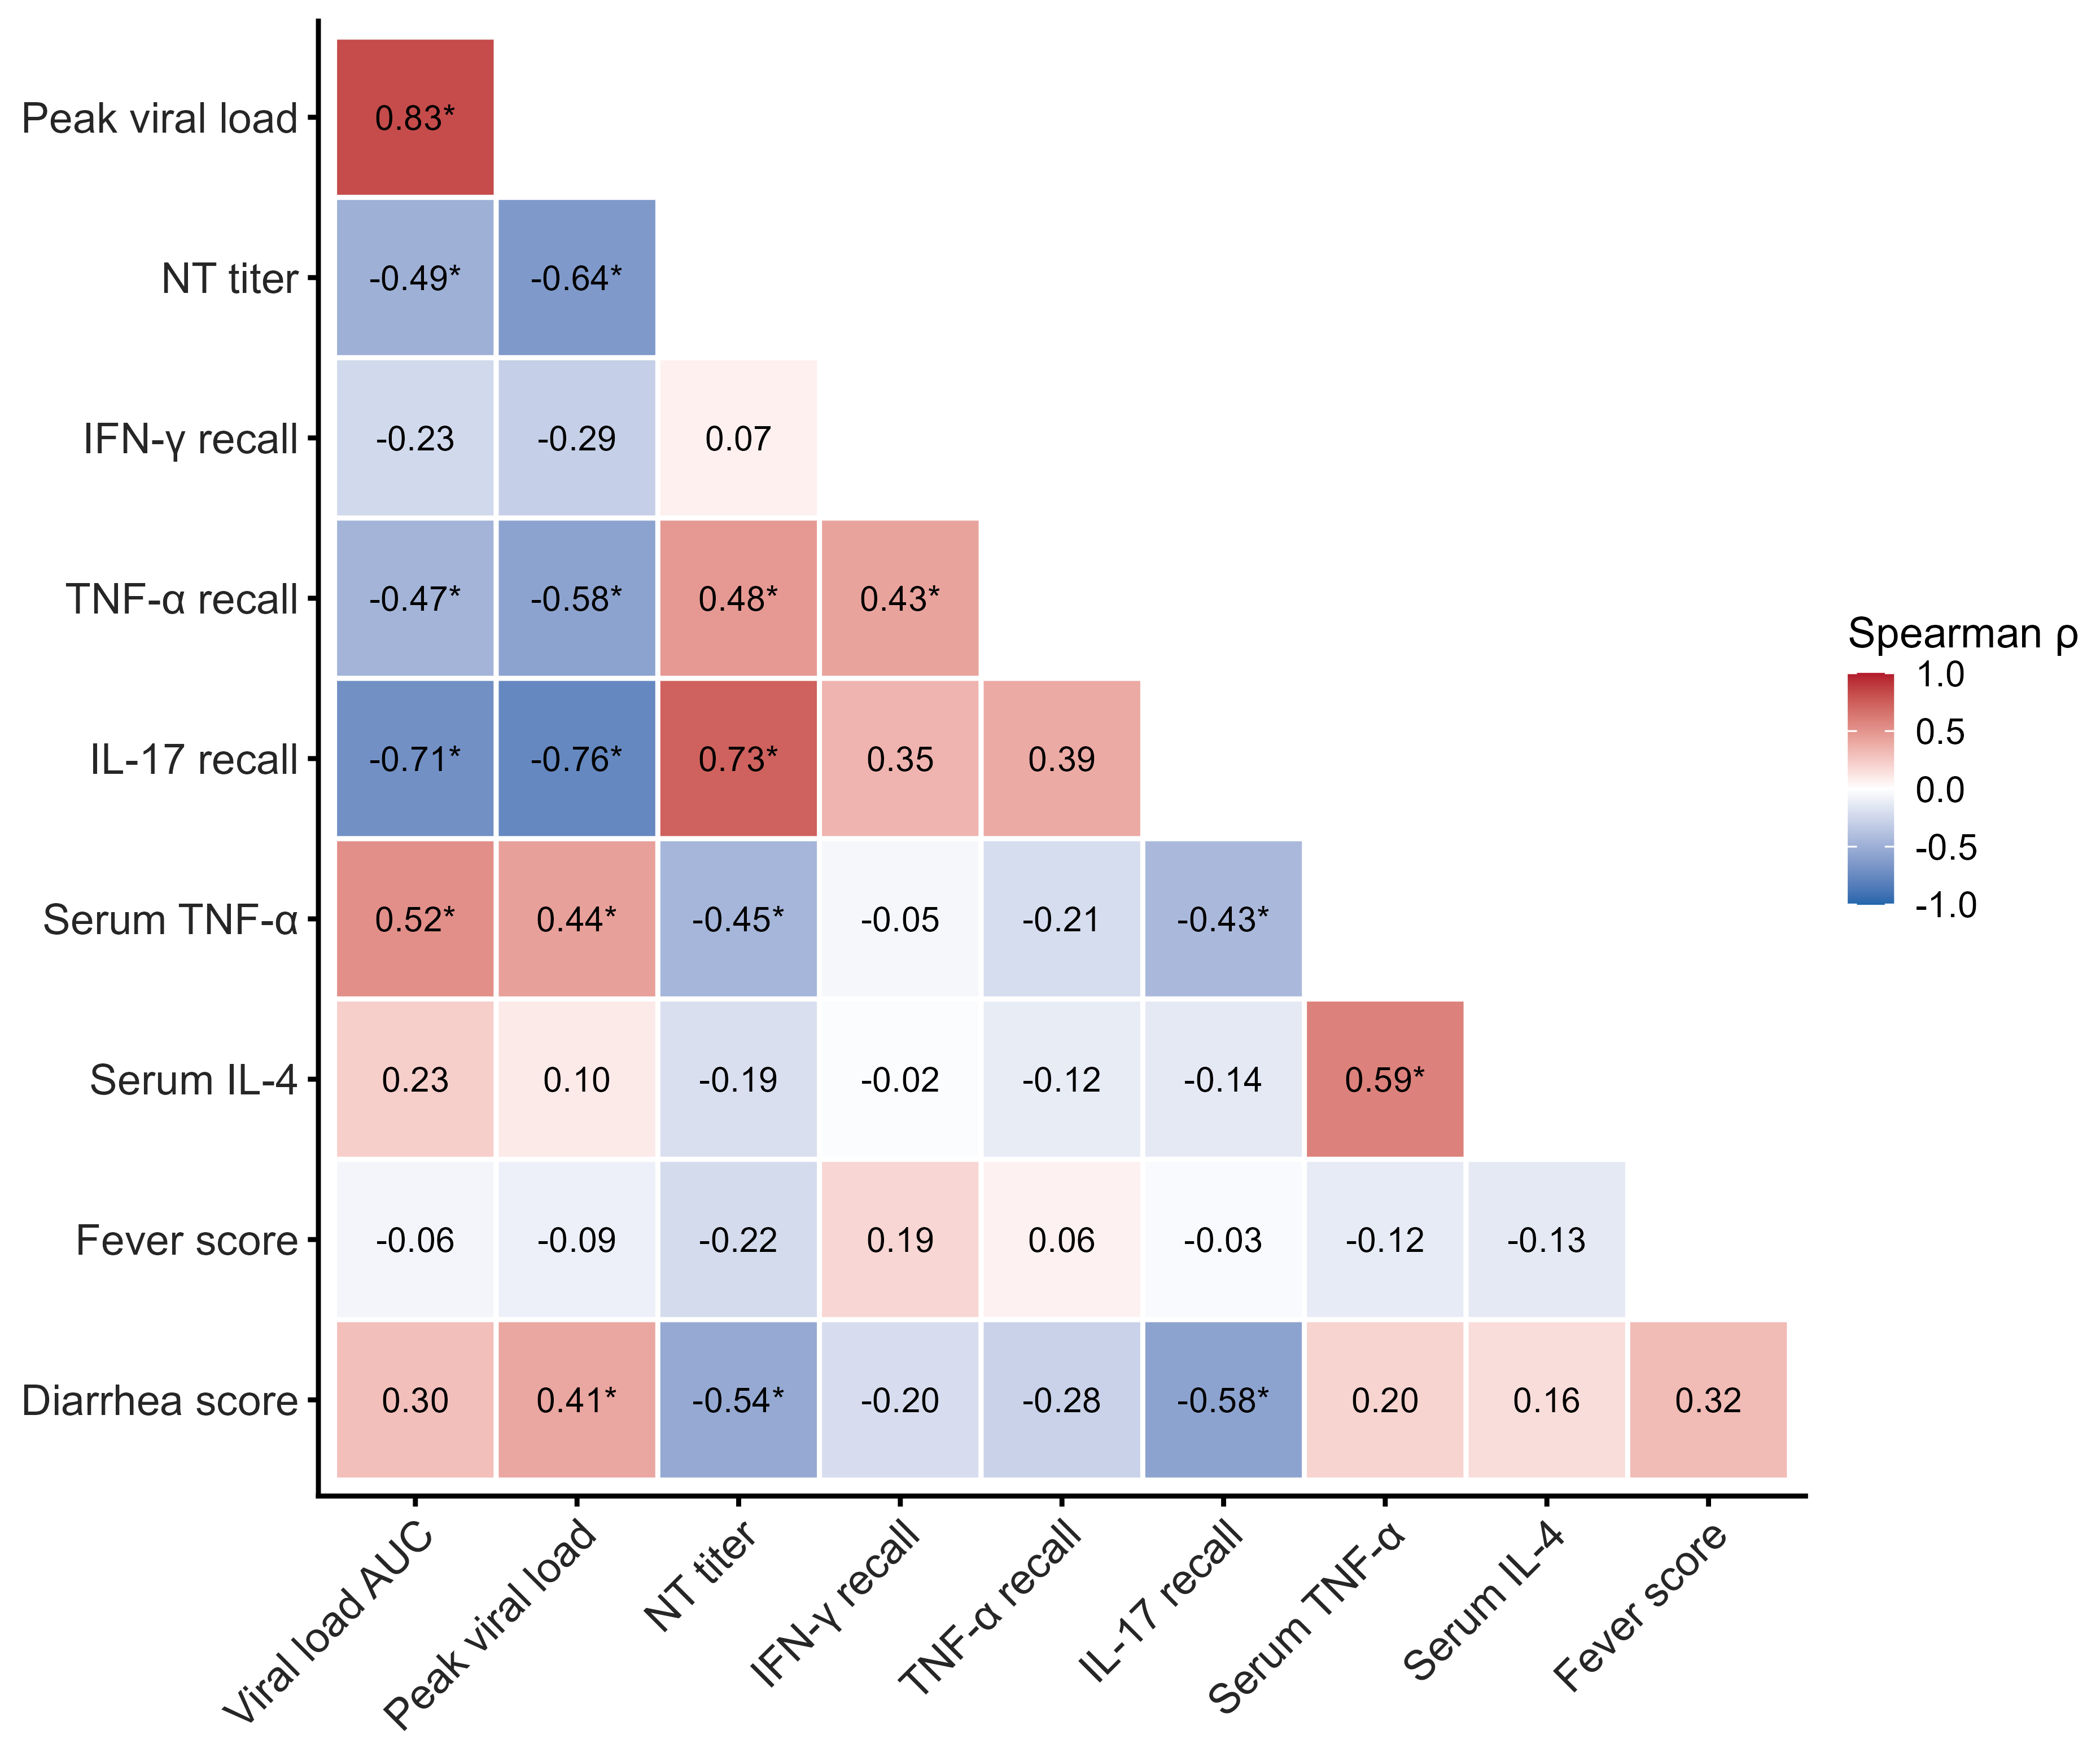
* p < 0.05 (unadjusted).

Figure S6: main associations
