Rectal temperature and lymphocytes
Generated on 2026-09-27 with R version 4.6.0 (2026-04-24 ucrt).

Draft text
Temperature LMM: Time, F30,540 = 10.70, p < 0.001; group × time, F120,540 = 2.45, p < 0.001; group, F4,18 = 0.23, p = 0.919.
Day 8: One-way ANOVA, F4,18 = 17.13, p < 0.001. Tukey vs commercial: 25 µg - Commercial, p < 0.001; 50 µg - Commercial, p < 0.001; 100 µg - Commercial, p < 0.001. Among recombinant doses: all p > 0.9.
Day 8 control: Control (n = 2): 39.90 ± 1.70 °C (mean ± SD).
Fever ≥ 39.2 °C on day 8: Recombinant 0/18 vs commercial 3/3 (Fisher, p < 0.001).
Temperature > 40 °C, whole period: Recombinant 3/18 vs commercial 3/3 (Fisher, p = 0.015).
Post-vaccination, first dose: > 40 °C: recombinant 2/18 vs commercial 3/3 (Fisher, p = 0.008).
Post-vaccination, booster: > 40 °C: recombinant 7/18 vs commercial 3/3; sustained fever: recombinant 3/18 vs commercial 1/3.

Mixed models (temperature)
Dataset | Effect | NumDF | DenDF | F_value | p
Challenge | Group | 4 | 18 | 0.23 | 0.9192
Challenge | Time | 30 | 540 | 10.70 | < 0.0001
Challenge | Group × time | 120 | 540 | 2.45 | < 0.0001
First dose | Group | 4 | 18 | 3.03 | 0.0449
First dose | Time | 9 | 162 | 37.36 | < 0.0001
First dose | Group × time | 36 | 162 | 2.17 | 0.0006
Booster | Group | 4 | 17 | 1.91 | 0.1553
Booster | Time | 4 | 68 | 27.65 | < 0.0001
Booster | Group × time | 16 | 68 | 0.83 | 0.6515

Sensitivity: CAR(1) within-animal correlation (challenge)
Effect | numDF | denDF | F_value | p | Phi
Grupo | 4 | 18 | 0.10 | 0.9824 | 0.006
TimeF | 30 | 540 | 3.29 | < 0.0001 | 0.006
Grupo:TimeF | 120 | 540 | 2.44 | < 0.0001 | 0.006

Day 8: Tukey comparisons
Contrast | Estimate | t | p
Control - 25 µg | 1.41 | 3.32 | 0.0272
Control - 50 µg | 1.55 | 3.37 | 0.0246
Control - 100 µg | 1.49 | 3.49 | 0.0192
Control - Commercial | -1.10 | -2.27 | 0.1995
25 µg - 50 µg | 0.14 | 0.41 | 0.9936
25 µg - 100 µg | 0.07 | 0.25 | 0.9990
25 µg - Commercial | -2.51 | -6.87 | < 0.0001
50 µg - 100 µg | -0.06 | -0.19 | 0.9997
50 µg - Commercial | -2.65 | -6.54 | < 0.0001
100 µg - Commercial | -2.59 | -7.06 | < 0.0001

Incidence by group (Table 4 and post-vaccination)
Dataset | Group | n | ≥39.2 am | ≥39.2 all | >40 | >40 day 8 | ≥39.2 day 8 | Sustained >40
Challenge | Control | 2 | 2 | 2 | 1 | 1 | 1 | 0
Challenge | 25 µg | 7 | 5 | 5 | 2 | 0 | 0 | 0
Challenge | 50 µg | 4 | 3 | 3 | 0 | 0 | 0 | 0
Challenge | 100 µg | 7 | 3 | 5 | 1 | 0 | 0 | 0
Challenge | Comm. | 3 | 3 | 3 | 3 | 3 | 3 | 0
First dose | Control | 2 | 0 | 2 | 0 | 0 | 0 | 0
First dose | 25 µg | 7 | 2 | 7 | 1 | 0 | 0 | 0
First dose | 50 µg | 4 | 3 | 4 | 1 | 0 | 0 | 0
First dose | 100 µg | 7 | 2 | 7 | 0 | 0 | 0 | 0
First dose | Comm. | 3 | 3 | 3 | 3 | 0 | 0 | 1
Booster | Control | 1 | 0 | 1 | 0 | 0 | 0 | 0
Booster | 25 µg | 7 | 2 | 7 | 1 | 0 | 0 | 0
Booster | 50 µg | 4 | 3 | 4 | 3 | 0 | 0 | 1
Booster | 100 µg | 7 | 4 | 7 | 3 | 0 | 0 | 2
Booster | Comm. | 3 | 2 | 3 | 3 | 0 | 0 | 1

Fisher's exact tests (recombinant pooled vs commercial)
Dataset | Outcome | Recombinant | Commercial | p
Challenge | ge_fever_day_peak | 0/18 | 3/3 | 0.0008
Challenge | any_gt_40 | 3/18 | 3/3 | 0.0150
Challenge | any_ge_fever_am | 11/18 | 3/3 | 0.5211
Challenge | sustained_gt_40 | 0/18 | 0/3 | 1.0000
First dose | any_gt_40 | 2/18 | 3/3 | 0.0075
Booster | any_gt_40 | 7/18 | 3/3 | 0.0902
Booster | sustained_gt_40 | 3/18 | 1/3 | 0.4887

Figure 8A–B
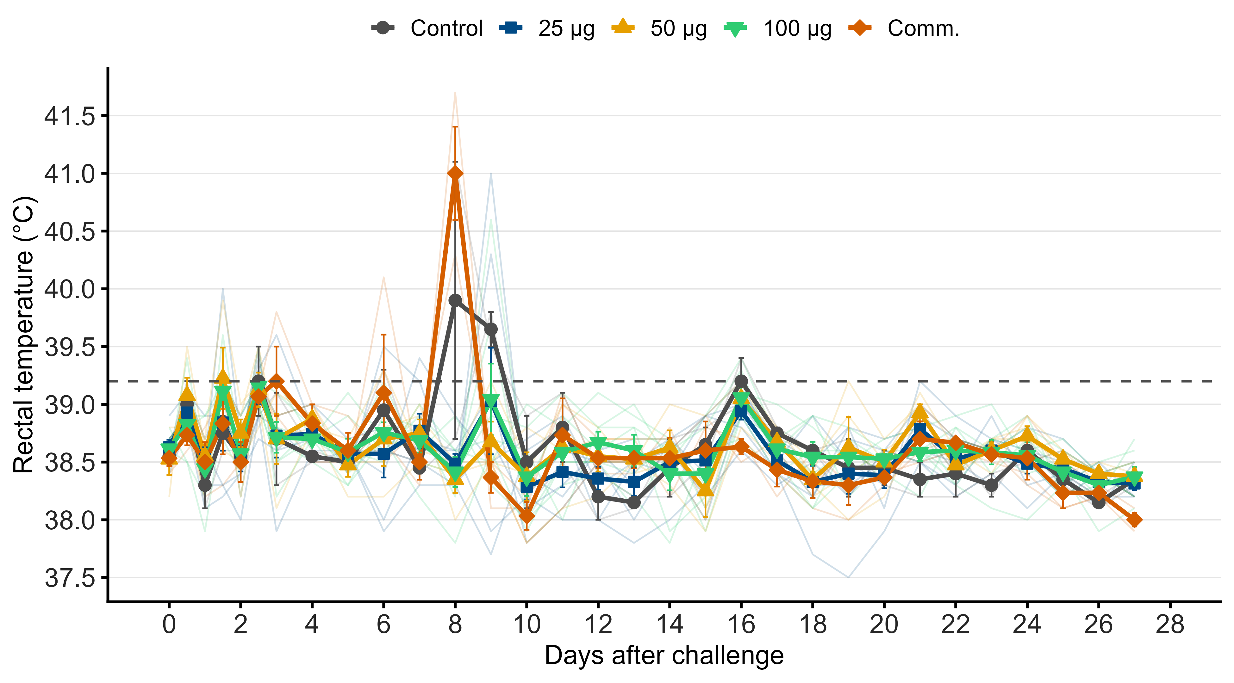
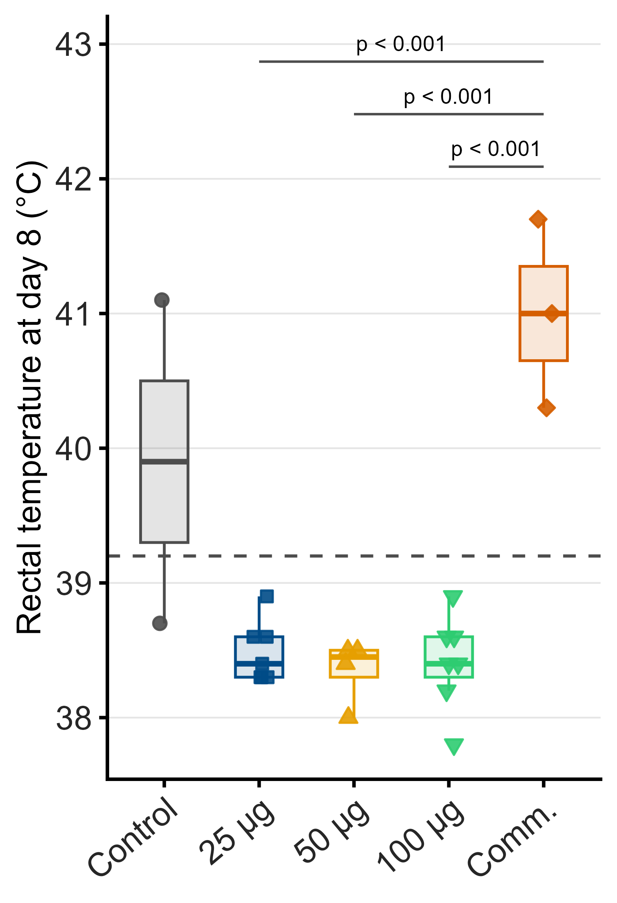

Figure S1: post-vaccination temperature
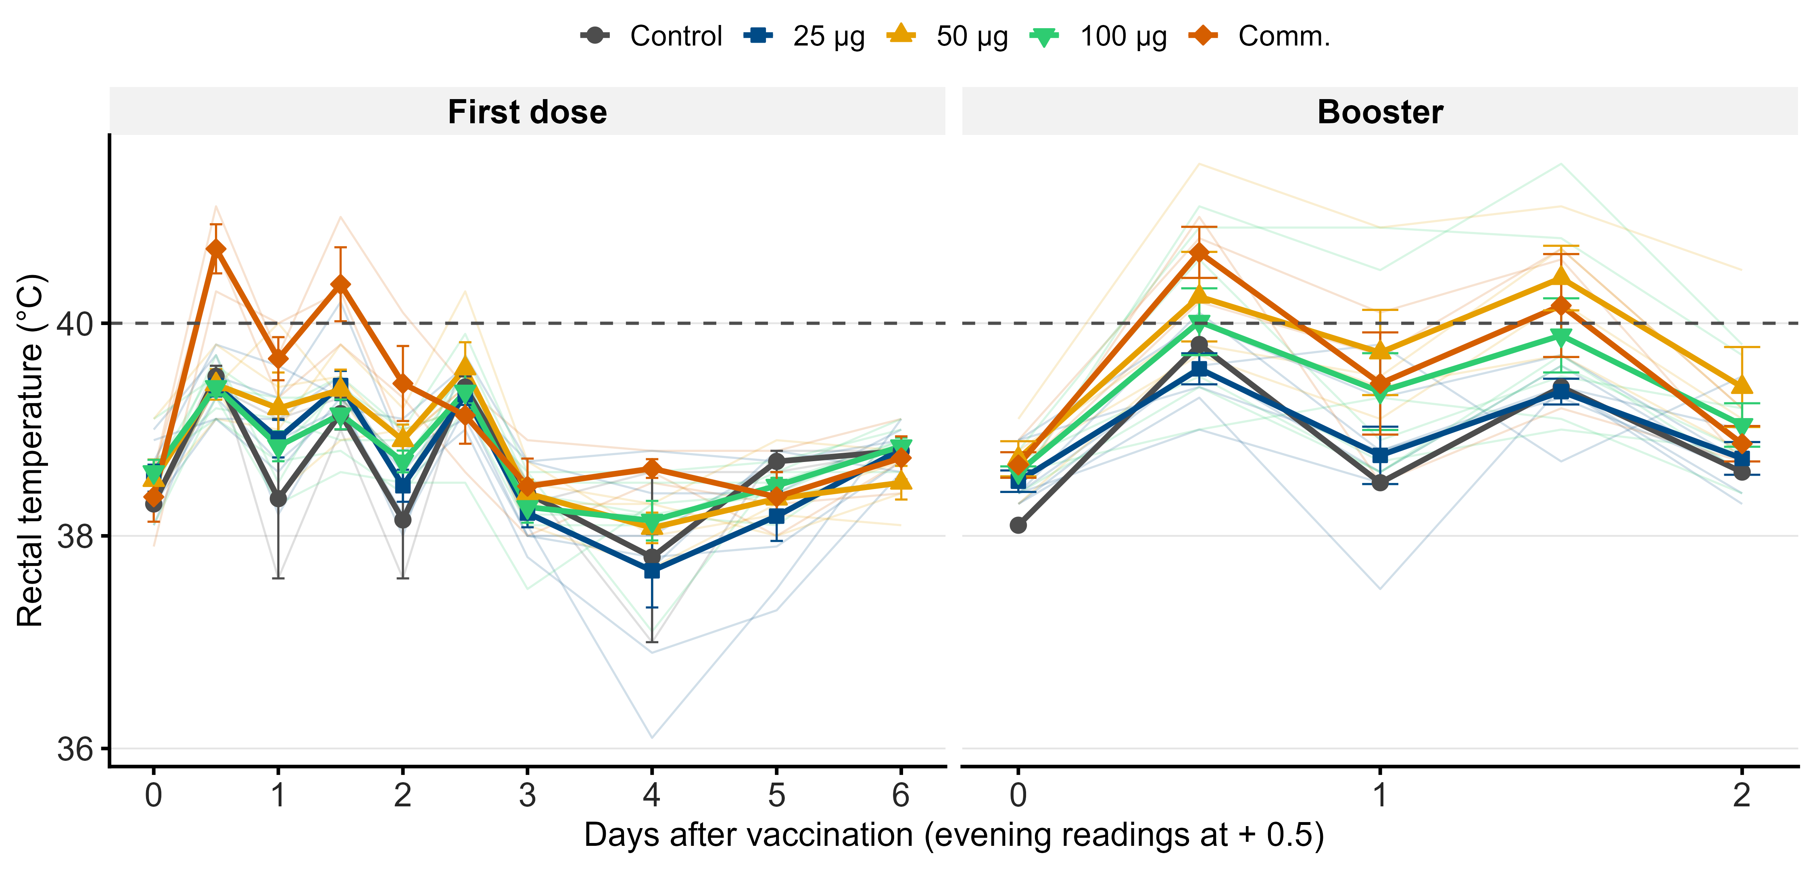

Figure S3: lymphocytes (group means)
