Supplementary Material
Immunogenicity and Post-Challenge Virological and Clinical Outcomes of a Multivalent Recombinant E2 Subunit Vaccine Against Four BVDV-1 Subgenotypes in Calves
Santiago Salazar, Erick Bonilla, Verónica Avello, Eduardo Ramos, Florence Hugues, Ignacio Cabezas, Raquel Montesino
Figure S1. Rectal temperature after vaccination. Rectal temperature after the first dose (day 0 to day 6) and after the booster (day 0 to day 2). Thin lines show individual animals, and thick lines and symbols show group means ± SEM. Morning readings are plotted at whole days and evening readings at +0.5 days. The dashed line marks 40.0 °C. n = 2 (control), 7 (25 µg), 4 (50 µg), 7 (100 µg) and 3 (commercial).
Figure S2. Composite clinical score after challenge. The composite score is the sum of the daily scores for nasal and ocular discharge, cough, dyspnea, behavior, diarrhea, appetite and dehydration (Table 2); rectal temperature was analyzed separately. (A) Daily composite score (mean ± SEM, shown as shaded bands). (B) Cumulative composite score (AUC over 28 days) shown as boxplots (median, IQR, 1.5 × IQR) with individual values; groups were compared with the Kruskal–Wallis test followed by Dunn’s test (BH-adjusted), and no comparison among vaccinated groups reached p < 0.05. (C) Contribution of each sign to the cumulative composite score in each group (percentage of the group total AUC). n = 2 (control), 7 (25 µg), 4 (50 µg), 7 (100 µg) and 3 (commercial).

Figure S3. Peripheral blood lymphocyte counts. Mean lymphocyte counts (× 10⁹ cells/L) per group after the first vaccination (V; days 0, 7, 14 and 22) and after challenge (C; days 0, 3, 6, 14, 21 and 28). The dashed line marks the day of challenge. Only group means were available, so no measure of dispersion is shown and the data are reported descriptively. n = 2 (control), 7 (25 µg), 4 (50 µg), 7 (100 µg) and 3 (commercial).
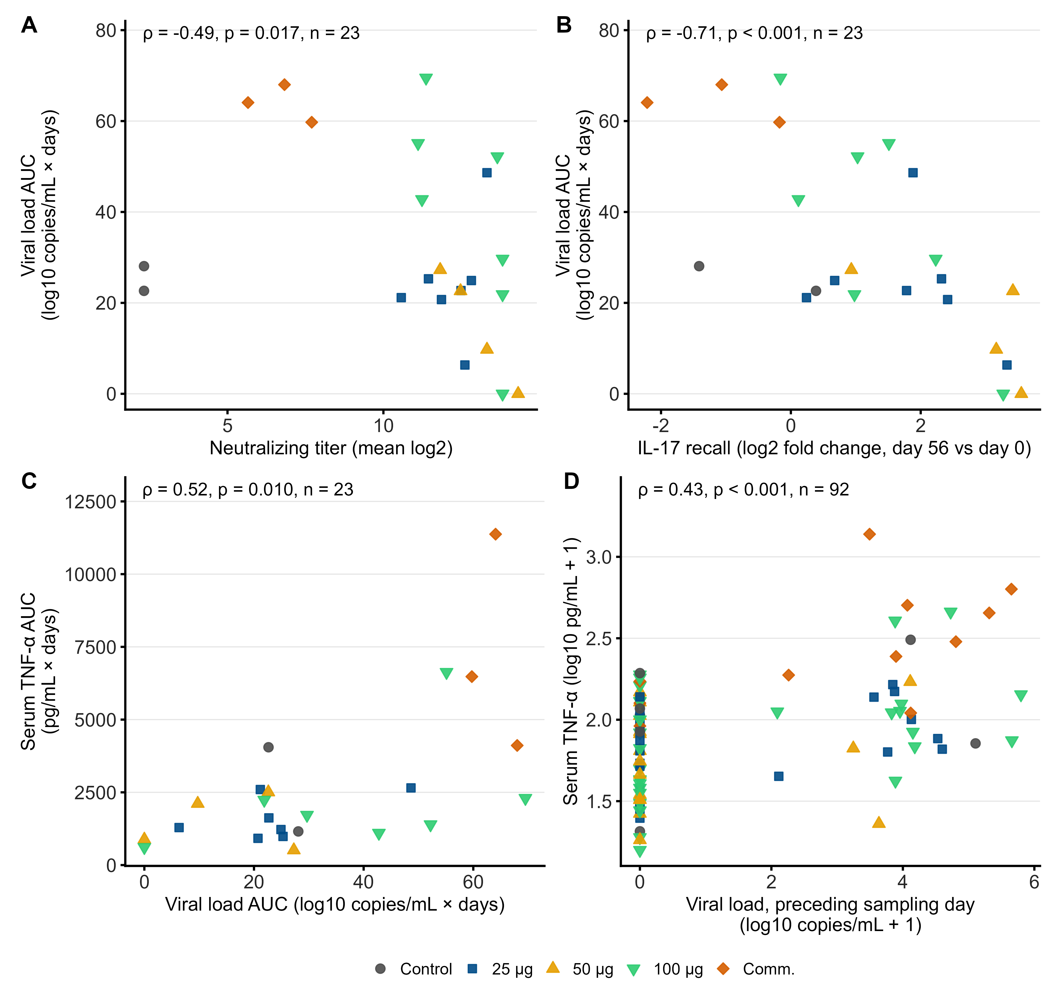
Figure S4. Associations among neutralizing titers, IL-17 recall response, viremia and serum TNF-α. (A) Mean neutralizing titer (log₂ titer against BVDV-1b, 1c, 1d and 1e) versus viral load AUC. (B) IL-17 recall response (log₂ fold change of the net E2-stimulated PBMC concentration at day 56 relative to day 0) versus viral load AUC. (C) Viral load AUC versus serum TNF-α AUC. (D) Serum TNF-α versus viral load at the preceding sampling day, using all animal–time observations (n = 92); because repeated observations from the same animal are not independent, the p-value is approximate. Spearman ρ, p and n are shown in each panel (n = 23 animals in A–C). Viral load is expressed as log₁₀(copies/mL + 1) and its AUC was calculated over days 0–21; serum TNF-α AUC is expressed as pg/mL × days. Symbols indicate the vaccine group.
Figure S5. Spearman correlation matrix of immune, virological and clinical variables. Correlations were calculated per animal in all challenged animals (n = 23). Each cell shows Spearman ρ; the color scale ranges from −1 (blue) to +1 (red), and asterisks indicate unadjusted p < 0.05. Variables: viral load AUC and peak (log₁₀ copies/mL + 1); mean neutralizing titer at day 56 (log₂); IFN-γ, TNF-α and IL-17 recall responses (log₂ fold change of net E2-stimulated PBMC concentrations at day 56 relative to day 0); serum TNF-α and IL-4 AUC after challenge (pg/mL × days, days 0–21); and fever and diarrhea score AUC (days 0–28). BH-adjusted p-values for the prespecified comparisons are given in Tables S1 and S2 and in Section 3.7.

Table S1. Spearman correlations between day-56 neutralizing antibody titers and viremia after challenge (n = 23).
Neutralizing titer (log₂) | Viral load AUC: ρ (95% CI) | p | Adjusted p | Peak viral load: ρ (95% CI) | p | Adjusted p
Mean of the four subgenotypes | −0.49 (−0.79 to −0.08) | 0.017 | 0.029 | −0.64 (−0.83 to −0.32) | 0.001 | 0.004
BVDV-1b | −0.45 (−0.77 to −0.02) | 0.029 | 0.037 | −0.63 (−0.83 to −0.31) | 0.001 | 0.004
BVDV-1c | −0.43 (−0.73 to −0.01) | 0.043 | 0.043 | −0.58 (−0.80 to −0.27) | 0.004 | 0.007
BVDV-1d | −0.46 (−0.76 to −0.03) | 0.027 | 0.037 | −0.63 (−0.82 to −0.31) | 0.001 | 0.004
BVDV-1e | −0.44 (−0.77 to −0.02) | 0.037 | 0.041 | −0.62 (−0.82 to −0.30) | 0.002 | 0.004
95% CI, percentile bootstrap confidence interval (5,000 resamples of animals). Adjusted p, Benjamini–Hochberg adjustment within the family of 10 tests shown in the table. Viral load was analyzed as log₁₀(copies/mL + 1); AUC over days 0–21.
Table S2. Spearman correlations between pre-challenge recall responses and viremia or serum cytokines after challenge (n = 23).
Recall response | Outcome | ρ (95% CI) | p | Adjusted p
IFN-γ | Viral load AUC | −0.23 (−0.57 to 0.18) | 0.288 | 0.288
IFN-γ | Peak viral load | −0.29 (−0.61 to 0.10) | 0.173 | 0.207
TNF-α | Viral load AUC | −0.47 (−0.73 to −0.07) | 0.025 | 0.038
TNF-α | Peak viral load | −0.58 (−0.83 to −0.19) | 0.004 | 0.008
IL-17 | Viral load AUC | −0.71 (−0.88 to −0.36) | < 0.001 | < 0.001
IL-17 | Peak viral load | −0.76 (−0.90 to −0.46) | < 0.001 | < 0.001
IFN-γ | Serum IFN-γ AUC | −0.22 (−0.58 to 0.22) | 0.318 | 0.969
IFN-γ | Serum IL-17 AUC | 0.02 (−0.48 to 0.49) | 0.930 | 0.969
IFN-γ | Serum TNF-α AUC | −0.05 (−0.47 to 0.44) | 0.834 | 0.969
IFN-γ | Serum IL-6 AUC | 0.04 (−0.37 to 0.44) | 0.841 | 0.969
IFN-γ | Serum IL-4 AUC | −0.02 (−0.50 to 0.45) | 0.936 | 0.969
TNF-α | Serum IFN-γ AUC | −0.01 (−0.44 to 0.40) | 0.969 | 0.969
TNF-α | Serum IL-17 AUC | 0.03 (−0.51 to 0.48) | 0.901 | 0.969
TNF-α | Serum TNF-α AUC | −0.21 (−0.60 to 0.26) | 0.336 | 0.969
TNF-α | Serum IL-6 AUC | −0.14 (−0.59 to 0.32) | 0.519 | 0.969
TNF-α | Serum IL-4 AUC | −0.12 (−0.56 to 0.32) | 0.598 | 0.969
IL-17 | Serum IFN-γ AUC | 0.15 (−0.33 to 0.60) | 0.498 | 0.969
IL-17 | Serum IL-17 AUC | 0.09 (−0.38 to 0.58) | 0.673 | 0.969
IL-17 | Serum TNF-α AUC | −0.43 (−0.77 to 0.00) | 0.041 | 0.613
IL-17 | Serum IL-6 AUC | −0.30 (−0.66 to 0.11) | 0.165 | 0.969
IL-17 | Serum IL-4 AUC | −0.14 (−0.53 to 0.29) | 0.538 | 0.969
Recall responses are the log₂ fold change of net E2-stimulated PBMC cytokine concentrations (stimulated minus unstimulated) at day 56 relative to day 0, log₂[(day 56 + 1)/(day 0 + 1)]. Serum cytokine AUC was calculated over days 0–21 after challenge (pg/mL × days). 95% CI, percentile bootstrap confidence interval (5,000 resamples of animals). Adjusted p, Benjamini–Hochberg adjustment within each family of tests: recall responses versus viremia (6 tests) and recall responses versus serum cytokines (15 tests).

