SynapCode AI – Business Plan
Date: 2026-03-11
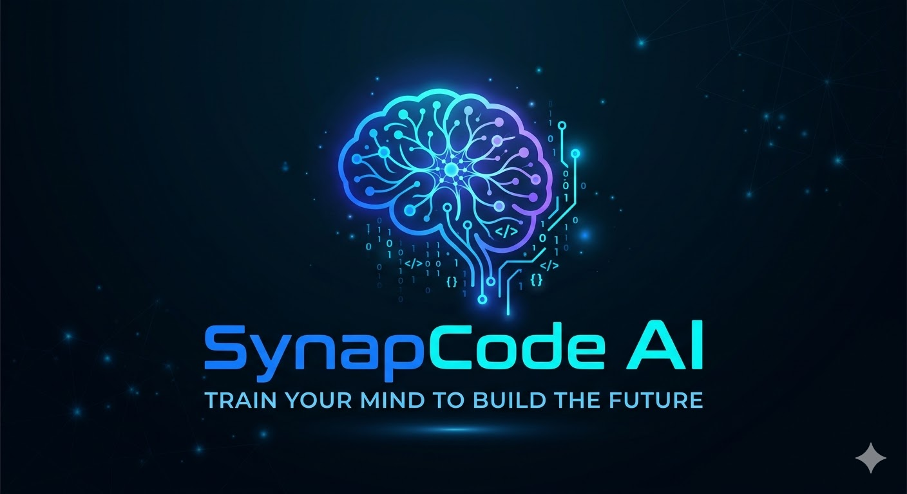

Executive Summary
SynapCode AI is an AI‑powered education platform designed to teach software development and artificial intelligence using personalized learning powered by AI mentors.

Instead of static courses, SynapCode AI uses intelligent agents that adapt learning paths, generate exercises, evaluate code, and guide students through real‑world projects.

Brand Identity
Name: SynapCode AI
Slogan: Train your mind to build the future

Concept:
SynapCode combines the idea of neural synapses with programming code, symbolizing the connection between human intelligence and artificial intelligence.

Vision
To transform global technology education by enabling anyone to learn software development and AI through personalized AI‑driven learning systems.

Mission
To build an intelligent learning platform where AI mentors guide students through adaptive learning paths, coding exercises, and real development projects.

Objectives
General Objective:
Develop a scalable AI‑powered learning platform for programming and artificial intelligence.

Specific Objectives:
• Build AI mentor systems
• Create adaptive learning paths
• Evaluate code automatically
• Provide project‑based learning
• Track student progress with analytics

Market
Target users:
• Beginner developers
• University students
• Career switchers
• Junior developers
• Companies training employees

Revenue Model
Subscription Plans

Basic Plan: $15/month
Pro Plan: $30/month
Enterprise Plan: Custom

Example projection:
1000 users x $20/month = $20,000 monthly revenue

Marketing Strategy
Growth channels:
• YouTube technical content
• TikTok coding tutorials
• Developer communities
• GitHub open‑source projects
• Discord learning community

Financial Estimates
Estimated beta operating costs:

Infrastructure: $100‑250/month
AI API usage: $100‑500/month
Marketing: ~$500/month

Estimated yearly cost: $12k‑$20k

