Module 2- Lesson Plan Model

1.2 Meetings

Level: B1
Duration: 60 minutes
Topic: Vocabulary for meetings
Main objective: By the end of the lesson, the student will be able to understand and use common vocabulary and expressions for participating in a professional sales meeting.

1. Lead-in—Your Experience with Meetings
10 minutes
Start by activating the student's own vocabulary.

The teacher asks:
- How often do you have meetings at work?
- Who usually attends your meetings?
- What types of meetings do you have?
- Do you usually have meetings online or face-to-face?
- What do you usually discuss in sales meetings?
- What makes a meeting successful?
- What problems can happen during a meeting?
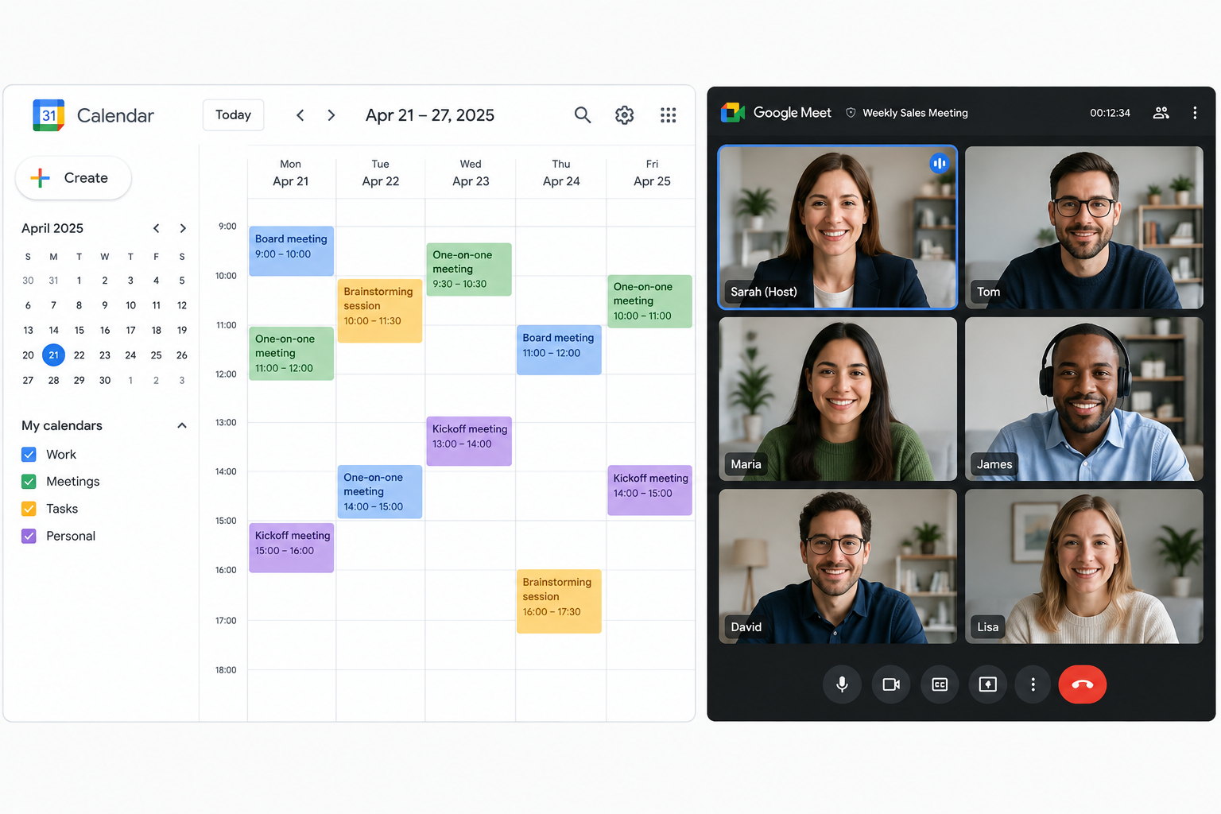
2. Warm-up activity. Ask students to describe the following images. Explain words such as "host," "guests," "brainstorming," "kickoff," etc.

3. Vocabulary Presentation — The Language of Meetings
15/20 minutes
Present the following vocabulary list:

A. Before the meeting

Expression | Meaning
schedule a meeting | arrange a meeting
attend a meeting | go to a meeting
invite someone | ask someone to participate
agenda | list of topics to discuss
meeting objective | what the meeting wants to achieve
prepare for a meeting | get ready for it

B. Starting the meeting
- Let's get started.
- Thanks everyone for joining.
- Let's go over today's agenda.
- The main objective of today's meeting is...
- I'd like to start with...
- Let's begin with...

C. Managing the discussion
- move on to...
- come back to that later
- raise a point
- bring something up
- clarify something
- give an update
- discuss an issue
- ask for clarification

D. Giving opinions
- I think...
- I believe...
- In my opinion...
- From my perspective...
- I agree.
- I agree with you.
- I'm not sure I agree.
- I see your point, but...

E. Sales-specific meeting vocabulary
- customer needs
- sales target
- sales opportunity
- potential client
- proposal
- pricing
- budget
- follow-up
- next steps
- action item
- deadline

4. Vocabulary Practice—Match the Meeting Language
10 minutes

A. Match the expressions with their meanings.
- agenda
- action item
- deadline
- sales target
- follow-up
- clarify
- raise a point
- move on
- proposal
- next steps
a. ___ explain something more clearly
b. ___ a specific task that someone needs to complete
c. ___ a document or plan presented to a potential customer
d. ___ the date by which something must be completed
e. ___ discuss a new point or issue
f. ___ what you will do after the meeting
g. ___ a list of topics for a meeting
h. ___ continue to the next topic
i. ___ a planned contact or communication after a meeting
j. ___ a sales objective

B. Complete the sentences
Use:
agenda – proposal – clarify – action item – sales target – follow-up
- Before the meeting, let's prepare an __________.
- Our main __________ this quarter is to increase sales by 15%.
- Could you __________ what you mean?
- We need to send the customer a new __________.
- One important __________ is to contact the client on Friday.
- I'll send you a __________ email after the meeting.

5. Reading—A Sales Team Meeting
15 minutes
This should be the main contextual input, similar to the “Meeting a New Business Contact” text in Lesson 1. Your first lesson uses a professional situation to introduce the language before moving into vocabulary work.

A Weekly Sales Meeting
It's Monday morning, and the sales team at TechPro is having its weekly meeting. The Sales Manager, Sarah, is leading the meeting. Three Account Managers and a Business Development Executive are also attending.
Sarah: Good morning, everyone. Thanks for joining. Let's get started. The main objective of today's meeting is to review our sales performance and discuss our priorities for this week.
Tom: Sounds good.
Sarah: First, let's look at last week's results. Tom, could you give us an update on your accounts?
Tom: Sure. I contacted five potential clients last week. Two of them are interested in our software solution. I'm planning to schedule another call with them this week.
Sarah: Great. What about the other three?
Tom: Two aren't ready to buy yet, and one client asked for more information about our pricing.
Sarah: Okay. Let's come back to pricing later. Maria, could you tell us about your biggest sales opportunity?
Maria: Yes. I'm working with a company that needs a new CRM system. They like our proposal, but they're concerned about the budget.
Sarah: I see. Do you think we can offer them a different package?
Maria: I think we could. From my perspective, a smaller package could be a good solution.
Sarah: I agree. Let's discuss that after the meeting. Now, let's move on to this week's priorities.
Tom: Can I raise a point?
Sarah: Of course.
Tom: I think we need to follow up with some of our older leads. We haven't contacted them recently.
Sarah: Good point. Let's make that an action item. Tom, could you prepare a list of the leads we need to contact?
Tom: Sure.
Sarah: Great. So, to summarize, our priorities are following up with old leads, contacting new prospects, and preparing the new proposal. Let's meet again on Friday to review our progress.

A. Reading Comprehension
- Who is leading the meeting?
- What is the main objective of the meeting?
- How many potential clients did Tom contact?
- What information does one client want?
- What problem does Maria's potential client have?
- What solution does Maria suggest?
- What point does Tom raise?
- What action item does Sarah give Tom?
- What are the team's three priorities?
- When will the team meet again?

6. Vocabulary in Context
10 minutes
Ask the student to find examples from the text.

Find expressions for:
- Starting a meeting
→ ______________________________
- Stating the objective
→ ______________________________
- Asking someone for an update
→ ______________________________
- Moving to another topic
→ ______________________________
- Asking for someone's opinion
→ ______________________________
- Giving an opinion
→ ______________________________
- Introducing a new point
→ ______________________________
- Agreeing with someone
→ ______________________________
- Assigning an action item
→ ______________________________
- Summarizing a meeting
→ ______________________________
This follows the same approach you used in Lesson 1, where the student extracts useful professional expressions directly from the dialogue.
If there’s extra time, I suggest doing a roleplay activity, where students can pretend they arrange a meeting and use the vocabulary learned in class.

7. Wrap-up & Feedback
5 minutes
The teacher gives feedback on:
- Grammar accuracy
- Vocabulary
- Pronunciation
- Fluency
- Professional register

