SCREENSHOTS FOR JAVA ABOUT CONNECTION WITH DATA BASE

- BasicConnection

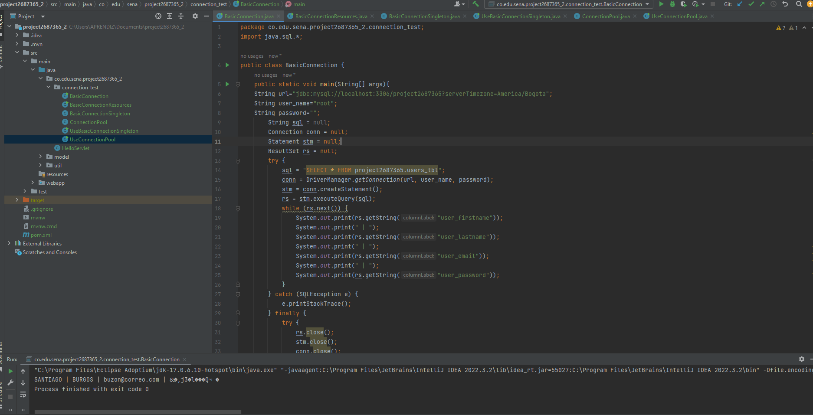

- BasicConnectionResources

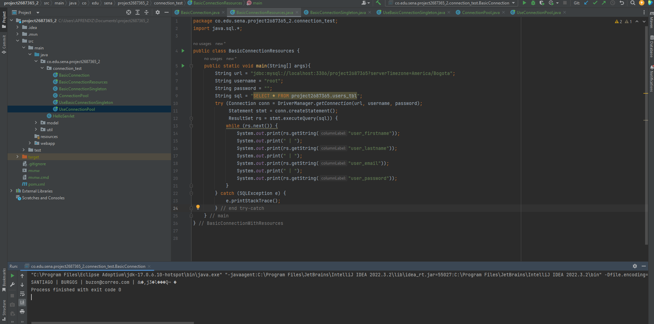

- BasicConnectionSingleton

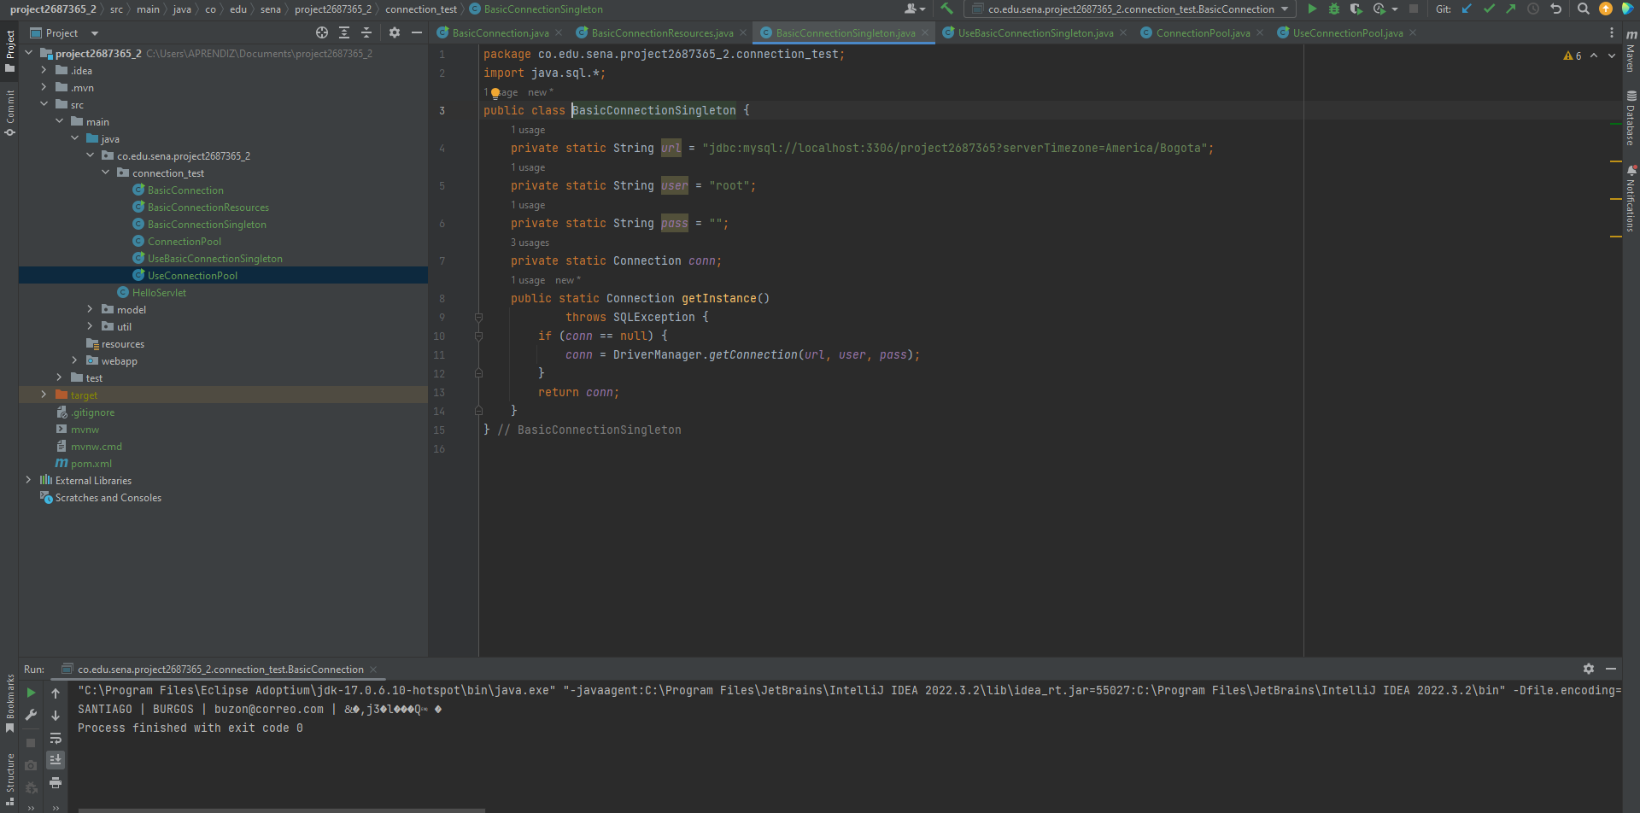

- UseBasicConnectionSingleton

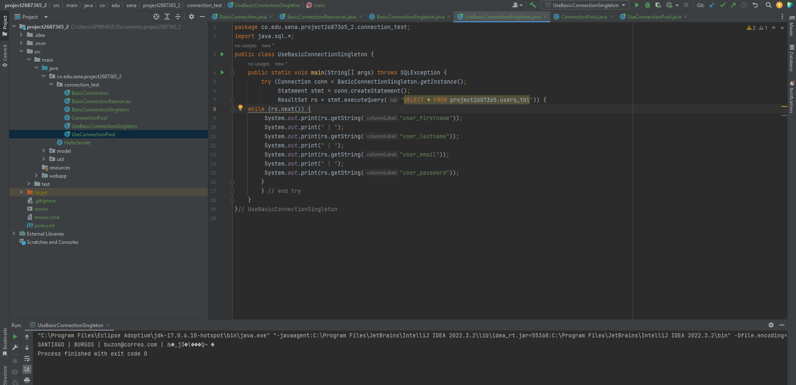

- ConnectionPool

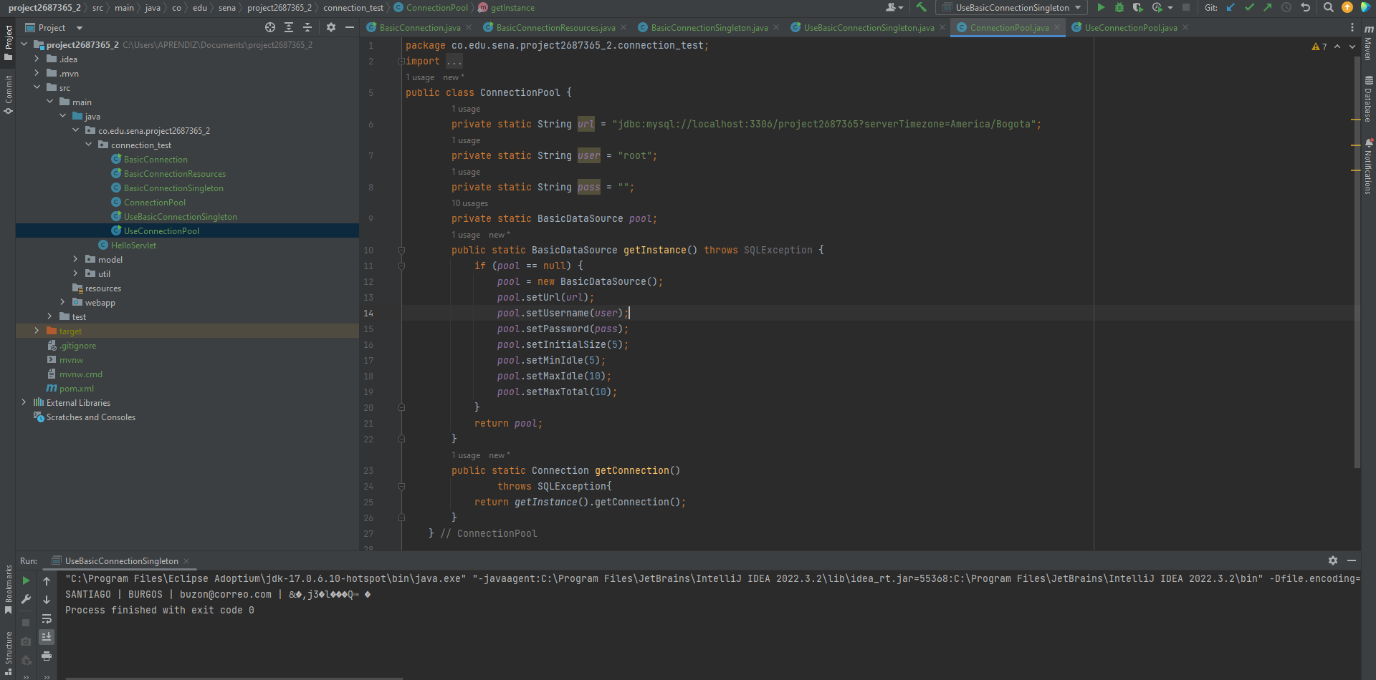

- UseConnectionPool

