**Student name: Santiago Trujillo Zuluaga**

**https://www.linkedin.com/in/santiagotrujilloz/**

**Objective**: create a smart contract to track universities properly registered by the ministry of education on the blockchain and test it on a local ganache network.

**Tools used:** Solidity, Ganache, Remix IDE.

**DESCRIPTION**

It is becoming increasingly difficult to locate illegal universities that offer education services, with this program you can verify that the university where you enroll is properly registered as an institution in your country.

**Background of the problem statement:**

In many countries around the world, there are illegal universities that are not affiliated with any government educational institution. Many students enroll in these universities unknowingly and, in turn, end up without jobs or the universities are closed after some time, which ruins their career.

An immutable solution, such as Blockchain, is needed where all the faculties of a university are registered as blockchain to ensure that no one can modify any old registration. That same solution should make it possible to ban any university from registering new students in case there is any complaint against that university. Subsequently, the ban would be removed once the university resolved all complaints.

**WHAT I WOULD CHANGE?**

I would change to the smart contract, the feature that when registering each student, the student provides his unique ETH address to have an identity instead of his name(string), adding it to a mapping of address => students and inside the Student structure add the address and leave the string, example:

From this:

To this:

1. Smart contract deployment

**Admin Address (Minister of education)**: 0xB8Fa92A5d451d7Ee69b368c0c65d411B98101371

**Contract address**: 0xfE924377877927DecDe4a97679a823e899f41Cd5

Remix IDE

Ganache / TX Hash: 0x4051c6485d5025942eb8bffde379f3a4ccb0ff91bc1dab60c82b5631ee6cbbde

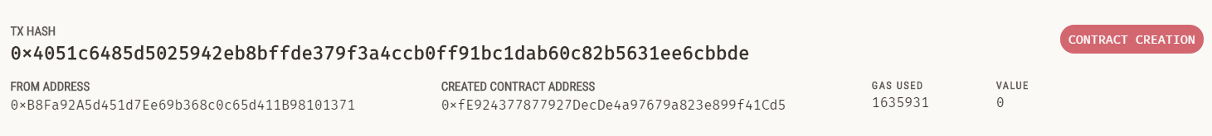

2. Functions

We have 5 functions that can register new data on the blockchain and 5 functions that only call data from the blockchain (public view returns).

3.1 Adding 2 new colleges

3.1.1 Simplilearn university address: 0x3F74280c7f45f443Ed6e5b8470d4aBa85BB50BcD

3.1.2 Simplilearn university cAdmin address: 0x47ee903Ad17Aaa8AA0620C6305432F8bbA176E71

TX Hash: 0x036334861417149bfb631ce1a90f1706fd2f6e16757d5cfb5a33aca71eff01cb

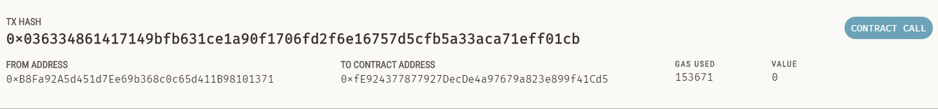

3.1.3 ETH University address: 0xfA8DC2a9aAb9FB50b51809C62C2009237cA04996

3.1.4 ETH university cAdmin address: 0x5c49325463d1f1F68791b820b9a6148eEa76EE77

TX Hash: 0xaed846c5f8a2e999f58d90e48e5980effc717851be6aa9c0cc85807575884468

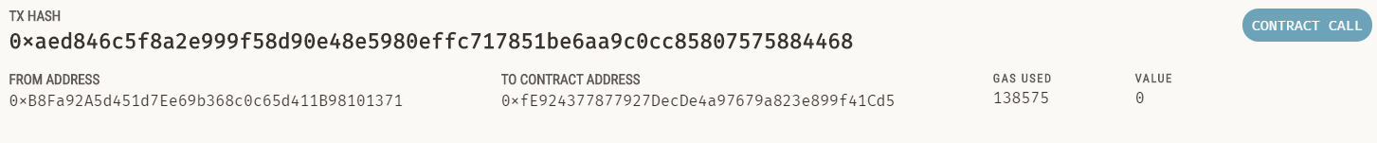

4. Adding students to colleges

4.1 Adding student “Santiago” to Simplilearn university

-Simplilearn university address: 0x3F74280c7f45f443Ed6e5b8470d4aBa85BB50BcD

-Simplilearn university cAdmin address: 0x47ee903Ad17Aaa8AA0620C6305432F8bbA176E71

TX HASH: 0x0914261c02cd185c1bdc911b3c5f410448a3a78f1c87a3eed8a2dd89c4d78b9b

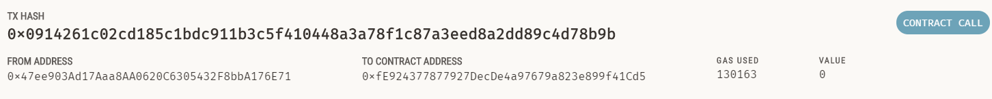

4.2 Adding student “Juan” to ETH University

ETH University address: 0xfA8DC2a9aAb9FB50b51809C62C2009237cA04996

ETH university cAdmin address: 0x5c49325463d1f1F68791b820b9a6148eEa76EE77

TX HASH: 0x68487866d4d534ae2eb3099d8fe6074d4511bfa6762edc238b129079a9b6b844

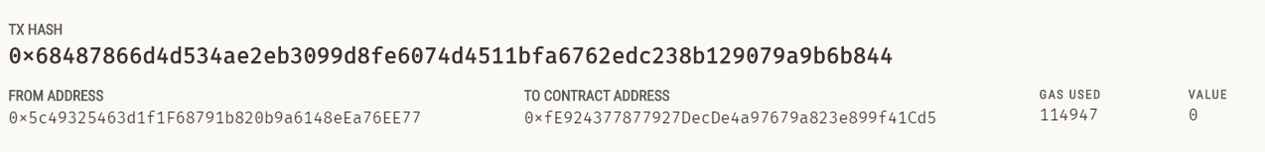

5.1 Block Simplilearn university from adding new students

- **Admin Address (Minister of education)**: 0xB8Fa92A5d451d7Ee69b368c0c65d411B98101371

-Simplilearn university address: 0x3F74280c7f45f443Ed6e5b8470d4aBa85BB50BcD

**TX HASH**: 0xd1f90e9540c355fe4741b05ea57a7203e8e958c51ae1a21b61bd1f44451890f9

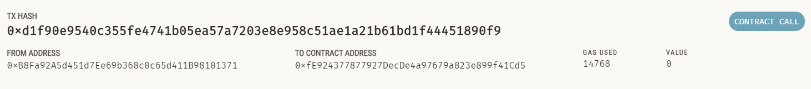

6.1 Changing student course Juan, from Marketing to Java course

ETH University address: 0xfA8DC2a9aAb9FB50b51809C62C2009237cA04996

ETH university cAdmin address: 0x5c49325463d1f1F68791b820b9a6148eEa76EE77

TX HASH: 0x9aa3f38d6ca1e299d33aa2271f2573fc216d652f3251840a7eb65611c8f0fe25

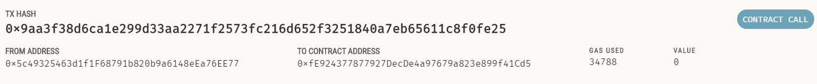

7.1 Unblocking Simplilearn university from adding new students

- **Admin Address (Minister of education)**: 0xB8Fa92A5d451d7Ee69b368c0c65d411B98101371

-Simplilearn university address: 0x3F74280c7f45f443Ed6e5b8470d4aBa85BB50BcD

TX HASH: 0x4f2c204e83c1256ccd81564f64dd6857c6d1c4c8157c9ecef28699feb3f52112



8.0 Calls **FROM RANDOM WALLET:** 0xf6EA75e2ecfd6457D7968F4cF757bC6084110021

8.1 Call number of students for Simplilearn university: 0x3F74280c7f45f443Ed6e5b8470d4aBa85BB50BcD

8.2 Call number of students for ETH University: 0xfA8DC2a9aAb9FB50b51809C62C2009237cA04996

8.3 Total number of colleges

8.4 Total number of students

8.5 View college details for Simplilearn University: 0x3F74280c7f45f443Ed6e5b8470d4aBa85BB50BcD

(Name, registration number, number of students)

8.6 View college details for ETH university: 0xfA8DC2a9aAb9FB50b51809C62C2009237cA04996

(Name, registration number, number of students)

8.7 View student details for Santiago

8.8 View student details for Juan

