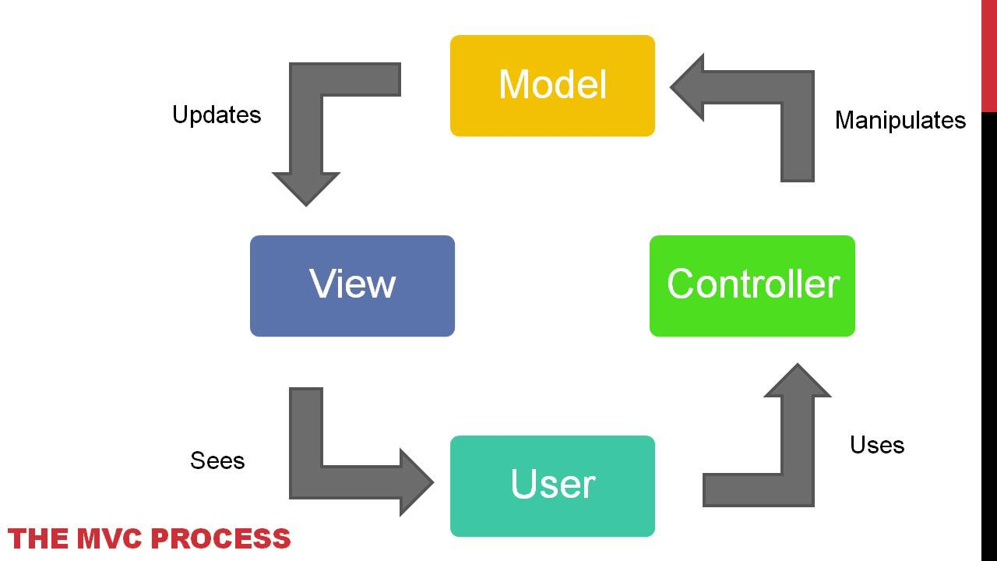

Controller Files:

/server.js

Controller/Config/connection.js

Controller/Config/orm.js

Controller/x_controller.js

Model Files:

Models/x.js

Db/schema.sql

Db/seeds.sql

View files:

View/layout/main.handlebars

View/index.handlebars

Where do assets/css and assets/js and assets.img go?