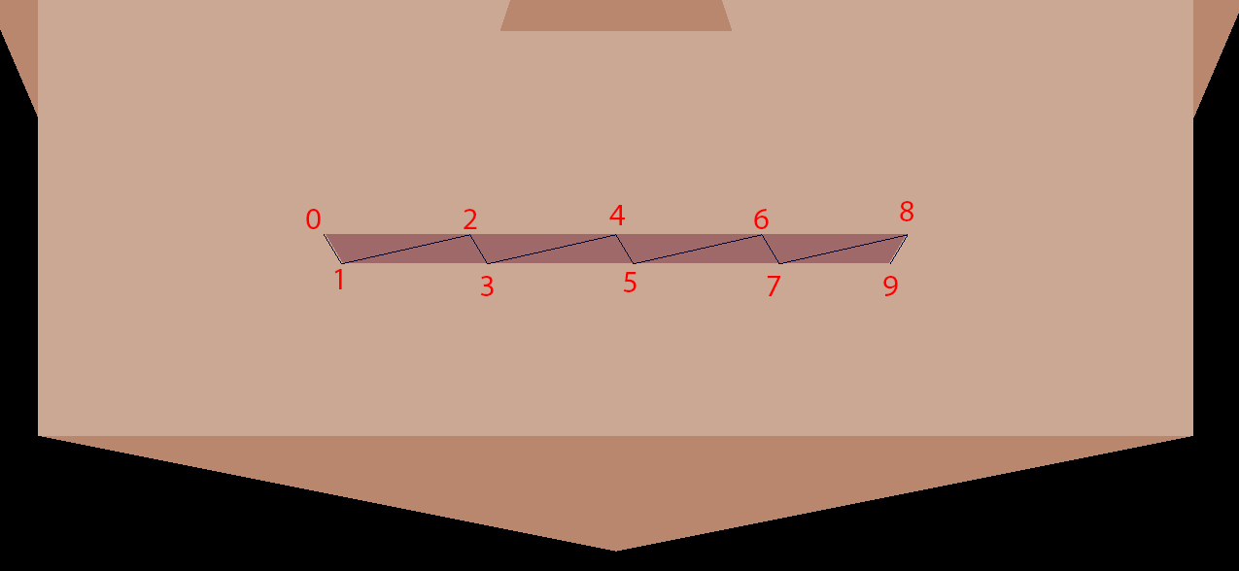

|  |  |  |  |  |
| --- | --- | --- | --- | --- |
| **BOCA** | | | | |
| **Vértice** | **Triangulo** | | | **Sentido de los vértices** |
| 0 | Ninguno | | | |
| 1 | Ninguno | | | |
| 2 | 0 | 1 | 2 | Antihorario |
| 3 | 1 | 2 | 3 | Horario |
| 4 | 2 | 3 | 4 | Antihorario |
| 5 | 3 | 4 | 5 | Horario |
| 6 | 4 | 5 | 6 | Antihorario |
| 7 | 5 | 6 | 7 | Horario |
| 8 | 6 | 7 | 8 | Antihorario |
| 9 | 7 | 8 | 9 | Horario |

Estructura Strip.

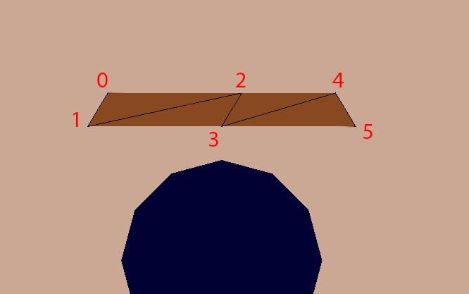

|  |  |  |  |  |
| --- | --- | --- | --- | --- |
| **CEJAS** | | | | |
| **Vértice** | **Triangulo** | | | **Sentido de los vértices** |
| 0 | Ninguno | | | |
| 1 | Ninguno | | | |
| 2 | 0 | 1 | 2 | Antihorario |
| 3 | 1 | 2 | 3 | Horario |
| 4 | 2 | 3 | 4 | Antihorario |
| 5 | 3 | 4 | 5 | Horario |

Estructura Strip.

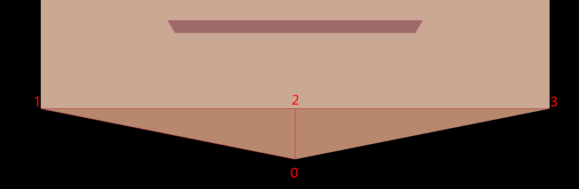

Estructura Fan.

|  |  |  |  |  |
| --- | --- | --- | --- | --- |
| **MENTON** | | | | |
| **Vértice** | **Triangulo** | | | **Sentido de los vértices** |
| 0 | Ninguno | | | |
| 1 | Ninguno | | | |
| 2 | 0 | 1 | 2 | Horario |
| 3 | 0 | 2 | 3 | Horario |

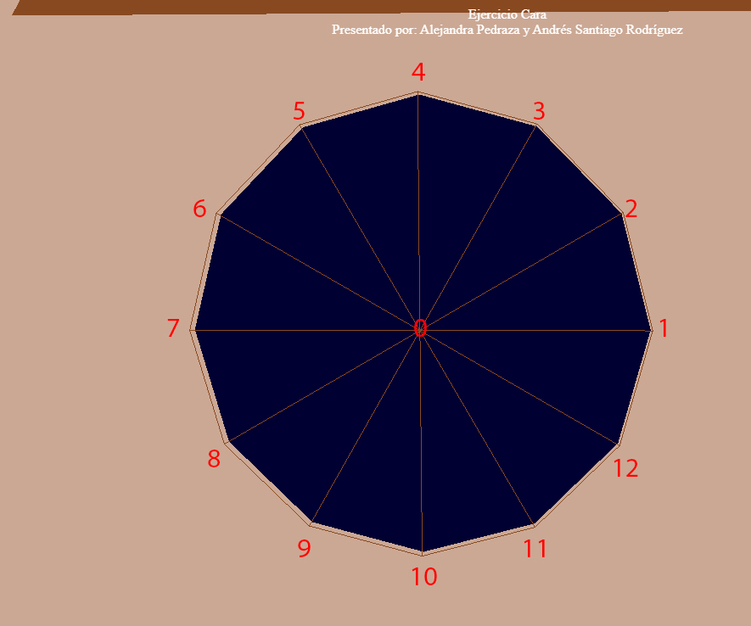

Estructura Fan.

|  |  |  |  |  |
| --- | --- | --- | --- | --- |
| **OJOS** | | | | |
| **Vértice** | **Triangulo** | | | **Sentido de los vertices** |
| 0 | 0 | 12 | 1 | Antihorario |
| 1 | Ninguno | | | |
| 2 | 0 | 1 | 2 | Antihorario |
| 3 | 0 | 2 | 3 | Antihorario |
| 4 | 0 | 3 | 4 | Antihorario |
| 5 | 0 | 4 | 5 | Antihorario |
| 6 | 0 | 5 | 6 | Antihorario |
| 7 | 0 | 6 | 7 | Antihorario |
| 8 | 0 | 7 | 8 | Antihorario |
| 9 | 0 | 8 | 9 | Antihorario |
| 10 | 0 | 9 | 10 | Antihorario |
| 11 | 0 | 10 | 11 | Antihorario |
| 12 | 0 | 11 | 12 | Antihorario |

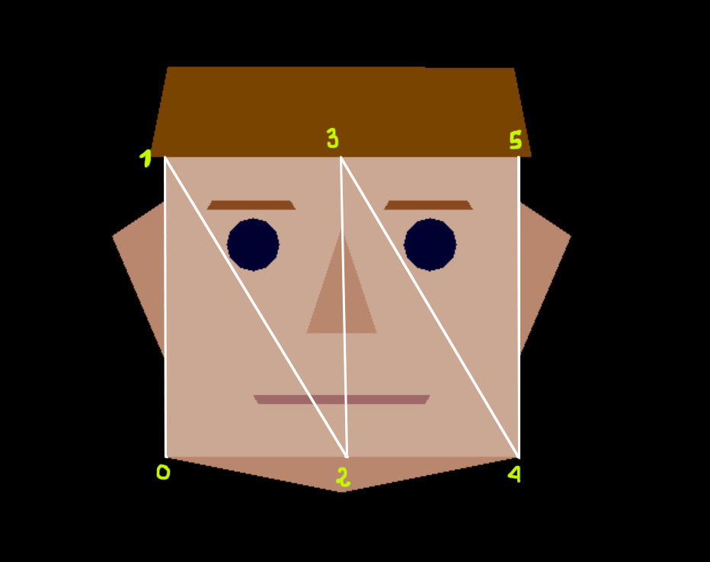

Estructura Strip.

|  |  |  |  |  |
| --- | --- | --- | --- | --- |
| **CARA** | | | | |
| **Vértices** | **Triángulos** | | | **Sentido de los vértices** |
| 0 | Ninguno | | |  |
| 1 | Ninguno | | |  |
| 2 | 0 | 1 | 2 | Horario |
| 3 | 1 | 2 | 3 | Anti horario |
| 4 | 2 | 3 | 4 | Horario |
| 5 | 3 | 4 | 5 | Anti horario |

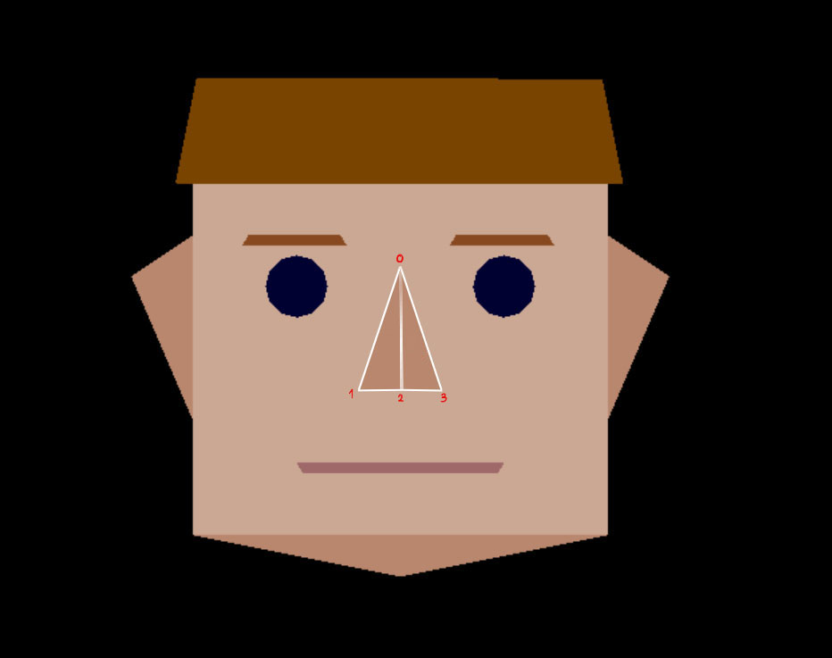

Estructura Fan

|  |  |  |  |  |  |
| --- | --- | --- | --- | --- | --- |
| **NARIZ** | | | | |  |
| **Vértices** | **Triángulos** | | | **Sentido de los vértices** |  |
| 0 | Ninguno | | |  |  |
| 1 | Ninguno | | |  |  |
| 2 | 0 | 1 | 2 | Horario |  |
| 3 | 0 | 2 | 3 | Anti horario |  |

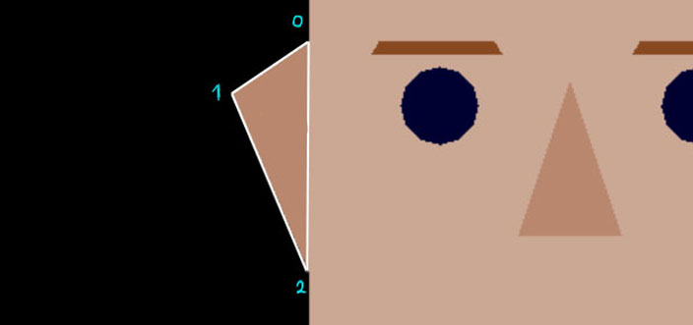

Estructura Fan

|  |  |  |  |  |
| --- | --- | --- | --- | --- |
| **OREJA** | | | | |
| **Vértices** | **Triángulos** | | | **Sentido de los vértices** |
| 0 | Ninguno | | |  |
| 1 | Ninguno | | |  |
| 2 | 0 | 1 | 2 | Anti horario |

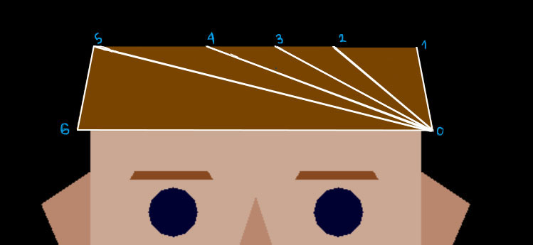

Estructura Fan

|  |  |  |  |  |
| --- | --- | --- | --- | --- |
| **PELO** | | | | |
| **Vértices** | **Triángulos** | | | **Sentido de los vértices** |
| 0 | Ninguno | | |  |
| 1 | Ninguno | | |  |
| 2 | 0 | 1 | 2 | Horario |
| 3 | 0 | 2 | 3 | Anti horario |
| 4 | 0 | 3 | 4 | Horario |
| 5 | 0 | 4 | 5 | Anti horario |
| 6 | 0 | 5 | 6 | Horario |