Simple Future (Predictions)
EXAMPLES EXPRESSING PREDICTIONS:
“In the year 2050, robots will clean our house.”
“People won’t use cellphones in the future.”
“Will you study at a university next year? Yes, I will”
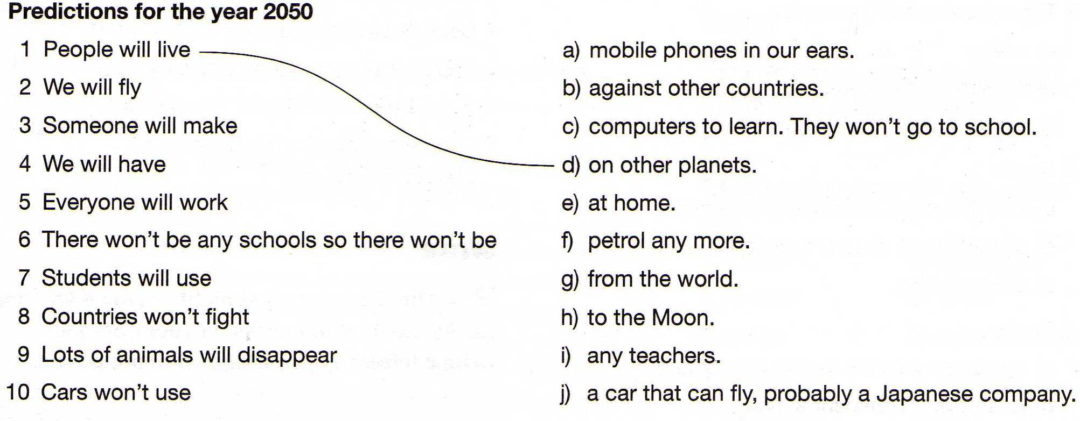
- Match the predictions.

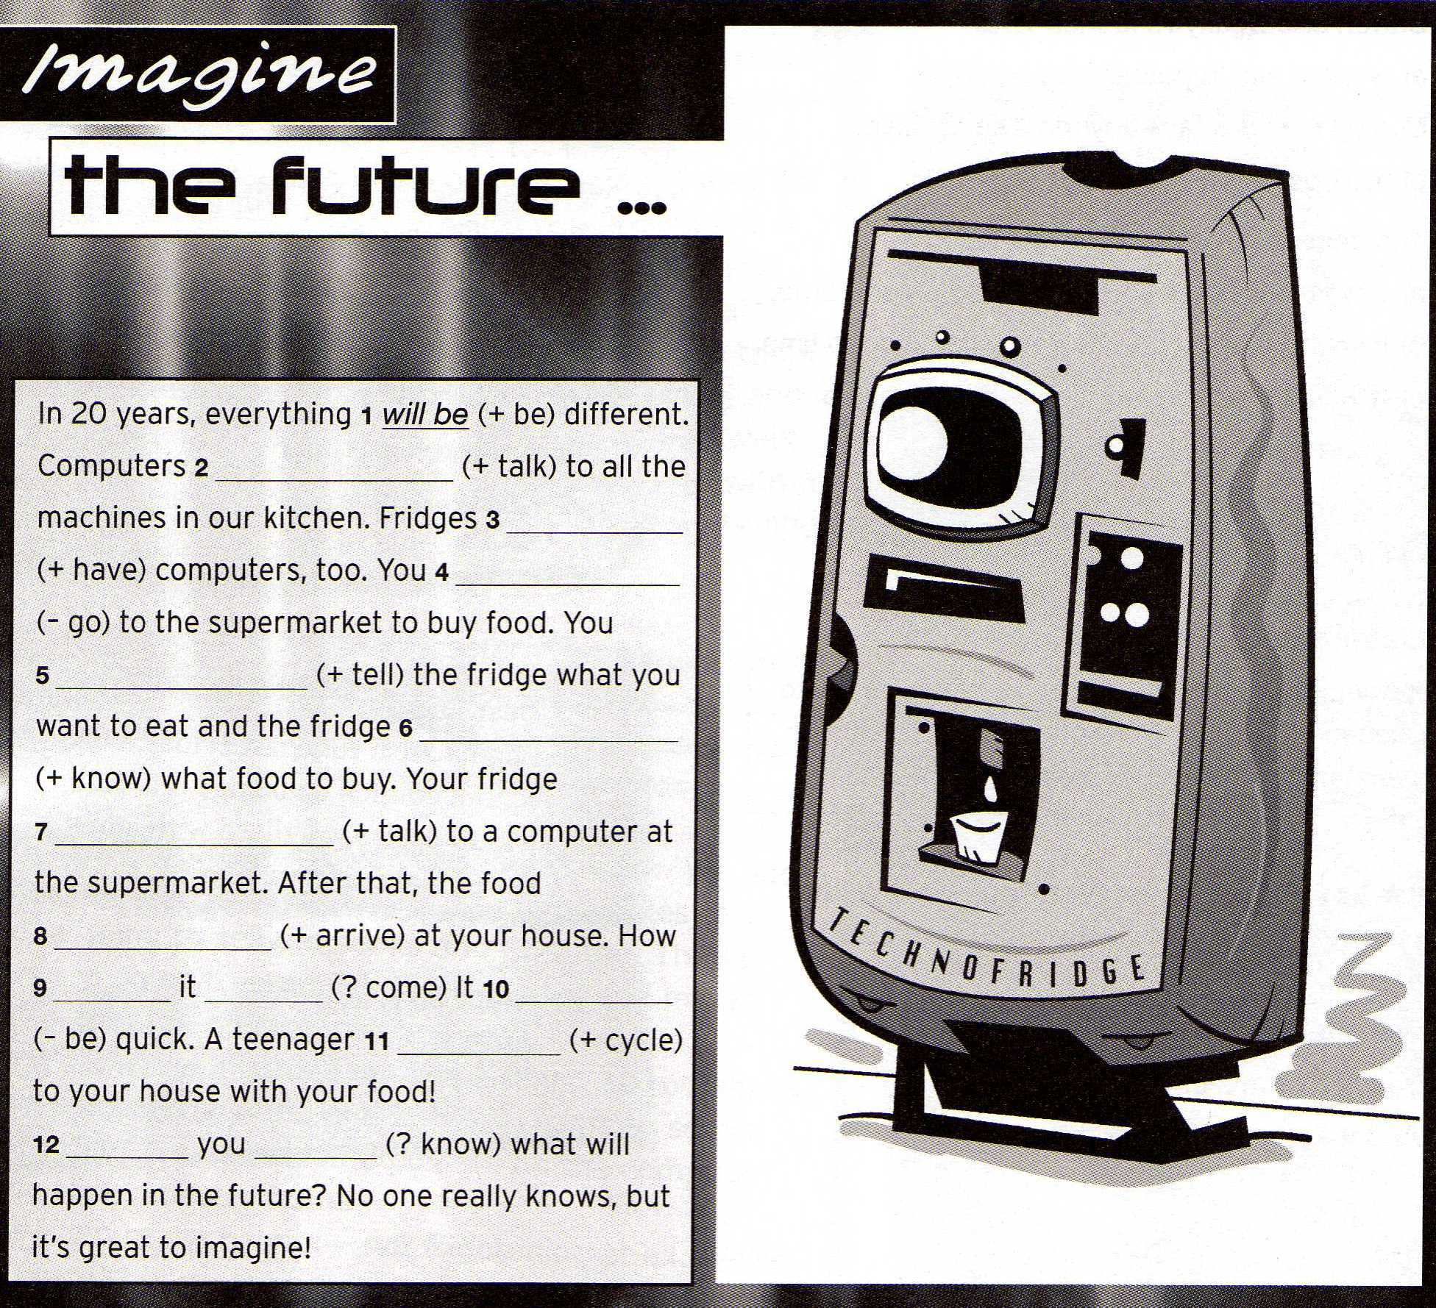
- Complete the text using the verbs in Simple Future.

Will talk
Will have
Will go
Will tell
Will know
Will talk
Will arrive
Will come
Will cycle
Will be
Will
know

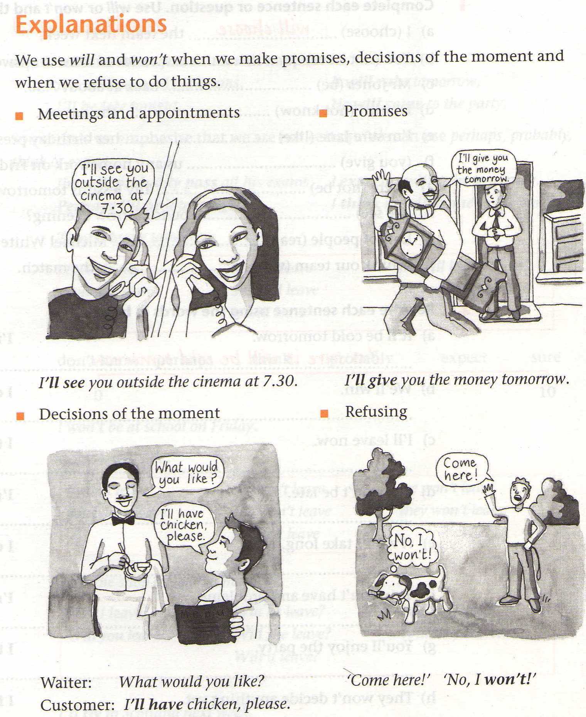

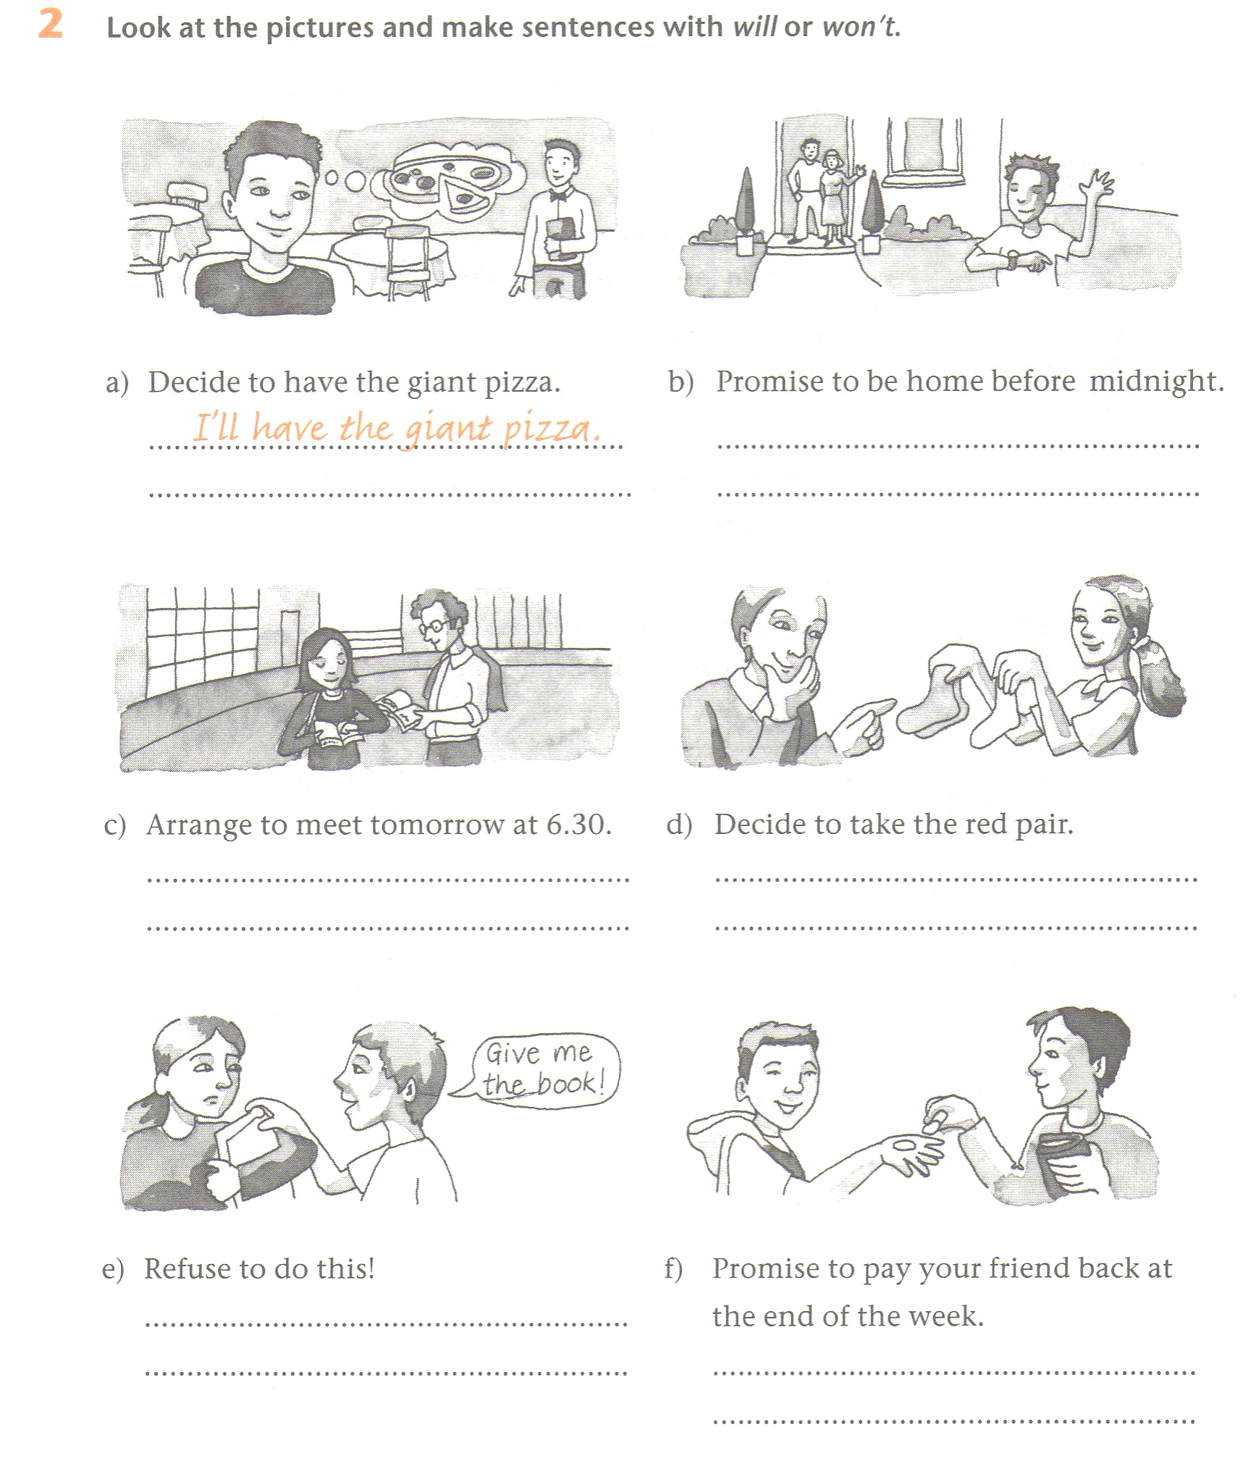

I won’t be at home before midnight

We will meet tomorrow at 6:30
We won’t take the red pair

I won’t refuse to do this
I will pay my friend back at the end of the week

