Online Library
Santiago De Alba Cazares
100002721
SRH University
BST-AMS-12: Advanced Programming
Instructor: Esteban Pozo
Due Date: December 12, 2025

Table of contents
Abstract 3
Introduction 4
Tasks 4
Task 1 4
Task 2 5
Task 3 6
Task 4 6
References 7
Appendix 8
Backend code: 8
GUI code: 10
Connecting backend with frontend: 13
Library dictionary: 17
Photos of the GUI: 35
Test_backend.py 36
Test_frontend.py 36
Test_integration.py 36

Abstract
This document details the development of a online library system, integrating a Flask-based API backend with a PyQt desktop application frontend. The project leverages AI-powered tools, specifically Copilot and ChatGPT, for accelerating the generation of core backend logic, Qt Designer-based GUI components, and the Python integration code facilitating communication between the frontend and backend via HTTP requests.
The implemented system provides comprehensive functionalities for media management, including dynamic search and sorting capabilities across book attributes (name, author, publication year, category), as well as mechanisms for adding new media items, and managing their availability through rental and return operations. All library data is structured as a list of Python dictionaries within an in-memory database. To ensure the reliability and functional integrity of the system, a multi-tiered testing strategy was adopted, encompassing dedicated unit tests for the backend API, initialization validation for the GUI frontend, and end-to-end integration tests confirming seamless data flow and interaction between client and server components.

Introduction

In this project we will see how to create an online library with the use of “Copilot”. Following the tasks given by the teacher, to fulfill all the required point. With the use of a backend with flask and a front end with GUI you will have on display a library where you will be able to search for books, check if they are available or if someone has borrowed it and when did that user borrowed it. Apart from that you will also be able to add more books if wanted and to remove.

Copilot is a conversational, AI-powered assistant that helps boost productivity and streamline workflows by offering contextual assistance, automating routine tasks, and analyzing data. (What Is a Copilot and How Does It Work? | Microsoft Copilot, n.d.)

Tasks

Task 1
The backend needs all the code such as a library to store data, a sorting code for it to find the users input, and all the code for the frontend to work. The frontend in the other hand needs to be simple for the user to interact with it and be able to work with the backend. The frontend and backend communicate by HTTP requests, meaning that every click the users does the frontend will send a request to the backend and it will perform the necessary operations and send a response back to the frontend. All the data such as name of the book, name of the author, year of publishment, and category will be stored in list of dictionaries.
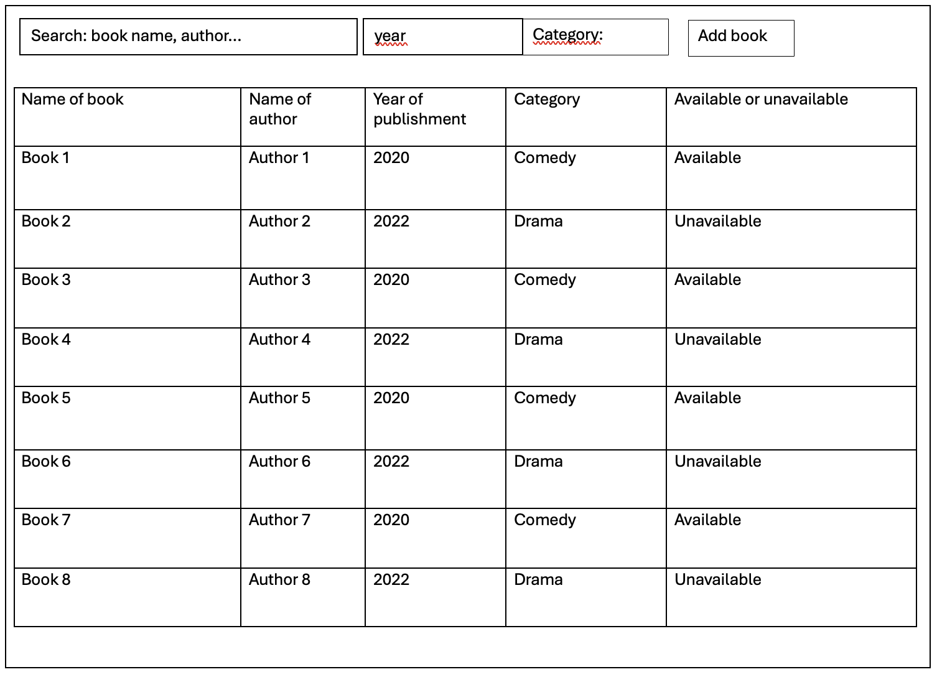
---------------------------------------------------------------------------------------------------------------------
Figure 1. GUI sketch
---------------------------------------------------------------------------------------------------------------------
Some error that can occur are problems connecting the backend with the frontend, also some problems with the code. An easy solution to deal with them is to use the correct prompt with copilot and it will fix it.

Task 2
Prompt to copilot and ChatGPT:
“We need to create the backend for an online library that will use the books stored in the file Book_library.py the user should be able to search for books by writing the name of the book or the name of the author. also, the user should be able to sort the books by year, and by category. the user should be able to rent the book, and the book should now be marked as unavailable if a user has rented it otherwise it should be available. to end the user also needs to be able to add more books, by writing the name of the book, name of the author, year of publishment and category”
“Code In appendix”
“I copied and pasted the code in ChatGPT and told it to create me a GUI for the code in .ui”
“GUI in the appendix”
“Pasted the given GUI for ChatGPT in Visual studio and prompted copilot to connect the backend with the front end”
“It created a file called desktop_library_app.py to connect the backend to the frontend, also in the appendix”
“Prompted ChatGPT to give me 180 books in lists of dictionaries of Python with name, author, year of publishment and category”
“Lists in the appendix”

Task 3
Created three tests:
“Test_backend.py” that checks if the API is running correctly
“Test_frontend.py” that checks if the GUI initializes with the correct title.
“Test_integration.py” checks if the integration between both frontend and backend by adding a book to the library.
(All codes are in the appendix)

Task 4
The weaknesses of my implementation are that sometimes it is hard to connect the flask API to the GUI. The thing that I like the most of this, is the number of books there is in the library and that finally it worked. Further development would be needed if some user would like to use this as a real library, to add users maybe to have more units of one same book and more personal implementations the user requires. To do this we would need to code some more, and to change the GUI probably do a GUI display for the main user and other display where the common user has access.

References
Bratslavsky, P. (n.d.). How frontend and backend components interact in a Full-Stack app. Strapi. https://strapi.io/blog/how-frontend-and-backend-components-interact-in-a-full-stack-app
Chatbot App - AI Chatbot. (n.d.). https://chat.chatbotapp.ai/chats/-OdXo1BTDbBWzncoK6JR?model=superbot
Syntax highlighter for Word. (n.d.). https://www.syntax-highlighter.dev/
unittest — Unit testing framework. (n.d.). Python Documentation. https://docs.python.org/3/library/unittest.html#basic-example
What is a copilot and how does it work? | Microsoft Copilot. (n.d.). https://www.microsoft.com/en-us/microsoft-copilot/copilot-101/what-is-copilot

Appendix

Backend code:
1 | from flask import Flask, request, jsonify
2 | from flask_cors import CORS
3 | import threading
4 | ​
5 | # Load the book data from Book_library.py
6 | from Book_library import library_data
7 | ​
8 | app = Flask(__name__)
9 | CORS(app)
10| ​
11| # In-memory data for this session
12| books = library_data['media']
13| books_lock = threading.Lock()
14| ​
15| def save_books():
16| # Optionally, implement saving to file if you want persistence
17| pass
18| ​
19| @app.route('/sort', methods=['GET'])
20| def sort_books():
21| by = request.args.get('by') or (request.json.get('by') if request.is_json else None)
22| with books_lock:
23| if by == 'year':
24| sorted_books = sorted(books, key=lambda b: b.get('date_published', ''))
25| elif by == 'category':
26| sorted_books = sorted(books, key=lambda b: b.get('category', ''))
27| else:
28| sorted_books = list(books)
29| return jsonify(sorted_books)
30| ​
31| @app.route('/search', methods=['GET', 'POST'])
32| def search_books():
33| if request.method == 'POST':
34| data = request.get_json() or {}
35| query = data.get('query', '').strip().lower()
36| year = data.get('year', '').strip()
37| category = data.get('category', '').strip().lower()
38| else:
39| query = request.args.get('query', '').strip().lower()
40| year = request.args.get('year', '').strip()
41| category = request.args.get('category', '').strip().lower()
42| with books_lock:
43| results = books
44| if query:
45| results = [b for b in results if query in b['name'].lower() or query in b['author'].lower()]
46| if year:
47| results = [b for b in results if year in b['date_published']]
48| if category:
49| results = [b for b in results if category in b['category'].lower()]
50| return jsonify(results)
51| ​
52| @app.route('/media', methods=['POST'])
53| def add_book():
54| data = request.get_json()
55| required = ['name', 'author', 'date_published', 'category']
56| if not all(k in data and data[k] for k in required):
57| return jsonify({'success': False, 'message': 'All fields are required.'}), 400
58| with books_lock:
59| if any(b['name'].lower() == data['name'].lower() for b in books):
60| return jsonify({'success': False, 'message': 'Book already exists.'}), 400
61| new_book = {
62| 'name': data['name'],
63| 'author': data['author'],
64| 'date_published': data['date_published'],
65| 'category': data['category'],
66| 'available': True
67| }
68| books.append(new_book)
69| save_books()
70| return jsonify({'success': True, 'message': 'Book added successfully!'})
71| ​
72| @app.route('/media/<book_name>', methods=['DELETE'])
73| def delete_book(book_name):
74| with books_lock:
75| for i, b in enumerate(books):
76| if b['name'].lower() == book_name.lower():
77| del books[i]
78| save_books()
79| return jsonify({'success': True, 'message': 'Book deleted successfully!'})
80| return jsonify({'success': False, 'message': 'Book not found.'}), 404
81| ​
82| @app.route('/rent', methods=['POST'])
83| def rent_book():
84| data = request.get_json()
85| book_name = data.get('book_name', '').strip()
86| if not book_name:
87| return jsonify({'success': False, 'message': 'Book name required.'}), 400
88| with books_lock:
89| for b in books:
90| if b['name'].lower() == book_name.lower():
91| if not b['available']:
92| return jsonify({'success': False, 'message': 'Book is already rented.'}), 400
93| b['available'] = False
94| save_books()
95| return jsonify({'success': True, 'message': f"You have rented '{b['name']}'!"})
96| return jsonify({'success': False, 'message': 'Book not found.'}), 404
97| ​
98| @app.route('/return', methods=['POST'])
99| def return_book():
100| data = request.get_json()
101| book_name = data.get('book_name', '').strip()
102| if not book_name:
103| return jsonify({'success': False, 'message': 'Book name required.'}), 400
104| with books_lock:
105| for b in books:
106| if b['name'].lower() == book_name.lower():
107| if b['available']:
108| return jsonify({'success': False, 'message': 'Book is already available.'}), 400
109| b['available'] = True
110| save_books()
111| return jsonify({'success': True, 'message': f"You have returned '{b['name']}'!"})
112| return jsonify({'success': False, 'message': 'Book not found.'}), 404
113| ​
114| @app.route('/')
115| def index():
116| return 'Library API is running!'
117| ​
118| if __name__ == '__main__':
119| app.run(host='127.0.0.1', port=5050, debug=True)
120| ​

GUI code:
1 | <?xml version="1.0" encoding="UTF-8"?>
2 | <ui version="4.0">
3 | <class>MainWindow</class>
4 | <widget class="QMainWindow" name="MainWindow">
5 | <property name="geometry">
6 | <rect>
7 | <x>0</x>
8 | <y>0</y>
9 | <width>800</width>
10| <height>700</height>
11| </rect>
12| </property>
13| <property name="windowTitle">
14| <string>Book Library Desktop Dashboard</string>
15| </property>
16| <widget class="QWidget" name="centralwidget">
17| <layout class="QVBoxLayout" name="mainVerticalLayout">
18| <item>
19| <widget class="QLabel" name="headerLabel">
20| <property name="font">
21| <font>
22| <pointsize>16</pointsize>
23| <weight>75</weight>
24| <bold>true</bold>
25| </font>
26| </property>
27| <property name="text">
28| <string>Book Library Dashboard</string>
29| </property>
30| <property name="alignment">
31| <set>Qt::AlignCenter</set>
32| </property>
33| </widget>
34| </item>
35| <item>
36| <widget class="QGroupBox" name="bookListGroupBox">
37| <property name="title">
38| <string>Book List &amp; Search</string>
39| </property>
40| <layout class="QVBoxLayout" name="bookListLayout">
41| <item>
42| <layout class="QHBoxLayout" name="searchSortLayout">
43| <item>
44| <widget class="QLineEdit" name="searchInput">
45| <property name="placeholderText">
46| <string>Search by name or author...</string>
47| </property>
48| </widget>
49| </item>
50| <item>
51| <widget class="QLineEdit" name="yearSearchInput">
52| <property name="placeholderText">
53| <string>Search by year...</string>
54| </property>
55| </widget>
56| </item>
57| <item>
58| <widget class="QLineEdit" name="categorySearchInput">
59| <property name="placeholderText">
60| <string>Search by category...</string>
61| </property>
62| </widget>
63| </item>
64| <item>
65| <widget class="QPushButton" name="searchButton">
66| <property name="text">
67| <string>Search</string>
68| </property>
69| </widget>
70| </item>
71| </layout>
72| </item>
73| <item>
74| <widget class="QTableWidget" name="bookTable">
75| <property name="editTriggers">
76| <set>QAbstractItemView::NoEditTriggers</set>
77| </property>
78| <property name="selectionBehavior">
79| <enum>QAbstractItemView::SelectRows</enum>
80| </property>
81| <column>
82| <property name="text">
83| <string>Name</string>
84| </property>
85| </column>
86| <column>
87| <property name="text">
88| <string>Author</string>
89| </property>
90| </column>
91| <column>
92| <property name="text">
93| <string>Date Published</string>
94| </property>
95| </column>
96| <column>
97| <property name="text">
98| <string>Category</string>
99| </property>
100| </column>
101| <column>
102| <property name="text">
103| <string>Available</string>
104| </property>
105| </column>
106| </widget>
107| </item>
108| </layout>
109| </widget>
110| </item>
111| <item>
112| <layout class="QHBoxLayout" name="actionsLayout">
113| <item>
114| <widget class="QGroupBox" name="addBookGroupBox">
115| <property name="title">
116| <string>Add New Book</string>
117| </property>
118| <layout class="QFormLayout" name="addBookFormLayout">
119| <item row="0" column="0">
120| <widget class="QLabel" name="addNameLabel">
121| <property name="text">
122| <string>Name:</string>
123| </property>
124| </widget>
125| </item>
126| <item row="0" column="1">
127| <widget class="QLineEdit" name="addNameInput"/>
128| </item>
129| <item row="1" column="0">
130| <widget class="QLabel" name="addAuthorLabel">
131| <property name="text">
132| <string>Author:</string>
133| </property>
134| </widget>
135| </item>
136| <item row="1" column="1">
137| <widget class="QLineEdit" name="addAuthorInput"/>
138| </item>
139| <item row="2" column="0">
140| <widget class="QLabel" name="addDatePublishedLabel">
141| <property name="text">
142| <string>Date Published:</string>
143| </property>
144| </widget>
145| </item>
146| <item row="2" column="1">
147| <widget class="QLineEdit" name="addDatePublishedInput">
148| <property name="placeholderText">
149| <string>e.g., 2023</string>
150| </property>
151| </widget>
152| </item>
153| <item row="3" column="0">
154| <widget class="QLabel" name="addCategoryLabel">
155| <property name="text">
156| <string>Category:</string>
157| </property>
158| </widget>
159| </item>
160| <item row="3" column="1">
161| <widget class="QLineEdit" name="addCategoryInput"/>
162| </item>
163| <item row="4" column="1">
164| <widget class="QPushButton" name="addBookButton">
165| <property name="text">
166| <string>Add Book</string>
167| </property>
168| </widget>
169| </item>
170| </layout>
171| </widget>
172| </item>
173| </layout>
174| </item>
175| <item>
176| <widget class="QLabel" name="statusLabel">
177| <property name="text">
178| <string>Application Ready.</string>
179| </property>
180| </widget>
181| </item>
182| </layout>
183| </widget>
184| <widget class="QMenuBar" name="menubar">
185| <property name="geometry">
186| <rect>
187| <x>0</x>
188| <y>0</y>
189| <width>800</width>
190| <height>37</height>
191| </rect>
192| </property>
193| </widget>
194| <widget class="QStatusBar" name="statusbar"/>
195| </widget>
196| <resources/>
197| <connections/>
198| </ui>
199| ​​

Connecting backend with frontend:
1 | import os
2 | import sys
3 | import requests
4 | from PyQt6 import uic
5 | from PyQt6.QtWidgets import QApplication, QMainWindow, QTableWidgetItem, QMessageBox, QPushButton, QWidget, QHBoxLayout, QLineEdit, QLabel
6 | from PyQt6.QtCore import Qt
7 | ​
8 | API_BASE_URL = 'http://127.0.0.1:5050'
9 | ​
10| script_dir = os.path.dirname(__file__)
11| ui_file_path = os.path.join(script_dir, "mainwindow.ui")
12| ​
13| try:
14| MainWindowUI, _ = uic.loadUiType(ui_file_path)
15| except Exception as e:
16| print(f"Error loading UI file: {e}")
17| print(f"Please ensure '{ui_file_path}' exists in the same directory as this script.")
18| sys.exit(1)
19| ​
20| class DesktopLibraryApp(QMainWindow):
21| def __init__(self):
22| super().__init__()
23| self.ui = MainWindowUI()
24| self.ui.setupUi(self)
25| self.setWindowTitle("Book Library Desktop Dashboard")
26| self.all_books_cache = []
27| self._setup_ui_elements()
28| self._connect_signals()
29| self.load_all_books()
30| ​
31| def _setup_ui_elements(self):
32| headers = ["Name", "Author", "Date Published", "Category", "Available", "Actions"]
33| self.ui.bookTable.setColumnCount(len(headers))
34| self.ui.bookTable.setHorizontalHeaderLabels(headers)
35| self.ui.bookTable.setColumnWidth(0, 200)
36| self.ui.bookTable.setColumnWidth(1, 150)
37| self.ui.bookTable.setColumnWidth(2, 100)
38| self.ui.bookTable.setColumnWidth(3, 120)
39| self.ui.bookTable.setColumnWidth(4, 70)
40| self.ui.bookTable.setColumnWidth(5, 120)
41| self.ui.bookTable.horizontalHeader().setStretchLastSection(True)
42| self.ui.bookTable.verticalHeader().setVisible(False)
43| self.ui.bookTable.setSelectionBehavior(self.ui.bookTable.SelectionBehavior.SelectRows)
44| self.ui.bookTable.setEditTriggers(self.ui.bookTable.EditTrigger.NoEditTriggers)
45| self.ui.bookTable.setSelectionMode(self.ui.bookTable.SelectionMode.SingleSelection)
46| self.ui.statusLabel.setText("Welcome to the Book Library Dashboard!")
47| # Remove sortSelect and add year/category search bars
48| if hasattr(self.ui, 'sortSelect'):
49| self.ui.sortSelect.hide()
50| # Add year and category search bars if not present
51| if not hasattr(self.ui, 'yearSearchInput'):
52| self.ui.yearSearchInput = QLineEdit()
53| self.ui.yearSearchInput.setPlaceholderText("Search by year...")
54| self.ui.categorySearchInput = QLineEdit()
55| self.ui.categorySearchInput.setPlaceholderText("Search by category...")
56| self.ui.mainVerticalLayout.insertWidget(2, QLabel("Search by Year:"))
57| self.ui.mainVerticalLayout.insertWidget(3, self.ui.yearSearchInput)
58| self.ui.mainVerticalLayout.insertWidget(4, QLabel("Search by Category:"))
59| self.ui.mainVerticalLayout.insertWidget(5, self.ui.categorySearchInput)
60| ​
61| def _connect_signals(self):
62| self.ui.searchButton.clicked.connect(self.perform_search)
63| self.ui.searchInput.returnPressed.connect(self.perform_search)
64| self.ui.addBookButton.clicked.connect(self.add_new_book)
65| self.ui.bookTable.itemSelectionChanged.connect(self.display_selected_book_metadata)
66| self.ui.yearSearchInput.returnPressed.connect(self.perform_search)
67| self.ui.categorySearchInput.returnPressed.connect(self.perform_search)
68| ​
69| def _show_message(self, message, type='info'):
70| if type == 'error':
71| self.ui.statusLabel.setStyleSheet("color: red;")
72| QMessageBox.critical(self, "Error", message)
73| elif type == 'success':
74| self.ui.statusLabel.setStyleSheet("color: green;")
75| else:
76| self.ui.statusLabel.setStyleSheet("color: black;")
77| self.ui.statusLabel.setText(message)
78| ​
79| def _clear_add_book_form(self):
80| self.ui.addNameInput.clear()
81| self.ui.addAuthorInput.clear()
82| self.ui.addDatePublishedInput.clear()
83| self.ui.addCategoryInput.clear()
84| ​
85| def _clear_rent_book_form(self):
86| self.ui.rentBookNameInput.clear()
87| ​
88| def _make_api_request(self, endpoint, method='GET', data=None):
89| url = f"{API_BASE_URL}{endpoint}"
90| try:
91| if method == 'GET':
92| response = requests.get(url, params=data)
93| elif method == 'POST':
94| response = requests.post(url, json=data)
95| elif method == 'DELETE':
96| response = requests.delete(url)
97| else:
98| raise ValueError("Unsupported HTTP method")
99| response.raise_for_status()
100| return response.json()
101| except requests.exceptions.ConnectionError:
102| self._show_message("Could not connect to the Flask API. Is it running?", 'error')
103| return None
104| except requests.exceptions.RequestException as e:
105| error_message = f"API request failed: {e}"
106| if response is not None and response.content:
107| try:
108| error_json = response.json()
109| if 'message' in error_json:
110| error_message = error_json['message']
111| except Exception:
112| error_message = response.text
113| self._show_message(error_message, 'error')
114| return None
115| ​
116| def load_all_books(self):
117| books_data = self._make_api_request('/search', data={})
118| if books_data is not None:
119| self.all_books_cache = books_data
120| self._update_book_table(books_data)
121| self._show_message(f"Loaded {len(books_data)} books.", 'info')
122| else:
123| self._update_book_table([])
124| ​
125| def perform_search(self):
126| query = self.ui.searchInput.text().strip()
127| year = self.ui.yearSearchInput.text().strip()
128| category = self.ui.categorySearchInput.text().strip()
129| if not query and not year and not category:
130| self.load_all_books()
131| return
132| # Compose search parameters
133| params = {}
134| if query:
135| params['query'] = query
136| if year:
137| params['year'] = year
138| if category:
139| params['category'] = category
140| search_results = self._make_api_request('/search', data=params)
141| if search_results is not None:
142| self._update_book_table(search_results)
143| self._show_message(f"Found {len(search_results)} book(s) matching your search.", 'info')
144| else:
145| self._update_book_table([])
146| ​
147| def _update_book_table(self, books):
148| self.ui.bookTable.setRowCount(0)
149| for row_idx, book in enumerate(books):
150| self.ui.bookTable.insertRow(row_idx)
151| self.ui.bookTable.setItem(row_idx, 0, QTableWidgetItem(book.get("name", "")))
152| self.ui.bookTable.setItem(row_idx, 1, QTableWidgetItem(book.get("author", "")))
153| self.ui.bookTable.setItem(row_idx, 2, QTableWidgetItem(book.get("date_published", "")))
154| self.ui.bookTable.setItem(row_idx, 3, QTableWidgetItem(book.get("category", "")))
155| available_item = QTableWidgetItem("Yes" if book.get("available", False) else "No")
156| available_item.setForeground(Qt.GlobalColor.darkGreen if book.get("available", False) else Qt.GlobalColor.red)
157| self.ui.bookTable.setItem(row_idx, 4, available_item)
158| actions_widget = self._create_actions_widget(book['name'], book['available'])
159| self.ui.bookTable.setCellWidget(row_idx, 5, actions_widget)
160| ​
161| def _create_actions_widget(self, book_name, is_available):
162| widget = QWidget()
163| layout = QHBoxLayout(widget)
164| layout.setContentsMargins(0,0,0,0)
165| layout.setSpacing(5)
166| rent_btn = QPushButton("Rent")
167| rent_btn.setEnabled(is_available)
168| rent_btn.clicked.connect(lambda: self.rent_book_action(book_name))
169| layout.addWidget(rent_btn)
170| return_btn = QPushButton("Return")
171| return_btn.setEnabled(not is_available)
172| return_btn.clicked.connect(lambda: self.return_book_action(book_name))
173| layout.addWidget(return_btn)
174| delete_btn = QPushButton("Delete")
175| delete_btn.clicked.connect(lambda: self.delete_book_action(book_name))
176| layout.addWidget(delete_btn)
177| return widget
178| ​
179| def return_book_action(self, book_name):
180| response = self._make_api_request('/return', method='POST', data={'book_name': book_name})
181| if response and response.get('success'):
182| self._show_message(response.get('message', 'Book returned successfully!'), 'success')
183| self.load_all_books()
184| elif response:
185| self._show_message(response.get('message', 'Failed to return book.'), 'error')
186| ​
187| def display_selected_book_metadata(self):
188| pass
189| ​
190| def rent_book_action(self, book_name):
191| response = self._make_api_request('/rent', method='POST', data={'book_name': book_name})
192| if response and response.get('success'):
193| self._show_message(response.get('message', 'Book rented successfully!'), 'success')
194| self.load_all_books()
195| elif response:
196| self._show_message(response.get('message', 'Failed to rent book.'), 'error')
197| ​
198| def delete_book_action(self, book_name):
199| reply = QMessageBox.question(self, 'Delete Book',
200| f"Are you sure you want to delete '{book_name}'?",
201| QMessageBox.StandardButton.Yes | QMessageBox.StandardButton.No)
202| if reply == QMessageBox.StandardButton.Yes:
203| response = self._make_api_request(f'/media/{book_name}', method='DELETE')
204| if response and response.get('success'):
205| self._show_message(response.get('message', 'Book deleted successfully!'), 'success')
206| self.load_all_books()
207| elif response:
208| self._show_message(response.get('message', 'Failed to delete book.'), 'error')
209| ​
210| def add_new_book(self):
211| name = self.ui.addNameInput.text().strip()
212| author = self.ui.addAuthorInput.text().strip()
213| date_published = self.ui.addDatePublishedInput.text().strip()
214| category = self.ui.addCategoryInput.text().strip()
215| if not all([name, author, date_published, category]):
216| self._show_message("All fields are required to add a book.", 'error')
217| return
218| book_data = {
219| 'name': name,
220| 'author': author,
221| 'date_published': date_published,
222| 'category': category
223| }
224| response = self._make_api_request('/media', method='POST', data=book_data)
225| if response and response.get('success'):
226| self._show_message('Book added successfully!', 'success')
227| self._clear_add_book_form()
228| self.load_all_books()
229| elif response:
230| self._show_message(response.get('message', 'Failed to add book.'), 'error')
231| ​
232| def rent_selected_book(self):
233| book_name = self.ui.rentBookNameInput.text().strip()
234| if not book_name:
235| self._show_message("Please enter the name of the book to rent.", 'error')
236| return
237| self.rent_book_action(book_name)
238| self._clear_rent_book_form()
239| ​
240| if __name__ == '__main__':
241| app = QApplication(sys.argv)
242| window = DesktopLibraryApp()
243| window.show()
244| sys.exit(app.exec())
245| ​

Library dictionary:
1 | library_data = {
2 | "media": [
3 | {
4 | "name": "To Kill a Mockingbird",
5 | "author": "Harper Lee",
6 | "date_published": "1960",
7 | "category": "Classic Fiction",
8 | "available": True
9 | },
10| {
11| "name": "1984",
12| "author": "George Orwell",
13| "date_published": "1949",
14| "category": "Dystopian Fiction",
15| "available": True
16| },
17| {
18| "name": "Pride and Prejudice",
19| "author": "Jane Austen",
20| "date_published": "1813",
21| "category": "Classic Romance",
22| "available": True
23| },
24| {
25| "name": "The Great Gatsby",
26| "author": "F. Scott Fitzgerald",
27| "date_published": "1925",
28| "category": "Classic Fiction",
29| "available": True
30| },
31| {
32| "name": "One Hundred Years of Solitude",
33| "author": "Gabriel Garc\u00eda M\u00e1rquez",
34| "date_published": "1967",
35| "category": "Magical Realism",
36| "available": True
37| },
38| {
39| "name": "The Lord of the Rings",
40| "author": "J.R.R. Tolkien",
41| "date_published": "1954",
42| "category": "Fantasy",
43| "available": True
44| },
45| {
46| "name": "Harry Potter and the Sorcerer's Stone",
47| "author": "J.K. Rowling",
48| "date_published": "1997",
49| "category": "Fantasy, Young Adult",
50| "available": True
51| },
52| {
53| "name": "The Catcher in the Rye",
54| "author": "J.D. Salinger",
55| "date_published": "1951",
56| "category": "Coming-of-age Fiction",
57| "available": True
58| },
59| {
60| "name": "Dune",
61| "author": "Frank Herbert",
62| "date_published": "1965",
63| "category": "Science Fiction",
64| "available": True
65| },
66| {
67| "name": "Crime and Punishment",
68| "author": "Fyodor Dostoevsky",
69| "date_published": "1866",
70| "category": "Philosophical Fiction",
71| "available": True
72| },
73| {
74| "name": "Don Quixote",
75| "author": "Miguel de Cervantes",
76| "date_published": "1605",
77| "category": "Classic Satire",
78| "available": False
79| },
80| {
81| "name": "Alice's Adventures in Wonderland",
82| "author": "Lewis Carroll",
83| "date_published": "1865",
84| "category": "Children's Fantasy",
85| "available": True
86| },
87| {
88| "name": "The Hobbit",
89| "author": "J.R.R. Tolkien",
90| "date_published": "1937",
91| "category": "Fantasy",
92| "available": True
93| },
94| {
95| "name": "Frankenstein",
96| "author": "Mary Shelley",
97| "date_published": "1818",
98| "category": "Gothic Fiction, Science Fiction",
99| "available": True
100| },
101| {
102| "name": "Les Mis\u00e9rables",
103| "author": "Victor Hugo",
104| "date_published": "1862",
105| "category": "Historical Fiction",
106| "available": True
107| },
108| {
109| "name": "Anna Karenina",
110| "author": "Leo Tolstoy",
111| "date_published": "1877",
112| "category": "Realist Fiction",
113| "available": True
114| },
115| {
116| "name": "The Odyssey",
117| "author": "Homer",
118| "date_published": "c. 8th century BCE",
119| "category": "Epic Poetry, Mythology",
120| "available": True
121| },
122| {
123| "name": "Wuthering Heights",
124| "author": "Emily Bront\u00eb",
125| "date_published": "1847",
126| "category": "Gothic Romance",
127| "available": True
128| },
129| {
130| "name": "Jane Eyre",
131| "author": "Charlotte Bront\u00eb",
132| "date_published": "1847",
133| "category": "Gothic Romance",
134| "available": True
135| },
136| {
137| "name": "Little Women",
138| "author": "Louisa May Alcott",
139| "date_published": "1868",
140| "category": "Classic Fiction, Young Adult",
141| "available": True
142| },
143| {
144| "name": "Gone with the Wind",
145| "author": "Margaret Mitchell",
146| "date_published": "1936",
147| "category": "Historical Romance",
148| "available": True
149| },
150| {
151| "name": "The Grapes of Wrath",
152| "author": "John Steinbeck",
153| "date_published": "1939",
154| "category": "Social Realism",
155| "available": True
156| },
157| {
158| "name": "Brave New World",
159| "author": "Aldous Huxley",
160| "date_published": "1932",
161| "category": "Dystopian Fiction",
162| "available": True
163| },
164| {
165| "name": "Fahrenheit 451",
166| "author": "Ray Bradbury",
167| "date_published": "1953",
168| "category": "Dystopian Fiction, Science Fiction",
169| "available": True
170| },
171| {
172| "name": "Catch-22",
173| "author": "Joseph Heller",
174| "date_published": "1961",
175| "category": "Satirical Fiction, War Fiction",
176| "available": True
177| },
178| {
179| "name": "The Picture of Dorian Gray",
180| "author": "Oscar Wilde",
181| "date_published": "1890",
182| "category": "Philosophical Fiction, Gothic",
183| "available": True
184| },
185| {
186| "name": "The Count of Monte Cristo",
187| "author": "Alexandre Dumas",
188| "date_published": "1844",
189| "category": "Adventure, Historical Fiction",
190| "available": True
191| },
192| {
193| "name": "A Tale of Two Cities",
194| "author": "Charles Dickens",
195| "date_published": "1859",
196| "category": "Historical Fiction",
197| "available": True
198| },
199| {
200| "name": "Of Mice and Men",
201| "author": "John Steinbeck",
202| "date_published": "1937",
203| "category": "Novella, Social Realism",
204| "available": True
205| },
206| {
207| "name": "The Alchemist",
208| "author": "Paulo Coelho",
209| "date_published": "1988",
210| "category": "Allegorical Fiction",
211| "available": True
212| },
213| {
214| "name": "The Brothers Karamazov",
215| "author": "Fyodor Dostoevsky",
216| "date_published": "1880",
217| "category": "Philosophical Fiction, Classic",
218| "available": True
219| },
220| {
221| "name": "Moby Dick",
222| "author": "Herman Melville",
223| "date_published": "1851",
224| "category": "Adventure, Classic Fiction",
225| "available": True
226| },
227| {
228| "name": "War and Peace",
229| "author": "Leo Tolstoy",
230| "date_published": "1869",
231| "category": "Historical Fiction, Epic",
232| "available": True
233| },
234| {
235| "name": "Great Expectations",
236| "author": "Charles Dickens",
237| "date_published": "1861",
238| "category": "Classic Fiction, Bildungsroman",
239| "available": True
240| },
241| {
242| "name": "Ulysses",
243| "author": "James Joyce",
244| "date_published": "1922",
245| "category": "Modernist Fiction, Literary Classic",
246| "available": True
247| },
248| {
249| "name": "The Old Man and the Sea",
250| "author": "Ernest Hemingway",
251| "date_published": "1952",
252| "category": "Novella, Classic Fiction",
253| "available": True
254| },
255| {
256| "name": "A Farewell to Arms",
257| "author": "Ernest Hemingway",
258| "date_published": "1929",
259| "category": "War Fiction, Classic Romance",
260| "available": True
261| },
262| {
263| "name": "Mrs Dalloway",
264| "author": "Virginia Woolf",
265| "date_published": "1925",
266| "category": "Modernist Fiction",
267| "available": True
268| },
269| {
270| "name": "To the Lighthouse",
271| "author": "Virginia Woolf",
272| "date_published": "1927",
273| "category": "Modernist Fiction",
274| "available": True
275| },
276| {
277| "name": "The Sound and the Fury",
278| "author": "William Faulkner",
279| "date_published": "1929",
280| "category": "Southern Gothic, Literary Classic",
281| "available": True
282| },
283| {
284| "name": "Their Eyes Were Watching God",
285| "author": "Zora Neale Hurston",
286| "date_published": "1937",
287| "category": "Harlem Renaissance, Classic Fiction",
288| "available": True
289| },
290| {
291| "name": "Beloved",
292| "author": "Toni Morrison",
293| "date_published": "1987",
294| "category": "Historical Fiction, Magical Realism",
295| "available": True
296| },
297| {
298| "name": "The Handmaid's Tale",
299| "author": "Margaret Atwood",
300| "date_published": "1985",
301| "category": "Dystopian Fiction, Speculative Fiction",
302| "available": True
303| },
304| {
305| "name": "Slaughterhouse-Five",
306| "author": "Kurt Vonnegut",
307| "date_published": "1969",
308| "category": "Satirical Fiction, Anti-War",
309| "available": True
310| },
311| {
312| "name": "Lord of the Flies",
313| "author": "William Golding",
314| "date_published": "1954",
315| "category": "Allegory, Classic Fiction",
316| "available": True
317| },
318| {
319| "name": "The Stranger",
320| "author": "Albert Camus",
321| "date_published": "1942",
322| "category": "Philosophical Fiction, Existentialism",
323| "available": True
324| },
325| {
326| "name": "The Hunger Games",
327| "author": "Suzanne Collins",
328| "date_published": "2008",
329| "category": "Young Adult, Dystopian",
330| "available": True
331| },
332| {
333| "name": "Life of Pi",
334| "author": "Yann Martel",
335| "date_published": "2001",
336| "category": "Philosophical Fiction, Adventure",
337| "available": True
338| },
339| {
340| "name": "Foundation",
341| "author": "Isaac Asimov",
342| "date_published": "1951",
343| "category": "Science Fiction, Space Opera",
344| "available": True
345| },
346| {
347| "name": "Neuromancer",
348| "author": "William Gibson",
349| "date_published": "1984",
350| "category": "Cyberpunk, Science Fiction",
351| "available": True
352| },
353| {
354| "name": "Stranger in a Strange Land",
355| "author": "Robert A. Heinlein",
356| "date_published": "1961",
357| "category": "Science Fiction, Social Commentary",
358| "available": True
359| },
360| {
361| "name": "The Hitchhiker's Guide to the Galaxy",
362| "author": "Douglas Adams",
363| "date_published": "1979",
364| "category": "Science Fiction, Humour",
365| "available": True
366| },
367| {
368| "name": "The Chronicles of Narnia: The Lion, the Witch and the Wardrobe",
369| "author": "C.S. Lewis",
370| "date_published": "1950",
371| "category": "Children's Fantasy, Allegory",
372| "available": True
373| },
374| {
375| "name": "American Gods",
376| "author": "Neil Gaiman",
377| "date_published": "2001",
378| "category": "Fantasy, Mythology",
379| "available": True
380| },
381| {
382| "name": "Hyperion",
383| "author": "Dan Simmons",
384| "date_published": "1989",
385| "category": "Science Fiction, Epic",
386| "available": True
387| },
388| {
389| "name": "A Wizard of Earthsea",
390| "author": "Ursula K. Le Guin",
391| "date_published": "1968",
392| "category": "Fantasy, Young Adult",
393| "available": True
394| },
395| {
396| "name": "And Then There Were None",
397| "author": "Agatha Christie",
398| "date_published": "1939",
399| "category": "Mystery, Whodunit",
400| "available": True
401| },
402| {
403| "name": "The Da Vinci Code",
404| "author": "Dan Brown",
405| "date_published": "2003",
406| "category": "Thriller, Mystery",
407| "available": True
408| },
409| {
410| "name": "The Girl with the Dragon Tattoo",
411| "author": "Stieg Larsson",
412| "date_published": "2005",
413| "category": "Crime, Thriller",
414| "available": True
415| },
416| {
417| "name": "Gone Girl",
418| "author": "Gillian Flynn",
419| "date_published": "2012",
420| "category": "Thriller, Mystery",
421| "available": True
422| },
423| {
424| "name": "Dracula",
425| "author": "Bram Stoker",
426| "date_published": "1897",
427| "category": "Gothic Horror, Classic",
428| "available": True
429| },
430| {
431| "name": "IT",
432| "author": "Stephen King",
433| "date_published": "1986",
434| "category": "Horror",
435| "available": True
436| },
437| {
438| "name": "The Haunting of Hill House",
439| "author": "Shirley Jackson",
440| "date_published": "1959",
441| "category": "Gothic Horror",
442| "available": True
443| },
444| {
445| "name": "The Name of the Rose",
446| "author": "Umberto Eco",
447| "date_published": "1980",
448| "category": "Historical Mystery, Philosophical Fiction",
449| "available": True
450| },
451| {
452| "name": "Pillars of the Earth",
453| "author": "Ken Follett",
454| "date_published": "1989",
455| "category": "Historical Fiction",
456| "available": True
457| },
458| {
459| "name": "Shogun",
460| "author": "James Clavell",
461| "date_published": "1975",
462| "category": "Historical Fiction, Adventure",
463| "available": True
464| },
465| {
466| "name": "Sapiens: A Brief History of Humankind",
467| "author": "Yuval Noah Harari",
468| "date_published": "2011",
469| "category": "Non-Fiction, History",
470| "available": True
471| },
472| {
473| "name": "The Diary of a Young Girl",
474| "author": "Anne Frank",
475| "date_published": "1947",
476| "category": "Memoir, Holocaust",
477| "available": True
478| },
479| {
480| "name": "Cosmos",
481| "author": "Carl Sagan",
482| "date_published": "1980",
483| "category": "Popular Science, Astronomy",
484| "available": True
485| },
486| {
487| "name": "A Brief History of Time",
488| "author": "Stephen Hawking",
489| "date_published": "1988",
490| "category": "Popular Science, Physics",
491| "available": True
492| },
493| {
494| "name": "Educated",
495| "author": "Tara Westover",
496| "date_published": "2018",
497| "category": "Memoir, Biography",
498| "available": True
499| },
500| {
501| "name": "Atomic Habits",
502| "author": "James Clear",
503| "date_published": "2018",
504| "category": "Self-help, Productivity",
505| "available": True
506| },
507| {
508| "name": "Thinking, Fast and Slow",
509| "author": "Daniel Kahneman",
510| "date_published": "2011",
511| "category": "Psychology, Non-Fiction",
512| "available": True
513| },
514| {
515| "name": "Hamlet",
516| "author": "William Shakespeare",
517| "date_published": "c. 1603",
518| "category": "Tragedy, Play",
519| "available": True
520| },
521| {
522| "name": "Romeo and Juliet",
523| "author": "William Shakespeare",
524| "date_published": "c. 1597",
525| "category": "Tragedy, Play",
526| "available": True
527| },
528| {
529| "name": "Macbeth",
530| "author": "William Shakespeare",
531| "date_published": "c. 1606",
532| "category": "Tragedy, Play",
533| "available": True
534| },
535| {
536| "name": "Death of a Salesman",
537| "author": "Arthur Miller",
538| "date_published": "1949",
539| "category": "Drama, Play",
540| "available": True
541| },
542| {
543| "name": "The Little Prince",
544| "author": "Antoine de Saint-Exup\u00e9ry",
545| "date_published": "1943",
546| "category": "Children's Literature, Philosophical Fiction",
547| "available": True
548| },
549| {
550| "name": "Charlotte's Web",
551| "author": "E.B. White",
552| "date_published": "1952",
553| "category": "Children's Literature",
554| "available": True
555| },
556| {
557| "name": "Where the Wild Things Are",
558| "author": "Maurice Sendak",
559| "date_published": "1963",
560| "category": "Children's Picture Book",
561| "available": True
562| },
563| {
564| "name": "The Giver",
565| "author": "Lois Lowry",
566| "date_published": "1993",
567| "category": "Dystopian, Young Adult",
568| "available": True
569| },
570| {
571| "name": "The Road",
572| "author": "Cormac McCarthy",
573| "date_published": "2006",
574| "category": "Post-apocalyptic, Literary Fiction",
575| "available": True
576| },
577| {
578| "name": "No Country for Old Men",
579| "author": "Cormac McCarthy",
580| "date_published": "2005",
581| "category": "Neo-Western, Thriller",
582| "available": True
583| },
584| {
585| "name": "Of Human Bondage",
586| "author": "W. Somerset Maugham",
587| "date_published": "1915",
588| "category": "Semi-autobiographical, Bildungsroman",
589| "available": True
590| },
591| {
592| "name": "The Sun Also Rises",
593| "author": "Ernest Hemingway",
594| "date_published": "1926",
595| "category": "Modernist, Lost Generation",
596| "available": True
597| },
598| {
599| "name": "For Whom the Bell Tolls",
600| "author": "Ernest Hemingway",
601| "date_published": "1940",
602| "category": "War Fiction, Literary Classic",
603| "available": True
604| },
605| {
606| "name": "Invisible Man",
607| "author": "Ralph Ellison",
608| "date_published": "1952",
609| "category": "African American Literature, Modernist",
610| "available": True
611| },
612| {
613| "name": "Native Son",
614| "author": "Richard Wright",
615| "date_published": "1940",
616| "category": "African American Literature, Social Realism",
617| "available": True
618| },
619| {
620| "name": "A Streetcar Named Desire",
621| "author": "Tennessee Williams",
622| "date_published": "1947",
623| "category": "Play, Southern Gothic",
624| "available": True
625| },
626| {
627| "name": "The Glass Menagerie",
628| "author": "Tennessee Williams",
629| "date_published": "1944",
630| "category": "Play, Memory Play",
631| "available": True
632| },
633| {
634| "name": "The Color Purple",
635| "author": "Alice Walker",
636| "date_published": "1982",
637| "category": "Epistolary Novel, Historical Fiction",
638| "available": True
639| },
640| {
641| "name": "Catching Fire",
642| "author": "Suzanne Collins",
643| "date_published": "2009",
644| "category": "Young Adult, Dystopian",
645| "available": True
646| },
647| {
648| "name": "Mockingjay",
649| "author": "Suzanne Collins",
650| "date_published": "2010",
651| "category": "Young Adult, Dystopian",
652| "available": True
653| },
654| {
655| "name": "The Martian",
656| "author": "Andy Weir",
657| "date_published": "2011",
658| "category": "Science Fiction, Adventure",
659| "available": True
660| },
661| {
662| "name": "Project Hail Mary",
663| "author": "Andy Weir",
664| "date_published": "2021",
665| "category": "Science Fiction, Adventure",
666| "available": True
667| },
668| {
669| "name": "Ready Player One",
670| "author": "Ernest Cline",
671| "date_published": "2011",
672| "category": "Science Fiction, Dystopian",
673| "available": True
674| },
675| {
676| "name": "Snow Crash",
677| "author": "Neal Stephenson",
678| "date_published": "1992",
679| "category": "Cyberpunk, Science Fiction",
680| "available": True
681| },
682| {
683| "name": "The Hitchhiker's Guide to the Galaxy (series)",
684| "author": "Douglas Adams",
685| "date_published": "1979",
686| "category": "Science Fiction, Comedy",
687| "available": True
688| },
689| {
690| "name": "Good Omens",
691| "author": "Terry Pratchett & Neil Gaiman",
692| "date_published": "1990",
693| "category": "Fantasy, Comedy",
694| "available": True
695| },
696| {
697| "name": "Discworld: Mort",
698| "author": "Terry Pratchett",
699| "date_published": "1987",
700| "category": "Fantasy, Satire",
701| "available": True
702| },
703| {
704| "name": "The Name of the Wind",
705| "author": "Patrick Rothfuss",
706| "date_published": "2007",
707| "category": "Fantasy",
708| "available": True
709| },
710| {
711| "name": "Mistborn: The Final Empire",
712| "author": "Brandon Sanderson",
713| "date_published": "2006",
714| "category": "Fantasy",
715| "available": True
716| },
717| {
718| "name": "Jonathan Strange & Mr Norrell",
719| "author": "Susanna Clarke",
720| "date_published": "2004",
721| "category": "Fantasy, Historical",
722| "available": True
723| },
724| {
725| "name": "The Ocean at the End of the Lane",
726| "author": "Neil Gaiman",
727| "date_published": "2013",
728| "category": "Dark Fantasy, Modern Literature",
729| "available": True
730| },
731| {
732| "name": "The Secret History",
733| "author": "Donna Tartt",
734| "date_published": "1992",
735| "category": "Literary Fiction, Dark Academia",
736| "available": True
737| },
738| {
739| "name": "A Little Life",
740| "author": "Hanya Yanagihara",
741| "date_published": "2015",
742| "category": "Contemporary Fiction, Literary Fiction",
743| "available": True
744| },
745| {
746| "name": "Where the Crawdads Sing",
747| "author": "Delia Owens",
748| "date_published": "2018",
749| "category": "Mystery, Literary Fiction",
750| "available": True
751| },
752| {
753| "name": "The Silent Patient",
754| "author": "Alex Michaelides",
755| "date_published": "2019",
756| "category": "Psychological Thriller, Mystery",
757| "available": True
758| },
759| {
760| "name": "The Guest List",
761| "author": "Lucy Fokley",
762| "date_published": "2020",
763| "category": "Mystery, Thriller",
764| "available": True
765| },
766| {
767| "name": "The Woman in Cabin 10",
768| "author": "Ruth Ware",
769| "date_published": "2016",
770| "category": "Mystery, Thriller",
771| "available": True
772| },
773| {
774| "name": "Rebecca",
775| "author": "Daphne du Maurier",
776| "date_published": "1938",
777| "category": "Gothic Romance, Psychological Thriller",
778| "available": True
779| },
780| {
781| "name": "Bird Box",
782| "author": "Josh Malerman",
783| "date_published": "2014",
784| "category": "Post-apocalyptic, Horror",
785| "available": True
786| },
787| {
788| "name": "The Exorcist",
789| "author": "William Peter Blatty",
790| "date_published": "1971",
791| "category": "Horror",
792| "available": True
793| },
794| {
795| "name": "Rosemary's Baby",
796| "author": "Ira Levin",
797| "date_published": "1967",
798| "category": "Horror, Psychological Thriller",
799| "available": True
800| },
801| {
802| "name": "American Psycho",
803| "author": "Bret Easton Ellis",
804| "date_published": "1991",
805| "category": "Satirical Fiction, Horror",
806| "available": True
807| },
808| {
809| "name": "The Kite Runner",
810| "author": "Khaled Hosseini",
811| "date_published": "2003",
812| "category": "Historical Fiction, Literary Fiction",
813| "available": True
814| },
815| {
816| "name": "A Thousand Splendid Suns",
817| "author": "Khaled Hosseini",
818| "date_published": "2007",
819| "category": "Historical Fiction, Literary Fiction",
820| "available": True
821| },
822| {
823| "name": "The Book Thief",
824| "author": "Markus Zusak",
825| "date_published": "2005",
826| "category": "Historical Fiction, Young Adult",
827| "available": True
828| },
829| {
830| "name": "All the Light We Cannot See",
831| "author": "Anthony Doerr",
832| "date_published": "2014",
833| "category": "Historical Fiction, War",
834| "available": True
835| },
836| {
837| "name": "The Nightingale",
838| "author": "Kristin Hannah",
839| "date_published": "2015",
840| "category": "Historical Fiction, War",
841| "available": True
842| },
843| {
844| "name": "When Breath Becomes Air",
845| "author": "Paul Kalanithi",
846| "date_published": "2016",
847| "category": "Memoir, Non-Fiction",
848| "available": True
849| },
850| {
851| "name": "Into Thin Air",
852| "author": "Jon Krakauer",
853| "date_published": "1997",
854| "category": "Non-Fiction, Adventure",
855| "available": True
856| },
857| {
858| "name": "Outliers",
859| "author": "Malcolm Gladwell",
860| "date_published": "2008",
861| "category": "Non-Fiction, Sociology",
862| "available": True
863| },
864| {
865| "name": "Freakonomics",
866| "author": "Steven D. Levitt & Stephen J. Dubner",
867| "date_published": "2005",
868| "category": "Non-Fiction, Economics",
869| "available": True
870| },
871| {
872| "name": "The Art of War",
873| "author": "Sun Tzu",
874| "date_published": "c. 5th Century BCE",
875| "category": "Non-Fiction, Philosophy",
876| "available": True
877| },
878| {
879| "name": "Meditations",
880| "author": "Marcus Aurelius",
881| "date_published": "c. 161-180 CE",
882| "category": "Philosophy, Stoicism",
883| "available": True
884| },
885| {
886| "name": "The Prince",
887| "author": "Niccol\u00f2 Machiavelli",
888| "date_published": "1532",
889| "category": "Political Philosophy, Non-Fiction",
890| "available": True
891| },
892| {
893| "name": "Candide",
894| "author": "Voltaire",
895| "date_published": "1759",
896| "category": "Satire, Philosophical Fiction",
897| "available": True
898| },
899| {
900| "name": "The Republic",
901| "author": "Plato",
902| "date_published": "c. 380 BCE",
903| "category": "Philosophy, Political Theory",
904| "available": True
905| },
906| {
907| "name": "Paradise Lost",
908| "author": "John Milton",
909| "date_published": "1667",
910| "category": "Epic Poem, Religious Allegory",
911| "available": True
912| },
913| {
914| "name": "Brave New World Revisited",
915| "author": "Aldous Huxley",
916| "date_published": "1958",
917| "category": "Non-Fiction, Social Commentary",
918| "available": True
919| },
920| {
921| "name": "The Hitchhiker's Guide to the Galaxy (novel)",
922| "author": "Douglas Adams",
923| "date_published": "1979",
924| "category": "Science Fiction, Comedy",
925| "available": True
926| },
927| {
928| "name": "Catch-22",
929| "author": "Joseph Heller",
930| "date_published": "1961",
931| "category": "Satirical Fiction, War",
932| "available": True
933| },
934| {
935| "name": "The Picture of Dorian Gray",
936| "author": "Oscar Wilde",
937| "date_published": "1890",
938| "category": "Gothic Fiction, Philosophical",
939| "available": True
940| },
941| {
942| "name": "Anna Karenina",
943| "author": "Leo Tolstoy",
944| "date_published": "1877",
945| "category": "Realist Fiction, Classic",
946| "available": True
947| },
948| {
949| "name": "Dracula",
950| "author": "Bram Stoker",
951| "date_published": "1897",
952| "category": "Gothic Horror, Classic",
953| "available": True
954| },
955| {
956| "name": "Frankenstein",
957| "author": "Mary Shelley",
958| "date_published": "1818",
959| "category": "Gothic Fiction, Science Fiction",
960| "available": True
961| },
962| {
963| "name": "Wuthering Heights",
964| "author": "Emily Bront\u00eb",
965| "date_published": "1847",
966| "category": "Gothic Romance, Classic",
967| "available": True
968| },
969| {
970| "name": "Jane Eyre",
971| "author": "Charlotte Bront\u00eb",
972| "date_published": "1847",
973| "category": "Gothic Romance, Classic",
974| "available": True
975| },
976| {
977| "name": "Little Women",
978| "author": "Louisa May Alcott",
979| "date_published": "1868",
980| "category": "Classic Fiction, Coming-of-age",
981| "available": True
982| },
983| {
984| "name": "The Adventures of Huckleberry Finn",
985| "author": "Mark Twain",
986| "date_published": "1884",
987| "category": "Adventure, Classic American",
988| "available": True
989| },
990| {
991| "name": "Adventures of Tom Sawyer",
992| "author": "Mark Twain",
993| "date_published": "1876",
994| "category": "Adventure, Children's Classic",
995| "available": True
996| },
997| {
998| "name": "Gulliver's Travels",
999| "author": "Jonathan Swift",
1000| "date_published": "1726",
1001| "category": "Satire, Fantasy",
1002| "available": True
1003| },
1004| {
1005| "name": "Robinson Crusoe",
1006| "author": "Daniel Defoe",
1007| "date_published": "1719",
1008| "category": "Adventure, Classic",
1009| "available": True
1010| },
1011| {
1012| "name": "The Count of Monte Cristo",
1013| "author": "Alexandre Dumas",
1014| "date_published": "1844",
1015| "category": "Adventure, Historical Fiction",
1016| "available": True
1017| },
1018| {
1019| "name": "The Three Musketeers",
1020| "author": "Alexandre Dumas",
1021| "date_published": "1844",
1022| "category": "Adventure, Historical Fiction",
1023| "available": True
1024| },
1025| {
1026| "name": "The Grapes of Wrath",
1027| "author": "John Steinbeck",
1028| "date_published": "1939",
1029| "category": "Social Realism, American Classic",
1030| "available": True
1031| },
1032| {
1033| "name": "Of Mice and Men",
1034| "author": "John Steinbeck",
1035| "date_published": "1937",
1036| "category": "Novella, Social Realism",
1037| "available": True
1038| },
1039| {
1040| "name": "East of Eden",
1041| "author": "John Steinbeck",
1042| "date_published": "1952",
1043| "category": "Literary Fiction, Epic Saga",
1044| "available": True
1045| },
1046| {
1047| "name": "Lolita",
1048| "author": "Vladimir Nabokov",
1049| "date_published": "1955",
1050| "category": "Literary Fiction, Controversial",
1051| "available": True
1052| },
1053| {
1054| "name": "A Clockwork Orange",
1055| "author": "Anthony Burgess",
1056| "date_published": "1962",
1057| "category": "Dystopian, Satirical",
1058| "available": True
1059| },
1060| {
1061| "name": "The Handmaid's Tale",
1062| "author": "Margaret Atwood",
1063| "date_published": "1985",
1064| "category": "Dystopian, Speculative Fiction",
1065| "available": True
1066| },
1067| {
1068| "name": "Slaughterhouse-Five",
1069| "author": "Kurt Vonnegut",
1070| "date_published": "1969",
1071| "category": "Satirical Fiction, Anti-War",
1072| "available": True
1073| },
1074| {
1075| "name": "Cat's Cradle",
1076| "author": "Kurt Vonnegut",
1077| "date_published": "1963",
1078| "category": "Satirical Fiction, Postmodern",
1079| "available": True
1080| },
1081| {
1082| "name": "Dune Messiah",
1083| "author": "Frank Herbert",
1084| "date_published": "1969",
1085| "category": "Science Fiction",
1086| "available": True
1087| },
1088| {
1089| "name": "Children of Dune",
1090| "author": "Frank Herbert",
1091| "date_published": "1976",
1092| "category": "Science Fiction",
1093| "available": True
1094| },
1095| {
1096| "name": "Do Androids Dream of Electric Sheep?",
1097| "author": "Philip K. Dick",
1098| "date_published": "1968",
1099| "category": "Science Fiction, Cyberpunk",
1100| "available": True
1101| },
1102| {
1103| "name": "Ubik",
1104| "author": "Philip K. Dick",
1105| "date_published": "1969",
1106| "category": "Science Fiction, Philosophical",
1107| "available": True
1108| },
1109| {
1110| "name": "The Left Hand of Darkness",
1111| "author": "Ursula K. Le Guin",
1112| "date_published": "1969",
1113| "category": "Science Fiction, Feminist Literature",
1114| "available": True
1115| },
1116| {
1117| "name": "The Dispossessed",
1118| "author": "Ursula K. Le Guin",
1119| "date_published": "1974",
1120| "category": "Science Fiction, Anarchist Fiction",
1121| "available": True
1122| },
1123| {
1124| "name": "American Gods",
1125| "author": "Neil Gaiman",
1126| "date_published": "2001",
1127| "category": "Fantasy, Urban Fantasy",
1128| "available": True
1129| },
1130| {
1131| "name": "Stardust",
1132| "author": "Neil Gaiman",
1133| "date_published": "1999",
1134| "category": "Fantasy, Fairy Tale",
1135| "available": True
1136| },
1137| {
1138| "name": "Good Omens",
1139| "author": "Terry Pratchett & Neil Gaiman",
1140| "date_published": "1990",
1141| "category": "Fantasy, Comedy",
1142| "available": True
1143| },
1144| {
1145| "name": "Guards! Guards!",
1146| "author": "Terry Pratchett",
1147| "date_published": "1989",
1148| "category": "Fantasy, Satire",
1149| "available": True
1150| },
1151| {
1152| "name": "The Golden Compass (Northern Lights)",
1153| "author": "Philip Pullman",
1154| "date_published": "1995",
1155| "category": "Fantasy, Young Adult",
1156| "available": True
1157| },
1158| {
1159| "name": "His Dark Materials: The Subtle Knife",
1160| "author": "Philip Pullman",
1161| "date_published": "1997",
1162| "category": "Fantasy, Young Adult",
1163| "available": True
1164| },
1165| {
1166| "name": "His Dark Materials: The Amber Spyglass",
1167| "author": "Philip Pullman",
1168| "date_published": "2000",
1169| "category": "Fantasy, Young Adult",
1170| "available": True
1171| },
1172| {
1173| "name": "The Perks of Being a Wallflower",
1174| "author": "Stephen Chbosky",
1175| "date_published": "1999",
1176| "category": "Young Adult, Epistolary",
1177| "available": True
1178| },
1179| {
1180| "name": "The Fault in Our Stars",
1181| "author": "John Green",
1182| "date_published": "2012",
1183| "category": "Young Adult, Romance",
1184| "available": True
1185| },
1186| {
1187| "name": "Looking for Alaska",
1188| "author": "John Green",
1189| "date_published": "2005",
1190| "category": "Young Adult, Coming-of-age",
1191| "available": True
1192| },
1193| {
1194| "name": "The Secret Garden",
1195| "author": "Frances Hodgson Burnett",
1196| "date_published": "1911",
1197| "category": "Children's Classic, Mystery",
1198| "available": True
1199| },
1200| {
1201| "name": "A Wrinkle in Time",
1202| "author": "Madeleine L'Engle",
1203| "date_published": "1962",
1204| "category": "Children's Science Fiction, Fantasy",
1205| "available": True
1206| },
1207| {
1208| "name": "The Hobbit, or There and Back Again",
1209| "author": "J.R.R. Tolkien",
1210| "date_published": "1937",
1211| "category": "Fantasy, Children's Literature",
1212| "available": True
1213| },
1214| {
1215| "name": "Watership Down",
1216| "author": "Richard Adams",
1217| "date_published": "1972",
1218| "category": "Adventure, Allegory",
1219| "available": True
1220| },
1221| {
1222| "name": "Jonathan Livingston Seagull",
1223| "author": "Richard Bach",
1224| "date_published": "1970",
1225| "category": "Novella, Allegory",
1226| "available": True
1227| },
1228| {
1229| "name": "The Art of War",
1230| "author": "Sun Tzu",
1231| "date_published": "c. 5th Century BCE",
1232| "category": "Non-Fiction, Philosophy",
1233| "available": True
1234| },
1235| {
1236| "name": "Meditations",
1237| "author": "Marcus Aurelius",
1238| "date_published": "c. 161-180 CE",
1239| "category": "Philosophy, Stoicism",
1240| "available": True
1241| },
1242| {
1243| "name": "The Republic",
1244| "author": "Plato",
1245| "date_published": "c. 380 BCE",
1246| "category": "Philosophy, Political Theory",
1247| "available": True
1248| },
1249| {
1250| "name": "On the Origin of Species",
1251| "author": "Charles Darwin",
1252| "date_published": "1859",
1253| "category": "Non-Fiction, Science",
1254| "available": True
1255| },
1256| {
1257| "name": "A Brief History of Time",
1258| "author": "Stephen Hawking",
1259| "date_published": "1988",
1260| "category": "Popular Science, Cosmology",
1261| "available": True
1262| }
1263| ]
1264| }

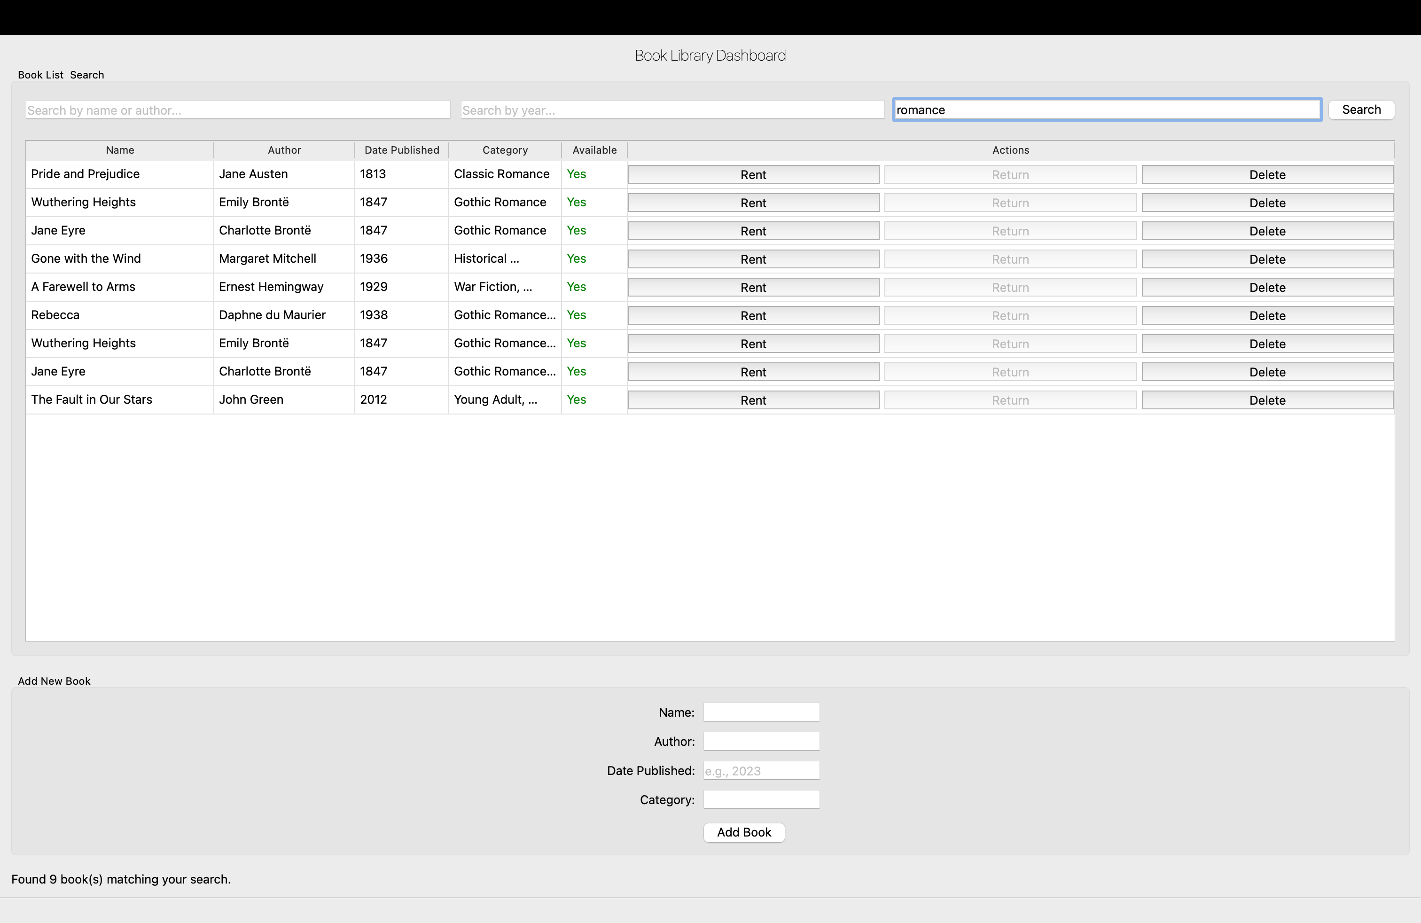
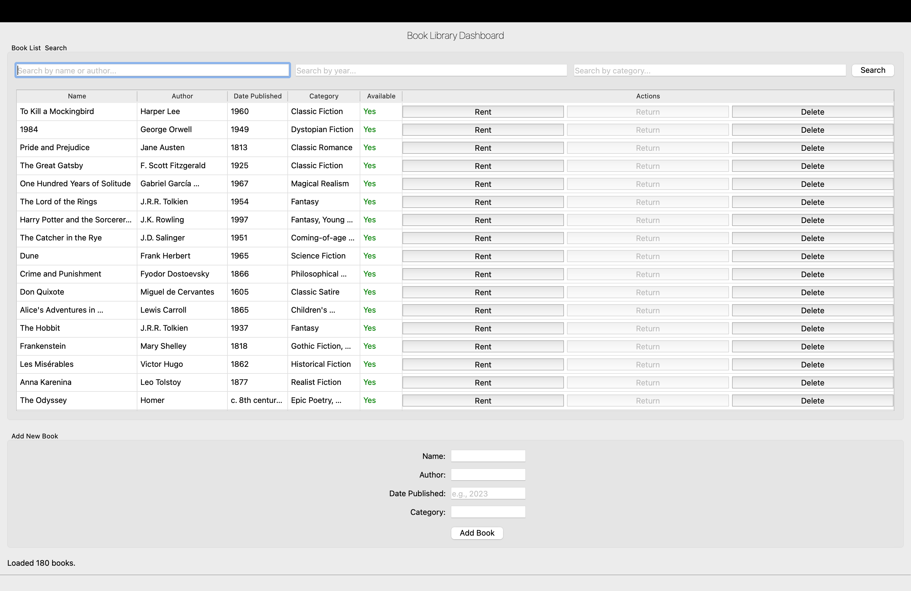
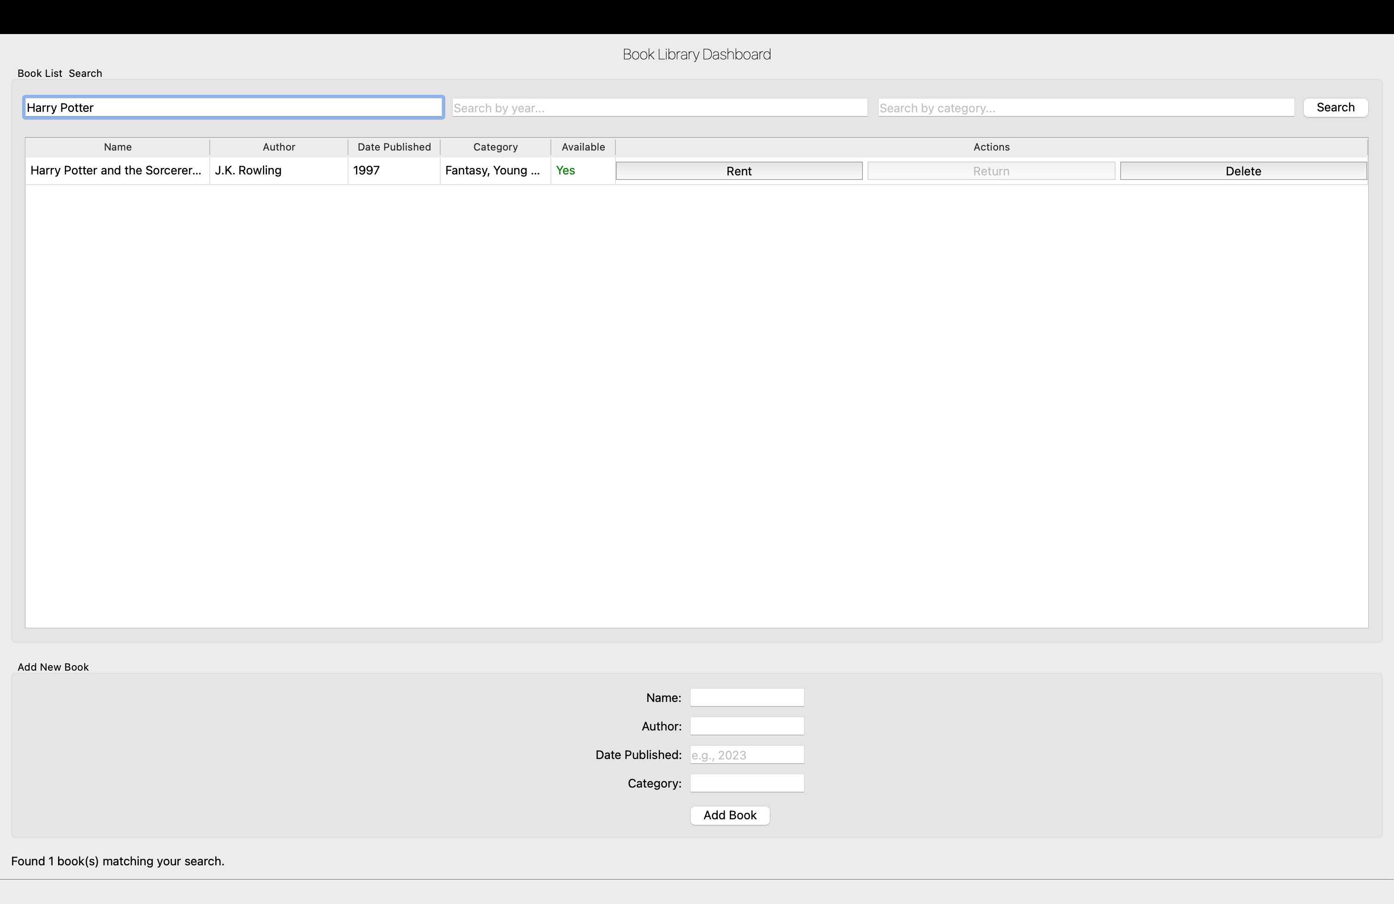
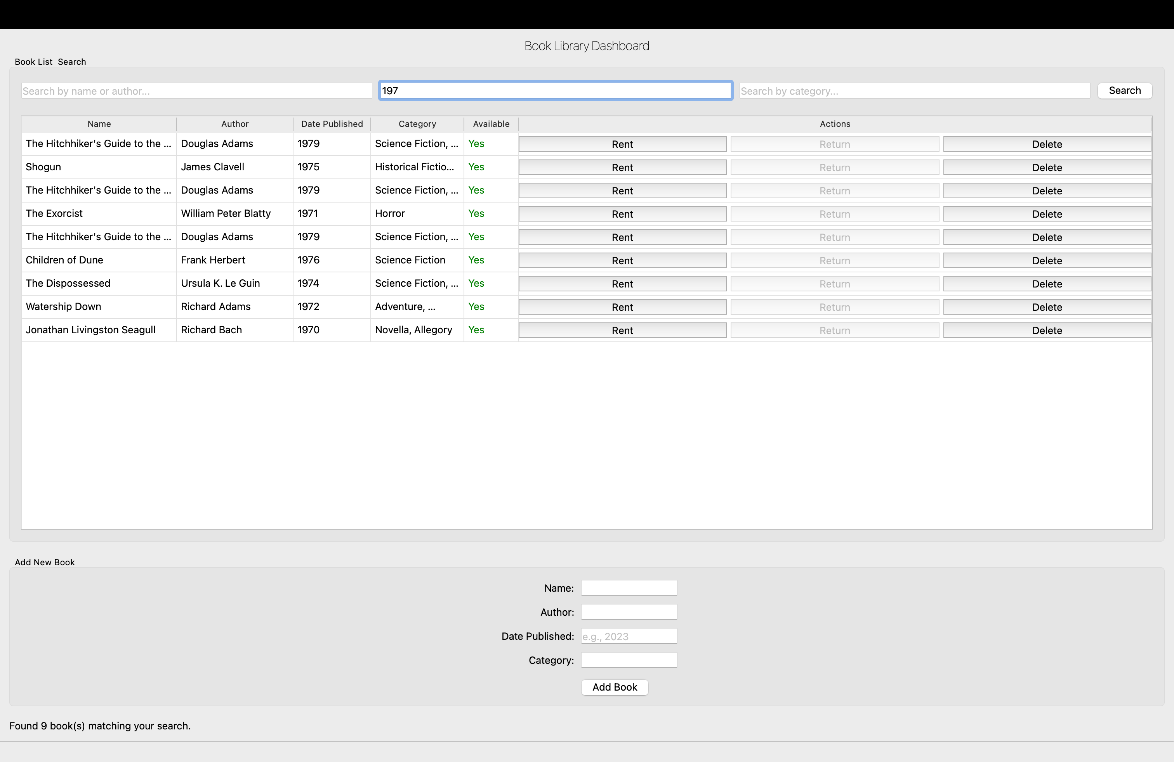
Photos of the GUI:
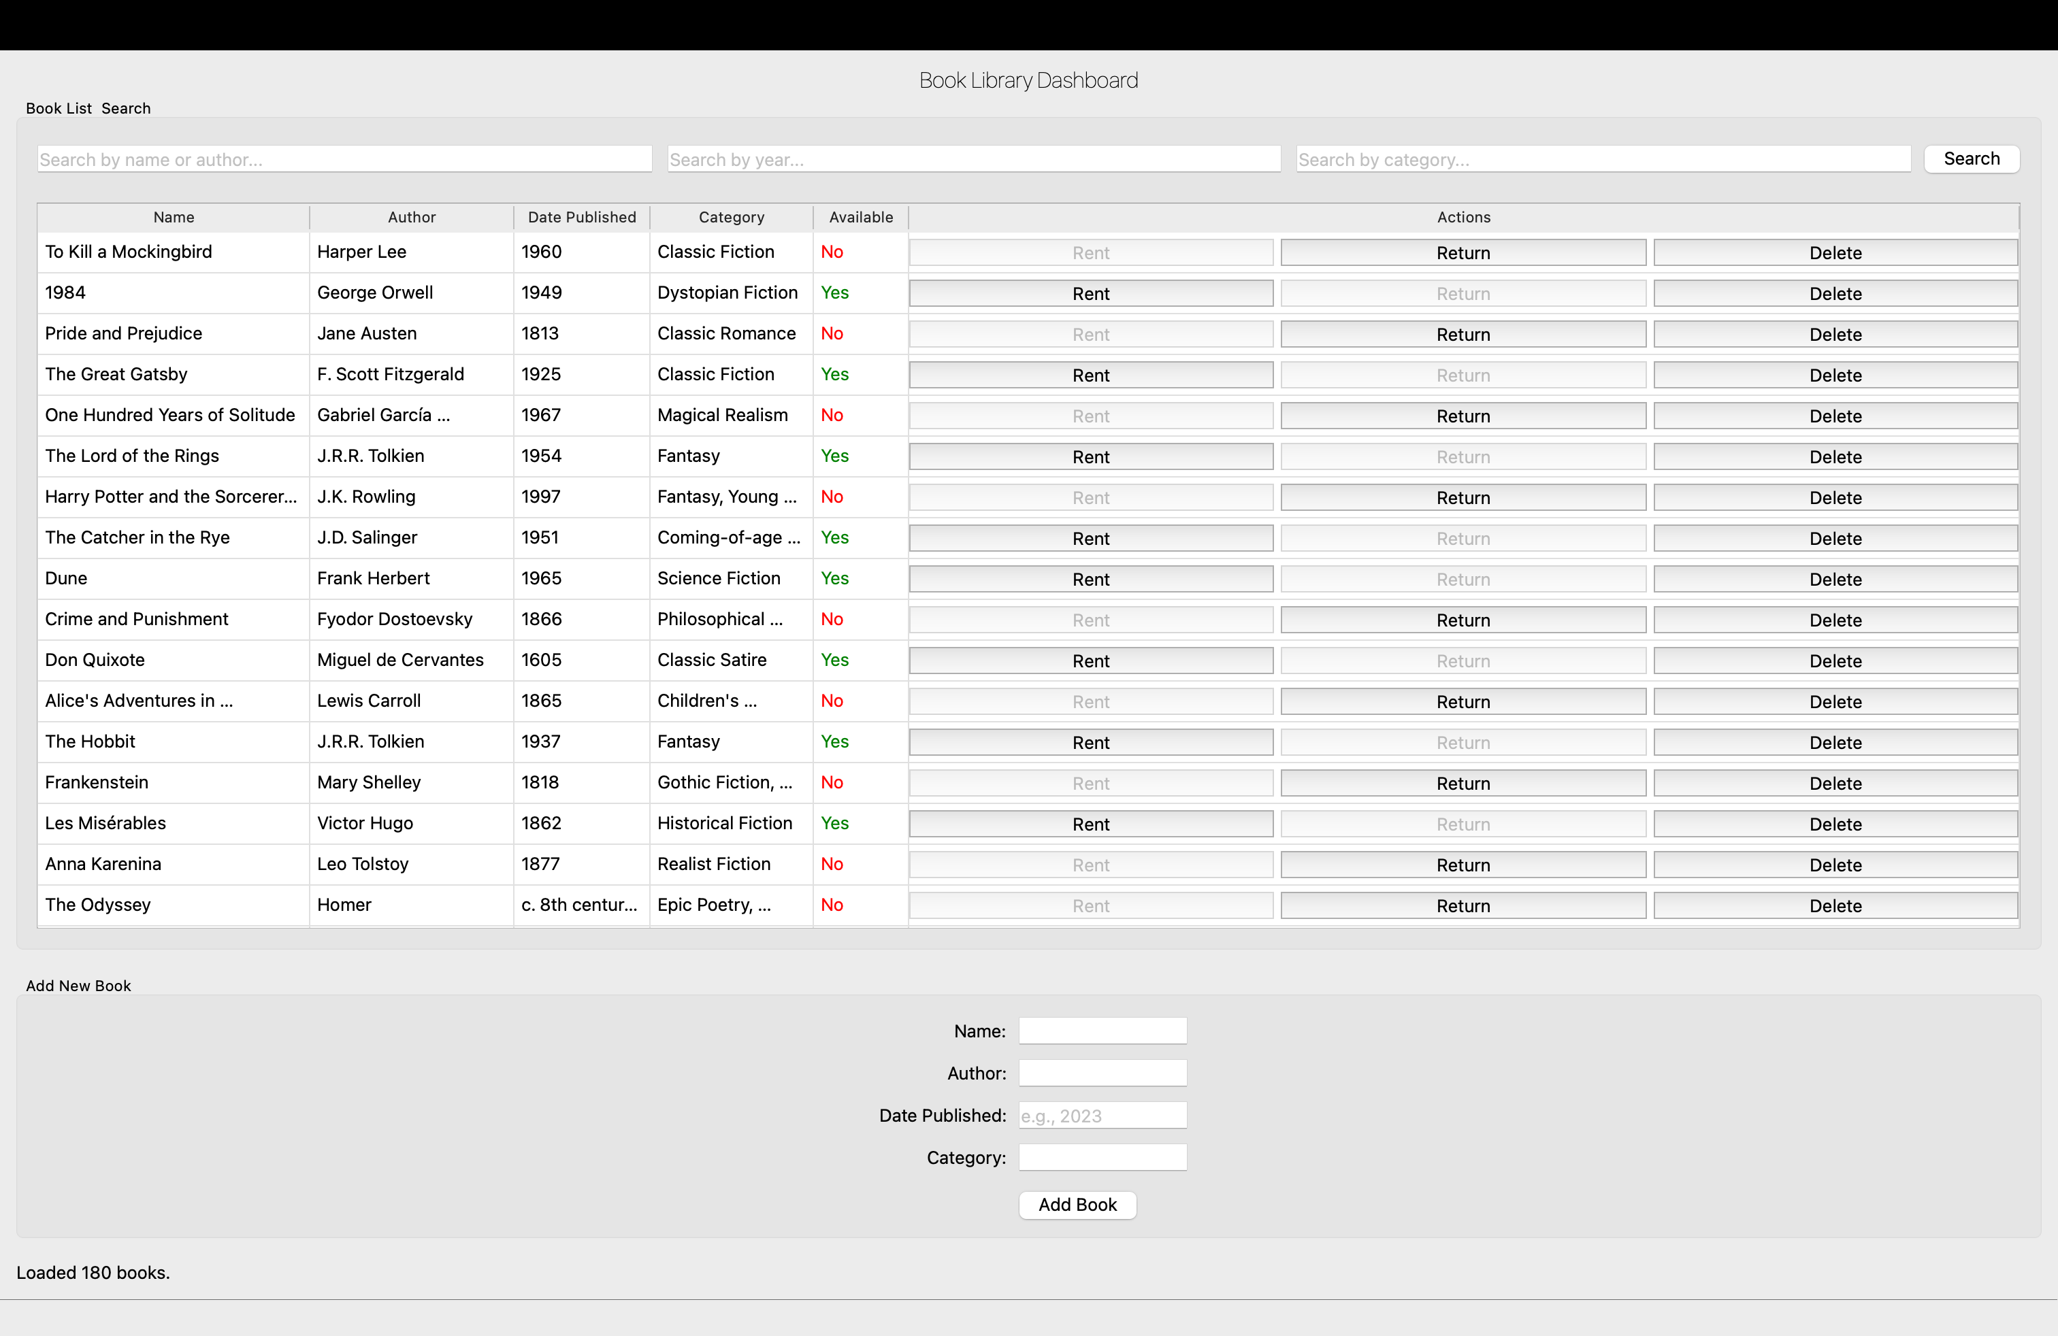

Test_backend.py
1 | import unittest
2 | from backend import app
3 | ​
4 | class BackendTestCase(unittest.TestCase):
5 | def setUp(self):
6 | self.app = app.test_client()
7 | ​
8 | def test_index(self):
9 | response = self.app.get('/')
10| self.assertEqual(response.status_code, 200)
11| self.assertIn(b'Library API is running!', response.data)
12| ​
13| if __name__ == '__main__':
14| unittest.main()

Test_frontend.py
1 | import unittest
2 | from PyQt6.QtWidgets import QApplication
3 | import sys
4 | from desktop_library_app import DesktopLibraryApp
5 | ​
6 | class FrontendTestCase(unittest.TestCase):
7 | @classmethod
8 | def setUpClass(cls):
9 | cls.app = QApplication(sys.argv)
10| ​
11| def test_window_title(self):
12| window = DesktopLibraryApp()
13| self.assertEqual(window.windowTitle(), "Book Library Desktop Dashboard")
14| ​
15| if __name__ == '__main__':
16| unittest.main()

Test_integration.py
1 | import unittest
2 | import requests
3 | ​
4 | class IntegrationTestCase(unittest.TestCase):
5 | def test_add_and_rent_book(self):
6 | # Add a new book
7 | book = {
8 | 'name': 'Test Book',
9 | 'author': 'Test Author',
10| 'date_published': '2025',
11| 'category': 'Test Category'
12| }
13| add_resp = requests.post('http://127.0.0.1:5050/media', json=book)
14| self.assertTrue(add_resp.json().get('success'))
15| # Rent the book
16| rent_resp = requests.post('http://127.0.0.1:5050/rent', json={'book_name': 'Test Book'})
17| self.assertTrue(rent_resp.json().get('success'))
18| ​
19| if __name__ == '__main__':
20| unittest.main()

