Online Library
Santiago De Alba Cazares
100002721
SRH University
BST-AMS-12: Advanced Programming
Instructor: Esteban Pozo
Due Date: December 12, 2025

Contents

Abstract

Introduction
In this project we will see how to create an online library with the use of “Copilot”. Following the tasks given by the teacher, to fulfill all the required point. With the use of a backend with flask and a front end with GUI you will have on display a library where you will be able to search for books, check if they are available or if someone has borrowed it and when did that user borrowed it. Apart from that you will also be able to add more books if wanted and to remove.

Copilot is a conversational, AI-powered assistant that helps boost productivity and streamline workflows by offering contextual assistance, automating routine tasks, and analyzing data. (What Is a Copilot and How Does It Work? | Microsoft Copilot, n.d.)

Task 1
The backend needs all the code such as a library to store data, a sorting code for it to find the users input, and all the code for the frontend to work. The frontend in the other hand needs to be simple for the user to interact with it and be able to work with the backend. The frontend and backend communicate by HTTP requests, meaning that every click the users does the frontend will send a request to the backend and it will perform the necessary operations and send a response back to the frontend. All the data such as name of the book, name of the author, year of publishment, and category will be stored in list of dictionaries.
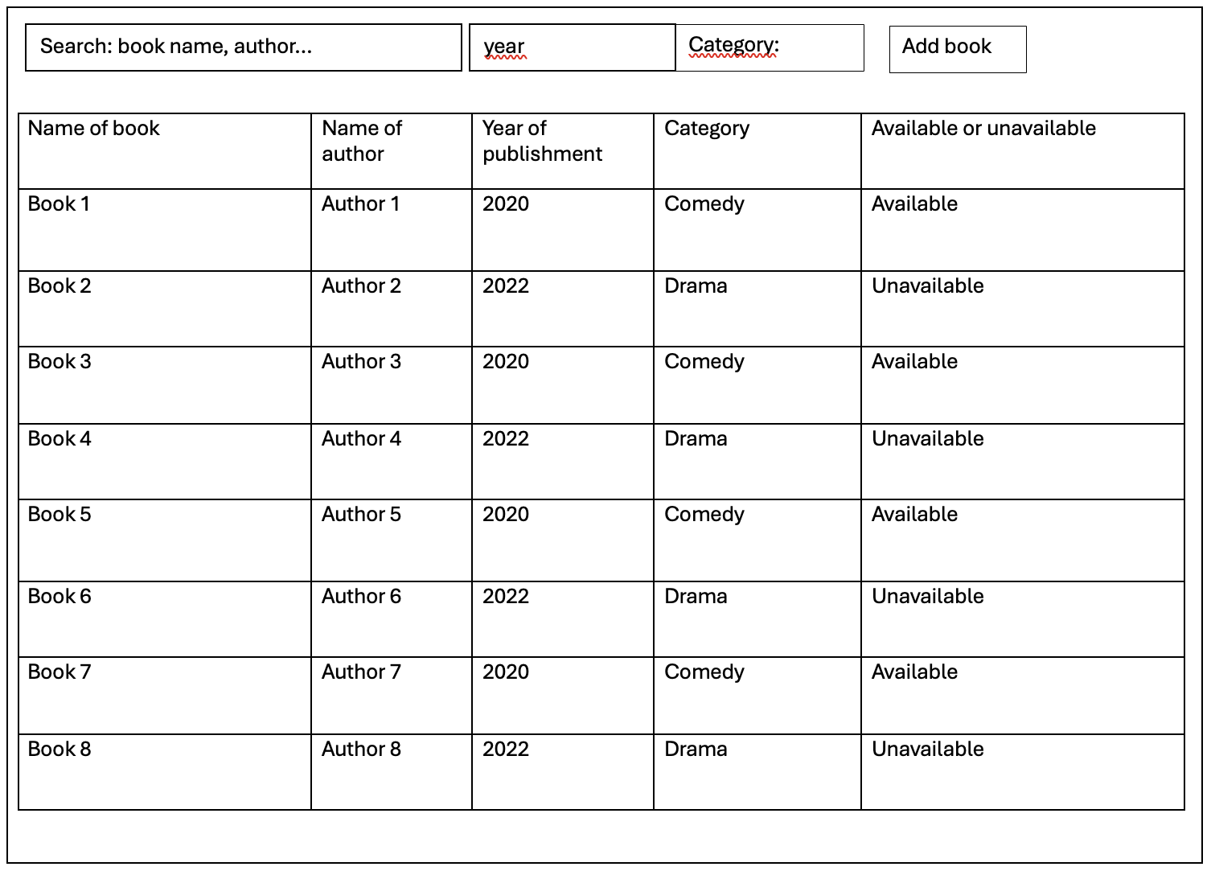
---------------------------------------------------------------------------------------------------------------------
Figure 1. GUI sketch
---------------------------------------------------------------------------------------------------------------------
Some error that can occur are problems connecting the backend with the frontend, also some problems with the code. An easy solution to deal with them is to use the correct prompt with copilot and it will fix it.

Task 2
Program the front end and back end. Take into account your findings from Task 1 and the
requirements from the task description.
When implementing, don't forget to apply the best practices you have learned. Assign meaningful
names. Comment on your program code. Create modules, functions, and classes were
appropriate. Structure your program code.
Prompt to copilot:
“We need to create the backend for an online library that will use the books stored in the file Book_library.py the user should be able to search for books by writing the name of the book or the name of the author. also, the user should be able to sort the books by year, and by category. the user should be able to rent the book, and the book should now be marked as unavailable if a user has rented it otherwise it should be available. to end the user also needs to be able to add more books, by writing the name of the book, name of the author, year of publishment and category”
“Code In appendix”
“I copied and pasted the code in ChatGPT and told it to create me a GUI for the code in .ui”
“GUI in the appendix”
“Pasted the given GUI for ChatGPT in Visual studio and prompted copilot to connect the backend with the front end”
“It created a file called desktop_library_app.py to connect the backend to the frontend, also in the appendix”

Task 3

Subtitle
Your text goes here

Task 4

Subtitle
Your text goes here

References
What is a copilot and how does it work? | Microsoft Copilot. (n.d.). https://www.microsoft.com/en-us/microsoft-copilot/copilot-101/what-is-copilot

Bratslavsky, P. (n.d.). How frontend and backend components interact in a Full-Stack app. Strapi. https://strapi.io/blog/how-frontend-and-backend-components-interact-in-a-full-stack-app

Appendix

Backend code:
import json
from Book_library import library_data
from flask import Flask, request, jsonify

app = Flask(__name__)

class Book:
def __init__(self, name, author, date_published, category, available=True):
self.name = name
self.author = author
self.date_published = date_published
self.category = category
self.available = available

@classmethod
def from_dict(cls, data):
return cls(
name=data['name'],
author=data['author'],
date_published=data['date_published'],
category=data['category'],
available=data.get('available', True)
)

def to_dict(self):
return {
'name': self.name,
'author': self.author,
'date_published': self.date_published,
'category': self.category,
'available': self.available
}

class Library:
def __init__(self, data):
self.books = [Book.from_dict(b) for b in data['media']]

def ensure_availability(self):
for book in self.books:
if not hasattr(book, 'available'):
book.available = True

def search_books(self, query):
query = query.lower()
return [b.to_dict() for b in self.books if query in b.name.lower() or query in b.author.lower()]

def sort_books(self, by='year'):
if by == 'year':
def year_key(book):
try:
return int(''.join(filter(str.isdigit, book.date_published)))
except:
return 0
return [b.to_dict() for b in sorted(self.books, key=year_key)]
elif by == 'category':
return [b.to_dict() for b in sorted(self.books, key=lambda x: x.category)]
else:
return [b.to_dict() for b in self.books]

def rent_book(self, book_name):
for book in self.books:
if book.name.lower() == book_name.lower():
if book.available:
book.available = False
return True
else:
return False
return None

def add_book(self, name, author, date_published, category):
new_book = Book(name, author, date_published, category)
self.books.append(new_book)
return new_book.to_dict()

def list_books(self):
return [b.to_dict() for b in self.books]

def save(self, filename='Book_library.py'):
data = {'media': [b.to_dict() for b in self.books]}
with open(filename, 'w') as f:
f.write('library_data = ' + json.dumps(data, indent=4))

library = Library(library_data)
library.ensure_availability()

@app.route('/search', methods=['GET'])
def api_search_books():
query = request.args.get('query', '')
results = library.search_books(query)
return jsonify(results)

@app.route('/sort', methods=['GET'])
def api_sort_books():
by = request.args.get('by', 'year')
results = library.sort_books(by)
return jsonify(results)

@app.route('/rent', methods=['POST'])
def api_rent_book():
data = request.get_json()
book_name = data.get('book_name', '')
result = library.rent_book(book_name)
if result is True:
library.save()
return jsonify({'success': True, 'message': 'Book rented successfully.'})
elif result is False:
return jsonify({'success': False, 'message': 'Book is not available.'}), 400
else:
return jsonify({'success': False, 'message': 'Book not found.'}), 404

@app.route('/add', methods=['POST'])
def api_add_book():
data = request.get_json()
required = ['name', 'author', 'date_published', 'category']
if not all(k in data for k in required):
return jsonify({'success': False, 'message': 'Missing book information.'}), 400
new_book = library.add_book(data['name'], data['author'], data['date_published'], data['category'])
library.save()
return jsonify({'success': True, 'book': new_book})

@app.route('/books', methods=['GET'])
def api_list_books():
return jsonify(library.list_books())

@app.route('/', methods=['GET'])
def api_home():
return (
'<h2>Online Library API</h2>'
'<ul>'
'<li>GET /books - List all books</li>'
'<li>GET /search?query=... - Search books by name or author</li>'
'<li>GET /sort?by=year|category - Sort books</li>'
'<li>POST /rent - Rent a book (JSON: {"book_name": "..."})</li>'
'<li>POST /add - Add a book (JSON: {"name", "author", "date_published", "category"})</li>'
'</ul>'
)

if __name__ == '__main__':
app.run(debug=True)

