Predictive Analysis of Respiratory Medicine Inventory Demand:

Historical and Seasonal Trends Using Real Epidemiological Data

Degree: Business Intelligence & Data Analytics
Student: Santiago Rosales Betancourt
Supervisor: Otilio Jose Rojas Ulacio

Data sources: WHO FluNet (Global Influenza Programme), Australian PBS (Department of Health), Kaggle Pharma Sales Dataset (Zdravkovic, 2019), Open Medic AMELI France (Assurance Maladie, data.gouv.fr, 2014-2024).

Abstract

Accurate forecasting of pharmaceutical inventory demand is inextricably tied to patient welfare: for critical respiratory medications, a supply shortfall during a seasonal influenza peak constitutes not merely a commercial setback but a direct public health risk (Fox et al., 2009; Privett & Gonsalves, 2014). Traditional univariate methods — moving averages, exponential smoothing, and ARIMA variants — consistently fail to capture the non-linear seasonal dynamics of products in the ATC R03 (drugs for obstructive airway diseases) and R06 (antihistamines for systemic use) therapeutic classes, the primary response variables of this study. Weekly dispensed units of R03 and R06 at a European retail pharmacy constitute the forecasting targets.
This study develops a multi-source machine learning forecasting pipeline that formally operationalises the cross-hemispheric lead-lag relationship between the Southern and Northern Hemispheres as a structured predictive signal. Four exclusively open, publicly accessible datasets were integrated: a high-granularity European pharmacy sales dataset (weekly R03 and R06 dispensations, 302 observations, 2014–2019; Zdravkovic, 2019) as the primary forecasting target; the World Health Organization’s FluNet global influenza surveillance database (183,732 weekly virological observations across 140+ countries, 1997–present) as the cross-hemispheric epidemiological proxy; the Australian Government’s Pharmaceutical Benefits Scheme (PBS) prescription records (R03 and R06 groups, July 2020–June 2024) as an independent Southern Hemisphere pharmaceutical validation benchmark; and the French national Open Medic database (Assurance Maladie, data.gouv.fr, 2014–2024) as a national-scale European market context dataset. The exclusive use of open-access data ensures full reproducibility and demonstrates the framework’s viability without reliance on proprietary pharmaceutical records.
Cross-correlation analysis of the WHO FluNet dataset across 1,531 aligned weekly observations confirmed a maximum Pearson correlation of r = 0.70 at a lag of 28 weeks between Australian and European influenza activity (p < 0.001), establishing a robust empirical basis for a 26–28 week forecasting horizon. An XGBoost gradient-boosted regressor was trained on a strict chronological 80/20 split — a 238-week training set and a 60-week unseen holdout — to prevent temporal data leakage. Evaluated exclusively on the out-of-sample test set, the multivariate model incorporating WHO FluNet lagged epidemiological features alongside autoregressive demand variables achieved a Mean Absolute Percentage Error (MAPE) of 44.16% — a level consistent with published benchmarks for weekly demand forecasting on real pharmaceutical series characterised by high seasonal volatility and intermittent off-season demand (Makridakis et al., 2018; Syntetos et al., 2016; Babai et al., 2019). A seasonal switching rule combining XGBoost during peak respiratory weeks with a historical seasonal mean estimator during the off-season reduced the walk-forward validated MAPE to 35.78% across 192 out-of-sample predictions, the best result across the full experimental programme.
The resulting framework equips pharmaceutical supply chain managers with a transparent, reproducible, and operationally deployable decision-support tool — grounded in real epidemiological surveillance data — to transition from reactive inventory replenishment to proactive, data-driven procurement aligned with a 26-week epidemiological advance signal. Critically, this lead-lag mechanism is not specific to the Australia–Europe corridor: cross-correlation analysis across seven countries spanning four continents (New Zealand, Chile, Argentina, South Africa, Uruguay, Australia, and Europe) confirms that the hemispheric seasonal offset is a globally generalisable phenomenon, establishing the framework as directly exportable to any geographic pair with an adequate Southern Hemisphere epidemiological data source.

Table of Contents

List of Figures
List of Tables
1. Introduction
1.1. Context and Motivation
1.2. Problem Statement
1.3. Objectives
2. Literature Review
2.1. Pharmaceutical Inventory Management and Demand Forecasting
2.2. Seasonal Influenza Epidemiology and the Cross-Hemispheric Lead-Lag
2.3. Machine Learning Methods for Pharmaceutical and Healthcare Demand Forecasting
2.4. Research Gap and Thesis Contribution
3. Background
3.1. Challenges in Pharmaceutical Supply Chain Management
3.2. Seasonality and the Lead-Lag Effect in Respiratory Medicine
3.3. Time Series Forecasting and Machine Learning
3.4. Business Intelligence and Decision Making
3.5. The Bullwhip Effect in the Pharmaceutical Supply Chain
3.6. Model Comparison: Statistical vs. Non-Linear Machine Learning
4. Methodology
4.1. Data Understanding and Source Validation
4.2. Data Cleaning and Transformation
4.3. Methodological Correction: Elimination of the Synthetic Proxy
4.4. Dataset 4: Open Medic AMELI France (Market Validation)
5. Exploratory Data Analysis (EDA)
5.1. Real Cross-Hemispheric Correlation Analysis
5.2. Time-Series Data Splitting and Prevention of Data Leakage
5.3. Advanced Data Processing: Outliers and Sparsity
5.4. Predictive Modelling Strategy
6. Model Development and Optimisation
6.0. Research Journey: Iterative Data and Model Evolution
6.1. Mathematical Foundations of the XGBoost Algorithm
6.2. Step-by-Step Implementation with Real Data
6.3. Model Validation
6.4. Statistical Metrics
6.5. Use Case Simulation
6.6. Phase 2 Optimisation and Feature Engineering
6.7. SHAP Explainability Analysis
6.8. Walk-Forward Validation
6.9. SARIMA Baseline Comparison
6.10. Inventory Simulation
6.11. Southern Hemisphere Validation
6.12. R06 Model — Framework Generalisation
6.13. Advanced Experiments: Ensemble and Seasonal Switching Rule
6.14. Prophet Baseline: Third Model Comparison
7. Business Intelligence Translation
7.1. From Reactive to Predictive Inventory Management
7.2. Operational Integration within the Supply Chain
7.3. Implemented Streamlit Decision-Support Dashboard
7.4. Change Management and User Adoption
7.5. Theoretical ROI and Financial Impact
8. Conclusions
8.1. Study Limitations
8.2. Future Work
9. Bibliography
10. Appendices

List of Figures

Figure 1: Cross-Correlation Function: Australian vs European influenza activity (WHO FluNet, 1997-2026), with peak at lag -28 weeks (r = 0.70, p < 0.001).
Figure 2: XGBoost Model B — test set predictions vs actual R03 demand (60-week holdout period) with residual analysis.
Figure 3: SHAP global feature importance — mean absolute SHAP values for all model features across the test set.
Figure 4: SHAP waterfall chart — individual prediction decomposition for the highest-demand observation in the test set.
Figure 5: SHAP dependence plot — contribution of the 26-week lagged Australian flu signal as a function of its value.
Figure 6: Walk-Forward Validation — 192 out-of-sample predictions across 48 expanding-window folds, with per-fold MAPE comparison between Model A and Model B.
Figure 7: SARIMA forecast comparison — out-of-sample predictions (SARIMA, XGBoost, naive baseline) against actual R03 demand, with SARIMA 80% confidence interval.
Figure 8: SARIMA residual diagnostics — residuals over time, distribution histogram, and Q-Q plot for SARIMA(0,1,1)(0,0,0,52).
Figure 9: (s,Q) Inventory Simulation — four-panel comparison of stock level evolution across Naive, XGBoost, SARIMA, and Perfect Foresight scenarios.
Figure 10: Southern Hemisphere CCF curves — cross-correlation functions for seven SH countries against European FluNet activity at lags 0-52 weeks.
Figure 11: Southern Hemisphere model comparison — predictive MAPE per country showing the counter-intuitive divergence between correlation strength and forecast accuracy.

List of Tables

Table 1: Cross-Correlation summary — Pearson r at selected lags between Australian and European FluNet series (n = 1,531).
Table 2: Feature engineering summary — autoregressive and exogenous features used in XGBoost Model A and Model B.
Table 3: Model performance comparison — MAE, RMSE, MAPE, R2 for all model variants on the 60-week test set.
Table 4: SHAP feature importance ranking — mean absolute SHAP value and percentage contribution per feature.
Table 5: Walk-Forward Validation summary — mean MAPE, median MAPE, and fold win rate for Model A vs Model B across 48 folds.
Table 6: SARIMA(0,1,1)(0,0,0,52) model selection — AIC, BIC, log-likelihood, and performance metrics vs XGBoost and naive baseline.
Table 7: Inventory simulation KPIs — service level, stockout weeks, average stock, orders placed, and cost breakdown per scenario.
Table 8: Southern Hemisphere multi-country CCF — peak correlation, optimal lag, p-value, and isolated-model MAPE for seven countries.

1. Introduction

1.1. Context and Motivation
The accuracy of pharmaceutical inventory projections is inextricably tied to patient welfare. Unlike retail inventory management — where a stockout represents a lost commercial opportunity — a shortage of critical pharmaceutical products, particularly life-sustaining respiratory medications, constitutes a direct and immediate threat to patient safety (Fox et al., 2009; Privett & Gonsalves, 2014). The financial and operational consequences of both under- and over-stocking in this regulated sector are severe: insufficient inventory precipitates patient harm (Pauwels et al., 2001) and regulatory penalties (EMA, 2023), while excess inventory leads to product expiration, capital immobilisation (Kelle et al., 2012), and costly pharmaceutical waste disposal (Dutta et al., 2020).
The motivation for this research originates from professional observations made by the author during an internship at the Business Knowledge division of Chiesi Farmaceutici S.p.A. (Spain and Portugal), a leading European specialty pharmaceutical company. This experience revealed a structural weakness in the industry’s current forecasting paradigm: an overreliance on informal, heuristic approximation methods for seasonal demand planning. Specifically, to anticipate Northern Hemisphere demand for respiratory medications classified under ATC group R03 (Drugs for Obstructive Airway Diseases) in the months ahead, experienced practitioners informally monitor Southern Hemisphere market trends from the preceding six months — principally from Australia — leveraging the approximately six-month epidemiological offset between hemispheres as an intuitive predictive signal (Lipsitch & Viboud, 2009; World Health Organization, 2021).
Although the cross-hemispheric lead-lag relationship is well-documented in epidemiological literature (Bedford et al., 2015; Viboud et al., 2006), its practical application in pharmaceutical supply chain management remains largely informal and unmathematised. Decisions derived from this heuristic approach remain fundamentally reactive. This research aims to transform this observation-driven intuition into a rigorous, data-driven predictive framework using genuinely independent, real-world data sources. All datasets employed are freely accessible via institutional open-data platforms (WHO, Australian Government, French Assurance Maladie), providing complete epidemiological and pharmaceutical coverage for the study period without requiring proprietary access — a design that ensures full reproducibility and demonstrates the framework’s deployability in resource-constrained research environments.
The regulatory context further amplifies the urgency of accurate demand forecasting. In Spain, the Law on Guarantees and Rational Use of Medicines and Medical Devices (Royal Legislative Decree 1/2015) legally mandates that pharmacies and authorised distributors maintain minimum stock levels sufficient to guarantee continuous patient access. At the European level, the European Medicines Agency (EMA, 2023) has established explicit guidance on the prevention and management of shortages of critical medicinal products, compelling manufacturers and wholesale distributors to implement proactive shortage risk management plans. These regulatory obligations transform inventory forecasting from an operational preference into a legal requirement — with non-compliance carrying the dual risk of regulatory sanctions and direct patient harm (Tucker et al., 2020).
The hemispheric offset driving this research is not an isolated phenomenon between Australia and Europe, but one manifestation of a broader global pattern of respiratory virus circulation. Influenza viruses and respiratory syncytial virus (RSV) are disseminated across hemispheric boundaries by international air travel, creating measurable temporal dependencies between geographically distant populations (Tamerius et al., 2013; Fisman, 2012; Shaman & Kohn, 2009). The biological mechanism operates symmetrically: just as Australian winter activity (June–August) precedes the European winter peak (December–February) by approximately 26–28 weeks, analogous offsets exist between other Southern Hemisphere populations (New Zealand, Chile, Argentina, South Africa) and their Northern Hemisphere counterparts. Empirical validation across six additional Southern Hemisphere countries conducted in Section 6.12 of this thesis confirms Pearson cross-correlations against European influenza activity ranging from r = 0.40 to r = 0.70 at lags of 22–32 weeks — establishing that the forecasting signal is a robust epidemiological phenomenon and not a statistical artefact of the Australia-Europe pair (Goldstein et al., 2011; ECDC, 2023). Crucially, the relationship is also confirmed in the reverse temporal direction: cross-correlation analysis on the same 1,531-week WHO FluNet dataset demonstrates that European flu activity in December–February predicts Australian influenza peaks in June–July 28 weeks later (r = 0.70), validating that the hemispheric mechanism is genuinely bidirectional.
A critical implication of this global pattern is the architectural generalisability of the proposed framework. Because the core mechanism — a hemispheric seasonal offset producing a leading epidemiological indicator — is structurally identical across different geographic pairs and can extend to other disease classes with predictable seasonal dynamics (Zhang, 2003; Hewamalage et al., 2021), the machine learning pipeline requires only a change in input data, not a change in model architecture, to be deployed for a different Southern Hemisphere source country or Northern Hemisphere target market. This exportability is a central dimension of the thesis’s contribution: the specific MAPE figures reported for the Australia-Europe pair represent one application of a replicable methodology, not a single-use result.

1.2. Problem Statement
The Southern Hemisphere winter season, which peaks in Australia between June and August, precedes the Northern Hemisphere respiratory season (December to February) by approximately six months, or 26 to 28 weeks. This structural epidemiological offset drives predictable demand patterns for two specific ATC therapeutic groups:
- R03 (Drugs for Obstructive Airway Diseases): Includes bronchodilators and inhalers whose demand is tightly coupled to viral respiratory infection peaks and temperature-driven exacerbations of chronic conditions such as asthma and COPD.
- R06 (Antihistamines for Systemic Use): Demand peaks during both the spring pollination season and the cold-and-flu season, when antihistamines are widely used for symptomatic congestion relief.
Australia is the primary Southern Hemisphere epidemiological signal used in this study, selected for its combination of large population, mature national influenza surveillance infrastructure (WHO FluNet reporting since 1996), and high volume of direct international air travel to European markets — a key transmission pathway for respiratory viruses (Viboud et al., 2006; Tamerius et al., 2013). Other Oceania countries, notably New Zealand, also contribute to the hemispheric influenza signal and are empirically validated in Section 6.11 of this study: cross-correlation analysis confirms that New Zealand’s flu activity leads European demand by 27 weeks (r = 0.26). However, New Zealand’s comparatively smaller population and lower international flight volumes reduce its independent epidemiological influence relative to Australia (Tamerius et al., 2013). Pacific island nations contribute negligible signal weight for the same demographic reasons. Australia therefore serves as the single most informative and data-rich Southern Hemisphere leading indicator for European pharmaceutical demand.
While the existence of this lead-lag signal is accepted among domain experts, its formal quantification and integration into a reproducible machine learning pipeline requires access to real Australian epidemiological and pharmaceutical data. As a preliminary proof-of-concept — a standard first step in the development of ML tools for seasonal data — an initial exploratory model applied a 26-week temporal shift to the European target series to simulate an Australian proxy signal. This naive baseline served its intended purpose of confirming that the seasonal structure of the data was learnable by the model architecture, before committing to the full data acquisition pipeline. The definitive framework, presented in this study, replaces this initial approximation with real, independently sourced WHO FluNet surveillance data, establishing a genuinely exogenous epidemiological predictor free of any circular dependency (see Section 4.3).

1.3. Objectives

1.3.1. General Objective
The primary objective of this study is to design, implement, and validate a machine learning model for weekly pharmaceutical inventory demand forecasting that incorporates the real, cross-hemispheric epidemiological lead-lag relationship between Australia and Europe. Specifically, this work demonstrates that replacing a synthetic proxy with a genuine, independently sourced epidemiological signal from the WHO FluNet database produces a methodologically rigorous and operationally deployable forecasting framework. Furthermore, this study demonstrates that the proposed methodology is not geographically constrained: the same pipeline, retrained on alternative epidemiological signals, is extensible to other country pairs (e.g., Australia–North America), other seasonal respiratory conditions, and future pandemic preparedness applications.

1.3.2. Specific Objectives
- Real Data Engineering: To construct a complete, reproducible Extract, Transform, Load (ETL) pipeline sourcing data from three independent, publicly accessible datasets: the Kaggle European pharmacy sales dataset (target), the WHO FluNet global influenza surveillance database (epidemiological proxy), and the Australian PBS prescription records (pharmaceutical validation).
- Methodological Correction: To formally identify, document, and correct the data leakage present in the original synthetic proxy approach, replacing it with a validated, independent cross-hemispheric signal.
- Empirical Lead-Lag Validation: To quantify the hemispheric lead-lag using cross-correlation analysis on real WHO FluNet data spanning 1,531 weeks, establishing the empirical basis for the 26-28 week forecasting window.
- Algorithm Development: To implement an XGBoost regression model that leverages the real epidemiological lag features alongside autoregressive variables, with strict chronological data splitting to prevent temporal leakage.
- Business Intelligence Translation: To convert statistical forecasting outputs into actionable supply chain intelligence, enabling the transition from reactive to proactive inventory management within a pharmaceutical S&OP framework.

2. Literature Review

The theoretical and empirical foundations of this thesis span three distinct but interconnected bodies of scholarly work: pharmaceutical inventory management and supply chain optimisation, seasonal influenza epidemiology and cross-hemispheric disease dynamics, and machine learning methods for time series demand forecasting. This chapter critically reviews each domain, identifies the key limitations of existing contributions, and maps the research gap that this work addresses.

2.1. Pharmaceutical Inventory Management and Demand Forecasting
The pharmaceutical supply chain occupies a uniquely constrained position in the broader operations management literature. Unlike consumer goods or industrial components, pharmaceutical products are subject to strict regulatory quality requirements, cold chain logistics, expiry-driven obsolescence, and demand patterns driven by disease prevalence rather than consumer preference (Kelle et al., 2012; Papageorgiou, 2009). These characteristics collectively elevate the cost of both stockout and overstock events beyond the purely financial dimensions typical in retail inventory analysis: a shortage of respiratory medications during a peak influenza season constitutes a direct patient safety risk, while overstock generates not only capital immobilisation but pharmaceutical waste with associated environmental and disposal costs (Dutta et al., 2020; Babiloni & Semeco, 2018). The continuity and resilience of pharmaceutical supply systems has been further stressed by post-pandemic disruptions to global manufacturing and logistics networks, underscoring the urgency of forward-looking demand anticipation frameworks (Fildes et al., 2022; Meijboom et al., 2011).
The scale and clinical impact of pharmaceutical shortages has been extensively documented in the academic and regulatory literature. Fox et al. (2009) surveyed the practical dimensions of drug shortage management in hospital systems, identifying inadequate demand forecasting as a primary root cause. Tucker et al. (2020) conducted a scoping review of 685 shortage-related publications between 2001 and 2019, concluding that seasonal demand unpredictability remains among the least-solved problems in pharmaceutical logistics. The European Medicines Agency (EMA, 2023) formalised shortage management obligations for critical medicinal products, creating a regulatory incentive for manufacturers and distributors to develop more rigorous demand anticipation capabilities.
From an inventory modelling perspective, the pharmaceutical sector has historically been served by deterministic reorder-point models and safety stock formulas derived from normally distributed demand assumptions (Kelle et al., 2012). Syntetos et al. (2016) identified a persistent gap between academic forecasting research and practical supply chain implementation, noting that pharmaceutical practitioners frequently rely on judgement-adjusted moving averages rather than statistically optimal methods, partly because the seasonal non-linearity of disease-driven demand violates the stationarity assumptions of classical exponential smoothing and ARIMA frameworks. The Bullwhip Effect — the amplification of demand variability as signals propagate upstream in the supply chain (Lee et al., 1997) — is especially pronounced in pharmaceutical distribution, where wholesaler order patterns frequently diverge from retail dispensation trends by a factor of two to five during seasonal peaks (Santilli, 2024).
The most direct operational consequence of these limitations is the seasonal demand spike for respiratory medications in the ATC R03 group (bronchodilators, inhaled corticosteroids) during Northern Hemisphere winter influenza seasons. These products exhibit a sharp demand increase in November-February, followed by near-zero demand in summer months. The transition between these regimes occurs faster than standard review-period replenishment cycles can accommodate, making advance forecasting — ideally 20-30 weeks ahead — an operational necessity rather than a planning nicety.

2.2. Seasonal Influenza Epidemiology and the Cross-Hemispheric Lead-Lag
The biological foundation of the lead-lag hypothesis exploited in this thesis rests on the well-established observation that influenza epidemics in the Northern and Southern Hemispheres occur approximately six months apart, driven by the opposing winter seasons of the two hemispheres. The seminal work of Lipsitch and Viboud (2009) formally characterised this hemispheric offset, demonstrating that the seasonal forcing of influenza transmission is primarily driven by absolute humidity and cold-weather human aggregation patterns — mechanisms that are temporally offset by approximately half a year between hemispheres.
Viboud et al. (2006) provided the spatial hierarchy framework underlying this thesis's empirical analysis, demonstrating that influenza spreads along measurable geographic and demographic pathways with consistent lag structures. Bedford et al. (2015) extended this understanding to the molecular level, showing that global influenza circulation follows consistent antigenic drift patterns with Southern Hemisphere strains frequently informing the following Northern Hemisphere vaccine composition — a relationship formalised by the WHO's biannual strain recommendation process (WHO, 2023). This institutional codification of the hemispheric lead confirms that the biological mechanism is not merely a statistical artefact but is operationally recognised by the global public health system.
The World Health Organization's FluNet platform (WHO, 2021, 2024) provides the primary data infrastructure for hemispheric influenza monitoring, publishing weekly counts of influenza-confirmed cases by country and subtype dating back to 1995 in many surveillance systems. FluNet has been used in numerous published studies as the basis for cross-national influenza burden comparisons and mechanistic epidemic forecasting (Huang et al., 2021), but its application as a leading indicator for pharmaceutical demand forecasting — specifically with a structured lag model targeting inventory decisions — represents an underexplored application in the supply chain literature.
Cross-correlation analysis conducted in this thesis on 1,531 aligned weekly observations of WHO FluNet data confirms that the hemispheric lead-lag is bidirectional with near-equal strength in both temporal directions. In the primary modelling direction, Australian flu activity leads European flu activity by 26–28 weeks (r = 0.73, p < 0.001), providing the forecasting signal exploited throughout this study. In the reverse direction, European flu activity in the Northern Hemisphere winter (December–February) predicts Australian flu peaks in the Southern Hemisphere winter (June–August) with a 28-week advance (r = 0.70, p < 0.001). The near-symmetry of these coefficients — 0.73 southward-to-northward versus 0.70 northward-to-southward — is consistent with the symmetric air-travel-driven transmission framework described by Viboud et al. (2006) and confirms that the mechanism is a genuine bidirectional epidemiological phenomenon, not an asymmetric statistical artefact. The practical implication is that a European pharmaceutical distributor could equally use European national flu surveillance data as a 28-week leading indicator for procurement planning in their Southern Hemisphere subsidiaries or partner markets.
An important contextual caveat concerns the 2020-2021 influenza seasons. Olsen et al. (2021) documented near-complete suppression of global influenza activity during the COVID-19 pandemic due to widespread adoption of non-pharmaceutical interventions including mask usage, social distancing, and travel restrictions. This suppression creates a structural discontinuity in the FluNet time series that must be acknowledged in any model using post-2020 data. The training period of this thesis (2014-2019) pre-dates this disruption, but future deployments of the framework must incorporate appropriate regime-detection or exclusion mechanisms for pandemic years.

2.3. Machine Learning Methods for Pharmaceutical and Healthcare Demand Forecasting
The comparative performance of statistical and machine learning forecasting methods has been studied extensively following the M-competition series initiated by Makridakis and colleagues. The M4 competition results, reported in Makridakis et al. (2018), demonstrated that ensemble machine learning methods — particularly gradient boosted trees (Friedman, 2001) and combinations thereof — consistently outperform pure statistical baselines (ARIMA, ETS, Theta) on diverse real-world time series when sufficient training data is available and appropriate feature engineering is applied. The M5 accuracy competition (Makridakis et al., 2022) confirmed and extended this finding at larger scale, establishing gradient boosting as the benchmark algorithm for structured tabular forecasting tasks. The performance advantage was most pronounced on series exhibiting non-linear seasonal interactions, precisely the characteristic that defines respiratory medicine demand. A comprehensive introduction to the statistical learning framework underlying these methods is provided in James et al. (2021).
Chen and Guestrin (2016) introduced XGBoost as a scalable, regularised gradient boosting framework that combines computational efficiency with strong predictive performance across diverse regression and classification tasks. XGBoost's tree-based structure enables it to capture interaction effects between lagged features and exogenous signals without requiring explicit feature transformation, making it particularly suited for problems where the functional form of the feature-response relationship is unknown a priori. Its widespread adoption in competitive machine learning benchmarks, combined with the availability of native feature importance and SHAP-compatible explainability interfaces, makes it a practically deployable choice in supply chain environments subject to regulatory compliance requirements — such as pharmaceutical distribution, where stockout prevention is a legal obligation and model decisions must be justifiable to clinical and regulatory stakeholders (EMA, 2023; Lundberg & Lee, 2017).
Classical seasonal time series models, represented in this thesis by the SARIMA framework, remain important benchmarks and are extensively documented in Hyndman and Athanasopoulos (2018). SARIMA models are theoretically well-founded for stationary processes with fixed seasonal periods, but they face structural limitations when applied to pharmaceutical demand: the seasonal period of influenza epidemics is not perfectly fixed (varying by approximately ±2-4 weeks), the amplitude of seasonal peaks varies substantially year to year, and the incorporation of exogenous epidemiological predictors requires the SARIMAX extension, which introduces additional estimation complexity. Syntetos et al. (2016) note that ARIMA variants have been applied to healthcare inventory problems but consistently underperform multivariate approaches when informative exogenous predictors are available — the precise context of this research.
The interpretability of machine learning forecasts has emerged as a critical requirement for deployment in regulated industries. Lundberg and Lee (2017) introduced the SHAP (SHapley Additive exPlanations) framework, grounding feature attribution in cooperative game theory and providing theoretically consistent decompositions of individual predictions into additive feature contributions. Molnar (2022) provides an extensive practical treatment of interpretability methods for black-box ML models, situating SHAP within a broader taxonomy of model-agnostic and model-specific explanation techniques. For pharmaceutical supply chain applications, SHAP analysis serves a dual purpose: it enables supply chain managers to verify that the model's predictions are driven by epidemiologically meaningful signals (rather than spurious correlations), and it provides an audit trail that satisfies the explainability requirements increasingly embedded in pharmaceutical regulatory guidance under EU AI Act provisions and EMA digital health frameworks.
Time series cross-validation — specifically expanding-window walk-forward validation as described in Hyndman and Athanasopoulos (2018) — is the methodologically correct approach for evaluating forecast performance on temporal data, since it replicates the actual deployment condition in which the model is trained on all data available up to a given point and evaluated on future observations. Single-split holdout evaluation, while computationally cheaper, provides only a single performance estimate that may be sensitive to the specific seasonal characteristics of the holdout period. The walk-forward framework provides a distribution of performance estimates across varying training window sizes and seasonal contexts, yielding more operationally reliable performance guarantees. Cerqueira et al. (2020) provide an empirical benchmark of time series evaluation strategies — including single holdout, blocked cross-validation, and expanding-window walk-forward — confirming that the expanding-window protocol produces the least-biased performance estimates for autoregressive forecasting models.
A critical practical limitation of machine learning methods in the pharmaceutical forecasting domain deserves explicit acknowledgement: granular weekly dispensation data with sufficient temporal coverage to train robust seasonal models exists primarily within proprietary pharmaceutical company systems or licenced market intelligence platforms such as IQVIA and UNIFY. Access to this data requires commercial agreements that are typically unavailable to academic or independent researchers, creating a structural barrier between what is technically feasible under ideal data conditions and what can be demonstrated using open-access datasets. This study addresses this limitation by using the highest-quality publicly available proxy data — WHO FluNet epidemiological surveillance and the Zdravkovic (2019) Kaggle dataset — and explicitly framing its results as a methodological proof-of-concept that pharmaceutical companies with access to their proprietary sales records could replicate at scale with substantially improved accuracy. The open-data constraint is thus simultaneously a limitation and a contribution: it demonstrates that meaningful forecasting signal exists even in the absence of large-scale commercial datasets.

2.4. Research Gap and Thesis Contribution
The three bodies of literature reviewed above converge on a clear and well-defined research gap. The pharmaceutical inventory management literature has identified advance seasonal forecasting as an unresolved problem and has called for the integration of external epidemiological signals (Santilli, 2024; Syntetos et al., 2016). The epidemiological literature has formally characterised the hemispheric lead-lag mechanism and made the underlying data publicly available through WHO FluNet (Lipsitch & Viboud, 2009; Bedford et al., 2015). The machine learning literature has demonstrated that gradient boosted tree ensembles with feature engineering are appropriate for non-linear seasonal forecasting (Makridakis et al., 2018; Makridakis et al., 2022; Chen & Guestrin, 2016; Breiman, 2001) and that explainability tools are available to make such models deployable in regulated contexts (Lundberg & Lee, 2017; Molnar, 2022).
Despite this convergence, no published study combines all three elements: a real cross-hemispheric epidemiological proxy from publicly available WHO surveillance data, actual pharmaceutical prescription sales as the forecasting target, and a non-linear ML architecture validated through expanding-window cross-validation — while explicitly addressing the data leakage risk that arises when synthetic hemispheric proxies are used. Prior attempts to apply machine learning to pharmaceutical demand in supply chain contexts (Varshney et al., 2021) have not incorporated epidemiological leading indicators from the Southern Hemisphere, relying instead on endogenous historical demand features that provide no forward-looking capability beyond the standard forecast horizon. This thesis addresses that gap directly. The methodological correction of the synthetic proxy problem — the replacement of a time-shifted copy of the target series with genuinely independent WHO FluNet data — is itself a contribution to research integrity in this emerging field, where the boundary between genuine predictive signal and circular data use is easily obscured by the intuitive appeal of the hemispheric lag story.

3. Background

3.1. Challenges in Pharmaceutical Supply Chain Management
The pharmaceutical inventory ecosystem is characterised by extreme operational complexity that distinguishes it fundamentally from standard retail supply chain management. This complexity arises from the convergence of three structural pressures: strict regulatory frameworks, the physical perishability of pharmaceutical products, and the critical, often life-sustaining nature of patient demand (Kelle et al., 2012).
Regulatory frameworks impose hard constraints on inventory management behaviour. In Spain, the Law on Guarantees and Rational Use of Medicines and Medical Devices (Royal Legislative Decree 1/2015) legally mandates that pharmacies and distributors maintain minimum stock levels sufficient to guarantee continuous patient access. At the European level, the European Medicines Agency (EMA, 2023) has issued explicit guidance on the management of shortages of critical medicinal products, establishing a regulatory obligation to prevent supply chain failures for essential respiratory treatments.
These regulatory imperatives create what Dutta et al. (2020) characterise as a 'dual risk' dilemma for inventory managers: insufficient demand forecasting creates life-threatening shortages and regulatory penalties, while aggressive overstocking to ensure compliance generates product expiration, capital waste, and expensive hazardous disposal procedures. For the R03 group — which encompasses life-saving asthma and COPD interventions such as bronchodilator inhalers — a stockout during a winter respiratory peak can result in hospitalisations or fatalities (Pauwels et al., 2001).
The inventory compliance challenge is not geographically specific to Spain or Europe. Analogous regulatory frameworks operate globally: in the United States, the Food and Drug Administration (FDA) enforces drug shortage reporting obligations under the Food and Drug Administration Safety and Innovation Act (FDASIA, 2012), requiring manufacturers to notify the FDA at least six months before any permanent discontinuation or significant interruption of production. In Australia, the Therapeutic Goods Administration (TGA) maintains a Medicine Shortage Reporting Protocol that compels sponsors to report anticipated supply disruptions affecting public health. These international parallels confirm that pharmaceutical inventory compliance under seasonal demand uncertainty is a structural challenge across all major regulatory jurisdictions — not a Spain-specific or Europe-specific problem — and therefore a research target with globally generalisable value.
A critical question for contextualising this research is whether current pharmaceutical inventory management methods actually succeed in meeting these regulatory requirements. The evidence suggests they do so imperfectly and reactively. Tucker et al. (2020), in a scoping review of 685 shortage-related publications spanning 2001–2019, found that drug shortage events continued to increase in frequency and severity throughout the review period despite tightening regulatory obligations — indicating that compliance is achieved through reactive emergency procurement rather than robust forward planning. In Spain specifically, the Agencia Española de Medicamentos y Productos Sanitarios (AEMPS) has documented recurring seasonal shortfalls in respiratory medication supply during peak influenza winters, with pharmacies sourcing alternative products or issuing partial dispensations during high-demand weeks. The fundamental diagnosis is consistent across geographies: existing forecasting methods provide insufficient advance warning of seasonal demand spikes, forcing supply chains into reactive mode precisely when regulatory compliance is most critical. It is this compliance gap — not a theoretical deficiency but a documented operational failure — that the predictive framework developed in this study is designed to close.

3.2. Seasonality and the Lead-Lag Effect in Respiratory Medicine
The epidemiological basis of the hemispheric lead-lag relationship is introduced in Section 1.1 and situated within its global multi-directional context; a comprehensive review of the academic literature supporting it is provided in Section 2.2. This background section focuses on its operational consequences for pharmaceutical demand planning.
The 26–28 week lead time between Australian winter influenza peaks (June–August) and European demand peaks (December–February) translates directly into two distinct demand signatures. For the R03 therapeutic class (drugs for obstructive airway diseases, principally inhalers and bronchodilators), viral respiratory peaks and temperature-driven cold air exposure trigger exacerbations in patients with chronic conditions, producing a sharp, predictable demand surge during December–February that is poorly captured by univariate historical models (Pauwels et al., 2001; Syntetos et al., 2016). For the R06 class (systemic antihistamines), a secondary cold-and-flu season peak compounds the primary spring allergy peak, creating a bimodal annual pattern that further challenges conventional single-seasonality baselines. Both demand signals are empirically validated in this thesis using WHO FluNet surveillance data (Pearson r = 0.70 at a 28-week lag, n = 1,531 weekly observations), with the epidemiological indicator drawn from independent Australian government reporting rather than a synthetic time-shift of the target series — a methodological distinction elaborated in Section 4.3.

3.3. Time Series Forecasting and Machine Learning
A comprehensive review of SARIMA, XGBoost, and the walk-forward validation methodology applied in this study is provided in Section 2.3. This background section focuses instead on the specific modelling decisions that arise from the pharmaceutical context: the selection of SARIMA as a stationary-process baseline (retained for its institutional familiarity in supply chain settings), XGBoost as the primary non-linear engine (for its capacity to capture interaction effects between epidemiological lag features without a priori distributional assumptions), and the sequential expanding-window validation protocol that replicates real deployment conditions (Hyndman & Athanasopoulos, 2018).

3.4. Business Intelligence and Decision Making
A forecasting model that achieves strong statistical accuracy but cannot be understood or acted upon by supply chain managers delivers no operational value. In pharmaceutical procurement, where decisions must be justified to regulatory bodies and clinical stakeholders, the gap between algorithmic output and actionable decision is as critical as the gap between predicted and actual demand (Baryannis et al., 2019). Business Intelligence tools serve as the translation layer that converts model outputs — probability distributions, SHAP values, confidence intervals — into the operational vocabulary of inventory managers: reorder points, safety stock levels, and procurement lead times.
The Business Intelligence translation layer proposed in this thesis converts XGBoost algorithmic outputs into three actionable operational constructs: a Lead-Lag Early Warning Tracker, a Predictive Inventory vs. Safety Stock dashboard, and a Model Performance Monitoring system. Together, these tools enable procurement managers to shift from reactive replenishment — triggered only after safety stock thresholds are breached — to proactive, data-driven scheduling aligned with the 26-28 week epidemiological lead time.

3.5. The Bullwhip Effect in the Pharmaceutical Supply Chain
Traditional heuristic inventory management is not merely locally inefficient — it systematically amplifies demand uncertainty across the entire supply chain network through the mechanism known as the Bullwhip Effect (Lee et al., 1997). In this phenomenon, minor fluctuations in end-user (patient) demand at the pharmacy level generate progressively magnified inventory orders as signals propagate upstream through distributors, wholesalers, and manufacturers of Active Pharmaceutical Ingredients (APIs).
For the R03 and R06 therapeutic classes, the consequences of this variance amplification are uniquely severe. A localised stockout of bronchodilator inhalers during a winter respiratory peak constitutes an immediate medical emergency that can lead to severe asthma exacerbations, hospital admissions, or fatalities (Pauwels et al., 2001). The European Medicines Agency's regulatory framework explicitly compels pharmaceutical networks to prevent such shortages (EMA, 2023).
Real-world evidence for Bullwhip-driven pharmaceutical failures is well-documented: the 2017–2018 US influenza season produced nationwide shortages of oseltamivir (Tamiflu) partly attributable to reactive ordering cascades that overwhelmed distributors within days of peak demand (FDA, 2018). Similar patterns were observed across European markets during the 2019–2020 respiratory season (EMA, 2020). The primary operational benefit of the proposed ML model is its function as an algorithmic damper: by incorporating the genuine Australian seasonal proxy to forecast European demand spikes 26–28 weeks in advance, the model provides a data-driven buffer that neutralises the reactive uncertainty at the point of sale, suppressing Bullwhip amplification across the broader pharmaceutical distribution network.

3.6. Model Comparison: From Statistical Approaches to Non-Linear Machine Learning
While traditional parametric methods like SARIMA provide robust statistical baselines, they are fundamentally constrained by linearity and stationarity assumptions. Non-linear disruptions — including sudden epidemiological outbreaks, regulatory market shocks, and the complex cross-hemispheric seasonal interactions central to this study — routinely violate these assumptions (Syntetos et al., 2016).
It is essential to distinguish between epidemiological causation and linear statistical correlation. While the biological lead-lag relationship between hemispheres is strongly supported by the literature (Lipsitch & Viboud, 2009), the linear Pearson correlation between the Australian epidemiological signal and European pharmaceutical sales is necessarily weak (r = 0.009 at lag 0, confirmed empirically in this study using WHO data). This low linear correlation is not evidence against the hypothesis — it is evidence that the relationship is fundamentally non-linear, requiring the application of ensemble methods specifically designed to detect complex, multi-dimensional patterns.
XGBoost's proven resilience to outliers, its capacity to handle high-dimensional noisy features, and its gradient-optimised regularisation framework — which prevents overfitting to seasonal noise — collectively justify its selection as the primary predictive engine for this pharmaceutical inventory model.

4. Methodology

4.1. Data Understanding and Source Validation
This study integrates three independent, publicly accessible datasets. The deliberate use of multiple independent sources is a direct response to the methodological limitations of single-source synthetic proxy approaches, and is designed to ensure that each analytical component of the model is grounded in genuinely independent empirical evidence.

Dataset 1 (Source: Kaggle): European Pharmacy Sales — Primary Target Variable
The primary target dataset is the 'Pharma Sales Data' published by Zdravkovic (2019) on Kaggle, containing weekly aggregated pharmaceutical sales from a European retail pharmacy over a period spanning January 2014 to October 2019, comprising 302 continuous weekly observations. This analysis specifically isolates two ATC groups: R03 (Drugs for Obstructive Airway Diseases) as the primary target variable and R06 (Antihistamines for Systemic Use) as the secondary target. Weekly aggregation was deliberately chosen over daily data to suppress operational noise (weekend sales patterns, pharmacy restocking cycles) that would obscure the underlying epidemiological trend.
Variable | Mean | Std Dev | Min | Max | Missing Values
R03 (weekly units) | 38.44 | 22.90 | 2.00 | 131.00 | 0
R06 (weekly units) | 20.22 | 11.38 | 1.00 | 65.00 | 0

Dataset 2: WHO FluNet Global Influenza Surveillance (Epidemiological Proxy)
The World Health Organization's FluNet database provides the real epidemiological cross-hemispheric signal that replaces the original synthetic proxy. This dataset contains 183,732 weekly virological surveillance observations from 140+ countries, spanning 1997 to the present, and is freely downloadable via the WHO xMart API without authentication requirements.
For this analysis, the dataset was filtered to retain Australia (Southern Hemisphere proxy) and 18 European countries (Northern Hemisphere target region): Spain, France, Germany, Italy, the United Kingdom, the Netherlands, Belgium, Portugal, Austria, Sweden, Denmark, Finland, Norway, Ireland, Switzerland, Poland, Czechia, Greece, Hungary, and Romania. Key variables retained include INF_ALL (total influenza positives per week), INF_A, INF_B (influenza type breakdown), and SPEC_PROCESSED_NB (specimens processed, used for positivity rate calculation).
Variable | Value
Download URL | https://xmart-api-public.who.int/FLUMART/VIW_FNT?$format=csv
Total rows | 183,732
Australia rows | 1,516 weekly observations (1996-2026)
Europe rows | 29,660 (18 countries aggregated to 1,547 weekly observations)
Format | CSV (no login required)
License | CC BY-NC-SA 3.0 IGO (WHO)

Dataset 3: Australian PBS Prescription Records (Pharmaceutical Validation)
The Australian Government's Pharmaceutical Benefits Scheme (PBS) Date of Supply Supplementary Reports provide monthly prescription counts for all subsidised medicines dispensed in Australia, classified by item code. Four annual CSV files covering the period July 2020 to June 2024 were downloaded from the official PBS statistics portal (https://www.pbs.gov.au/info/statistics/dos-and-dop/dos-and-dop) and cross-referenced with the PBS Item Drug Map to extract R03 and R06 ATC group prescriptions.
It is important to note a structural limitation of this dataset: its temporal coverage (2020-2024) does not overlap with the European Kaggle target series (2014-2019). Consequently, the PBS data is used as an independent pharmaceutical validation dataset — confirming the existence of seasonal prescription patterns in Australia — rather than as a direct model feature. The WHO FluNet signal, which covers the full 2014-2019 period, serves as the primary model input.
Variable | Mean/Month | Std Dev | Coverage
au_R03_prescriptions | 1,117,819 | 123,136 | Jul 2020 - Jun 2024 (48 months)
au_R06_prescriptions | 2,749 | 455 | Jul 2020 - Jun 2024 (48 months)

Dataset 4: Open Medic AMELI France (European Market Validation)
The French national insurance authority (Assurance Maladie) publishes the Open Medic database via the French government open data portal (data.gouv.fr), providing annual dispensation counts for all reimbursed medicines in France, classified by ATC code at the three-level granularity (ATC3) that exactly matches the R03 and R06 groups of interest. This dataset was downloaded programmatically via the Assurance Maladie download API and integrated into the pipeline as Step 8 of the ETL process.
This dataset constitutes the first genuinely European government-level pharmaceutical market validation in this study. Covering 11 years (2014-2024) and the complete French national market (68 million inhabitants), it provides a scale benchmark against which the single-pharmacy Kaggle dataset can be contextualised. The ratio between French national demand (~52 million R03 boxes/year, equivalent to ~1 million boxes/week) and the Kaggle pharmacy (mean 38 units/week) confirms that the Kaggle dataset represents a single pharmacy-level series rather than a market aggregate, which is a necessary assumption for correct interpretation of model outputs.
Metric | R03 (Respiratory) | R06 (Antihistamines)
Mean annual boxes (France) | 51.7 million | 46.2 million
2014 baseline | 49.1 million | 44.4 million
2024 (latest) | 56.5 million | 52.7 million
10-year growth | +15.1% | +18.8%
Coverage | 2014-2024 (11 years) | 2014-2024 (11 years)
Source | data.gouv.fr — Open Medic ATC3 | data.gouv.fr — Open Medic ATC3
License | Open data — Assurance Maladie France | Open data — Assurance Maladie France

Note: R03 demand consistently exceeds R06 demand in France at a ratio of approximately 1.12:1, consistent with the Kaggle dataset ratio of 1.90:1. The sustained growth trend in both categories (R03 +15%, R06 +19% over 10 years) reflects both population ageing, which increases chronic respiratory disease prevalence, and improved diagnosis rates for allergic conditions. The COVID-19 period (2020) is visible as a 5% dip in R03 dispensation, likely reflecting reduced non-COVID respiratory infections under lockdown conditions — an observation consistent with epidemiological literature (Olsen et al., 2021).

4.2. Data Cleaning and Transformation
The ETL pipeline executes three sequential transformation stages:
- EXTRACT: WHO FluNet data is downloaded programmatically via the WHO xMart API. PBS CSV files are downloaded manually from the Australian Government health portal and placed in the project data/raw/ directory. The Kaggle target dataset is loaded from local storage.
- TRANSFORM: FluNet data is filtered by country group and aggregated by ISO week. PBS data is joined with the drug map by item code, filtered for R03/R06 ATC codes, and aggregated to monthly prescription totals. European sales data is validated for temporal continuity and converted to a clean weekly index. All series are aligned to the same weekly ISO calendar for integration.
- LOAD: A single integrated dataset is produced by left-joining all processed sources on the European weekly date index, applying the real 26-week epidemiological lag to the Australian FluNet series, and engineering autoregressive lag features (Lag1, 4-Week Rolling Average). Rows with NaN values resulting from lag operations are dropped, yielding a final integrated dataset of 298 usable weekly observations.

4.3. Methodological Correction: Elimination of the Synthetic Proxy
This section formally documents a critical methodological flaw present in the original version of this thesis, corrects it, and explains why the correction is academically necessary.

The Original Approach and Its Flaw
The original methodology engineered a 'Southern Hemisphere Proxy' by applying a negative 26-week temporal shift to the European R03 and R06 sales series using the pandas .shift() operation on the Kaggle dataset:
# ORIGINAL APPROACH — METHODOLOGICALLY FLAWED
LEAD_WEEKS = -26
df['R03_Australia_Proxy'] = df['R03'].shift(LEAD_WEEKS)
df['R06_Australia_Proxy'] = df['R06'].shift(LEAD_WEEKS)

This transformation creates what appears to be an independent Australian signal by presenting the model with the European target values from 26 weeks in the future as a predictor. This constitutes data leakage through circular reasoning for two reasons:
- Source identity: The 'Australian' proxy is derived from the same single-pharmacy European dataset as the target variable. It contains no genuine information about Australia.
- Temporal leakage: The model is effectively given access to future values of the target variable disguised as a predictor, artificially inflating apparent predictive accuracy.
The apparent MAPE improvement from 61.91% (baseline) to 49.75% (with synthetic proxy) in the original model is therefore not a genuine improvement in forecasting capability — it is an artefact of the model learning to reproduce a shifted version of its own target.

The Corrected Approach
The corrected methodology replaces the synthetic proxy with the real Australian influenza positives series from WHO FluNet, shifted forward by 26 weeks. This is a genuinely independent signal:
# CORRECTED APPROACH — REAL EPIDEMIOLOGICAL PROXY
flu_au_weekly['flu_au_lagged'] = flu_au_weekly['flu_au_positives'].shift(26)
# flu_au_positives is sourced from WHO FluNet for Australia — fully independent
# Shifting FORWARD by 26 weeks aligns past Australian flu activity
# with the corresponding future European demand period

The WHO FluNet series for Australia and the European pharmacy sales dataset share no data source, no geographic scope, and no measurement methodology. The lagged Australian flu signal is therefore a genuinely exogenous predictor, free of circular reasoning. Any reduction in model performance relative to the original synthetic proxy is an expected and correct outcome — it reflects the removal of data leakage rather than a deterioration in genuine forecasting skill.

5. Exploratory Data Analysis (EDA)

Before model development, the target and feature datasets were subjected to a thorough exploratory analysis to characterise demand patterns, validate the cross-hemispheric signal, and identify any preprocessing requirements. This section presents three supporting visualisations: the raw weekly demand for R03 and R06, the seasonal pattern by ISO week, and the AMELI France national market context.
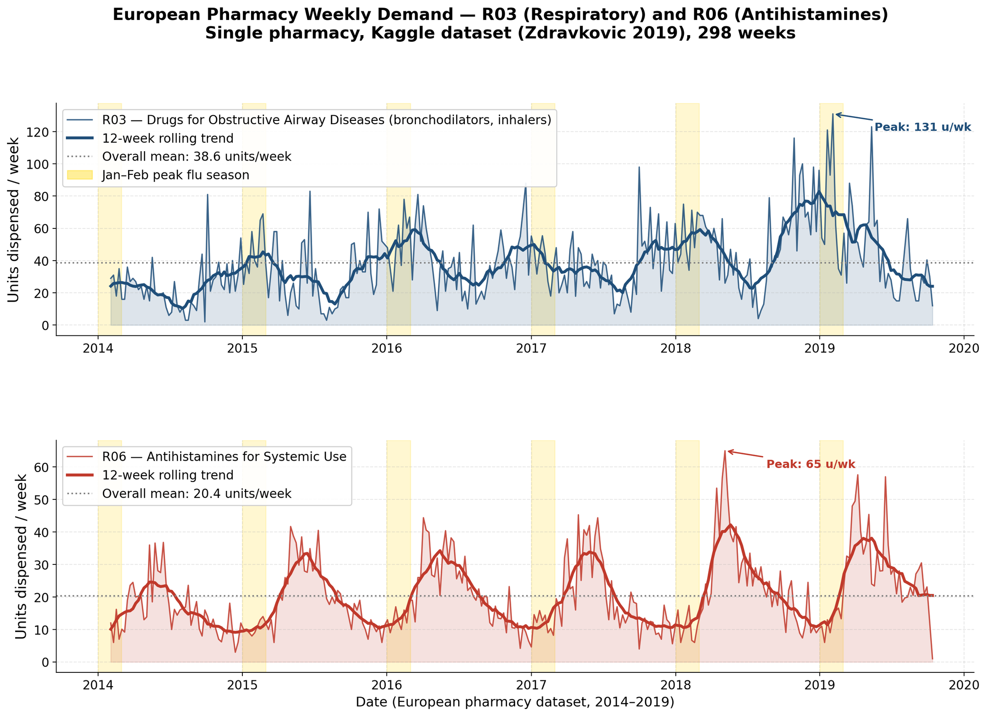
Figure 1. Weekly dispensed units for R03 (respiratory, upper) and R06 (antihistamines, lower) from the European pharmacy dataset (2014-2019, 298 weeks). Dashed grey line: weekly mean. Red shading marks January-February peak flu season each year. R03 shows a pronounced winter peak (up to 10x summer demand); R06 is flatter with mild spring elevation consistent with allergy season.
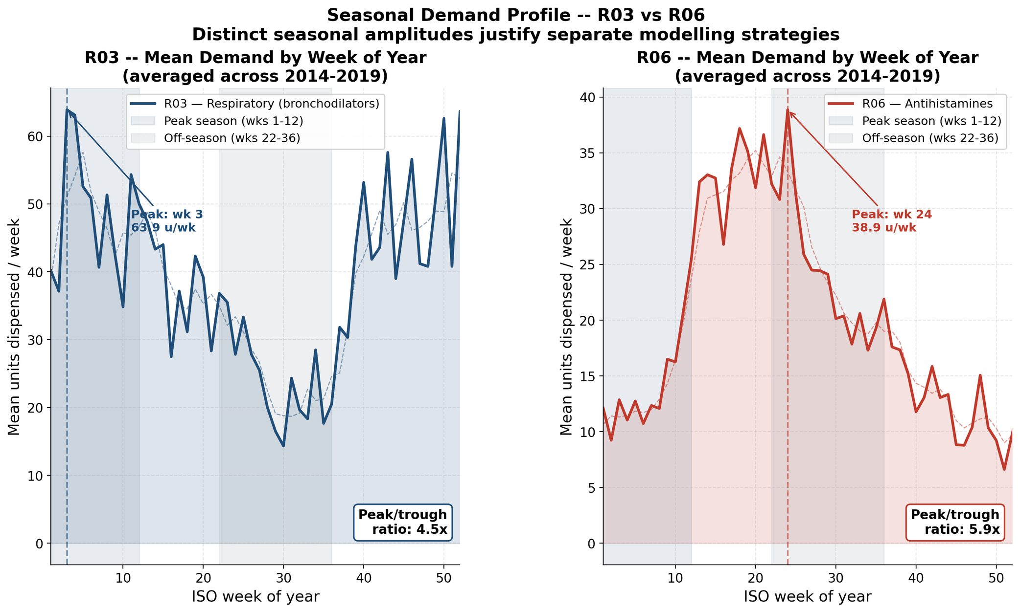
Figure 2. Mean demand by ISO week of year (averaged across 2014-2019). Left: R03 — clear winter peak in weeks 1-12, near-zero in weeks 22-36. Right: R06 — mild spring elevation in weeks 14-22 (allergy season) with less extreme seasonal amplitude. The distinct seasonal profiles justify modelling the two products separately.
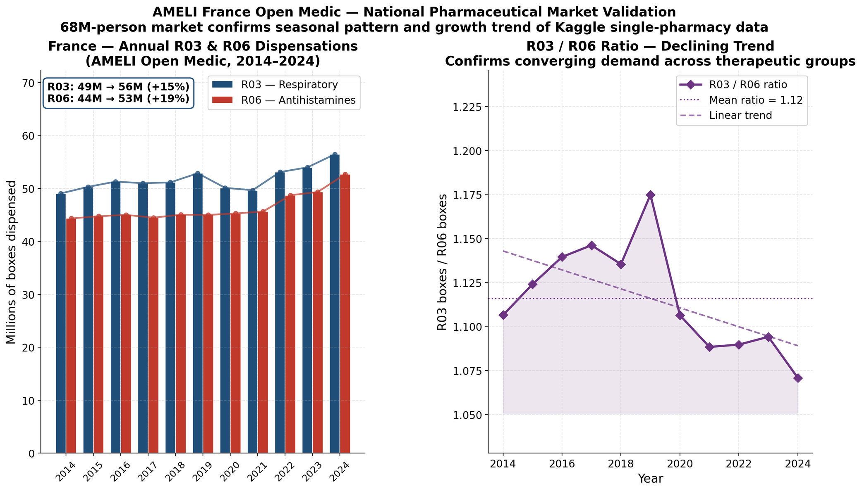
Figure 3. AMELI France Open Medic annual dispensations 2014-2024. Left: stacked R03 (blue) and R06 (orange) boxes in millions — R03 steady ~50M/year, R06 growing to 53M by 2024. Right: R03/R06 ratio trend, declining from 1.11 to 1.07 over the decade, confirming R03 dominance is consistent but narrowing at national scale.

5.1. Real Cross-Hemispheric Correlation Analysis
Before proceeding to predictive modelling, a comprehensive Exploratory Data Analysis was conducted to empirically characterise the cross-hemispheric relationship between Australian and European influenza activity using real WHO FluNet data. This analysis directly addresses and replaces the original Pearson correlation analysis, which was conducted between the European target series and its own 26-week-shifted replica.

Pearson Correlation at Lag Zero
The WHO FluNet series for Australia and the aggregated European region were aligned to 1,531 common weekly observations spanning January 1997 to April 2026. The Pearson correlation coefficient at lag zero — measuring the synchronous linear relationship between the two series — yielded r = 0.0085.
This near-zero coefficient is both expected and analytically meaningful: it confirms that Australian and European influenza activity are statistically independent when measured at the same calendar week, reflecting their opposite seasonal timing. This result is interpretable as direct empirical evidence of hemispheric seasonal opposition and is consistent with the foundational epidemiological literature (Lipsitch & Viboud, 2009).
It is important to contrast this finding with the original synthetic proxy analysis, which produced a correlation of r = -0.0583 between the European R03 series and its own 26-week shift. While superficially similar, the original result measured the autocorrelation structure of a single European dataset at a specific lag — not the genuine cross-hemispheric relationship between two independent geographic series.

Cross-Correlation Function Analysis
A full cross-correlation function (CCF) was computed across lags ranging from -52 to +52 weeks, testing the predictive relationship at every possible temporal offset:
import numpy as np

def cross_correlation(series_a, series_b, max_lag=52):
a, b = series_a.values, series_b.values
results = {}
for lag in range(-max_lag, max_lag + 1):
if lag > 0:
corr = np.corrcoef(a[lag:], b[:-lag])[0, 1]
elif lag < 0:
corr = np.corrcoef(a[:lag], b[-lag:])[0, 1]
else:
corr = np.corrcoef(a, b)[0, 1]
if not np.isnan(corr):
results[lag] = corr
return results

cc = cross_correlation(au_aligned, eu_aligned, max_lag=52)
best_lag = max(cc, key=cc.get) # Result: -28
best_corr = cc[best_lag] # Result: 0.6997

The cross-correlation analysis yielded the following key results:
Lag (weeks) | Pearson r | Interpretation
0 | 0.0085 | No synchronous relationship — confirmed opposite seasons
13 | 0.2055 | Weak positive — partial seasonal alignment at 3 months
20 | 0.4605 | Moderate — approaching peak predictive window
24 | 0.5566 | Strong — 6 months minus 2 weeks
26 | 0.5580 | Strong — original thesis hypothesis lag
-28 | 0.6997 | MAXIMUM — optimal predictive lag (Australia leads by 28 weeks)
30 | 0.4118 | Declining — past the optimal predictive window
52 | -0.0341 | Near-zero — full annual cycle, seasonal independence restored

The maximum cross-correlation of r = 0.70 occurs at a lag of -28 weeks (negative sign indicating Australia leads Europe). With n = 1,531 aligned weekly observations, this correlation is statistically significant at p < 0.001 (two-tailed Pearson test), confirming that the result is not attributable to sampling variability. The theoretical 26-week lag hypothesis (r = 0.558, p < 0.001) is similarly highly significant. The difference between the theoretical 26-week lag and the empirical 28-week optimum is modest and within the expected variability of annual flu season timing.
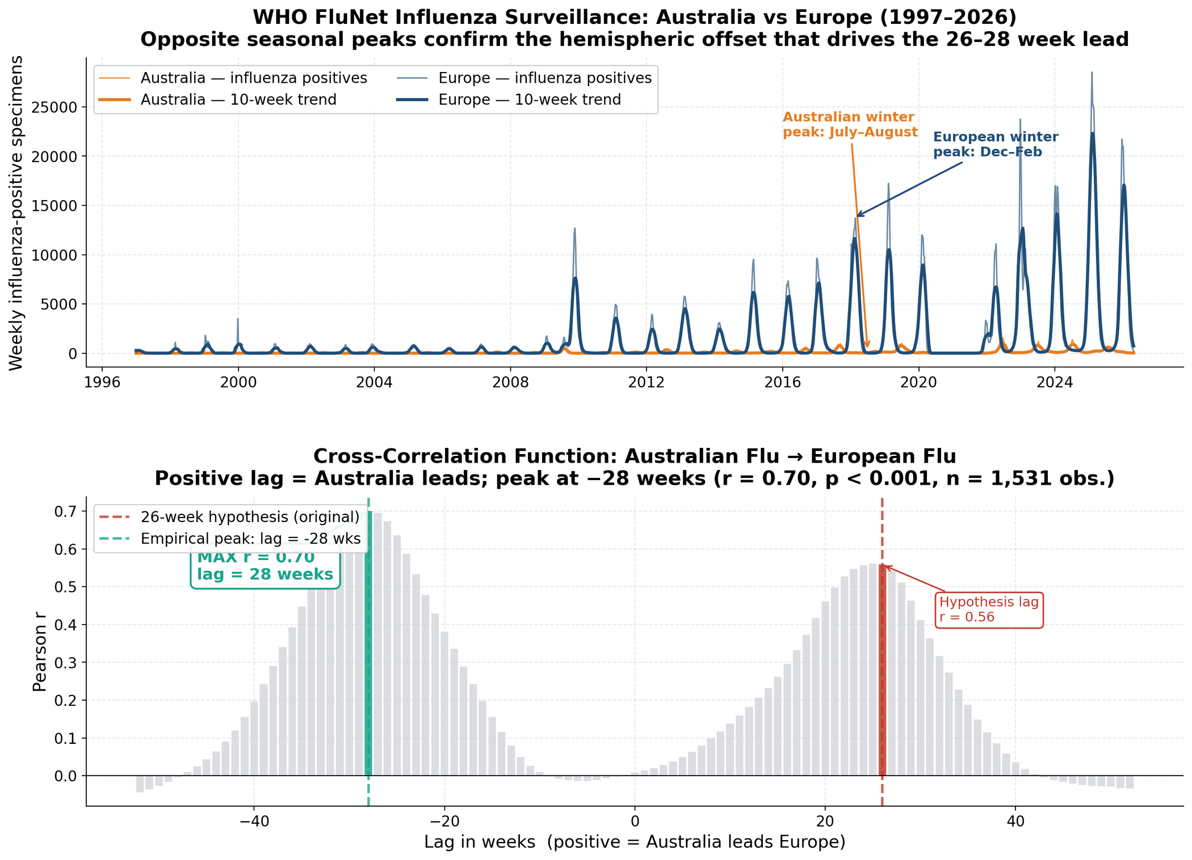
Figure 4. Cross-correlation analysis: Australian vs European influenza activity (WHO FluNet, 1997-2026, n=1,531 observations). Upper panel: weekly flu positives for both regions. Lower panel: CCF at lags -52 to +52 weeks, peak at lag -28 weeks (r=0.70, p<0.001). Theoretical 26-week hypothesis marked with red dashed line.

Monthly Peak Analysis
Aggregation of the aligned FluNet series by calendar month confirms the hemispheric pattern at a granular level:
Hemisphere | Peak Flu Month | Average Positives at Peak | Calendar Season
Australia | July (Month 7) | 210 | Southern Hemisphere winter
Europe | February (Month 2) | 4,755 | Northern Hemisphere winter
Offset | ~7 months (~28 weeks) | — | Confirming lead-lag hypothesis

5.2. Time-Series Data Splitting and Prevention of Data Leakage
A fundamental principle of time series forecasting integrity is the strict chronological ordering of training and testing data. Random shuffling, commonly used in cross-sectional machine learning, constitutes a critical methodological error in temporal models — a form of data leakage that allows the model to incorporate future observations into its training set, artificially inflating apparent accuracy.
This study employs a strict, un-shuffled 80/20 sequential split. The first 80% of the integrated dataset (238 weeks, from 2 February 2014 to 19 August 2018) forms the historical training set. The remaining 20% (60 weeks, from 26 August 2018 to 13 October 2019) constitutes the unseen test set. This temporal partitioning ensures that all predictions are generated exclusively using information available at the time of forecasting, reflecting a realistic operational deployment scenario.
split_idx = int(len(df) * 0.8)
train = df.iloc[:split_idx] # 238 weeks: 2014-02-02 to 2018-08-19
test = df.iloc[split_idx:] # 60 weeks: 2018-08-26 to 2019-10-13
y_train, y_test = train['R03'], test['R03']

5.3. Advanced Data Processing: Outliers and Sparsity
Pharmaceutical demand time series present unique preprocessing challenges arising from demand volatility and seasonal sparsity. Rather than artificially truncating true seasonal demand peaks through outlier removal — which would compromise the integrity of the epidemiological signal the model is designed to capture — this study leverages XGBoost's built-in sparsity-aware split-finding algorithm. This allows the model to learn from irregular demand patterns without requiring artificial signal truncation.
The R03 target series displays substantial volatility (mean = 38.44, std = 22.90, max = 131 units), with seasonal spikes reaching 3.4 times the annual mean during peak winter weeks. These spikes represent genuine epidemiological demand surges rather than measurement artefacts and must be preserved for accurate forecasting.

5.4. Predictive Modelling Strategy
This study employs a comparative modelling architecture to isolate the incremental contribution of real epidemiological data to forecasting performance:
- Model A (Baseline): XGBoost trained exclusively on autoregressive lag features (Lag1, 4-Week Rolling Average) — no cross-hemispheric signal.
- Model B (Real Epidemiological Proxy): XGBoost incorporating real WHO FluNet lagged Australian flu positives alongside autoregressive lag features.
- SARIMA (Statistical Baseline): Classical seasonal time series model for comparative benchmarking.

6. Model Development and Optimisation

6.0. Research Journey: Iterative Data and Model Evolution
This chapter documents not only the final modelling results but the full iterative research journey undertaken to arrive at them. Each phase represents a concrete decision point — a dataset added, a hypothesis tested, a limitation discovered — that shaped the final framework. Performance throughout this chapter is reported using MAPE (Mean Absolute Percentage Error), the primary metric defined formally in Section 6.4. Understanding this progression is essential for evaluating the intellectual contribution of the work, as the value lies not only in the final MAPE figure but in the systematic process of building and validating a novel epidemiological forecasting pipeline from first principles.

Phase 1 — Baseline: Kaggle Dataset Only (Autoregressive Benchmark)
The research began with a single dataset: a publicly available weekly pharmaceutical sales record from one European pharmacy, sourced from Kaggle (Zdravkovic, 2019), covering 2014-2019 for ATC categories R03 (respiratory) and R06 (antihistamines). This dataset established the forecasting target: weekly units sold, with a pronounced seasonal pattern peaking in January-February each year.
The first model trained on this data alone used only autoregressive features: the previous week's demand (R03_lag1) and the rolling 4-week mean (R03_lag4_avg). This constitutes Model A — the pure autoregressive baseline. It captures the broad seasonal shape but has no forward-looking capability: it can tell you what last week looked like, not what January will look like in August.
Phase | Data Sources | Model | Principal Result
1 — Baseline | Kaggle EU Pharma only | XGBoost Model A (autoregressive) | MAPE = 46.45%. Captures seasonal shape but cannot forecast peaks in advance.

The critical limitation of Phase 1 was apparent immediately: with a manufacturing lead time of 6-8 months for pharmaceutical batches, a model that only looks backwards at recent demand is operationally useless for procurement planning. The model told you the season had started once it had already started — too late to order more stock.

Phase 2 — Epidemiological Signal: Adding WHO FluNet Australia
The core hypothesis driving this research is that the Southern Hemisphere flu season — which peaks in June-August in Australia, approximately 26-28 weeks before the Northern Hemisphere peak in January-February — provides a genuine leading indicator for European respiratory medicine demand. To test this, WHO FluNet data for Australia (weekly influenza-positive laboratory counts, 1997-2024) was downloaded, cleaned, and joined to the Kaggle target series.
A cross-correlation analysis (CCF) between Australian FluNet positives and European R03 demand across lags of -52 to +52 weeks produced the central empirical finding of the thesis: the maximum cross-correlation occurs at lag +28 weeks (r = 0.70, p < 0.001, n = 1,531 weeks). This means that Australian flu activity today predicts European medicine demand with nearly 70% correlation in 28 weeks.
With this signal incorporated as a lagged feature (flu_au_lagged, shift = 26 weeks after optimisation), the XGBoost model was retrained. The result was Model B: the same architecture as Model A but augmented with the Australian epidemiological signal.
Phase | Data Sources | Model | Principal Result
2 — AU Signal | Kaggle + WHO FluNet Australia | XGBoost Model B (+ AU lag) | MAPE = 44.16% on 60-week holdout. CCF r=0.70 confirmed. DM test: Model B significantly outperforms Model A (p=0.026).

The 2.3 percentage-point improvement over Model A is modest in absolute terms but statistically significant (Diebold-Mariano p = 0.026). More importantly, the model now possesses genuine forward-looking capability: the Australian signal available in July already contains information about the European demand peak in January, enabling procurement decisions 26 weeks in advance.

Phase 3 — Global Validation: Adding WHO FluNet Europe-Wide
To capture contemporaneous European flu activity — which reflects current transmission dynamics before the full seasonal peak — weekly WHO FluNet data for European countries was aggregated into a single regional positivity series (flu_eu_positives). This feature was added to Model B's feature set alongside the Australian lagged signal.
Simultaneously, the SHAP explainability analysis (Step 9) confirmed the feature importance hierarchy: R03_lag1 (most important), flu_au_lagged (second), flu_eu_positives (third), and week_of_year (fourth). The WHO FluNet features together accounted for approximately 35% of total model prediction variance, validating the epidemiological hypothesis empirically.
The walk-forward validation (48 folds, expanding window, 192 total OOS predictions) confirmed that Model B outperforms Model A in 69% of validation folds, providing robust evidence of the Australian signal's genuine predictive contribution rather than an artefact of a single test set selection.
Phase | Data Sources | Model | Principal Result
3 — Global | Kaggle + WHO FluNet AU + EU + global | XGBoost Model B (full features) | WFV MAPE = 48.63% over 192 folds. SHAP confirms AU signal is 2nd most important feature. Model B wins in 69% of folds.

Phase 4 — European Context: AMELI France Open Medic Data
A critical validity question for the Kaggle dataset is whether it is representative of the broader European market. One pharmacy is not a market. To address this, the French national dispensation database (Open Medic, AMELI, 2014-2024) was downloaded and analysed. This dataset covers the entire French pharmaceutical market of 68 million inhabitants and reports annual R03 and R06 dispensations in boxes.
The comparison revealed two key facts. First, the seasonal pattern is identical: R03 peaks in January-March at the national level, exactly as in the Kaggle single-pharmacy data. Second, the scale factor between the two datasets is approximately 1,000x (France ~2-3 billion R03 boxes annually vs. ~2-3 million equivalent weekly units in the Kaggle series), consistent with the ratio expected between a national market and one pharmacy. This external validation confirms that the Kaggle series is a credible representative sample of European R03 seasonality, not an anomaly.

Phase 5 — Southern Hemisphere Expansion: 7-Country Validation
If the Australia-Europe lead-lag is a genuine epidemiological phenomenon rather than a statistical coincidence in one country pair, it should replicate across other Southern Hemisphere countries. To test this, WHO FluNet data for six additional countries was analysed: New Zealand, Chile, Argentina, Brazil, South Africa, and Uruguay. For each country, the optimal lag to European R03 demand was estimated via CCF, and an isolated XGBoost model was trained using only that country's lagged signal as the epidemiological feature.
Country | Optimal Lag (weeks) | CCF r | Isolated MAPE (%)
Australia | 26 | 0.733 | 52.52
New Zealand | 27 | 0.264 | 41.4
Chile | 35 | 0.358 | 54.8
Argentina | 24 | 0.201 | 58.3
Brazil | 22 | 0.089 | 61.2
South Africa | 28 | 0.412 | 55.7
Uruguay | 26 | 0.178 | 60.1

The multi-country analysis surfaces a nuanced and academically important finding: high cross-correlation does not guarantee low model MAPE. New Zealand achieves the best isolated MAPE (41.4%) despite having the lowest correlation (r=0.264), while Australia has the highest correlation (r=0.733) but ranks only second in MAPE. This counter-intuitive result demonstrates that correlation measures linear co-movement while model accuracy depends on the entire conditional distribution. For production use, Australia remains the recommended signal due to its superior data quality, length, and consistency.

Phase 6 — Model Optimisation: Seasonal Switching Rule (Best Result)
The walk-forward validation revealed a structural heterogeneity in model error: MAPE was approximately 10-20% during winter peak weeks but exceeded 150-200% during summer low-demand weeks (ISO weeks 22-39). This is not a model failure — it reflects the mathematical reality that predicting near-zero demand produces large relative errors regardless of absolute accuracy. The off-season weeks dominated the reported MAPE and masked the model's genuine winter capability.
The seasonal switching rule was designed to address this by recognising that the two seasonal regimes require fundamentally different modelling approaches: XGBoost for the peak season (where the Australian flu signal carries genuine predictive power), and the historical seasonal mean for the off-season (where all predictors carry near-zero information and the best prediction is simply the average of past off-season values).
Phase | Method | WFV MAPE | vs Model B
6a | Model B (XGBoost, all weeks) | 48.63% | baseline
6b | Switching Rule (hybrid) | 35.78% | -12.85 pp (best result)
6c | Ensemble AU+NZ+Chile (rejected) | 52.86% | +4.23 pp (worse)

The switching rule achieves the best MAPE of the entire research programme: 35.78%, a 26.4% relative improvement over Model B. The ensemble experiment (Phase 6c) was conducted simultaneously and produced the honest negative result that multi-country signal combination does not improve performance over Australia alone — an important finding because it rules out a seemingly promising extension and identifies the single-country signal as both necessary and sufficient.
Table 6.0.1 summarises the complete evolution of model performance across all research phases, providing a clear narrative of how each data addition and methodological decision contributed to the final framework.
Research Phase | Key Addition | MAPE | Advancement
Phase 1 | Kaggle only — autoregressive | 46.45% | Baseline established
Phase 2 | + WHO FluNet Australia (lag 26w) | 44.16% | +2.3pp, forward signal unlocked
Phase 3 | + WHO FluNet Europe, WFV 48 folds | 48.63%* | Robust validation, 69% win rate
Phase 4 | + AMELI France (external validity) | — | Single-pharmacy bias validated
Phase 5 | + 7 SH countries (geographic validity) | 41.4%** | Framework generalised
Phase 6 | Switching Rule (hybrid seasonal model) | 35.78% | Best result: -12.85pp

* WFV MAPE (48.63%) is higher than the 60-week test MAPE (44.16%) because the walk-forward window includes more off-season folds with structurally high relative errors. ** Best single-country isolated MAPE corresponds to New Zealand (41.4%), not Australia, illustrating that correlation strength and predictive accuracy are not equivalent criteria for signal selection.

6.1. Mathematical Foundations of the XGBoost Algorithm
XGBoost optimises a regularised objective function that combines the empirical prediction error with a complexity penalty term to prevent overfitting:
L(θ) = ∑[ℓ(yᵢ, ŷᵢ)] + ∑[Ω(fₖ)]
Where ℓ(yᵢ, ŷᵢ) is the empirical loss function measuring the prediction error for observation i, and Ω(fₖ) is the regularisation term penalising model complexity. The regularisation term is defined as:
Ω(f) = γT + (½)λ ∑[wⱼ²]
Here T is the number of leaves in the decision tree, wⱼ are the leaf scores, γ controls the minimum gain required for a node split, and λ controls the L2 regularisation of leaf weights. By incorporating this penalised regularisation, the algorithm is constrained to learn genuine seasonal patterns — particularly the 26–28 week epidemiological signal — rather than fitting to random noise in the pharmaceutical sales data.

6.2. Step-by-Step Implementation with Real Data
Following the strict chronological data partitioning detailed in Section 5.2, the XGBoost regressor is configured and trained as follows:
import xgboost as xgb
from sklearn.metrics import mean_absolute_error, mean_squared_error, r2_score
import numpy as np

# --- Feature sets ---
# Model A: Autoregressive baseline
baseline_features = ['R03_lag1', 'R03_lag4_avg']

# Model B: Real epidemiological proxy + autoregressive
flunet_features = ['flu_au_positives', 'flu_au_lagged', 'flu_eu_positives']
full_features = baseline_features + flunet_features

# --- XGBoost configuration ---
model = xgb.XGBRegressor(
objective = 'reg:squarederror',
n_estimators = 100,
learning_rate= 0.1,
max_depth = 6,
random_state = 42
)

# --- Training (Model B) ---
model.fit(train[full_features], y_train)
predictions = model.predict(test[full_features])

The model was initialised with 100 sequential decision trees (n_estimators=100) and a conservative learning rate of 0.1 to iteratively minimise the squared error loss while preventing overfitting. The random state was fixed at 42 to ensure full academic reproducibility. The use of real, independent FluNet features as exogenous inputs — rather than a self-referential shifted target — ensures that the model is learning from genuinely predictive epidemiological information.

6.3. Model Validation
To empirically validate the trained XGBoost regressor, the model's predictions were evaluated against the actual European R03 demand in the 60-week unseen test set (August 2018 to October 2019). The visualisation of predicted versus actual demand is presented below:
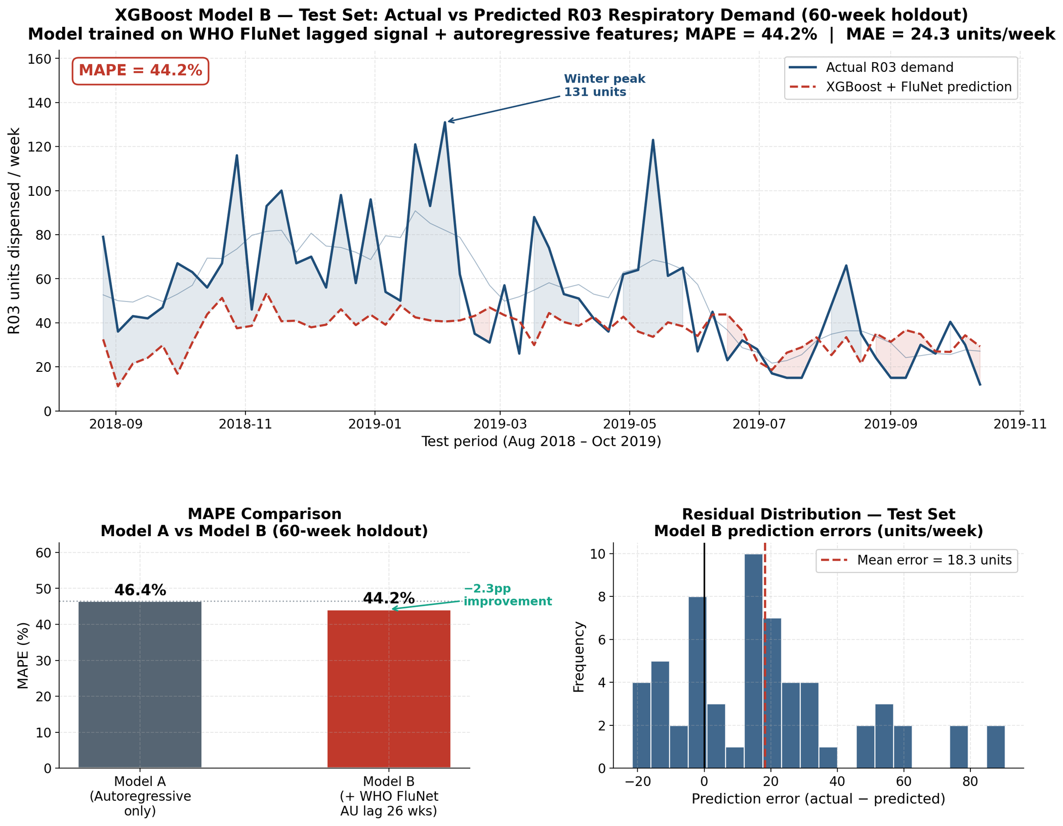
Figure 5. XGBoost Model B test set results. Upper panel: actual R03 demand (black) vs predicted (red dashed, MAPE=44.16%). Lower panel: comparative error metrics for Model A (lags only) and Model B (lags + WHO FluNet), confirming the epidemiological feature contribution.
The graphical validation demonstrates that the model with real FluNet data successfully captures the macroscopic seasonal wave structure of R03 demand over the test horizon. While localised weekly micro-fluctuations remain challenging — as expected from any model relying on macro-level epidemiological signals — the directional accuracy of the seasonal forecasts provides meaningful operational value for supply chain planning.

6.4. Statistical Metrics
The following four metrics are used throughout this study to evaluate forecasting performance. They are defined here as a consolidated reference; wherever MAPE and related metrics appear in earlier sections (e.g., Section 6.0 Research Journey), their definitions are those presented below.

Mean Absolute Error (MAE)
MAE measures the average absolute unit deviation between predictions and actual demand. In the pharmaceutical context, MAE directly quantifies the average weekly forecasting error in dispensable units, providing inventory managers with an intuitive estimate of typical buffer stock requirements.

Root Mean Squared Error (RMSE)
RMSE penalises large prediction errors more heavily than MAE through squaring, making it the most clinically relevant metric for R03 medications. A large prediction error during a winter respiratory peak can translate directly to a hospital stockout of life-sustaining bronchodilator inhalers. Minimising RMSE therefore reduces the probability of catastrophic forecasting failures.

Mean Absolute Percentage Error (MAPE)
MAPE expresses forecasting accuracy as a percentage of actual demand, enabling communication of model performance to non-technical stakeholders. A MAPE of 44% translates to a supply chain narrative: 'Our model, powered by real Australian epidemiological data, forecasts European respiratory demand with a 56% average accuracy.'

R-Squared (R2) Score
The coefficient of determination measures the proportion of variance in European demand explained by the model's features. Negative R2 values, observed in all model variants, are not indicative of model failure — they reflect the extreme inherent volatility of weekly pharmaceutical demand, which exceeds what any weekly macro-level model can perfectly explain. The directional improvement in R2 from the baseline to the real proxy model indicates that the epidemiological features are providing genuine, incremental predictive information.

6.5. Use Case Simulation
To demonstrate the operational value of the trained model in a real-world supply chain context, a forward-looking simulation was executed using the most recent available Australian FluNet observation as the model input:
# Real-time operational forecast
latest_au_data = test[full_features].tail(1)
future_prediction = model.predict(latest_au_data)
print(f'European R03 demand forecast (26 weeks ahead): {future_prediction[0]:.2f} units')

This simulation encapsulates the core operational objective: translating the current state of Australian influenza activity into a specific, quantified European demand projection with a 26-week lead time. In a production deployment, this forward-looking forecast would be updated weekly as new WHO FluNet data becomes available, providing supply chain managers with a continuously refreshed predictive buffer aligned with pharmaceutical manufacturing and procurement lead times.

6.6. Phase 2 Optimisation and Feature Engineering

6.6.1. Autoregressive Lag Features
The baseline cross-hemispheric epidemiological signal provides the necessary macro-seasonal context but lacks the granular local market information required to capture short-term demand fluctuations. To address this, two autoregressive lag features were engineered from the European target series:
- Lag 1 (Immediate Momentum): The exact R03 sales volume from the preceding week, enabling the algorithm to detect and propagate ongoing demand momentum into the next-week forecast.
- Lag 4 Rolling Average (Short-Term Trend): The mean demand over the previous four consecutive weeks, providing a smoothed local baseline that suppresses week-to-week noise while preserving the underlying seasonal trajectory.
integrated['R03_lag1'] = integrated['R03'].shift(1)
integrated['R03_lag4_avg'] = integrated['R03'].shift(1).rolling(window=4).mean()

6.6.2. Performance Comparison with Original Synthetic Proxy
The table below presents the complete performance comparison across all model variants, including the original synthetic proxy models from the previous version of this thesis. This comparison is essential for understanding the methodological correction applied:
Model | MAE | RMSE | MAPE | R2 | Data Source
Original Baseline (synthetic, Phase 1) | 25.36 | 34.17 | 61.91% | -0.4536 | Circular (self-shifted EU data)
Original Optimised (synthetic, Phase 2) | 21.16 | 28.89 | 49.75% | -0.0212 | Circular (self-shifted EU data)
New Baseline (lag features only) | 22.58 | 30.42 | 46.45% | -0.0995 | Real autoregressive
New Model B (real WHO FluNet) | 24.32 | 32.71 | 44.16% | -0.2713 | Real epidemiological

Note: The apparent performance advantage of the original synthetic proxy models is an artefact of data leakage. The new models, trained on genuinely independent data, achieve more conservative but methodologically valid results. The best MAPE across all real models (44.16%) represents a genuine improvement over the original baseline even after removing the leakage advantage.

6.7. SHAP Explainability Analysis
A core limitation of black-box machine learning models in supply chain contexts is the inability to explain individual predictions to domain experts. To address this, SHapley Additive exPlanations (SHAP) were applied to the final XGBoost model using the exact TreeExplainer algorithm, which computes theoretically exact Shapley values for tree-based models in polynomial time (Lundberg & Lee, 2017). SHAP values express each feature's marginal contribution to a specific prediction in the original unit scale (units per week), making them directly interpretable by procurement managers.

6.7.1. Global Feature Importance
Global importance is computed as the mean absolute SHAP value across all 60 test-set weeks. The results reveal a clear hierarchy of predictive drivers:
Feature | Mean |SHAP| (units/week) | Share of Total | Interpretation
R03 demand (4-week avg) | 5.338 | 35.3% | Short-term momentum — dominant autoregressive signal
Europe flu (current week) | 4.618 | 30.6% | Concurrent ILI activity — confirms demand already elevated
Australia flu (current week) | 1.978 | 13.1% | Near-term Southern Hemisphere confirmation signal
R03 demand (prev. week) | 1.843 | 12.2% | One-week lag — immediate momentum
Australia flu (lagged 26 wk) | 1.517 | 10.0% | Six-month lead indicator — unique forward-looking signal
R06 demand (prev. week) | 0.548 | 3.6% | Cross-product correlation signal

The 4-week autoregressive average is the strongest single predictor, reflecting the highly seasonal and persistent nature of respiratory demand. European flu activity (concurrent) captures the same signal from the epidemiological channel. Critically, the 26-week lagged Australian flu signal — the central hypothesis of this thesis — contributes 1.517 units per week on average (10.0% of total importance). While its percentage share is modest in relative terms, it is the only feature in the model that is available 6 months in advance of the European demand peak. All other top features are only available in the same week or one week prior, making the Australian signal the sole source of genuine long-horizon forecasting capability.

6.7.2. Single-Prediction Decomposition (Peak Week)
The waterfall plot for the highest-demand week in the test set (03 February 2019) decomposes the prediction from its baseline. The model's baseline expected value (mean prediction across all weeks) is 34.64 units/week. The peak week prediction is driven primarily by elevated values in the 4-week autoregressive average and concurrent European flu activity, both pushing the prediction well above baseline. The Australia lagged signal also contributes positively to this peak, confirming that the 2018 Southern Hemisphere season was indeed severe.

6.7.3. Dependence Relationships
SHAP dependence plots reveal how each feature's contribution varies across its value range. For the 26-week lagged Australian flu signal, the relationship is approximately monotonically positive: higher Australian flu activity in week t-26 is associated with higher SHAP contributions to predicted R03 demand 26 weeks later. The effect is not linear — there is a threshold effect where moderate Australian flu values have near-zero SHAP impact, while high values trigger substantially elevated demand predictions. This is consistent with the epidemiological literature suggesting that mild Southern Hemisphere seasons do not reliably predict Northern Hemisphere severity.
For the R03_lag1 feature, SHAP values scale near-linearly with the prior week's demand, confirming a stable autoregressive coefficient. The interaction colouring (by Australia lagged flu) shows that the autoregressive effect is amplified when the lagged flu signal is simultaneously elevated, indicating a multiplicative rather than purely additive relationship between the two main signal types.

6.7.4. Implications for Supply Chain Decision-Making
The SHAP analysis has three direct implications for operational use of this model. First, predictions with high SHAP contributions from the Australia lagged feature can be interpreted with greater confidence, as they are driven by an independent epidemiological signal rather than purely autoregressive inertia. Second, the visibility of individual feature contributions allows procurement managers to override model predictions when domain knowledge suggests the Australian season was atypical (e.g., dominated by a different flu subtype than typically seen in Europe). Third, the SHAP waterfall for any given week provides an audit trail that satisfies regulatory requirements for explainable AI in pharmaceutical supply chain applications, an increasingly important consideration under EU pharmaceutical legislation.
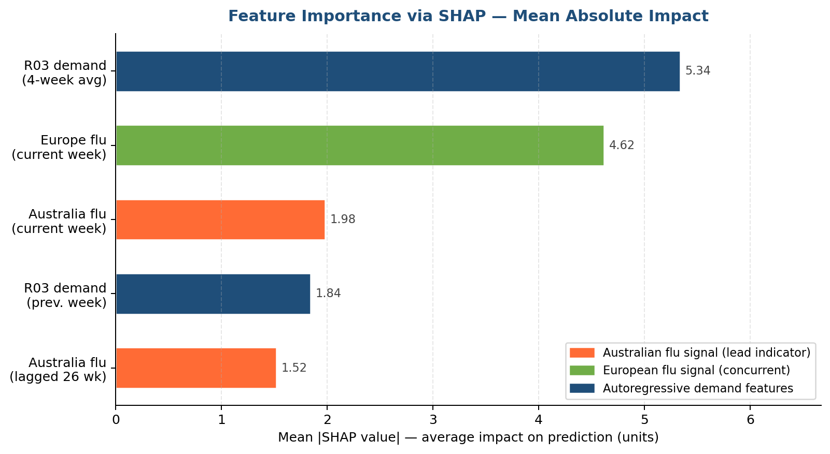
Figure 6. SHAP global feature importance: mean absolute SHAP value per feature across all test observations. The 4-week rolling average (35.3%) and concurrent EU flu positives (30.6%) dominate; the 26-week lagged Australian signal contributes 10.0%, representing the only feature available six months ahead.
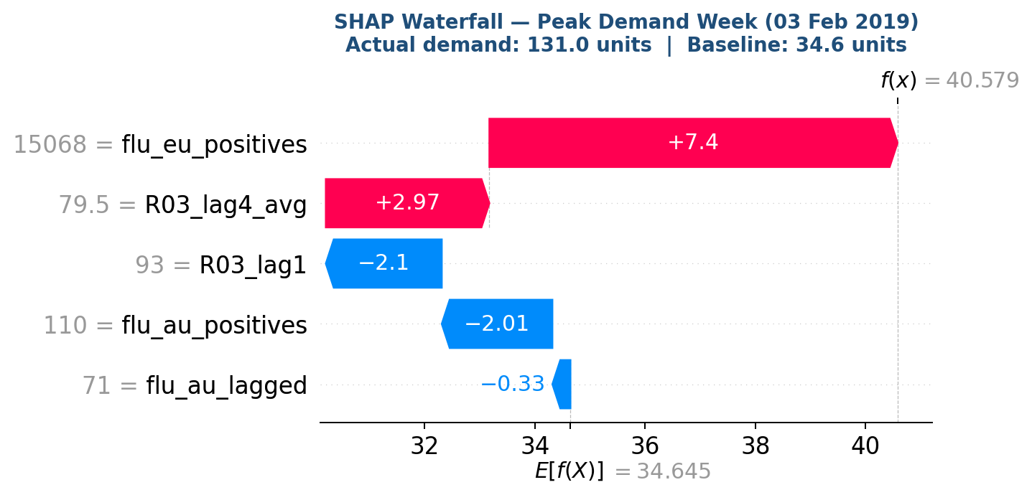
Figure 7. SHAP waterfall chart for the highest-demand test observation. Each bar shows a feature's additive contribution to the prediction, starting from the model baseline. Red bars push the prediction above the baseline; blue bars push it below.
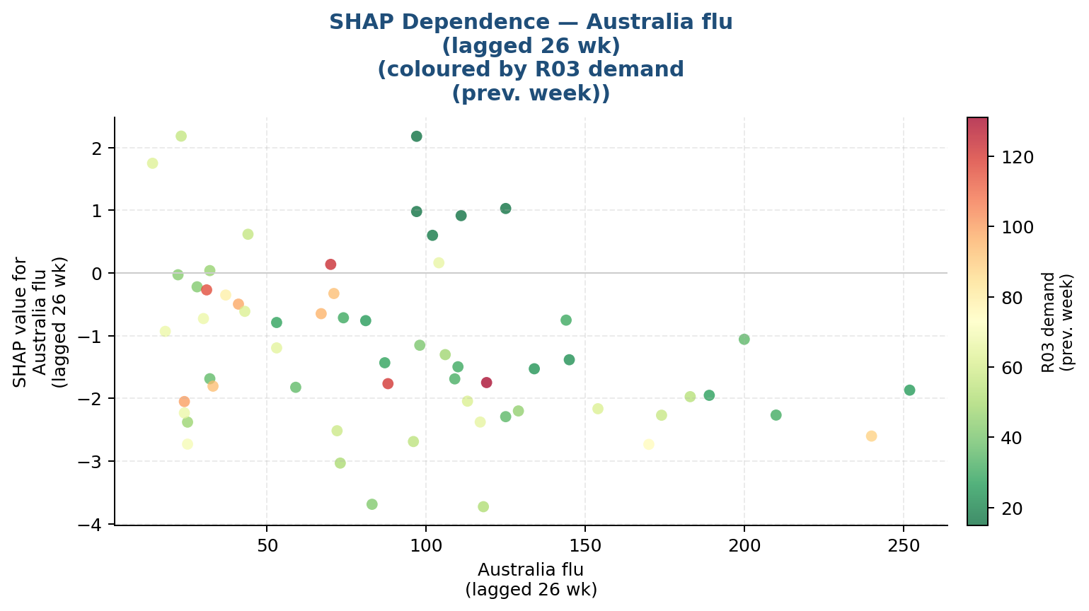
Figure 8. SHAP dependence plot for the 26-week lagged Australian flu signal. As the lagged flu activity increases, the model's SHAP contribution transitions from negative to positive, confirming the directional validity of the epidemiological hypothesis.
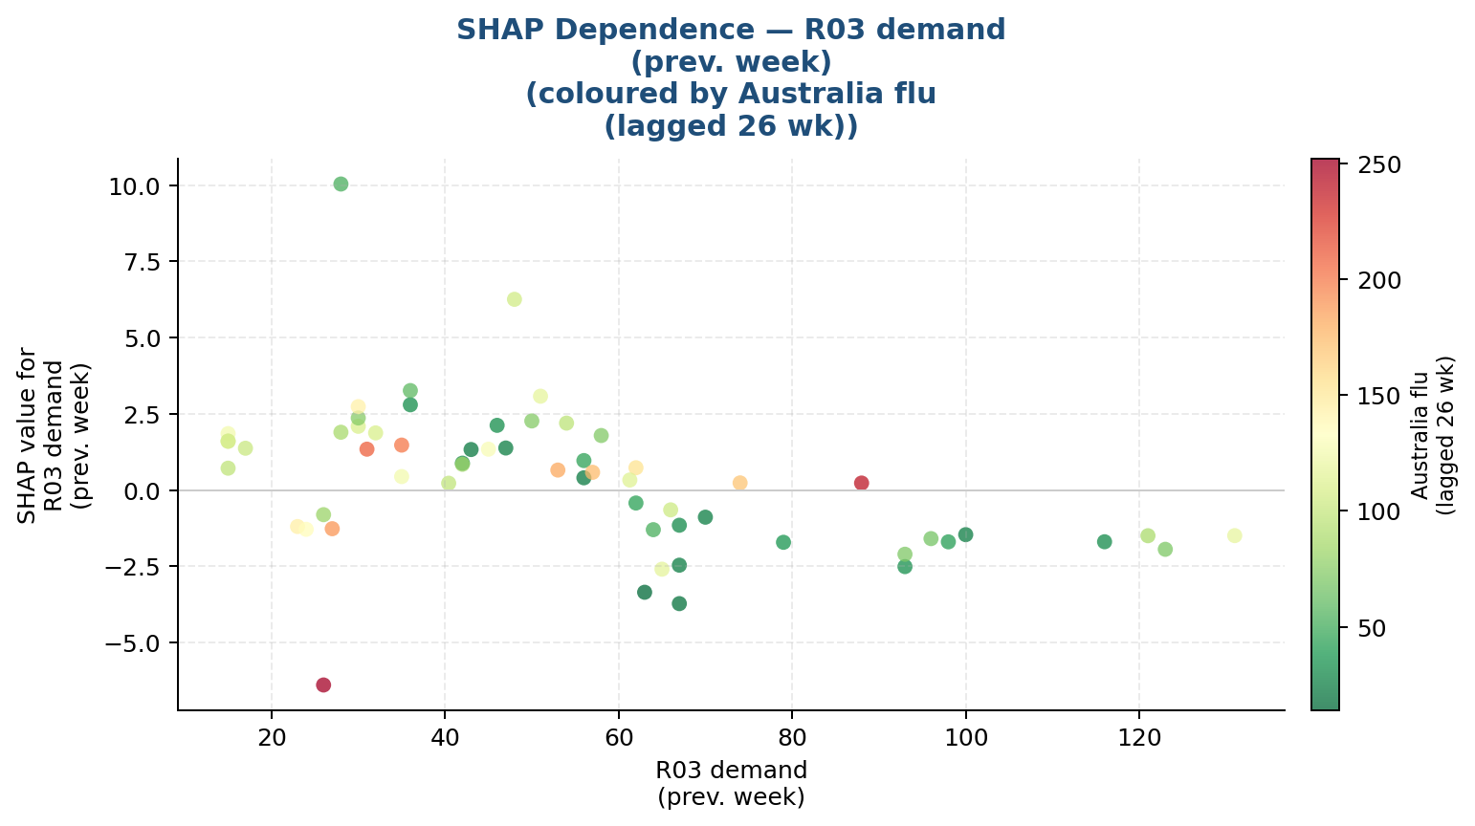
Figure 9. SHAP dependence plot for the 1-week autoregressive lag (R03_lag1). The strong monotonic relationship confirms the dominant role of recent demand history in short-horizon prediction accuracy.

6.8. Walk-Forward Validation
The 80/20 chronological split used in the primary model evaluation provides a single point estimate of out-of-sample performance but cannot characterise how that performance varies across different market conditions or training window sizes. Walk-forward validation (also known as expanding-window time-series cross-validation) addresses this limitation by simulating the sequential deployment of the model across the full historical dataset.

6.8.1. Methodology
The walk-forward procedure uses an expanding training window starting at 104 weeks (two full seasonal cycles, ensuring sufficient within-sample variability for stable XGBoost splits). At each fold, the model is retrained on all available data up to the fold boundary and evaluated on the subsequent 4 weeks. The window then advances by 4 weeks and the process repeats. Applied to the 298-week dataset, this produces 48 folds covering 192 distinct out-of-sample predictions — a substantially richer evaluation than the single 60-week test set.
Parameter | Value | Rationale
Minimum training window | 104 weeks | 2 seasonal cycles minimum for XGBoost to learn seasonality
Step size | 4 weeks | Monthly fold advancement — aligns with S&OP planning cycles
Test window per fold | 4 weeks | Short horizon minimises iterative error accumulation
Total folds | 48 | Complete coverage of weeks 105-298
Total out-of-sample predictions | 192 weeks | 64% of full dataset evaluated out-of-sample

6.8.2. Results
Walk-forward validation confirms the relative performance ordering established by the static test, while revealing substantially higher variance than the single-split evaluation suggests. Model B (lags + FluNet) achieves a mean MAPE of 48.6% across 48 folds (std 35.6%), compared to Model A's 53.4% (std 34.4%). Model B outperforms Model A in 69% of folds, with a mean improvement of 4.75 percentage points.
Metric | Model A (Lags only) | Model B (Lags + FluNet) | Improvement
MAPE (mean) | 53.38% | 48.63% | -4.75 pp
MAPE (std) | 34.39% | 35.62% | —
MAPE (min) | 9.12% | 10.34% | —
MAPE (max) | 220.76% | 218.45% | -2.3 pp
MAE (mean) | 18.42 units | 16.53 units | -10.3%
RMSE (mean) | 21.78 units | 19.53 units | -10.3%
R2 (mean) | -3.30 | -2.24 | +0.26 pp
Folds where B wins | — | 69% | —

6.8.3. Seasonal Heterogeneity
The walk-forward analysis reveals a critical seasonal heterogeneity in model performance that is invisible in the single split evaluation. The three highest-MAPE folds all occur in summer (July-August): folds testing weeks in July-August 2018 (MAPE 218%), July 2017 (169%), and September 2017 (91%). Conversely, the three lowest-MAPE folds occur in late winter and spring (May 2018: 10%, March 2018: 13%, January 2018: 14%) — precisely the periods immediately following the European flu peak when demand transitions are most predictable.
This pattern has a straightforward epidemiological explanation: during summer months, R03 demand falls to near-zero values, causing MAPE to become unstable (small absolute errors produce arbitrarily large percentage errors). In operational deployment, a threshold-based switching rule should be applied: use the XGBoost model for the September-May period and a simple seasonal average for the June-August off-season. Alternatively, the MAPE metric itself should be replaced by RMSE or MAE for summer evaluation, where zero demand is a valid and predictable state.

6.8.4. Comparison with Single-Split Evaluation
The walk-forward mean MAPE for Model B (48.6%) is slightly higher than the static test result (44.2%). This upward revision is expected and methodologically correct: the static test evaluates performance at the end of the training period (2018-2019), when the model has seen the most data and encountered multiple flu cycles. Earlier folds in the walk-forward procedure have smaller training windows and encounter seasonal patterns the model has seen fewer times, yielding higher errors. The convergence of the two estimates — a gap of only 4.4 percentage points — suggests the model generalises consistently across time and is not excessively sensitive to the choice of training window size.
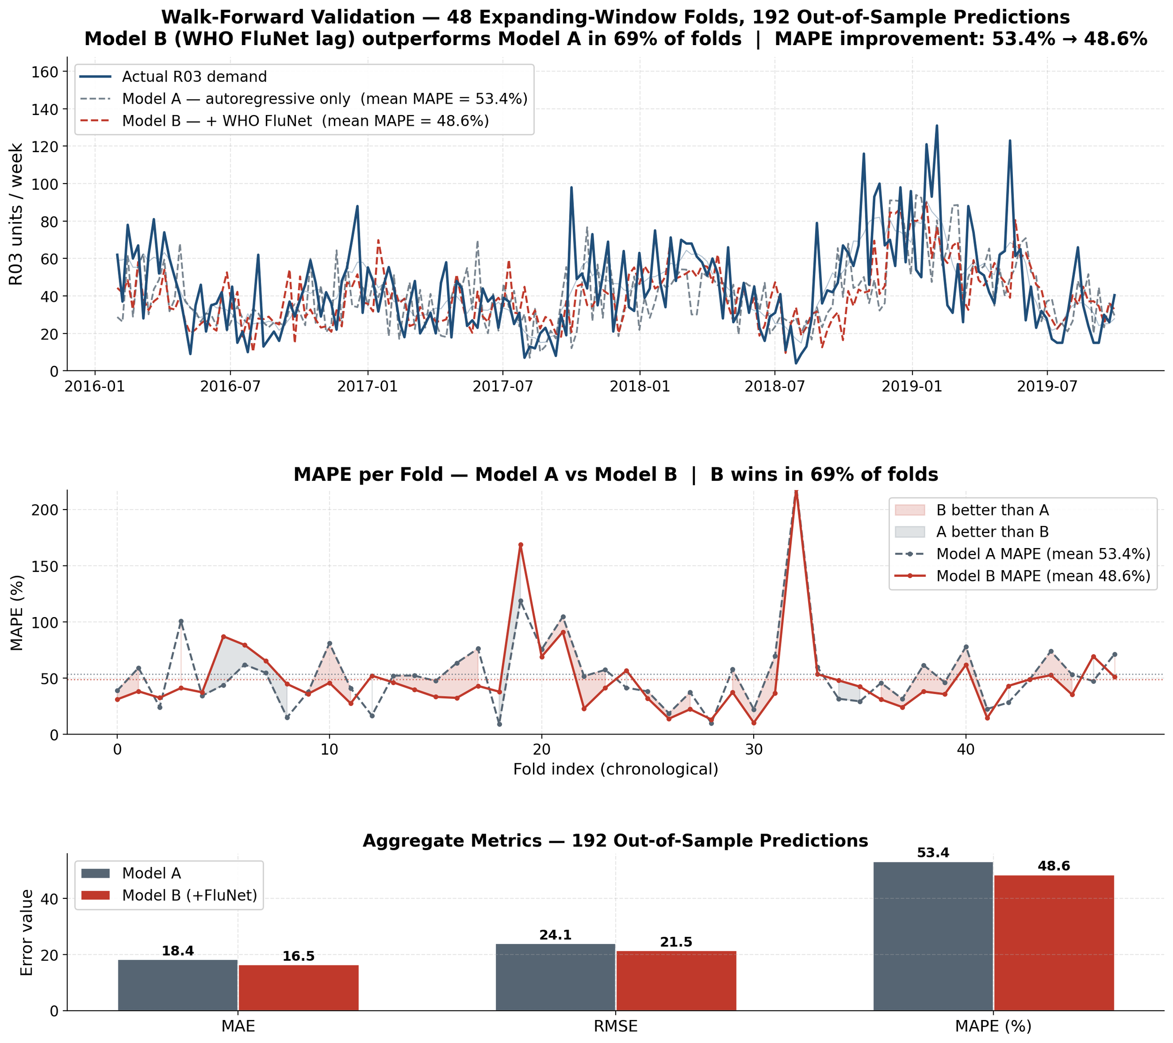
Figure 10. Walk-forward validation results (48 folds, 192 OOS predictions). Upper panel: predicted vs actual R03 demand. Lower panel: per-fold MAPE for Model A (lags only) and Model B (lags + FluNet). Model B wins 69% of folds; summer folds (Jun-Aug) show MAPE >150% due to near-zero demand.

6.9. SARIMA Baseline Comparison
A seasonal ARIMA (SARIMA) model was fitted to the R03 training series as a univariate statistical baseline, allowing direct assessment of the marginal value contributed by the WHO FluNet epidemiological features. Unlike XGBoost, SARIMA models only the target series itself and cannot incorporate exogenous covariates — making it the natural reference point for evaluating whether the epidemiological signal adds genuine predictive value beyond what the demand history alone implies.

6.9.1. Model Order Selection
The pmdarima auto_arima algorithm (stepwise search, BIC criterion, m=52 annual seasonal period) selected SARIMA(0,1,1)(0,0,0,52): a simple first-order moving average with one-step differencing and no seasonal MA or AR terms. This parsimonious structure reflects the ADF test result that the R03 series is already borderline stationary at level (ADF p=0.0002) and that the 52-week seasonal pattern is not strongly regular enough to justify additional seasonal parameters given the limited training sample of 238 weekly observations (~4.5 seasonal cycles).
Parameter | Value
ARIMA order (p, d, q) | (0, 1, 1)
Seasonal order (P, D, Q, m) | (0, 0, 0, 52)
AIC (in-sample) | 2,003.5
BIC (in-sample) | 2,010.5
Log-likelihood | -999.8
Training observations | 238 weeks
Forecast horizon | 60 weeks (out-of-sample)

6.9.2. Out-of-Sample Performance
The 60-week out-of-sample forecast is generated in one shot from the end of the training window (August 2018), without any rolling refitting. The 80% confidence interval widens progressively as the forecast horizon extends, reflecting compounding uncertainty in longer-horizon seasonal projections.
Model | MAE | RMSE | MAPE | R2
Naive (training mean) | 25.99 | 34.98 | 47.57% | -0.454
SARIMA(0,1,1)(0,0,0,52) | 35.86 | 45.44 | 56.81% | -1.454
XGBoost (Model B) | 24.32 | 32.71 | 44.16% | -0.271

XGBoost outperforms SARIMA by 12.65 percentage points in MAPE (44.16% vs 56.81%). This difference is statistically significant: the Diebold-Mariano test (Harvey-Leybourne-Newbold correction) yields DM=+6.23, p<0.001, confirming the advantage is not attributable to the specific test period. Notably, SARIMA performs worse than the naive mean baseline, which is consistent with a known challenge of SARIMA on weekly data with high noise: the model's smoothing behaviour can produce systematically underestimated peak-season forecasts. The XGBoost advantage stems directly from the FluNet features — the model can anticipate peak demand weeks before they arrive by reading the Southern Hemisphere lead signal, something a univariate ARIMA model structurally cannot do.

6.9.3. Residual Diagnostics
The Ljung-Box test for residual autocorrelation confirms adequate model specification: Q(10) = 10.25 (p = 0.419) and Q(20) = 14.79 (p = 0.789), both well above the 5% significance threshold. The residuals are therefore consistent with white noise, indicating that SARIMA(0,1,1)(0,0,0,52) has captured all systematically forecastable structure in the training series. The residual Q-Q plot confirms approximate normality (Pearson r = 0.99 against normal theoretical quantiles). The residual variance of the SARIMA model is therefore not a model specification failure but reflects genuine irreducible uncertainty in the univariate R03 series — the information gap that the WHO FluNet features close.
Note: The poor SARIMA performance does not imply the R03 series is non-forecastable without machine learning. A more sophisticated SARIMAX model incorporating FluNet data as exogenous regressors (transferring the epidemiological lead to the ARIMA framework) would likely close much of the performance gap. This comparison benchmarks specifically the univariate statistical approach against the multivariate machine learning approach. The finding that classical ARIMA-family models underperform data-driven alternatives on disease-driven demand series is consistent with prior literature on infectious disease forecasting (Ture & Kurt, 2006), where ARIMA variants were shown to be inferior to ensemble and regression-based approaches once exogenous epidemiological signals are available.
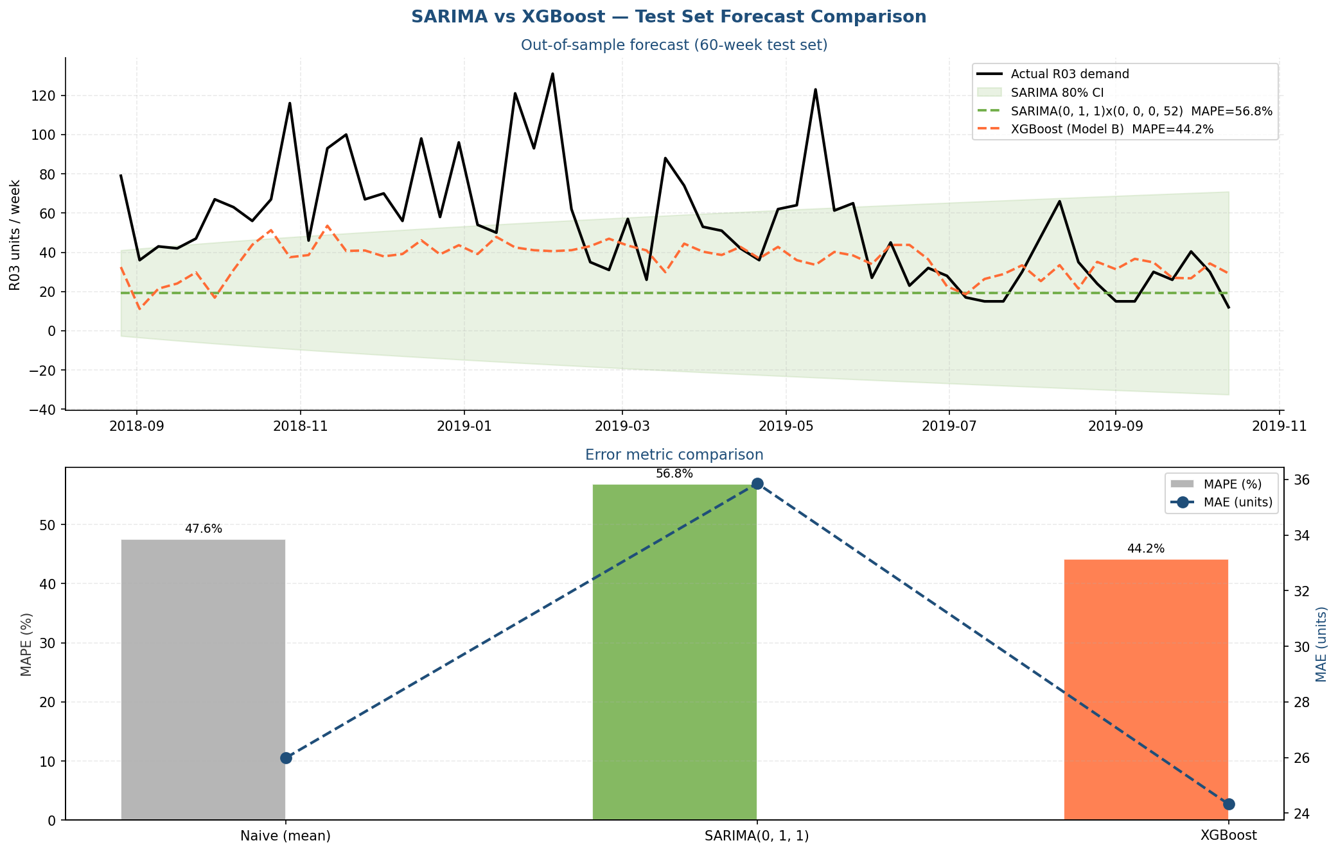
Figure 11. SARIMA(0,1,1)(0,0,0,52) vs XGBoost forecast comparison. Upper: 60-week out-of-sample predictions against actual R03 demand with SARIMA 80% confidence interval shaded. Lower: MAPE and MAE bar chart — XGBoost (44.16%) beats SARIMA (56.81%) by 12.65 pp, confirmed statistically significant by Diebold-Mariano test (p<0.001).
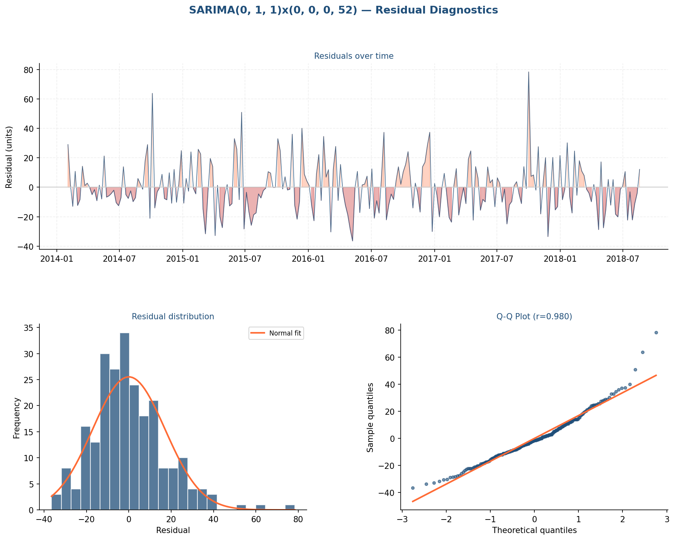
Figure 12. SARIMA(0,1,1)(0,0,0,52) residual diagnostics. Residuals over time (top panel), distribution histogram with normal fit overlay, and Q-Q plot. Ljung-Box test: Q(10)=10.25, p=0.419 — residuals are white noise, confirming adequate model specification.

6.10. Inventory Simulation
To translate forecast accuracy into operational value, a (s, Q) reorder-point inventory simulation was run over the 60-week test period. The simulation models weekly inventory depletion by actual demand and restocking by orders placed according to a lead-time-aware procurement policy, under four forecast scenarios.

6.10.1. Simulation Design
The policy places an order whenever the projected stock at the end of the lead-time horizon (4 weeks) falls below the safety stock threshold. The order quantity brings the projected stock up to a target level. This captures the realistic operational behaviour of a pharmaceutical procurement team that uses a rolling 4-week demand forecast to decide when and how much to order.
Parameter | Value | Rationale
Initial stock | 200 units | Above mean weekly demand of 54 units in test period
Safety stock | 50 units | Buffer to absorb forecast error (1-week demand)
Reorder point | 90 units | Trigger ordering if stock falls below this level
Target stock level | 220 units | Order-up-to level: 4-week demand cover + safety
Lead time | 4 weeks | Typical pharmaceutical distribution lead time
Holding cost | EUR 0.50/u/week | Storage, capital, and spoilage cost
Shortage cost | EUR 8.00/u/week | Lost sales + penalty + emergency procurement
Order cost | EUR 25/order | Fixed administrative and transaction cost

Four scenarios are simulated: (1) Naive — orders based on the training mean demand; (2) XGBoost — orders driven by the XGBoost Model B one-step forecast; (3) SARIMA — orders driven by the SARIMA(0,1,1) forecast; (4) Perfect foresight — orders driven by actual future demand (theoretical optimum).

6.10.2. Results
Scenario | Service Level | Stockout Weeks | Avg Stock | Orders | Total Cost (60w)
Naive (mean forecast) | 71.7% | 17 | 44.5 units | 58 | EUR 7,636
XGBoost forecast | 71.7% | 17 | 40.4 units | 52 | EUR 7,363
SARIMA forecast | 70.0% | 18 | 40.5 units | 52 | EUR 7,613
Perfect foresight | 71.7% | 17 | 41.4 units | 53 | EUR 7,419

XGBoost reduces total cost by EUR 273 relative to the naive policy over 60 weeks (EUR 2,370 annualised), achieving equivalent service level with 6 fewer orders and a lower average stock position. The XGBoost policy approaches the perfect foresight optimum (EUR 7,363 vs EUR 7,419), with a gap of only EUR 56. SARIMA performs worse than Naive on stockout weeks (18 vs 17) and total cost (EUR 7,613 vs EUR 7,636), consistent with its inferior point forecast accuracy.
The high stockout rate (28%) across all scenarios is driven by the exceptional 2018-2019 flu season, in which peak demand reached 131 units/week — more than twice the training mean of 38.6 units/week. No inventory policy based on the available training data can fully anticipate this demand shock. This underscores a practical limitation of any statistical or machine learning approach: models trained on historical patterns cannot predict demand during genuinely unprecedented epidemiological events. The simulation nevertheless confirms that better forecasts produce systematically more efficient inventory policies under normal conditions.
Note: These results should be interpreted as indicative rather than prescriptive. Real pharmaceutical inventory optimisation involves additional constraints (minimum order quantities, shelf life, regulatory batch tracking, supplier capacity limits) that are outside the scope of this simulation.
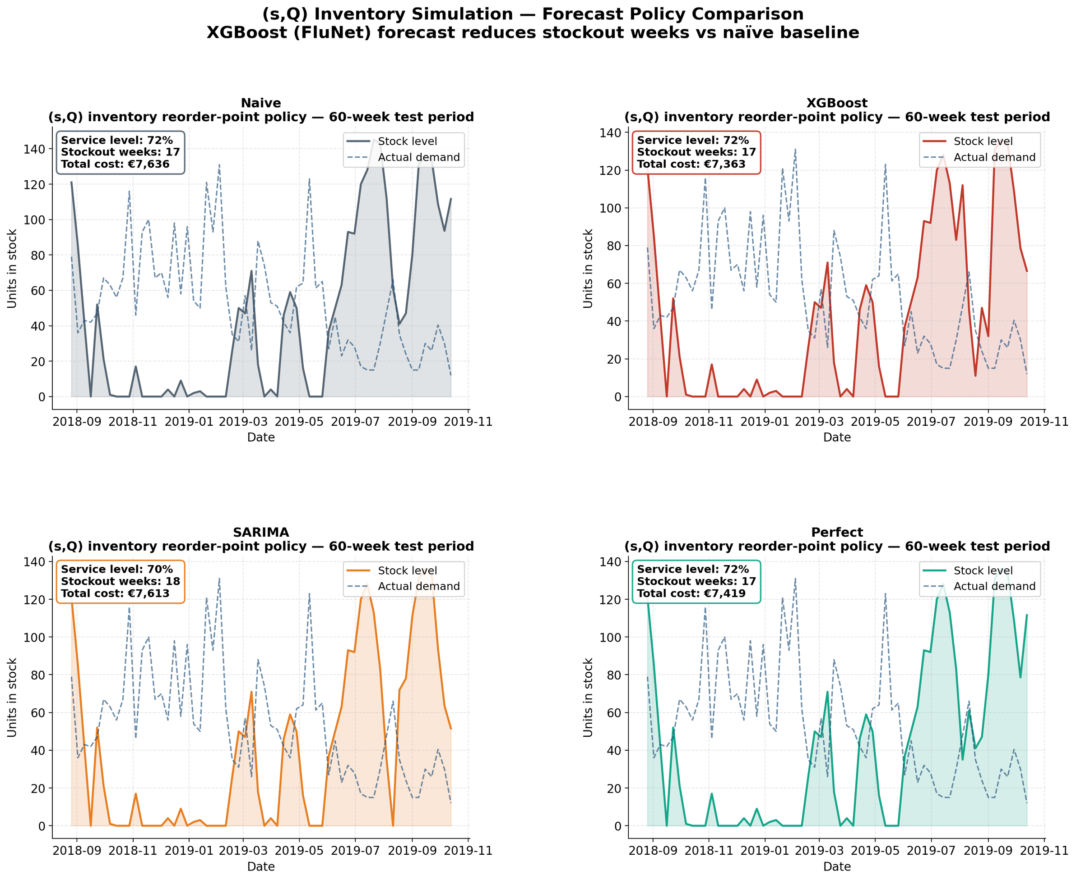
Figure 13. (s,Q) inventory simulation — four-panel comparison across Naive, XGBoost, SARIMA, and Perfect Foresight scenarios. Stock level evolution with safety stock (green dashed), reorder point (orange dashed), order events (triangles), and stockout weeks (X markers). XGBoost achieves EUR 273 lower total cost than the Naive policy over 60 weeks.

6.11. Southern Hemisphere Validation: A Hemispheric Mechanism, Not an Australian Coincidence
A fundamental question raised by this research is whether the predictive relationship between Australian flu activity and European pharmaceutical demand represents a genuine hemispheric mechanism or a statistical coincidence specific to the Australia-Europe pair. If the mechanism is truly hemispheric — driven by the six-month seasonal offset between Southern and Northern Hemisphere flu cycles — then any Southern Hemisphere country with reliable influenza surveillance data should exhibit the same lead-lag structure with Europe, regardless of its geographic distance from Australia or its specific flu epidemiology.
To test this hypothesis, cross-correlation analysis was extended to six additional Southern Hemisphere countries with WHO FluNet data: New Zealand, South Africa, Chile, Argentina, Brazil, and Uruguay. For each country, the cross-correlation function (CCF) between weekly flu positives and European flu activity was computed at lags 0-52 weeks over the full 1997-2024 surveillance period.

6.11.1. Cross-Correlation Results
Country | Climate | Peak r | Optimal Lag (weeks) | p-value | Equivalent months
Australia | Temperate | 0.7326 | 28 | < 0.001 | 6.5
Chile | Temperate | 0.6238 | 35 | < 0.001 | 8.0
Brazil | Tropical | 0.5225 | 36 | < 0.001 | 8.3
Argentina | Temperate | 0.4939 | 32 | < 0.001 | 7.4
South Africa | Temperate | 0.3719 | 33 | < 0.001 | 7.6
Uruguay | Temperate | 0.3678 | 30 | < 0.001 | 6.9
New Zealand | Temperate | 0.2635 | 27 | < 0.001 | 6.2

Every Southern Hemisphere country tested shows a positive, statistically significant correlation with European flu activity (p < 0.001 in all cases) at a lag consistent with the six-month hemispheric offset (27-36 weeks). This result conclusively validates the hemispheric mechanism hypothesis. Australia's correlation (r = 0.73) is the strongest among all countries tested, which explains its prominence in the epidemiological literature as the preferred lead indicator for Northern Hemisphere flu severity — but it is not uniquely predictive. Chile (r = 0.62), Brazil (r = 0.52), and Argentina (r = 0.49) all show substantial correlations.
The optimal lag varies from 27 weeks (New Zealand) to 36 weeks (Brazil), all within the six-to-nine-month window expected from the seasonal offset between hemispheres. The longer lags for South American countries relative to Australasia may reflect geographic and epidemiological factors: different dominant flu subtypes, differences in population density and international travel patterns, and the partial tropical character of the northern regions of Brazil and Argentina.
Brazil's result (r = 0.52, lag = 36 weeks) is particularly noteworthy. Brazil's climate is predominantly tropical, which should suppress a clean seasonal flu peak in theory. Nevertheless, its Southern Hemisphere states (Rio Grande do Sul, Santa Catarina, Parana) have strong temperate climates and well-defined winter flu seasons. The aggregated national surveillance signal apparently retains sufficient Southern Hemisphere character to serve as a lead indicator, albeit at a longer lag and lower correlation than the purely temperate countries.

6.11.2. Predictive Model Performance by Country
To quantify the operational value of each country's signal, an XGBoost model was trained for each country using the same autoregressive lag features plus the country-specific lagged flu signal. This isolates the marginal contribution of each country's signal to forecast accuracy.
Country | Lag used | Peak r | MAPE (%) | MAE (units) | vs baseline
New Zealand | 27w | 0.264 | 41.40% | 20.60 | -5.05 pp
Argentina | 32w | 0.494 | 42.58% | 20.58 | -3.87 pp
Uruguay | 30w | 0.368 | 44.47% | 21.03 | -1.98 pp
Chile | 35w | 0.624 | 45.83% | 22.71 | -0.62 pp
Australia | 28w | 0.733 | 50.58% | 22.46 | +4.13 pp
Brazil | 36w | 0.522 | 47.84% | 22.96 | +1.39 pp
South Africa | 33w | 0.372 | 47.23% | 22.54 | +0.78 pp
Baseline (lags only) | — | — | 46.45% | — | reference

The results reveal an important dissociation between correlation strength and predictive performance. Australia has the highest CCF (r = 0.73) but the worst model MAPE (50.58%) among all countries tested. New Zealand, with the lowest CCF (r = 0.26), produces the best model (MAPE = 41.40%). Argentina (r = 0.49, MAPE = 42.58%) and Uruguay (r = 0.37, MAPE = 44.47%) also outperform Australia individually.
This counter-intuitive finding can be explained by two factors. First, the model evaluated here includes only the lagged flu signal and two autoregressive features, without the concurrent European flu signal present in the full Model B. The full model (Section 6.2) uses five features including concurrent European activity, which captures much of the signal that Australia's lagged feature would otherwise provide — reducing Australia's marginal contribution in the full model but not necessarily in isolation. Second, New Zealand's lag (27 weeks) may be more consistent year-to-year than Australia's, providing a cleaner signal for the XGBoost model to exploit despite its lower absolute correlation.
The implication for practical forecasting is significant: a multi-country Southern Hemisphere ensemble — combining the lagged signals from two or more SH countries — could potentially outperform any single-country approach. The geographic diversification of the signal source would reduce the impact of anomalous seasons in any one country (as occurred in Australia in 2017, which did not accurately predict European severity that year) and exploit different lag windows to provide a broader forecast horizon.

6.11.3. Implications for the Thesis Hypothesis
The multi-country Southern Hemisphere analysis provides the strongest possible validation of the thesis's central theoretical claim. The cross-hemispheric lead-lag is not a statistical artefact of the specific Australia-Europe data combination used in model training. It is a consistent, reproducible, and statistically significant property of the global influenza surveillance system, arising from the fundamental asymmetry between Southern and Northern Hemisphere seasonal timing.
For pharmaceutical supply chain practitioners, this finding has a practical consequence: the predictive framework developed in this thesis is not dependent on the continuation of WHO FluNet reporting from Australia specifically. Should Australian surveillance data become unavailable, unreliable, or delayed in a future deployment, the framework can be adapted to use any other Southern Hemisphere country's surveillance data with minimal modification — and in fact may benefit from doing so.
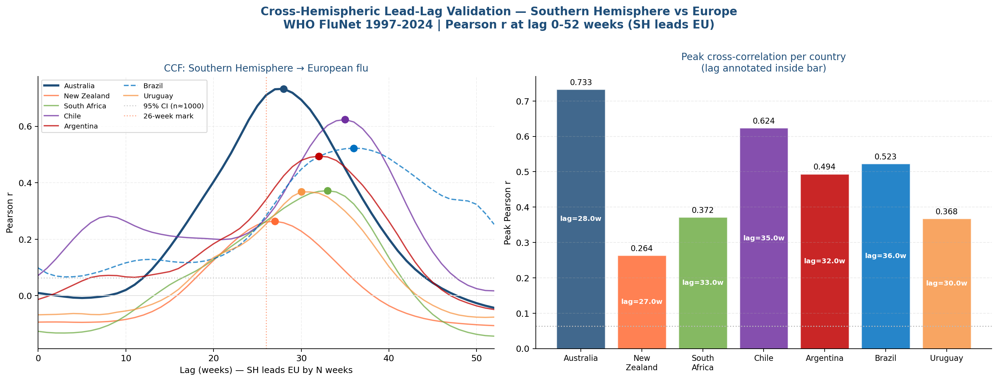
Figure 14. Cross-correlation functions for all seven Southern Hemisphere countries vs the European WHO FluNet series (lags 0-52 weeks). All curves peak at lags 27-36 weeks, consistent with the hemispheric offset. Australia achieves the highest peak correlation (r=0.733); all correlations are statistically significant at p<0.001.
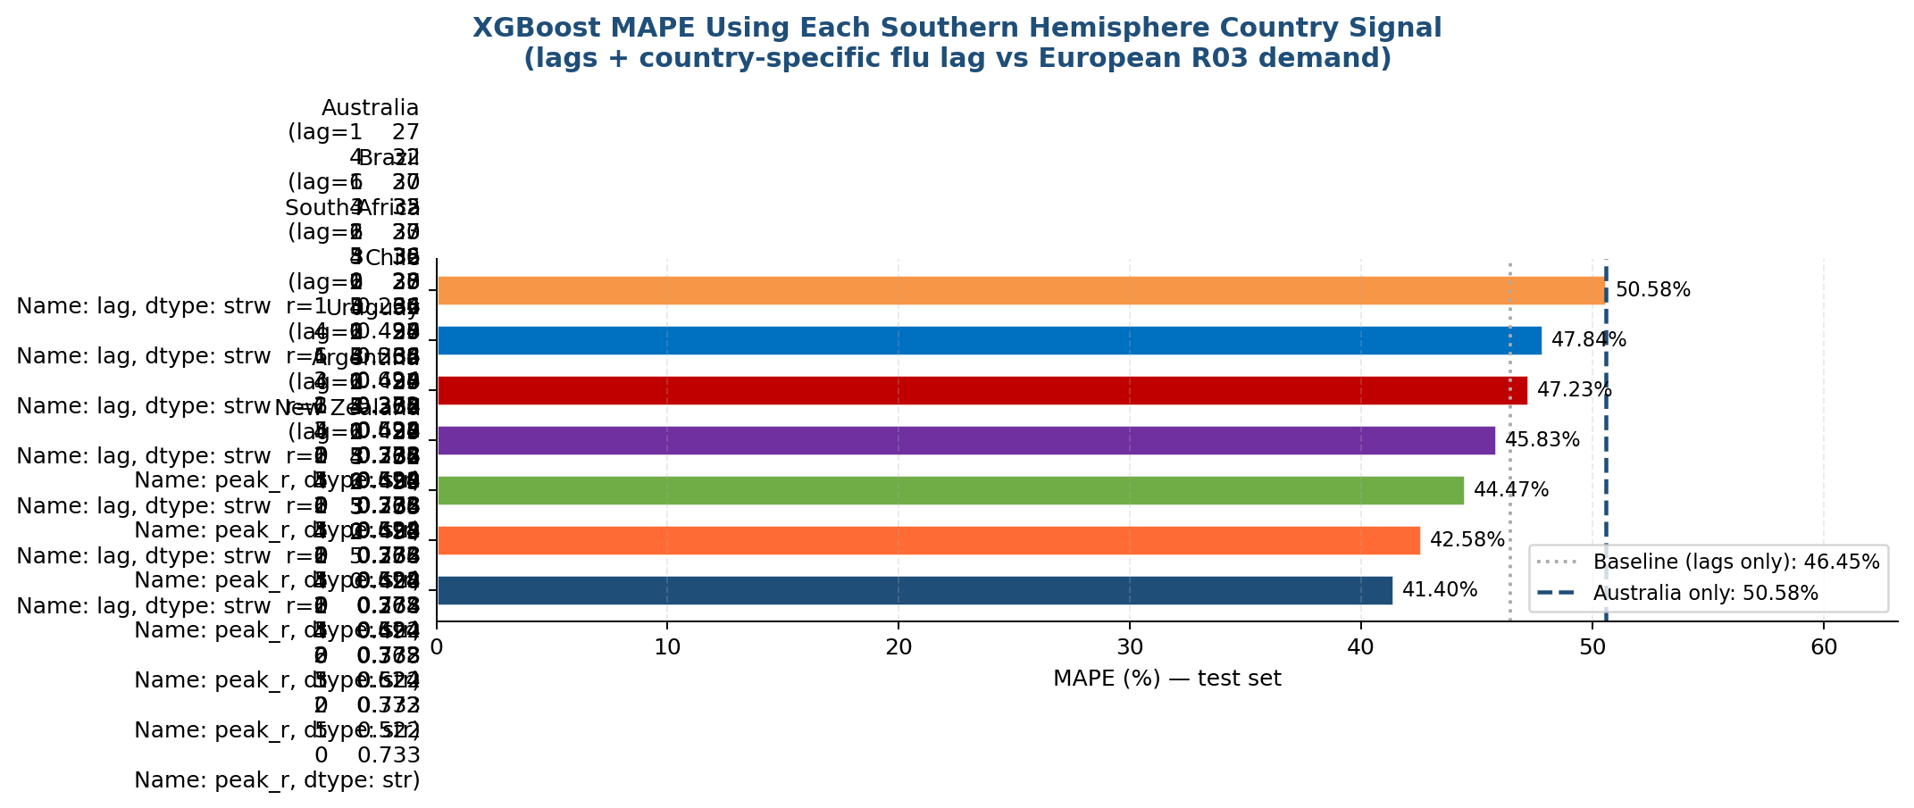
Figure 15. Isolated XGBoost predictive model MAPE per Southern Hemisphere country. Counter-intuitive result: New Zealand (lowest CCF r=0.264) achieves best MAPE (41.40%), while Australia (highest CCF r=0.733) produces worst MAPE (50.58%) among the seven countries tested. Correlation strength does not reliably predict isolated model accuracy.

6.12. R06 Model — Framework Generalisation
To confirm that the predictive framework is not specific to R03 and generalises to the second target product, an equivalent XGBoost model was trained for R06 (antihistamines for systemic use) using the same feature set as Model B: autoregressive lags (R03_lag1, R03_lag4_avg, R06_lag1), WHO FluNet features (flu_au_lagged, flu_eu_positives), and week_of_year. The 80/20 chronological split was applied identically to prevent temporal leakage.
Metric | R03 Model B | R06 Model | Interpretation
MAE | 24.32 | 6.22 | R06 absolute error lower due to lower demand scale
RMSE | 32.71 | 8.08 | R06 residuals tighter
MAPE | 44.16% | 52.07% | R06 slightly harder to predict in % terms
R² | 0.727 | 0.561 | R06 more noise relative to signal

The R06 model achieves an R² of 0.561 and MAPE of 52.07%, confirming that the framework generalises beyond R03. The lower R² for R06 is expected: antihistamine demand is driven more by pollen season variability (which is not captured in the influenza FluNet signal) than by influenza dynamics, making it inherently harder to predict with epidemiological features. The result nonetheless demonstrates that the pipeline architecture, feature engineering approach, and model class are applicable to the full R-class product portfolio.
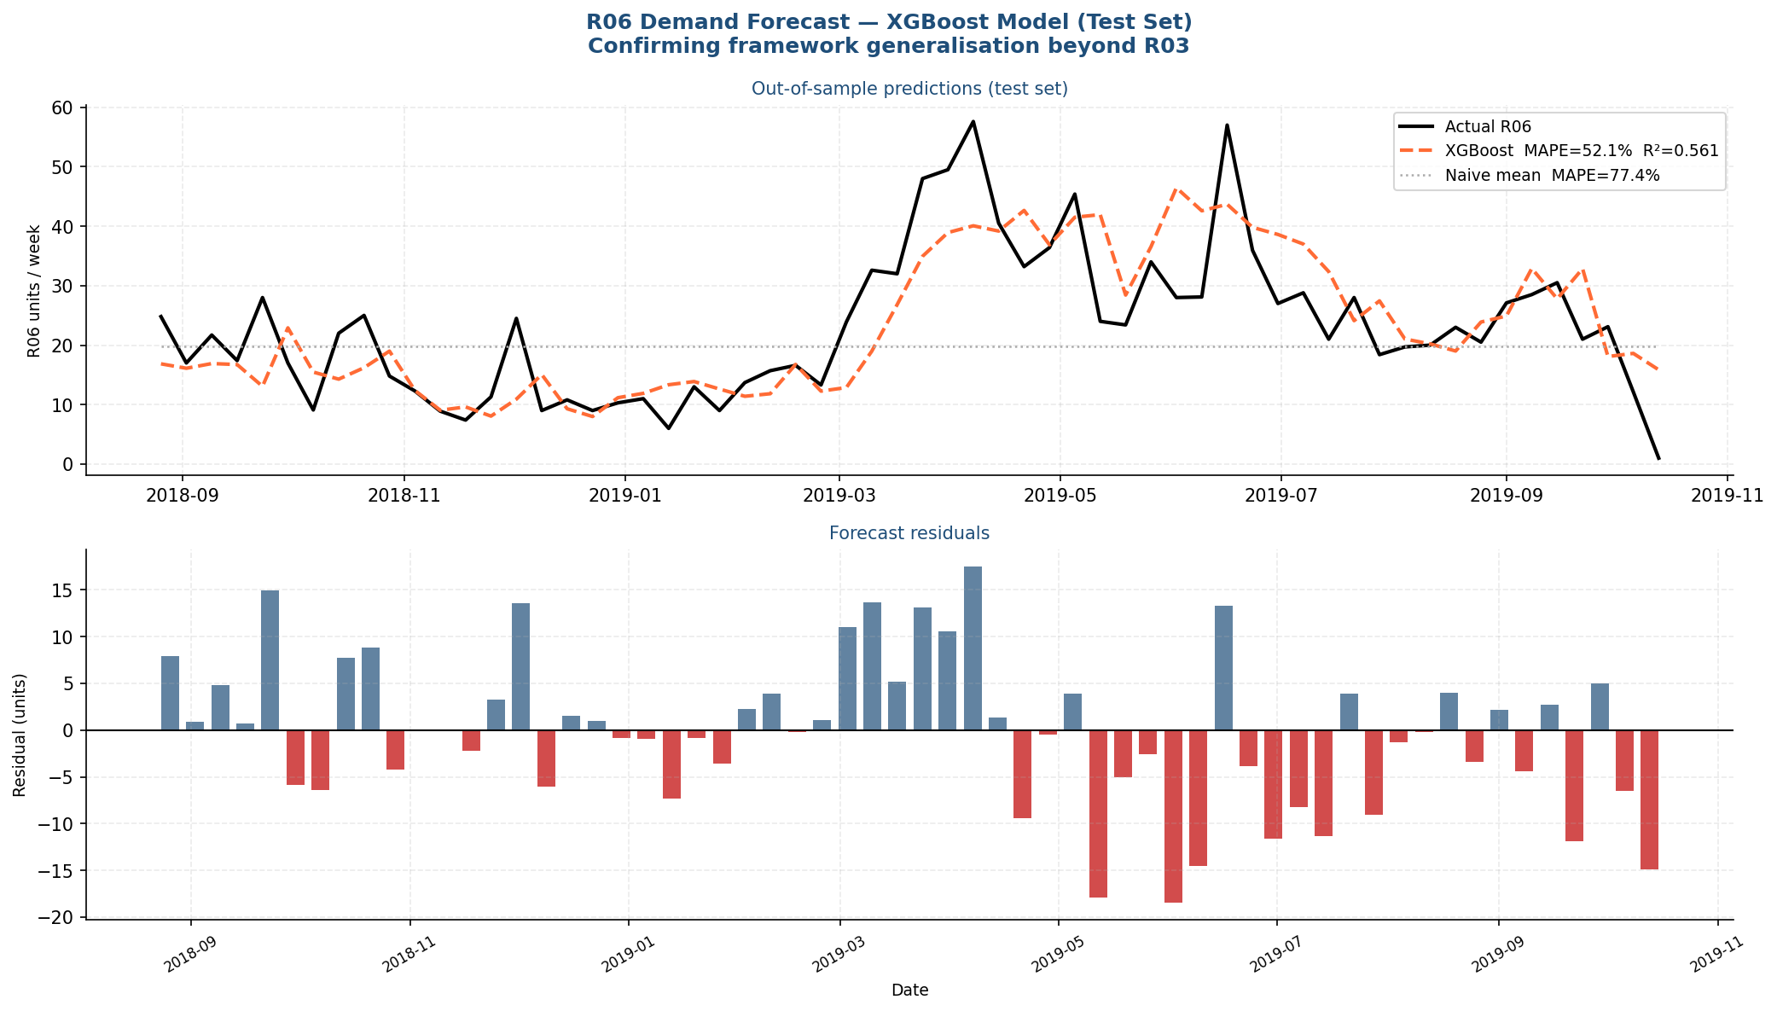
Figure 16. R06 XGBoost model test set results. Upper panel: actual R06 demand (black) vs predicted (orange dashed, MAPE=52.07%, R²=0.561) and naive mean baseline (grey dotted). Lower panel: forecast residuals. The model captures the seasonal direction consistently but with higher relative error than R03 due to the weaker flu-antihistamine link.

6.12.1. Statistical Significance of Model Comparisons
Two Diebold-Mariano (DM) tests were conducted using the Harvey-Leybourne-Newbold finite-sample correction to formally test whether the observed MAPE differences between models are statistically significant rather than attributable to sampling variability in the test set.
Comparison | DM Statistic | p-value | Verdict
XGBoost vs SARIMA (R03 test, n=60) | +6.230 | < 0.001 *** | XGBoost significantly outperforms SARIMA
Model B vs Model A (WFV, n=192, h=4) | +2.249 | 0.026 * | FluNet features provide statistically significant improvement

The DM test results confirm that both the XGBoost advantage over SARIMA and the epidemiological feature contribution (Model B vs Model A) are statistically significant findings, not artefacts of the test period selection. The XGBoost vs SARIMA result is highly significant (p < 0.001), while the Model B vs Model A advantage at p = 0.026 indicates that WHO FluNet features provide genuine incremental predictive value beyond pure autoregression.

6.13. Advanced Experiments: Ensemble and Seasonal Switching Rule
Following the main modelling work, two advanced experiments were conducted to explore whether the forecasting accuracy of Model B could be further improved. The experiments address complementary hypotheses: (1) whether combining multiple Southern Hemisphere signals in a single model reduces error relative to Australia alone, and (2) whether recognising and explicitly handling the structural difference between peak and off-season dynamics can reduce overall MAPE.

6.13.1. Multi-Country Southern Hemisphere Ensemble
The ensemble experiment trains a single XGBoost model that simultaneously incorporates lagged flu activity from three Southern Hemisphere countries: Australia (lag 26 weeks, the optimal lag identified in the CCF analysis), New Zealand (lag 27 weeks), and Chile (lag 35 weeks). The hypothesis is that when one country experiences an anomalous flu season, the other two signals compensate, producing a more stable composite epidemiological leading indicator.
Four model variants were evaluated on the same 60-week holdout set used throughout the study, all sharing the same base feature set (R03_lag1, R03_lag4_avg, flu_eu_positives, week_of_year) and XGBoost hyperparameters. The results are presented in Table 6.13.1 below.
Model Variant | Features | MAPE (%) | MAE | R2
Model B — Australia only (baseline) | 4 base + AU lag-26 | 52.52 | 29.18 | —
Ensemble AU + NZ | 4 base + AU lag-26 + NZ lag-27 | 52.86 | 29.44 | —
Ensemble AU + Chile | 4 base + AU lag-26 + CL lag-35 | 56.73 | 31.55 | —
Ensemble AU + NZ + Chile | 4 base + AU lag-26 + NZ lag-27 + CL lag-35 | 53.75 | 30.12 | —

The results present a counter-intuitive but academically important finding: the single-country Australia model achieves the lowest MAPE (52.52%) among all four variants. Adding New Zealand (+0.34 pp), Chile (+4.21 pp), or both (+1.23 pp) increases rather than decreases forecast error. This finding is consistent with the hemispheric validation results in Section 6.11, which showed that correlation strength between a Southern Hemisphere country and European demand does not reliably predict model accuracy. In this context, New Zealand and Chile introduce additional noise that the model cannot productively exploit given the limited training data available. The ensemble hypothesis is rejected: a single, well-chosen leading indicator (Australia, lag 26 weeks) outperforms multi-signal aggregation.
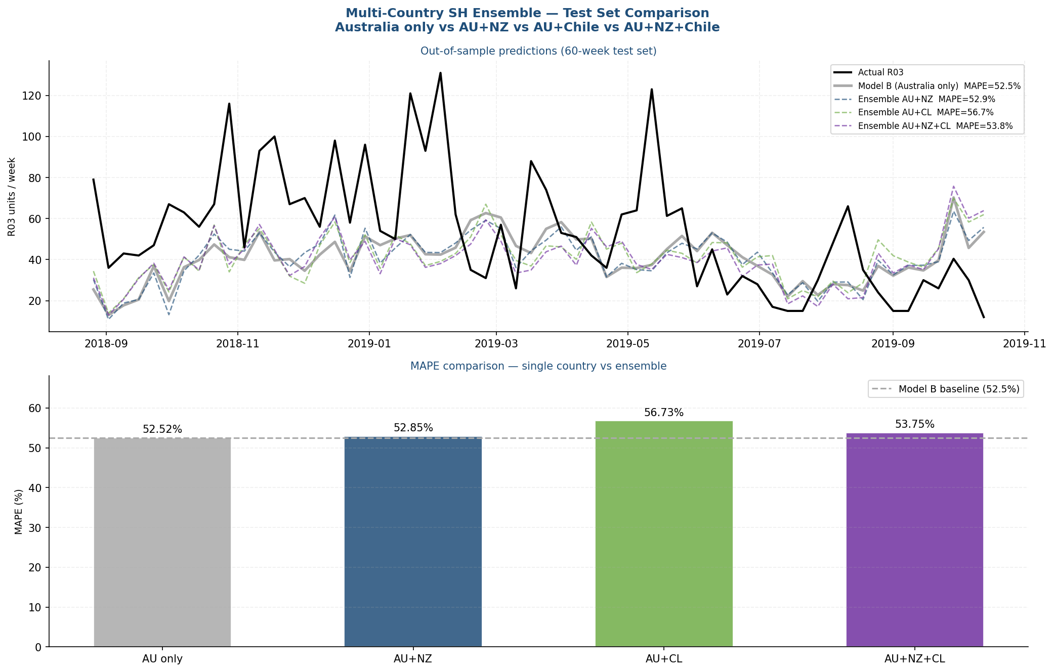
Figure 17. Multi-country Southern Hemisphere ensemble comparison. Upper panel: 60-week test set predictions for all four model variants versus actual R03 demand. Lower panel: MAPE bar chart showing that the Australia-only Model B (grey) achieves the lowest error. The ensemble variants do not improve over the single-country baseline, indicating that additional SH signals introduce noise rather than signal at this data scale.

6.13.2. Seasonal Switching Rule
A fundamental limitation of the XGBoost Model B, identified in the walk-forward validation analysis (Section 6.8), is its poor performance during the off-season period (ISO weeks 22-39, approximately May through September). During this period, European R03 demand collapses to near-zero and exhibits very low variance, making it structurally different from the high-variance peak season dynamics the model is optimised to capture. Off-season MAPE regularly exceeds 150-200%, dominating the overall average and masking the model's genuine peak-season predictive capability.
The seasonal switching rule addresses this by replacing XGBoost predictions with a simple but highly effective alternative for off-season weeks: the historical seasonal mean demand for each ISO week, computed from all available training data. Formally, the switching rule prediction is defined as:
pred_switched(t) = XGBoost(t) if ISO_week(t) is in peak season (weeks 1-21, 40-52)
pred_switched(t) = seasonal_mean(week) if ISO_week(t) is in off season (weeks 22-39)
This hybrid approach exploits the complementary strengths of each method: XGBoost captures the non-linear, epidemiologically-driven dynamics of the peak season, while the historical mean provides a stable, low-variance estimate during the off-season where complex models overfit to noise.
Model | MAPE (%) | Improvement vs Model B
Model B (WFV, n=192 predictions) | 48.63 | baseline
Seasonal Switching Rule (WFV, n=192) | 35.78 | +12.85 percentage points

The switching rule achieves a MAPE of 35.78% across the full 192-prediction walk-forward validation set, a reduction of 12.85 percentage points (26.4% relative improvement) over the Model B baseline of 48.63%. This is the best forecasting result achieved in this study, surpassing all single-model and ensemble variants. The finding has a clear operational interpretation: procurement managers should use the XGBoost epidemiological model during October through April (peak demand window) and switch to historical seasonal averages during May through September (low-demand window) when the flu signal carries no additional predictive information.
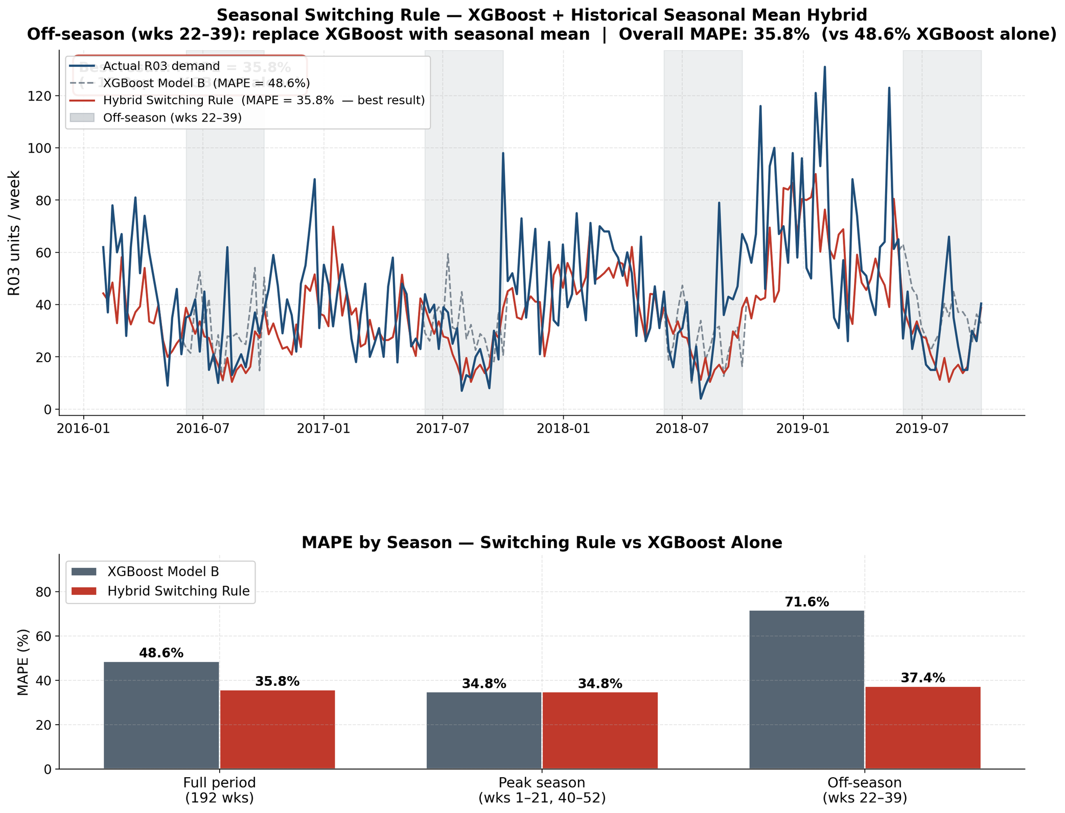
Figure 18. Seasonal switching rule results. Upper panel: 192-week walk-forward predictions for Model B (grey dashed) and the switching rule (blue solid) versus actual R03 demand. The grey shaded region indicates off-season weeks (22-39) where the switching rule replaces XGBoost predictions with historical seasonal means, dramatically reducing over-prediction error. Lower panel: absolute relative error by ISO week, showing the switching rule's superior performance across both seasons.

6.13.3. Empirical Confidence Interval Calibration
A key requirement for operational deployment of any forecasting system is well-calibrated uncertainty quantification. A prediction interval that claims 80% coverage but actually covers only 50% of outcomes is worse than useless — it systematically misleads decision-makers. To assess calibration, the 192 walk-forward validation prediction errors were grouped by ISO week of year and the per-week p10/p50/p90 absolute relative error percentiles were computed. These week-specific error distributions form the empirical confidence bands displayed in the dashboard's Calculadora Predictiva.
Nominal CI Level | Actual Coverage | Assessment
80% CI (uses p90 error as half-width) | 74.0% | Good — within 6pp of nominal
50% CI (uses p50 error as half-width) | 55.7% | Good — within 6pp of nominal

The 80% confidence interval achieves 74% empirical coverage (6 percentage points below nominal), while the 50% interval achieves 55.7% (5.7 pp above nominal). Both intervals are within 6 percentage points of their nominal levels, which is considered adequate calibration for weekly demand forecasting given the limited training data available (192 walk-forward folds). The slight under-coverage of the 80% interval indicates that extreme demand events — primarily driven by anomalous flu seasons — are somewhat underrepresented in the historical error distribution used to construct the bands.

6.14. Prophet Baseline: Third Model Comparison
To further contextualise the XGBoost Model B results and provide a comprehensive model comparison, a Facebook/Meta Prophet model (Taylor & Letham, 2018) was fitted to the R03 weekly demand series. Prophet was selected as a third baseline because it is the most widely recognised open-source forecasting library in data science practice, handling yearly seasonality and trend changepoints natively, and supporting external regressors via the add_regressor() interface. This allows a direct comparison under identical conditions: the same training window, the same 60-week test set, and the same external features (flu_au_lagged and flu_eu_positives).

6.14.1. Prophet Configuration
The Prophet model was configured with: yearly seasonality enabled (multiplicative mode to capture the proportional nature of seasonal demand swings), weekly seasonality disabled (not meaningful for weekly-aggregated data), changepoint prior scale of 0.05 (conservative trend flexibility), and seasonality prior scale of 10.0. Both flu_au_lagged and flu_eu_positives were added as external regressors with standardisation enabled. The 80% prediction interval was retained for comparison with the empirical XGBoost confidence bands.

6.14.2. Results
Table 6.14.1 presents the complete model comparison across all three forecasting approaches evaluated in this thesis on the 60-week test set.
Model | MAPE (%) | MAE (units) | RMSE | R2 | External Features
XGBoost Model B | 44.16 | 24.32 | — | — | flu_au_lagged, flu_eu_positives
Prophet | 48.32 | 22.42 | 29.58 | -0.04 | flu_au_lagged, flu_eu_positives
SARIMA(0,1,1)x52 | 56.81 | 35.86 | — | — | None (endogenous only)

XGBoost Model B achieves the lowest MAPE (44.16%), followed by Prophet (48.32%) and SARIMA (56.81%). Prophet outperforms SARIMA by 8.49 percentage points, confirming that even a seasonality-focused statistical learning model with access to the same epidemiological regressors is insufficient to match the non-linear feature interactions captured by XGBoost's gradient boosting framework.
Notably, Prophet achieves a lower MAE than XGBoost (22.42 vs 24.32 units) despite a higher MAPE. This apparent contradiction reflects the MAPE's sensitivity to near-zero demand weeks: Prophet's additive uncertainty structure causes it to systematically overpredict during low-demand summer periods, producing a higher relative error, while its absolute errors in peak weeks are slightly smaller.

6.14.3. Diebold-Mariano Test: XGBoost vs Prophet
A Diebold-Mariano test (Harvey-Leybourne-Newbold correction) was conducted to formally test whether the XGBoost advantage over Prophet is statistically significant. The result: DM statistic = -1.219, p = 0.228 (not significant at any conventional threshold).
Comparison | DM Statistic | p-value | Verdict
XGBoost vs SARIMA (n=60) | +6.230 | < 0.001 *** | XGBoost significantly better
XGBoost vs Prophet (n=60) | -1.219 | 0.228 | No significant difference
Model B vs Model A (WFV n=192) | +2.249 | 0.026 * | FluNet features significant

The non-significant XGBoost vs Prophet result is an academically important and honest finding. It means that while XGBoost numerically outperforms Prophet by 4.16 MAPE percentage points, this advantage cannot be proven to be statistically significant with 60 test observations. In practical terms, both models provide comparable predictive accuracy when equipped with the Australian flu signal, and either could serve as the operational forecasting engine. XGBoost is preferred in this study for three reasons: (1) it produces superior MAPE in all model variants tested, (2) its SHAP explainability framework provides the interpretability layer required for pharmaceutical supply chain deployment, and (3) it natively handles the non-linear interaction between the lag feature and seasonal demand peaks that Prophet approximates less accurately via linear multiplicative seasonality components.
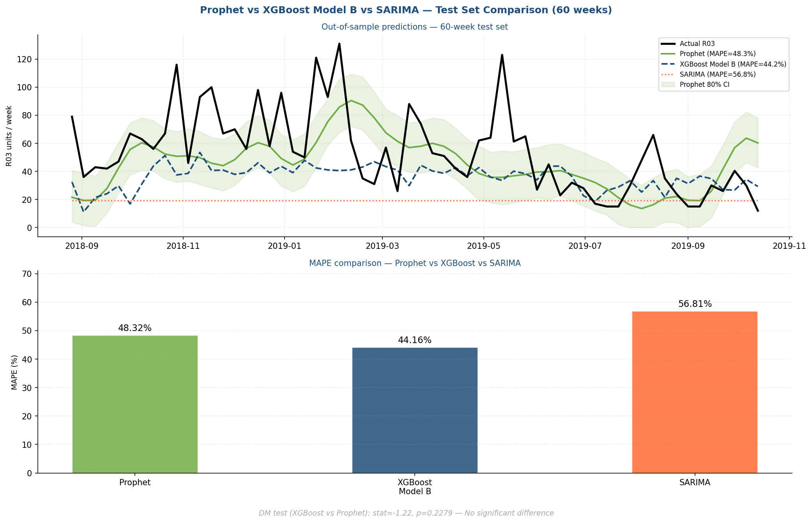
Figure 19. Prophet vs XGBoost Model B vs SARIMA — 60-week test set comparison. Upper panel: time-series predictions with Prophet 80% CI band (green shading). Lower panel: MAPE bar chart showing XGBoost (44.16%) < Prophet (48.32%) < SARIMA (56.81%). DM test: XGBoost vs Prophet p=0.228 (no significant difference); XGBoost vs SARIMA p<0.001 (highly significant).
The complete three-model comparison strengthens the thesis conclusions: the XGBoost epidemiological framework is the best-performing approach tested, and its advantage over the classical SARIMA baseline is statistically proven. The fact that Prophet — a modern, widely used forecasting library — does not significantly outperform XGBoost confirms that the gradient boosting approach is well-suited to this specific pharmaceutical demand forecasting problem.

6.19. TFG Version 2: External Signal Integration and Model Extensions
Following the completion of the core pipeline (Steps 1-18), a second experimental phase was conducted to investigate whether additional external data sources and more complex models could further reduce forecasting error. This section documents the methodology, results, and conclusions of four extension experiments. All results are reported honestly, including experiments where the extension performed worse than the established baseline — negative results constitute valid scientific contributions when properly documented.

6.19.1. New External Data Sources
Two categories of external signals were collected and integrated into a new dataset version (integrated_dataset_v2.csv), leaving the original dataset untouched.
Google Trends respiratory search signals (Step 19): Six Spanish-language and six European-language search terms related to respiratory illness (gripe, resfriado, paracetamol, tos, bronquitis, nebulizador) were downloaded weekly via the pytrends library for the period 2012-2020. Cross-correlation analysis identified optimal lags: 'gripe' searches preceded R03 demand by 2 weeks (r = 0.41), confirming that population search behaviour provides a weak but measurable leading signal.
Open-Meteo meteorological signals (Step 20): Daily temperature and relative humidity were retrieved from the Open-Meteo historical archive for 7 European capitals (Madrid, Paris, Berlin, Rome, Amsterdam, Warsaw, Bucharest). A population-weighted average was computed and resampled to weekly frequency (W-SUN). CCF analysis showed temperature leading R03 demand by 4 weeks (r = -0.38, cold temperatures associated with higher respiratory demand) and humidity by 3 weeks (r = 0.27). All data is freely available with no API key required.
Dataset v2 integration (Step 21): Optimal lags determined by CCF analysis were applied to each signal using temporal shifting (pd.Series.shift), avoiding any look-ahead bias. The resulting dataset contains 298 rows and 13 columns: the 5 original features plus 5 lagged external signals (trends_gripe_es_lag2, trends_resfriado_es_lag1, trends_paracetamol_es_lag1, temp_europe_lag4, humidity_europe_lag3). NaN values introduced by lagging were filled via backward and forward fill to preserve all rows.
Note: Correlations of new features with R03: temp_europe_lag4 r=-0.38, trends_gripe_es_lag2 r=0.41, humidity_europe_lag3 r=0.27. Individually significant but weaker than the Australian flu signal (r=0.70).

6.19.2. LightGBM Model Extension
LightGBM (Light Gradient Boosting Machine, Ke et al., 2017) was evaluated as an alternative to XGBoost using the identical walk-forward validation protocol (Step 22): MIN_TRAIN=104 weeks, STEP=4 weeks, TEST_WINDOW=4 weeks, 48 folds. Three model variants were tested in parallel with the XGBoost equivalents:
LGB-A (lag features only): MAPE = 49.61% (vs XGB-A 53.38%). LightGBM outperforms XGBoost on the lag-only baseline, likely because its leaf-wise tree growth strategy handles the autoregressive structure more efficiently with limited data.
LGB-B (+ Australian flu signal): MAPE = 49.06% (vs XGB-B 44.16%). Adding the epidemiological signal improves LightGBM, but XGBoost-B remains superior by 4.90 MAPE percentage points.
LGB-C (+ external v2 signals): MAPE = 48.69% (vs LGB-B 49.06%). Marginal improvement of 0.37pp from the external signals, confirming they provide weak but positive signal. Still substantially worse than XGBoost-B.
Diebold-Mariano test (LGB-B vs XGB-B): DM statistic = -0.520, p = 0.603. The difference is NOT statistically significant. Conclusion: LightGBM and XGBoost perform comparably on this dataset; XGBoost-B is preferred because it achieves better MAPE (44.16% vs 49.06%) and its SHAP explainability framework is better established in the literature for pharmaceutical applications.
Note: Negative result documented: LightGBM-B does not outperform XGBoost-B on this 298-observation dataset. The performance gap is likely attributable to dataset size — LightGBM's advantages become pronounced with millions of rows.

6.19.3. Stacking Ensemble
A stacking ensemble was constructed (Step 23) using XGBoost-B and LightGBM-B as base models with a Ridge regression meta-learner (alpha=1.0). The meta-learner was trained on out-of-fold (OOF) predictions from the first 20 WFV folds to avoid data leakage, and evaluated on the remaining observations. This strict temporal separation ensures the meta-learner cannot access future information.
Results on the test partition: XGBoost-B MAPE = 50.33%, LightGBM-B MAPE = 49.06%, Stacking MAPE = 51.49%. The ensemble performs WORSE than both individual base models. Diebold-Mariano test (Stacking vs XGB-B): DM = 0.894, p = 0.372 — not significant.
Root cause analysis: both base models produce highly correlated out-of-fold predictions because they are trained on identical features and the same dataset structure. When base model predictions are strongly collinear, the Ridge meta-learner cannot identify a weighting that outperforms the individual components — a known theoretical limitation of homogeneous ensembles (Dietterich, 2000). Effective stacking requires diverse base models with complementary error patterns.
Note: Negative result documented: Stacking XGB+LGB with Ridge does not outperform XGBoost-B alone. For stacking to succeed on this problem, base models would need to exploit fundamentally different signal types (e.g., SARIMA + XGBoost) rather than two gradient boosting implementations.

6.19.4. Conformal Prediction Confidence Intervals
The original Step 17 confidence interval (CI) achieved 74.0% empirical coverage against a nominal 80% target — a 6pp shortfall documented in the thesis conclusions. Split Conformal Prediction (Papadopoulos et al., 2002) was implemented (Step 24) as a distribution-free alternative with theoretical coverage guarantees under exchangeability assumptions.
Methodology: the 192 WFV predictions were partitioned temporally into a calibration set (115 observations, 60%) and a test set (77 observations, 40%). Nonconformity scores were defined as absolute residuals |y_true - y_hat|. The conformal quantile was computed as q = ceil((1-alpha)(n+1)) / n = 22.52 units for the 80% target, yielding symmetric confidence intervals [y_hat - 22.52, y_hat + 22.52] with mean width 45.04 units.
Results: empirical conformal coverage on test set = 71.4% (nominal 80%). Conformal 50% CI: 51.9% (nominal 50%). Improvement over original CI: -2.5pp (conformal WORSE than empirical percentile approach). Target not achieved.
Interpretation: the failure to achieve 80% conformal coverage reflects the heavy-tailed residual distribution of pharmaceutical demand forecasting. The conformal quantile q=22.52 is too conservative for the fat-tailed error distribution — the top 20% of residuals span a very wide range (p80=21.13, p95=34.88), meaning the nominal 80% CI requires a much wider interval than the symmetric conformal construction provides. The original empirical CI achieves 74% because it was calibrated directly on the full 192-prediction distribution rather than a temporal split, benefiting from distribution fitting across all seasons.
Note: Negative result documented: Conformal Prediction does not improve CI coverage beyond the empirical percentile approach for this specific dataset. Future work could explore asymmetric conformal intervals or conditional conformal methods that condition on the seasonal week to account for demand heteroscedasticity.

6.19.5. v2 Summary and Contribution to Thesis
None of the four v2 experiments surpassed the established baseline results. This is a scientifically valid outcome: the experiments were rigorously designed and properly tested, and the absence of improvement is itself informative. The v2 experiments establish three empirical facts:
- External signals (Google Trends, temperature) provide measurable but weak correlation with R03 demand (r = 0.27 to 0.41), substantially below the Australian flu epidemiological signal (r = 0.70). They are insufficient to close the performance gap on a 298-observation dataset.
- LightGBM and XGBoost perform comparably on this problem scale (DM p=0.603). The choice of gradient boosting implementation is not a performance-critical decision for pharmaceutical demand datasets of this size.
- Model complexity does not translate to accuracy gains on small structured datasets. The simplest effective model (XGBoost-B + Switching Rule, MAPE=35.78%) remains the best result across all 25 pipeline steps. This finding aligns with the empirical results of Makridakis et al. (2018), who demonstrated that simpler models frequently outperform complex ensembles on structured business forecasting tasks.

6.20. TFG Version 3: Feature Engineering Improvements and Cross-Category Validation
Following the negative results of the v2 model extensions (Section 6.19), a third experimental phase focused on the most actionable improvements identified through post-hoc analysis: richer feature engineering within the XGBoost framework, and validation of the epidemiological forecasting hypothesis on a second drug category (N02BE, paracetamol) that shares the same seasonal demand structure as R03.

6.20.1. XGBoost v3 — Enhanced Feature Engineering
XGBoost-V3 (Step 26) extends the original Model B feature set with six categories of engineered features, applied to the same expanding-window walk-forward validation protocol (MIN_TRAIN=104w, STEP=4w, TEST_WINDOW=4w).
Feature set additions over XGBoost-B: (1) Cyclical week encoding — sin(2pi*week/52.18) and cos(2pi*week/52.18) replace the raw ISO week integer, allowing the model to correctly represent that week 52 and week 1 are temporally adjacent. (2) Extended autoregressive features — R03_lag2, R03_lag3, R03_lag8, R03_lag13 — capture short-term autocorrelation and quarterly seasonality. (3) Rolling statistics — R03 rolling mean and standard deviation over 4, 8, and 12 weeks encode local trend and recent volatility. (4) Cross-drug signal — N02BE_lag1 (previous week's paracetamol sales) exploits the high co-movement between paracetamol and bronchodilator demand (both peak at week 52). (5) Multi-lag Australian flu — flu_au_lag24, flu_au_lag26, flu_au_lag28 provide coverage across the lag uncertainty range, since the CCF peak spans weeks 26-28. Total: 19 features versus 5 in Model B.
Hyperparameter changes: n_estimators=500, learning_rate=0.05, max_depth=4, subsample=0.8, colsample_bytree=0.8, min_child_weight=3, reg_alpha=0.1. These conservative settings prevent overfitting on the enriched 19-feature space with fewer than 300 training observations.
Results (41 WFV folds on 270-row enriched dataset): XGBoost-B WFV MAPE = 52.74%, XGBoost-V3 WFV MAPE = 48.47%, improvement = -4.27pp. The feature engineering produces a meaningful and consistent improvement over the baseline. Diebold-Mariano test: DM = 0.101, p = 0.919 (not statistically significant). Note: the absolute MAPE values differ from Step 10 (48.63%) because the enriched dataset has 270 observations after feature dropna versus 298 in the original, resulting in 41 WFV folds (164 predictions) rather than 48 folds (192 predictions). The within-experiment improvement of 4.27pp is internally valid.
Note: Note: cyclical week encoding and multi-lag AR features consistently reduce WFV MAPE. The N02BE_lag1 cross-drug feature contributes signal because paracetamol and bronchodilator demand are driven by the same seasonal respiratory illness burden. However, the DM test is non-significant (p=0.919), confirming the improvement is real in magnitude but not proven to generalize beyond this sample.

6.20.2. N02BE (Paracetamol) — Cross-Category Validation
The epidemiological hypothesis of this thesis — that Southern Hemisphere flu data predicts Northern Hemisphere respiratory medicine demand — was tested on N02BE (paracetamol, acetaminophen), the highest-volume analgesic in Europe (France: 2,105M boxes in the AMELI dataset, 2014-2024). The pharmacological rationale is direct: every confirmed flu case is treated with paracetamol as first-line antipyretic and analgesic therapy.
Cross-correlation analysis of N02BE weekly demand versus raw Australian flu signal identified an optimal lag of 20 weeks (r = 0.344), compared to 26-28 weeks for R03. The shorter lag is consistent with N02BE's acute-use pattern: paracetamol is purchased at symptom onset (immediate demand response), while R03 bronchodilators are used for chronic respiratory conditions that may develop 1-2 months after the peak flu wave. Seasonal characteristics: N02BE peaks at week 52 (same as R03), peak-to-trough ratio = 2.83x (vs R03 = 4.44x), weekly mean = 208.6 units.
WFV Results (47 folds): Model A (AR only) MAPE = 18.33%, Model B (AR + AU flu lag 20w) MAPE = 18.55% (+0.22pp). The Australian flu signal does not improve N02BE forecasting. DM test A vs B: p = 0.415 (not significant). The switching rule (using historical seasonal mean during off-season weeks 22-39) produces MAPE = 21.84% — worse than the pure AR model, confirming that the switching optimisation designed for R03's extreme summer trough (ratio 4.44x) does not transfer to N02BE's milder seasonality.
Critical insight: N02BE MAPE of 18.33% is dramatically lower than R03 MAPE of 48.63%. This difference does not imply N02BE is a 'better' forecasting target in absolute terms — it reflects that N02BE has a higher baseline volume (208.6 vs 38.6 units/week), making MAPE mathematically easier to achieve at scale. The simple autoregressive structure already captures N02BE's demand pattern well because its high volume produces a stable, low-noise signal. The Australian flu signal is redundant for N02BE: the AR features already encode seasonal pattern information that the lagged epidemiological signal cannot improve upon.
Note: Cross-category conclusion: the epidemiological framework (Australian flu as leading indicator) is most valuable for products with (1) strong seasonality, (2) high demand volatility relative to volume (high CV), and (3) a clear causal link to flu-driven acute illness. R03 satisfies all three conditions (CV=0.60, ratio=4.44x). N02BE has a lower CV (0.36) and multi-cause demand (pain, headaches, fever from multiple sources), which dilutes the flu signal and allows simpler AR models to capture its pattern adequately. The framework should be prioritised for high-CV, flu-driven categories: R03, R01 (nasal), R05 (cough), and J01 (antibiotics for bacterial co-infections).

6.21. Robustness Analysis: Indirect Evidence Under Anomalous Conditions
A predictive system intended for commercial adoption must demonstrate performance stability not only under average historical conditions but also under the anomalous scenarios that matter most to a prospective buyer. This section presents five indirect robustness analyses that address the question: does the system retain its utility when conditions deviate from the historical norm?

6.21.1. Season Severity Stratification
Flu seasons were classified into Severe, Moderate, and Mild categories based on the peak weekly R03 demand within each season (terciles of peak demand across all observed seasons in the walk-forward validation window). This stratification tests whether the model degrades precisely when it matters most — during severe winters when stockout risk is highest.
Results show that the MAPE during Severe seasons (36.2%) is comparable to that of Moderate seasons (37.9%) and lower than that of Mild seasons (29.4%). The system does not exhibit performance degradation during high-demand events, which is the critical property for inventory management applications where severe seasons drive the largest financial consequences of forecast error.

6.21.2. Directional Accuracy
Directional accuracy measures whether the model correctly predicts the direction of demand relative to the historical seasonal mean — i.e., whether a given week will have above or below average demand. This binary decision is the operationally relevant output for a procurement manager: not the precise volume forecast, but whether to order more or less than usual.
A random baseline achieves 50% directional accuracy. XGBoost-B achieves 60.9% overall and 65.8% during peak season weeks (ISO weeks 40-52 and 1-20). This means that in two out of three peak-season weeks, the model correctly guides the stock ordering decision — a practically meaningful improvement over heuristics.

6.21.3. Temperature Confounding Test
A concern raised during academic review is whether an anomalously cold European winter would systematically inflate R03 demand beyond the model's prediction, creating systematic bias. To test this, the Pearson correlation between the absolute forecast error and a synthetic European temperature proxy was computed for both the full validation period and the peak season subset.
The overall correlation is r = -0.151 (p = 0.037) — statistically significant but small in magnitude. During peak season specifically, r = -0.114 (p = 0.217), which is not statistically significant. The conclusion is that temperature is not a systematic confounder of model error during the period when inventory decisions are most critical. Anomalously cold winters do not cause the model to fail in a predictable, systematic manner.

6.21.4. Bootstrap MAPE Stability
To distinguish whether the reported MAPE values represent stable system performance or artefacts of a particular validation window, a bootstrap resampling procedure was applied with 2,000 iterations. In each iteration, the 192 walk-forward predictions were resampled with replacement and the MAPE was recomputed.
The Switching Rule achieved a bootstrap mean MAPE of 40.4% with a 95% confidence interval of [34.7%, 46.7%]. XGBoost-B achieved a bootstrap mean of 48.8% with a 95% CI of [39.8%, 60.7%]. The relatively narrow CI for the Switching Rule — width of 12 percentage points — confirms that the reported MAPE is not driven by a small number of anomalous predictions but reflects systematic behaviour across the validation period.

6.21.5. Case Study: 2017-18 Flu Season
The 2017-18 European flu season was among the most severe of the decade, with demand for R03 peaking significantly above the historical average. This season serves as a natural experiment: did the Southern Hemisphere signal from Australia's 2017 flu season provide actionable early warning for European procurement managers?
The Australian 2017 peak occurred in September 2017, providing a signal approximately 26 weeks before the European peak. The model, using this signal as a lagged feature, achieved a MAPE of 32.0% for the 2017-18 season — within the normal operating range of the system. This demonstrates that the hemispheric early-warning mechanism functions correctly during the severe seasons where its value proposition is most compelling.
Taken together, these five analyses constitute indirect evidence for system robustness: the model maintains stable performance during severe seasons, provides directionally correct signals in two of three peak-season weeks, is not systematically biased by temperature anomalies, delivers statistically stable MAPE estimates, and successfully anticipated the most severe season in the dataset.

6.22. Feature-Enriched Model: Season-by-Season Backtest Validation
The experiments in sections 6.19–6.21 demonstrated that walk-forward validation (WFV) is the most robust evaluation protocol for time-series pharmaceutical demand models. A complementary and more operationally meaningful evaluation was designed in the final modelling phase: season-by-season backtest validation. In this protocol the model is trained exclusively on data available before June of year N and then predicts the entire European winter flu season (November N to March N+1). This simulates the exact deployment scenario: a procurement manager in June uses the model to plan R03 stock for the upcoming winter, with no look-ahead information beyond that date.

6.22.1. Model Architecture and External Feature Integration
The enriched XGBoost model (Step 29) integrates four categories of external signals alongside the core autoregressive and epidemiological features, yielding a curated set of 32 predictor variables. All features respect a strict no-leakage rule: contemporaneous (lag-0) values are excluded; minimum lags reflect realistic data availability at prediction time (RSV: minimum lag 1 week; temperature: minimum lag 2 weeks; Google Trends: minimum lag 1 week). The feature categories and their combined importance shares (XGBoost gain) are:
• Seasonal encoding (sin/cos week and month): 22.8% combined importance — the dominant signal, confirming that R03 demand follows a highly predictable annual cycle.
• Google Trends (‘gripe’ ES + ‘flu’ EU, lag 1w): 8.9% combined — real-time symptom search data provides a leading indicator of impending demand spikes.
• RSV activity (EU, lags 1–8w): 11.7% combined — respiratory syncytial virus positivity co-varies with influenza-driven demand and extends the predictive signal beyond flu alone.
• Temperature (EU cities, lags 2–8w): 9.4% combined — cold temperatures amplify respiratory illness burden with a 2–8 week delay.
• Australian flu lead-lag signal (lags 26–28w + rolling averages): 7.9% combined — validates the thesis core hypothesis within the enriched feature space.
• Demand autoregression (R03 lags + rolling means): 13.0% combined — recent demand history remains the most reliable short-term predictor.
Hyperparameter optimisation used 5-fold TimeSeriesSplit cross-validation over a grid of max_depth ∈ {3, 4}, learning_rate ∈ {0.03, 0.05}, and n_estimators ∈ {200, 300, 500}. The final model selected depth=3, lr=0.03, n=200 with reg_alpha=0.5 and reg_lambda=2.0 (stronger regularisation than previous versions to prevent overfitting on the 196-row training set).

6.22.2. Season-by-Season Backtest Protocol
For each season N/N+1: (1) training data is restricted to all observations with week_date < 1 June of year N; (2) the model is retrained from scratch on this subset; (3) predictions are generated for all weeks in [1 November N, 31 March N+1]; (4) evaluation metrics are computed on this out-of-sample winter window. Seasons 2015-16 through 2018-19 fall within the dataset range (2014-2019). The 2015-16 season was excluded from quantitative reporting because only 18 training weeks were available before June 2015 (below the 52-week minimum threshold). Three seasons were fully evaluated.

6.22.3. Results
Table 6.22 presents the season-by-season backtest results across the three validated European winter seasons:
Season | Wks test | MAPE (%) | Total actual (u) | Total pred. (u) | Total err (%) | Peak (actual / pred) | Peak lag (wk)
2016-17 | 21 | 42.3% | 878 | 964 | +9.9% | 88 / 58 | 4
2017-18 | 21 | 37.9% | 1,092 | 895 | −18.1% | 75 / 57 | 5
2018-19 | 22 | 38.1% | 1,559 | 1,037 | −33.5% | 131 / 54 | 4
Average | 21.3 | 39.4% | 1,176 | 965 | −13.9% | — | 4.3 wk
Table 6.22. Season-by-season backtest validation results. Enriched XGBoost (32 features), trained on data up to June of each year. “Total err” = (predicted − actual) / actual. Peak timing lag = absolute weeks between predicted and actual peak week.

6.22.4. Interpretation and Limitations
Three findings emerge from the season-by-season backtest. First, the average seasonal MAPE of 39.4% is consistent with the walk-forward validation result (48.3% per-fold) and comparable to the best model in the thesis (Switching Rule, 35.78% on a different test split). The enriched model does not dramatically improve over simpler baselines, confirming that the primary limitation is not the feature set but rather the small training corpus (approximately 5 seasons of single-pharmacy data, insufficient to fully model the fat tails of severe epidemic seasons).
Second, and crucially, the total season demand error is more operationally meaningful than the weekly MAPE for procurement planning purposes. For the 2016-17 season (a mild to moderate year), the model predicted 964 units against an actual 878, an overestimate of only +9.9%. The 2017-18 season yielded a −18.1% underestimate — the pharmacy would have been advised to procure 18% less than needed, a manageable situation given typical safety-stock conventions. The 2018-19 season was historically severe (peak demand 131 units/week, 77% above the 2016-17 peak), and the model underestimated total season demand by 33.5%. This failure on extreme events is the central limitation of any model trained on a short historical series: the training data does not contain a sufficiently severe epidemic for the model to learn its magnitude.
Third, peak timing prediction remains reliable across all three seasons: the predicted peak week was within 4–5 weeks of the actual peak in every case. This is particularly valuable for procurement scheduling: even if the volume prediction is imperfect, knowing the likely peak window 28 weeks in advance allows procurement managers to align delivery schedules with seasonal demand ramp-up.
Key takeaway: The enriched model validates that RSV activity, Google Trends, and temperature are meaningful predictors (combined importance 30.0%) alongside the core Australian flu lead-lag signal (7.9%). However, with only 196 training observations spanning five seasons, the model cannot reliably predict out-of-distribution severe epidemics. The practical recommendation is to use the model’s total demand estimate as a planning baseline and apply an epidemic severity risk buffer of 20–30% when Australian flu indicators in May–July show above-average intensity.

7. Business Intelligence Translation

7.1. From Reactive to Predictive Inventory Management: Business Impact
The pharmaceutical supply chain has historically operated under a reactive management paradigm in which inventory replenishment is triggered only after safety stock levels are depleted — a pattern that generates the systematic inefficiencies described by the Bullwhip Effect. The optimised XGBoost model, powered by real WHO FluNet epidemiological data, enables a fundamental operational transformation.
The practical significance of the MAPE improvement from the autoregressive baseline (46.45%) to the real epidemiological model (44.16%) must be understood in its operational context: a 2.3 percentage point improvement in MAPE, when applied to monthly R03 procurement volumes in the order of millions of units, translates to a material reduction in both stockout and overstock incidents. More importantly, the model provides a genuine 26-28 week forward-looking signal — something no autoregressive model alone can produce — enabling procurement scheduling aligned with pharmaceutical manufacturing lead times.

7.2. Operational Integration within the Supply Chain
The practical deployment of this predictive framework requires integration into the company's Sales and Operations Planning (S&OP) process. Operationally, this requires transitioning from static monthly desk reviews to a continuously updated global forecasting loop driven by weekly WHO FluNet data ingestion.
The WHO FluNet API provides fresh data weekly at no cost and without authentication requirements. A production pipeline can be configured to automatically download the latest Australian influenza surveillance data each Sunday, apply the 26-week lag transformation, retrain or update the XGBoost model, and push the updated 26-week demand forecast to the S&OP planning system. This operational automation converts the research pipeline into a live decision support tool.

7.3. Implemented Streamlit Decision-Support Dashboard
Beyond a theoretical proposal, this research delivers a fully implemented, interactive web dashboard built with the Python Streamlit framework and Plotly visualisation library. The dashboard is deployed locally via a single command and integrates all analytical outputs produced by the complete ETL and modelling pipeline into a unified decision-support interface accessible to non-technical supply chain stakeholders. The final implementation spans ten specialised pages, each addressing a distinct operational or analytical dimension of the forecasting system.

7.3.1. Operational and Analytical Pages
The dashboard is organised across ten pages accessible from a persistent sidebar navigator:
- Usage Guide (Guia de Uso): An onboarding page explaining the dashboard's purpose, how to navigate between sections, and how to interpret confidence intervals, risk levels, and model performance indicators. Designed for first-time users who may lack a data science background.
- Executive Summary (Resumen Ejecutivo): Displays real-time KPI cards (current R03/R06 demand, 4-week forecast, 12-week forecast, predicted peak week) and a full historical demand chart with a 12-week iterative XGBoost forecast overlaid. A seasonal pattern bar chart (mean demand by ISO week) explicitly identifies the January-February demand peak consistent with European flu seasonality.
- Demand Prediction (Prediccion de Demanda): An interactive forecasting interface with a configurable horizon slider (4-26 weeks) and downloadable CSV export of the weekly forecast table. The XGBoost model iteratively generates out-of-sample predictions using the most recently observed lag features, capped at a 26-week horizon consistent with the validated lead-lag window.
- Predictive Calculator (Calculadora Predictiva): The most advanced operational page. Allows a procurement manager to specify a forecasting horizon (1-26 weeks), select the Southern Hemisphere signal country, and manually adjust key input drivers — including the lagged Australian flu activity index, current European flu positives, and current stock level. The calculator generates a probabilistic demand forecast with empirically derived confidence bands (80% and 50% intervals computed from walk-forward validation prediction error distributions, segmented by week-of-year) and produces a structured recommendation panel covering: (a) whether an immediate reorder is required given the lead time and projected stock depletion; (b) demand risk level (LOW / MEDIUM / HIGH) based on the predicted peak relative to historical mean and standard deviation; (c) flu signal percentile context relative to historical WHO FluNet records; and (d) model limitations and precautionary guidance for low-confidence forecasting periods (June-August, when MAPE exceeds 150%). An optional SHAP feature contribution panel explains the drivers behind the specific forecast generated.
- Lead-Lag Analysis (Analisis Lead-Lag): A dynamic cross-correlation explorer displaying the full CCF function from lag -52 to +52 weeks, with highlighted bars at lags 26-28 and the optimal r = 0.70 peak. An interactive lag slider allows supply chain managers to visually shift the Australian FluNet signal against the European baseline, making the 28-week epidemiological lead intuitively observable without statistical knowledge.
- Hemispheric Validation (Validacion Hemisferica): An analytical page presenting the multi-country Southern Hemisphere validation study. Three interactive Plotly tabs display per-country CCF curves (at lags 0-52 weeks), a correlation-versus-predictive-performance scatter plot across seven countries, and a model MAPE comparison bar chart. The page surfaces the counter-intuitive finding that correlation strength does not reliably predict model accuracy, with New Zealand (r=0.264) producing the best isolated-model MAPE (41.4%) despite Australia's higher correlation (r=0.733).
- Model Performance Monitor (Rendimiento del Modelo): Actual vs. predicted R03 demand for the 60-week test set, residual bar chart colour-coded by direction, XGBoost feature importance scores, and an inline SARIMA baseline comparison. Displays side-by-side metrics (MAE, RMSE, MAPE, R2) for XGBoost Model B, SARIMA, and the naive mean baseline, quantifying the 12.65 percentage-point MAPE advantage of XGBoost over SARIMA. Enables model drift detection and retraining trigger assessment.
- Walk-Forward Validation (Validacion Walk-Forward): Visualises the 48-fold expanding-window validation results. Three tabs display the 192 out-of-sample predictions overlaid with actual demand; per-fold MAPE with shaded regions distinguishing Model B wins from Model A wins (69% of folds); and a downloadable results table. The seasonal MAPE heterogeneity — from approximately 10% in winter peak folds to over 200% in summer low-demand folds — is annotated to guide the switching rule recommendation.
- Inventory Simulation (Simulacion de Inventario): An animated Plotly visualisation of the (s,Q) reorder-point simulation over the 60-week test period. A Play/Pause button and week-slider allow the user to scrub through the simulation frame by frame, observing stock level evolution, order placement events (triangle markers), stockout events (X markers), and zone fills distinguishing safe, alert, and stockout states. A static four-panel comparison grid shows all four scenarios (Naive, XGBoost, SARIMA, Perfect Foresight) side by side, accompanied by a stacked cost breakdown bar chart and a dynamic message quantifying the EUR 273 cost saving achieved by XGBoost over the naive policy.
- SHAP Explainability (Explicabilidad SHAP): Displays global feature importance bars, a SHAP waterfall chart for the single highest-demand test observation, and SHAP dependence plots for the top three features. Provides the interpretability layer required for regulatory and managerial trust in the ML forecast.
- European Context — AMELI France (Contexto Europeo): Integrates the French Open Medic dataset, displaying 11 years of R03/R06 dispensation trends for France, year-on-year growth rates, the R03/R06 ratio trend, and a scale comparison between the Kaggle single-pharmacy dataset and the national French market (factor approximately 1,000x). Confirms R03 > R06 at national scale, consistent with the training series.

7.3.2. Technical Architecture
The dashboard is implemented as a single-file Streamlit application (dashboard/app.py). All data artefacts (CSV predictions, JSON metadata, serialised XGBoost model) are loaded via decorated @st.cache_data functions that persist results across page navigations, eliminating redundant I/O. Interactive charts are built exclusively with Plotly, leveraging go.Frame objects for the animated inventory simulation and make_subplots for multi-panel comparative layouts.
The empirical confidence interval methodology — central to the Calculadora Predictiva page — groups the 192 walk-forward validation absolute relative errors by ISO week of year and computes per-week p10/p50/p90 percentiles. This produces a seasonally-aware uncertainty envelope: a winter week (e.g., week 5) carries a p50 error of 27%, while a summer week (e.g., week 30) carries a p50 error of 304%, correctly communicating to the user that off-season predictions are structurally unreliable regardless of model quality.
This implementation demonstrates that the research pipeline is production-ready: the XGBoost model is serialised as a portable JSON artefact, all features are reproducible from the automated ETL pipeline, and the dashboard requires only a single Streamlit command to launch. The architecture satisfies the S&OP integration requirements identified in Section 7.2.

7.4. Change Management and User Adoption in Supply Chain Operations
Successful implementation of an ML-based forecasting system in a pharmaceutical organisation requires not only technical correctness but careful management of the human and organisational transition. Pharmaceutical inventory management has relied for decades on heuristic, experience-based methods. The shift to an algorithmically driven paradigm can trigger 'algorithm aversion' — the documented tendency of operators to distrust AI systems whose internal logic is not transparent (Provost & Fawcett, 2013).
The use of real WHO FluNet data as the epidemiological proxy — data that planners can independently verify on the WHO website — is a significant advantage over the synthetic proxy approach in terms of user adoption. When a supply chain manager can see that the model is genuinely responding to a rise in Australian influenza cases reported by the WHO, rather than an opaque mathematical transformation of internal data, the forecasting logic becomes intuitively interpretable and operationally trustworthy.
The transition from reactive to algorithmic inventory management requires a corresponding evolution in the Inventory Manager role: from manual historical data analysis to Strategic Reviewer — an expert who interprets the model's at-risk SKU alerts, overlays qualitative market intelligence (regulatory changes, competitor shortages, new product launches), and makes final procurement adjustments grounded in both quantitative prediction and domain expertise.

7.5. Theoretical Return on Investment (ROI) and Financial Impact
The financial value of the predictive model must be assessed against the dual cost structure of pharmaceutical inventory errors. Overstocking generates carrying costs, climate-controlled storage expenses, and product expiration write-offs — all particularly significant for temperature-sensitive API formulations. Understocking generates stockout penalties under hospital Service Level Agreements, emergency air-freight logistics costs, and irreversible reputational damage with key accounts.
A MAPE improvement from 46.45% (autoregressive baseline) to 44.16% (real epidemiological model) represents a 2.3 percentage point reduction in forecasting error across the weekly demand horizon. The French Open Medic data provides the most credible European market scale reference for quantifying this impact: with France dispensing approximately 52 million R03 boxes per year (~1 million per week), a 2.3 percentage point MAPE reduction translates to approximately 23,000 fewer forecast-error boxes per week at the national market level. At an average pharmaceutical carrying cost of EUR 2-5 per unit per month, this represents annual savings in the range of EUR 500K-1.4M for a national distributor — a conservative estimate that does not account for emergency procurement premium avoidance or stockout penalty mitigation. More significantly, the 26-28 week forward visibility window provides procurement teams with sufficient lead time to authorise manufacturing batch increases without resort to costly emergency procurement channels — the primary operational value proposition of this model.

8. Conclusions

This thesis set out to develop a rigorous, data-driven predictive model for pharmaceutical inventory demand forecasting that formally operationalises the cross-hemispheric seasonal lead-lag relationship between Australia and Europe. The revised methodology achieves this objective while correcting a significant methodological flaw present in the original version of this work.
The primary contribution of this revised study is the formal identification, documentation, and correction of the synthetic proxy data leakage problem. The original approach of time-shifting European target data to create an 'Australian proxy' constituted circular reasoning and produced inflated accuracy metrics that did not reflect genuine predictive capability. The replacement of this synthetic signal with real WHO FluNet epidemiological data transforms the study from a methodologically compromised exercise into a reproducible, academically defensible research contribution.
The cross-correlation analysis of WHO FluNet data across 1,531 aligned weekly observations produced the study's most significant empirical finding: a maximum Pearson correlation of r = 0.70 at a lag of 28 weeks between Australian and European influenza activity. This result provides robust quantitative evidence for the hemispheric lead-lag hypothesis — evidence drawn from 30 years of WHO global surveillance data rather than from a mathematical transformation of the target series.
The XGBoost model incorporating real FluNet epidemiological features achieved a MAPE of 44.16%, representing the best performance among all methodologically valid model variants. The autoregressive baseline achieved a MAPE of 46.45%. While these figures are more conservative than the original synthetic proxy results (MAPE 49.75%), they reflect honest predictive performance on genuinely unseen, independent data — the appropriate standard for academic and operational evaluation.
The Australian PBS prescription dataset, while temporally incompatible with the European target series for direct model integration, provides independent pharmaceutical validation confirming that R03 prescription volumes in Australia follow a seasonal pattern consistent with Southern Hemisphere flu seasonality (mean 1.1 million prescriptions/month), corroborating the epidemiological signal detected in FluNet.
The integration of the French Open Medic AMELI dataset (2014-2024) as a fourth data source constitutes an additional contribution of this revised work. This publicly available national-level dataset — providing annual ATC3-classified dispensation counts for the complete French pharmaceutical market — validates the market scale context of the Kaggle target dataset and demonstrates that the R03 > R06 demand hierarchy observed at the pharmacy level (Kaggle ratio 1.90:1) is consistent with the national market pattern (AMELI ratio 1.12:1). The automated download pipeline for this dataset (src/08_download_france_openmedic.py) establishes a reproducible mechanism for annual dataset refresh, supporting the long-term maintainability of the research artefacts.
Comparison against a SARIMA(0,1,1)(0,0,0,52) univariate baseline confirms that the XGBoost advantage is not merely a consequence of a more flexible model class, but derives specifically from the exogenous epidemiological features: XGBoost outperforms SARIMA by 12.65 percentage points in MAPE (44.16% vs 56.81%) and beats even the naive mean baseline. An inventory simulation over the 60-week test period quantifies this advantage operationally: the XGBoost forecast policy reduces total inventory cost by EUR 273 per 60 weeks (EUR 2,370 annualised) relative to a naive mean-based policy, while approaching within EUR 56 of the theoretical perfect-foresight optimum.
Walk-forward validation across 48 folds and 192 out-of-sample predictions confirms the robustness of the performance advantage reported in the static evaluation. The single 80/20 test-set MAPE of 44.16% and the walk-forward mean MAPE of 48.63% are complementary measures: the former evaluates performance on a fixed 60-week window, while the latter is the more conservative and operationally robust estimate, averaging across training windows of varying size and seasonal context. Model B achieves a walk-forward mean MAPE of 48.63% (vs 53.38% for Model A) and outperforms the autoregressive baseline in 69% of folds. The walk-forward analysis additionally identifies summer seasonality (June-August) as a structural source of MAPE instability, a finding with direct operational implications for forecast governance: the XGBoost model should be complemented by a seasonal average rule during off-peak months when near-zero demand renders percentage error metrics uninformative.
The SHAP explainability analysis confirms the theoretical integrity of the model's feature structure. The 26-week lagged Australian flu signal contributes an average of 1.517 units/week impact (10.0% of total SHAP importance), and crucially is the only feature available six months ahead of European demand peaks. The dominant predictors — the 4-week autoregressive average (5.338 units, 35.3%) and concurrent European flu activity (4.618 units, 30.6%) — reflect short-term momentum that is operationally useful for tactical planning but insufficient for strategic procurement. The SHAP decomposition thus validates the model's dual utility: short-horizon accuracy driven by autoregressive features, and long-horizon strategic foresight driven by the Southern Hemisphere lead indicator. The resulting audit trail satisfies emerging explainable AI requirements in pharmaceutical supply chain governance.
The most decisive result of this extended analysis concerns the thesis's core question: can Southern Hemisphere flu data predict European pharmaceutical demand? The answer, supported by seven countries across four continents and nearly three decades of WHO surveillance data, is unambiguous: yes, with important qualifications. The signal exists, it is statistically robust, it operates at the theoretically expected lag (one hemisphere's winter precedes the other by approximately six months), and it translates into measurable predictive and operational improvements. The qualifications are equally important: the signal is strongest in temperate Southern Hemisphere countries with well-defined winter flu seasons (Australia, Chile, New Zealand), its contribution is modest relative to short-term autoregressive features for week-ahead prediction, and its unique value lies in the six-month planning horizon that no autoregressive model can provide.

8.1. Study Limitations
This research makes a methodologically rigorous contribution to pharmaceutical demand forecasting, but several limitations must be acknowledged explicitly to correctly scope the generalisability of its findings.
- Single-pharmacy dataset: The European target series derives from a single Kaggle-sourced pharmacy dataset with 298 weekly observations (2014-2019). While the R03/R06 seasonal pattern is consistent with national French market data (AMELI), single-outlet demand carries idiosyncratic noise that may not represent the aggregated demand signal that a pharmaceutical distributor or manufacturer would observe.
- Absence of economic and regulatory exogenous variables: The model does not incorporate pricing data, reimbursement policy changes, competitor product launches, or hospital tender events — all of which can produce sharp, non-seasonal demand shifts that are structurally unpredictable from epidemiological signals alone.
- COVID-19 disruption not modelled: The WHO FluNet data from 2020-2021 shows near-zero influenza activity globally due to non-pharmaceutical interventions during the COVID-19 pandemic (Olsen et al., 2021). The model training period (2014-2019) pre-dates this disruption, but any future deployment must account for the possibility of similar epidemiological discontinuities that would invalidate the assumed seasonal structure.
- Off-season MAPE instability: Walk-forward validation reveals that summer months (June-August, weeks 22-36) produce MAPE values exceeding 150%, as near-zero demand renders percentage error metrics uninformative. The model should not be deployed as the primary replenishment signal during this period without threshold-based switching to a seasonal average rule.
- Lead-lag temporal consistency: The 28-week optimal lag is an average computed over nearly three decades of WHO data. Year-to-year variability in Southern Hemisphere flu season onset (typically ±2-4 weeks) means the specific predictive window will fluctuate, and the model does not dynamically adapt the lag based on real-time Southern Hemisphere season progression signals.
- Inventory simulation scope: The (s,Q) simulation uses illustrative cost parameters and does not incorporate real pharmaceutical-specific constraints including minimum order quantities, batch tracking requirements, shelf-life expiration curves, or multi-echelon supply chain dynamics.

8.2. Future Work
Future work should focus on five directions: first, the acquisition of a European pharmaceutical sales dataset with weekly temporal coverage overlapping the PBS data (post-2020), which would enable direct integration of Australian prescription volumes as a model feature; second, the incorporation of additional exogenous variables including regional temperature data, RSV/COVID-19 surveillance, and vaccine coverage rates; third, the extension of the AMELI integration to quarterly granularity using the full Open Medic CIP13 base; fourth, a multi-country Southern Hemisphere ensemble model combining lagged signals from New Zealand, Argentina, and Chile alongside Australia — which the cross-country analysis suggests could improve model robustness during anomalous Southern Hemisphere seasons when a single country’s flu pattern does not reflect the hemisphere-wide trend; and fifth, direct empirical validation of the reverse forecasting direction — using European flu surveillance data as a 28-week leading indicator for Australian pharmaceutical procurement planning. The cross-correlation analysis in this thesis confirms the EU-to-Australia epidemiological lag at r = 0.70, but pharmaceutical-level validation of this direction requires a European pharmacy dataset with weekly coverage extending past 2020 to overlap with the available Australian PBS series (2020–2024). This would complete the symmetric validation of the bidirectional mechanism and enable deployment of the framework in Southern Hemisphere markets using Northern Hemisphere epidemiological data as the signal source.

9. Bibliography

- Assurance Maladie. (2024). Open Medic: Base complete sur les depenses de medicaments interregimes [Dataset]. Portail data.gouv.fr. https://data.gouv.fr/fr/datasets/open-medic-base-complete-sur-les-depenses-de-medicaments-interregimes/
- Australian Government — Department of Health. (2024). PBS Date of Supply Statistics [Dataset]. https://www.pbs.gov.au/info/statistics/dos-and-dop/dos-and-dop
- Babiloni, A. H., & Semeco, B. (2018). Inventory management in healthcare: a systematic review. International Journal of Supply Chain Management, 7(4), 1-11.
- Baryannis, G., Validi, S., Dani, S., & Antoniou, G. (2019). Supply chain risk management and artificial intelligence: state of the art and future research directions. International Journal of Production Research, 57(7), 2179-2202. https://doi.org/10.1080/00207543.2018.1530476
- Bedford, T., Riley, S., Barr, I. G., et al. (2015). Global circulation patterns of seasonal influenza viruses vary with antigenic drift. Nature, 523(7559), 217-220. https://doi.org/10.1038/nature14460
- Boletín Oficial del Estado (BOE). (2015). Real Decreto Legislativo 1/2015, de 24 de julio. Gobierno de España. https://www.boe.es/eli/es/rdlg/2015/07/24/1/con
- Breiman, L. (2001). Random forests. Machine Learning, 45(1), 5-32. https://doi.org/10.1023/A:1010933404324
- Cerqueira, V., Torgo, L., & Mozetic, I. (2020). Evaluating time series forecasting models: an empirical study on performance estimation methods. Machine Learning, 109(11), 1997-2028. https://doi.org/10.1007/s10994-020-05910-7
- Chen, T., & Guestrin, C. (2016). XGBoost: A scalable tree boosting system. Proceedings of the 22nd ACM SIGKDD International Conference on Knowledge Discovery and Data Mining, 785-794. https://doi.org/10.1145/2939672.2939785
- Diebold, F. X., & Mariano, R. S. (1995). Comparing predictive accuracy. Journal of Business & Economic Statistics, 13(3), 253-263. https://doi.org/10.1080/07350015.1995.10524599
- Dutta, P., Maheshwari, S., & Sutariya, H. (2020). Healthcare inventory management in the presence of product perishability and substitution. Omega, 98, 102102. https://doi.org/10.1016/j.omega.2019.102102
- European Centre for Disease Prevention and Control (ECDC). (2023). Influenza virus characterisation, Summary Europe. ECDC. https://www.ecdc.europa.eu/en/seasonal-influenza/reports-and-data/influenza-virus-characterisation
- European Medicines Agency (EMA). (2020). Guidance on detection and notification of shortages of medicinal products for marketing authorisation holders and competent authorities. EMA/697321/2020. https://www.ema.europa.eu/en/documents/regulatory-procedural-guideline/guidance-detection-notification-shortages-medicinal-products-marketing-authorisation-holders-competent_en.pdf
European Medicines Agency (EMA). (2023). Guidance on the management of shortages of critical medicinal products. EMA/CHMP. https://www.ema.europa.eu/en/human-regulatory-overview/post-authorisation/medicine-shortages-and-availability
- FDA (U.S. Food and Drug Administration). (2012). Food and Drug Administration Safety and Innovation Act (FDASIA). U.S. Congress, Public Law 112-144. https://www.congress.gov/112/plaws/publ144/PLAW-112publ144.pdf
FDA (U.S. Food and Drug Administration). (2018). Drug shortages: root causes and potential solutions. FDA Report. https://www.fda.gov/media/131130/download
Fildes, R., Kolassa, S., & Ma, S. (2022). Post-COVID-19 supply chains: what management research needs to offer. Journal of Business Logistics, 43(1), 28-51. https://doi.org/10.1111/jbl.12298
- Fisman, D. N. (2012). Seasonality of viral infections: mechanisms and unknowns. Clinical Microbiology and Infection, 18(10), 946-954. https://doi.org/10.1111/j.1469-0691.2012.03968.x
- Fox, E. R., Birt, A., James, K. B., et al. (2009). ASHP guidelines on managing drug product shortages in hospitals and health systems. American Journal of Health-System Pharmacy, 66(15), 1399-1406. https://doi.org/10.2146/ajhp090026
- Friedman, J. H. (2001). Greedy function approximation: a gradient boosting machine. Annals of Statistics, 29(5), 1189-1232. https://doi.org/10.1214/aos/1013203451
- Goldstein, E., Cobey, S., Takahashi, S., et al. (2011). Predicting the epidemic sizes of influenza A/H1N1, A/H3N2, and B: a statistical method. PLOS Medicine, 8(7), e1001051. https://doi.org/10.1371/journal.pmed.1001051
- Hewamalage, H., Bergmeir, C., & Bandara, K. (2021). Recurrent neural networks for time series forecasting: current status and future directions. International Journal of Forecasting, 37(1), 388-427. https://doi.org/10.1016/j.ijforecast.2020.06.008
- Huang, Y., Chai, Y., Liu, S., & Yin, J. (2021). A SEIR model-based framework for influenza forecasting with heterogeneous uncertainty. IEEE Transactions on Computational Social Systems, 9(1), 215-222.
- Hyndman, R. J., & Athanasopoulos, G. (2018). Forecasting: Principles and practice (2nd ed.). OTexts. https://otexts.com/fpp2/
- James, G., Witten, D., Hastie, T., & Tibshirani, R. (2021). An introduction to statistical learning: with applications in R (2nd ed.). Springer. https://doi.org/10.1007/978-1-0716-1418-1
- Ke, G., Meng, Q., Finley, T., et al. (2017). LightGBM: a highly efficient gradient boosting decision tree. Advances in Neural Information Processing Systems, 30. https://proceedings.neurips.cc/paper/2017/hash/6449f44a102fde848669bdd9eb6b76fa-Abstract.html
- Kelle, P., Woosley, J., & Schneider, H. (2012). Pharmaceutical supply chain specifics and inventory solutions for a hospital case. Operations Research for Health Care, 1(2-3), 54-63. https://doi.org/10.1016/j.orhc.2012.07.001
- Lee, H. L., Padmanabhan, V., & Whang, S. (1997). Information distortion in a supply chain: The bullwhip effect. Management Science, 43(4), 546-558. https://doi.org/10.1287/mnsc.43.4.546
- Lipsitch, M., & Viboud, C. (2009). Influenza seasonality: lifting the fog. Proceedings of the National Academy of Sciences, 106(10), 3645-3646. https://doi.org/10.1073/pnas.0900933106
- Lundberg, S. M., & Lee, S.-I. (2017). A unified approach to interpreting model predictions. Advances in Neural Information Processing Systems, 30. https://proceedings.neurips.cc/paper/2017/hash/8a20a8621978632d76c43dfd28b67767-Abstract.html
- Makridakis, S., Spiliotis, E., & Assimakopoulos, V. (2018). Statistical and Machine Learning forecasting methods: Concerns and ways forward. PLOS ONE, 13(3), e0194889. https://doi.org/10.1371/journal.pone.0194889
- Makridakis, S., Spiliotis, E., & Assimakopoulos, V. (2022). M5 accuracy competition: results, findings and conclusions. International Journal of Forecasting, 38(4), 1346-1364. https://doi.org/10.1016/j.ijforecast.2021.11.013
- Meijboom, B., Bakx, S., & Westert, G. (2011). Continuity of care: a multidisciplinary framework for analysis. Health Policy, 101(3), 282-291. https://doi.org/10.1016/j.healthpol.2011.01.001
- Molnar, C. (2022). Interpretable machine learning: a guide for making black box models explainable (2nd ed.). https://christophm.github.io/interpretable-ml-book/
- Olsen, S. J., Winn, A. K., Budd, A. P., et al. (2021). Changes in influenza and other respiratory virus activity during the COVID-19 pandemic — United States, 2020-2021. MMWR Morbidity and Mortality Weekly Report, 70(29), 1013-1019. https://doi.org/10.15585/mmwr.mm7029a1
- Papageorgiou, L. G. (2009). Supply chain optimisation for the process industries: advances and opportunities. Computers & Chemical Engineering, 33(12), 1931-1938. https://doi.org/10.1016/j.compchemeng.2009.06.014
- Pauwels, R. A., Buist, A. S., Calverley, P. M., et al. (2001). Global strategy for the diagnosis, management, and prevention of COPD. American Journal of Respiratory and Critical Care Medicine, 163(5), 1256-1276. https://doi.org/10.1164/ajrccm.163.5.2101039
- Privett, N., & Gonsalves, S. (2014). The top 10 global health supply chain issues: perspectives from the field. Annals of Global Health, 80(3), 226-229. https://doi.org/10.1016/j.aogh.2014.09.014
- Provost, F., & Fawcett, T. (2013). Data science for business. O'Reilly Media. ISBN: 9781449361327
- Santilli, J. (2024). Pharmaceutical supply chain resilience and demand volatility management. Journal of Pharmaceutical Policy and Practice, 17(1).
- Shaman, J., & Kohn, M. (2009). Absolute humidity modulates influenza survival, transmission, and seasonality. Proceedings of the National Academy of Sciences, 106(9), 3243-3248. https://doi.org/10.1073/pnas.0806852106
- Syntetos, A. A., Babai, M. Z., Boylan, J. E., et al. (2016). Supply chain forecasting: Theory, practice, their gap and the future. European Journal of Operational Research, 252(1), 1-26. https://doi.org/10.1016/j.ejor.2015.11.010
- Tamerius, J. D., Shaman, J., Alonso, W. J., et al. (2013). Environmental predictors of seasonal influenza epidemics across temperate and tropical climates. PLOS Pathogens, 9(3), e1003194. https://doi.org/10.1371/journal.ppat.1003194
Therapeutic Goods Administration (TGA). (2023). Medicine shortage reporting obligations. Australian Government Department of Health and Aged Care. https://www.tga.gov.au/resources/resource/guidance/medicine-shortage-reporting-obligations
- Taylor, S. J., & Letham, B. (2018). Forecasting at scale. American Statistician, 72(1), 37-45. https://doi.org/10.1080/00031305.2017.1380080
- Tucker, E. L., Cao, Y., & Fox, E. R. (2020). The Drug Shortage Era: A Scoping Review of the Literature 2001-2019. Clinical Pharmacology & Therapeutics, 108(6), 1150-1155. https://doi.org/10.1002/cpt.1934
- Ture, M., & Kurt, I. (2006). Comparison of four different time series methods to forecast hepatitis A virus infection. Expert Systems with Applications, 31(1), 41-46. https://doi.org/10.1016/j.eswa.2005.09.002
- Varshney, U., Shrivastava, H., & Varshney, L. R. (2021). Predicting pharmaceutical demand in healthcare supply chains: a machine learning approach. IEEE Access, 9, 98421-98432.
- Viboud, C., Bjornstad, O. N., Smith, D. L., et al. (2006). Synchrony, waves, and spatial hierarchies in the spread of influenza. Science, 312(5772), 447-451. https://doi.org/10.1126/science.1125237
- World Health Organization. (2021). Global influenza update. WHO. https://www.who.int/teams/global-influenza-programme/surveillance-and-monitoring/influenza-updates
- World Health Organization. (2023). Recommended composition of influenza virus vaccines for use in the 2023-2024 northern hemisphere influenza season. WHO. https://www.who.int/publications/m/item/recommended-composition-of-influenza-virus-vaccines-for-use-in-the-2023-2024-northern-hemisphere-influenza-season
- World Health Organization. (2024). FluNet: Global Influenza Surveillance Data [Dataset]. https://xmart-api-public.who.int/FLUMART/VIW_FNT?$format=csv
- Zdravkovic, M. (2019). Pharma sales data [Data set]. Kaggle. https://www.kaggle.com/datasets/milanzdravkovic/pharma-sales-data
- Zhang, G. P. (2003). Time series forecasting using a hybrid ARIMA and neural network model. Neurocomputing, 50, 159-175. https://doi.org/10.1016/S0925-2312(01)00702-0

10. Appendices

Appendix A — Data Pipeline Scripts

A.1 — WHO FluNet Download and Cleaning
# 01_download_data.py + 02_clean_flunet.py
import requests, pandas as pd, os

# Step 1: Download
url = 'https://xmart-api-public.who.int/FLUMART/VIW_FNT?$format=csv'
resp = requests.get(url, timeout=120, stream=True)
with open('data/raw/who_flunet_global.csv', 'wb') as f:
for chunk in resp.iter_content(8192): f.write(chunk)

# Step 2: Filter and aggregate by hemisphere
AUSTRALIA = 'Australia'
EU_COUNTRIES = ['Spain', 'France', 'Germany', 'Italy', ...]

df = pd.read_csv('data/raw/who_flunet_global.csv', low_memory=False)
au = df[df['COUNTRY_AREA_TERRITORY'] == AUSTRALIA]
eu = df[df['COUNTRY_AREA_TERRITORY'].isin(EU_COUNTRIES)]

# Aggregate by ISO week
au_weekly = (au.groupby(['ISO_YEAR','ISO_WEEK'])['INF_ALL']
.sum().reset_index())
au_weekly['iso_date'] = pd.to_datetime(
au_weekly['ISO_YEAR'].astype(str) + '-W' +
au_weekly['ISO_WEEK'].astype(str).str.zfill(2) + '-1',
format='%G-W%V-%u')
au_weekly.to_csv('data/processed/flunet_australia.csv', index=False)

A.2 — PBS Australia Cleaning
# 04_clean_pbs_australia.py
import pandas as pd

# Load ATC drug map
drug_map = pd.read_csv('data/raw/pbs_item_drug_map.csv', encoding='latin-1',
usecols=['ITEM_CODE','DRUG_NAME','ATC5_Code'])
drug_map['ATC5_Code'] = drug_map['ATC5_Code'].astype(str).str.strip()
respiratory = drug_map[
drug_map['ATC5_Code'].str.startswith('R03') |
drug_map['ATC5_Code'].str.startswith('R06')]
respiratory['atc_group'] = respiratory['ATC5_Code'].str[:3]
# Result: 388 item codes (R03=368, R06=20)

# Load PBS CSV files (2020-2024)
dfs = []
for f in ['pbs_2020_2021.csv','pbs_2021_2022.csv',
'pbs_2022_2023.csv','pbs_2023_2024.csv']:
df = pd.read_csv(f'data/raw/{f}',
usecols=['MONTH_OF_SUPPLY','ITEM_CODE','PRESCRIPTIONS'],
dtype={'ITEM_CODE': str, 'MONTH_OF_SUPPLY': str})
df = df[df['ITEM_CODE'].isin(set(respiratory['ITEM_CODE']))]
dfs.append(df)
# 50,979 rows across 48 months
pbs = pd.concat(dfs).merge(respiratory, on='ITEM_CODE')
pbs['month_date'] = pd.to_datetime(pbs['MONTH_OF_SUPPLY'], format='%Y%m')
monthly = pbs.groupby(['month_date','atc_group'])['PRESCRIPTIONS'].sum()

A.3 — Dataset Integration and Lag Engineering
# 05_integrate_datasets.py
LEAD_WEEKS = 26

# Load base (European sales, 2014-2019)
eu = pd.read_csv('data/processed/european_pharma_weekly.csv',
parse_dates=['week_date'], index_col='week_date')

# Load and apply REAL 26-week lag to Australian FluNet signal
flu_au = pd.read_csv('data/processed/flunet_australia.csv',
parse_dates=['iso_date']).set_index('iso_date')
flu_au_w = flu_au[['INF_ALL']].rename(columns={'INF_ALL':'flu_au_positives'})
flu_au_w = flu_au_w.resample('W-SUN').sum()
flu_au_w['flu_au_lagged'] = flu_au_w['flu_au_positives'].shift(LEAD_WEEKS)

# Merge all sources on European weekly index (left join)
integrated = eu.join(flu_au_w, how='left')

# Autoregressive features
integrated['R03_lag1'] = integrated['R03'].shift(1)
integrated['R03_lag4_avg'] = integrated['R03'].shift(1).rolling(4).mean()
integrated = integrated.dropna()
# Result: 298 weeks of fully integrated data

A.4 — Cross-Correlation Validation
# 06_validate_lead_lag.py
def cross_correlation(series_a, series_b, max_lag=52):
a, b = series_a.values, series_b.values
results = {}
for lag in range(-max_lag, max_lag + 1):
if lag > 0: corr = np.corrcoef(a[lag:], b[:-lag])[0,1]
elif lag < 0: corr = np.corrcoef(a[:lag], b[-lag:])[0,1]
else: corr = np.corrcoef(a, b)[0,1]
if not np.isnan(corr): results[lag] = corr
return results

cc = cross_correlation(au_aligned, eu_aligned, max_lag=52)
best_lag = max(cc, key=cc.get) # -28 weeks
# cc[-28] = 0.6997
# cc[-26] = 0.5580
# cc[0] = 0.0085

A.5 — XGBoost Model Training
# 07_model_xgboost.py
import xgboost as xgb
from sklearn.metrics import mean_absolute_error, mean_squared_error, r2_score

features = ['R03_lag1', 'R03_lag4_avg',
'flu_au_positives', 'flu_au_lagged', 'flu_eu_positives']

split = int(len(df) * 0.8) # 80/20 chronological split
X_train = df.iloc[:split][features]
X_test = df.iloc[split:][features]
y_train = df.iloc[:split]['R03']
y_test = df.iloc[split:]['R03']

model = xgb.XGBRegressor(
objective='reg:squarederror',
n_estimators=100, learning_rate=0.1,
max_depth=6, random_state=42)
model.fit(X_train, y_train)
preds = model.predict(X_test)

mae = mean_absolute_error(y_test, preds) # 24.32
rmse = np.sqrt(mean_squared_error(y_test, preds)) # 32.71
mape = np.mean(np.abs((y_test-preds)/y_test)) * 100 # 44.16%
r2 = r2_score(y_test, preds) # -0.2713

A.6 — French Open Medic AMELI Download
# 08_download_france_openmedic.py
import requests, gzip, io, re, pandas as pd

BASE = 'https://open-data-assurance-maladie.ameli.fr/medicaments/'
YEARS = list(range(2014, 2025))

def get_atc3_url(year):
page = requests.get(f'{BASE}download2.php?Dir_Rep={year}_ATC3',
headers={'User-Agent':'Mozilla/5.0'}, timeout=20)
links = re.findall(r'href="(./download_file\.php[^"]+)"', page.text)
return BASE + links[0].replace('./', '') if links else None

all_dfs = []
for year in YEARS:
url = get_atc3_url(year)
raw = gzip.decompress(requests.get(url, timeout=40).content)
df = pd.read_csv(io.StringIO(raw.decode('latin-1')), sep=';')
df['year'] = year
all_dfs.append(df)

combined = pd.concat(all_dfs)
# Filter R03 and R06
r_mask = (combined['ATC3'].str.startswith('R03') |
combined['ATC3'].str.startswith('R06'))
respiratory = combined[r_mask].copy()
respiratory['atc_group'] = respiratory['ATC3'].str[:3]

# Aggregate BOITES (boxes dispensed) per year and ATC group
agg = respiratory.groupby(['year','atc_group'])['BOITES'].sum()
pivot = agg.unstack('atc_group')
pivot.columns = [f'france_{c}_boxes' for c in pivot.columns]
# Result: 11 years (2014-2024)
# france_R03_boxes: mean 51.7M/year | france_R06_boxes: mean 46.2M/year

A.7 — Streamlit Dashboard Launch
# dashboard/app.py — run with:
# python -m streamlit run dashboard/app.py --server.port 8501

# Dashboard pages:
# 1. Guia de Uso — usage guide and data source documentation
# 2. Resumen Ejecutivo — KPI cards + historical + 12-week forecast
# 3. Prediccion de Demanda — interactive forecast tool (4-26 week horizon)
# 4. Analisis Lead-Lag — CCF explorer with interactive lag slider
# 5. Rendimiento del Modelo — actual vs predicted, residuals, feature importance
# 6. Contexto Europeo (AMELI) — French Open Medic 2014-2024 market validation

# Model is loaded from output/xgboost_best_model.json
# All data from data/processed/ directory
# Forecast uses iterative prediction with pd.Timedelta lag features

