Secure Authentication Module for Operating Systems

PROJECT REPORT
As a Field work for Course OPERATING SYSTEMS (CSE316)
By
Sr. No. | Registration No | Name of Students | Roll No
1 |  | Mukesh kumar Pandey | 49
2 |  | Laksh | 51
3 | 12411144 | Santlaj kumar Mehta | 52



Submitted To- Isha
Lovely Professional University
Jalandhar, Punjab, India.

Table of Contents
Sr. No. | Topic
1 | Project Overview  1.1 Introduction  1.2 Objectives of the project  1.3 Scope of the project
2 | Module-Wise Breakdown  2.1 Authentication Core Module  2.2 Security Enforcement and Recovery Module  2.3 Session and User Interaction Module
3 | Functionalities  3.1 Authentication Core Functionalities  3.2 Security Monitoring and Protection Functionalities  3.3 Session, Recovery and Interface Functionalities
4 | Technology Used  4.1 Programming Languages  4.2 Libraries and Frameworks  4.3 Other Tools
5 | Revision Tracking on GitHub
6 | Flow Diagram
7 | Conclusion and Future Scope  7.1 Conclusion  7.2 Future Scope
8 | References
9 | Appendices  A. AI-Generated Project Elaboration/Breakdown Report  B. Problem Statement  C. Solution Code Snippets

1. Project Overview

1.1 Introduction
Authentication is one of the most important jobs of an operating system. Before a user can open files, use services, or work inside the system, the operating system must confirm that the user is genuine. If this first check is weak, then the full system becomes weak. That is why secure login design is a major part of operating system security.
Many simple systems still depend only on a password. In real life, that is not always enough because passwords can be guessed, stolen, reused, or shared. This project was created to show how an operating system can follow a stronger and layered method. Instead of trusting one password only, the system checks identity in more than one step and also records what happens during the process.
The project is implemented as a Flask-based prototype, but the design idea comes from operating system security. It models important OS responsibilities such as user verification, access control, session tracking, security logging, and safe password recovery. In simple words, this project shows how a secure authentication subsystem can be organised, tested, and explained in a practical way.

1.2 Objectives of the Project
- To design a layered authentication workflow inspired by operating system access-control principles.
- To secure passwords using bcrypt hashing instead of storing them in plaintext form.
- To implement multi-factor authentication using time-based one-time passwords (TOTP).
- To reduce brute-force risk by locking accounts after repeated failed login attempts.
- To manage and revoke active user sessions in a controlled manner.
- To maintain audit logs for accountability, monitoring, and security review.
- To provide secure password recovery through time-limited, single-use reset tokens.

1.3 Scope of the Project
The scope of this project includes the complete user authentication journey. It starts from new-user registration and continues through password validation, OTP verification, session creation, session control, password reset, and audit logging. Every major step has been included so that the system can be shown as a complete security workflow instead of a small isolated login example.
This project does not directly replace the built-in login system of a real operating system. Instead, it acts as a working model that explains how an OS-style authentication layer can be designed. Its purpose is educational and demonstrative. It helps show how security ideas from operating systems can be converted into a practical authentication module.

2. Module-Wise Breakdown
The Secure Authentication Module is divided into three main modules so that each part has a clear and separate responsibility. This modular structure is important in operating systems because it keeps the design organised and easier to manage. Instead of keeping all logic in one place, the system separates verification, protection, and user interaction.
This separation also improves understanding. A teacher or evaluator can clearly see which part checks identity, which part applies security rules, and which part handles user-facing actions. That is why the project was structured in three modules instead of one large combined block.

2.1 Authentication Core Module
Purpose: The Authentication Core Module performs the main identity checks of the system. It is the part that decides whether a user should move forward in the login process or not. This module handles username lookup, password checking, and OTP-based second-step verification.
Role in the System: In operating system terms, this module acts like the central login engine. It does not give access immediately after receiving credentials. Instead, it follows an ordered process. First it checks the user record, then it verifies the password, and then it asks for OTP. Only after these steps are successful does it allow an authenticated session to be created.
- Registration of new users with username, email, hashed password, and OTP secret.
- Password verification using bcrypt.
- OTP generation and validation using time-based codes.
- Creation of active session records after successful authentication.

2.2 Security Enforcement and Recovery Module
Purpose: This module applies the security rules that make the system stronger. It is responsible for protecting stored credentials, limiting repeated wrong attempts, supporting safe password reset, and recording security events. In simple words, this module makes sure the login system is not only functional but also secure.
Role in the System: In an operating system, security is not only about checking who the user is. It is also about how the system behaves when something goes wrong. This module handles such situations in a controlled way. If the password is wrong many times, the account gets locked. If the user forgets the password, the reset process uses a secure token. If something important happens, it is written to the audit log for review.
- Tracking failed login attempts and locking accounts after three failures.
- Generating cryptographically secure reset tokens with expiry control.
- Sending email-based OTP and password-reset notifications.
- Maintaining a timestamped audit log of authentication events.

2.3 Session and User Interaction Module
Purpose: This module provides the pages and actions that the user sees after or during authentication. It includes the dashboard, session view, 2FA setup, audit log view, and password-reset screens. These pages are important because they let the user interact with the security system in a controlled and understandable way.
Role in the System: After a user is authenticated, the system must still manage what happens next. The operating system must know which session is active, whether other devices are logged in, and whether the user should be allowed to close those sessions. This module supports that idea by showing session details, displaying recent security activity, and helping users configure authenticator-based OTP.
- Protected dashboard shown only after successful authentication.
- Display and revocation of active login sessions.
- QR-based onboarding for authenticator applications such as Google Authenticator or Authy.
- Audit-log viewing for security monitoring and accountability.

3. Functionalities

3.1 Authentication Core Functionalities
The authentication core focuses on verifying identity step by step. It begins with user registration and then handles the secure login path. These features make sure that the system does not trust input blindly and that access is given only after the required checks are complete.
- User registration with unique username validation.
- Secure password hashing using bcrypt with salting.
- Password verification against stored hashes.
- TOTP generation and verification as the second authentication factor.
- Creation of a database-backed session only after both factors succeed.

3.2 Security Monitoring and Protection Functionalities
These functions improve system safety when users make mistakes or when an attacker tries to misuse the login process. The goal is to reduce risk, maintain control, and keep evidence of important actions for later checking.
- Account lockout after three consecutive failed password attempts.
- Single-use password reset tokens with a fifteen-minute validity window.
- Anti-enumeration response during password-reset requests.
- Timestamped logging of registration, login, OTP, reset, and session events.
- Audit visibility that helps trace suspicious activity and review system usage.

3.3 Session, Recovery, and Interface Functionalities
The final group of features deals with what the user can manage and observe. This is important because security becomes stronger when users can see active sessions, understand recent actions, and recover access safely when needed.
- Session listing with browser, IP address, login time, and current-session marking.
- Revocation of individual sessions and logout from all active sessions.
- Authenticator-app setup through QR code and manual secret key entry.
- Protected dashboard that groups all security operations in one place.
- Email-based recovery workflow for users who forget their password.

4. Technology Used
The project was developed using a simple but effective technology stack. The selected tools make it easier to build secure login features, store user information, and demonstrate operating system security ideas in a working form. Each technology was chosen because it supports a specific part of the authentication process.

4.1 Programming Languages
Language | Purpose
Python | Backend logic, database coordination, authentication flow, OTP handling, and audit support
HTML | Structure of user-facing authentication pages
CSS | Styling of the login, dashboard, session, and audit interfaces
SQL | Persistent storage queries for users, sessions, and reset tokens

Python was selected because it is easy to understand, quick to develop with, and well supported by security-related libraries. It also helps represent system logic clearly, which is useful in an academic project where explanation is as important as implementation.

4.2 Libraries and Frameworks
Library / Framework | Purpose
Flask | Web routing and application flow control
bcrypt | Secure password hashing and verification
pyotp | Time-based one-time password generation and validation
qrcode | QR-code generation for authenticator-app onboarding
python-dotenv | Loading email credentials from environment variables
smtplib | Sending OTP and password-reset emails
sqlite3 | Lightweight persistent user and session storage

4.3 Other Tools
Tool | Purpose
SQLite | Local database storage for users, sessions, and reset tokens
GitHub | Version tracking and repository hosting
Visual Studio Code | Code development and editing
Web Browser | Running and testing the authentication workflow

5. Revision Tracking on GitHub
Version control is important in software projects because it helps track changes over time. It also gives a safe backup of the work and makes it easier to review how the project developed from one stage to another. In this project, GitHub was used to keep the source code organised and to preserve the revision history of the authentication system.
The repository includes the main application file, database module, security module, templates, and setup files. As features such as OTP verification, session handling, and logging were added, GitHub helped maintain a clear development path. This is useful not only for coding, but also for project reporting and presentation.
Repository Name: Secure-Authentication-Module-for-Operating-Systems
GitHub Link: https://github.com/dhawan2006/Secure-Authentication-Module-for-Operating-Systems.git
YouTube Video Link: To be added after final recording
LinkedIn Video Link: To be added after final posting

6. Flow Diagram
The following flow diagram shows the full path followed by a user in the system. It begins when the application is opened and the user chooses either signup or login. From there, the flow moves through input checking, password validation, OTP generation, OTP verification, and finally dashboard access after successful authentication.
This diagram is important because it explains the project in one visual structure. It shows that authentication in this system is not a single step. It is a chain of checks and decisions. The same flowchart idea used in the earlier OS project report has been kept here so that the logic remains consistent.
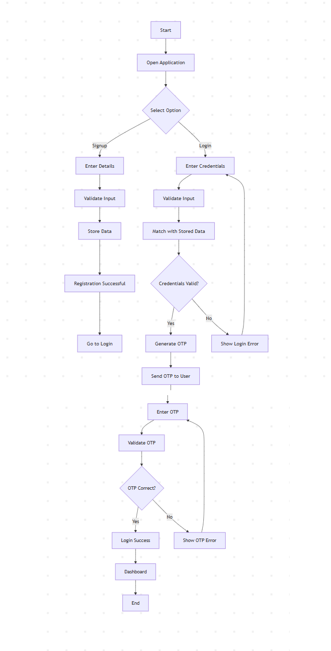
Figure 1. Secure Authentication workflow used in the project.

7. Conclusion and Future Scope

7.1 Conclusion
The Secure Authentication Module for Operating Systems successfully demonstrates a layered approach to login security. The project shows that a secure system should not depend only on one password. Instead, it should combine identity checks, second-factor verification, session control, recovery support, and logging in one complete process.
The main achievement of this project is that it goes beyond a basic login page. It presents authentication as a full operating system function. The system verifies users carefully, protects access, records events, and gives control over active sessions. In this way, the project works as a useful and practical model of OS-inspired security design.

7.2 Future Scope
- Integration of biometric or WebAuthn-based authentication.
- Role-based access control for multiple categories of users.
- Production-grade session hardening with HTTPS-only deployment and stronger cookie policies.
- Automated anomaly detection on audit logs to identify suspicious behaviour.
- Adaptation of the architecture into a deeper OS-level or PAM-style integration model.

8. References
- Python Software Foundation. Python 3 Documentation. https://docs.python.org/3/
- Flask Documentation. https://flask.palletsprojects.com/
- bcrypt Documentation and USENIX references for password hashing.
- RFC 6238: TOTP - Time-Based One-Time Password Algorithm.
- pyotp Documentation. https://pyauth.github.io/pyotp/
- OWASP Authentication Cheat Sheet. https://owasp.org/
- SQLite Documentation. https://www.sqlite.org/docs.html

9. Appendices

Appendix A: AI-Generated Project Elaboration/Breakdown Report

A.1 What Is This Project?
SecureAuth is a Flask-based multi-factor authentication application created as an Operating Systems project prototype. It simulates a secure login subsystem by combining identity verification, time-based OTP validation, session tracking, password-reset recovery, and activity logging.

A.2 Project File Structure
secure_auth_v2/
- app.py - main routing and application control
- database.py - SQLite data-access layer
- security.py - hashing, OTP, email, QR, and logging utilities
- templates/ - login, dashboard, audit, session, and reset interfaces
- logs/auth.log - persistent authentication event log
- users.db - user, session, and reset-token database

A.3 Security Highlights
- Passwords are stored as bcrypt hashes rather than plaintext.
- OTP is used as a second factor before access is granted.
- Accounts are locked after repeated failed attempts.
- Session records can be reviewed and revoked.
- Password reset is token-based and time-limited.
- All important events are written to an audit log.

Appendix B: Problem Statement
Traditional operating system login mechanisms that rely only on static passwords are vulnerable to brute-force attacks, password theft, session abuse, and weak recovery mechanisms. The objective of this project is to design and demonstrate a secure authentication module that strengthens user verification through password hashing, multi-factor authentication, controlled session management, account lockout, secure password reset, and audit logging, thereby improving overall access-control security in an OS-inspired environment.

Appendix C: Solution Code Snippets
This appendix contains image-based views of the important source code used in the project. The files shown below are taken from the main application, database, security, and key template files. Sensitive environment data such as .env contents has been excluded.

C.1 Main Application Code
app.py
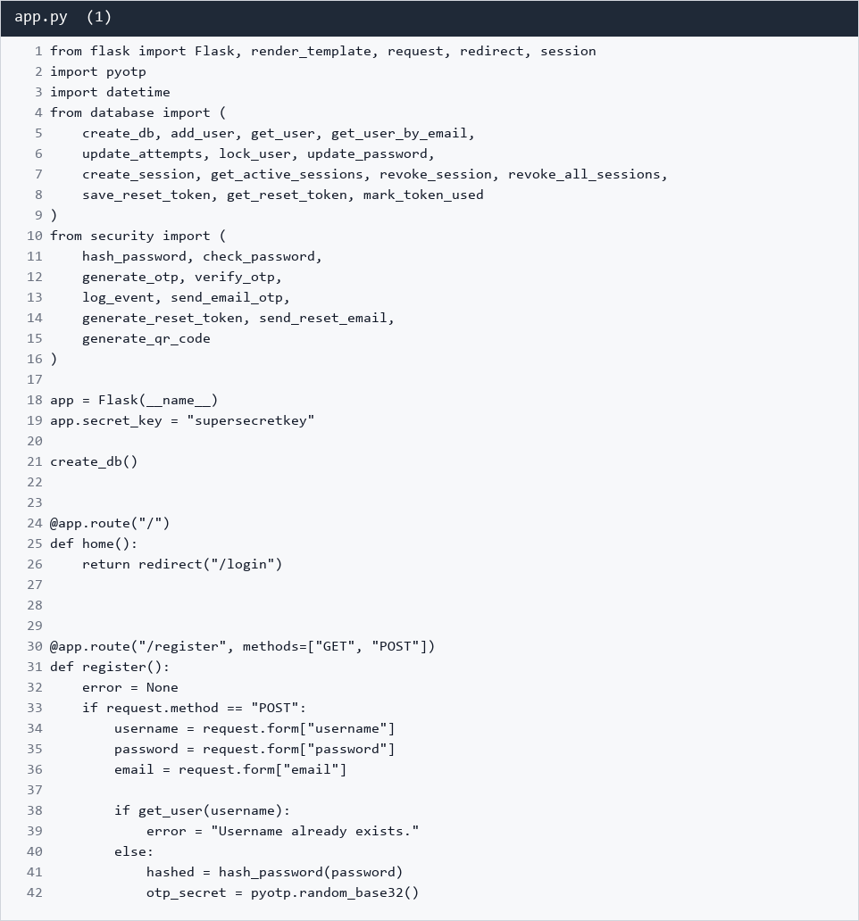
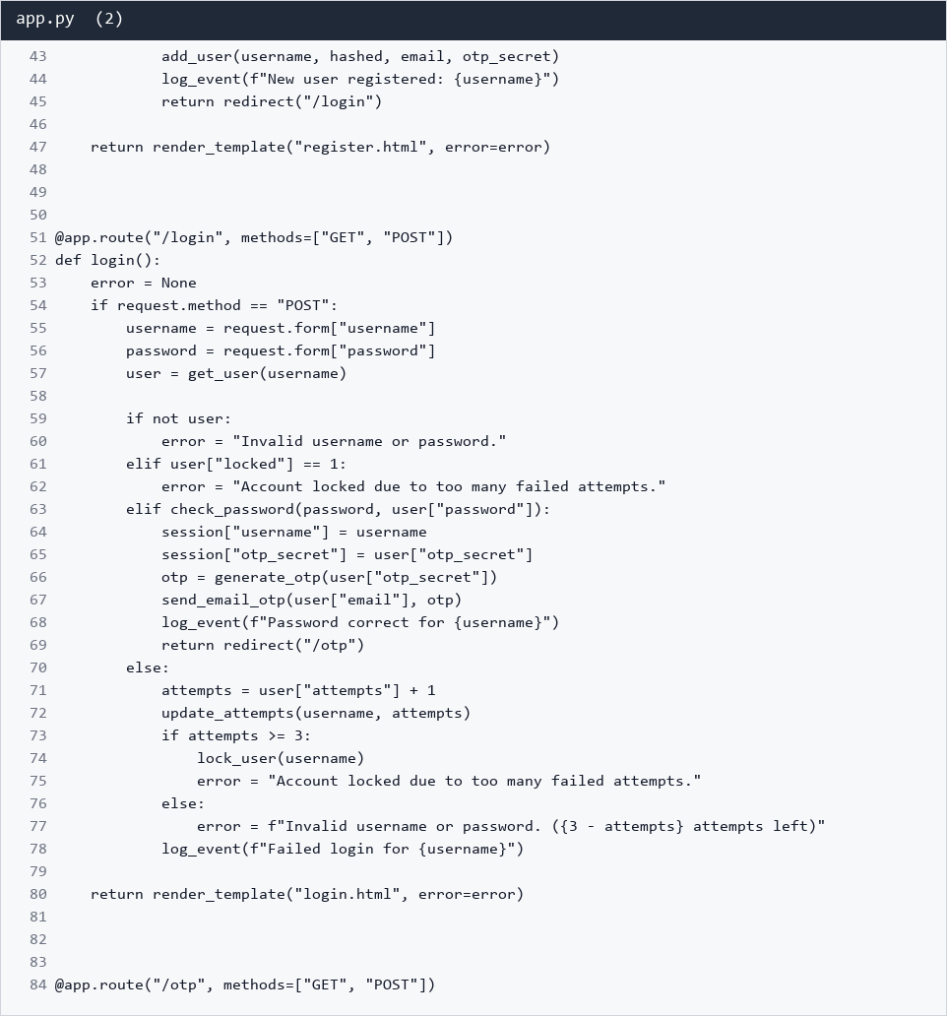
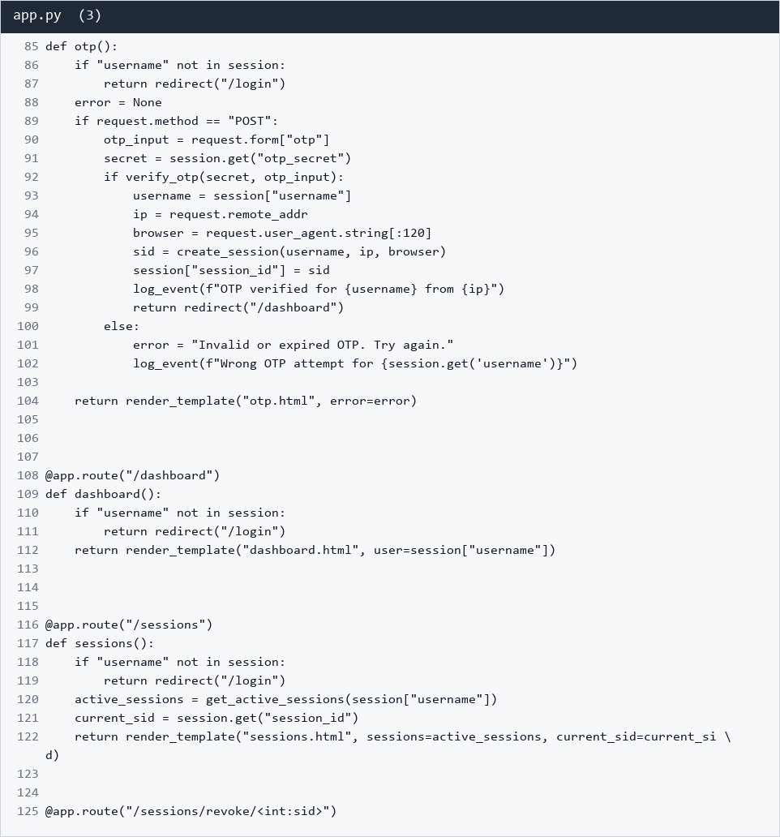
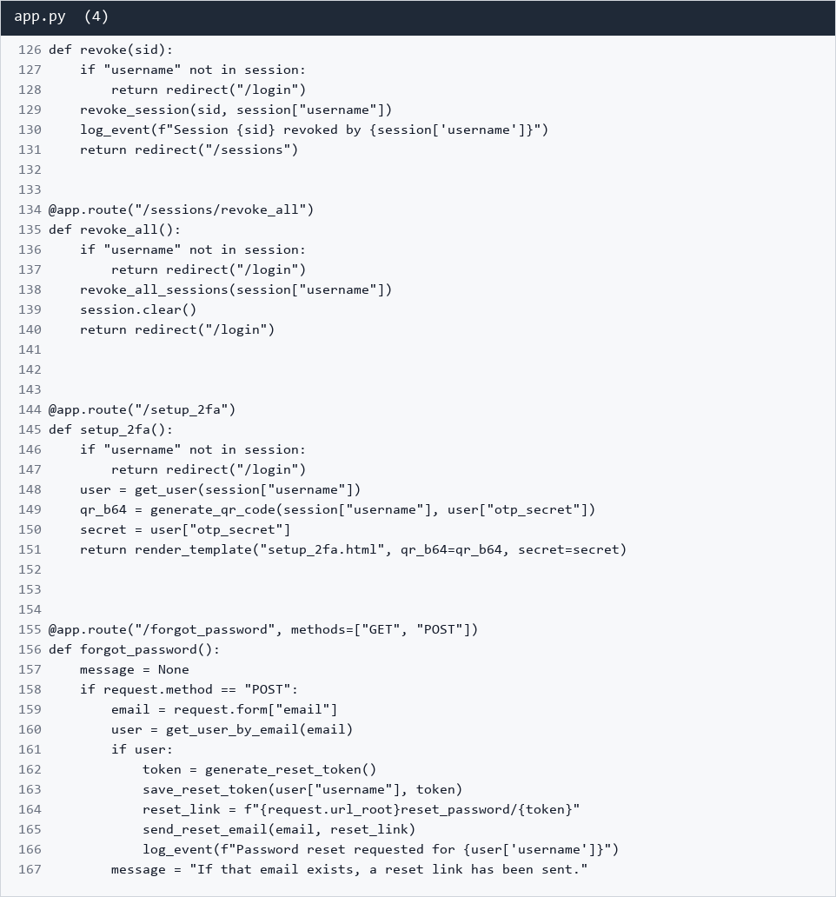
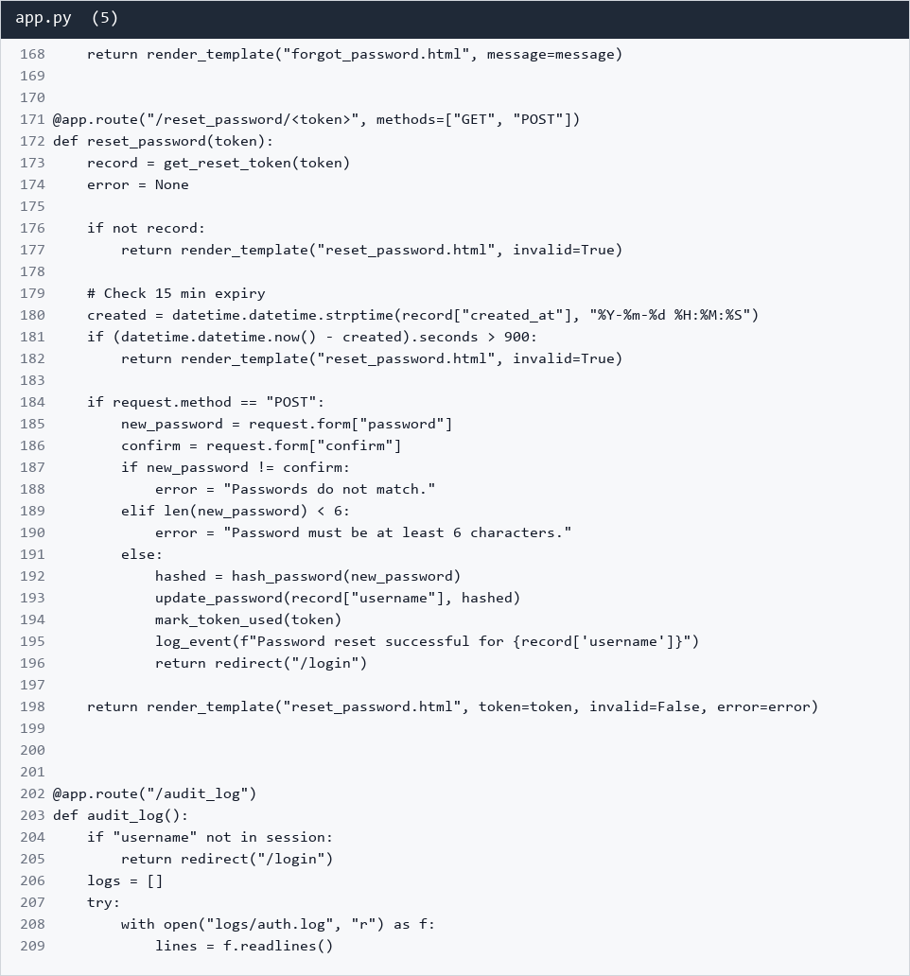
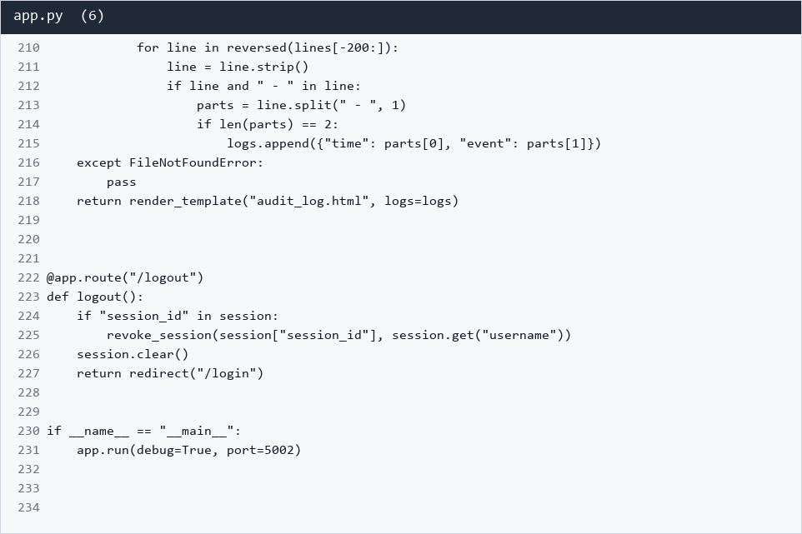

C.2 Database and Security Modules
database.py
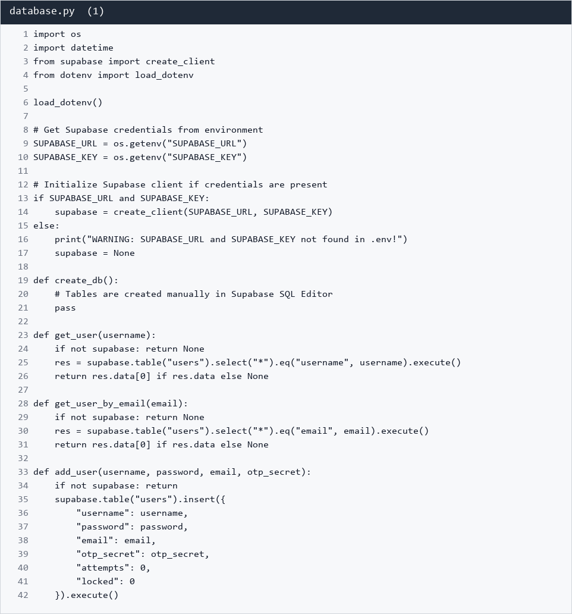
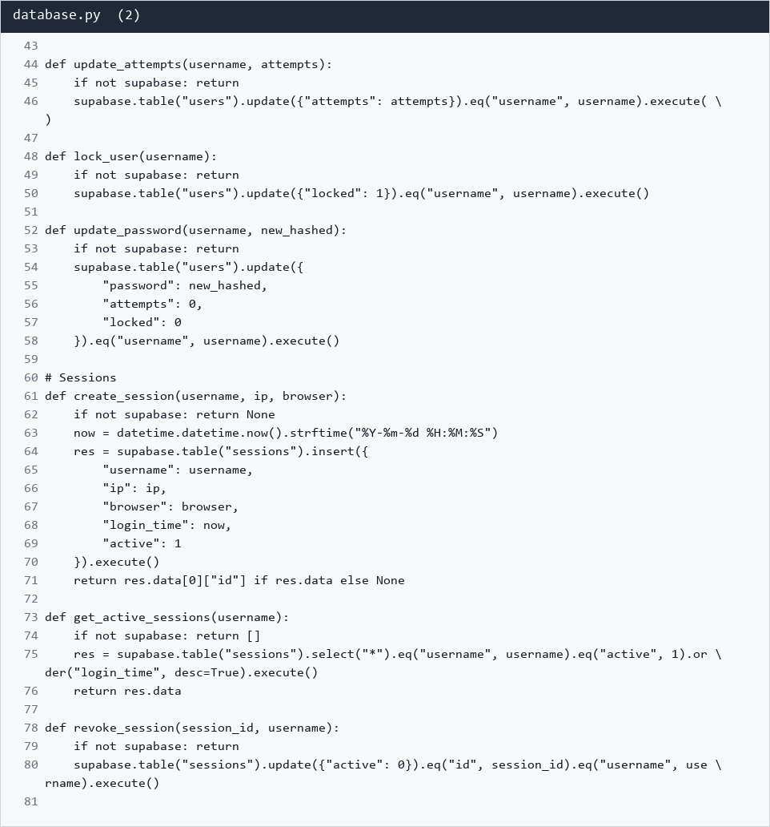
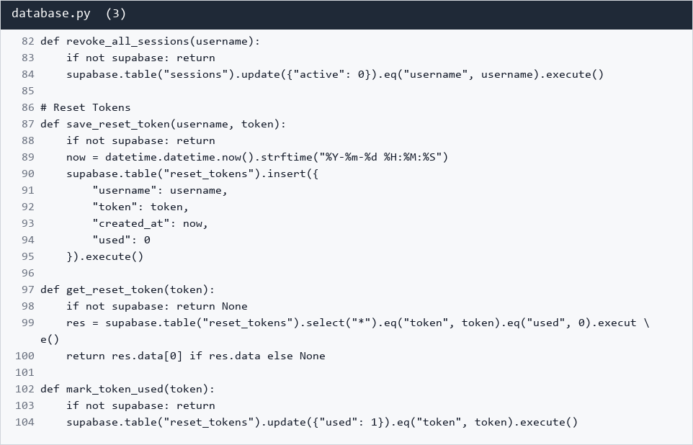
security.py
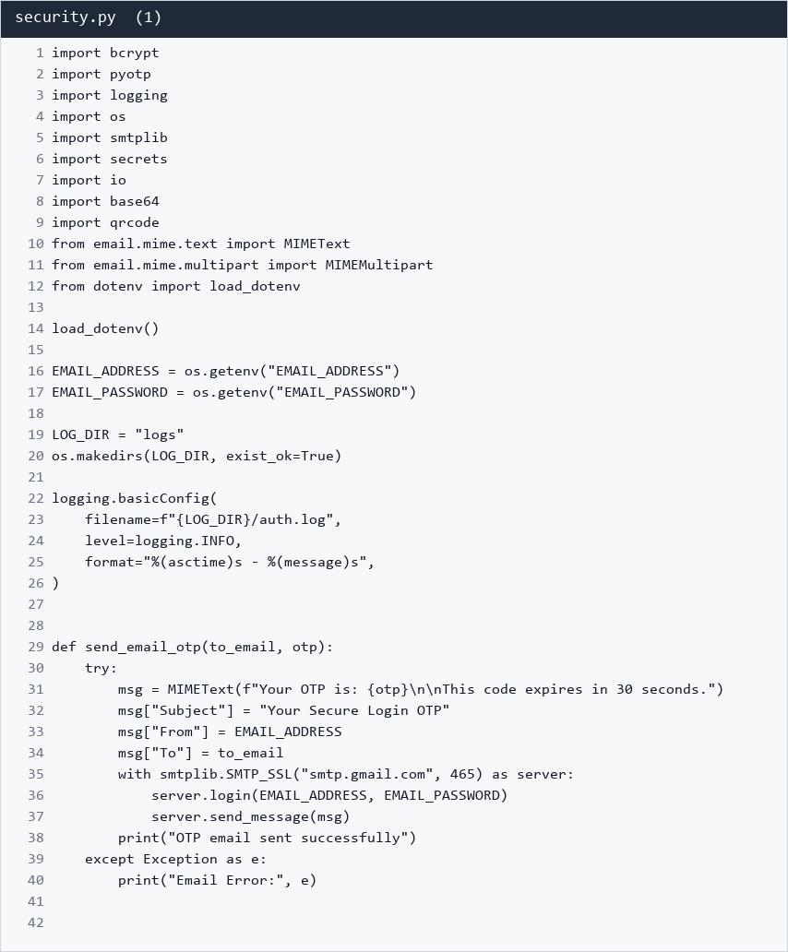
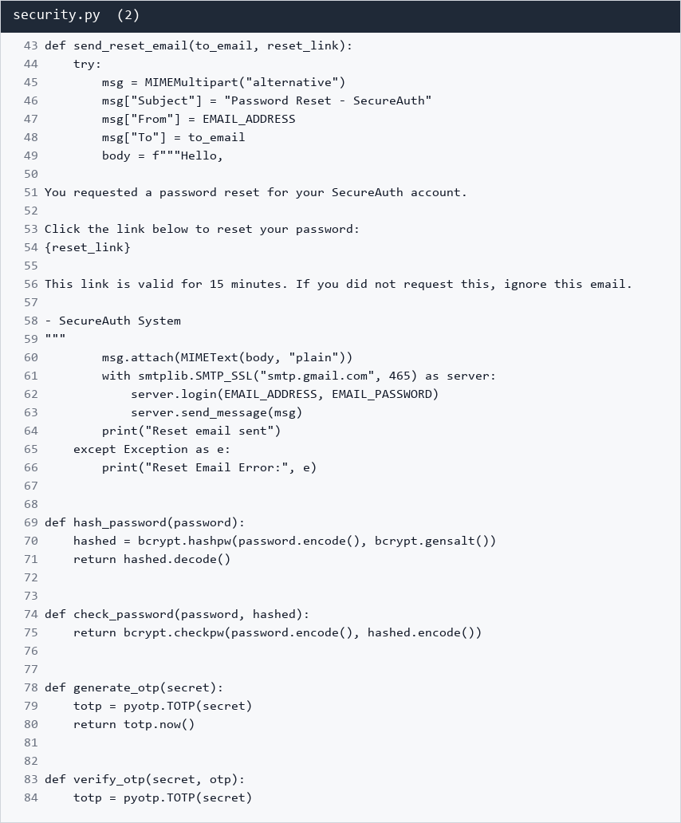
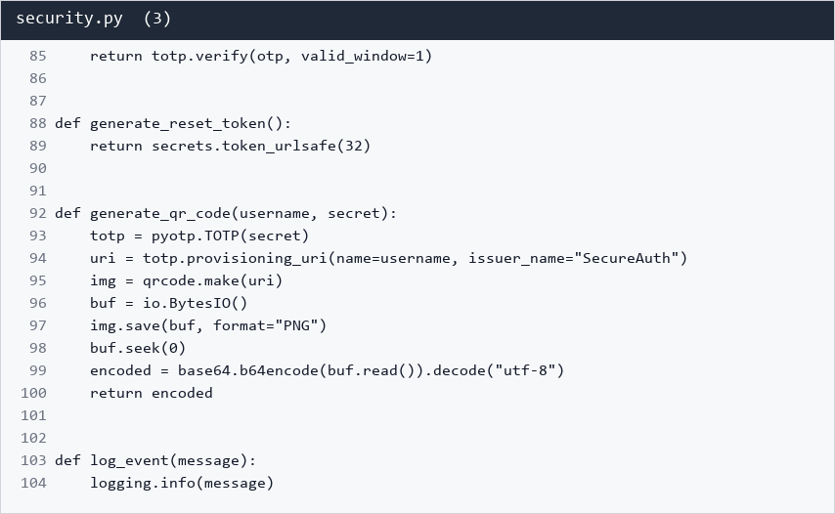

C.3 Key User Interface Templates
templates/base.html
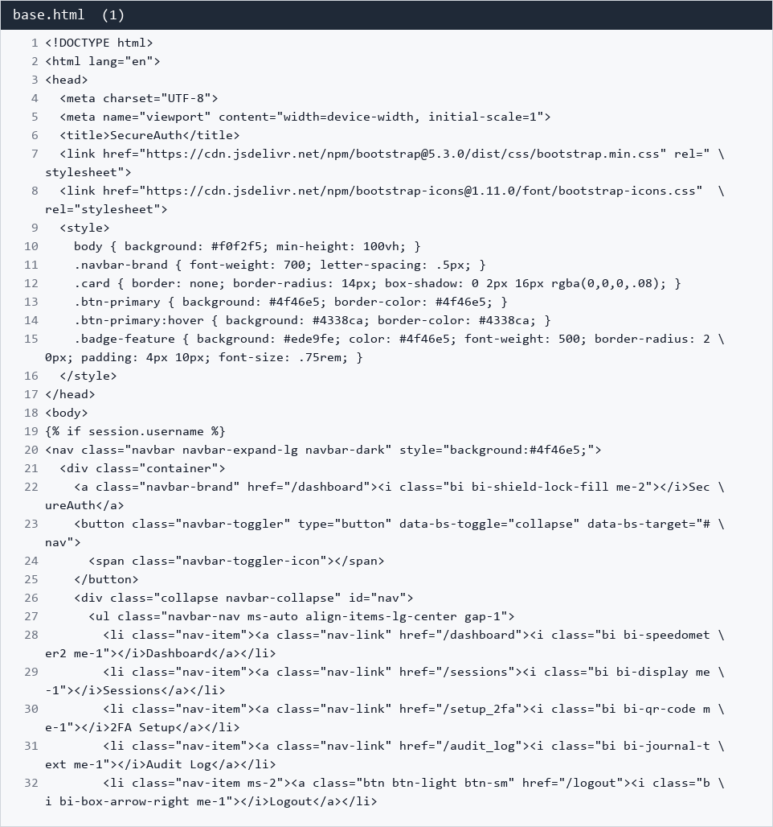
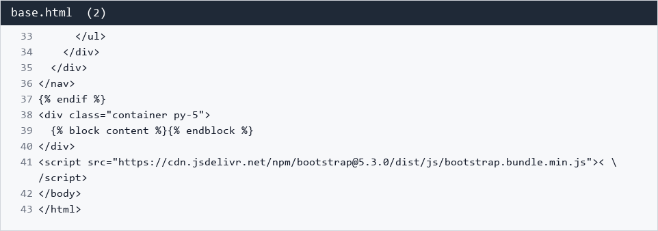
templates/login.html
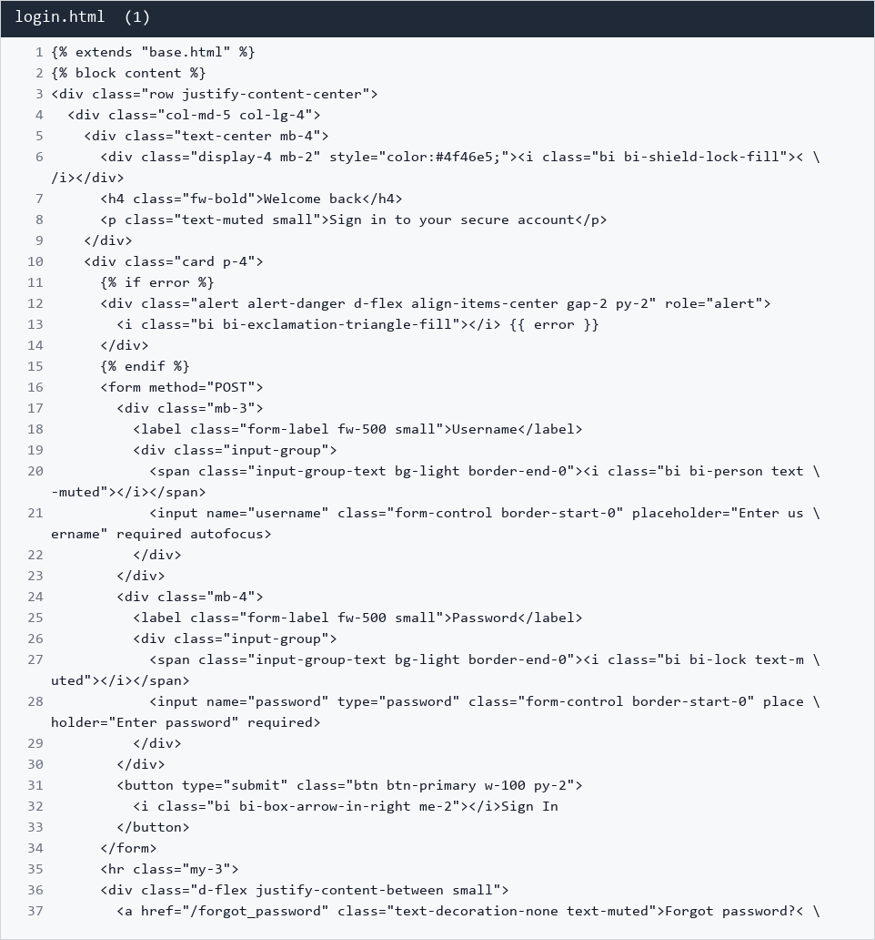
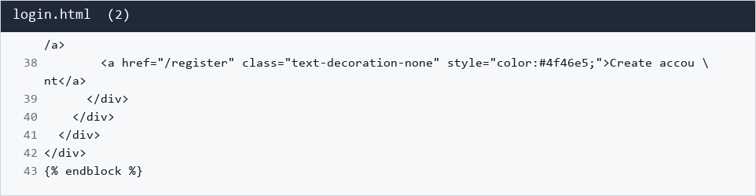
templates/register.html
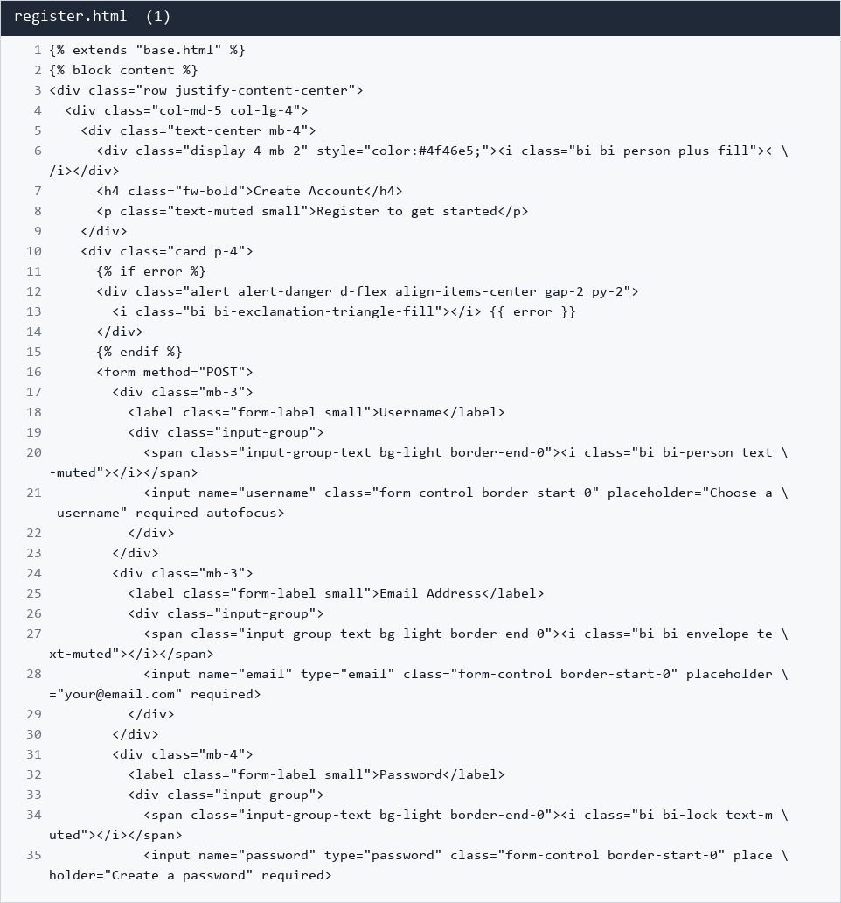
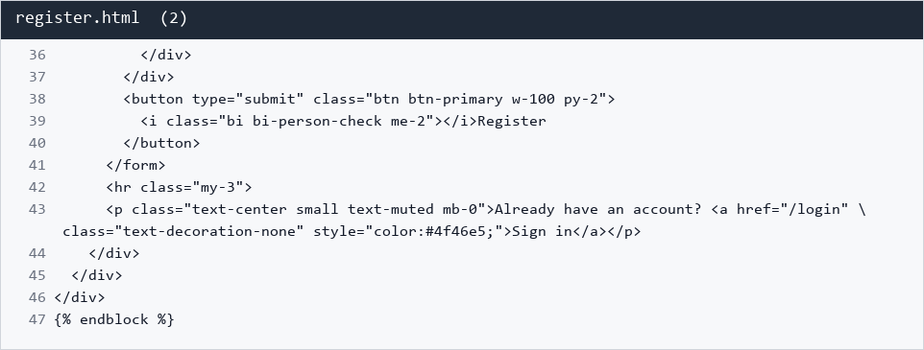
templates/otp.html
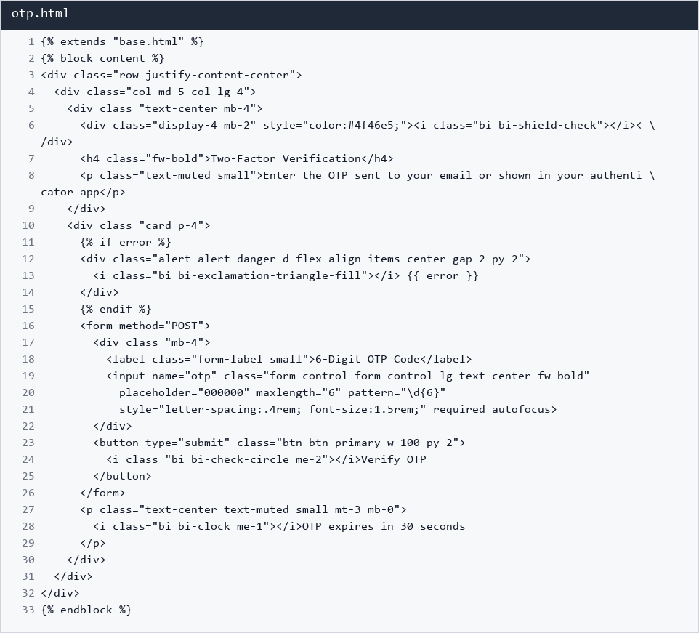
templates/dashboard.html
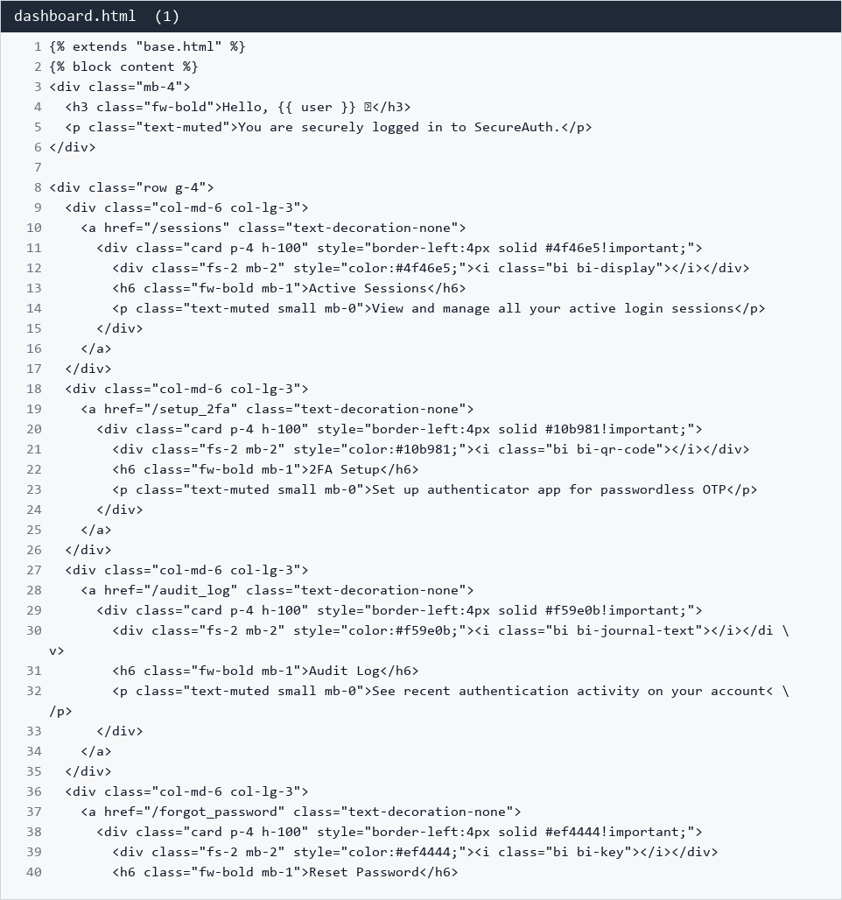
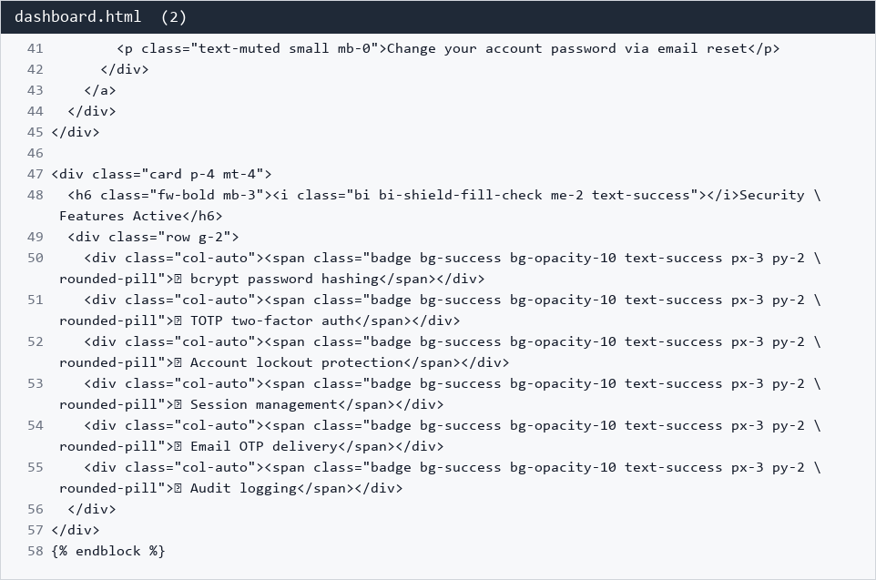
templates/sessions.html
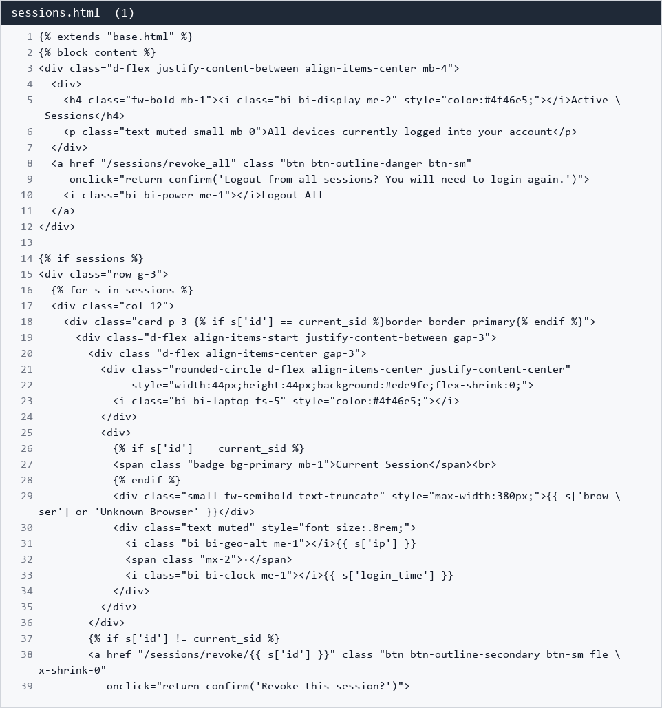
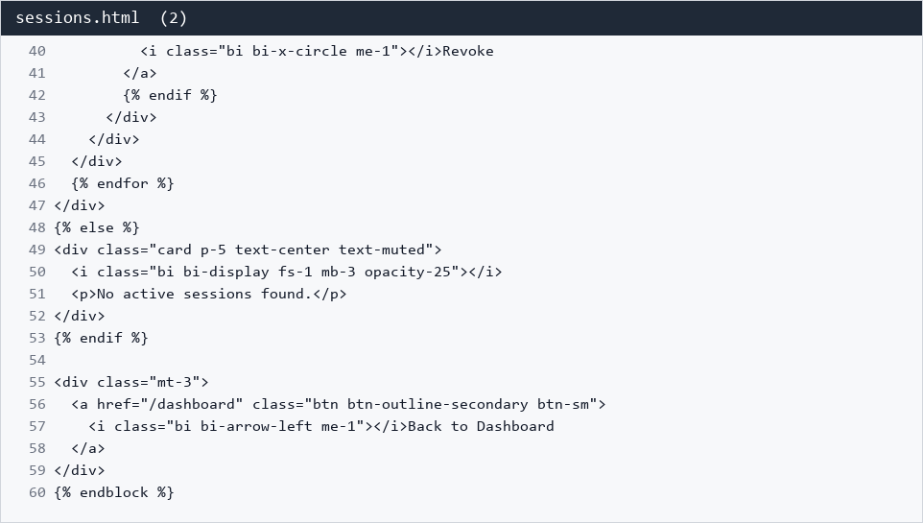
templates/setup_2fa.html
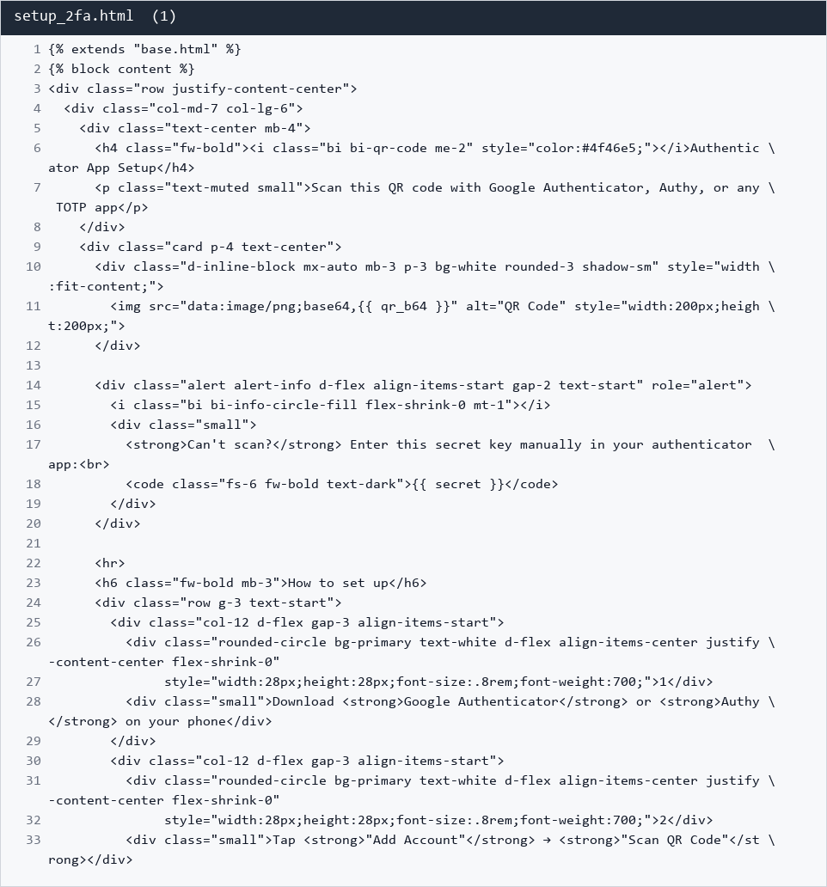
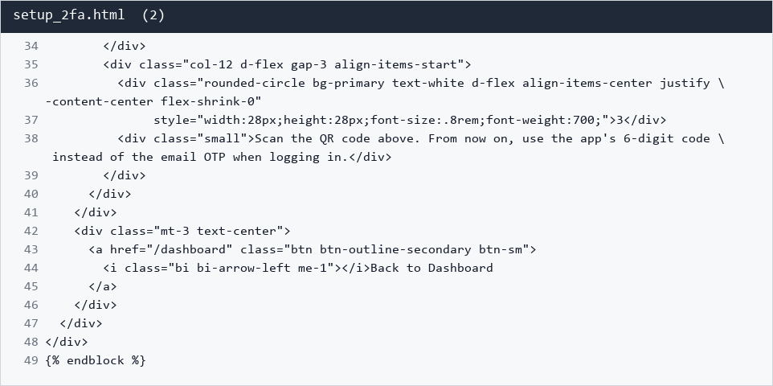
templates/audit_log.html
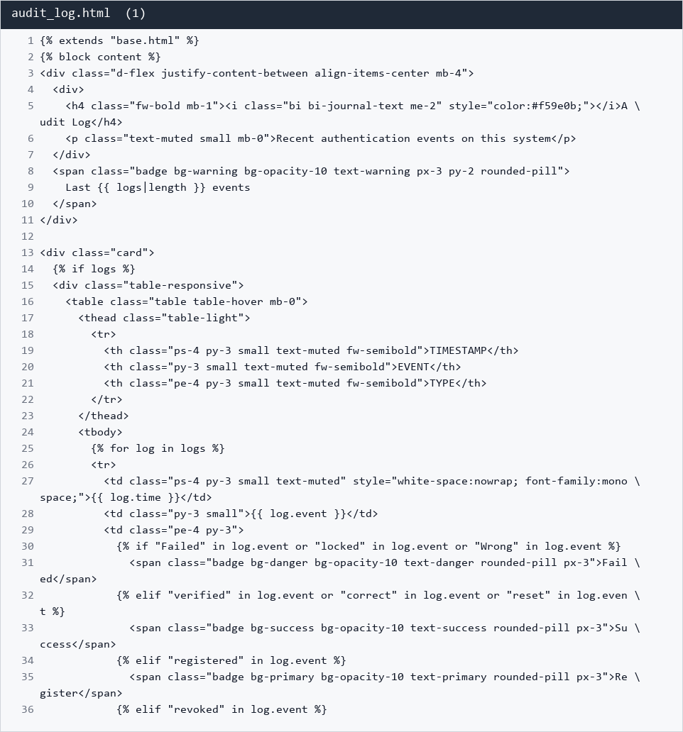
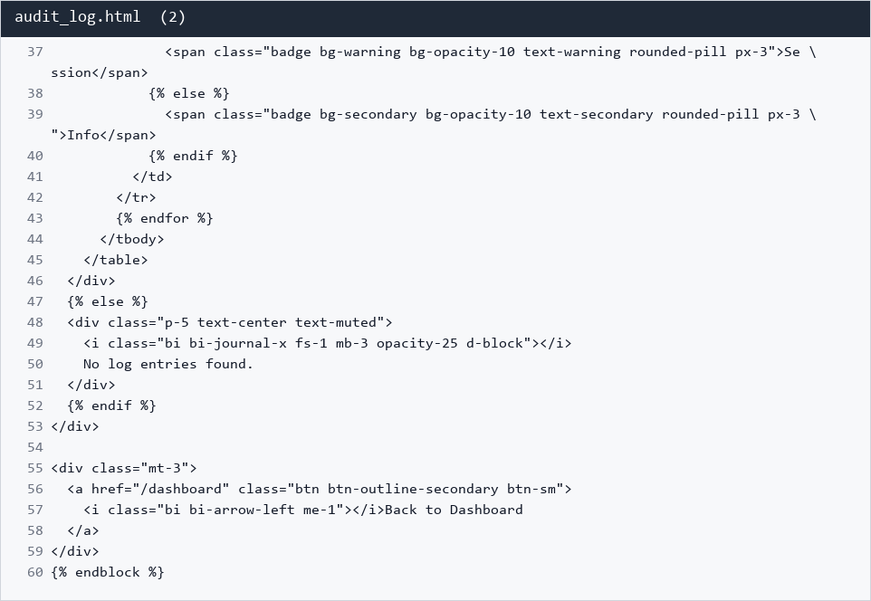
templates/forgot_password.html
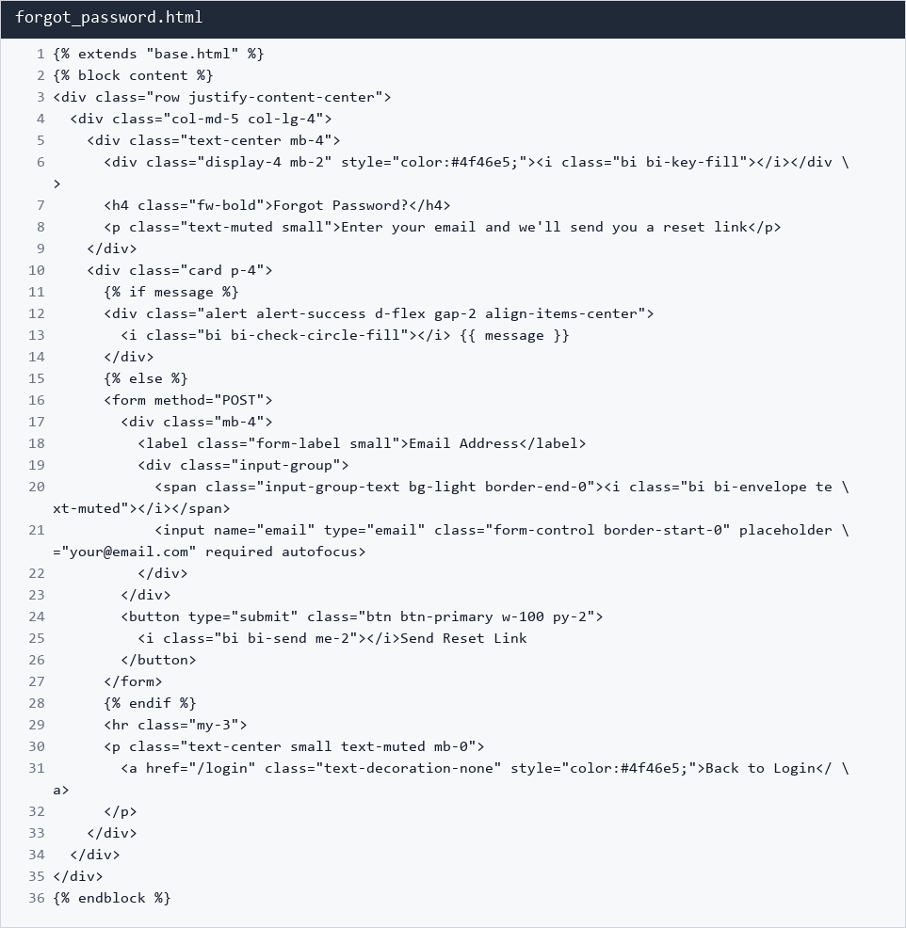
templates/reset_password.html
