**create AWS EC2 instance using CLI**

We now finally look at how to create the EC2 instance using CLI. The CLI command for creating instance is called run-instances. When you create an instance from the console, you go through seven steps of configuration. All of that can be done using specific parameters on the CLI. While creating the instance we want to be able to select the AMI (machine image); select the instance type (hardware); set the VPC, IAM role, and other configuration parameters; configure additional block storage; add tags; add security groups and then launch one or multiple instances. Let’s see what parameters we need to set to configure each of the above:  
[table id=2 /]  
The table above specifies only some of the options. Look at [this](http://docs.aws.amazon.com/cli/latest/reference/ec2/run-instances.html) link to look at all the options.

*Create an AWS security group using command line.*

Before we create the EC2 instance, lets create the security group from the command line.  
The first command creates the security group. Once that is done the next command adds a rule that opens up port 22 for SSH for all users. In real world scenario you would use a fixed IP or fixed range of IPs. The last command shows the security group created.



|  |  |
| --- | --- |
| 1  2  3 | aws ec2 create-security-group --group-name EC2SecurityGroup --description "Security Group for EC2 instances to allow port 22"  aws ec2 authorize-security-group-ingress --group-name EC2SecurityGroup --protocol tcp --port 22 --cidr 0.0.0.0/0  aws ec2 describe-security-groups --group-names EC2SecurityGroup |

[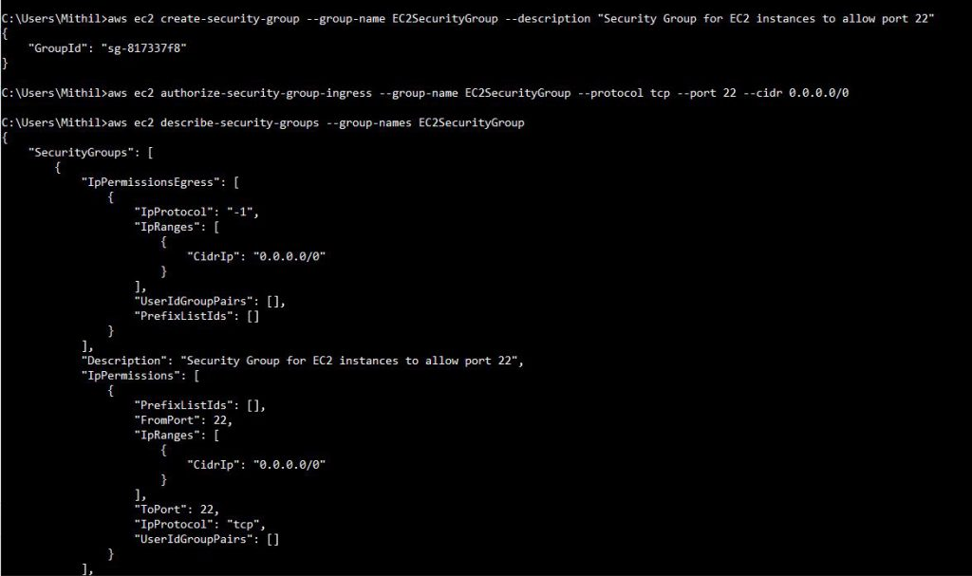](http://d18fvftsc9acw8.cloudfront.net/wp-content/uploads/2016/11/create_security_group_using_cli.jpg)

*Command to Create AWS EC2 instance using CLI*

Finally, here is the command to create the EC2 instance using the CLI.



|  |  |
| --- | --- |
| 1 | aws ec2 run-instances   --image-id ami-5ec1673e --key-name MyKey --security-groups EC2SecurityGroup --instance-type t2.micro --placement AvailabilityZone=us-west-2b --block-device-mappings DeviceName=/dev/sdh,Ebs={VolumeSize=100} --count 2 |

This creates two instances and here’s how the two instances look.  
[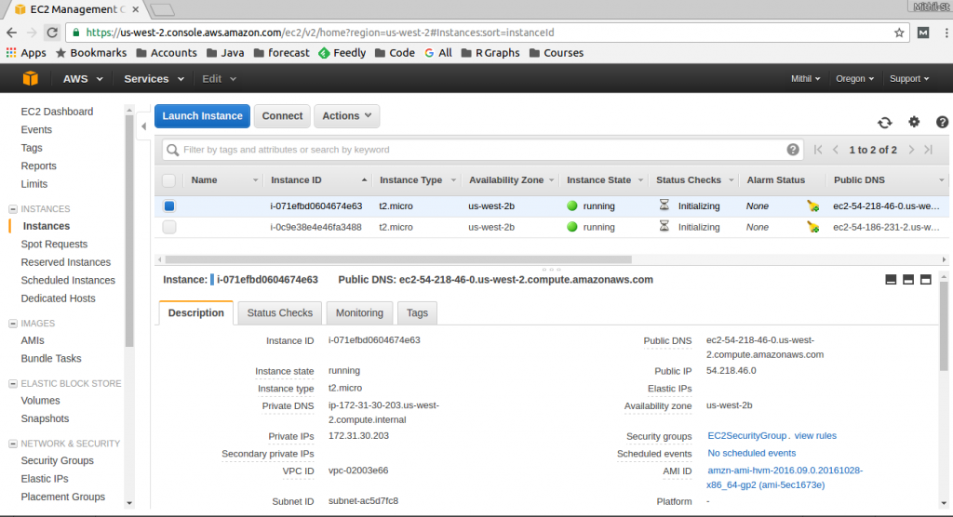](http://d18fvftsc9acw8.cloudfront.net/wp-content/uploads/2016/11/Selection_025.png)

This completes our tutorial on creating the EC2 instances using the CLI. The run-instances method has many options that cover most of the situations. Look at [this](http://docs.aws.amazon.com/cli/latest/reference/ec2/run-instances.html) amazon doc link for reference.