**PROJECT**

**Generate “CLASSICMODELS” Sales Report Using PowerBI**

**Problem Statement:**

A small company Axon, which is a retailer selling classic cars, is facing issues in managing and analyzing their sales data. The sales team is struggling to make sense of the data and they do not have a centralized system to manage and analyze the data. The management is unable to get accurate and up-to-date sales reports, which is affecting the decision-making process.

To address this issue, the company has decided to implement a Business Intelligence (BI) tool that can help them manage and analyze their sales data effectively. They have shortlisted Microsoft PowerBI and SQL as the BI tools for this project.

**Objective of Project:**

The objective of this project is to understand the company “Axon” sales policies, reviewing the sales stats etc. To perform analyze and visualize sales data effectively. This typically involves extracting insights that can help the company improve its sales and creating interactive and informative dashboards and reports that help sales teams, managers, and other stakeholders in making data-driven decisions, optimizing sales strategies, and improve overall sales performance. The ultimate goal of the project is to design and implement a BI solution using PowerBI and SQL that can help the company manage and analyze their sales data effectively.

**Insights of Report Dashboard**

* Top 10 Countries Who generated Most of the Company revenue

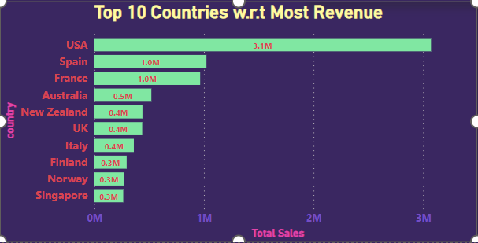

Here, with this visualization of the insight created we can say that these are the top countries, those who generated most of the revenue for the company with extraordinary sale records over the years.

* Revenue Generated by All Categories of Classic Models Over Season

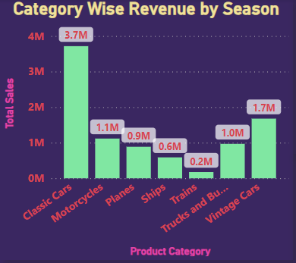

Here, with this visualization of the insight created we can get the overall sales data of all product categories over time and season and can make decisions on which products we have to give much priority and on which we need to give less priority over seasons for making good revenue according to seasonal sale.

* Customers Who have Generated Most Revenues Among All the Countries

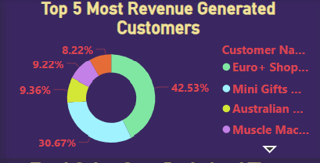

Here, with this visualization of the insight created we can filter out the most profit-making customers among all the countries, those who have generated most of revenue for the company. In future giving priority to these customers will help to build up the company revenue.

* Total Sales made By the Company in Three Year Span Over Period of Time

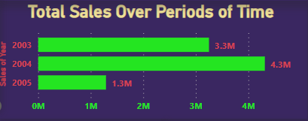

Here, with this visualization of the insight created we can see the company's overall sales over a period of time and it will help us to fix a benchmark of sales for the upcoming years. It will help the company to carry out the sale strategies as per the benchmark set and also for the sales team who will get an overview to increase sales.

* Most Popular Brands Over Years

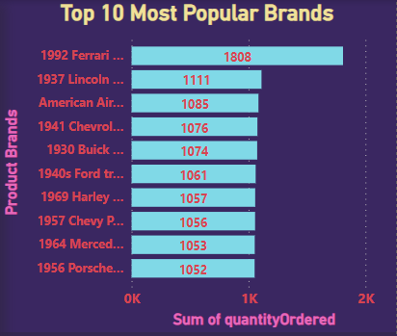

Here, with this visualization of insight created we can analyze which brands were most popular in past years and on which bands we need to give focus. We need to create more demand for the most popular brands and also create demand for other brands also for making a huge grow in terms of sales of the company and generate more and more revenue in future.

* Insight of Most Selling vs Most Profitable Products

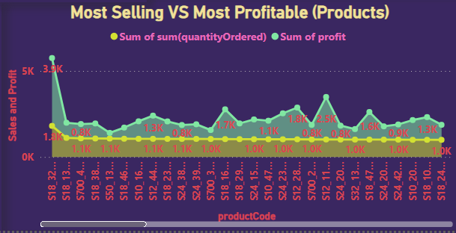

Here, with this visualization of insight created we can analyze which products have the higher selling rate and which product have higher profit margin rate over years. We can filter out those products with this and make the company take some good decisions about the in-stock products whether to continue maintaining stocks or finish the stocks with discounted price etc.

**Conclusion of Project:**

In summary, with these above-mentioned insights the company will get a very definite overview of the project's objectives and outcomes. These will make a huge contribution to solving issues of the company's operations and decision-making and also will help the sales team to make data-driven decisions in the field. It should also lay the groundwork for future data-driven initiatives and the continued use of Power BI for business improvement.

**------------------------------------END----------------------------------**