CAPSTONE FSE: Core Retail Ledger & Balance Mutation Engine
Track Scope: Exclusively Full-Stack Engineering (Hema)

Project Theme: High-Throughput Relational Balance Mutation, Distributed In-Memory Validation, and Data Auditing.
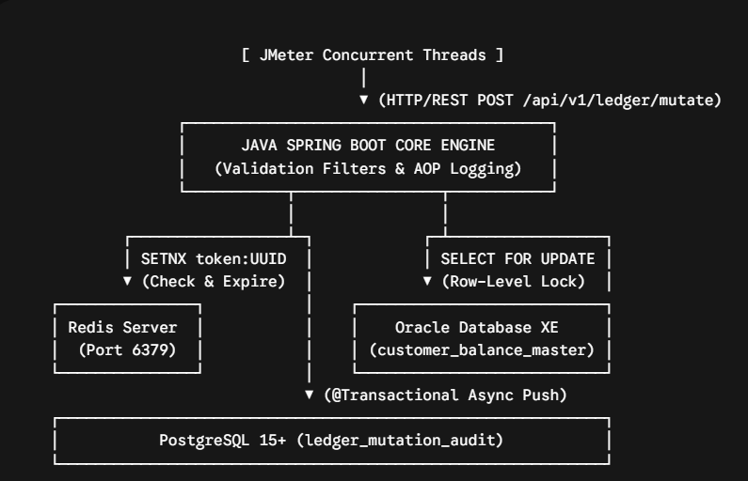
1. Expanded Technical Specification & Constraints
A. Data Validation & Boundary Protections
- Payload Constraints: The /api/v1/ledger/mutate endpoint must strictly enforce JSR-380 validation. The transaction amount field (mutation_amount) must match a decimal format with a maximum precision of 18 digits and exactly 4 decimal places (@Digits(integer=14, fraction=4)). Negative values must be instantly blocked at the controller perimeter via @Positive.
- Malformed Payload Handling: Any unparseable JSON schemas or invalid strings must be intercepted by a global @ControllerAdvice handler, converting messy stack traces into an RFC-7807 compliant Problem Details JSON structure containing specific validation fault arrays.
B. Concurrency Control & Row Isolation
- The Race Condition: If two threads attempt to process a 50 PHP debit simultaneously for an account with a 60 PHP balance, both might read 60 PHP before either update, causing an invalid balance of -40 PHP.
- The Mitigation: In the Spring Data JPA layer, students must annotate the lookup repository method with @Lock(LockModeType.PESSIMISTIC_WRITE). This translates to a native SELECT balance_amount FROM customer_balance_master WHERE account_id = ? FOR UPDATE statement inside Oracle XE 21c.
- Database Queueing: This lock block causes the second database thread to cleanly stall at the persistence layer until the first thread executes its commit or rollback boundary, forcing deterministic updates.
C. Two-Phase Storage Topology (Dual-Write)
- Master State (Oracle XE): Houses the transactional master record. An update command updates the row state directly.
- Immutable Audit Trail (PostgreSQL 15+): Every state mutation pushes an append-only transaction line into the ledger_mutation_audit table. This write operation is wrapped in a Spring @Transactional service context.
- Data Drift Remediation: If the PostgreSQL server drops offline mid-transaction, the entire block must trigger a clean rollback on Oracle XE, throwing a custom checked LedgerPersistenceException to prevent un-audited state changes.

D. Event-Driven Solutioning
Event-Driven Solutioning: Implementing asynchronous messaging via message queues (such as Kafka or RabbitMQ) to decouple non-critical downstream workflows—like transaction alerts and audit logging—from the core sync path, alongside a distributed caching engine (Redis) to optimize high-throughput balance lookups.

E. Telemetry & Observability
Telemetry & Observability: Integrating comprehensive telemetry using Prometheus, Grafana, and OpenTelemetry for real-time metrics collection and distributed tracing, ensuring we can monitor system throughput, isolate latency bottlenecks, and meet strict performance standards across containerized environments.
2. Non-Functional Requirements (NFRs) & Performance SLAs
- Throughput Target: The core engine must maintain a steady processing volume of $≥800$ Transactions Per Second (TPS) during peak concurrent execution windows.
- Latency Target: Under maximum thread velocity, 95% of incoming mutation requests must compute and return a response within an SLA threshold of $≤50\text{ ms}$.
- Availability Simulation: The distributed validation matrix via Redis must achieve an operational turnaround of $≤5\text{ ms}$ per token verification check.

3. Execution Blueprint (Days 31–37)
- Day 31: FSE Capstone – Kickoff & Contract Engineering
  - Activities: Formulate your API schemas, define your strict validation fields, and construct the basic project layout. Set up the JIRA backlog with epics, assigning story point estimations based on developer velocity.
- Day 32: FSE Capstone – Design & Schema Generation
  - Activities: Construct database tables using strict numeric parameters. Configure HikariCP configuration values within application.properties to isolate thread pooling dimensions (hikari.maximum-pool-size=30, hikari.minimum-idle=5).
- Day 33: FSE Capstone – Sprint 1 (Core Engine & Lock Mechanics)
  - Activities: Build the Spring Boot HandlerInterceptor that maps incoming transaction IDs to Redis caches. Implement your @Lock methods in JPA and configure the relational dual-write flow.
- Day 34: FSE Capstone – Sprint 2 (Perimeter Token Security)
  - Activities: Protect your backend endpoints by setting up a stateless Spring Security configuration. Configure a token verification filter that decodes incoming JWT components and applies strict role check logic.
- Day 35: FSE Capstone – Hardening & Stress Testing
  - Activities: Launch Apache JMeter thread groups to simulate intense parallel transaction flows. Use VisualVM to trace active threads, look for query bottlenecks, and track JVM garbage collection behaviours.
- Day 36: FSE Capstone – Demo Preparation & Code Quality Sweeps
  - Activities: Conduct formal peer review loops to clean up code structures, eliminate runtime print statements, reset database data states, and finalize the presentation slide deck.
- Day 37: FSE Capstone – Live Presentation & Milestone 5 Assessment
  - Activities: Demonstrate your system's stability by running a live JMeter stress test that successfully stops concurrent double-spend requests. Sit for the formal Milestone 5 composite exam.

FSE Capstone Evaluation Matrix (100-Point Model)
Evaluation Pillar | Weight | Scoring Criteria & Focus Areas
Task1  - Architecture & Schema Setup | 15 Points | Microservices boundary definition, PostgreSQL DB schemas, and ERD approval.
Task2  Core Microservices Development  - Core Engine & Lock Mechanics  - Perimeter Token Security | 30 Points | Implementation of Account, Transaction, and Notification services with Gateway integration.
Task3  - Hardening & Stress Testing  - Demo Preparation & Code Sweeps | 30 Points | Full SPA integration with backend, docker-compose setup, and security validation
Task4  - Final Assessment & Code Review | 25 Points | End-to-end load testing (JMeter), SonarQube quality report, and trainer code review.

