Homework

Github

i. Create Github account: https://github.com/

Jupyter Notebooks

Option 1. VS code (Optional but Prefered)

i. Install Vscode

- install: https://code.visualstudio.com/download

- intro: https://www.youtube.com/watch?v=B-s71n0dHUk

ii. Create Environment

- https://code.visualstudio.com/docs/python/environments

- nice vídeo explanation : https://www.youtube.com/watch?v=eWk497uCgf0

iii. Install libraries

- install tutorial: https://www.alphr.com/vs-code-how-to-install-numpy/

- install libraries pandas, numpy, seaborn, matplotlib.

ii. Install Jupyter Notebook extention

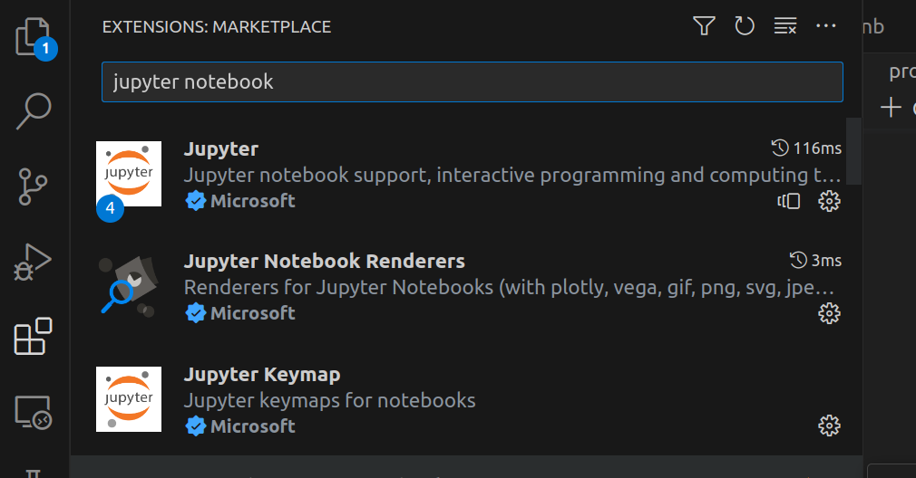

iii. Ctrl+P (or Cmd+P) – start jupyter notebook
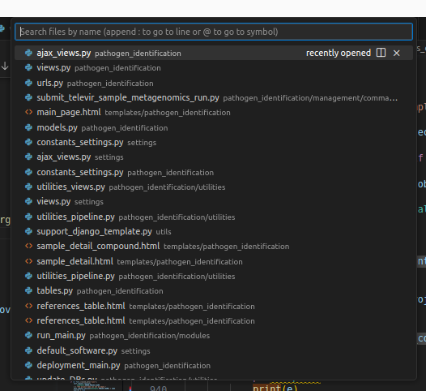

tutorial vídeo: https://www.youtube.com/watch?v=h1sAzPojKMg

Option 2. Kaggle

i. Sign In

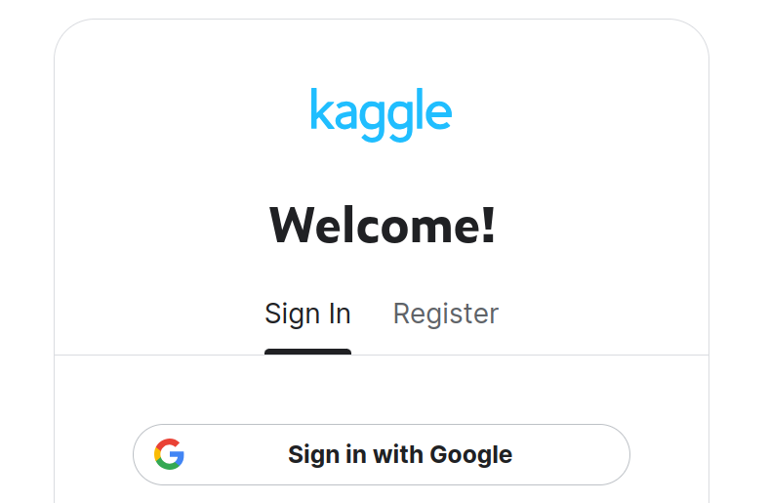

ii. Find Class URL

- url class 1.1 - https://www.kaggle.com/santosjgnd/distributions-class-distrbutions-1-1

iii. Copy and Edit

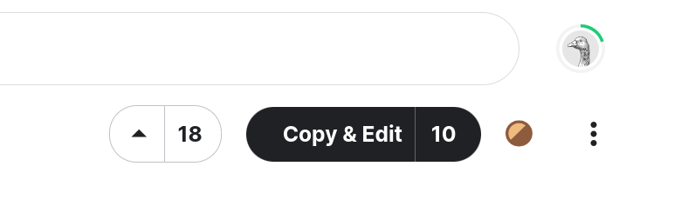

iv. Play

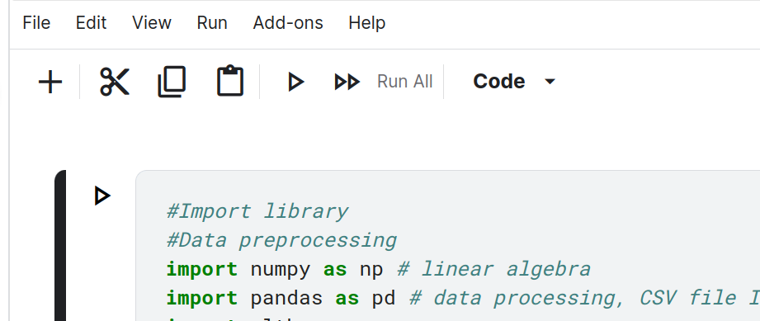

v. Change name & Share



