**Homework**

**Github**

i. Create Github account: <https://github.com/>

**Jupyter Notebooks**

**Option 1. VS code (Optional but Prefered)**

i. Install Vscode

- install: <https://code.visualstudio.com/download>

- intro: <https://www.youtube.com/watch?v=B-s71n0dHUk>

ii. Create Environment

- <https://code.visualstudio.com/docs/python/environments>

- nice vídeo explanation : <https://www.youtube.com/watch?v=eWk497uCgf0>

iii. Install libraries

- install tutorial: <https://www.alphr.com/vs-code-how-to-install-numpy/>

- install libraries **pandas, numpy, seaborn, matplotlib.**

ii. Install Jupyter Notebook extention

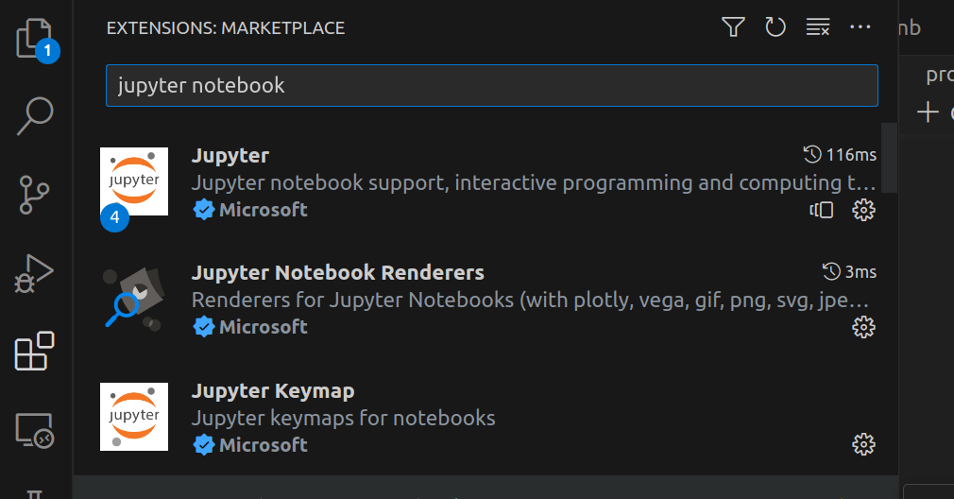

iii. Ctrl+P (or Cmd+P) – start jupyter notebook

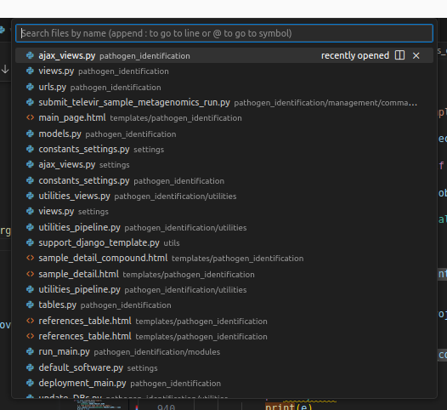

tutorial vídeo: <https://www.youtube.com/watch?v=h1sAzPojKMg>

**Option 2. Kaggle**

i. Sign In

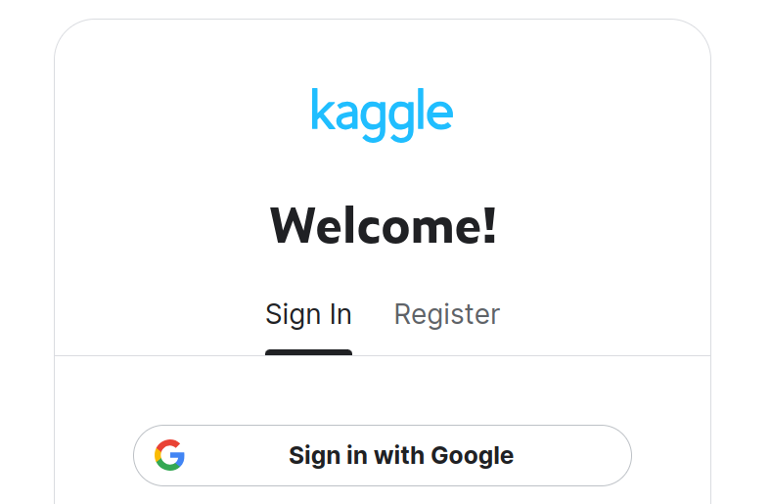

ii. Find Class URL

- url class 1.1 - https://www.kaggle.com/santosjgnd/distributions-class-distrbutions-1-1

iii. Copy and Edit

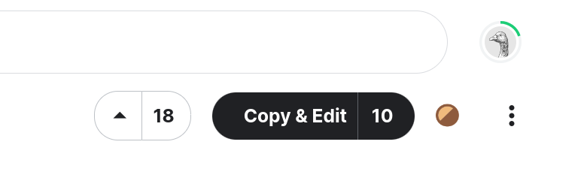

iv. Play

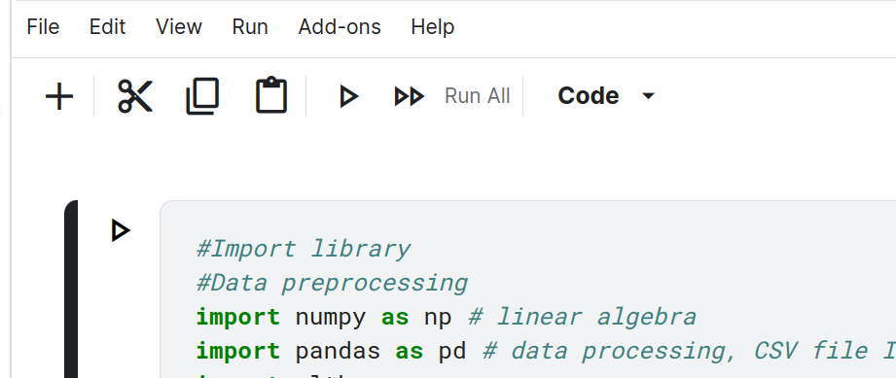

v. Change name & Share



