**Manual curation of local assignment**

Studying the distribution of local classifications to assign shared structures to a particular origin.

**Data**: Chromosome 8 random sample of 13000 SNPs (< 0.001 NA). 650 random accessions. Only Japonia, Indica and cAus plotted here (Wang et al. 2018).

*Step I – local supervised classification using KDE*

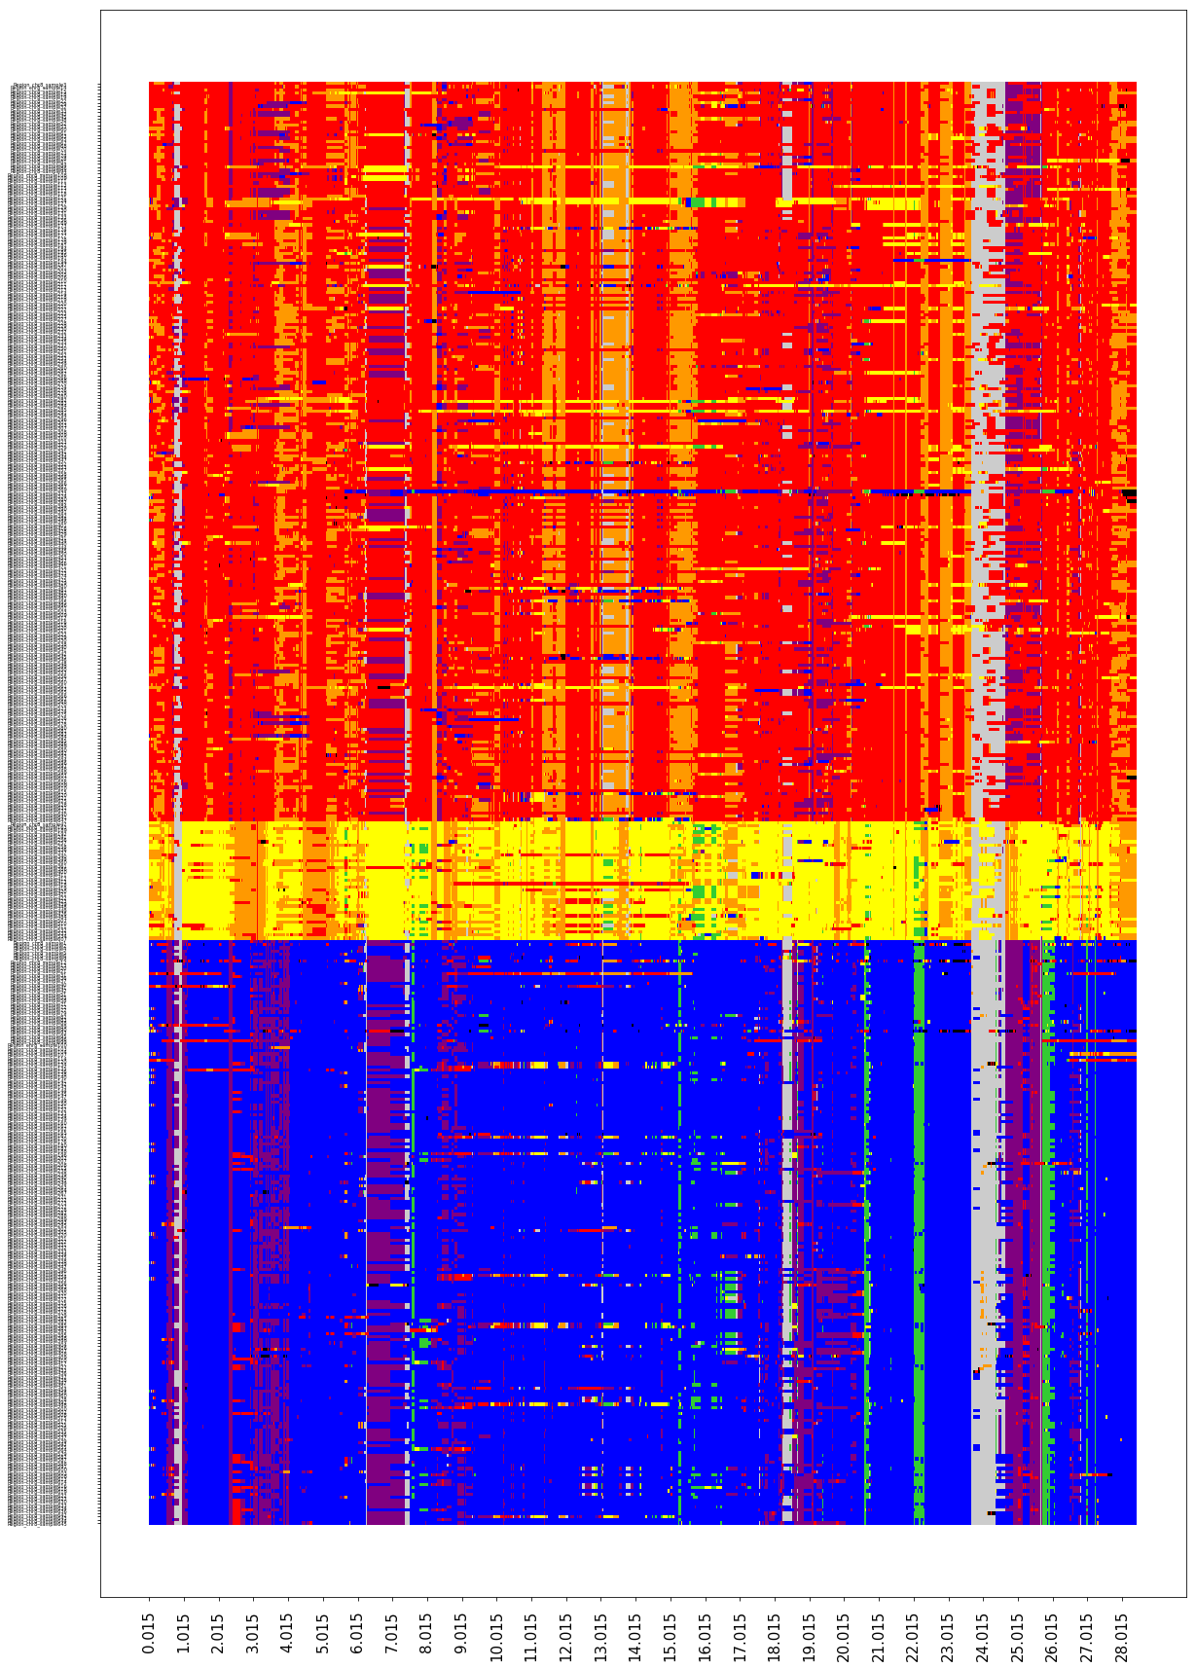

*Step II – Identify patterns indicative of the transfer of genetic material*

- Adjusted for correlation between local clusters and classification.

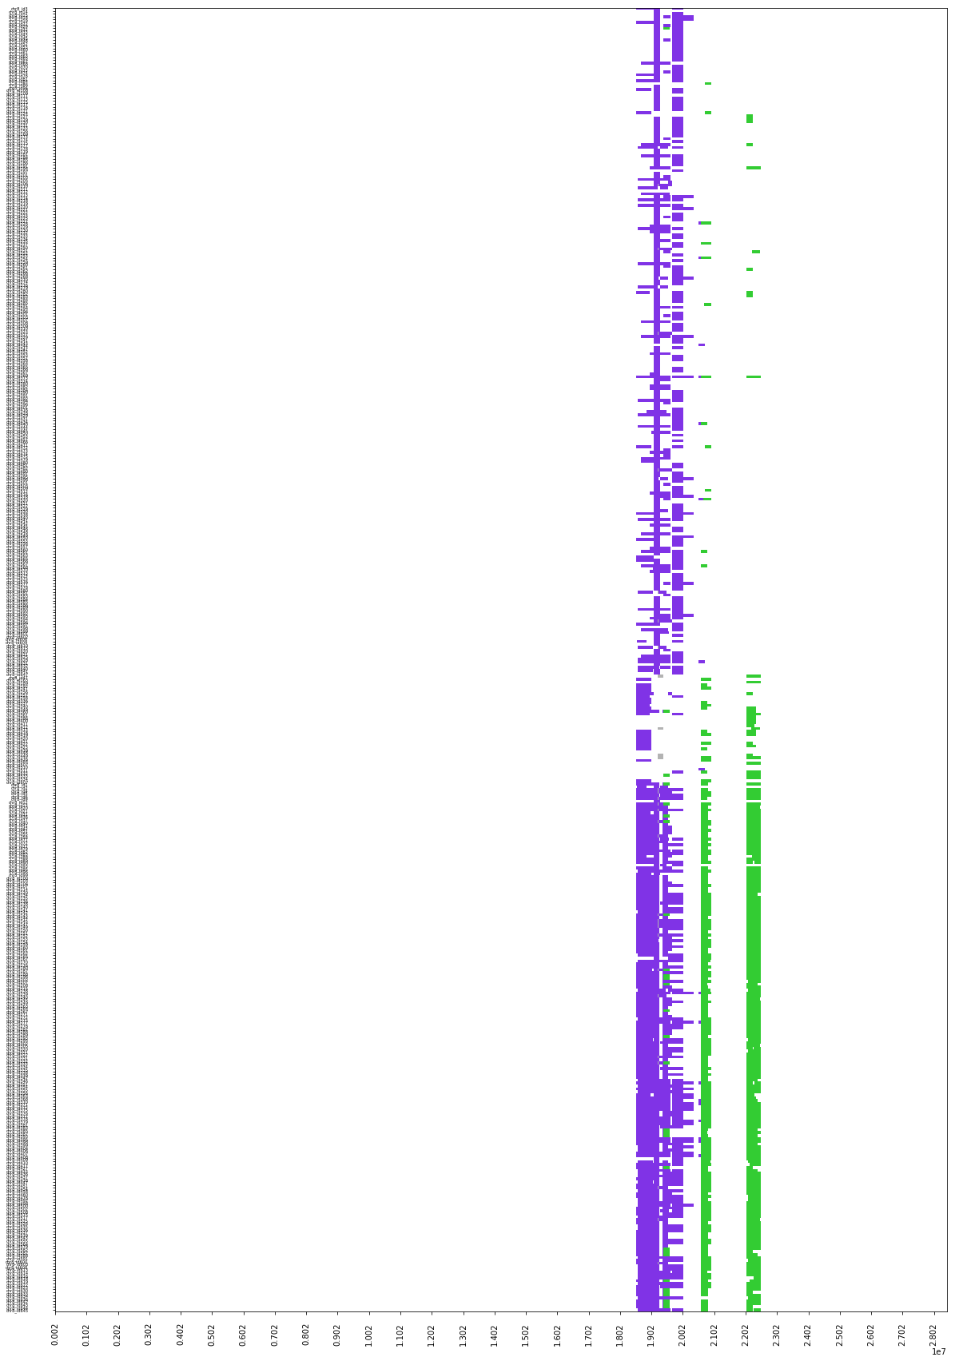

*Step III – Reclass target assignments, providing an “informed guess on the true origins”*

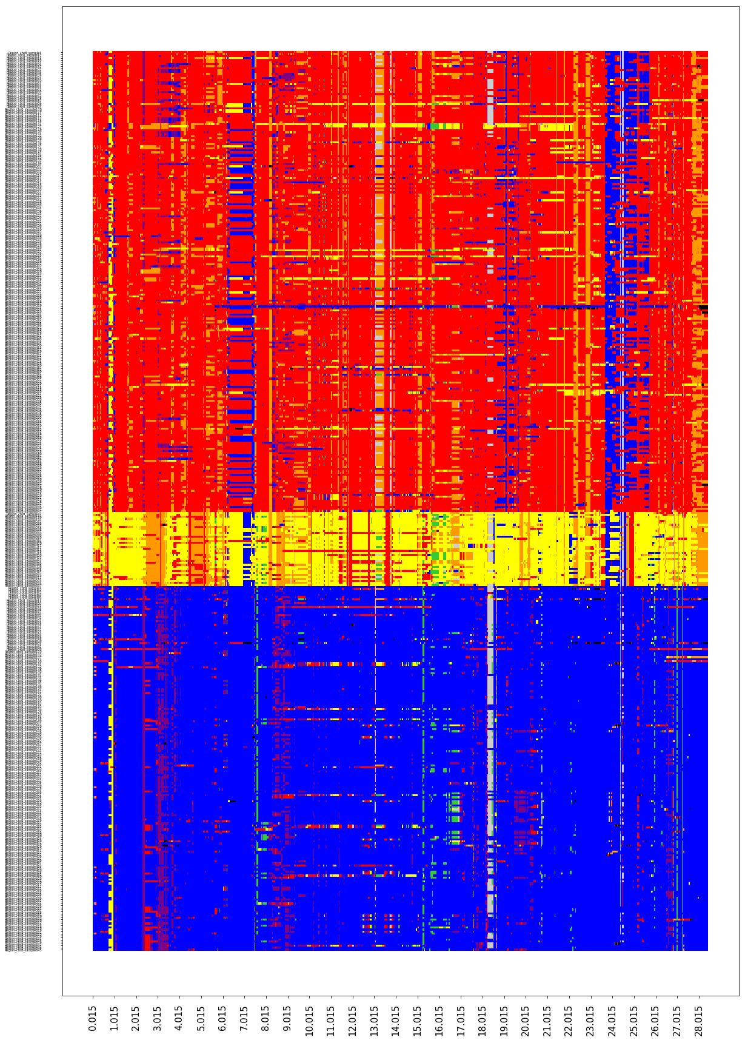

**Steps forward:**

- Register all modifications – train machine to do this for us.

- Extend to Admix falling on the same clusters.