**Practical – 1 :-**

**1**  Write a prolog program to put facts indicating that sachin likes cricket, saurav likes cricket, raj likes football, karan likes basketball, indra likes chess and add rule that parth likes whatever saurav likes. Write goal for following queries:

a) Find the name of all players who like cricket.

b) Check whether raj likes cricket or not.

c) Display the list of all players with the game they like.

d) Display the names of players who likes any game except cricket.

**Code:-**

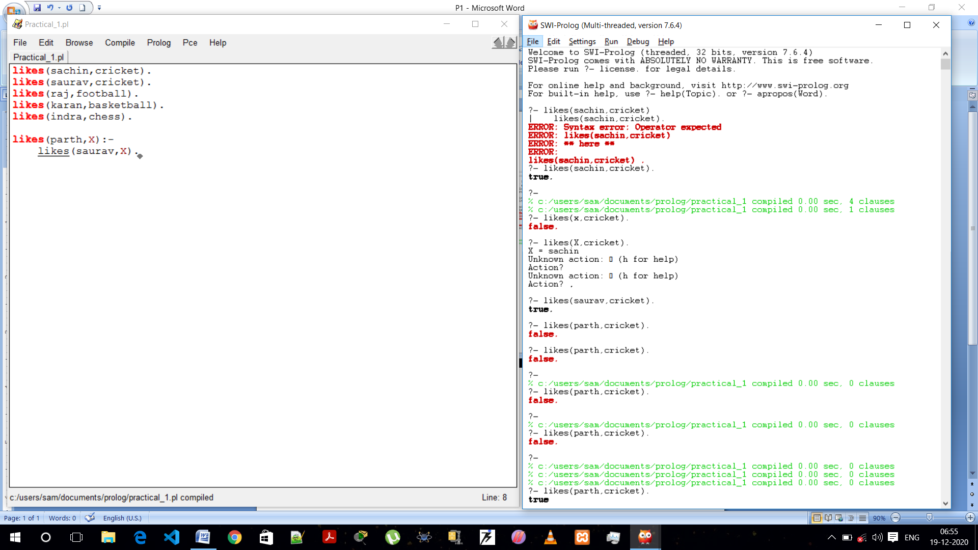

**Queries :-**

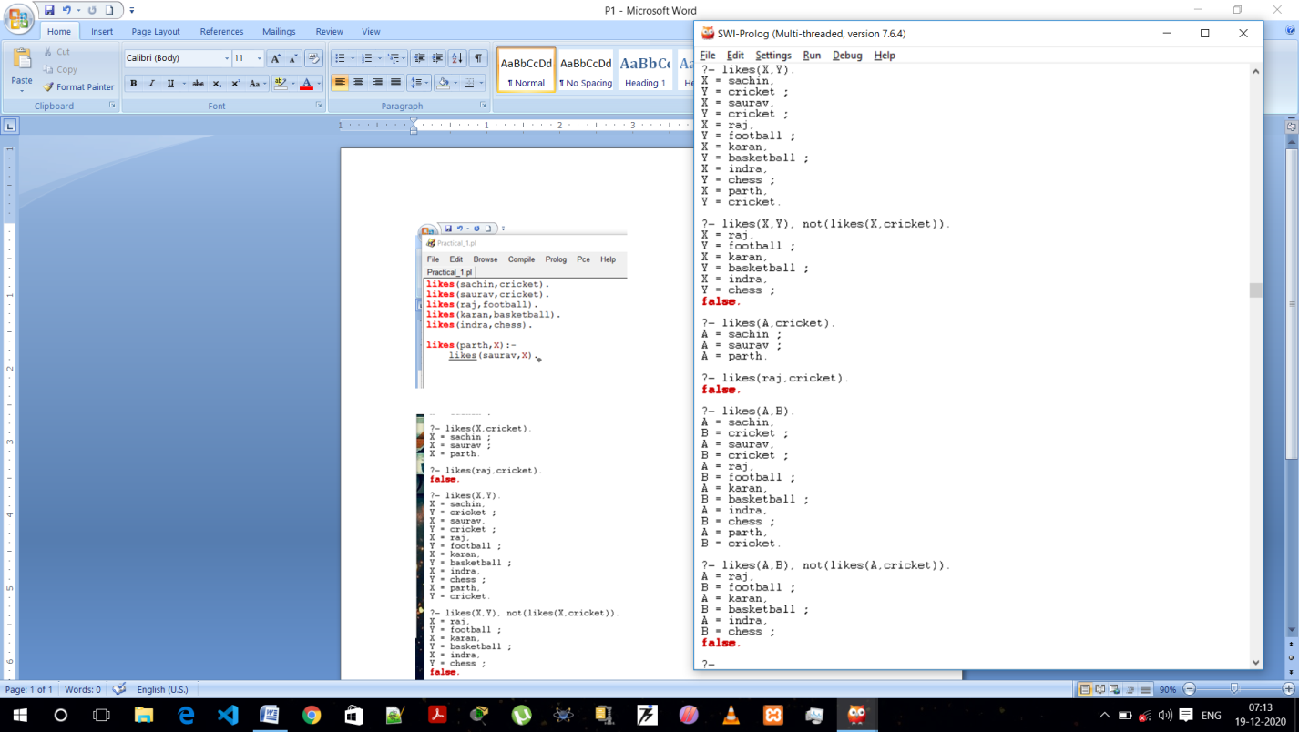

**1 B.** Implement prolog program that asks username and password from the user and display whether login is successful or not according to knowledge base considered in the Program.

a) Perform above program without recursion.

b) Perform above program with recursion.

**Code :- Without Recursion :-**

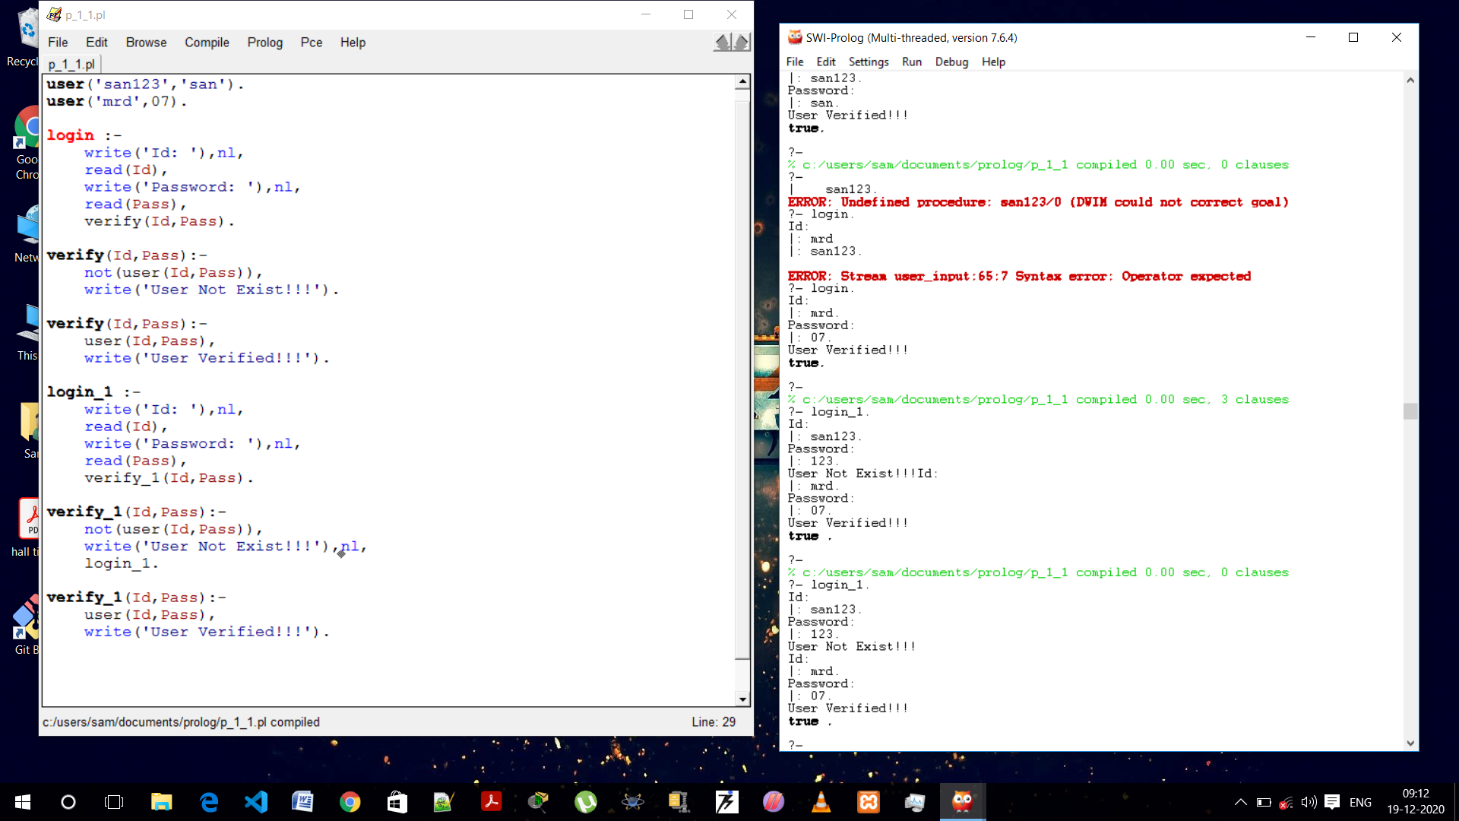

**Checking : -**



**Code :- With Recursion**

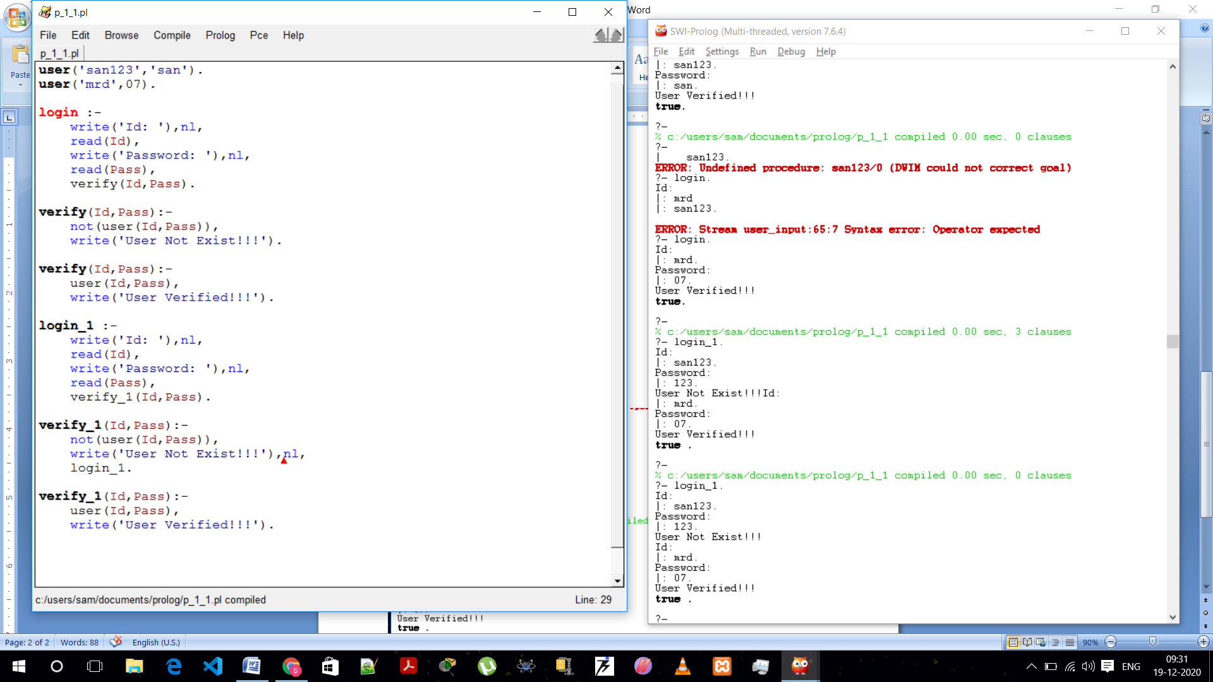

**Checking :-**

