**Practical – 2**

AIM :-

* 1. To find the greatest variable among the three variables.
  2. To find a factorial of a given number.
  3. To check whether a given number is palindrome or not.
  4. To check whether a given number is prime or not.

======**> To find the greatest variable among the three variables.**

**CODE** 🡺

**OUTPUT 🡺**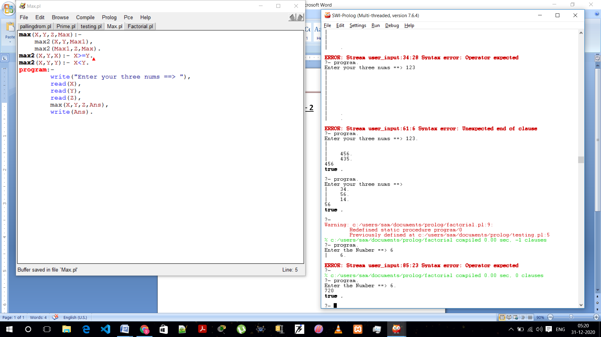



======**> To find a factorial of a given number.**

**CODE 🡺**

**OUTPUT 🡺**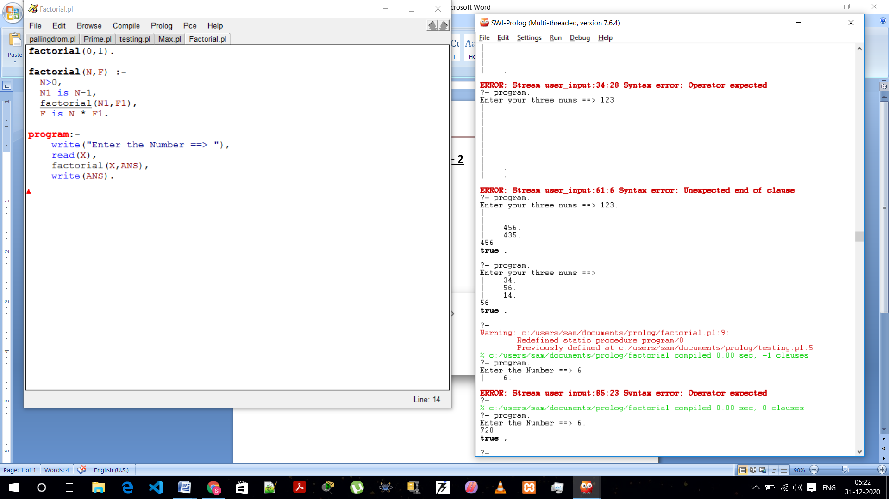



======**> To check whether a given number is prime or not.**

**CODE 🡺**

**OUTPUT 🡺** 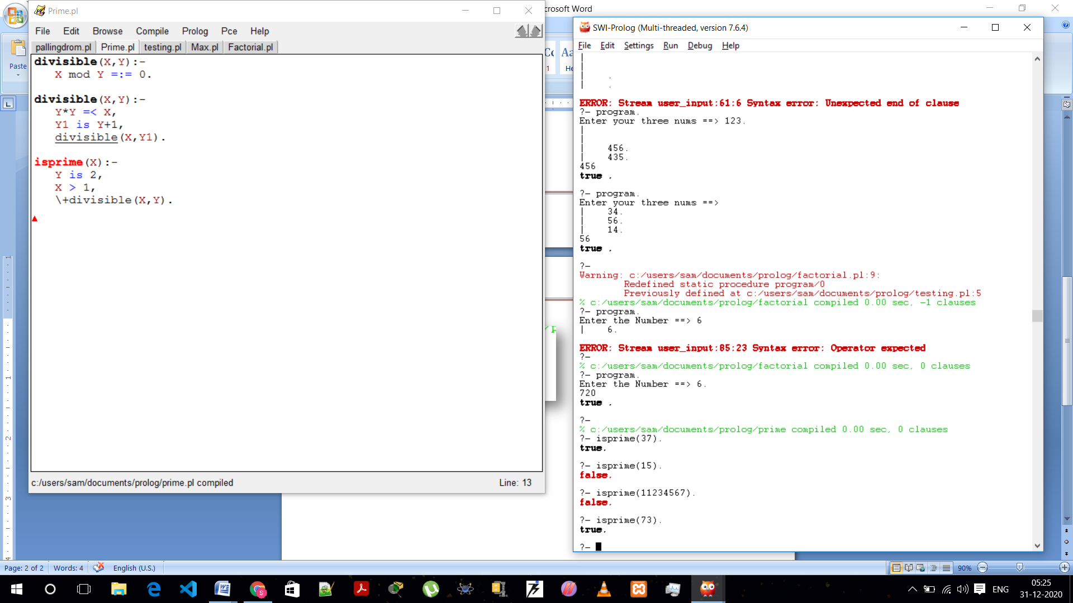



======**> To check whether a given number is pallindrom or not.**

**CODE 🡺**

**OUTPUT 🡺**

