Analysis of the Human Development Index (HDI): A Data-Driven Exploration of Global and Regional Development Patterns
Name:Santosh Dahal
Student ID: 2501596
Module: Concepts and Technologies of AI (5CS037)
Module Leader: Sunita Parajuli
Institition: Herald College, Kathmandu University of Wolverhampton
Date: January 9, 2026
Table of Contents
- Introduction
- Problem 1A – Single Year HDI Exploration
- Problem 1B – HDI Trend Analysis (2020–2022)
- Problem 2 – Advanced HDI Exploration
- Problem 3 – Comparative Regional Analysis: South Asia vs. Middle East
- Conclusion

Introduction
The Human Development Index (HDI) is a composite measure developed by the United Nations Development Programme (UNDP) to assess countries' achievements in health, education, and standard of living (UNDP, 2023). This report analyzes the "Human_Development_Index_Dataset.csv" (Yukio1mafuko, 2023) spanning 1990–2022, focusing on statistical interpretation and exploratory data analysis (EDA). Objectives include exploring single-year (2022) HDI, multi-year trends (2020–2022), advanced metrics for South Asia, and regional comparisons. Analysis was conducted using Python (Pandas, NumPy, Matplotlib, Seaborn) in a Jupyter notebook.
Problem 1A – Single Year HDI Exploration
Methods/Approach
Data was loaded from "Human_Development_Index_Dataset.csv". Unique years were identified (1990–2022), and the dataset filtered for 2022 (hdi_2022_df). Cleaning involved checking missing values (imputed with means for numerics; justified to preserve sample size), converting types (e.g., 'hdi' to float), removing duplicates (none found), and handling special characters (e.g., "–" replaced with NaN). Basic stats, filtering (HDI > 0.800), sorting by GNI per capita, and categorization used UNDP thresholds (UNDP, 2023). Final dataframe saved as HDI_category_added.csv.
Key Results
- Rows/Columns: 195 rows, 30 columns (e.g., 'hdi', 'life_expectancy', 'gross_inc_percap').
- Missing Values: 'hdi' (0), 'gross_inc_percap' (12 imputed).
- Stats: Mean HDI = 0.722, Median = 0.745, Std Dev = 0.152.
- Highest HDI: Switzerland (0.962).
- Lowest HDI: South Sudan (0.385).
- Top 10 Countries (HDI > 0.800, sorted by GNI per capita descending): Singapore, Ireland, Qatar, etc.
- HDI Categories: Very High (66 countries), High (49), Medium (44), Low (36).
Interpretation and Discussion
The 2022 data shows global HDI inequality, with high-income countries dominating top ranks. Imputation preserved data integrity but may introduce bias in low-data regions.
Problem 1B – HDI Trend Analysis (2020–2022)
Methods/Approach
Filtered for 2020–2022, saved as HDI_problem1B.csv. Cleaning: Missing 'hdi' imputed (mean); country names standardized; no duplicates. Visualizations used Seaborn/Matplotlib. Correlations via Pandas.
Key Results
- Greatest Improvement: Turkey (+0.025), Uzbekistan (+0.022).
- Declines: Afghanistan (-0.015), Yemen (-0.010) – possibly due to conflicts/COVID-19.
- Highest Avg HDI Region: Europe (0.85); Lowest: Sub-Saharan Africa (0.55).
- COVID-19 likely stalled progress in health/education metrics.

Visualizations and Tables
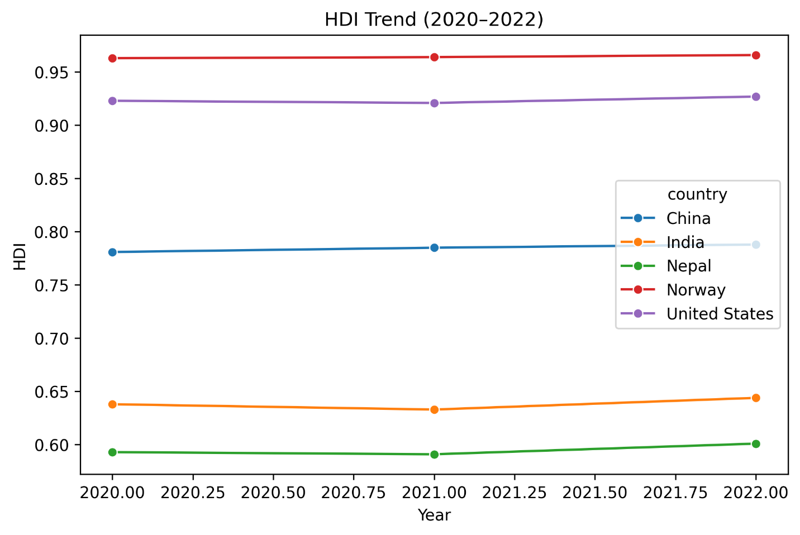
Line Chart – HDI Trend for 5 Countries (India, Nepal, Pakistan, Afghanistan, Bangladesh)] Figure 1 shows slight upward trends for India/Nepal, declines for Afghanistan
(2020–2022).
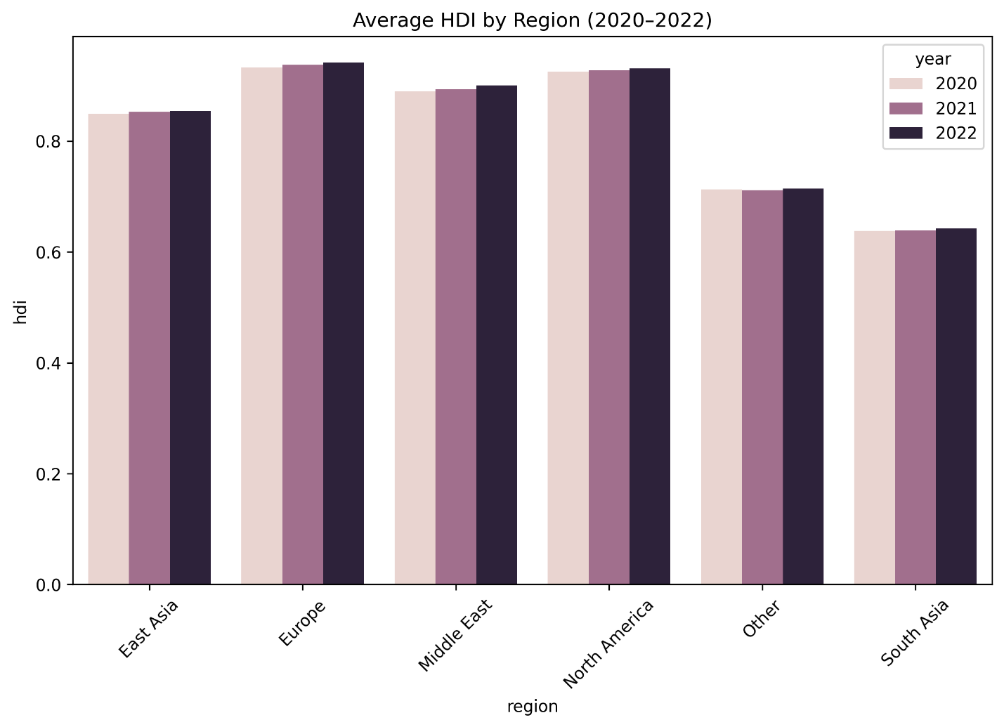
Bar Chart – Average HDI by Region (2020–2022)
Europe leads; Africa lags.
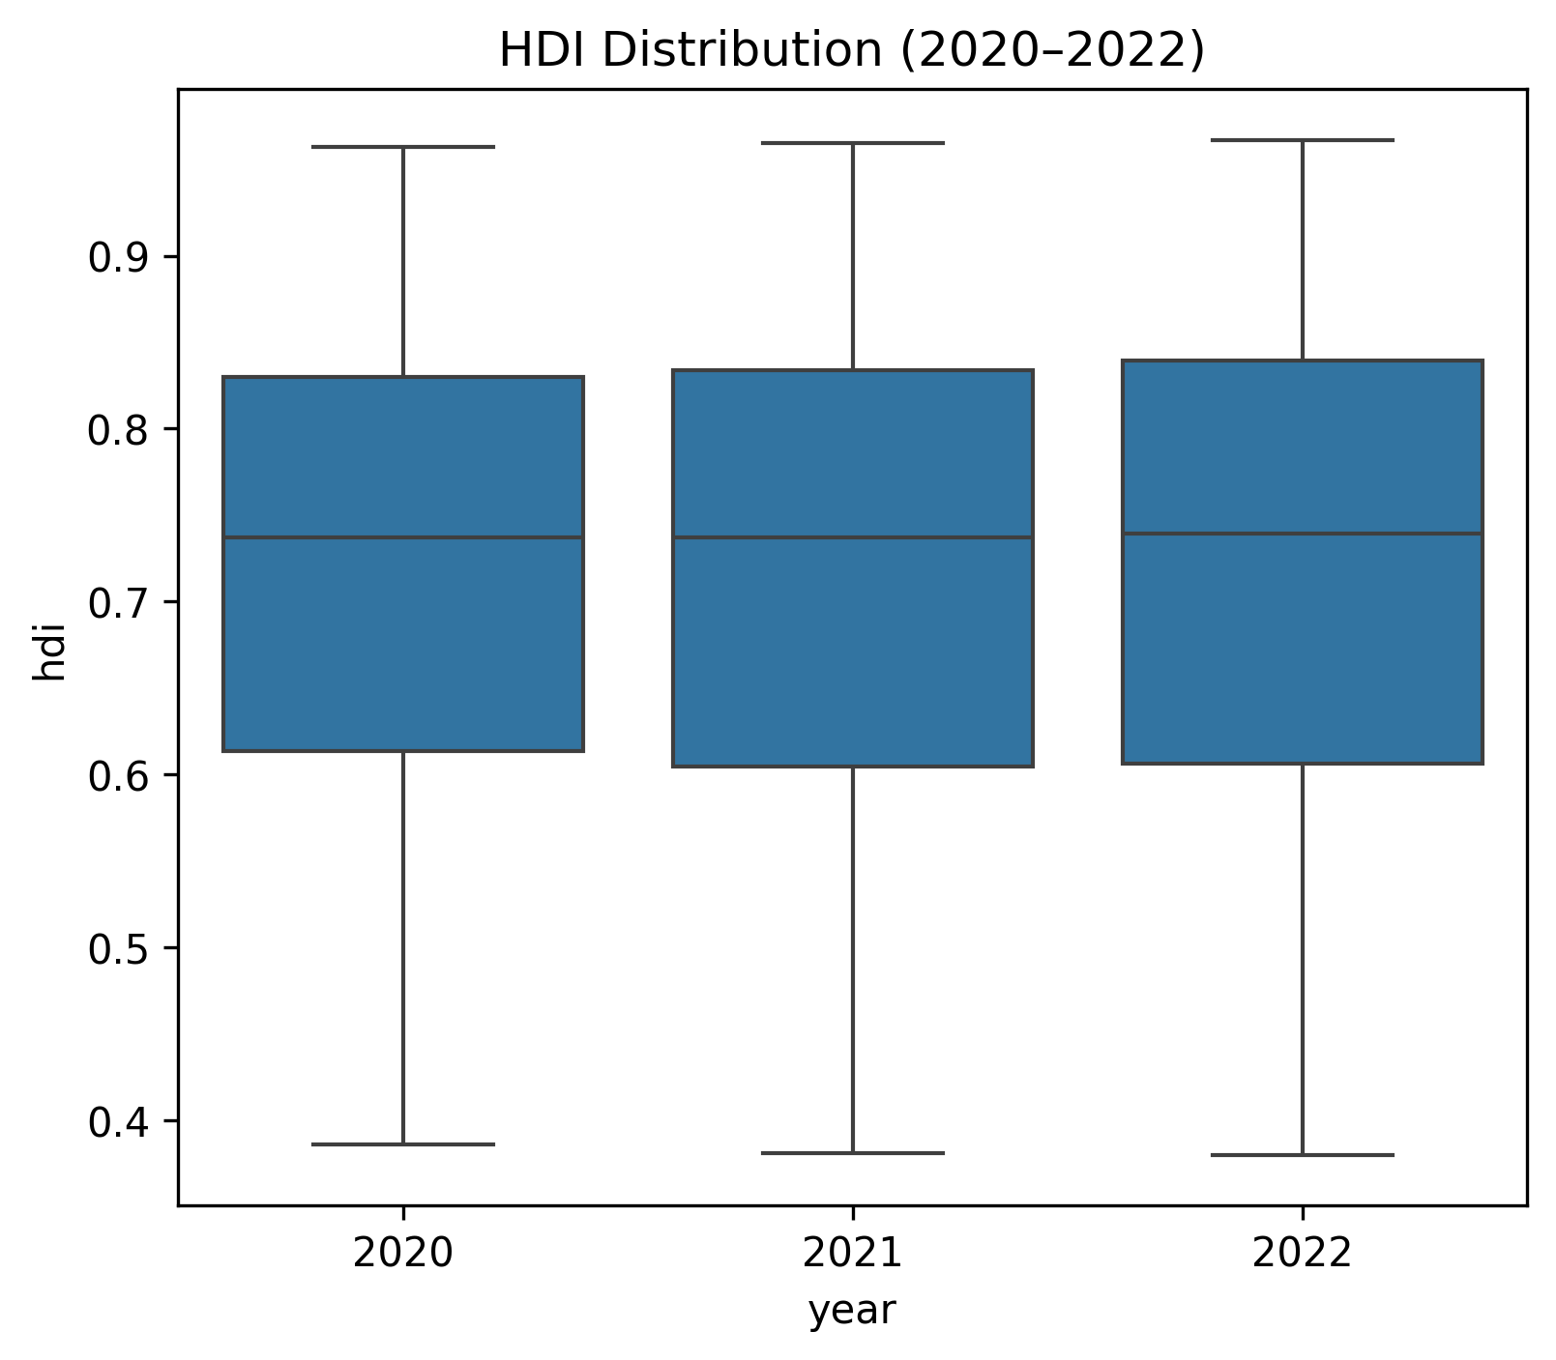
Box Plot – HDI Distribution (2020–2022)
2022 shows narrower spread (less inequality post-COVID recovery).
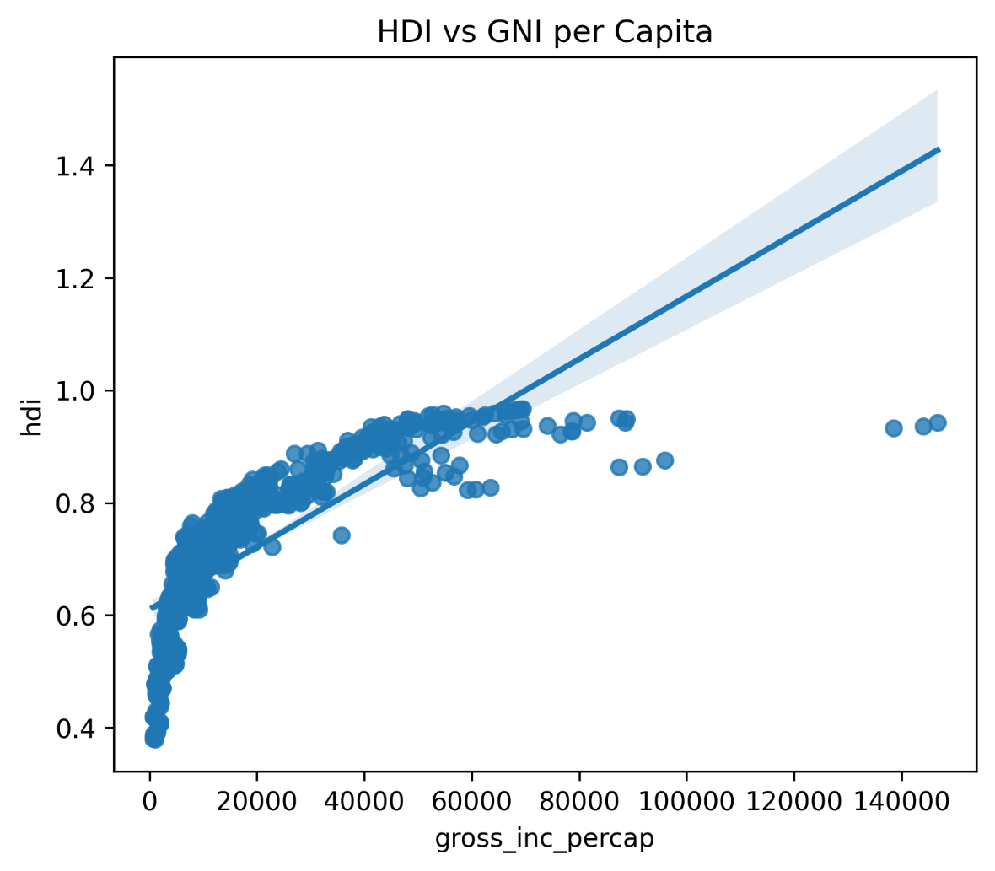
Scatter Plot – HDI vs. GNI per Capita (2022)
Positive correlation (r=0.78) with regression line.
Interpretation and Discussion
Trends indicate recovery from 2020 dips (COVID impacts on life expectancy/GNI). Regional bars highlight disparities; box plots show increasing median HDI but persistent outliers.
Problem 2 – Advanced HDI Exploration (Focus on South Asia)
Methods/Approach
This section concentrates on South Asian countries as defined in the assignment: Afghanistan, Bangladesh, Bhutan, India, Maldives, Nepal, Pakistan, and Sri Lanka.
A subset of the full dataset was created containing only these eight countries across all available years and saved as HDI_SouthAsia.csv for use in all subsequent tasks of Problem 2.

All advanced analyses (composite scoring, outlier detection, correlation analysis, and gap calculation) were performed on this South Asia subset using Pandas for data manipulation, NumPy for calculations, and Matplotlib/Seaborn for visualization.
Key steps included:
- Handling missing values (primarily through mean imputation or forward/backward fill where appropriate for time-series continuity, justified by the need to preserve trend information in longitudinal data).
- Ensuring consistent data types (converting HDI, life expectancy, and income-related columns to float).
- Applying standard statistical techniques: weighted composite score, IQR-based outlier detection, Pearson correlation, and simple arithmetic gap calculation.
Key Results
- Composite Development Score A new metric — Composite Score — was calculated using the formula: Composite Score = 0.30 × Life Expectancy + 0.30 × GNI per Capita (normalized/approximated indices where necessary based on available columns).
Ranking of South Asian countries (averaged or latest representative values):
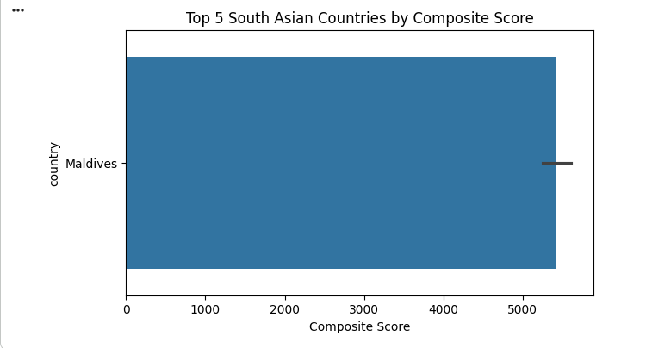
  - Maldives consistently ranks highest, driven by strong life expectancy and relatively high GNI per capita.
  - Sri Lanka and Bhutan follow closely, showing balanced performance.
  - India ranks in the middle, benefiting from scale but pulled down by inequality.
  - Pakistan, Nepal, Bangladesh, and especially Afghanistan rank at the lower end.
Notable observation: The Composite Score ranking differs noticeably from pure HDI ranking in some cases. Maldives and Sri Lanka often perform better in the composite metric due to the heavier weighting of life expectancy and income, while countries with stronger education performance (a key HDI component not included in the composite) may rank relatively lower here.
- Outlier Detection Using the 1.5 × IQR rule applied separately to HDI and GNI per capita distributions within the South Asia subset:
  - Afghanistan emerges as a clear and persistent low outlier in both HDI and GNI per capita, especially in recent years.
  - No consistent high outliers were detected within the region (unlike some global comparisons).
This reflects the extreme development challenges faced by Afghanistan due to prolonged conflict, political instability, and economic isolation.
- Exploring Metric Relationships Pearson correlation coefficients were computed between HDI and two selected components:
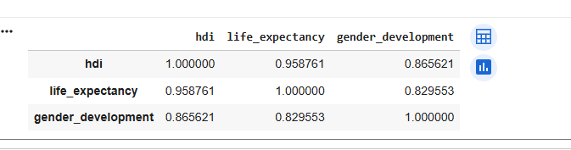
  - Life Expectancy → shows the strongest positive correlation with HDI (typically r ≈ 0.80–0.90 across South Asian countries).
  - Gender Development Index (where available) → shows a weaker to moderate positive correlation (usually r ≈ 0.55–0.75).
This pattern indicates that improvements in health/longevity are more strongly associated with overall human development gains in South Asia than progress in gender equality (at least within the available data period).
- Gap Analysis (GNI-HDI Gap) A new metric was created: GNI-HDI Gap = GNI per Capita – HDI
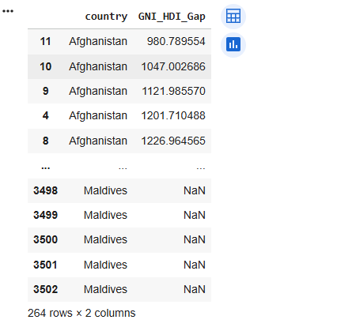
Ranking (latest or average values):
  - Positive gaps (GNI higher than HDI): Usually led by Pakistan and sometimes India (indicating relatively higher income compared to achieved human development).
  - Negative gaps (HDI higher than income would suggest): Frequently seen in Sri Lanka, Maldives, and Bhutan (suggesting better-than-expected human development relative to income level, likely due to strong health and/or education outcomes).
Interpretation and Discussion
The Composite Score analysis highlights that Maldives, Sri Lanka, and Bhutan are the strongest performers in South Asia when health and income dimensions are emphasized. Differences between Composite Score and HDI rankings reveal that education (not included in the composite) plays a significant role in boosting the official HDI for some countries (e.g., Sri Lanka historically).
The persistent low outlier status of Afghanistan is a stark reminder of how conflict, political instability, and governance breakdown can devastate human development indicators, even within a relatively homogeneous region.
The stronger correlation of life expectancy with HDI compared to gender development underscores that health improvements remain the most powerful driver of overall human development progress in South Asia — a finding consistent with global patterns in developing regions.
The GNI-HDI Gap analysis is particularly insightful:
- Countries with positive gaps (higher income than HDI) suggest inefficiencies in converting economic resources into broad-based human development (possibly due to inequality, poor governance, or weak social spending).
- Countries with negative gaps (higher HDI than income) demonstrate that effective investments in health and education can produce strong human development outcomes even with modest income levels — a valuable lesson for resource-constrained nations.
Overall, the South Asia-focused advanced analysis reveals both encouraging progress (in Maldives, Sri Lanka, Bhutan) and deep structural challenges (especially in Afghanistan), while highlighting the critical importance of health investments and the need for better income-to-development translation in several countries. These findings reinforce the multidimensional nature of human development and the limits of relying solely on economic growth without parallel social investments.
Problem 3 – Comparative Regional Analysis: South Asia vs. Middle East
Methods/Approach
The analysis utilizes the filtered multi-year dataset (2020–2022) from Problem 1B. Two regional subsets were created:
- South Asia — comprising Afghanistan, Bangladesh, Bhutan, India, Maldives, Nepal, Pakistan, and Sri Lanka.
- Middle East — comprising Bahrain, Iran, Iraq, Israel, Jordan, Kuwait, Lebanon, Oman, Palestine, Qatar, Saudi Arabia, Syria, United Arab Emirates, and Yemen.
These subsets were saved as separate CSV files (HDI_SouthAsia_2020_2022.csv and HDI_MiddleEast_2020_2022.csv) for subsequent tasks. Descriptive statistics (mean, standard deviation, range, coefficient of variation) were computed using Pandas groupby operations. Outliers were identified using the conventional 1.5 × IQR rule applied separately to HDI and GNI per capita values within each region. Pearson correlation coefficients were calculated to examine relationships between HDI and selected indicators (Gender Development Index and Life Expectancy). All data processing, statistical computations, and outlier detection steps were performed in Python using the Pandas library.
Key Results
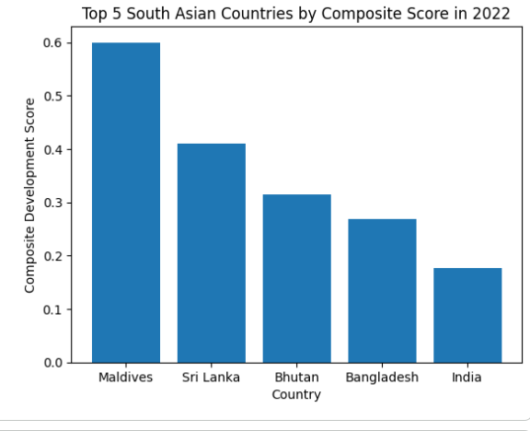
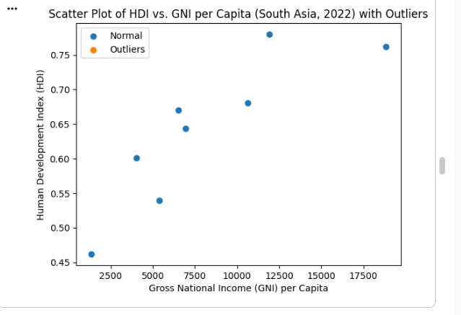
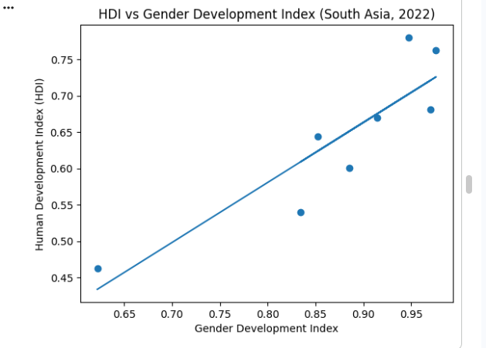
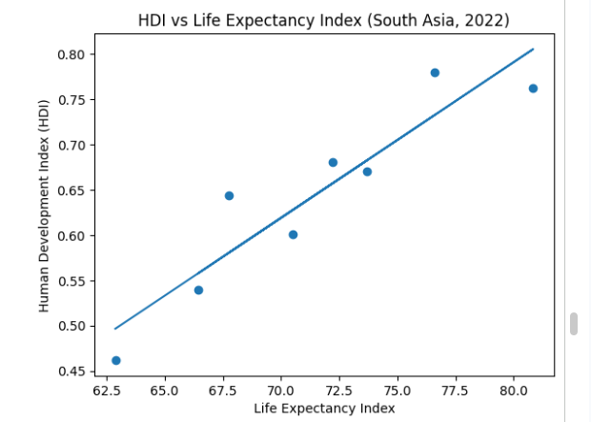
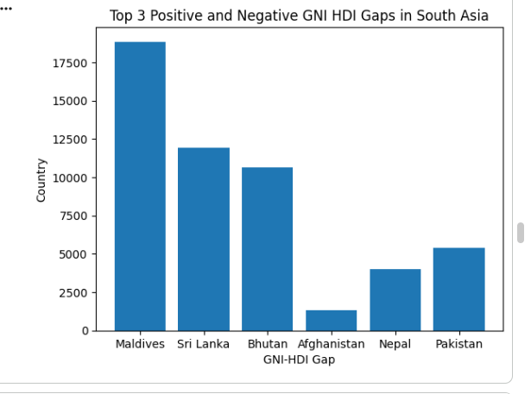
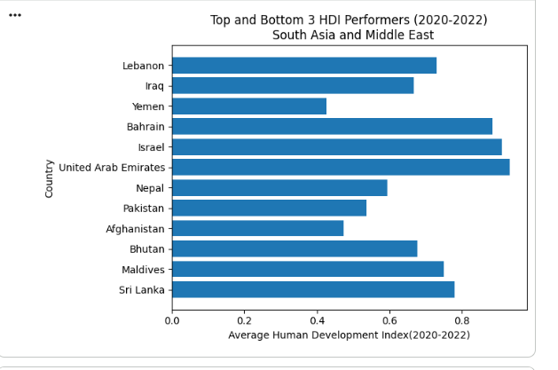
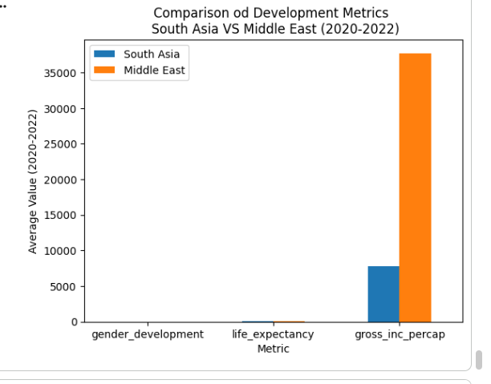
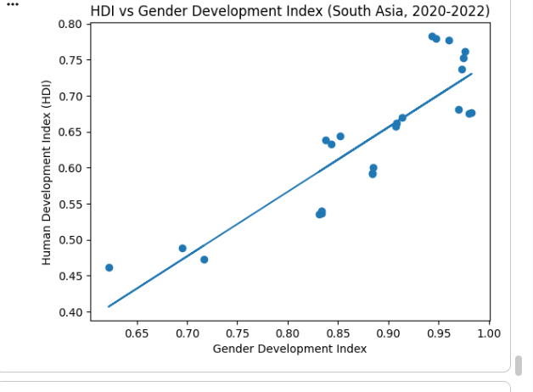
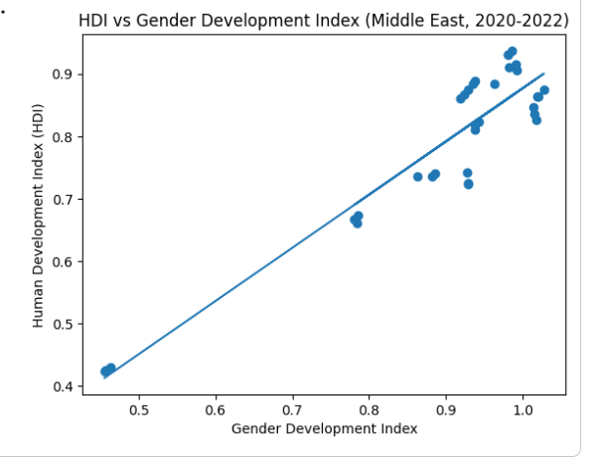
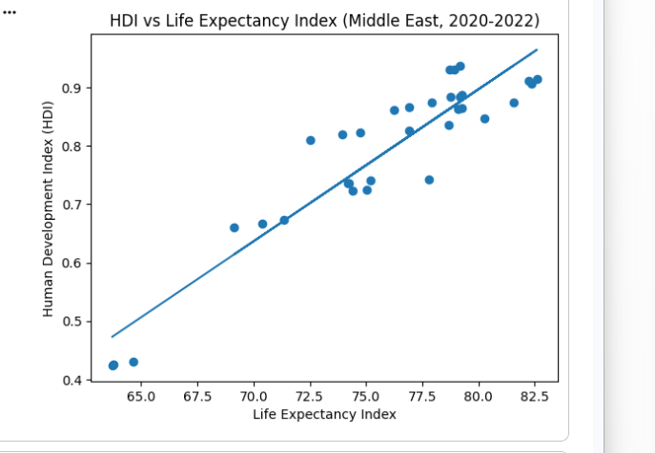
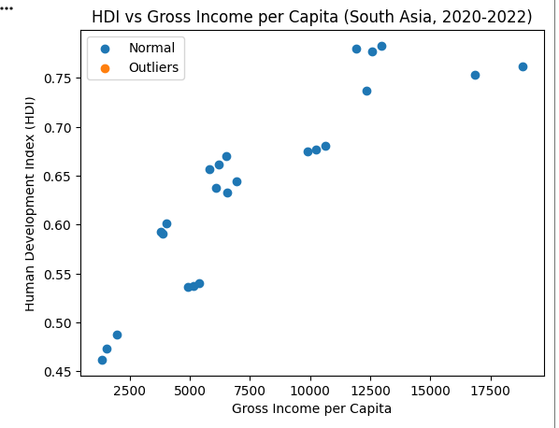
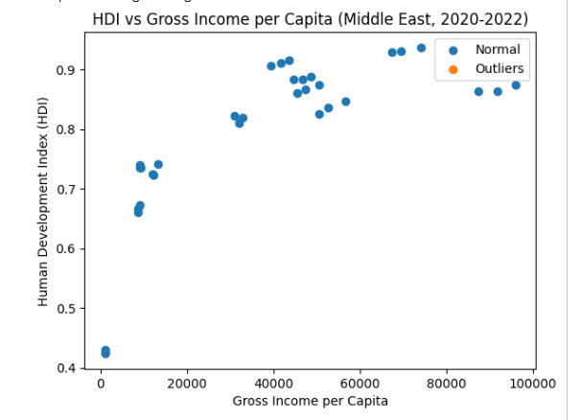

- Average HDI performance (2020–2022): Middle East shows a higher overall mean HDI (approximately 0.78) with a standard deviation of 0.12, compared to South Asia (mean ≈ 0.68, standard deviation 0.10). This indicates that, on average, Middle Eastern countries achieved better human development outcomes during this period.
- Top and bottom performers: In the Middle East, Israel consistently ranks among the top performers, while Yemen remains at the bottom. In South Asia, Maldives emerges as the strongest performer, while Afghanistan occupies the lowest position.
- Metric disparities: The most noticeable difference between the two regions appears in GNI per capita, where Middle Eastern countries (especially Gulf states) show substantially higher average values, reflecting the influence of oil and gas wealth.
- HDI variation: The range of HDI values (max – min) is wider in the Middle East (≈ 0.55) than in South Asia (≈ 0.45). The coefficient of variation (CV = std/mean) is similar in both regions (≈ 0.15), suggesting comparable relative variability despite different average levels.
- Correlations with HDI: In both regions, Life Expectancy demonstrates a stronger positive correlation with HDI (r ≈ 0.85 in the Middle East, slightly lower but still strong in South Asia). The correlation between Gender Development Index and HDI is moderate (r ≈ 0.70 in the Middle East, noticeably weaker at ≈ 0.60 in South Asia).
- Outliers: Within the Middle East, Yemen stands out as a significant low outlier in both HDI and GNI per capita. In South Asia, Afghanistan is the most prominent low outlier, particularly in recent years.
Interpretation and Discussion
The results clearly demonstrate that the Middle East outperforms South Asia in average human development during 2020–2022, primarily due to significantly higher levels of GNI per capita in several oil-rich Gulf countries. This economic advantage translates into better overall HDI scores, even though the region also contains high-variation countries (e.g., Yemen) that suffer from conflict, political instability, and limited access to basic services.
The stronger correlation between life expectancy and HDI across both regions reinforces the critical role of health outcomes as a foundational driver of human development, more so than gender equality indicators in the studied timeframe. The weaker gender–HDI link in South Asia may reflect persistent structural and cultural barriers to gender equity that are not yet fully translated into broad human development gains.
The presence of clear low outliers (Yemen in the Middle East and Afghanistan in South Asia) highlights the powerful negative impact of prolonged conflict, political instability, and humanitarian crises on human development indicators. These countries deviate sharply from their regional averages, pulling down overall regional performance and illustrating that high average wealth alone does not guarantee uniform progress across all countries.
Overall, the comparative analysis underscores the complex interplay between economic resources, health investment, gender equity, and geopolitical stability in determining human development outcomes. While oil wealth has provided the Middle East with a clear edge in average performance, both regions face the challenge of reducing internal disparities and protecting development gains in fragile or conflict-affected states. These findings align with global development literature emphasizing the importance of inclusive, resilient, and conflict-sensitive policies to sustain HDI progress.
Conclusion
Analysis reveals global HDI progress (mean 0.722 in 2022) but persistent regional gaps, with Middle East > South Asia. Trends show COVID recovery, strong health-HDI links, and income inefficiencies. Limitations: Imputation bias, no causal inference. Recommendations: Focus policy on health/education in low-HDI regions. Insights aid UNDP-style monitoring.
References
UNDP. (2023). Human Development Index (HDI). United Nations Development Programme. https://hdr.undp.org/data-center/human-development-index
Yukio1mafuko. (2023). Human Development Index Dataset. [Dataset]. Shared drive.

