**Home Automation using Blynk Application**

**INTRODUCTION**

Home automation evolution starts with some basic ideas. It minimizes the human efforts and it can be deployed in a lot of fields like military, surveillance application is developed in the modern world. Now a day’s Home automation is developed by using Wireless technology. Wireless technology in Home automation starts with Bluetooth, WI-FI, and Zigbee Communication. Based on the Requirement and Application we deployed the communication in Projects. And we have numerous android Applications in the Play store to control Home automation. Blynk is a Popular App used in this Project it has a lot of features like buttons, gauges, Sliders and Plotting Features also. By using Wi-Fi technology we can connect a greater number of Home automation to control it very useful for surveillance applications.

**PROPOSED SYSTEM**

Home automation was controlled by the wi-fi network in the Blynk android application. The wi-fi Home automation can be easy to make on and off by using the command in the Blynk application. We can make Home automation do the various task using wi-fi network technologies.

**BLOCK DIAGRAM**

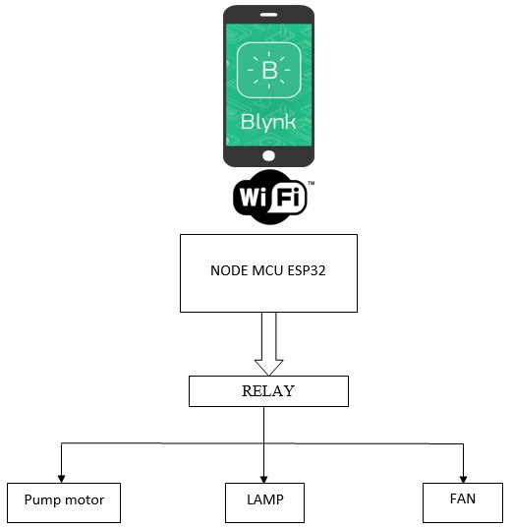

**BLOCK DIAGRAM EXPLANATION**

•Home automation is operating with the Nodemcu esp8266 controller and the command is given by the Blynk android application in a mobile phone using the wi-fi network.

•The Nodemcu esp8266 as inbuilt wi-fi module and the devices connected with Home automation.

•Both wi-fi is connected with an authentication token.

•Blynk android application will transmit command using wi-fi to the electrical equipment so that its electrical equipment depends upon the required condition.

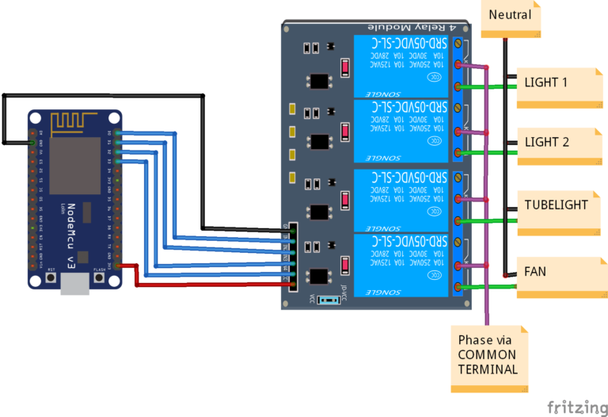

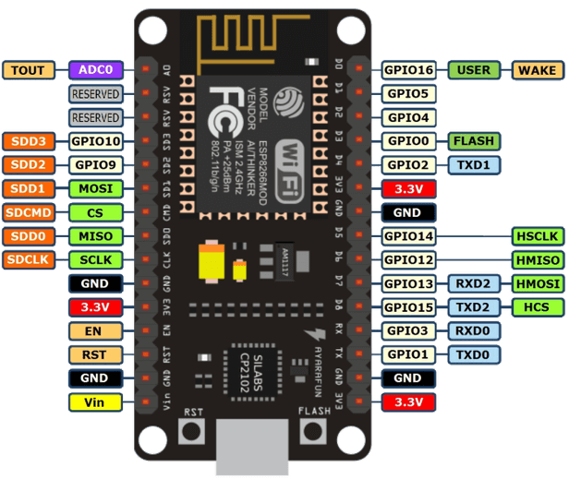

**HARDWARE REQUIREMENTS**

* Nodemcu esp8266 controller
* Relay circuit
* Cooling fan
* Lights

**SOFTWARE REQUIREMENTS**

* Arduino IDE
* Blynk android application

**STEPS:-**

1. 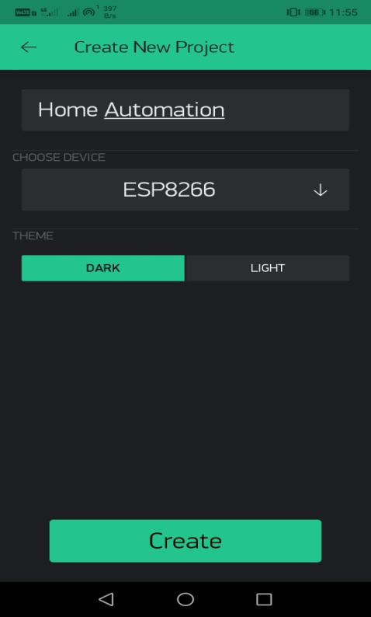**Project Creation**
2. 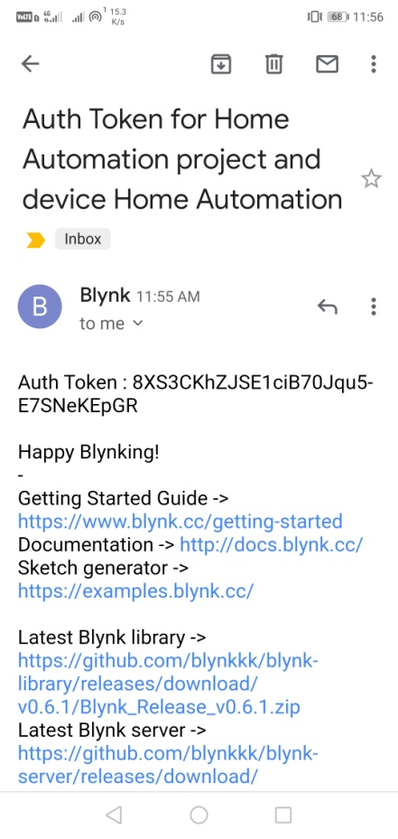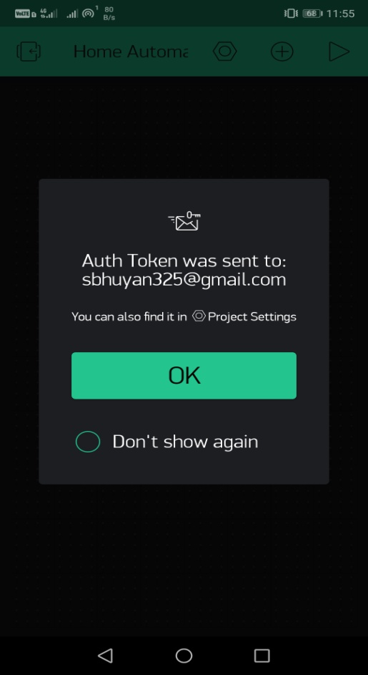**Auth token generation**
3. **Button Settings**

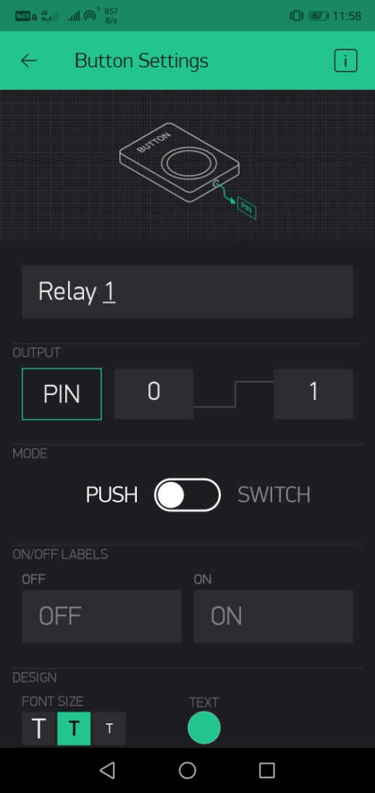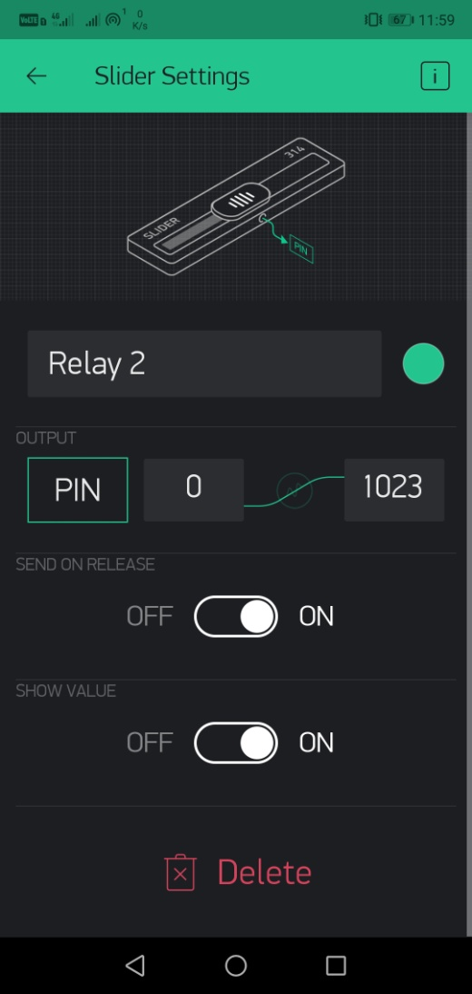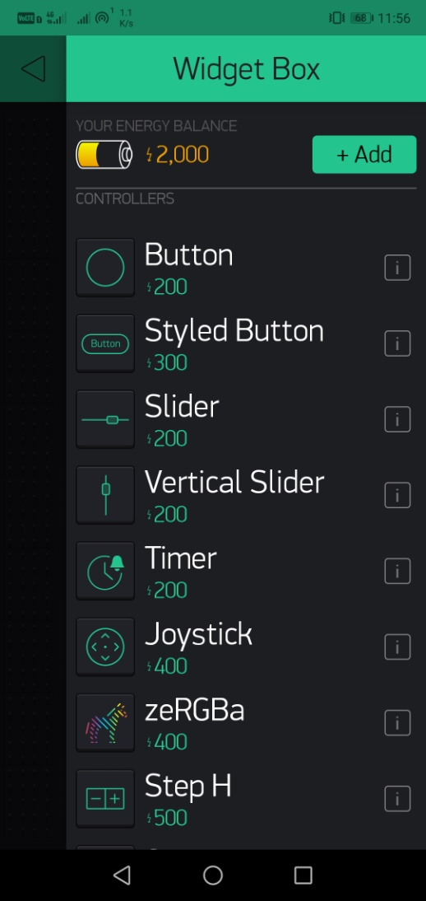

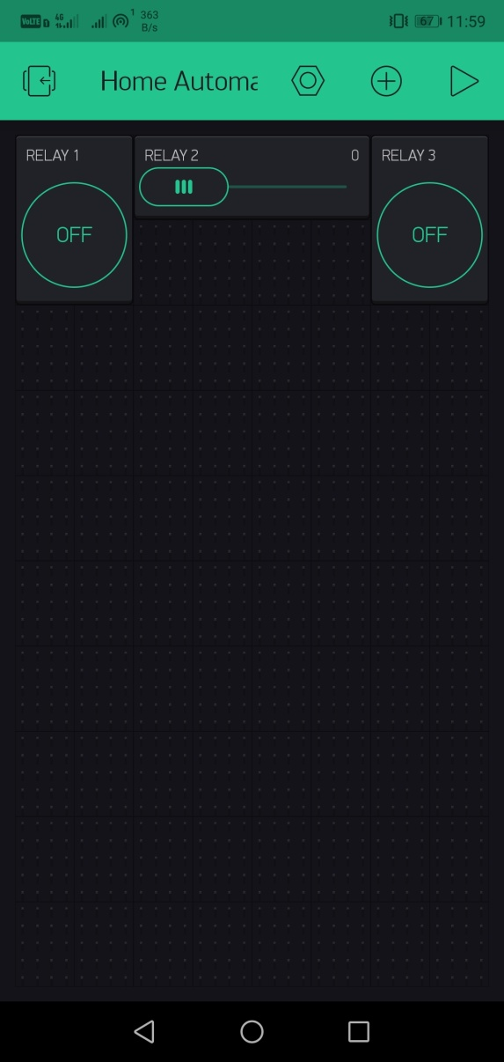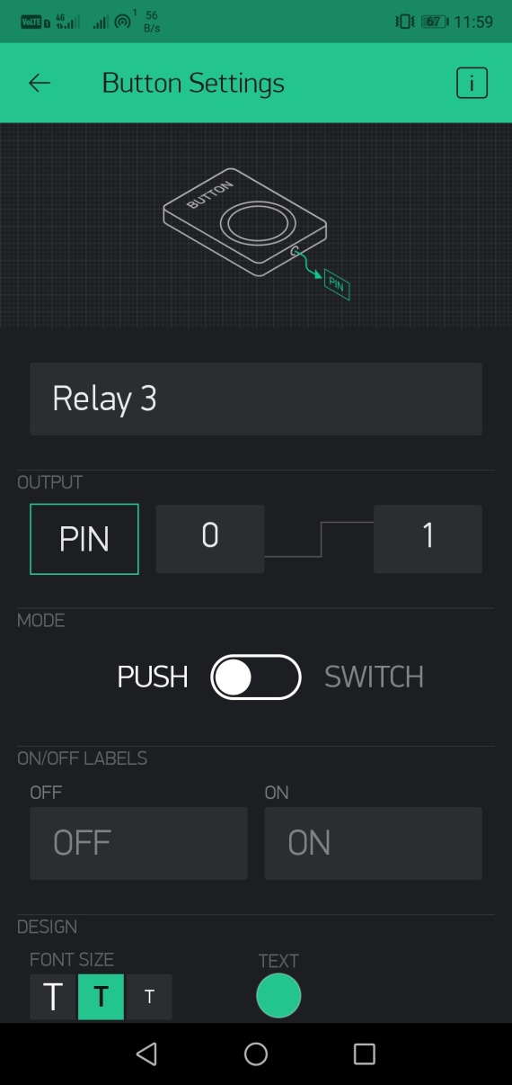

**CONCLUSION**

* Blynk android application will transmit command using wi-fi to the car so that it can move in the required direction like moving forward, reverse, turning left, turning right and stop.
* Wireless control is the most important basic needs for all the people. So using this model we can remotely operate appliances in our home.