**Nagios**

**what is Nagios?**

Nagios is a free to use open source software tool for continuous monitoring. It

helps you to monitor system, network, and infrastructure. It is used for

continuous monitoring of systems, applications, service and business process

in a DevOps culture.

or

Nagios is a powerful monitoring system that enables organizations to identify and resolve IT Infrastucture problems

before they affect critical business process

**Why We Need Nagios?**

• Detects all types of network or server issues

• Helps you to find the root cause of the problem.

• Active monitoring of your entire infrastructure and business processes

• Allows you to monitors and troubleshoot server performance issues

• Helps you to plan for infrastructure upgrades before outdated systems

create failures

• You can maintain the security and availability of the service

• Automatically fix problems in a panic situation

**Nagios Architecture**

Nagios is a client-server architecture. Usually, on a network, a Nagios server

is running on a host, and plugins are running on all the remote hosts which

should be monitored.

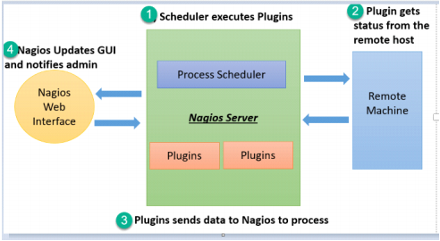

**Plugins**: Nagios plugins provide low-level intelligence on how to monitor anything and everything with Nagios Core. Plugins operate acts as a standalone application, but they are designed to be executed by Nagios Core. It connects to Apache that is controlled by CGI to display the result. Moreover, a database connected to Nagios to keep a log file.

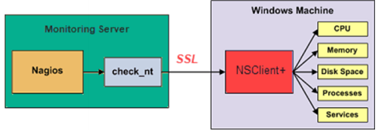

• Check_nt is a plugin to monitor a windows machine which is mostly available in the monitoring server

• NSClinet++ should be installed in every Windows machine that you wants to monitor

• There is an SSL connection between the server and the host which continuously exchange information with each other

**Server :** 1) Alerts 2) Dashboard

**Agent**: which is installed in each server which you want to monitor which runs on the servers

**Agentless** monitoring can be possible through protocols

Linux -> SNMP protocol

Windows -> WMI protocol

Two type of monitoring

Active Monitoring -> XI server -> Agents -> XI server

Passive Monitoring -> Agent -> XI server

======================================================

1. Download, Setup, Configure Nagios Server XI

======================================================

Nagios XI Server

> yum update -y

> sudo -s

> cd

> yum install wget -y

> wget https://assets.nagios.com/downloads/nagiosxi/5/xi-5.4.13.tar.gz

> tar -zxvf xi-5.4.13.tar.gz

> cd nagiosxi

> ./fullinstall

(you will get ip )

Open browser

<http://---ip---/nagiosxi/>

fill the form

Username -> nagiosadmin

Password -> (there is pre-define password) copy that and save it for future.

======================================================

2. How to install agent

======================================================

https://assets.nagios.com/downloads/nagiosxi/agents/linux-nrpe-agent.tar.gz

HOW TO INSTALL AGENT?

$ yum update

$ /opt

$ yum install wget -y

$ wget https://assets.nagios.com/downloads/nagiosxi/agents/linux-nrpe-agent.tar.gz

$ tar -zxvf linux-nrpe-agent.tar.gz

$ cd linux-nrpe-agent

$ ./fullinstall

NOTICE:

Your firewall configuration was skipped

You need to manually open ports 5666 for TCP traffic

MBP8P7wcDawciJnC

OR

You can directly install Nagios iso in vmware