MLOps Assignment — Heart Disease Prediction Pipeline
Student: Appana Santosh
ID: 2025CS05017
Git Repo : MLOPS_Pipeline
Video :

Table of Contents
MLOps Assignment 1 — Heart Disease Prediction Pipeline 2
Contents 2
1. Overview 2
2. Prerequisites & Local Setup 3
Prerequisites 3
Reproducible setup 3
Run the API locally 4
Deploy the full stack to local Kubernetes 4
3. Data Acquisition & EDA 4
Dataset 4
Cleaning (dataprocessing/process_data.py) 5
EDA (notebooks/eda.ipynb) 5
EDA Visualisations 5
4. Feature Engineering & Model Development 5
Preprocessing pipeline (src/data_prep/preprocess.py) 5
Models (src/training/train.py) 6
Cross-validation results 6
Model selection rationale 6
5. Experiment Tracking 7
Experiment tracking summary 7
6. Model Packaging & Reproducibility 7
7. CI/CD Pipeline & Automated Testing 8
Tests (17 total) 8
GitHub Actions (.github/workflows/ci.yml) 8
Manual triggers 9
Local execution with act 9
CI/CD workflow screenshots 9
8. Containerization 9
9. Production Deployment 10
Deployment verification 11
10. Monitoring & Logging 12
Structured request logs 12
Prometheus (pull model) 12
Grafana (auto-provisioned) 12
11. Screenshots & Evidence 12
12. Conclusion 13
Appendix: Deliverables Checklist 14

1. Overview
A binary classifier for heart disease, built on the Cleveland UCI dataset, wrapped in a full MLOps pipeline: data processing → training with MLflow tracking → tested FastAPI service → containerized → CI/CD via GitHub Actions → deployed to Docker Desktop Kubernetes with Prometheus + Grafana monitoring.

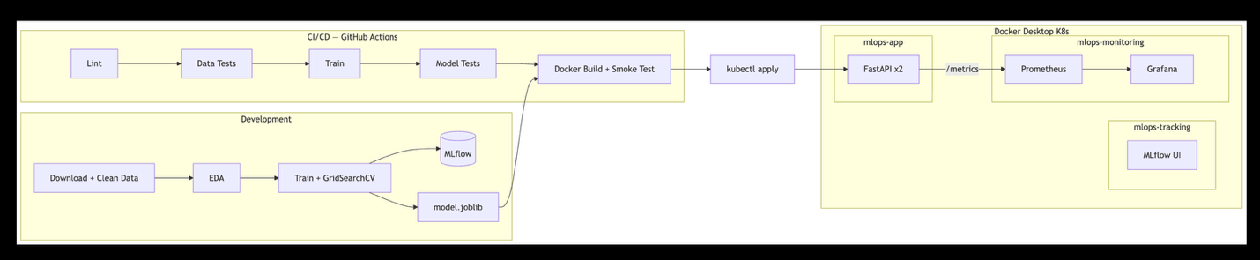

2. Prerequisites & Local Setup

Prerequisites
Tool | Version | Purpose
Python | 3.12+ | Runtime
Docker Desktop | latest | Container runtime + local Kubernetes cluster
kubectl | bundled | Ships with Docker Desktop
Git | any | Clone the repo
act (optional) | latest | Run the GitHub Actions workflow locally (brew install act)
Docker Desktop settings: enable Kubernetes (Settings → Kubernetes → Enable). Allocate at least 4 GB RAM and 2 CPUs (Settings → Resources). MLflow’s pod requests up to 1.5 GiB.
macOS users: disable AirPlay Receiver (System Settings → General → AirDrop & Handoff) or accept that MLflow runs on port 5001 to avoid a conflict on port 5000.

Reproducible setup (Local Setup)
git clone https://github.com/Santosh-src/MLOPS_Pipeline.git
cd MLOPS_Pipeline
python3 -m venv venv && source venv/bin/activate
pip install -r requirements.txt
python dataprocessing/process_data.py # cleans the Cleveland raw file
python -m src.training.train # trains, logs to MLflow, saves model
pytest tests/ -v # 17 tests

Run the API locally
uvicorn src.serving.app:app --port 8080
curl http://localhost:8080/health

Deploy the full stack to local Kubernetes
./scripts/deploy.sh # builds image, applies manifests, waits for rollouts
./scripts/undeploy.sh # tears it all down

3. Data Acquisition & EDA

Dataset
Cleveland Heart Disease Database, UCI ML Repository. Original investigators: Robert Detrano, M.D., Ph.D. The full database has 76 attributes; published research uses the standard 14-attribute extraction, which is what we use.
Feature | Description | Type
age | Age in years | Numeric
sex | 1 = male, 0 = female | Binary
cp | Chest pain type (1–4) | Categorical
trestbps | Resting blood pressure (mm Hg) | Numeric
chol | Serum cholesterol (mg/dl) | Numeric
fbs | Fasting blood sugar > 120 mg/dl | Binary
restecg | Resting ECG (0–2) | Categorical
thalach | Maximum heart rate achieved | Numeric
exang | Exercise-induced angina | Binary
oldpeak | ST depression induced by exercise | Numeric
slope | Slope of peak exercise ST segment | Categorical
ca | Major vessels coloured by fluoroscopy | Categorical
thal | Thalassemia (3=normal, 6=fixed, 7=rev) | Categorical
target | 0 = no disease, 1 = disease (binarised) | Binary

Cleaning (dataprocessing/process_data.py)
The raw UCI file (data/processed.cleveland.data) ships with the repository.
- Loads with ? mapped to NaN.
- Imputes numeric columns with median, categorical/binary with mode (6 missing values: 4 in ca, 2 in thal).
- Binarises target (0 vs 1–4) and casts integer columns.
- Writes dataprocessing/processed_cleveland.csv (303 rows, 14 cols, 0 missing).

EDA (notebooks/eda.ipynb)
- Class balance: 164 no-disease vs 139 disease (54.1% / 45.9%) — workable without resampling.
- Strongest correlates with target: thal, ca, oldpeak, exang, cp.
- Disease patients show lower max heart rate (thalach) and are slightly older.
- Asymptomatic chest pain (cp = 4) is strongly associated with disease.

EDA Visualisations
Key plots produced in the notebook (also saved to screenshots/):
Class distribution bar chart — 164 no-disease vs 139 disease (54.1%/45.9%), confirming no severe imbalance.

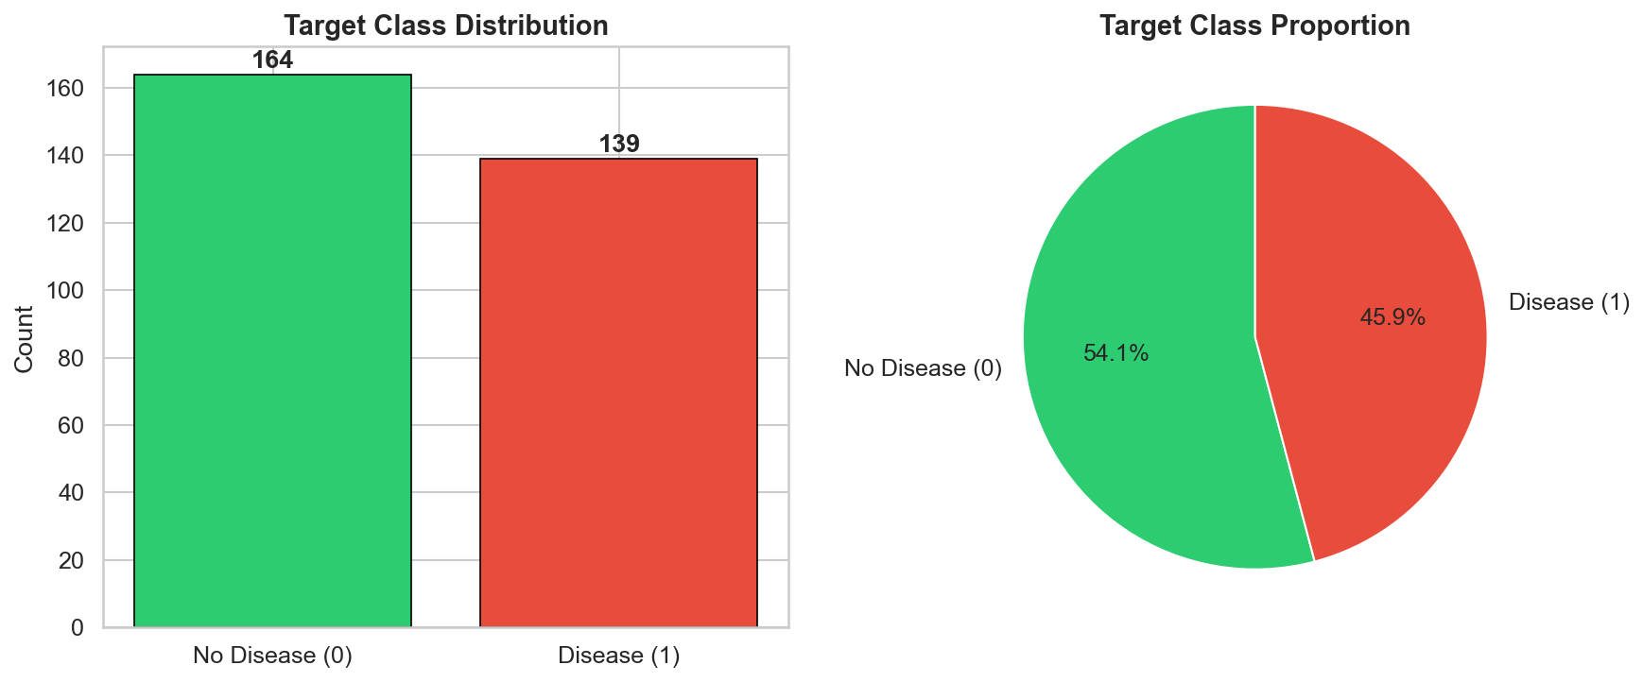
Correlation heatmap — highlights cp, thalach, exang, oldpeak, ca, and thal as the strongest correlates with the target.
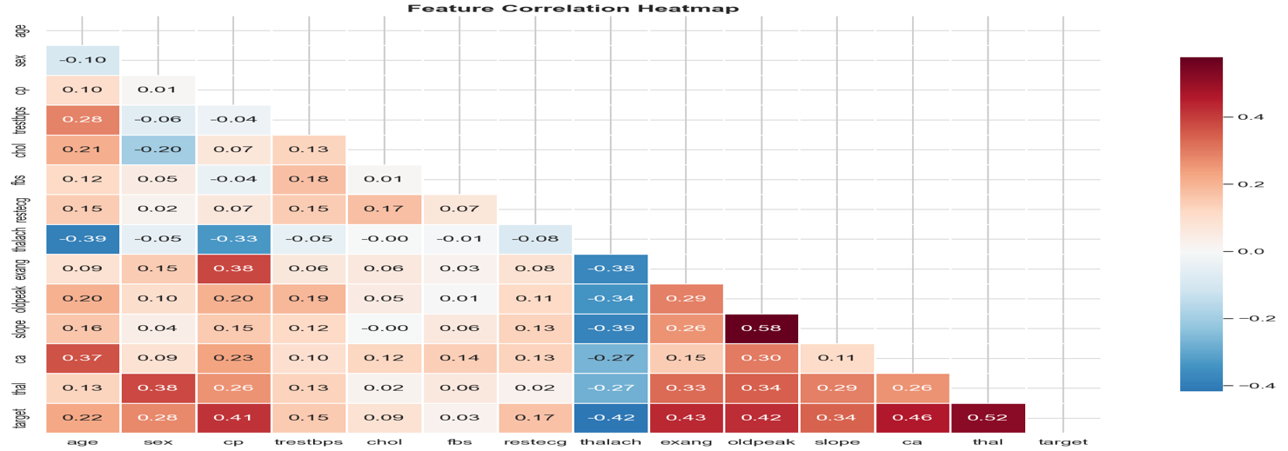

Histograms per feature — numeric feature distributions faceted by disease status; disease patients skew older with lower max heart rates.
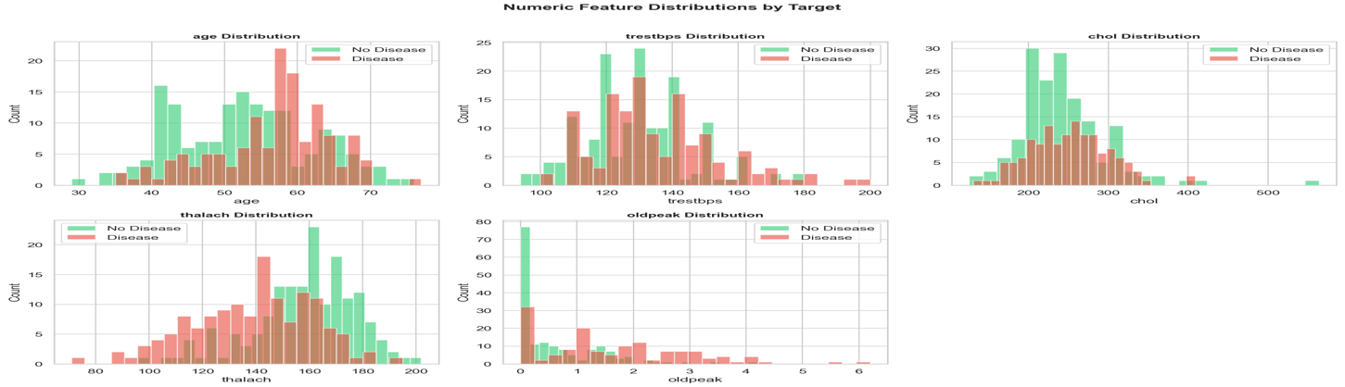

Box plots — oldpeak and thalach show clear separation between classes.
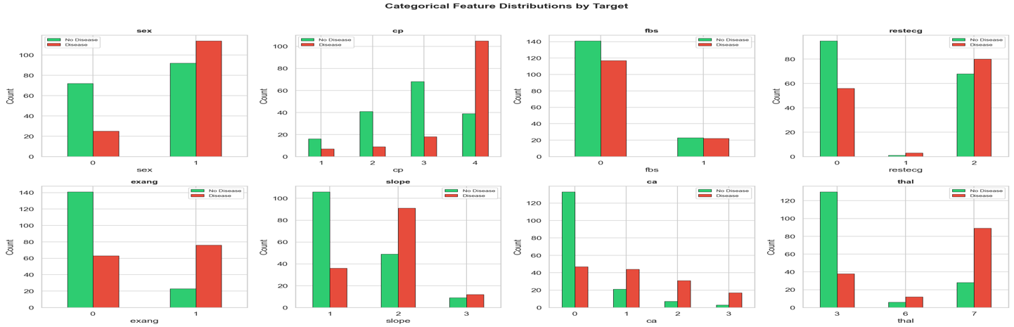
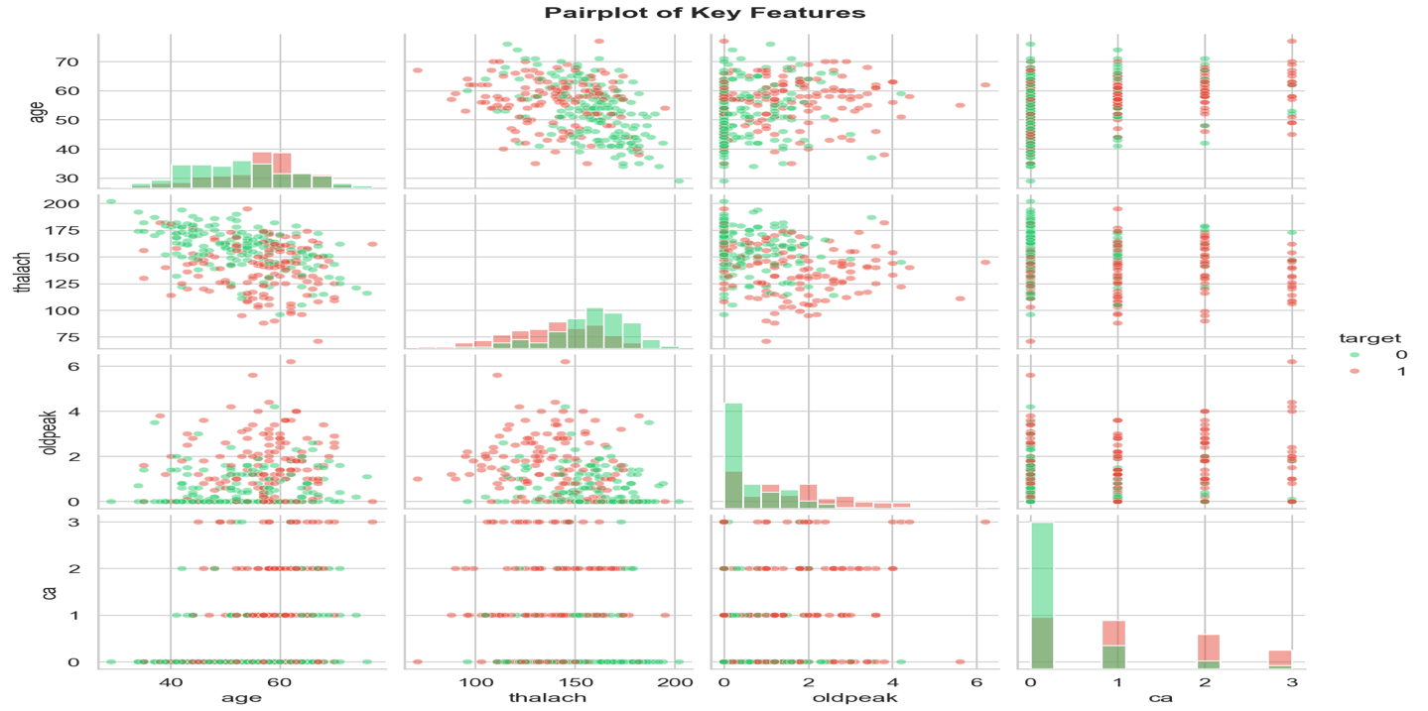

4. Feature Engineering & Model Development

Preprocessing pipeline (src/data_prep/preprocess.py)
A ColumnTransformer packed inside an sklearn Pipeline:
- Numeric (age, trestbps, chol, thalach, oldpeak) → StandardScaler
- Binary (sex, fbs, exang) → passthrough
- Categorical (cp, restecg, slope, ca, thal) → OneHotEncoder(handle_unknown="ignore")
The same pipeline is used at training and inference, so the served model accepts raw feature values.

Models (src/training/train.py)
Model | Hyperparameter grid
Logistic Regression | C ∈ {0.01, 0.1, 1.0, 10.0}
Random Forest | n_estimators ∈ {50, 100, 200}, max_depth ∈ {5, 10, None}, min_samples_split ∈ {2, 5}
Both are tuned with GridSearchCV(scoring="roc_auc") over a 5-fold StratifiedKFold, then re-evaluated with cross_validate across the full metric set.

Cross-validation results
Metric | Logistic Regression | Random Forest
Accuracy | 0.8580 | 0.8415
Precision | 0.8874 | 0.8716
Recall | 0.7905 | 0.7690
F1 | 0.8343 | 0.8155
ROC-AUC | 0.9192 | 0.9186
Selected: Logistic Regression (C = 1.0). Marginally higher CV ROC-AUC, smaller train/CV gap, faster inference, and easier to explain to a clinician than a forest.

Model selection rationale
Both models achieve strong CV ROC-AUC (>0.91). Logistic Regression was chosen because:
- Comparable performance — only 0.0006 ROC-AUC difference; not statistically significant.
- Lower variance — smaller gap between train and CV metrics, suggesting better generalisation.
- Interpretability — coefficients directly map to feature importance, critical in a clinical setting.
- Inference speed — single matrix multiply vs ensemble of trees; important for low-latency serving.

5. Experiment Tracking
MLflow is wired into train.py. Each model gets its own run logging:
- Params — model type, best hyperparameters, CV folds
- Metrics — accuracy, precision, recall, F1, ROC-AUC for both train set and CV (mean + std)
- Artifacts — confusion matrix PNG, ROC curve PNG, the serialized sklearn model
View experiments locally:
mlflow ui --port 5001
View on Kubernetes (after ./scripts/deploy.sh):
Open http://localhost:5001 — the mlops-tracking namespace runs ghcr.io/mlflow/mlflow:v3.11.1-full on port 5000 internally, exposed as 5001 to avoid the macOS AirPlay conflict.

Experiment tracking summary
Run | Model | Best Params | CV ROC-AUC | CV Accuracy | CV F1
1 | Logistic Regression | C=1.0 | 0.9192 | 0.8580 | 0.8343
2 | Random Forest | n_estimators=100, max_depth=None, min_samples_split=2 | 0.9186 | 0.8415 | 0.8155
Artifacts logged per run: confusion matrix (PNG), ROC curve (PNG), serialized sklearn pipeline (joblib), and metrics JSON.
MLflow — Experiment Runs
MLflow — Experiment Runs
MLflow — Metrics Comparison
MLflow — Metrics Comparison

6. Model Packaging & Reproducibility
- Artifact: model/heart_disease_model.joblib — the entire Pipeline (preprocessor + classifier), so inference doesn’t need a separate transform step.
- Metrics summary: model/metrics.json — best model, best params, CV and train metrics.
- Pinned dependencies: requirements.txt.
- Determinism: random_state = 42 everywhere; cleaning is deterministic given the source file.
python3 -m venv venv && source venv/bin/activate
pip install -r requirements.txt
python dataprocessing/process_data.py
python -m src.training.train

7. CI/CD Pipeline & Automated Testing

Tests (17 total)
- tests/test_data.py — 8 tests on the processed dataset: existence, shape, no nulls, columns, target binary, feature ranges, dtypes, class balance.
- tests/test_model.py — 9 tests on the trained model: file exists, loads, has predict/predict_proba, prediction shape and binary output, probabilities sum to 1, accuracy ≥ 0.75, batch prediction.

GitHub Actions (.github/workflows/ci.yml)
Three jobs, with sane gating:
ci — runs on every push, PR, or workflow_dispatch:
- Lint (ruff)
- Process data (download + clean)
- Data tests (8)
- Train models (GridSearchCV + MLflow)
- Model tests (9)
- Upload artifacts: test results (JUnit XML), trained model, MLflow runs
The data tests must pass before training, and the model tests must pass after — which catches silent breakage in either layer.
cd — runs after ci on push to main (skippable via skip_cd input):
- Pull the trained model artifact
- Build the Docker image
- Container smoke test — runs the image, hits /health and /predict. Failing here blocks the push.
- Tag and push to ghcr.io (gated by push_to_registry input)
- If invoked locally via act, deploy to Docker Desktop K8s
undeploy — only runs when action=undeploy is selected. Tears the stack down via act (no-op on the GitHub runner, since it can’t reach your local cluster).

Manual triggers
Input | Values | Effect
action | deploy / undeploy | Deploy stack (default) or tear it down
skip_cd | false / true | Run only the ci job
push_to_registry | false / true | Push image to ghcr.io (auto-true on push to main)

Local execution with act
brew install act
# CI only — no Kubernetes interaction
act -j ci
# Anything that touches K8s — wrapper mounts ~/.kube into the act container
./scripts/act-local.sh push
./scripts/act-local.sh workflow_dispatch -j undeploy --input action=undeploy
The cd and undeploy jobs install Linux kubectl inside the container and call k8s/act-kubeconfig.sh, which patches the kubeconfig to reach Docker Desktop’s K8s API through host.docker.internal with --insecure-skip-tls-verify. The wrapper exists because act does not expand environment variables in .actrc, so the kube mount path can’t be made portable there.

CI/CD workflow screenshots
GitHub Actions — CI job passing
GitHub Actions — CI job passing
GitHub Actions — CD job with container smoke test
GitHub Actions — CD job with container smoke test

8. Containerization
src/serving/app.py (FastAPI) exposes:
Method | Path | Purpose
GET | / | Liveness
GET | /health | Readiness probe
POST | /predict | Prediction (JSON in/out, Pydantic-validated)
GET | /metrics | Prometheus metrics
GET | /docs | Swagger UI
Dockerfile is a two-stage build on python:3.12-slim: dependencies in stage 1, runtime image in stage 2 with non-root appuser, HEALTHCHECK, and port 8080 exposed.
docker build -t heart-disease-api .
docker run -p 8080:8080 heart-disease-api
curl -X POST http://localhost:8080/predict \
-H "Content-Type: application/json" \
-d '{"age":63,"sex":1,"cp":3,"trestbps":145,"chol":233,"fbs":1,"restecg":0,"thalach":150,"exang":0,"oldpeak":2.3,"slope":0,"ca":0,"thal":6}'
Sample prediction response:
{
"prediction": 1,
"confidence": 0.8421,
"disease_probability": 0.8421
}
The /predict endpoint accepts JSON input matching the 13 features, validates via Pydantic, and returns the prediction (0/1), confidence, and disease probability.
Docker — Container build & run
Docker — Container build & run

9. Production Deployment
Deployed to Docker Desktop’s built-in Kubernetes across three namespaces.
Namespace | Components | Notes
mlops-app | Deployment (2 replicas) + Service + Ingress | Probes, resource limits, imagePullPolicy: Never
mlops-tracking | MLflow Deployment + Service | Official ghcr.io/mlflow/mlflow:v3.11.1-full image, SQLite backend, single worker, 1.5 GiB limit
mlops-monitoring | Prometheus + Grafana Deployments + Services | Cross-namespace scraping; Grafana auto-provisioned via ConfigMaps
Manifests (k8s/): namespaces.yaml, deployment.yaml, service.yaml, ingress.yaml, mlflow.yaml, prometheus.yaml, grafana.yaml.
One-shot deploy:
./scripts/deploy.sh
Endpoint | URL
API | http://localhost:8080
API (Ingress, optional) | http://heart-disease.local
MLflow UI | http://localhost:5001
Prometheus | http://localhost:9090
Grafana | http://localhost:3000 (admin / admin)
Tear down:
./scripts/undeploy.sh # delete the three namespaces
./scripts/undeploy.sh --all # also remove the local heart-disease-api Docker image

Deployment verification
After ./scripts/deploy.sh completes, all pods are running:
NAMESPACE NAME READY STATUS RESTARTS
mlops-app heart-disease-api-xxx-yyy 1/1 Running 0
mlops-app heart-disease-api-xxx-zzz 1/1 Running 0
mlops-tracking mlflow-xxx-yyy 1/1 Running 0
mlops-monitoring prometheus-xxx-yyy 1/1 Running 0
mlops-monitoring grafana-xxx-yyy 1/1 Running 0
Endpoints are verified with curl:
curl http://localhost:8080/health # {"status":"healthy","model_loaded":true}
curl http://localhost:5001 # MLflow UI accessible
curl http://localhost:9090/targets # Prometheus shows heart-disease-api target UP
curl http://localhost:3000 # Grafana dashboard loads
K8s — Pods running across namespaces
K8s — Pods running across namespaces
K8s — API health check
K8s — API health check
K8s — Ingress configuration
K8s — Ingress configuration

10. Monitoring & Logging

Structured request logs
Every prediction emits a single JSON line on stdout:
{"event":"prediction","input":{...},"prediction":1,"disease_probability":0.84,"confidence":0.84,"latency_ms":3.21}
Picked up by kubectl logs and any log shipper.

Prometheus (pull model)
prometheus-fastapi-instrumentator adds /metrics to the FastAPI app. Prometheus scrapes it every 15 seconds at:
heart-disease-api.mlops-app.svc.cluster.local:8080/metrics
Standard metrics exposed: http_requests_total, http_request_duration_seconds, http_requests_in_progress.

Grafana (auto-provisioned)
Defined in k8s/grafana.yaml via three ConfigMaps:
- Datasource — Prometheus at the in-cluster service URL, marked default.
- Dashboard provider — file provisioner pointing at /var/lib/grafana/dashboards.
- Dashboard — “Heart Disease API Monitoring” with six panels: request rate, latency p50/p95/p99, requests by status, error rate, health status, in-flight requests.
After ./scripts/deploy.sh, open http://localhost:3000 (admin/admin) — the dashboard is already there.
Prometheus — Targets UP
Prometheus — Targets UP
Grafana — Heart Disease API Monitoring Dashboard
Grafana — Heart Disease API Monitoring Dashboard

11. Screenshots & Evidence
All screenshots are stored in the screenshots/ folder. Below is the index for quick reference:
Screenshot | Description | Report Section
mlflow_experiment_runs.png | MLflow UI showing experiment runs | §5 Experiment Tracking
mlflow_metrics_comparison.png | Side-by-side metric comparison in MLflow | §5 Experiment Tracking
ci_pipeline_passing.png | GitHub Actions CI job (lint, test, train) | §7 CI/CD
cd_pipeline_smoke_test.png | GitHub Actions CD job (Docker build + smoke test) | §7 CI/CD
docker_build_run.png | Docker image build and local container run | §8 Containerization
k8s_pods_running.png | kubectl get pods across all namespaces | §9 Deployment
k8s_api_health.png | curl health check on deployed API | §9 Deployment
k8s_ingress.png | Ingress resource configuration | §9 Deployment
prometheus_targets.png | Prometheus targets page showing API UP | §10 Monitoring
grafana_dashboard.png | Grafana dashboard with six monitoring panels | §10 Monitoring

12. Conclusion
The pipeline covers the full lifecycle end to end:
- Deterministic data processing with download + cleaning
- Two models compared with cross-validation; Logistic Regression selected
- MLflow tracking of params, metrics, and plots for every run
- 17 unit tests gating CI; container smoke test gating CD
- Multi-stage Docker image, non-root, healthchecked
- Kubernetes deployment across three namespaces with auto-provisioned monitoring
- The whole CI/CD workflow is runnable locally with act (including real K8s deploy and undeploy)

