Front-End UI Visual Thesis
Eratex Planning & Scheduling Tool
Handoff document for UI engineering, product design, and implementation planning.
Company | Eratex
Source | Eratex Planning Scheduling Tool BRD, Version 1.0
Document purpose | Translate BRD surfaces into front-end information architecture, UI patterns, mockups, states, and build priorities.
Audience | Front-end UI development team, product owner, UX designer, QA lead
Date | 2026-05-26
Status | Professional handoff draft

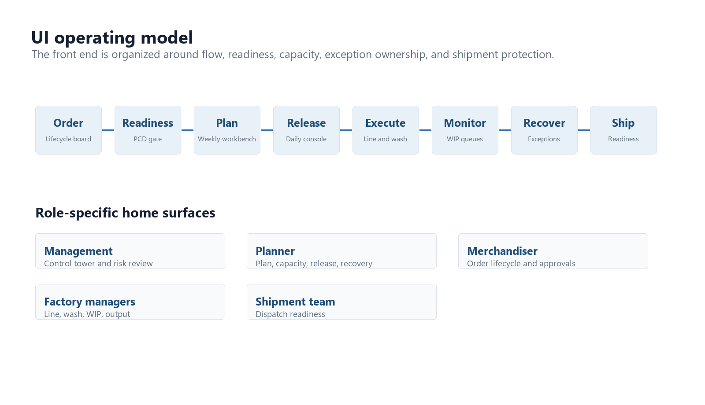
Figure 1 - UI operating model derived from the BRD.

1. Visual Thesis
Visual thesis: The product should feel like a factory control room: dense, calm, precise, and action-oriented, with risk signals visible without turning the interface into an alarm wall.

Interaction thesis
- Users should move from risk detection to owner assignment to recovery action without leaving the current screen.
- Planning tables and timelines should keep context stable through frozen columns, sticky headers, and detail drawers.
- Color must communicate status, but every risk signal also needs text, owner, due date, and next action.

Front-end design posture
- Use a restrained operational UI: left navigation, persistent filters, dense data tables, heatmaps, timelines, and drawers.
- Avoid marketing-style dashboards. The first screen for each role should expose actual work, blockers, and decisions.
- Use compact panels only when they frame an interaction, not as decoration. Data density is acceptable when hierarchy is clear.
- Treat exceptions, readiness gates, and plan changes as first-class workflows, not as comments on records.

2. Information Architecture
The application shell should organize the planning workflow around the factory flow: order visibility, readiness, weekly planning, daily release, capacity, execution, WIP, exceptions, and shipment readiness.
Navigation group | Representative screens
Control | Executive Control Tower, role-based home surfaces, business success metrics
Order visibility | Order Lifecycle Board, customer/order detail drawer, stage history
Readiness | PCD Readiness Gate, blocker ownership, conditional release approval
Planning | Weekly Planning Workbench, Gantt planning, plan change approval
Execution release | Daily Production Release, shopfloor update, department handover
Capacity | Workcenter Load Monitor, Sewing Line Loading, Wash Planning
Flow monitoring | WIP and Queue Monitoring, exception creation from aged WIP
Recovery | Exception and Alert Center, rework and recovery surface, what-if simulation
Dispatch | Shipment Readiness, shipment calendar, split shipment approval
Data foundation | Style master, BOM, vendor follow-up, fabric QC, master data governance

Role-to-screen ownership
Role | Primary surfaces
Management | Control Tower, exceptions, shipment risk, utilization, performance analytics
Production planner | Weekly plan, daily release, workcenter load, recovery planning, plan changes
Merchandiser | Order lifecycle, sampling approvals, buyer comments, shipment risk context
Procurement | Material status, vendor ETA, shortage alerts, PCD blockers
Fabric QC | Fabric inward, inspection, shade lot, pass/fail/hold clearance
Cutting manager | PCD gate, cutting plan, ready-to-cut release, cut output
Sewing manager | Line loading, daily output, line WIP, underperformance
Washing manager | Wash route, batch board, capacity, rewash reserve
Shipment team | Shipment readiness, documents, booking, split shipment decisions
Shopfloor supervisor | Daily task update, output, defects, shortages, handovers

3. Product UI System

Shell and layout
- Use a persistent left navigation with module names matching factory language.
- Use a top bar for factory context, week/date range, plan version, and sync status.
- Place global filters above work surfaces: buyer, order, style, workcenter, week, risk, owner.
- Open record details in right drawers so users retain table or timeline context.

Status language
Status | UI treatment and behavior
Ready / Green | Subtle green chip. Action is allowed, but details remain inspectable.
Conditional / Yellow | Amber chip. Action requires owner, reason, due date, and risk note.
Blocked / Red | Red chip. Release and freeze actions disabled until blocker is resolved or override is approved.
Black / Critical | Dark chip. Management escalation and audit log required.
Stale data | Muted badge with timestamp and source. Do not let stale data look safe.

Reusable front-end components
- Data grid with sticky header, frozen identity columns, row actions, column-level filters, and saved views.
- Timeline/Gantt lane with conflict overlays, frozen-zone indicators, and drag/edit impact preview.
- Readiness checklist with pass/fail/conditional states, owner assignment, and approval workflow.
- Capacity heatmap with keyboard-focusable cells, tooltips, and click-to-filter interactions.
- Exception drawer with owner, due date, suggested action, activity log, and closure evidence.
- Mobile task form with offline queue, local validation, sync status, and rejected-update retry path.

4. MVP Screen Blueprints
Each screen below includes a visual target and the front-end handoff contract needed to build the first implementation without losing the operating intent of the BRD.

4.1 Executive Control Tower
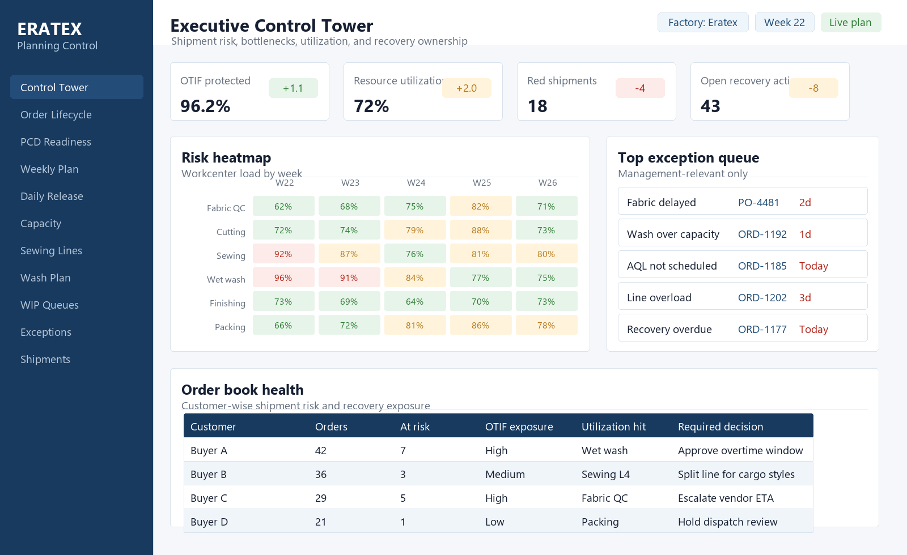
Figure 2 - Executive Control Tower visual composition.
Primary users | Management, head planner
Purpose | Show factory-wide risk, bottlenecks, OTIF exposure, and recovery ownership.
Core data inputs | Order book, capacity, WIP, exceptions, shipment readiness, recovery cost.
Primary interactions | Filter by week/customer/workcenter; drill into exception; create or approve recovery action.
Required states | Fresh, stale, no-risk, high-risk, integration unavailable.
Front-end handoff notes | Use aggregate APIs with cached summaries; preserve drill-down links to the underlying order and exception records.

4.2 Order Lifecycle Board
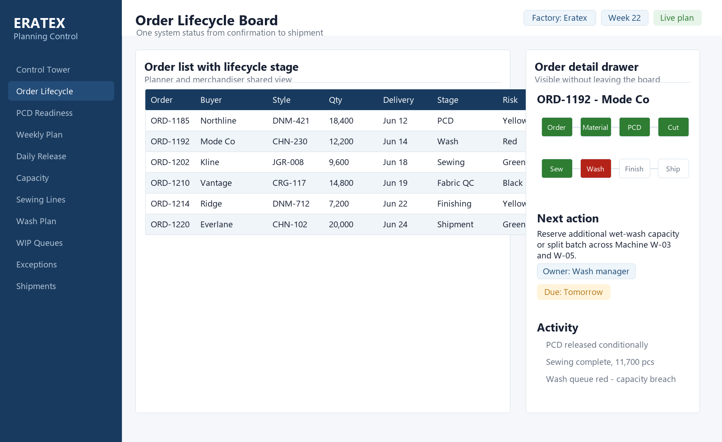
Figure 3 - Order Lifecycle Board visual composition.
Primary users | Planner, merchandiser, production planner
Purpose | Give every order a single lifecycle status and next action.
Core data inputs | Order master, planned/actual dates, stage owner, dependencies, risk, comments.
Primary interactions | Search, filter, open detail drawer, update next action, hand off to linked surfaces.
Required states | No orders, partial ERP sync, delayed stage, blocked stage, archived order.
Front-end handoff notes | Board must support high row counts through virtualization and stable row height.

4.3 PCD Readiness Gate
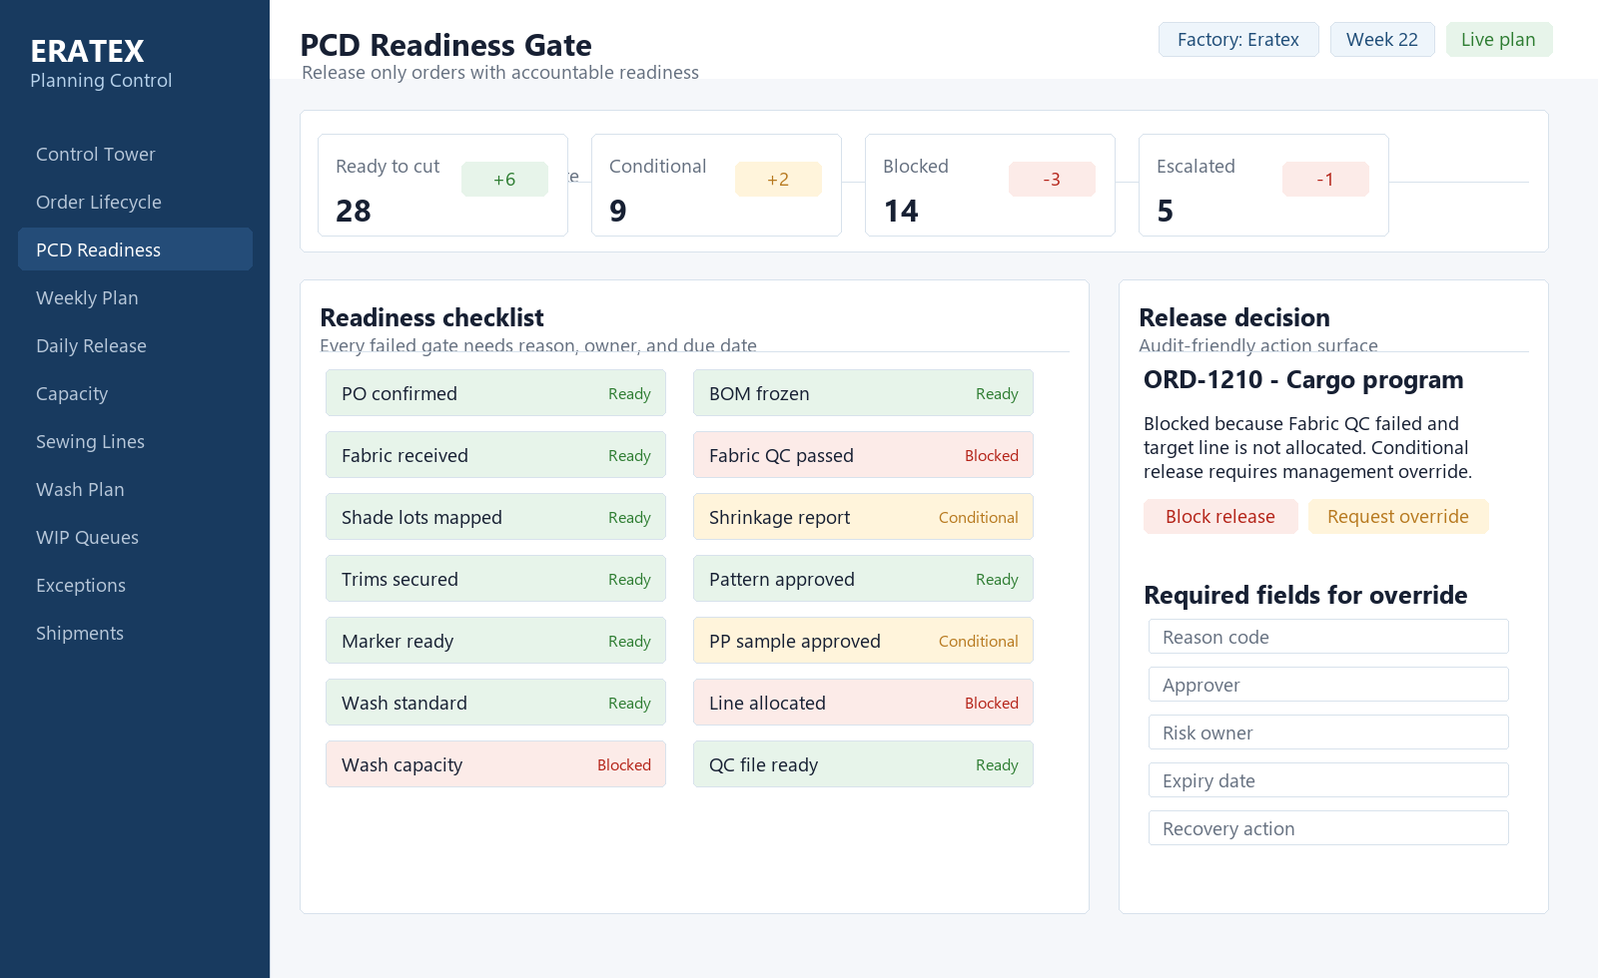
Figure 4 - PCD Readiness Gate visual composition.
Primary users | Planner, cutting manager, fabric QC, merchandiser
Purpose | Prevent cutting release without visible readiness and owner accountability.
Core data inputs | PO, BOM, fabric QC, trims, pattern, marker, PP sample, wash standard, line allocation.
Primary interactions | Approve ready release, block release, request conditional release, assign blocker owner.
Required states | Ready, conditional, blocked, escalated, override expired.
Front-end handoff notes | Every conditional release needs audit trail fields and immutable approval metadata.

4.4 Weekly Planning Workbench
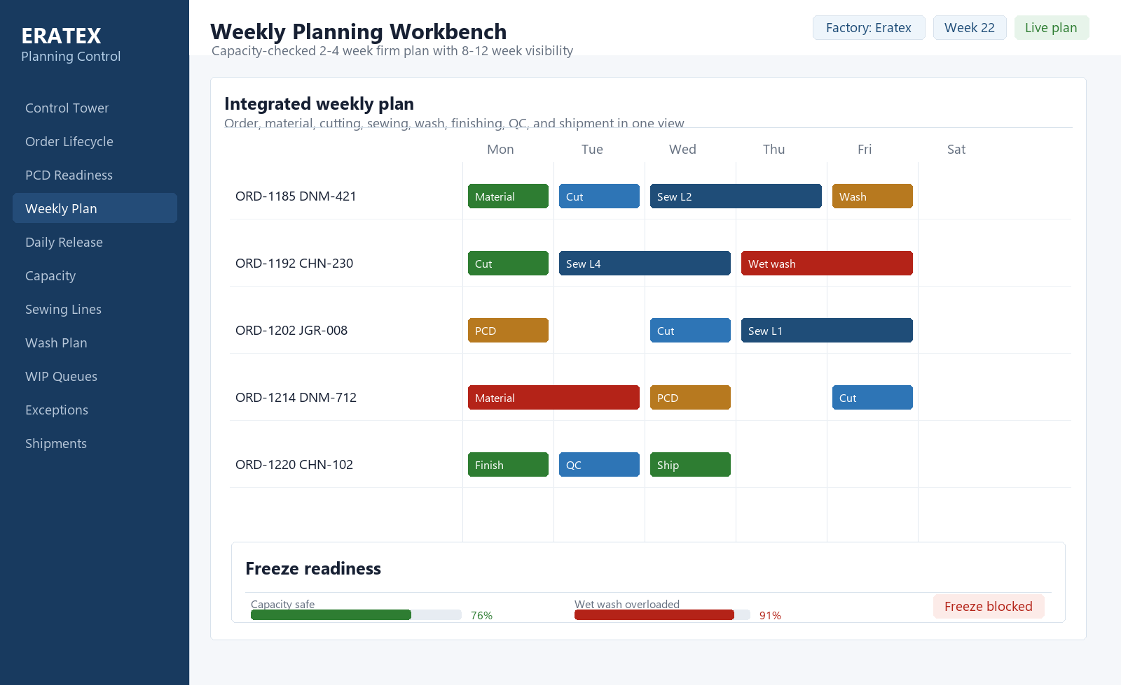
Figure 5 - Weekly Planning Workbench visual composition.
Primary users | Production planner, factory managers
Purpose | Convert order book into a capacity-checked weekly coordination contract.
Core data inputs | Orders, workcenter calendars, capacity, material readiness, shipment dates, line load.
Primary interactions | Drag schedule bars, freeze plan, inspect impact, resolve conflicts, compare versions.
Required states | Draft, frozen, change pending, conflict, overload, stale capacity.
Front-end handoff notes | Use a timeline component with sticky rows, left frozen columns, and conflict overlays.

4.5 Daily Production Release
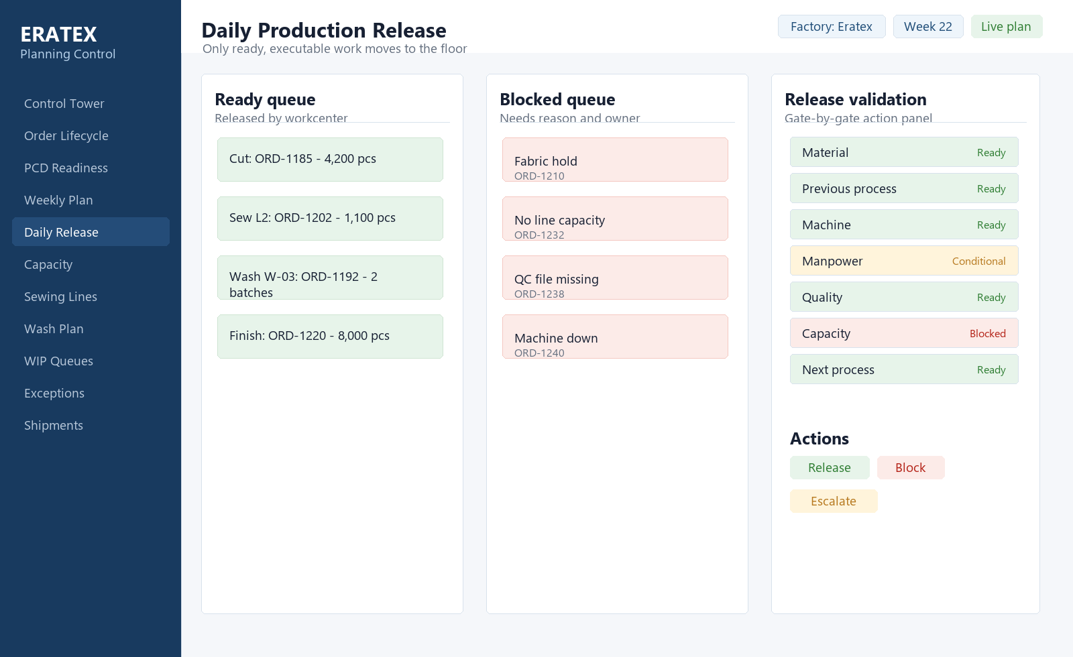
Figure 6 - Daily Production Release visual composition.
Primary users | Planner, department managers, shopfloor supervisors
Purpose | Release only work that is ready and executable today.
Core data inputs | Weekly plan, readiness gates, previous process completion, manpower, machine availability, QC clearance.
Primary interactions | Release, block, escalate, add reason code, view release history.
Required states | Ready queue, blocked queue, conditional approval, offline update, duplicate release.
Front-end handoff notes | All action buttons must be disabled until validations and required reason fields are satisfied.

4.6 Workcenter Load Monitor
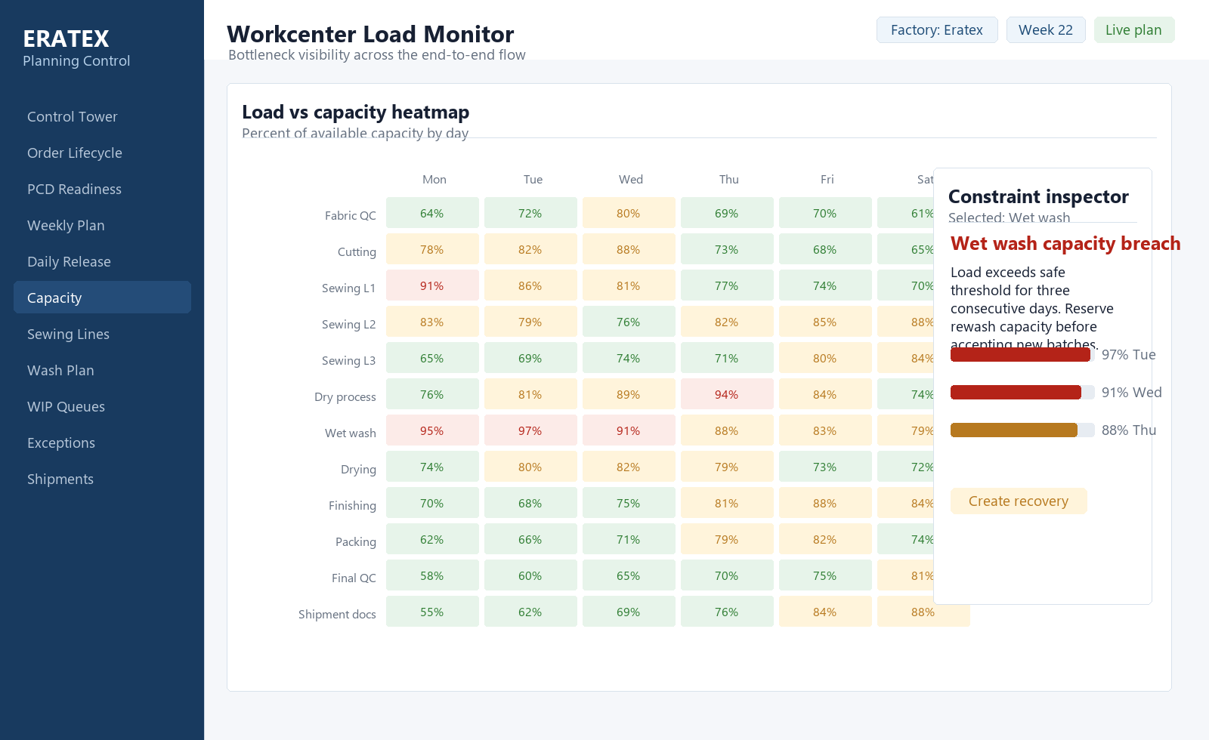
Figure 7 - Workcenter Load Monitor visual composition.
Primary users | Planner, production managers, management
Purpose | Expose shifting bottlenecks before they become shipment risk.
Core data inputs | Capacity by workcenter, planned load, WIP, queue age, throughput, recovery flags.
Primary interactions | Change date range, inspect cell, create recovery, compare available vs planned.
Required states | Normal, warning, overload, missing capacity calendar, stale actuals.
Front-end handoff notes | Heatmap cells need keyboard focus, tooltips, and click-to-filter behavior.

4.7 Sewing Line Loading
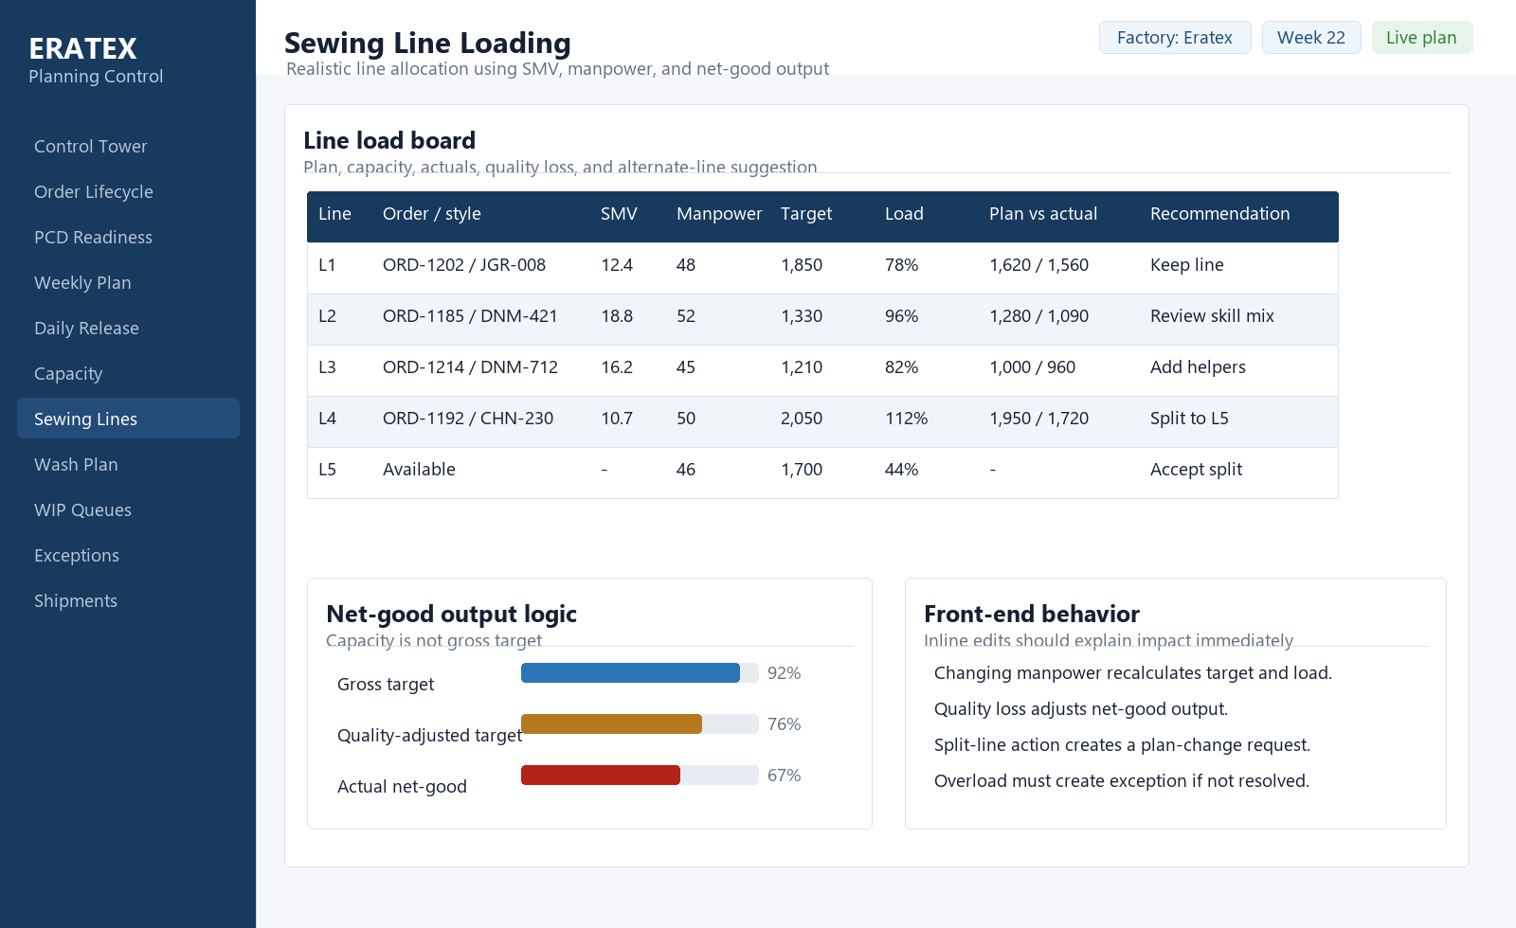
Figure 8 - Sewing Line Loading visual composition.
Primary users | Sewing manager, planner
Purpose | Allocate orders to sewing lines using realistic net-good capacity.
Core data inputs | SMV, manpower, machine availability, skill level, absenteeism, efficiency, quality loss.
Primary interactions | Assign line, split order, edit manpower, compare plan vs actual, create line overload exception.
Required states | Underloaded, overloaded, actuals delayed, quality loss high, skill mismatch.
Front-end handoff notes | Calculations should be shared between UI and backend or returned by a planning-calculation API.

4.8 Wash Planning Surface
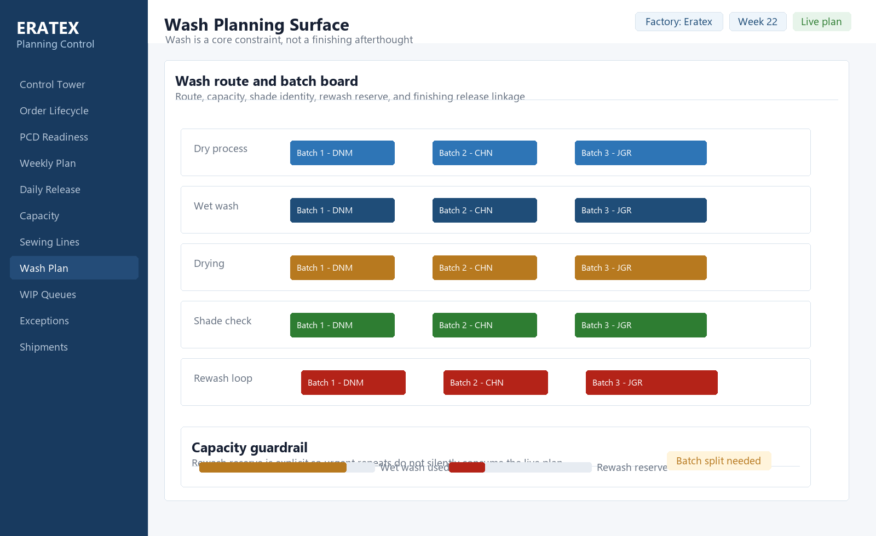
Figure 9 - Wash Planning Surface visual composition.
Primary users | Washing manager, planner
Purpose | Plan dry process, wet wash, rewash, and batch capacity as hard constraints.
Core data inputs | Wash route, batch size, machine capacity, shade lot, recipe, rewash requirement, finishing release.
Primary interactions | Create batch, sequence route, reserve rewash capacity, approve release to finishing.
Required states | Batch queued, in process, hold, rewash, passed, capacity breach.
Front-end handoff notes | Route visualization must preserve shade-lot identity and show rewash as capacity-consuming work.

4.9 WIP and Queue Monitoring
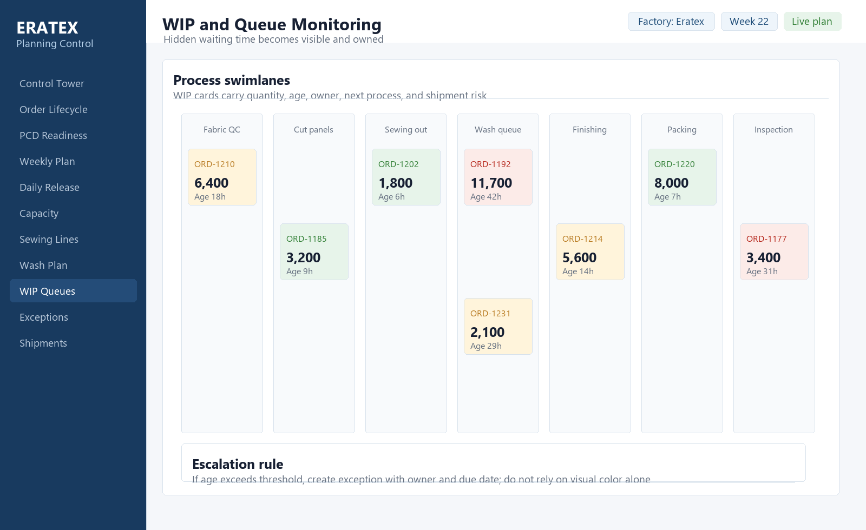
Figure 10 - WIP and Queue Monitoring visual composition.
Primary users | Planner, department managers, supervisors
Purpose | Surface hidden waiting time between processes.
Core data inputs | Stage inventory, quantity, queue age, owner, next process, hold reason, shipment risk.
Primary interactions | Filter by age, owner, stage, shipment risk; escalate WIP; confirm handover.
Required states | Normal age, threshold breach, quality hold, missing handover, owner unassigned.
Front-end handoff notes | Use lane virtualization if the board grows; card density should remain stable across zoom levels.

4.10 Exception and Alert Center
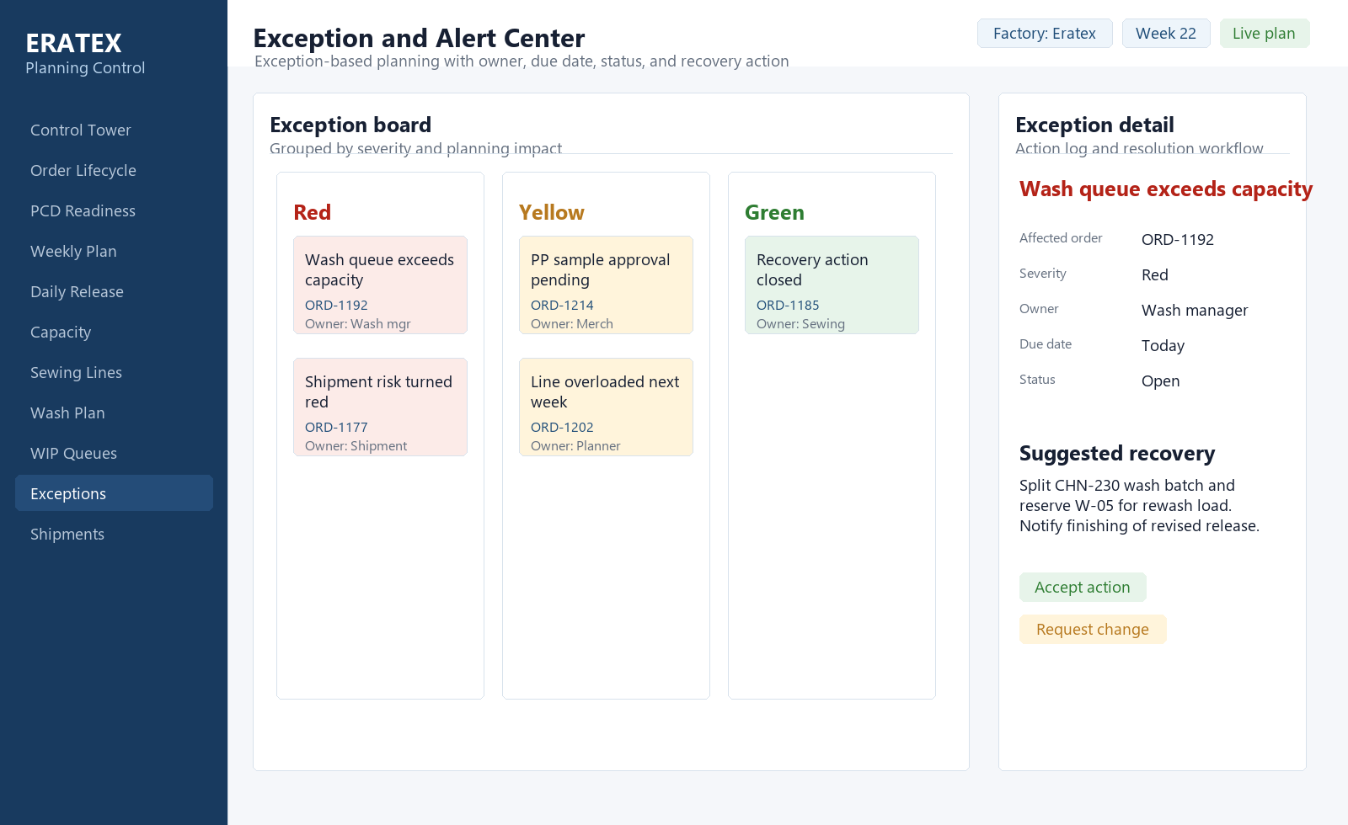
Figure 11 - Exception and Alert Center visual composition.
Primary users | Planner, management, functional owners
Purpose | Turn informal issues into structured recovery work.
Core data inputs | Exception type, affected order, severity, owner, due date, suggested action, status, escalation level.
Primary interactions | Accept action, request change, assign owner, close, escalate, view history.
Required states | Open, in progress, blocked, overdue, closed, reopened.
Front-end handoff notes | Alerts must be deduplicated; same issue should not spawn multiple competing tickets.

4.11 Shipment Readiness
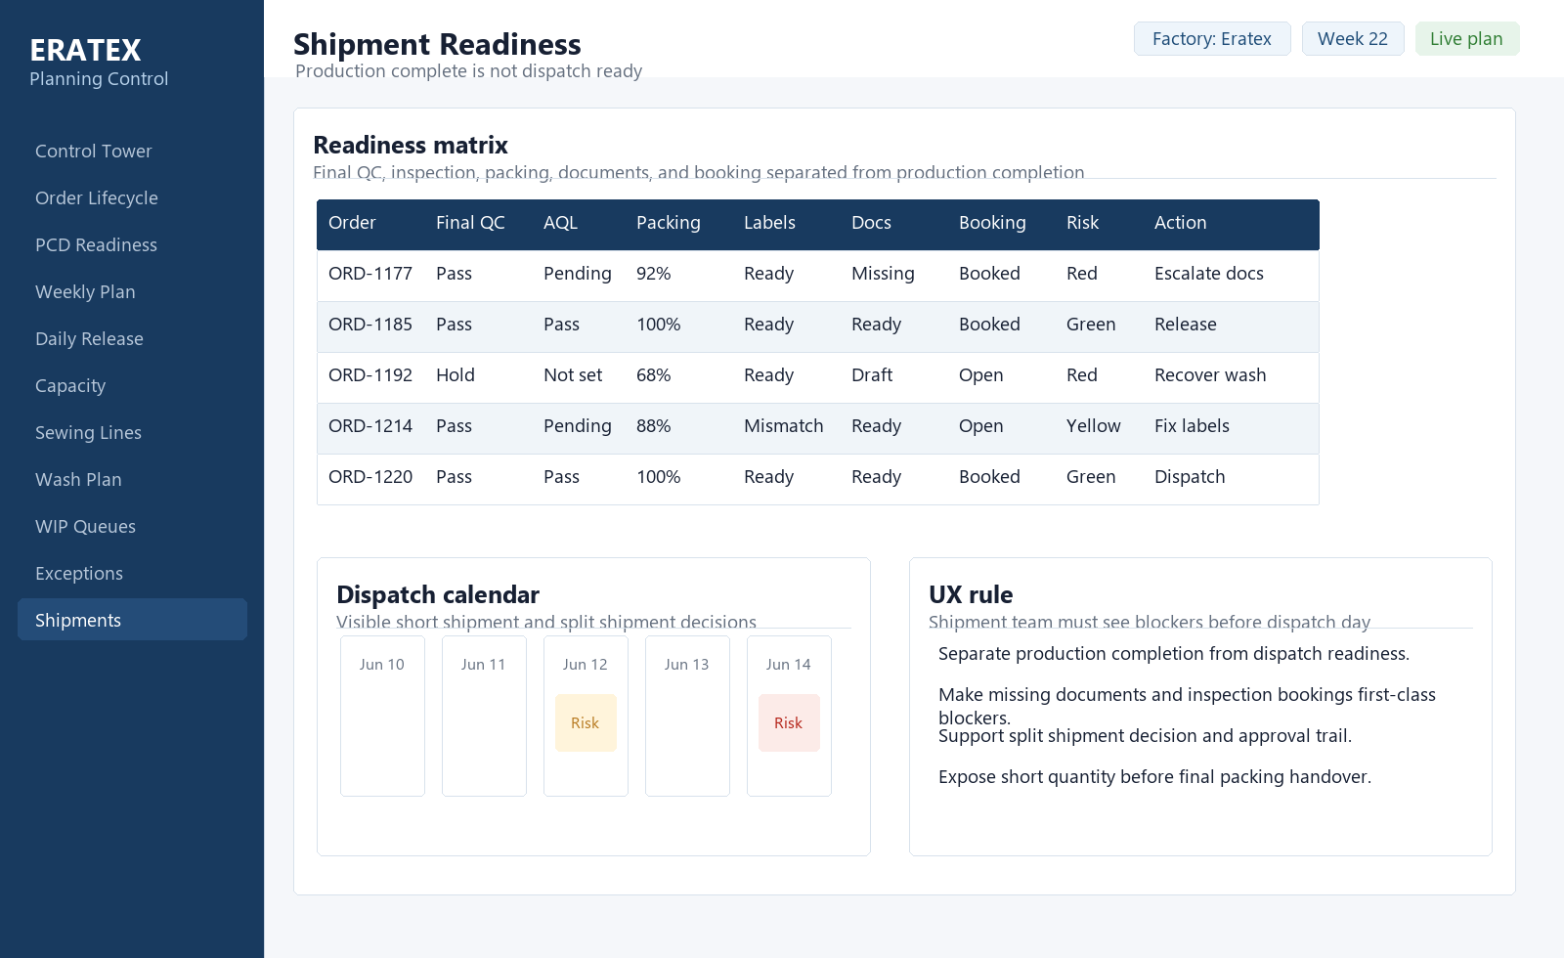
Figure 12 - Shipment Readiness visual composition.
Primary users | Shipment team, QC manager, planner
Purpose | Separate production completion from dispatch readiness.
Core data inputs | Final QC, AQL, packing, barcode/label, documents, forwarder booking, short quantity.
Primary interactions | Confirm readiness, escalate blocker, approve split shipment, release dispatch.
Required states | Ready, missing docs, AQL pending, label mismatch, booking open, short shipment.
Front-end handoff notes | Completion percent is not enough; show the exact blocker and responsible function.

4.12 Shopfloor Update Surface
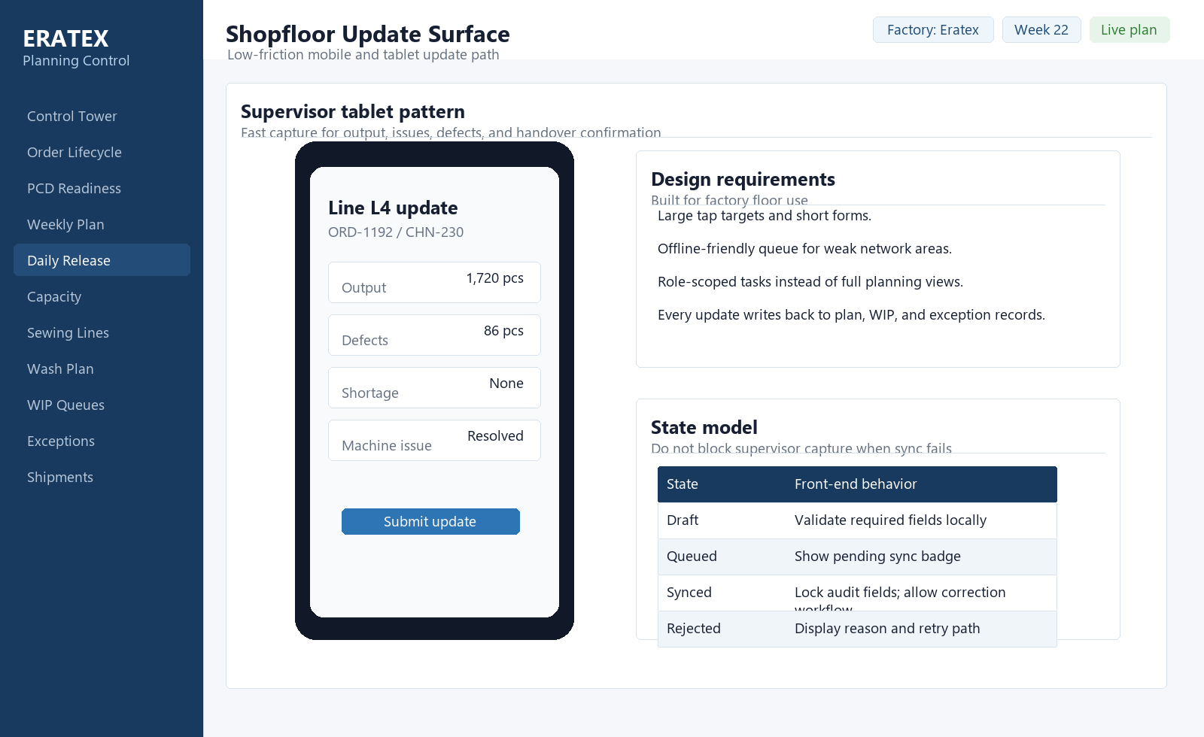
Figure 13 - Shopfloor Update Surface visual composition.
Primary users | Shopfloor supervisor, department managers
Purpose | Capture actuals and issues with minimum friction from tablet or mobile.
Core data inputs | Released work, output, defects, shortages, machine issues, handover confirmations.
Primary interactions | Submit update, queue offline, attach issue, confirm handover, correct rejected update.
Required states | Draft, queued, synced, rejected, duplicate, offline.
Front-end handoff notes | Mobile should be task-scoped and resilient to sync failure; avoid exposing full planning controls.

5. Front-End Delivery Priorities

MVP implementation sequence
Phase | Front-end scope
1. Foundation shell | Navigation, global filters, status chips, data grid, drawer framework, role-aware routing.
2. Planning core | Order Lifecycle, PCD Readiness, Weekly Planning, Daily Release.
3. Capacity core | Workcenter Load, Sewing Line Loading, Wash Planning.
4. Flow and recovery | WIP Queues, Exception Center, recovery action workflow.
5. Dispatch protection | Shipment Readiness, shipment blocker escalation, split shipment tracking.
6. Shopfloor capture | Mobile/tablet update path with offline queue and sync feedback.

Acceptance criteria for the front end
- A planner can identify the highest shipment risk, root blocker, owner, and next action in under one minute.
- A blocked order cannot be released from PCD or daily production without an explicit override path.
- A weekly plan cannot be frozen while unresolved workcenter overload or material blockers are present.
- Every critical exception has one owner, one due date, one current status, and a visible action history.
- Tables, heatmaps, timelines, and drawers remain usable with large order volumes and narrow laptop screens.
- Status color is never the only signal; all states have text labels and accessible names.

Responsive and accessibility requirements
- Desktop is primary for planning; tablet is primary for shopfloor update; mobile is limited to task capture and approvals.
- Keyboard navigation must work for grids, heatmap cells, filter controls, drawers, and action menus.
- Use WCAG-conscious contrast for status chips and never rely on red/green alone.
- Long tables need pagination or virtualization, but totals and selected filters must remain visible.
- All dates, quantities, statuses, and owner names should have deterministic formatting to avoid ambiguity.

6. Engineering Notes
Topic | Recommendation
State management | Use route-level state for filters and selected records so links can reproduce an operational view.
Data freshness | Show source and last-sync time on every planning-critical screen.
Authorization | Use role-based action permissions. Hidden actions are acceptable only if read-only users still understand why they cannot act.
Auditability | Plan changes, conditional releases, override approvals, and shipment splits require immutable audit metadata.
Performance | Use server-side filtering, pagination or virtualization, and summary endpoints for control tower metrics.
Design tokens | Centralize risk colors, spacing, table density, chip styles, and typography in a shared UI package.

