BUSINESS PROPOSAL
Flow Management and Transshipment Scheduling Control Tower
Prepared for PT Asian Bulk Logistics (ABL)
Prepared by Vector Consulting Indonesia as a delivery proposal for diagnostic, solution blueprinting, development, testing, training and handover of a constraint-aware scheduling platform for Berau Coal transshipment operations.
Proposal item | Detail
Primary source | ABL Flow Management and Transshipment Scheduling Proposal Context MD document.
Roadmap source | BerauABL Scheduling Platform PPTX, slides 5, 6 and 7.
Proposal purpose | Commit concrete delivery outputs while merging missing MD elements into the existing phase plan.
Date | 23 May 2026

Positioning. The proposed platform is a flow-management layer, not only a fleet tracker. It links Berau shipment commitments with ABL cargo readiness, port/BLC execution, barging, transshipment, survey and OGV departure.

PURPOSE AND BUSINESS CASE
1. Executive Proposal Summary
ABL's Berau operating reality is not a simple tug-and-barge scheduling problem. The operation sits at the intersection of shipment demand, coal quality and blending, stockpile readiness, port handling, BLC loading, tug-barge cycles, tide and bridge windows, CTS/floating crane capacity, OGV hatch/layering requirements, survey milestones and shipment closure.
Vector Consulting Indonesia proposes a Flow Management Scheduling Control Tower that converts Berau Coal's shipment commitments into an executable and continuously updated plan for ABL. The solution will combine planning, simulation, tracking, alerting and recovery workflows in a governed operating layer.
Delivery commitment | Output expected by ABL
Diagnostic | As-is process map, pain point validation, data inventory, constraint register and KPI baseline.
Solution blueprinting | To-be operating model, module scope, architecture, data model, release backlog and acceptance criteria.
Development | Incremental platform build across scheduling, simulation, live tracking, exception management and reporting.
Testing | Technical, integration, scenario, regression and UAT support with defect closure evidence.
Training | Role-based training, planner simulation workshops, administrator enablement and user materials.
Handover | Runbook, data dictionary, deployment notes, support transition, known limitations and acceptance closure.

BUSINESS CONTEXT
2. Operating Facts and Case for Change
The MD source frames ABL as an integrated logistics and infrastructure operator for Berau operations. ABL's scope extends beyond vessel movement into port management, coal processing/blending support, barging, transshipment, stevedoring and open-sea shipment support.
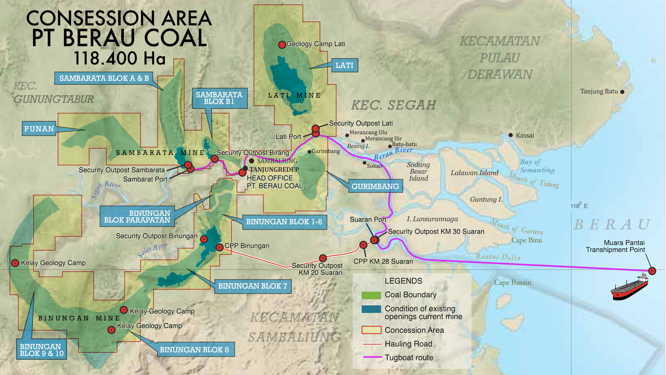
Berau corridor from mine/port sources through river route to transshipment point.
Fact | Scheduling implication
Port and blending scope | Cargo readiness and blend release must become planning constraints.
BLC gateway | BLC slot, loader rate, equipment uptime and survey availability must be visible in the plan.
Fleet and CTS scale | Planning must account for tug-barge pairing, route cycle, CTS capability and support assets.
Route variability | Near and far jetties require different cycle assumptions; generic asset availability will mislead planners.
Productivity gap | The main opportunity is reducing waiting and improving synchronization across control points.

CURRENT PAIN POINTS
3. Business Challenges to Address
The present process depends heavily on manual updates, Excel coordination and position visibility that does not fully explain operational state. The proposal must therefore address both planning feasibility and execution reliability.
- Demand volatility: Berau demand, production plans and source jetties change frequently, forcing repeated tug-barge allocation changes.
- Quality and blending dependency: A marine plan can fail if the required grade, blend recipe, sample status or quality release is not ready.
- Unequal cycle times: A nearby jetty can involve around 9 hours of sailing plus loading/unloading time, while the farthest jetty may be a 48-70 hour cycle.
- Environmental constraints: Low tide, bridge windows, river draft and grounding risk determine whether a movement is executable.
- Multiple waiting points: Waiting occurs at jetty, CTS, tide, bridge, OGV, survey, instruction and third-party asset checkpoints.
- AIS limitation: AIS confirms position, but not whether an asset is loading, waiting for release, under breakdown or available again.
- Charter lead time: Extra chartered tugs may take about one week to prepare, so recovery planning must track readiness and reliability.
FLOW MANAGEMENT CONTROL TOWER
4. Target Solution Concept
The system boundary should run from shipment demand through OGV departure. A shipment is complete only when the required hatch/layering plan is satisfied, quantity and quality are certified, survey documents are closed and the OGV is cleared to depart.
Planning layer | Required control content
Demand | OGV nomination, laycan, quantity, grade, customer priority and completion target.
Cargo readiness | Stockpile source, quality, moisture/rain impact, blend recipe, sample/release status and ready-to-load time.
Port and BLC | Jetty readiness, BLC loading slot, loader rate, equipment uptime and survey availability.
Tug-barge cycle | Pairing, loaded/empty route time, tide and bridge feasibility, queue, breakdown and return availability.
Transshipment | CTS/FTS/floating crane allocation by capacity, mode, sampler, detector, chute, blending capability and OGV requirement.
Closure | Hold inspection, draft survey, sampling, certificates, SOF, exception record and departure readiness.

Operating state discipline. The platform should separate planned, live/AIS, confirmed, inferred and recommended states. This keeps raw position data distinct from verified business status and avoids false certainty.

SOLUTION MODULES
5. Proposed Functional Scope
Module group | In-scope capability
Demand and shipping program | Capture OGV, laycan, quantity, grade, priority and hatch/layering requirement.
Cargo readiness and blending | Track stockpile, quality parameters, moisture, blend recipe, sample status, release status and blocked quantity.
Port and BLC scheduling | Plan BLC slots, jetty readiness, loader rate, port-side constraints and survey availability.
Tug-barge scheduling | Assign tug-barge combinations using true availability, route time, loaded/empty cycle and priority.
Constraint engine | Validate tide, bridge, route draft, weather and jetty constraints before confirming schedule.
CTS/transshipment scheduling | Allocate CTS/floating crane assets by availability, capability, OGV sequence and loading productivity.
AIS and business-state inference | Use GPS/AIS and geofence signals, then enrich them with manual confirmations and operational events.
Exception and recovery | Detect delay, missed tide, queue, breakdown, cargo-release delay and demurrage risk; support resequencing.
Shared control tower | Provide ABL, Berau and management views with role-based visibility, audit trail, KPIs and escalation.

MERGED WITH PPTX SLIDES 5-7
6. Product Roadmap
The roadmap below keeps the PPTX phase plan but adds the MD-driven elements needed to make the solution complete. Phases 1-3 establish the core platform. Phases 4-6 mature it into event-driven operations, optimization and multi-party control.
Phase 1: Collaborative Scheduling Architecture (Now to Month 3)
- Roadmap base: Master data for fleet, jetty, CTS, routes and grades; manual OGV demand and fleet availability input; tide/bridge calendar; feasible schedule board; conflict checklist.
- MD-driven additions: Cargo-readiness and blend-release fields, BLC/port slots, survey checkpoints, business-state event model and third-party asset readiness.
Phase 2: Simulation and Scenario Planning (Month 4-7)
- Roadmap base: What-if disruption engine, OGV completion projection, demurrage risk, asset utilization reports, version comparison and override audit trail.
- MD-driven additions: Hatch/layering sequence checks, closed-loop tug-barge availability, queue/wait reason buckets, cargo-release delays and recovery options by bottleneck.
Phase 3: GPS/AIS Live Tracking (Month 8-12)
- Roadmap base: Spinergie AIS/GPS ingestion, geofence events, planned-vs-actual ETA reconciliation, live map and automated delay alerts.
- MD-driven additions: Business-state inference, geofence-to-milestone rules, exception impact propagation and planner confirmation workflow.
Phase 4: IoT and Event-Driven Operations (Year 2 Q1)
- Roadmap base: Jetty loading and CTS discharge events via field devices; tide/bridge status via sensors or API; equipment health monitoring; event broker and local buffering.
- MD-driven additions: Trusted operational event log that replaces fragmented WhatsApp/status reporting and connects events to survey and closure milestones.
Phase 5: Optimization and Recovery AI (Year 2 Q2-Q3)
- Roadmap base: Assignment optimizer, trip sequencing under a multi-constraint solver, conflict auto-repair suggestions and recovery recommendation engine.
- MD-driven additions: Planner approval before auto-commit, with historical cycle data improving ETA, route, queue and readiness assumptions.

Phase 6: Multi-Party Control Tower (Year 2 Q4)
- Roadmap base: ABL dispatcher view, Berau cargo/OGV view, customer shipment portal, management KPI dashboard and alert escalation/SLA tracking.
- MD-driven additions: Shared governance across cargo, port, fleet, CTS, OGV, customer status, delay attribution and continuous improvement.
IMPLEMENTATION COMMITMENT
7. Delivery Model and Workstream Detail
Vector will run the work through controlled delivery workstreams with visible stage gates. Each gate creates a tangible artifact ABL can review, approve and use to control implementation risk.
Stage | Key deliverables
Diagnostic | Stakeholder interviews, as-is flow map, data/system inventory, pain point validation, constraint register and KPI baseline.
Blueprint | To-be operating model, business rules, screens/reports, data model, integration design, release backlog and acceptance criteria.
Development | Configured platform increments, workflows, dashboards, ingestion routines, role access, audit trail and reporting.
Testing | Test plan, scenario scripts, integration validation, UAT support, defect log, retest evidence and release acceptance pack.
Training | Role-based user sessions, planner simulations, administrator training, guides and attendance record.
Handover | Runbook, technical notes, data dictionary, issue/limitation register, roadmap backlog and support transition plan.

Testing focus
- Cargo not ready or quality release delayed.
- Missed tide or bridge window and grounding risk.
- Source jetty change after schedule publication.
- OGV delay, hatch/layering conflict or CTS allocation conflict.
- Tug, barge or CTS breakdown with recovery resequencing.
- Survey milestone blockage and document closure delay.
TRAINING AND TRANSITION
8. Adoption, Handover and Operating Ownership
The platform should not remain dependent on the build team after go-live. Training and handover will prepare ABL to operate the schedule, maintain master data, manage exceptions, validate feeds and control user access.
Area | Output
Role-based training | Dispatcher/planner, supervisor, Berau contributor/viewer, management and administrator sessions.
Planner workshops | Hands-on exercises for missed tide, cargo-release delay, OGV delay, CTS conflict and recovery comparison.
Operating runbook | Daily checks, schedule publication, exception triage, override approval, reporting cadence and escalation.
Technical handover | Deployment notes, configuration package, data dictionary, integration register template and support guide.
Final closure | Open issue register, known limitations, training record, acceptance form and support transition plan.

DECISION PATH
9. Assumptions, Success Measures and Next Step
Assumption | Implication
Stakeholder access | ABL will provide access to planners, dispatchers, port/BLC teams, fleet operations, transshipment users, IT and required Berau representatives.
Data availability | ABL will provide sample plans, master data, route/cycle assumptions, OGV schedules, tide/bridge calendars and relevant reports.
Integration access | Spinergie/AIS, OGV and environmental feeds depend on APIs, exports, credentials, approvals and data quality.
IoT scope | Field devices, sensors and marine hardware are later-phase scope unless separately approved.
Change control | Material scope, integration, geography, user-group or hardware changes will be handled through change control.

Success measures
- One shared Berau-ABL schedule view for demand, cargo, fleet, CTS and OGV execution.
- Reduced dependency on static Excel coordination for daily schedule changes.
- Clear visibility of blocked control point, waiting time, delay reason and responsibility bucket.
- Tide and bridge-aware movement planning with faster exception response.
- Better governance of hatch sequence, survey closure and OGV departure readiness.
Recommended next step. Approve the diagnostic and solution blueprinting stage, nominate stakeholders, confirm reference data access and schedule kickoff. Development scope and timing should be locked after the approved blueprint.
Immediate decision checklist
Decision item | What ABL should confirm
Stakeholder nominees | Named business, operations, IT and Berau-side participants for diagnostic and blueprint workshops.
Reference data package | Latest Excel schedules, asset masters, route assumptions, OGV schedule samples, tide/bridge references and status report examples.
Integration review | Owner and access path for Spinergie/AIS, environmental feeds and any OGV schedule source.
Blueprint acceptance forum | Approval group for scope, operating model, release plan, acceptance criteria and change-control decisions.

Expected first-year operating outcomes
Outcome area | Expected improvement direction
Planning reliability | One controlled plan version for demand, cargo, fleet, CTS and OGV execution, replacing fragmented daily coordination.
Exception response | Faster identification of the blocked control point and clearer recovery options for missed tide, queue, breakdown or cargo delay.
Asset utilization | Better visibility of active, idle and waiting time for tug-barge and CTS resources, supporting targeted productivity improvement.
Governance | Clear audit trail for overrides, manual confirmations, recovery decisions, delay attribution and handover of operating ownership.

