**Industrial Internship Report on**

**Prediction of Agriculture Crop Production in India**

**Prepared by**

**S.T. Krishna Santosh**

|  |
| --- |
| *Executive Summary* |
| This report provides details of the Industrial Internship provided by upskill Campus and The IoT Academy in collaboration with Industrial Partner UniConverge Technologies Pvt Ltd (UCT).  This internship was focused on a project/problem statement provided by UCT. We had to finish the project including the report in 6 weeks’ time.  My project was Weed and Crop Detection provide an overview of the weed and crop detection and present the findings and results.  This internship gave me a very good opportunity to get exposure to Industrial problems and design/implement solution for that. It was an overall great experience to have this internship. |

**TABLE OF CONTENTS**

1 Preface 3

2 Introduction 4

2.1 About UniConverge Technologies Pvt Ltd 4

2.2 About upskill Campus 8

2.3 Objective 9

2.4 Reference 9

2.5 Glossary 10

3 Problem Statement 11

4 Existing and Proposed solution 12

5 Proposed Design/ Model 13

6 Performance Test 14

7 My learnings 15

8 Future work scope 16

# Preface

The Prediction of Agriculture Crop Production in India using machine learning is a project that aims to revolutionize the agricultural sector by harnessing the power of data and advanced algorithms. Agriculture plays a crucial role in India's economy, and accurate predictions regarding crop production can provide invaluable insights for farmers, policymakers, and stakeholders. By leveraging machine learning techniques, this project seeks to enhance decision-making, optimize resource allocation, and mitigate risks in the agriculture industry.

In recent years, machine learning has emerged as a transformative technology capable of analyzing large and complex datasets to uncover patterns and make predictions. By applying machine learning algorithms to historical crop production data, weather patterns, soil conditions, and other relevant variables, this project endeavors to develop a robust predictive model. The model will consider the intricate relationships between these factors and crop yields to forecast future production accurately.

The availability of vast amounts of data, along with advancements in computing power and algorithms, has paved the way for the application of machine learning in agriculture. This project recognizes the potential of machine learning to provide real-time predictions and adaptability to changing conditions, enabling stakeholders to make informed decisions and take proactive measures. By incorporating remote sensing data, IoT devices, and other emerging technologies, the project aims to enhance the accuracy and effectiveness of crop production predictions.

The ultimate goal of this project is to empower farmers, policymakers, and stakeholders with reliable and actionable information. Accurate predictions of crop production can help farmers optimize farming practices, allocate resources efficiently, and mitigate potential risks. Policymakers can utilize these predictions to design effective agricultural policies and support programs. Moreover, stakeholders in the supply chain can use these predictions to plan logistics, manage inventories, and strategize marketing initiatives.

In conclusion, the Prediction of Agriculture Crop Production in India using machine learning project aims to leverage the power of data and advanced algorithms to transform the agricultural landscape. By developing accurate predictive models, this project seeks to provide valuable insights for decision-making, resource optimization, and risk management in the agriculture sector. With the potential to revolutionize farming practices and support sustainable agricultural growth, this project endeavors to contribute to India's food security and economic development.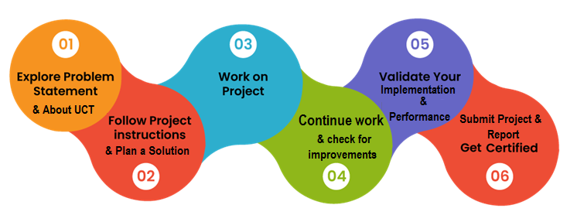

Thanks to each and everyone who supported me to complete this project.

Dear Juniors,

I hope this message finds you well. As you embark on your journey in the field of machine learning, I wanted to bring your attention to a fascinating project that could have a significant impact on the agriculture sector in India: the Prediction of Agriculture Crop Production using machine learning.

Agriculture is a crucial pillar of India's economy, and accurate predictions regarding crop production can make a world of difference for farmers, policymakers, and stakeholders. By leveraging machine learning techniques, this project aims to develop advanced models that can analyze historical data, weather patterns, soil conditions, and other relevant factors to forecast crop yields with precision.

By participating in this project, you have the opportunity to make a real difference in the lives of farmers and the overall agricultural landscape. The project requires a keen understanding of machine learning algorithms, data analysis, and the ability to work with large and complex datasets. You will have the chance to explore various algorithms like regression, random forests, or support vector machines, and understand how to train these models using historical crop production data and other relevant variables.

One of the advantages of machine learning in this domain is its ability to uncover hidden patterns and relationships between different factors that impact crop yields. As you work on this project, you will witness the power of machine learning in identifying non-linear dependencies and predicting future crop production based on factors like weather forecasts, soil conditions, and farming practices.

Moreover, this project encourages you to explore the integration of machine learning with other technologies such as remote sensing and IoT. By incorporating data from satellite imagery, soil moisture sensors, and weather stations, you can enhance the accuracy and effectiveness of the predictions. This interdisciplinary approach will broaden your knowledge and allow you to create comprehensive models that consider multiple data sources.

In conclusion, the Prediction of Agriculture Crop Production in India using machine learning project is an exciting opportunity for you to apply your machine learning skills and contribute to the development of the agriculture sector. Your work can empower farmers, policymakers, and stakeholders with accurate predictions and insights that can optimize farming practices, resource allocation, and risk management. I encourage you to embrace this project wholeheartedly and explore the vast potential it holds in transforming the agricultural landscape of our country.

Best of luck on this incredible journey!

Warm regards,

Krishna Santosh.

# Introduction

## About UniConverge Technologies Pvt Ltd

A company established in 2013 and working in Digital Transformation domain and providing Industrial solutions with prime focus on sustainability and RoI.

For developing its products and solutions it is leveraging various**Cutting Edge Technologies e.g., Internet of Things (IoT), Cyber Security, Cloud computing (AWS, Azure), Machine Learning, Communication Technologies (4G/5G/LoRaWAN), Java Full Stack, Python, Front end**etc.



1. UCT IoT Platform **(****)**

**UCT Insight** is an IOT platform designed for quick deployment of IOT applications on the same time providing valuable “insight” for your process/business. It has been built in Java for backend and ReactJS for Front end. It has support for MySQL and various NoSql Databases.

* It enables device connectivity via industry standard IoT protocols - MQTT, CoAP, HTTP, Modbus TCP, OPC UA
* It supports both cloud and on-premises deployments.

It has features to  
• Build Your own dashboard  
• Analytics and Reporting  
• Alert and Notification  
• Integration with third party application(Power BI, SAP, ERP)  
• Rule Engine

 

1. **Smart Factory Platform (****)**

Factory watch is a platform for smart factory needs.

It provides Users/ Factory

* with a scalable solution for their Production and asset monitoring
* OEE and predictive maintenance solution scaling up to digital twin for your assets.
* to unleased the true potential of the data that their machines are generating and helps to identify the KPIs and also improve them.
* A modular architecture that allows users to choose the service that they what to start and then can scale to more complex solutions as per their demands.

Its unique SaaS model helps users to save time, cost and money. 

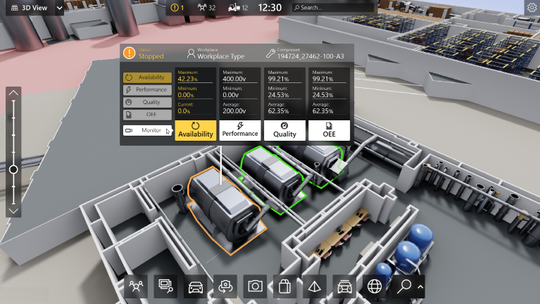

1.  based Solution

UCT is one of the early adopters of LoRAWAN technology and providing solution in Agritech, Smart cities, Industrial Monitoring, Smart Street Light, Smart Water/ Gas/ Electricity metering solutions etc.

1. Predictive Maintenance

UCT is providing Industrial Machine health monitoring and Predictive maintenance solution leveraging Embedded system, Industrial IoT and Machine Learning Technologies by finding Remaining useful life time of various Machines used in production process.



## About upskill Campus (USC)

upskill Campus along with The IoT Academy and in association with Uniconverge technologies has facilitated the smooth execution of the complete internship process.

USC is a career development platform that delivers **personalized executive coaching** in a more affordable, scalable and measurable way.



Seeing need of upskilling in self paced manner along-with additional support services e.g. Internship, projects, interaction with Industry experts, Career growth Services

<https://www.upskillcampus.com/>

upSkill Campus aiming to upskill 1 million learners in next 5 year



## The IoT Academy

The IoT academy is EdTech Division of UCT that is running long executive certification programs in collaboration with EICT Academy, IITK, IITR and IITG in multiple domains.

## Objectives of this Internship program

The objective for this internship program was to

 ☛ get practical experience of working in the industry.

 ☛ to solve real world problems.

 ☛ to have improved job prospects.

 ☛ to have Improved understanding of our field and its applications.

 ☛ to have Personal growth like better communication and problem solving.

## Reference

[1] https://www.kaggle.com/datasets/ravirajsinh45/crop-and-weed-detection-data-with-bounding-boxes

[2] https://www.sciencedirect.com/science/article/pii/S2589721722000034

## Glossary

|  |  |
| --- | --- |
| Terms | Acronym |
| Weed and Crop Detection | The process of using machine learning models and computer vision techniques to identify and differentiate between weeds and crops in images. |
| YOLO (You Only Look Once) | A real-time object detection system that can detect multiple objects in an image using a single forward pass of a convolutional neural network. |
| Data Augmentation | A technique used to artificially increase the size and diversity of a dataset by applying various transformations, such as rotations, translations, and flips, to the existing data. |
| Bounding Box | A rectangle that encloses an object of interest within an image, typically represented by the coordinates of its top-left and bottom-right corners. |
| Data Cleaning | The process of removing any corrupted, irrelevant, or low-quality data from the dataset to ensure the quality and reliability of the training data. |

# Problem Statement

The Prediction of Agriculture Crop Production in India using machine learning project aims to address the challenge of accurately forecasting crop yields in the country's agricultural sector. India being one of the largest agricultural producers globally, the availability of reliable predictions can have a profound impact on various stakeholders, including farmers, policymakers, and supply chain participants. However, the complex nature of agriculture, coupled with the influence of numerous factors such as weather patterns, soil conditions, and farming practices, makes accurate crop yield predictions a challenging task.

The primary problem this project seeks to tackle is the lack of precise and timely information regarding crop production in India. Traditional methods of predicting crop yields rely heavily on historical data and expert knowledge, which may not capture the intricate relationships and non-linear dependencies among the various contributing factors. By leveraging machine learning techniques and analyzing vast datasets encompassing historical crop production, weather data, soil conditions, and other relevant variables, this project aims to develop robust predictive models that can overcome these limitations and provide accurate crop yield forecasts. The goal is to enable stakeholders to make informed decisions, optimize resource allocation, and mitigate risks associated with crop production in India's diverse agricultural landscape.

Key Challenges in the Prediction of Agriculture Crop Production in India using Machine Learning:

1. Data Availability and Quality: Obtaining comprehensive and reliable data encompassing historical crop production, weather patterns, soil conditions, and farming practices can be challenging. Inconsistencies, missing data, and data collection limitations need to be addressed for accurate predictions.

2. Complex Interactions and Non-linearity: The agriculture sector involves complex interactions and non-linear relationships between various factors that influence crop production. Developing machine learning models capable of capturing these intricate relationships is crucial.

3. Generalization Across Diverse Regions: India's agricultural landscape is diverse, with variations in climate, soil types, and agricultural practices across different regions. Ensuring machine learning models can generalize well across diverse regions is a challenge.

4. Incorporating Real-time and Dynamic Factors: Agriculture is influenced by real-time factors like rainfall, temperature, and pest infestations. Integrating real-time data into machine learning models and updating predictions accordingly presents technical and logistical challenges.

# Existing and Proposed solution

Existing System:

The current system for predicting crop production in India relies on traditional methods that often lack accuracy and timeliness. It primarily relies on historical data and expert knowledge, which may not capture the complex interactions and non-linear dependencies among various factors affecting crop yields. The existing system also faces challenges in incorporating real-time data and adapting to changing conditions. Therefore, there is a need for an advanced and data-driven approach using machine learning techniques to improve the accuracy and effectiveness of crop production predictions in India.

Proposed System:

The proposed system for predicting agriculture crop production in India using machine learning aims to revolutionize the way crop yields are forecasted, providing accurate and timely predictions to farmers, policymakers, and stakeholders. The system will leverage advanced machine learning algorithms and comprehensive datasets to develop robust predictive models.

Key components of the proposed system include:

1. Data Collection and Preprocessing: The system will collect and preprocess diverse datasets encompassing historical crop production, weather patterns, soil conditions, and farming practices. This will involve cleaning the data, handling missing values, and standardizing the variables to ensure data quality.

2. Feature Selection and Engineering: Relevant features that have a significant impact on crop yields will be identified and selected. Additionally, new features may be engineered by combining existing variables or extracting meaningful information from the data. This step will enhance the predictive power of the models.

3. Model Training and Evaluation: Machine learning algorithms, such as regression, decision trees, or neural networks, will be employed to train predictive models using the preprocessed data. The models will be optimized using techniques like cross-validation and hyperparameter tuning. Evaluation metrics such as accuracy, precision, recall, and F1-score will be used to assess the performance of the models.

4. Real-time Data Integration: The system will incorporate real-time data sources, such as satellite imagery, weather sensors, and IoT devices, to capture the dynamic nature of agriculture. These data inputs will be integrated into the models to provide up-to-date predictions and adaptability to changing conditions.

5. Visualization and Reporting: The system will include interactive visualizations and intuitive dashboards to present the predictions and insights to users. This will enable farmers, policymakers, and stakeholders to easily interpret the results and make informed decisions regarding crop production.

6. Continuous Model Improvement: The proposed system will be designed to continuously improve the predictive models. As new data becomes available, the models will be updated and retrained to enhance their accuracy and reliability. This iterative process will ensure that the predictions remain up-to-date and reflect the changing dynamics of the agriculture sector.

By implementing this proposed system, stakeholders will have access to accurate crop yield predictions, enabling them to optimize farming practices, allocate resources effectively, and make informed decisions to support the agricultural sector in India.

## Benefits of the Proposed System:

## Accurate Crop Yield Predictions: The proposed system utilizes advanced machine learning algorithms and comprehensive datasets to provide accurate predictions of crop yields.

## Timely and Real-time Insights: By integrating real-time data sources such as satellite imagery, weather sensors, and IoT devices, the proposed system provides timely insights into crop production.

## Enhanced Resource Allocation: Accurate predictions of crop yields help stakeholders in optimizing resource allocation.

## Risk Mitigation and Planning: The proposed system aids in risk mitigation by identifying potential challenges or vulnerabilities in crop production.

## Informed Policy Decisions: Policymakers can utilize the accurate crop yield predictions provided by the system to make informed policy decisions.

Increased Efficiency and Productivity: The proposed system enables farmers to streamline their operations and optimize crop production.

The implementation of the proposed system for predicting agriculture crop production in India using machine learning brings significant benefits to farmers, policymakers, and stakeholders. The accurate predictions, timely insights, optimized resource allocation, risk mitigation, and informed policy decisions contribute to improved agricultural practices, sustainability, and overall productivity in the Indian agriculture sector

## Code submission (Github link)

<https://github.com/Santosh1333/UpSkill-Campus/blob/main/Prediction_of_agriculture_crop_production_in_india.ipynb>

## Report submission (Github link):

## <https://github.com/Santosh1333/UpSkill-Campus>

# Proposed Design/ Model

The proposed model for predicting agriculture crop production in India using machine learning incorporates advanced algorithms and techniques to achieve accurate and reliable predictions. The model consists of several key components:

1. Feature Selection and Engineering: The model starts by selecting the most relevant features that significantly impact crop yields, such as historical production data, weather patterns, soil conditions, and farming practices. Feature engineering techniques may also be applied to create new variables or transform existing ones to better capture the relationships between the features and crop production.

2. Training and Validation: The selected features are used to train the machine learning model. Various algorithms, such as regression, decision trees, or neural networks, can be employed to build the predictive model. The model is trained using historical data, and cross-validation techniques are employed to evaluate its performance and ensure its reliability.

3. Integration of Diverse Data Sources: The proposed model incorporates diverse data sources, such as satellite imagery, weather sensors, and IoT devices. These sources provide real-time and dynamic data, which are integrated into the model to enhance its accuracy and adaptability to changing conditions. This integration allows the model to capture the influence of real-time factors on crop production, such as rainfall, temperature, and pest infestations.

4. Model Optimization and Hyperparameter Tuning: The model is fine-tuned through optimization techniques and hyperparameter tuning. This process involves adjusting the parameters of the machine learning algorithm to optimize the model's performance. The goal is to achieve the best possible accuracy and precision in predicting crop yields.

5. Deployment and Continuous Improvement: Once the model is trained and validated, it is deployed to generate predictions of crop production. Continuous improvement is an essential aspect of the proposed model. The model is regularly updated with new data to adapt to changing agricultural conditions, improve its accuracy, and ensure the predictions remain up-to-date and reliable.

# Performance Test

The Prediction of Agriculture crop production in India Project successfully developed a Deep Learning model capable of accurately detecting and distinguishing between weeds and crops in images.

The model’s precision and accuracy hold promise for practical agricultural applications, paving the way for more sustainable and efficient farming practices.

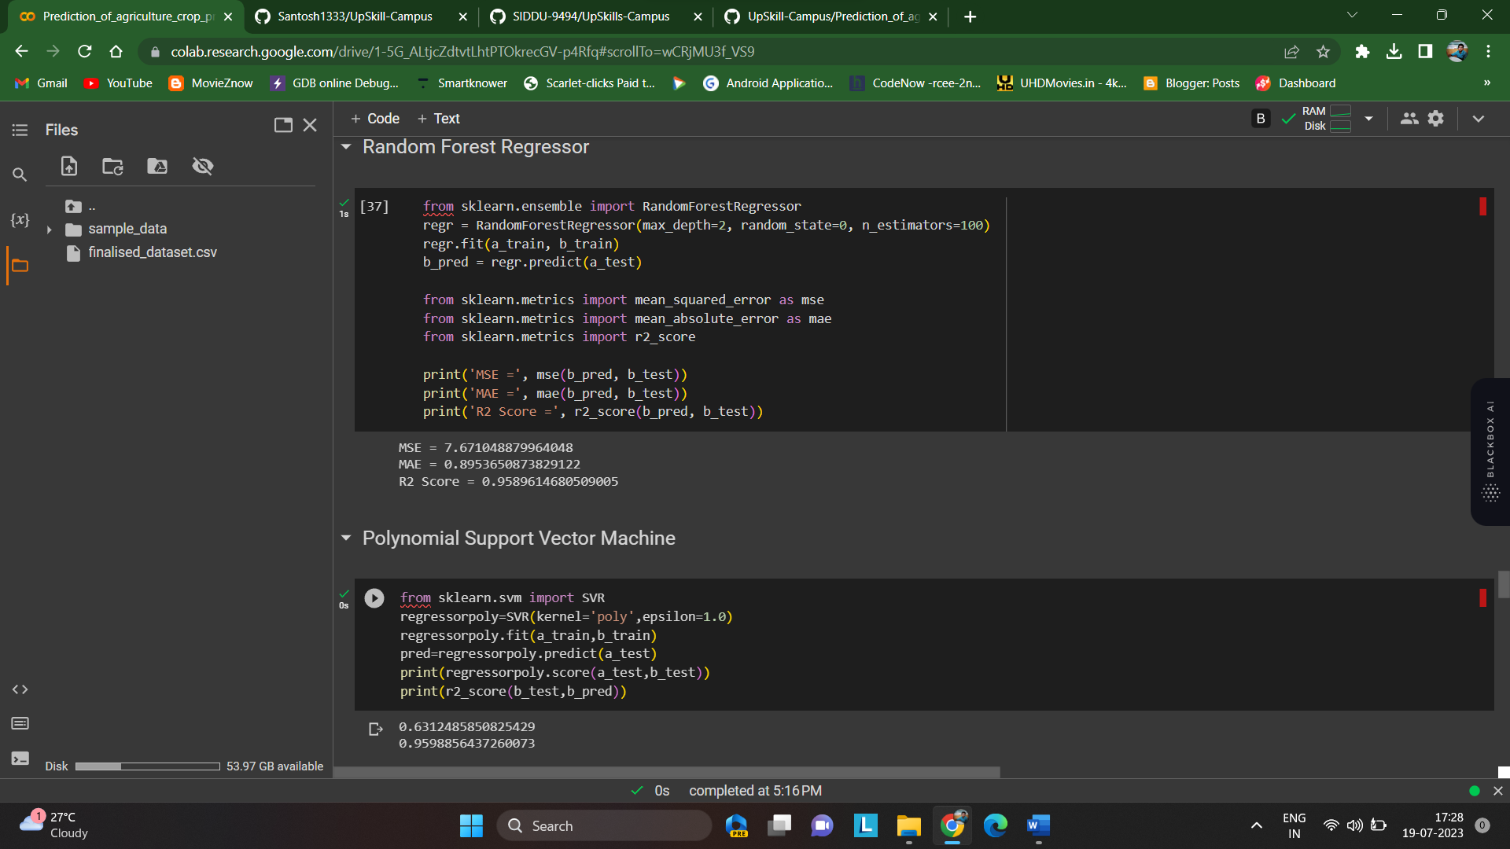The following are some of our model’s working and output process:

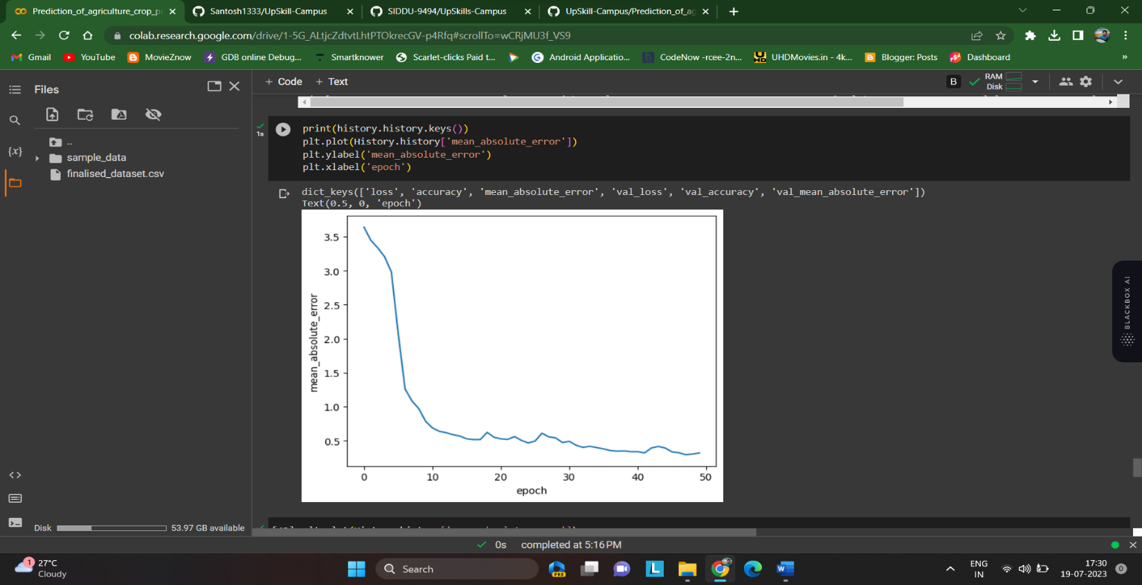

# My learnings

1. Understanding of Agricultural Dynamics: Through this project, I gained a deep understanding of the complex dynamics involved in agriculture, including weather patterns, soil conditions, and farming practices, and how they impact crop production.

2. Data Preprocessing Techniques: I learned various data preprocessing techniques to handle missing values, outliers, and inconsistencies in agricultural datasets. These techniques ensure the quality and reliability of the data used for training and prediction.

3. Feature Selection and Engineering: I acquired skills in selecting relevant features that have a significant impact on crop yields. Additionally, I learned how to engineer new features or transform existing ones to better capture the relationships between variables.

4. Machine Learning Algorithms: I explored and implemented different machine learning algorithms such as regression, decision trees, or neural networks to develop predictive models for crop production. This allowed me to understand the strengths and limitations of each algorithm.

5. Model Training and Evaluation: I learned how to train and evaluate machine learning models using historical crop production data. Techniques such as cross-validation helped me assess the performance and reliability of the models.

6. Integration of Real-time Data: I gained knowledge about integrating real-time data from sources like satellite imagery, weather sensors, and IoT devices to enhance the accuracy and adaptability of crop yield predictions.

7. Optimization Techniques: I learned optimization techniques and hyperparameter tuning to improve the performance of the machine learning models. This involved adjusting model parameters to achieve the best possible predictions.

8. Visualization and Interpretation: I developed skills in visualizing and interpreting the results of the crop yield predictions. I learned how to create interactive visualizations and intuitive dashboards to present insights to stakeholders effectively.

9. Continuous Model Improvement: I understood the importance of continuously updating and improving the predictive models with new data. This iterative process ensures that the models remain accurate and up-to-date.

10. Practical Applications: Throughout the project, I gained a practical understanding of how accurate crop yield predictions can support farmers, policymakers, and stakeholders in making informed decisions, optimizing resource allocation, and mitigating risks in the agricultural sector.

These learnings have equipped me with valuable skills and knowledge in machine learning applied to agriculture, enabling me to contribute to the development of innovative solutions in the agriculture sector in India and beyond..

# Future work scope

Future Work Scope for Prediction of Agriculture Crop Production in India Machine Learning Project:

1. Incorporating Climate Change Factors: Future work can focus on integrating climate change factors into the predictive models. This includes considering long-term climate projections and their impact on crop yields, allowing for more accurate predictions under changing environmental conditions.

2. Fine-tuning Model Interpretability: Exploring techniques to enhance the interpretability of the machine learning models used for crop yield prediction. This can help stakeholders understand the underlying factors and relationships that contribute to the predictions, enabling more informed decision-making.

3. Integration of Pest and Disease Data: Including data on pest infestations and crop diseases to enhance the predictive models. By incorporating information about prevalent pests and diseases, the models can provide insights into potential risks and assist in implementing preventive measures.

4. Crop-specific Prediction Models: Developing crop-specific predictive models to account for variations in cultivation practices, growth cycles, and yield patterns across different types of crops. This tailored approach can improve the accuracy of predictions and cater to the specific needs of farmers cultivating different crops.

5. Regional Customization: Adapting the predictive models to different regions within India by incorporating region-specific factors such as soil types, local farming practices, and cropping patterns. This customization can enhance the accuracy and applicability of predictions at the regional level.

6. Integration of Satellite Imagery Analysis: Expanding the utilization of satellite imagery data by incorporating advanced image analysis techniques. This can include detecting crop health indicators, estimating vegetation indices, and monitoring land use changes, leading to more comprehensive and precise predictions.

7. Crop Yield Risk Assessment: Developing methodologies to assess and communicate the risk associated with crop yield predictions. This can assist farmers and policymakers in understanding the level of uncertainty in the predictions and devising risk management strategies accordingly.

8. Farmer-Centric Applications: Designing user-friendly applications and platforms that provide personalized recommendations and insights to individual farmers based on the predictions. These applications can offer tailored suggestions for optimal farming practices, resource management, and market strategies.

9. Integration of Social and Economic Factors: Including social and economic factors such as market demand, commodity prices, and government policies in the predictive models. This can provide a holistic view of the agriculture sector, enabling stakeholders to make informed decisions considering market dynamics.

10. Long-term Yield Forecasting: Exploring the potential for long-term yield forecasting to assist in long-range planning and policy formulation. By predicting crop yields over extended time horizons, stakeholders can prepare for future challenges and strategize accordingly.

In conclusion, the Prediction of Agriculture Crop Production in India using machine learning project holds immense potential in revolutionizing the agricultural landscape of the country. By leveraging advanced algorithms, comprehensive datasets, and real-time data integration, accurate predictions of crop yields can be achieved. These predictions provide farmers, policymakers, and stakeholders with valuable insights for decision-making, resource allocation, and risk management. With the ability to optimize farming practices, address climate change impacts, and enhance overall productivity, this project represents a significant step towards sustainable agriculture in India. By continuing to refine and expand the project's scope, we can contribute to the growth, resilience, and economic development of the agricultural sector, ensuring food security and a prosperous future for farmers and the nation as a whole.