**1. Why are functions advantageous to have in your programs?**

**Answer: The advantages of using functions are:**

* Reducing duplication of code
* Decomposing complex problems into simpler pieces
* Improving clarity of the code
* Reuse of code
* Information hiding

**2. When does the code in a function run: when it's specified or when it's called?**

**Answer:** The code in a function executes when the function is called, not when the function is defined.

**3. What statement creates a function?**

**Answer:** The def functionName() createes a function

**4. What is the difference between a function and a function call?**

**Answer:** A function : is a block of code that does a particular operation and returns a result. It usually accepts inputs as parameters and returns a result. The parameters are not mandatory.

A Function call : is the code used to pass control to a function

**5. How many global scopes are there in a Python program? How many local scopes?**

**Answer:** There is one global scope, and a local scope is created whenever a function is called.

**6. What happens to variables in a local scope when the function call returns?**

**Answer:** When a function returns, the local scope is destroyed, and all the variables in it are forgotten. we will not be able to access the outside the function.

**7. What is the concept of a return value? Is it possible to have a return value in an expression?**

**Answer:** A return value is the value that a function call evaluates to. A return value can be used as part of an expression, Like any value.

**8. If a function does not have a return statement, what is the return value of a call to that function?**

**Answer:** If there is no return statement for a function, its return value is None

**9. How do you make a function variable refer to the global variable?**

**Answer:** By representing a variable by global keyword in the body of a function Example: global a

**10. What is the data type of None?**

**Answer:** The data type of none is NoneType

**11. What does the sentence import areallyourpetsnamederic do?**

**Answer:** areallyourpetsnamederic ia not a python module. Importing this module will throughs ModuleNotFoundError exception

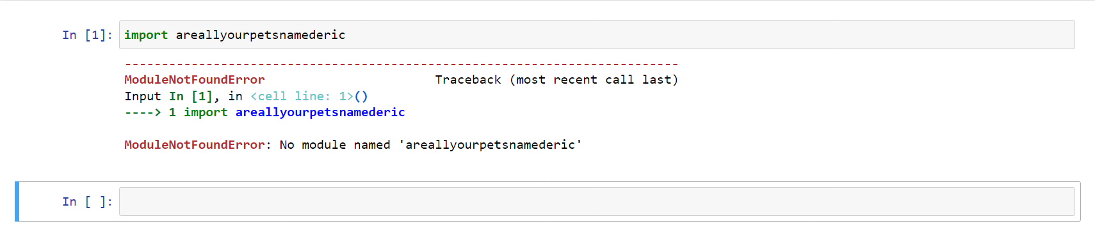

**12. If you had a bacon() feature in a spam module, what would you call it after importing spam?**

**Answer:** This function can be called with spam.bacon(). like below

import spam

spam.bacon()

**13. What can you do to save a programme from crashing if it encounters an error?**

**Answer:** we can write lines of code in try block. This will not crash the programme. And in except block we can catch the exception

**14. What is the purpose of the try clause? What is the purpose of the except clause?**

**Answer:** Try: The code that could potentially cause an error goes in the try clause.

except: The code that executes if an error happens goes in the except clause, like print statements about exceptions, logging statements.