

**Graduate 2020**

**Project**

*Block Moving Project*

**Course:**

*Foundation Of AI*

**Abstract**

This project is an AI based project, used for lifting box from one location to the other. The complete project is made using C++ language on visual studio platform, on a windows operating system. The project has two arms each arm having a specific task, the main task assigned to them is to lift the and move the seven boxes provided to them on the table. The boxes are labelled alphabetically to avoid confusions. The interface is so friendly, without any confusion. A non-computing background person can also understand the project interface without any confusion. The arms here are given the capability to grasp the box, move the boxes. The project has two predefined locations, at one location the boxes are stack over each other, and the other locations remains empty unless there is a command given to the arms by the user.

The main objective of this project is to demonstrate the use of Artificial intelligence in lifting an object and changing its position, this kind of work we are currently seeing in many big companies, where artificial intelligence has help humans to increase the productivity and work 24 hours a day to achieve the task. This project has a beginner-based coding, it is so simple for a computer programmer to understand. This project made me clearer with the language C++ and its various libraries. Which we will be discussing further in this report. The use of visual studio as the platform made the project more effective, it had many build in components which gives light to this project.

The purpose of this project is to draw a closer relationship between AI and programming, how can we take Artificial intelligence to a next level with the help of various language and the algorithmic concept of AI. The concept of algorithm in AI makes every path easy in creating artificial intelligence. This project was only possible with the help of algorithm, which we will discussing further in this report. There were many errors occurred while making this project, but with patience and lots of research every error came to an end, making the task interesting and challenging for me to work. This project made me dive into the dipper concept of C++ and AI.

**Table of Context**

*Introduction……………………………………………………………………………4*

*Moving block………………………………………………………………………….6*

*Loops………………………………………………………………………………………7*

*Flow Chart……………………………………………………………………………...7*

*Flow Chart Explanation………………………………………………………….8*

*Pseudocode……………………………………………………………………………8*

*User Interface……………………………………………………………………….10*

*Robotic Arm………………………………………………………………………….13*

*Example……………………………………………………………………………….17*

*Error…………………………………………………………………………………….18*

*Memory Leak……………………………………………………………………….19*

*Limitations………………………………………………………………………….19*

*Future Development……………………………………………………………19*

*Conclusion………………………………………………………………………….20*

*References…………………………………………………………………………21*

**Introduction**

The purpose of this project is to build two moving robotic arms, where the arms are used to move blocks from one location(L1) to another location(L2), every arm can execute only one task at a time. There are specifically seven blocks given naming alphabetically to them, and the user can input the block alphabetic in the framework, which he/she desired to move. After the specifying the box, one hand will lift the other boxes which is not intended by the user to move, and the other arm picks the specified box , and place in the air, after which the other unintended boxes are placed black to the location.

This project gave me a lot of motivation by giving many challenges to solve the error and learn deeply about the concept of C++, there were many new things like Microsoft foundation class libraries, memory leak error and etc. which came across me during accomplishing this project, this made me involve more and more towards the project and its goal. Being a computer science student, we need to learn everyday a new concept. This project made me learn new things. This project was only possible with the help algorithm. The execution of an algorithm in code was my first experience which came into lights for me. This new concept learning made me feel more motivated towards this project. The project was made with scratch and with small steps taken to accomplish this which is shown in a flowchart. Determining the action of hands was so challenging, which using various loops and libraries this made the ongoing actions easier.

The goal of this project was to show the importance of Artificial intelligence in day today life. This small project concept is being used my many big firms to accomplish their task and achieve their goal on time. AI is the trending market, where people are learning new things and making new things with the help AI. If we look around everything we go across to from our phones to automatic door’s in store, everything is AI. This project goal is to show the relationship between programming and AI making algorithm as their bridge. This project made me go into deep learning about the concept of AI, the execution of algorithm. The merging of algorithm to coding and above all the deep knowledge of C++, with this project I came across various new concept of C++ language, there libraries, the new concept of solving error, finding errors etc. The project was so helpful in developing oneself mentally in the field of computer science.

Furthermore, we will be discussing the logical and technical part involved in this project. The Block moving project sounds so easy, but its not that easy to make. There were many libraries like list, stack etc. involved in making this report, every library played the major role by creating a list of alphabetic order for naming the boxes. Stack container adapter here used for the concept of LIFO(Last In First Out) type of working, where a new element is added at one end and an element is removed from that end only, so basically this is the main concept of lifting and replacing the box from one position to an another. On other hand lists are sequence containers that allow constant time to insert and erase operation.

I basically had to install MFC extension on visual studio 2019 which were as follows:

* C++ v14.26 MFC for v142 build tools
* C++ v14.26 MFC for v142 build tools with Spectre Mitigations
* C++ ALT for the v142 build tools
* ALT and MFC for the v141 build tools

The above extension played a major role in managing the frame of the work, further we will be discussing more about the above extensions and the involvement of this extensions in my project.

**Moving Block**

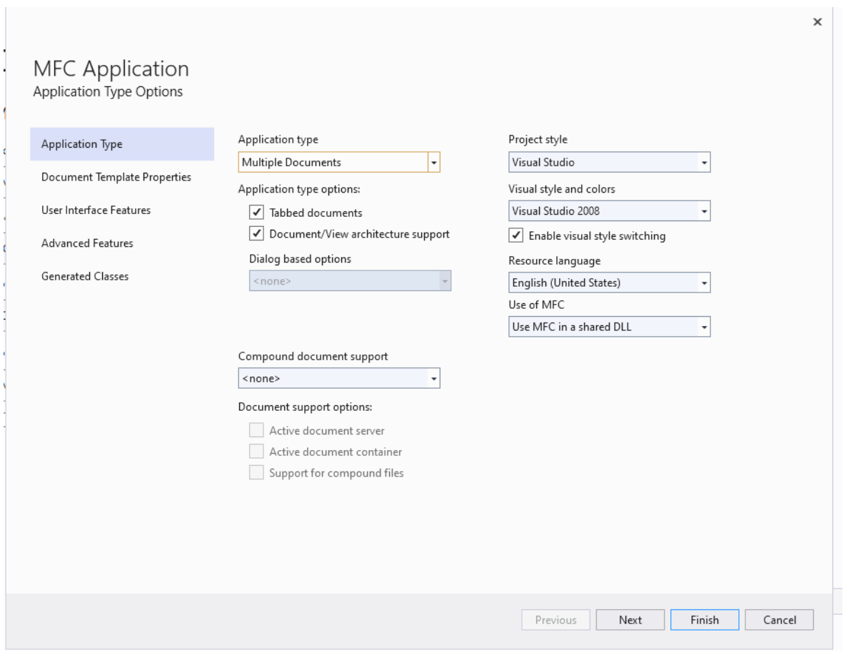The project is programmed using C++ on visual studio 2019. The initial step eventually taken by me was installing the Microsoft Foundation Class (MFC). MFC is a library which has a set of functions, data types, constants, and classes. MFC is basically used for creating applications for Microsoft windows operating system. MFC framework provides a set of reusable classes designed to simplify windows programming. MFC provides classes for many basic objects, such as strings, files, and collections that are used in programming. MFC provides an application framework, including the classes that make up the application architecture hierarchy.

Figure 1

As you see this how the installation process begins for MFC in visual studio, it supports various application, which makes it easy to work on C++.

**Loops**

The project done by me has a various involvement of loop in it, this because the hands had many small motion on various ten blocks, so lifting the blocks placing them back and again bringing them back to their original position involves a lot of action to be performed so this was only solved my using loops. The loops to determine the number of boxes needed for this project, and to perform all the specific movement was done by loop.

**Flow Chart**

Figure 2

**Flow Chart Explanation**

Step 1: Start

Step 2: Input the number of boxes

Step 3: Select the box to move

Step 4: Click on start motion button

Step 5: The arm start moving, if no action will be performed than move on to step

2 or else continue to another step.

Step 6: Is the selected box below other box, if no than directly go to step 11 or else

go to next step

Step 7: The R arm box moves the above boxes to L1

Step 8: Above boxes moved, if no than go back to step 7, if yes go to next step

Step 9: The R arm will lift the selected box up at a stationary position

Step 10: The L arm will move back the boxes from L1 to L2

Step 11: The R arm will place the selected box at L1

Step 12: Stop

The above flowchart shows the complete working for my project, from start to the end.

**Pseudocode**

***1.Block Moment***

The block moment event pseudocode:

**Input**:Select the box X.

**Output**: Box selected X.

**Data**: Testing box X.

Function OnClickedBtnStart ()

If GetCursesel = 0.

Int SelectedBlockID, SelectedBlockTableID, SelectBlockLevel.

*LOOP Process*

**For** i =0; i<m_block_count

Statements...

**If** m_block_array[i]. s_block_id == (tmpchar – ‘a’+1)

Statements...

**End if**

**End for**

**Return X**

The above pseudocode tells us how are blocks moment being generated using C++. Which can be clearly seen in the code with the same tables as a comment above the code snippet. This pseudocode just explains the functions and loop involved to pick a box by box which is selected, using the drop-down menu in the interface.

***2. Moving block from left to right***

The left to right moments of block

**Input**: input block y.

**Output**: block y selected.

**Data**: testing block y.

First statement

Loop Process

**If** selectblocktableID == 1.

**If** stacktableleft.top == selectblockID

Statement…

**While** stacktableleft.top ≠ selectBlockID

Statement…

**While** prepareCount ≠ selectblockid

Statement

Nooprighthand

Moveblocktoright

Nooplefthand

Endif

**Endif**

**End while**

**End while**

**Return y**

The above pseudocode tells us how the selected blocks move from left to right table; all the blocks are given an id based on the id every action are performed.

There are many various actions performed by the project, that includes the following:

* Attach to Current Block
* Drag Block about a Block Height
* Move to Left to L2
* Attach to Current Block
* Move Down to L2
* Drag Up

This are the actions performed to complete the block lifting project, this are the sub loops of the above pseudocode, which can be seen in the main file of the code.

**User Interface**

The in the project we can enter blocks from 1 to 10, the algorithm is not restricted to just 10 blocks, below is the screen shot:

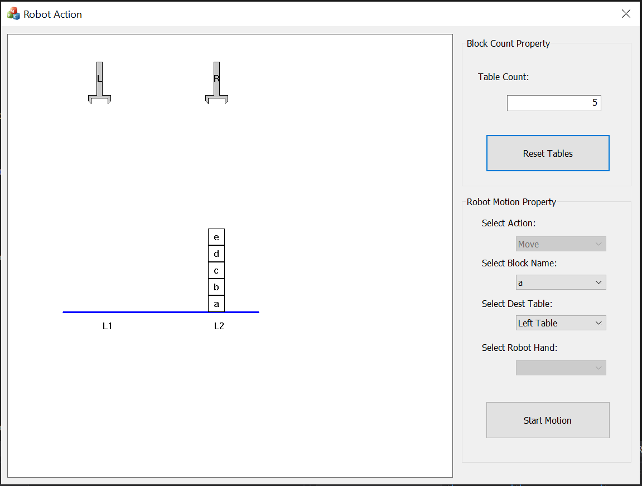

Figure 3

In the above figure 3, we can as I entered 5 and clicked on reset tables, there appears 5 boxes. As we discussed we can enter any number from 1 to 10 in the text box for that many number of boxes to appear on the L2 table, this makes the program not limited to just on number.

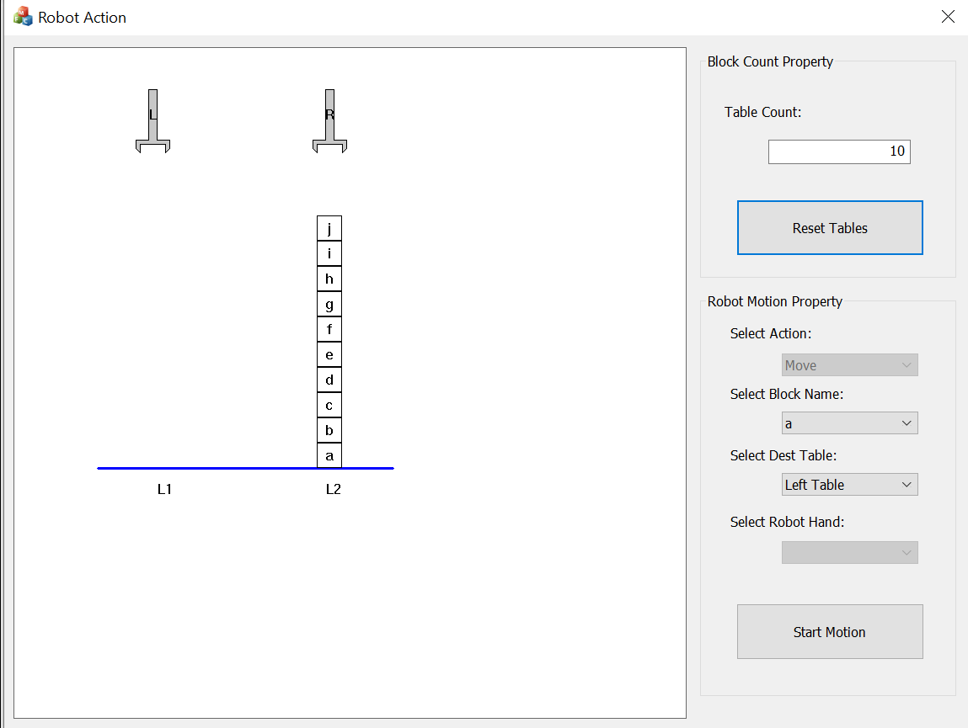

Figure 4

The figure 4, shows the 10 blocks present on the table, this is two screenshots shows that the user can place the desired boxes on the tables from 1 to 10. The above figure even shows that if there is no action done the **L1 locations remains clear**. Even the boxes are named alphabetically from a to j. The same will appear under the **select block name** for the users to select the block and make it user friendly.

Even we can select the destination where we want to move the block, as in figure 4 we can see and option **select destination(dest)** table , the drop-down menu will prompt the left(L1) and right(L2) table for user to select, where the user wants the box to move.

**Robotic Arm**

The robotic arms are given following actions:

* Grasp
* Pull-up
* Pull-down
* Release the box
* Hold the box stationary at position

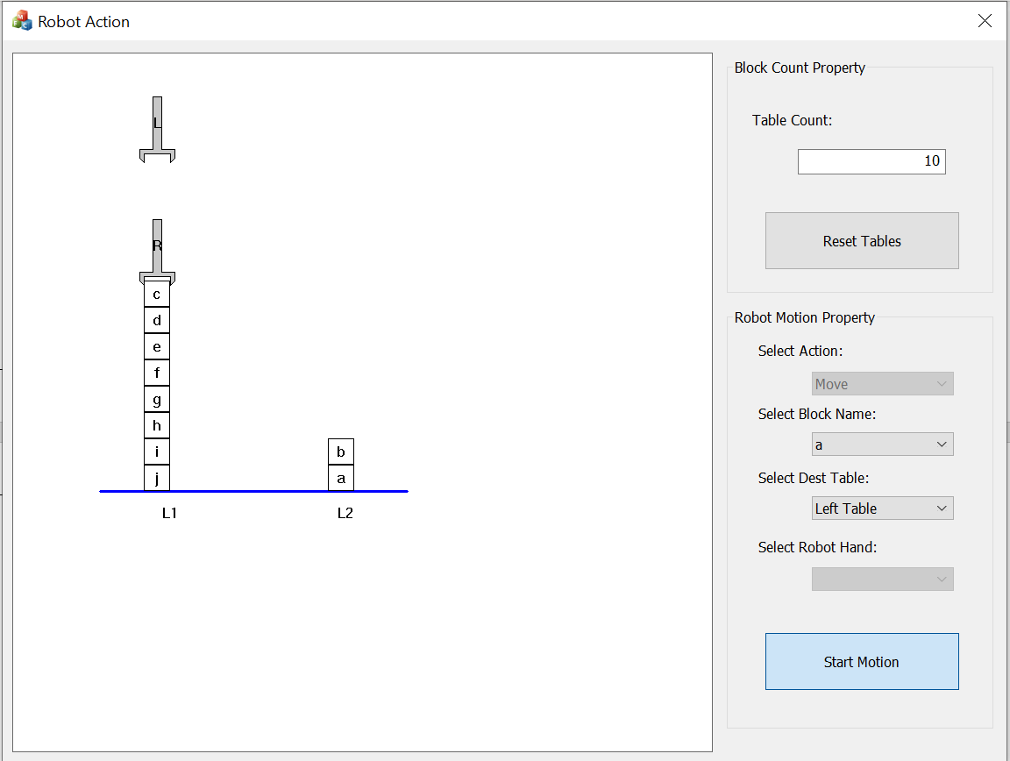

Figure 5

The above figure shows the **grasping action** of the robotic arm, to lift the placed block ‘c’ from location L1.

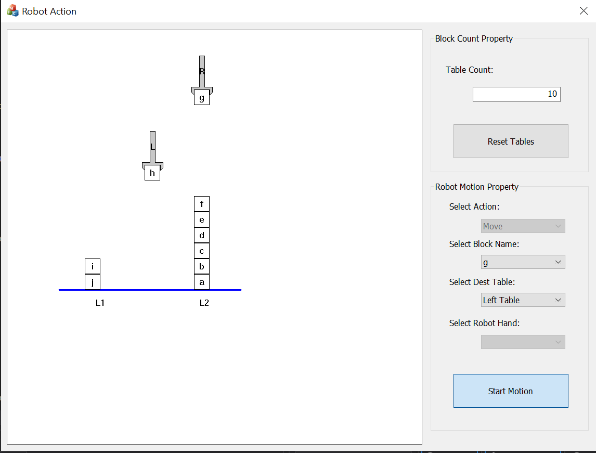

Figure 6

The figure 6, shows the **pull up action** of the block h by arm L from location L2 to place it on L1.

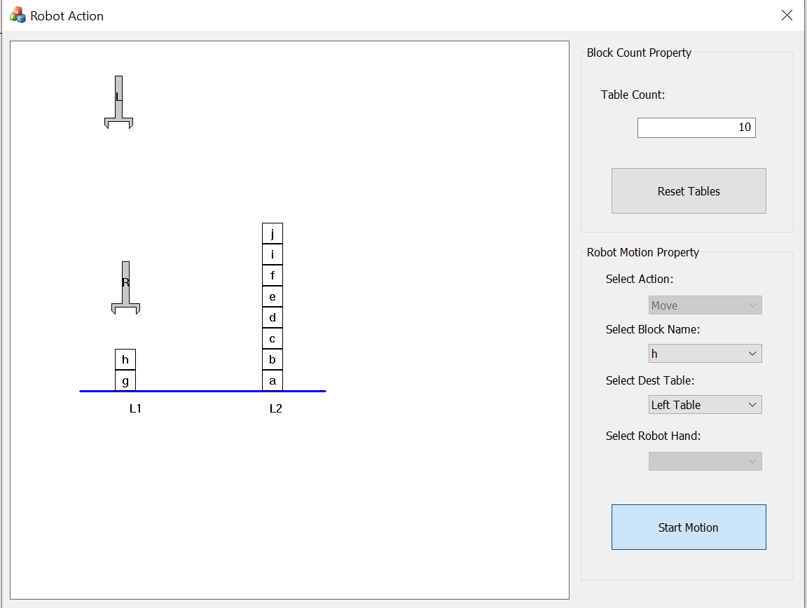

Figure 7

The figure 7, shows the **pull-down action** of the block h by arm R from location L2 to place it on L1.



Figure 8

The figure 8, shows the **releasing action** of block h by arm R on location L1.



Figure 9

The figure 9, shows the **stationary position** of arm R holding the block g, so that the L arm can move all the other blocks and create position for block g.

**Task(example)**

As demonstrated in class (class example 3) the initial and final position of the blocks will be shown below.

**Initial State**

Figure 10

The figure 10, shows the initial state, which was given in class, as input state, this action was done my both arms , to place the block from one location to another, it was even demonstrated in the class.

**Final State**

Figure 11

The figure 11, shows the final state from the initial state, this is also performed by two arms to move blocks from one destination to another.

**Errors**

During the process of completing the project, I face various minor to major errors in the project which includes missing colon, loop format error, variable and function naming error this were kind of minor error which were being solved easily, but as I moved further after completion of my report, there occurred a major error, which for long time I was not able to identify what kind of error is this, in this while I program used to run after a min or so it used to automatically crash, giving no line of error in the console. So, I started doing research and I came across an error namely **Memory Leak.**

**Memory Leak**

The memory leak error when a small memory which was previously occupied by the programmer. Then it is not deallocated properly. That memory is no longer in use by the program. That is why it this is called memory leak. It is worst type of issues to find it. To detect memory leak, we can use **Memcheck.** The memcheck can detect invalid memory access, uses of undefined values and problems related to allocation and deallocation of heap memory. This leak generated because of the different loops used in my program to generate small moments in the program.

**Limitations**

The project had few limitations such as:

* **Speed**, the movement performed by the robotic arms were so slow, this is because of the visual studio, if I would increase the speed of robotic arm that lead to the crash of visual studio, due to high animation it was not able to load the faster speed.
* **Boxes**, I was only able to input boxes till 10, this was also due to the interface, visual studio can only support small user interface, a bigger user interface was taking more time for the program to run.
* **Coloring** the box, I wanted to represent the box with colors to but, while I was trying to add the colors, the idea consumed a lot of time, this is because I was learning few new techniques, which consumed a lot of time for me to learn, as I’m not a quick learner, due to which I had no enough time to create colorful boxes.

**Future Development**

In future I would like to work on **MATLAB,** it is good platform used to develop AI related project, with the help of MATLAB I can solve all the mentioned above limitation and improve the project further more to an higher expectations. Moreover I would like to create more locations and more arms to show both initial and final state in one screen, this I was not able to do with the current project, due to some limitations in visual studio 2019, but with the help of MATLAB, I can surely achieve it in the coming future.

**Conclusion**

In conclusion, I would like to say that this project and idea of executing project has a wider scope in the coming future. In this fast-moving world, there is a higher scope of AI in the future, because AI save lots of time and can do all kind of heavy work. It was a great experience working on this project, the project gave me a widespread knowledge in the field of AI and C++, this project was so useful making us develop oneself for future development.

Artificial Intelligence and technology are always interesting and surprising giving us new ideas, topics, innovations, products etc. Artificial intelligence is the center of a new enterprise to build computational models of intelligence. The main prediction of this is that intelligence can be available in terms of symbol structures and symbolic operations which can be programmed. Artificial intelligence enables human capabilities like understanding, reasoning, planning, communication, and perception. This project leads me experience many new libraries, commands etc. due to this project report I came across pseudocode and studied it for the first, the pseudocode makes the code easily understand.

The sole purpose of this project was achieved by me due to a proper understanding if an algorithm, algorithm makes the project and the subject of artificial intelligence very much clear. Errors like memory leak was initially a new error which came across me, and it was so hard to find this kind of error, but with some research I came got the solution for this error , which is explained above in the report. This project was challenge but was a good experience to learn new things.

Blocks world example was one of the useful method to complete this project, I assumed a conceptual scene as ten objects and relations on, clear, table and above, and using the predicate calculus vocabulary, I used all the object naming a to j. The alphabetic naming makes it easier for user to understand without any confusion.

At the end, some further work is to be done in the viewpoints of visualization and reality. There are number of situations that are ignored in this project, what if we have blocks with different size. This will be noted in the future development.

**References**

Book

Genesereth, M. R., & Nilsson, N. J. (1987a). CHAPTER 2 - Declarative Knowledge. In M. R. Genesereth & N. J. Nilsson (Eds.), *Logical Foundations of Artificial Intelligence* (pp. 9-44). San Francisco (CA): Morgan Kaufmann.

Genesereth, M. R., & Nilsson, N. J. (1987b). CHAPTER 4 - Resolution. In M. R. Genesereth & N. J. Nilsson (Eds.), *Logical Foundations of Artificial Intelligence* (pp. 63-93). San Francisco (CA): Morgan Kaufmann.

Genesereth, M. R., & Nilsson, N. J. (1987c). CHAPTER 5 - Resolution Strategies. In M. R. Genesereth & N. J. Nilsson (Eds.), *Logical Foundations of Artificial Intelligence* (pp. 95-114). San Francisco (CA): Morgan Kaufmann.References

# Online

C++ loop types [Online] // tutorials point. - Tutorialspoint india limited, 2020.

How to install MFC extension [Online] // Stackoverfall . - 2020.

MFC tutorial [Online] // Tutorialspoint. - Tutorialspint india limited, 2020.