

**Power BI Exercises Part 1**

# Exercise 1: Skyscrapers use cases

|  |  |
| --- | --- |
| Dataset | Skyscrapers |
| Visual | * Slicer * Matrix |
| DAX | UseType (depending), AverageHeight |

Continuing on the skyscrapers dataset we’re going to split the use cases from the buildings into three different use cases. We also want to create a column which gives an indication if one of the use cases is as an office or not. We wont to use the values ‘Office, etc.’ and ‘Other’.

We’re going to create the following visuals.

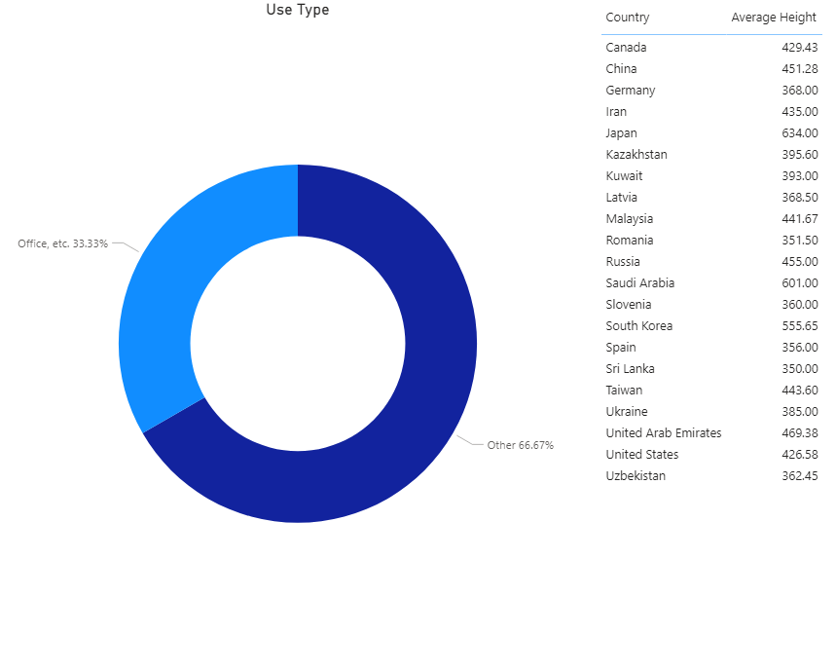

# Exercise 2: Skyscraper Overview

|  |  |
| --- | --- |
| Dataset | Skyscraper |
| Visual | * Bar Chart * Bar Chart with conditional formatting * Bar Chart with Top * Map |
| DAX | NumberOfSkyscrapers, HeightAmount |

The dataset contains an overview of skyscrapers around the world. Import the dataset into Power BI and split the location column into country and city. Make sure to not leave extra spaces.

Your first visual is going to be a simple bar chart with a representation of the number of skyscrapers by country. Make sure to use an explicit measure. To chart uses data labels and a fixed y-axis.

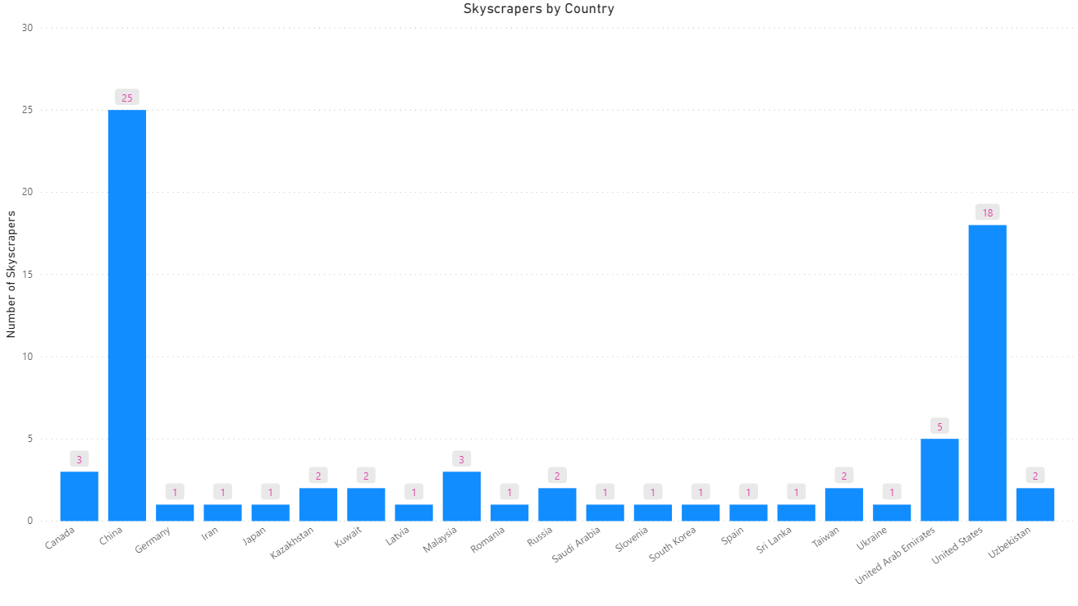

With conditional formatting we’re going to highlight the United States on this bar chart. This can be done multiple ways.

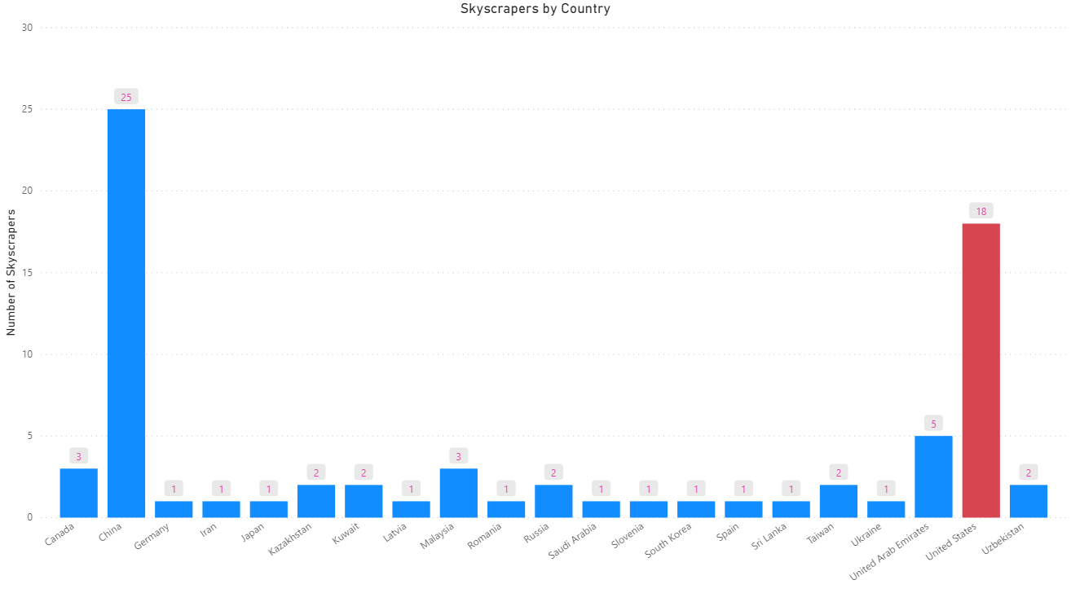

To create a clearer overview of the top countries we’re going to apply a visual filter on this bar chart so that it represents the top 5 countries, **based on height** not number of skyscrapers.

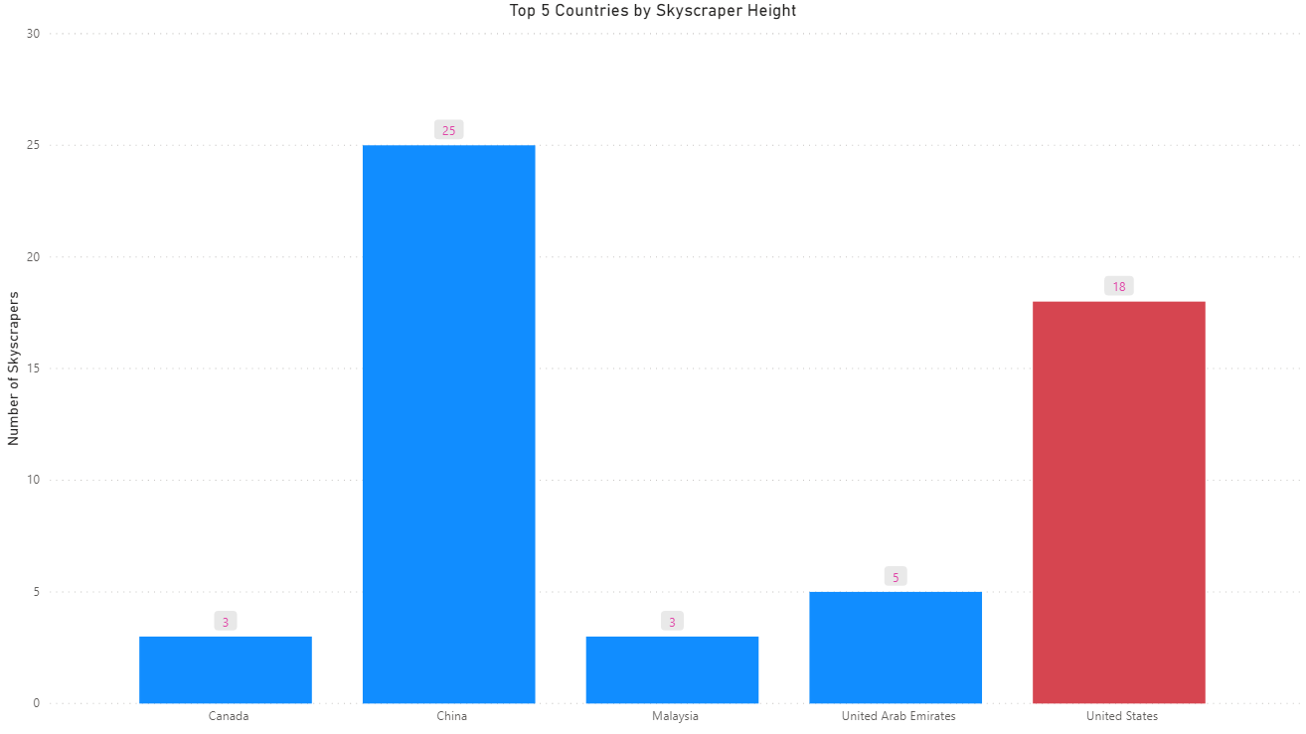

To round of this exercise, since the dataset contains geographical locations, we’re also going to produce a map visual. On this visual we’re going to represent the max height per city.

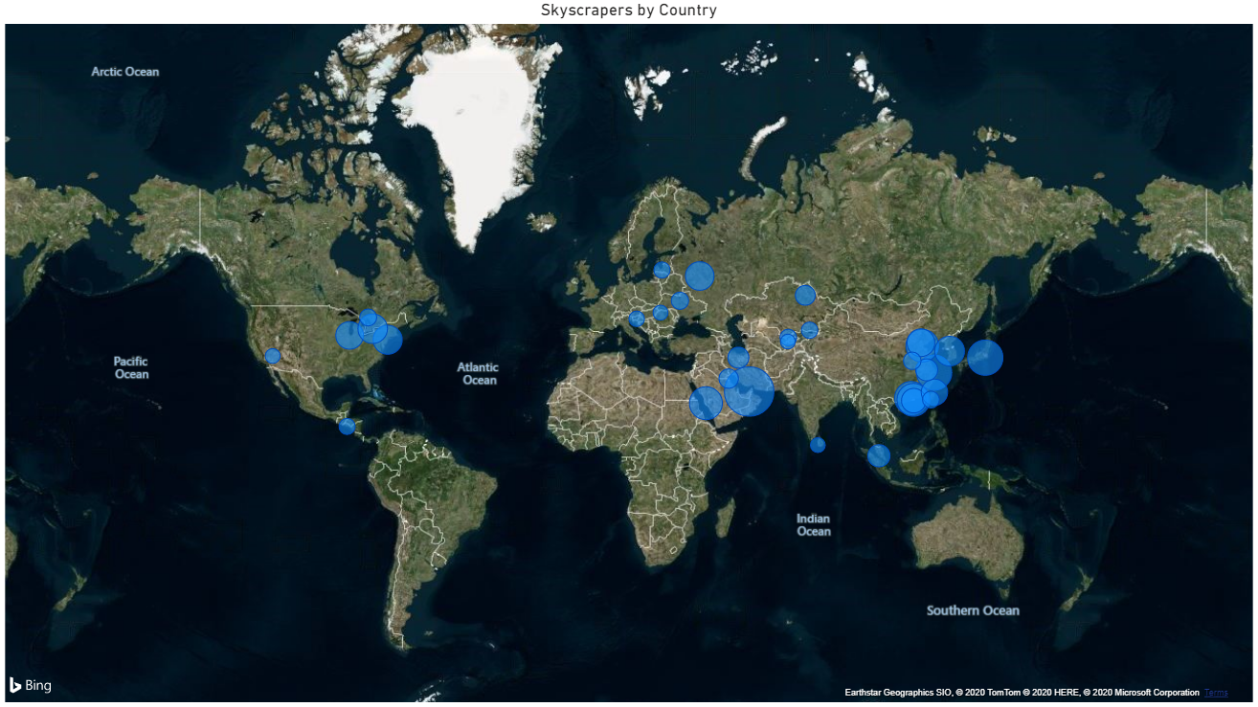

# Exercise 3: Whale sightings

|  |  |
| --- | --- |
| Dataset | Whales |
| Visual | * Horizontal Slicer * Bar Chart with hierarchy |
| DAX | / |

This dataset contains data for the sightings of whales and tortoises from the Whale and Dolphin Trust.

We’re going to create a horizontal slicer for species.



For the hierarchical bar chart, we are only going to use data that is not based on viewings by ‘Jan’.

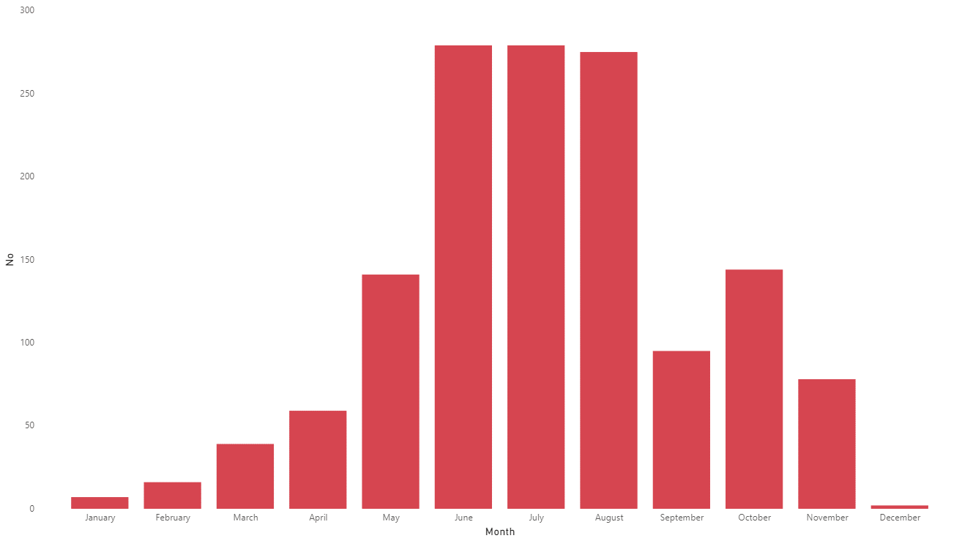

Here we can see the chart based on aggregated result on month level.

# Exercise 4: Crime Statistics

|  |  |
| --- | --- |
| Dataset | Crime Stats 2015-2016 |
| Visual | * Slicers * Text Box * Bar Chart with conditional formatting |
| DAX | / |

This dataset contains information about the crime statistics in the U.K. in the year 2015-2016. But when we’re looking at the dataset it contains a number of columns we don’t need. So we’re going to remove the following columns:

* Financial Year
* Financial Quarter
* Offense Code

For the exercise we’re going to recreate following report.

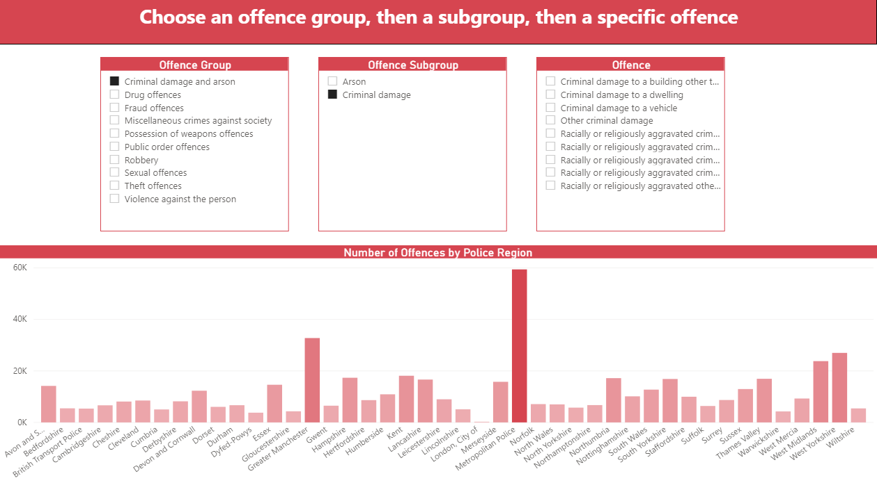

It’s important to note that the child slicers don’t effect the parent slicers, but the parent slicers do have a filtering effect on the child slicers. The bar chart has a conditional formatting for the data colors and uses solid gridlines.

# Exercise 5: Most Watched Shows

|  |  |
| --- | --- |
| Dataset | Most Viewed Shows 2019 |
| Visual | * 100% Stacked bar chart * 100% Stacked bar chart (grouped) |
| DAX | / |

This dataset contains information about the most watched shows according to the Nielsen rating in America in 2019.

In the dataset you’re going to see that the network is between brackets behind the name, we’re going to split this off into a new column. We’re also going to change the viewer numbers to the real value.

The first visual we’re going to create is a simple stacked bar chart with the top 10 most watch series and on which network there’re shown.

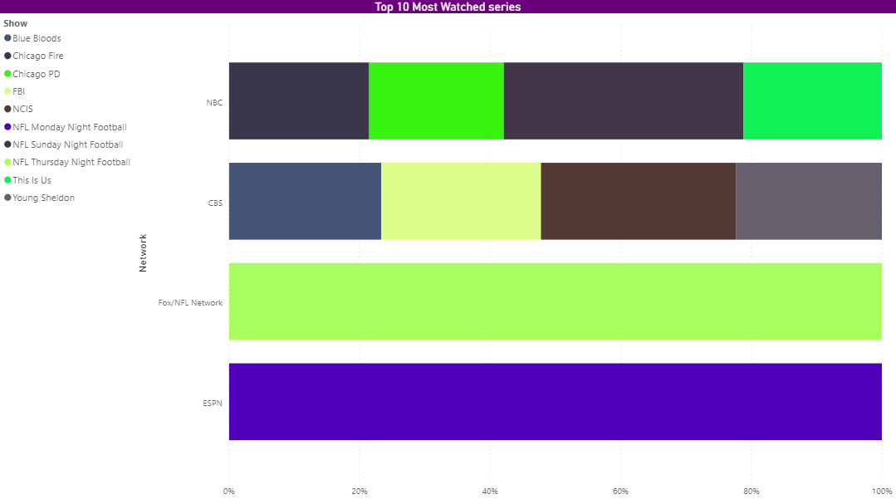

Afterwords we’re going to make use of the grouping feature to group a couple of series together. To create following visual.

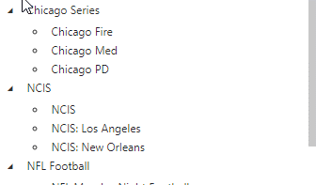

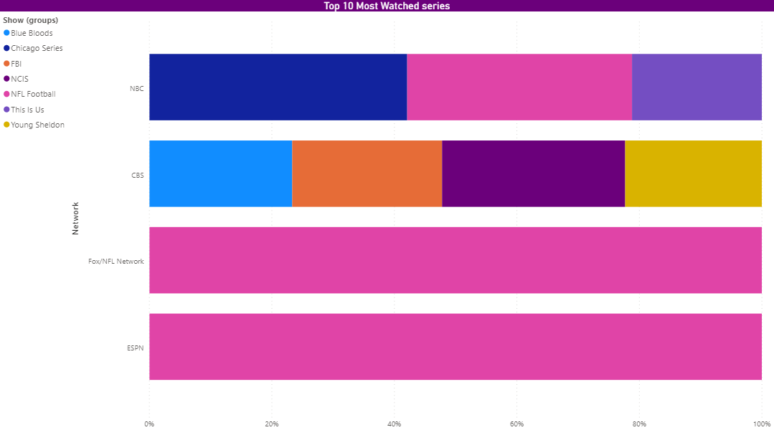

# Exercise 6: Brexit Votes

|  |  |
| --- | --- |
| Dataset | Votes, Region |
| Visual | * Matrix |
| DAX | / |

The next exercise is going to contain two datasets the first one contains all the votes that were cast in the Brexit poll and the other contains the regions in the U.K.

We’re going to do a number of transformations on this dataset:

* We’re going to calculate the percentages for the number of leave, remain, valid and invalid votes. Make sure to format them correctly.
* We’re going to add the region code to the region table.
* We’re going to create a new area table.

We’re going to create a hierarchical matrix with country, region and area representing the percentages of votes in that place.

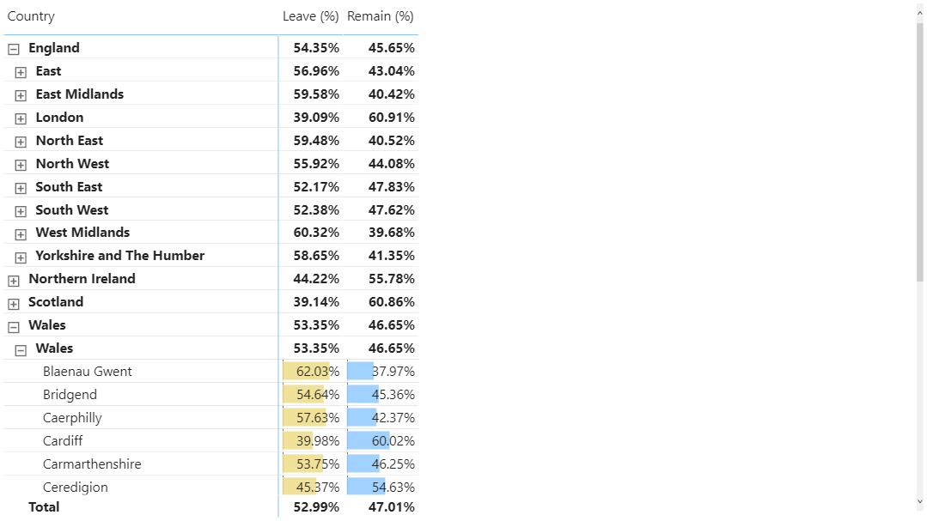

# Exercise 7: Skyscrapers uses

|  |  |
| --- | --- |
| Dataset | Skyscraper |
| Visual |  |
| DAX | UseTypeOffice, AvgFloorHeight |

In exercise 2 we already worked with a dataset about skyscrapers. The following exercise will expend on this dataset. To start with we want to define extra columns to split up the main uses of buildings. At the moment this is all present in one column, use Power Query to adjust this so that there are four columns with uses.

Because a lot of this buildings are being used as office space we want to option to apply a filter so we can easily single out these buildings. To do this we’re going to make a calculated column that sees if any of the four main uses is as an office building.

We’re also going to make a measure that calculates the average floor height for these buildings.

As an output we’re going to create the following report.

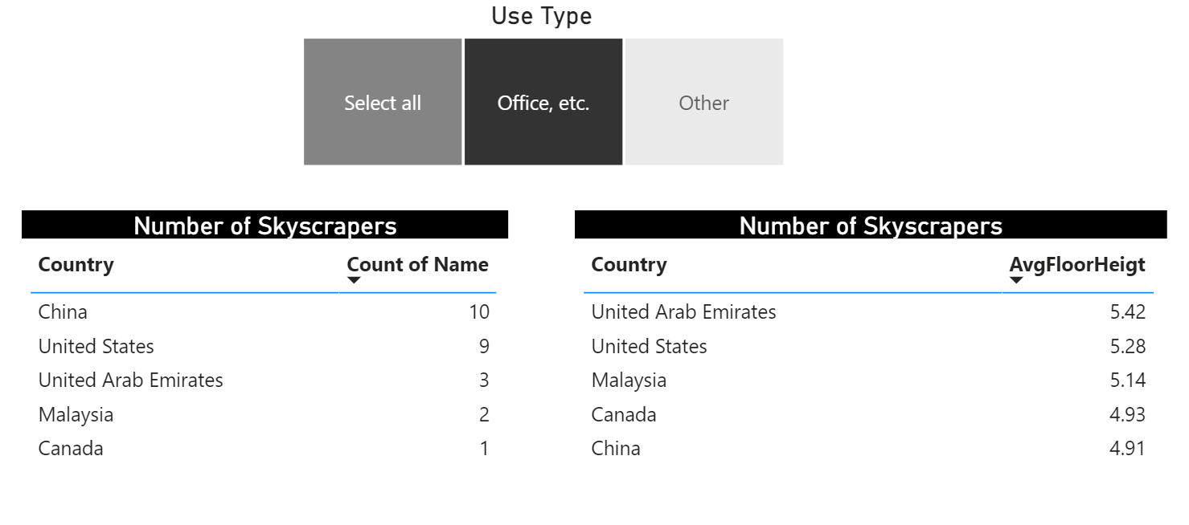

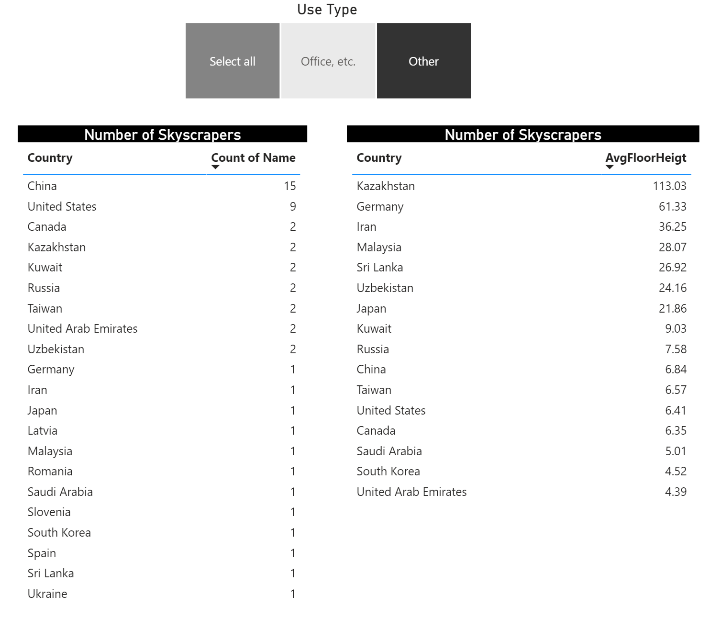

# Exercise 8: Premier League Season 2019-2020

|  |  |
| --- | --- |
| Dataset | Premier League 2019-2020 |
| Visual | T |
| DAX | Percentage of Total Points (%), England Ratio, Average Total Points, England Ratio Adjusted |

In the final exercise where going to take a look at the results of the Premier League season 2019-2020 and take a look at what (if any) impact the nationality of a manager has on the results of the club there’re managing.

We want to show the following statics in a table chart on nationality level:

* Total Number of Points Won
* Number of teams managed by that nationality
* Percentage of Total Points won by that nationality
* Compare the number of points won to the number of points won by English managers
* Total Points adjusted by the number of clubs
* The compare ratio to English managers adjusted by the number of clubs.

You should end up with following chart.

