# GIT

#INITIALIZING AND CONNECTING ONLINE REPOSITORY

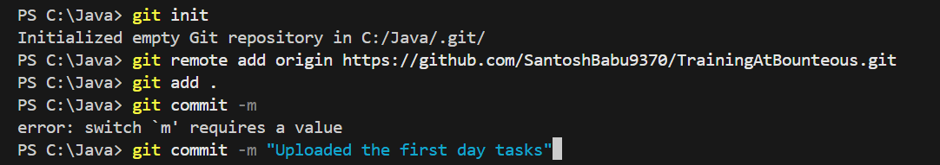

#CLONING A ONLINE REPO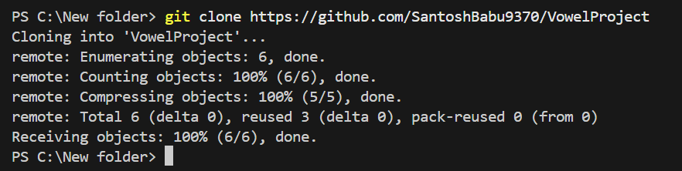

#STAGE AND COMMIT CHANGES IN OUR BRANCH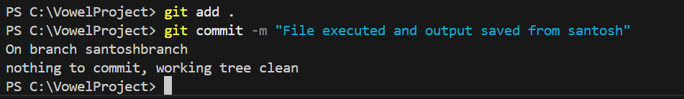

#CREATING AND SWITCHING TO SUBBRANCH

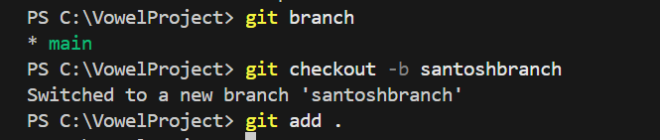

#PUSHING CHANGES TO OUR BRANCH

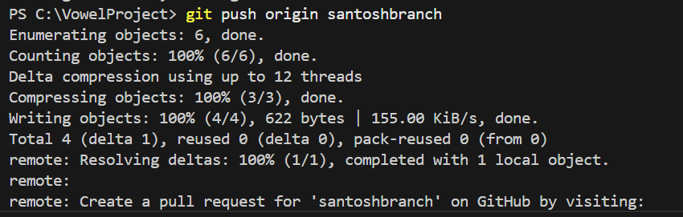

#STASH

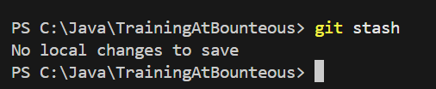

#REBASE

