**Approach**

According to the basic knowledge I acquired during the past 2 days I came across using Google custom search engine and by creating my own custom search engine.

**1st Approach**: By using custom google search engine.

Where google provides the search engine where we can restrict the sites to be displayed in our website , changing the layout, themes and customization of the search engine using the link [Google Search Engine](https://www.google.co.in/cse/) . Once we login and do customization they will provide the public url and code using one of them we can embed it into our application and yes the search engine is ready.

**2nd Approach**: By Creating My Own Custom Search Engine.

( Using **PHP, MYSQL, Google Keyword Planner** (To find the strength of keyword)).

In this I have created a database called **search_engine** which consists of site_url, keywords, site_description and page_rank fields. The database is as shown below.

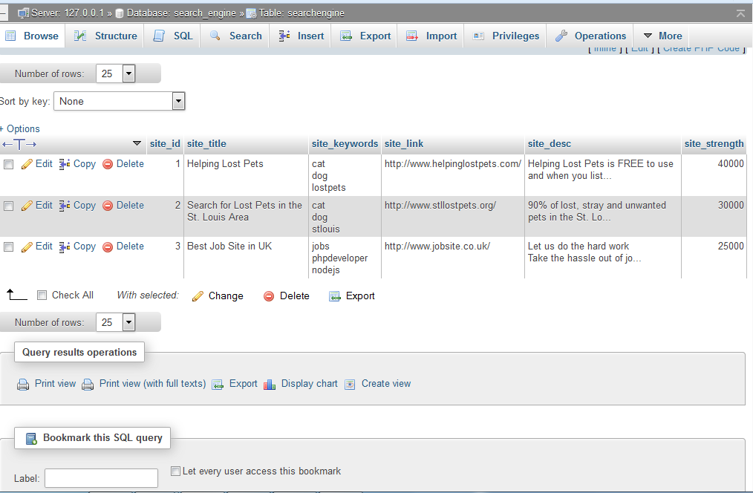

Where for particular product or service I used google keyword planner to find the strength of keywords for my site and stored in database ones with the maximum search and as per the customer requirements. For eg. See the below figure for web development product to find the strength of keywords and adding in to my database.

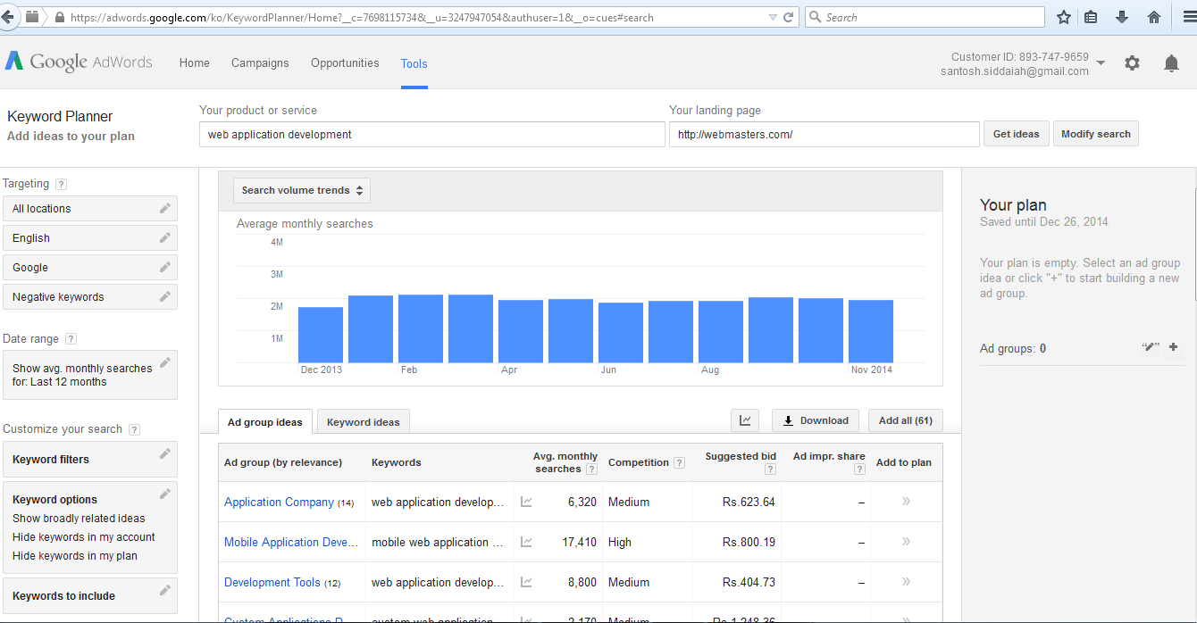

From the above figure we will get to know which are all the keywords with maximum search by the users for web application development which I will take list of keywords and will add in database to provide the better search results for the users.

Once I get the know which are all the keywords most used for the website I will make a list of all the keywords for that particular site and will add it in to the database with the site_url, keywords, and give some short description for that particular site and will provide the site_strength.

By using the site_strength field from my database if my search keyword is present in two or more rows in database I will display the result based on the decreasing order of the site_strength so that one with more visits will be displayed first.

**Result**:

1. On search of keyword **cat:**

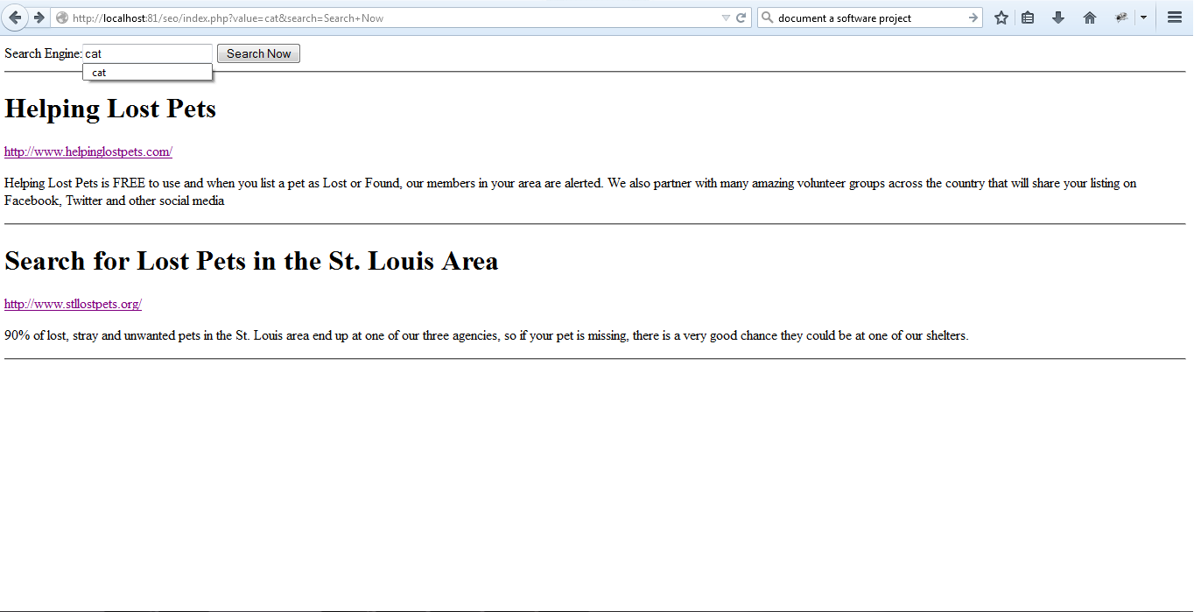

From the above fig. we can see that on search of cat keyword i searched the **database search_engine** for keyword cat and **displayed all the rows which has keyword cat in it and display the rows based on the site_strength in decreasing order** where site_strength stores the number of views of that particular site.

1. On search of keyword **job**:

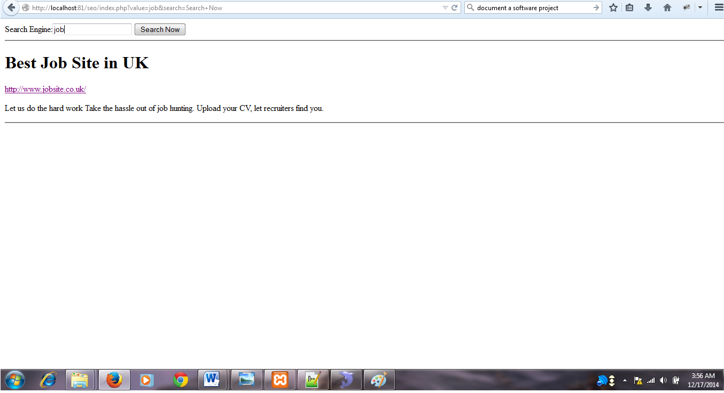

Based on job keyword it displayed job related keyword rows from the search_engine database.

1. On search of keyword **table**:

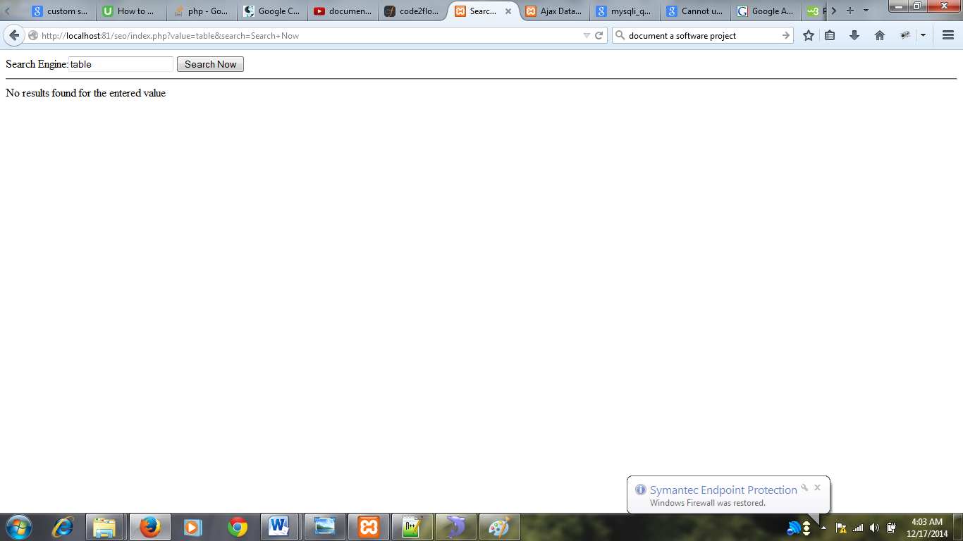

On search of keyword table since no keyword called table is present in database service engine it displayed No results for the entered value.

**Flow Chart** for this approach is as shown below.

