
{LOAFYBEE}
[Online shopping recommendation system]

[Date]
[Company name]
[Company address]

Project Name: LOAFYBEE
“Buzzing around the internet to find, so you don’t have to”

Prepared by: Omkar Jena
College: Kendrapara autonomous college

Problem Statement

- A recommendation system that helps personalizes the shopping experience by suggesting products based on users’ search history and interests. The system primarily identifies emerging trends and delivers relevant product recommendations to users who are likely to be interested in them.

Why does this problem exist?

- Users are often overwhelmed by large numbers of products available on platforms.
- Finding products that matches individual preferences can be time consuming.
- There needs a system that combines personalization and trend analysis to improve experience

who are the stake holders?

Internal Users
- System Administrator
- Platform Management
- Database administrator
- Customer system team
- Data analytics
- Role in the project:
- Manage products and categories.
- Handle customer issues and feedback
- Analyse user behaviour and trends

External Users
- Customer/shoppers
- Vendors
- Role in the project:
- Browse products
- Receive personalized recommendation
- Rate and review product

Expected Users
- Registered users seeking personalised recommendation
- Customers/online shopper

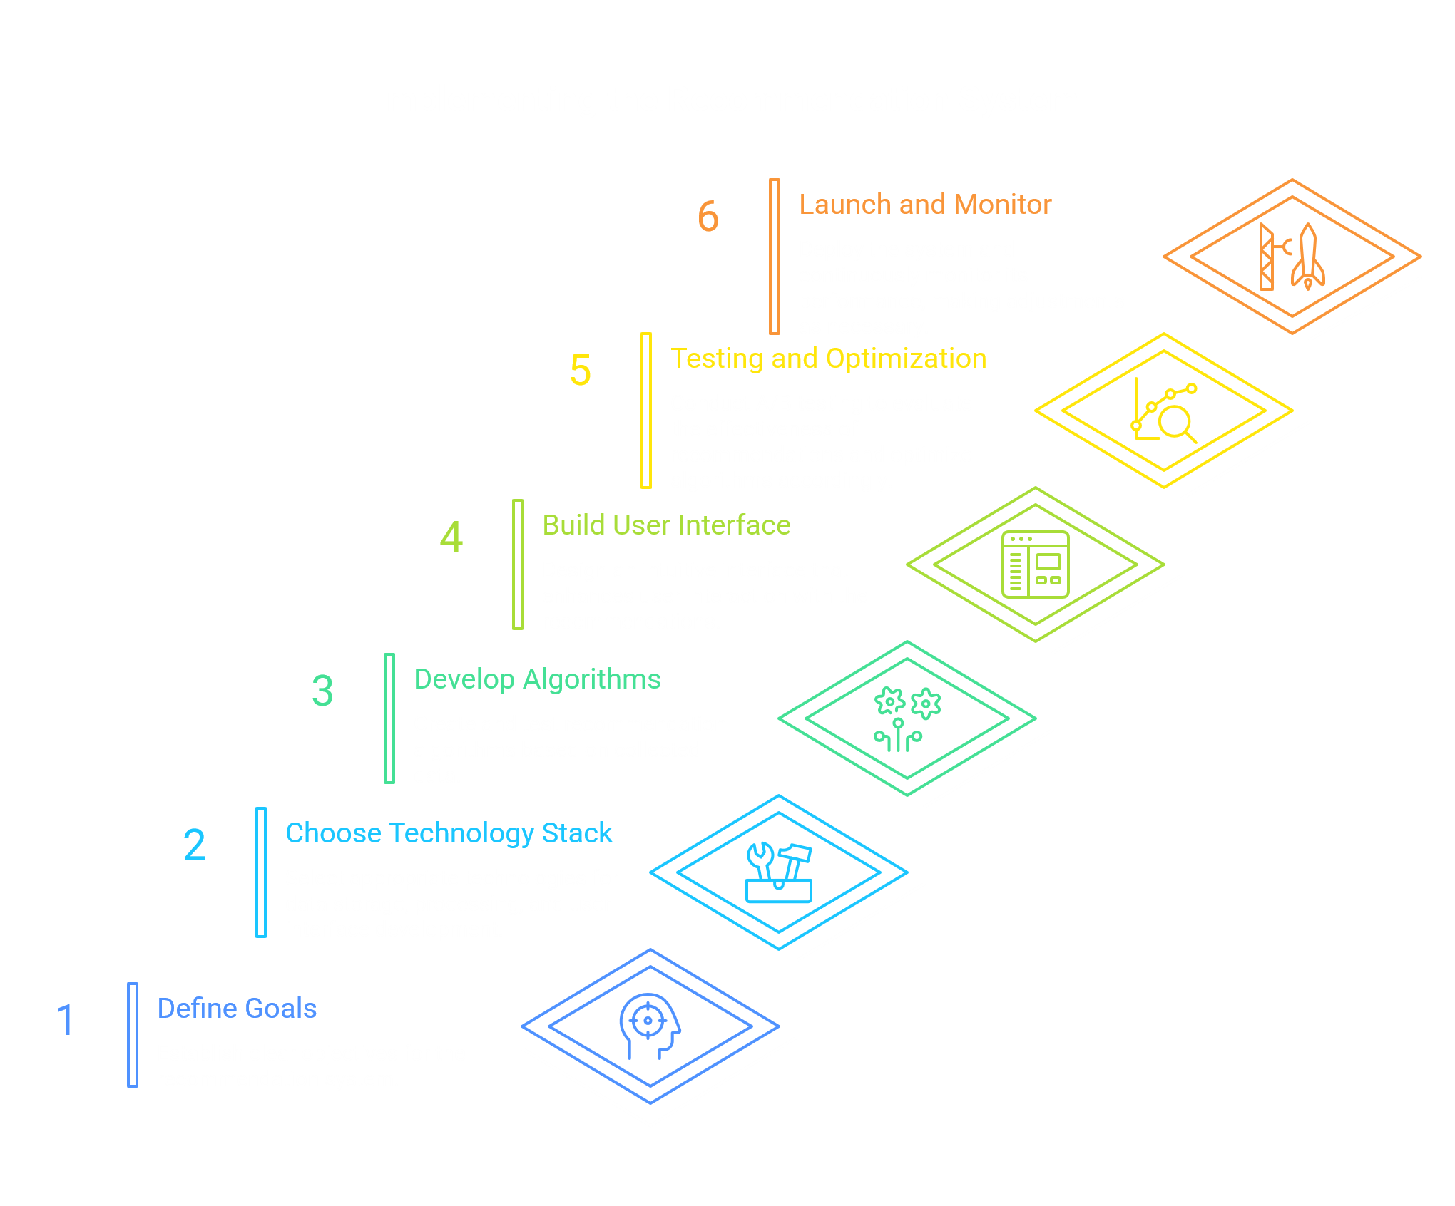

Project Goal
In today’s digital market, customers are often overwhelmed by vast,
variety of things offered on e-commerce platforms.
As a result, finding most suitable product can be challenging.
This project will help to tackle that issue
- To design a software system that provides personalized product recommendations to shoppers, reducing search times, finding suitable products.
- To enhance the overall shopping experience
- To increase engagement by offering recommendations that match interest

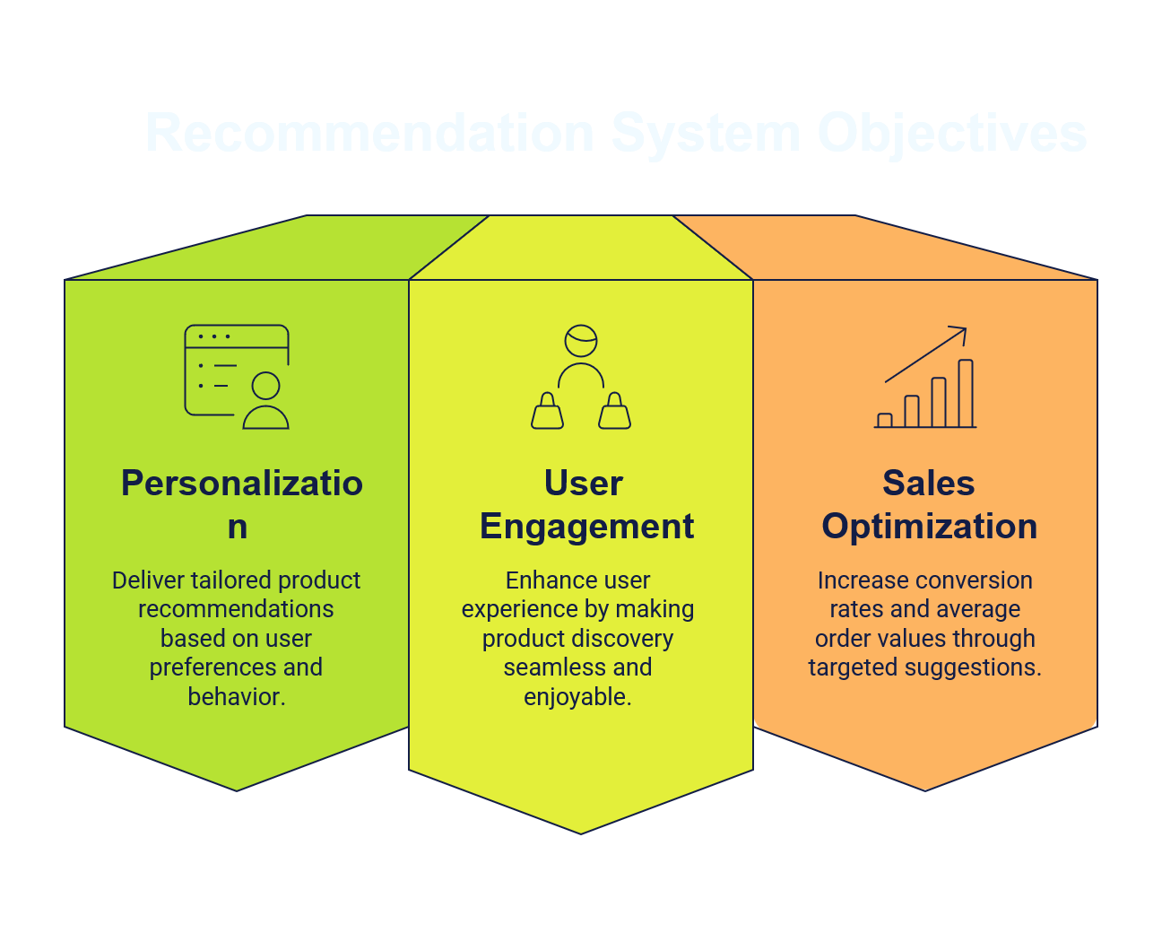

Objectives

- Analyse user behaviour (searches, purchases)
- Increase engagement and sales for the e-commerce platform
- Reduce time consumption through personalization
- To create a platform that benefits both customer and bridging the gap between customer neds and available products
- To design scalable and user-friendly system
- To make it as easy and attractive website

Real life problem solved

- Many stores have thousands of products. user have experience struggle to find particular type of interest and where to find it .it is a recommendation system suggesting relevant products automatically.

Hands-on activities
- Requirement gathering
- Market research
- System design
- Frontend development
- Backend development
- Testing and debugging
- Documentation and reporting

Feasibility Analysis

1. Technical Feasibility
This project is technically feasible because the required technologies and tools are readily available. The system can be developed using programming languages such as Python, Java, or JavaScript along with databases like MySQL or MongoDB. Recommendation logic can initially be implemented using rule-based techniques and later enhanced using machine learning algorithms. The hardware and software requirements are within the capabilities of a typical student development environment.

2. Economic Feasibility
The development cost of the system is relatively low because open-source tools, frameworks, and databases can be used. No specialized hardware or expensive software licenses are required. The expected benefits include improved user experience, increased customer satisfaction, and better product discovery.

3. Operational Feasibility
The system is easy for users to operate because it follows the familiar workflow of existing e-commerce platforms. Customers can browse products, receive recommendations, and place orders with minimal training. Administrators can manage products, users, and recommendation settings through a centralized dashboard.

4. Schedule Feasibility
The project can be completed within the internship duration by dividing the work into phases such as requirement gathering, UML design, database design, recommendation logic design, testing, and documentation. The scope is manageable for a student-level project.

5. Legal Feasibility
The system does not violate any legal regulations as long as user data is collected with consent and stored securely. The project will use publicly available technologies and avoid unauthorized use of copyrighted content.
UML Design
Actors
👤 Customer
- Register
- Login
- Manage Profile
- Browse Products
- Search Products
- View Product Details
- View Recommendations
- Add to Cart
- Place Order
- Rate & Review Products

👨‍💼 Admin
- Login
- Manage Products
- Manage Categories
- Manage Users
- Monitor User Activity
- View Recommendation Analytics
- Generate Reports

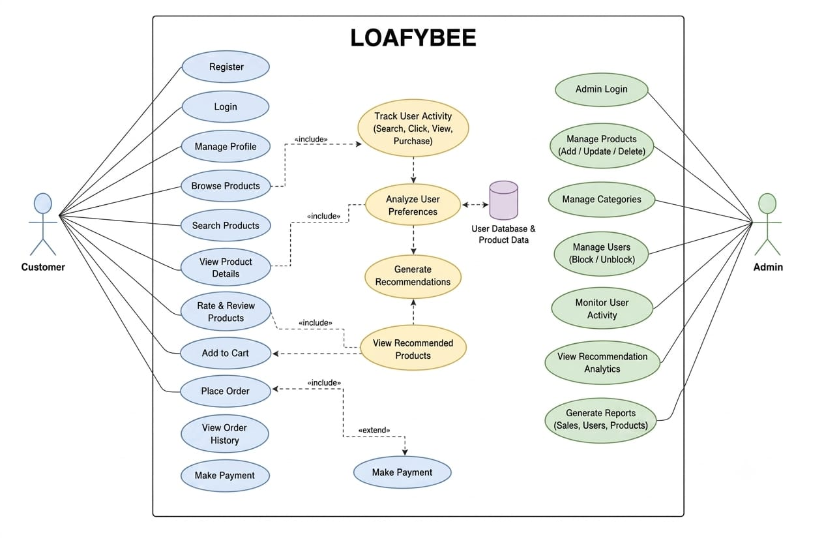
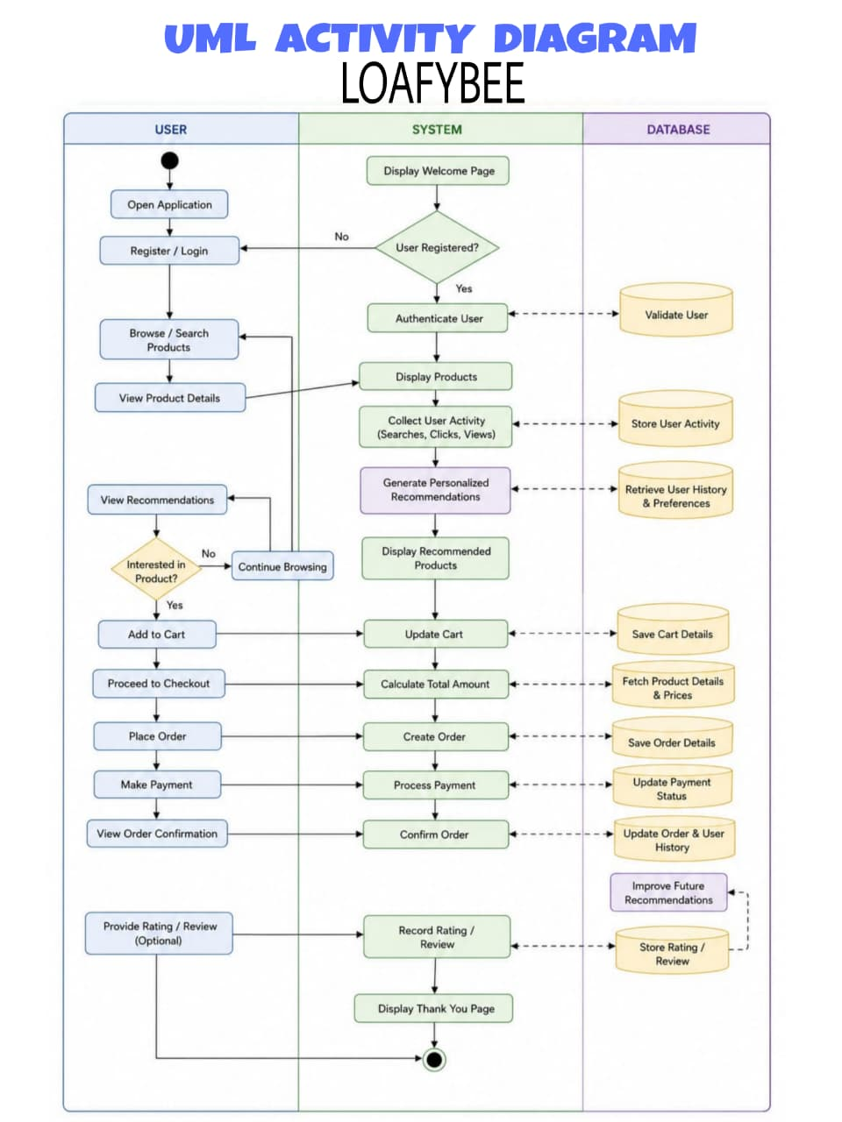

User activity diagram
The Customer Activity Diagram illustrates how a user interacts with the Online Shopping Recommendation System. The process begins when the customer opens the application and logs in or registers. After successful authentication, the user browses or searches for products and views product details. The system records user activities such as searches, clicks, views, purchases, and ratings. Based on this data, the recommendation engine generates personalized product suggestions. The customer can then view recommended products, select desired items, add them to the cart, proceed to checkout, make payment, and place an order. Finally, the system updates the user's purchase history and recommendations, and the customer logs out.
Customer Use Cases
- Register Account
- Login
- Search Products
- Browse Products
- View Product Details
- Add to Cart
- Purchase Product
- Rate & Review Product
- View Recommendations
- Manage Profile

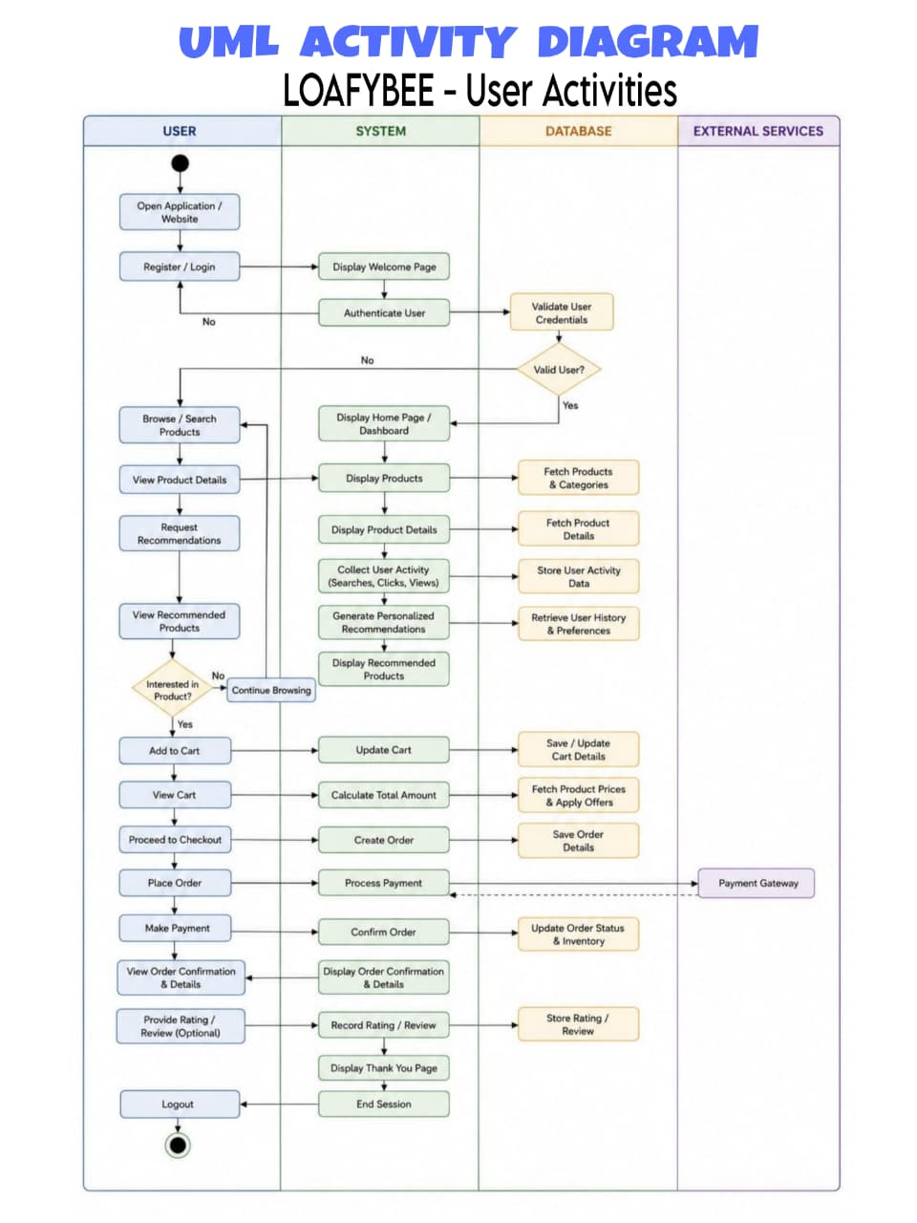

Admin activity diagram
- The Admin Activity Diagram represents the workflow of the administrator in managing the system. The process starts with admin login and credential verification.
- After successful authentication, the admin accesses the dashboard and performs various management tasks such as managing products, categories, and user accounts.
- The admin can monitor user activity, analyse recommendation performance, view sales and order data, and generate reports. The administrator may also update recommendation rules or algorithms to improve recommendation accuracy.
- Once all operations are completed, the admin logs out and ends the session.

Key Admin Activities
- Login Authentication
- Product Management
- Category Management
- User Management
- Monitoring User Behavior
- Reviewing Recommendation Performance
- Updating Recommendation Rules
- Generating Reports & Analytics
- Logout
