Internship: Writing SRS for Better Data Analytics

Syllabus
1-month (30 days / 60 hours) internship

Module 1: Foundations of Information Systems and MIS
Data vs Information, types of data, MIS concepts, strategic–tactical–operational information, real-world organizational information flow.
Module 2: Information System Design and SDLC
Information system design concepts, requirement analysis, feasibility study, SDLC models (Waterfall, Agile, Prototype, Spiral).
Module 3: Software Requirement Specification (SRS) Writing
IEEE SRS format, functional and non-functional requirements, constraints, use cases, user stories, complete SRS preparation.
Module 4: UML Modeling and Hands-on Design
Use case, activity, sequence, class, collaboration diagrams using tools like Draw.io/Lucidchart/Figma.
Module 5: Data Analytics Workflow and Capstone Project
Data science process, data collection and preprocessing concepts, connecting SRS to analytics design, final mini-project integrating SRS + UML + analytics workflow.
This structure works well because it follows a natural industry flow:
Understand business → Design system → Write requirements → Model solution → Apply to analytics project.
Duration: 30 Days | Total Hours: 60 Hours

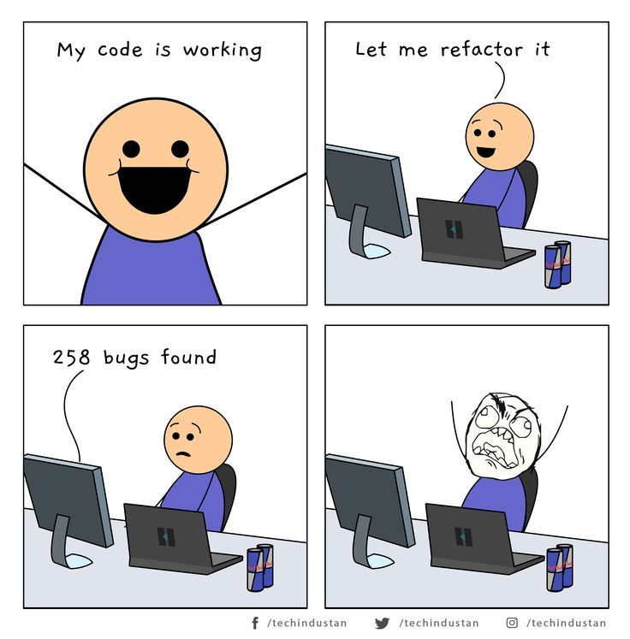

Module 1: Foundations of Information Systems and MIS
Duration: 12 Hours
What you will learn:
Understanding Data and Information
Types of Data: Structured, Semi-structured, Unstructured
Fundamentals of Management Information Systems (MIS)
Strategic, Tactical, and Operational Information
Real-world organizational information flow
Learning Outcome:
Students will understand how organizations collect, process, and use information for decision-making.
Hands-on Activity:
Analyze information flow in a University Management System.

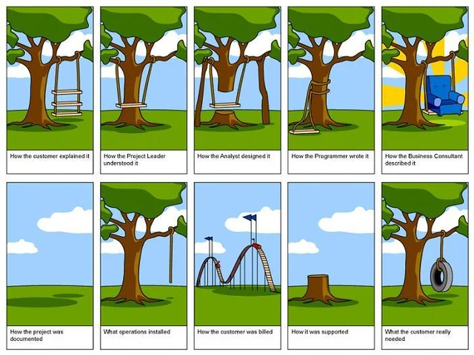
Tree Swing Joke: Old Version Joke
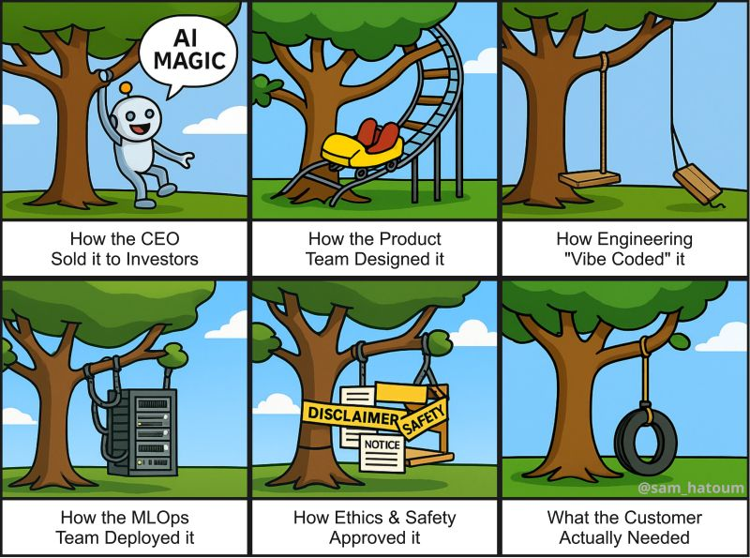
Tree Swing Joke: New Version

Module 2: Information System Design and SDLC
Duration: 12 Hours
What you will learn:
Basics of Information System Design
Requirement Analysis and Feasibility Study
SDLC concepts and phases
Waterfall, Agile, Prototype, and Spiral Models

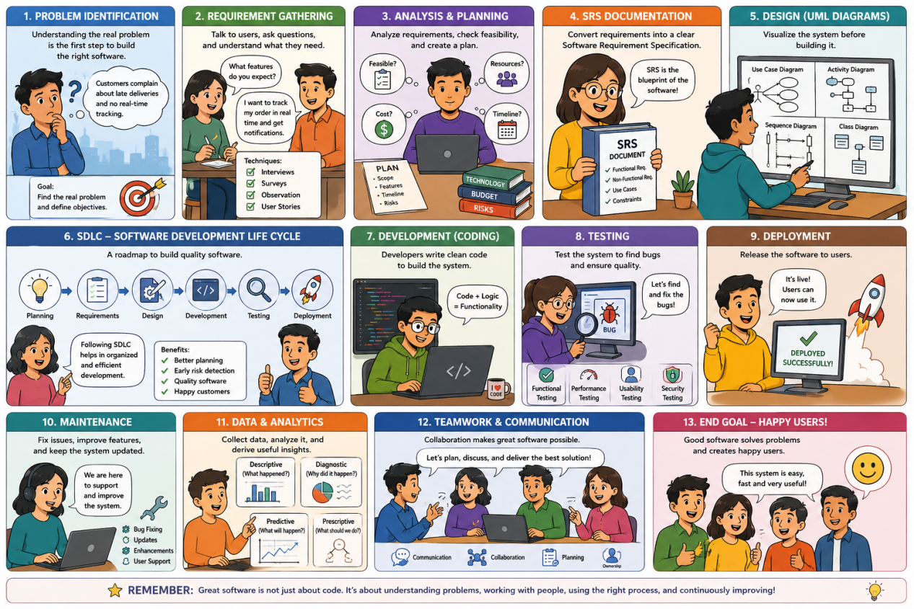
Selecting suitable models for real-world scenarios
Learning Outcome:
Students will learn how software systems are planned and developed systematically.
Hands-on Activity:
Design a requirement workflow for an online service system.

Module 3: Software Requirement Specification (SRS) Writing
Duration: 12 Hours
What you will learn:
Introduction to SRS
IEEE SRS Structure
Functional and Non-functional Requirements
Constraints and Assumptions
Use Cases and User Stories
Learning Outcome:
Students will learn to transform business problems into structured software requirements.
Hands-on Activity:
Write an SRS document for an Online Food Ordering System.

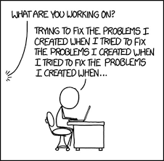

Module 4: UML Modeling and System Design Practice
Duration: 12 Hours
What you will learn:
Introduction to UML
Use Case Diagram
Activity Diagram
Sequence Diagram
Class Diagram
Collaboration Diagram
Learning Outcome:
Students will learn how to visualize and model software systems.
Hands-on Activity:
Create UML diagrams using Draw.io/Figma for a Hospital Management System.

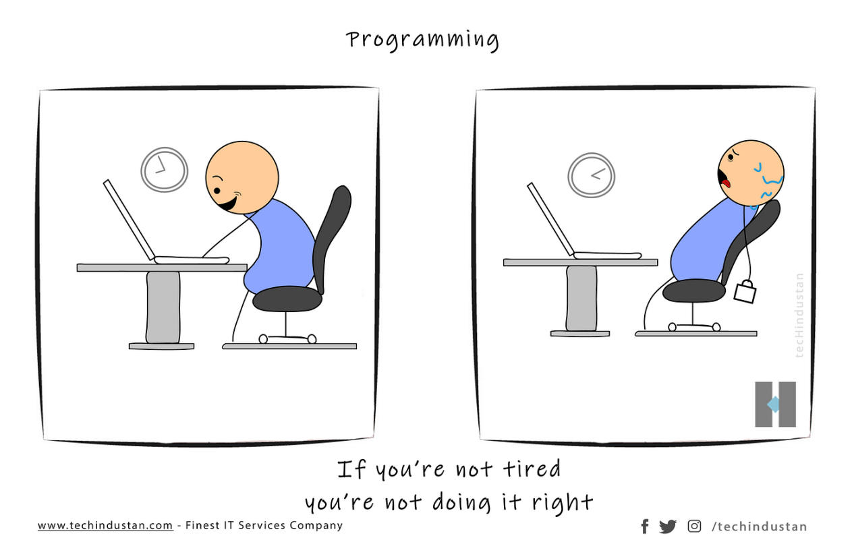

Module 5: Data Analytics Workflow and Capstone Project
Duration: 12 Hours
What you will learn:
Introduction to Data Science and Analytics Process
Data Collection and Data Preparation
Data Exploration Concepts
Linking SRS with Analytics Requirements
Project Planning and Documentation
Learning Outcome:
Students will understand how requirement engineering supports effective data analytics solutions.
Hands-on Activity:
Develop a mini-project integrating:
SRS Documentation
UML Design
Data Analytics Workflow
Final Presentation
Course Goal:
"Learn how to convert a problem statement into a complete software requirement and analytics solution using industry practices."
This is a strong approach for this one-month internship because students will not only learn concepts but will continuously build one complete project/SRS workbook throughout the course. By the end, every student will have an industry-style portfolio artifact rather than disconnected assignments.

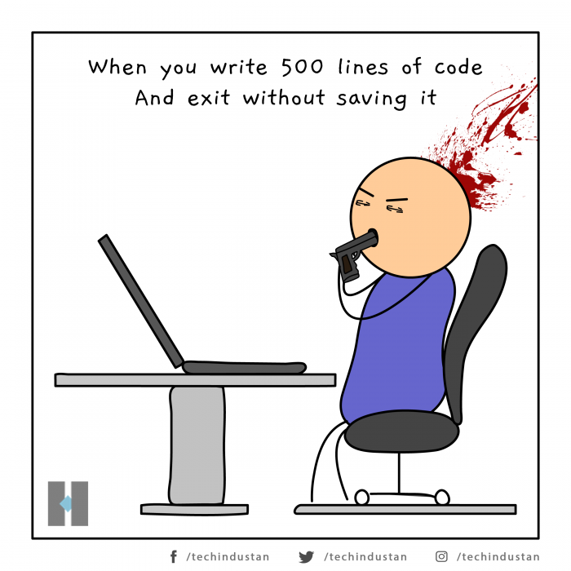

Workbook-Based Lesson Plan

Internship: Writing SRS for Better Data Analytics
Duration: 30 Days | 60 Hours
Project-based Learning Approach: One Project → One SRS → One Complete Design

Module 1: Problem Identification and Information Analysis
Workbook Goal: Select and understand a real-world problem.

Topics Covered
Data vs Information
Types of Data
MIS Concepts
Strategic, Tactical, Operational Information

Workbook Activity 1: Choose Your Real-Life Case Study
Students choose one project from examples such as:
Hospital Management System
Food Delivery System
Smart Library System
Agriculture Crop Recommendation System
University Management System
E-commerce Platform
Hotel Reservation System
Smart Attendance System
Online Job Portal
Transport Management System

Workbook Template
Project Name:
Hostel Management System
Problem Statement:
Hostel processes such as room allocation, fee collection, complaint handling, and visitor tracking are currently managed through paper registers, causing delays, double allocations, missed fee dues, and slow complaint resolution.
Why does this problem exist?
There is no centralized system linking room availability, student fee status, and maintenance requests, so wardens rely on manual registers that are error-prone and don't scale as hostel occupancy grows.
Who are the stakeholders?
Internal users:
Hostel warden, superintendent, accounts/admin office, maintenance staff
External users:
Parents/guardians, university administration, local security/visitor compliance
Expected system users:
Students (residents), wardens, admin staff, maintenance staff, and parents (view-only access)
Objectives of the project:
- Automate room allocation and vacancy tracking
Digitize fee payment and due tracking
- Enable online complaint/maintenance request submission and tracking
- Maintain visitor entry/exit logs for security
Generate occupancy and revenue reports for admin
- Reduce manual paperwork and allocation errors
- Give students real-time visibility into room status, fees, and complaint status
Support renewal/checkout workflows each academic year

Expected outputs:
Room allocation reports, fee due/paid reports, complaint resolution logs, visitor records, and occupancy dashboards.
Automated notifications for fee due dates and complaint status updates.

Hands-on Activity
Identify:
✓ Strategic information
✓ Tactical information
✓ Operational information
Example:
Hospital System
Strategic:
Long-term patient trends
Tactical:
Monthly doctor allocation
Operational:
Daily appointment scheduling

Part B: Data Science Activity (Analytics Lifecycle)
Students will analyze their selected project through the four stages of analytics in sequence.

Step 1: Descriptive Analysis
Question: What happened?
Students identify existing observations and summarize current situations.
Worksheet:
What data can describe the present system?
Examples:
- Number of daily customers
- Number of transactions
- Number of patients admitted
- Student attendance percentage
For my project:
- Number of occupied vs. vacant rooms
Number of students with pending fee dues
- Number of open vs. resolved maintenance complaints
- Average complaint resolution time
Daily visitor count
- Occupancy rate per block/floor

Step 2: Diagnostic Analysis
Question: Why did it happen?
Students identify reasons and patterns.
Worksheet:
Possible reasons behind observed patterns:
- Certain blocks show higher complaint volume due to older infrastructure
Fee delays cluster around the start of semester before scholarship disbursement
- Room vacancies spike after mid-year due to dropouts/transfers
- Maintenance requests peak during monsoon/exam season
Visitor logs show peak entries during weekends
- Certain floors show repeated plumbing/electrical issues, indicating an infrastructure fault

Possible influencing factors:
□ Human factors
□ Technical factors
□ Environmental factors
□ Economic factors
□ Other

Step 3: Predictive Analysis
Question: What is likely to happen in the future?
Students identify future trends and predictions.
Worksheet:
Possible future predictions:
- Predict which rooms/blocks will need maintenance next semester based on complaint history
Predict fee-default risk for specific student segments
- Predict occupancy for the next academic year based on admission trends
- Predict peak visitor times to plan security staffing
Predict complaint volume spikes around exam/monsoon season
- Predict room turnover/vacancy for early reallocation planning

Examples:
- Predict customer demand
- Predict student performance
- Predict disease occurrence
- Predict crop yield

Step 4: Prescriptive Analysis
Question: What action should be taken?
Students recommend decisions based on previous analyses.
Worksheet:
Suggested actions:
- Schedule preventive maintenance for high-complaint blocks before next semester
Send fee reminder alerts before the due date to at-risk students
- Reallocate/consolidate rooms early based on predicted vacancies
- Increase security staffing during predicted high-visitor periods
Prioritize maintenance staff allocation to blocks with recurring issues
- Automate waitlist assignment when a room becomes vacant

Expected benefits:
Faster complaint resolution, reduced fee defaults, better space utilization, improved security tracking, and less manual admin work.

Example (Food Delivery System)
Descriptive:
Average daily orders = 850
Diagnostic:
Weekend orders increased due to discount campaigns
Predictive:
Orders expected to increase by 20% during holidays
Prescriptive:
Increase delivery personnel and optimize delivery routes

Learning Outcome
By completing this activity, students will learn to:
✔ Identify a real-world problem
✔ Define project goals
✔ Think from a data analytics perspective
✔ Connect business requirements with SRS development
✔ Build a foundation for later UML and system design activities
This makes the first module not just introductory but the starting point of a complete problem → analytics → SRS → design workflow.
窗体顶端

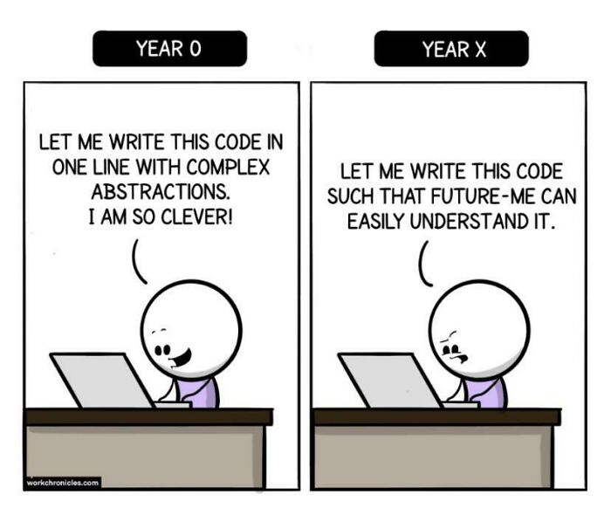

Module 2: Data Collection and Requirement Analysis
Workbook Goal: Understand information needs and collect project data.

Topics Covered
Requirement Analysis
Information System Design
Data Collection
Internal and External Sources

Workbook Activity 2

Identify Data Sources
Internal Data Sources
Source | Data collected | Purpose
Hostel admission/allocation records | Room number, student ID, allocation date | Track occupancy
Accounts/fee office records | Fee payment history, dues | Track fee collection
External Data Sources
Source | Data collected | Purpose
University admission database | New student enrollment data | Forecast incoming hostel demand
Security/visitor compliance requirements | Visitor ID, purpose, time | Maintain security compliance

Data Type Identification
Data Item | Type
Customer Name | Structured
Feedback | Unstructured
Images | Semi-structured
Students complete for their project.

Hands-on Exercise
Identify:
✓ Functional requirements
✓ Non-functional requirements
✓ Constraints
✓ Assumptions
Functional: system shall allocate rooms, track fee payments, and log complaints and visitor entries in real time.

Non-functional: system shall support 500+ concurrent student logins with page load times under 2 seconds.

Constraints: must integrate with the existing hostel fee payment gateway and student ID database.

Assumptions: all students have valid registration IDs; wardens have access to internet-enabled devices.

Module 3: Feasibility Analysis and SRS Development
Workbook Goal: Build SRS step-by-step.

Topics Covered
SRS Structure
Feasibility Study
Functional Requirements
Non-functional Requirements

Workbook Activity 3

Feasibility Analysis

Technical Feasibility
Questions:
Can existing technology support the project?
Answer:
Yes. Room-allocation, fee-tracking, and complaint web apps -- along with payment gateway integration -- use mature, low-cost technologies that integrate easily with existing student databases via APIs.

Economic Feasibility
Questions:
Estimated cost?
Expected benefits?
Answer:
Estimated cost: moderate, mainly web hosting and payment-gateway integration fees. Benefits: reduced fee defaults, faster complaint resolution, and less administrative staff time -- cost is recovered within 1-2 years.

Operational Feasibility
Questions:
Will users accept the system?
Answer:
Yes -- wardens and admin already perform these tasks manually, so the system reduces effort rather than adding new work; brief training is enough for adoption.

Schedule Feasibility
Questions:
Can the project be completed within available time?
Answer:
Yes -- a working prototype (room allocation + fee tracking + complaint module) can be built and piloted within one semester using an agile approach.

SRS Worksheet
Purpose:
To define the requirements for a system that automates hostel room allocation, fee tracking, complaint management, and visitor logging.
Scope:
Covers room allocation, fee payment tracking, complaint/maintenance requests, and visitor logs. Excludes mess/catering management.
User Characteristics:
Students and wardens with basic digital literacy; admin staff familiar with spreadsheet/ERP tools; parents accessing fee status via portal only.
Functional Requirements:
FR1: The system shall allow admin to allocate and reassign hostel rooms based on availability.
FR2: The system shall track fee payments and automatically flag overdue dues.
FR3: The system shall allow students to submit and track maintenance complaints online.
FR4: The system shall log visitor entry and exit details with timestamp and purpose.
Non-functional Requirements:
NFR1: The system shall be available 99% of the time, including during peak admission/allocation periods.
NFR2: The system shall support at least 500 concurrent users without performance degradation.
NFR3: The system shall encrypt student personal and payment data in compliance with data protection norms.

Ethical Measures
User Ethics
Students must be informed about what personal and payment data is collected and how it is used.
Business Ethics
Fee and complaint data must not be used for purposes beyond hostel administration.
Regulatory Ethics( Domain Specific)
System must comply with institutional data protection policy and any local visitor/security regulations.
Data and Provacy
Payment and ID data must be stored encrypted and access-restricted to authorized admin roles only.
AI and Technology Related
If predictive fee-risk or maintenance scoring is used, results should be reviewable by staff rather than fully automated decisions.
Developemnt Ethics
Development team must test the system to ensure no student group (e.g., by room block) is unfairly flagged or deprioritized.

Module 4: UML Design Workbook
Workbook Goal: Create UML models gradually.

Topics Covered
Use Case Diagram
Activity Diagram
Sequence Diagram
Collaboration Diagram
Database Design

Workbook Activity 4
Choose 3–4 use cases.
Example:
Food Delivery System
User Registration
Search Restaurant
Order Food
Payment
Students fill:
Use Case | Actor | Objective
Allocate Room | Admin / Warden | Assign a vacant room to a student
Submit Complaint | Student | Report a maintenance issue
Track Fee Payment | Student / Accounts | View and update fee payment status
Log Visitor Entry | Security staff | Record visitor details for security compliance

Activity Diagram Worksheet
Draw process flow:
Start
↓
Action 1
↓
Decision
↓
Action 2
↓
End

Sequence Diagram Worksheet
Actor: Student / Warden
Objects involved:
- Room Allocation Module
- Fee Management Module
- Complaint Tracking Module
- Database
Interaction sequence:
- Student submits a room request or complaint via the portal
- System routes the request to the Warden/Admin module
- Warden/Admin approves allocation or assigns the complaint to maintenance staff
- System updates the database and status
Student receives a notification of the update

Collaboration Diagram Worksheet
Objects: Student, Warden, Room Allocation Module, Complaint Module, Database
Relationships: Student interacts with Room Allocation and Complaint modules; Warden approves via the Admin module; all modules read/write to the Database
Message flow: Request -> Route -> Approve/Assign -> Update -> Notify

Database Design Worksheet
Entity | Attributes
Student | ID, Name, Email
Course | CourseID, CourseName
Room | RoomID, BlockName, FloorNumber, Capacity, Status
FeePayment | PaymentID, StudentID, Amount, DueDate, Status
Primary Key: StudentID (Student), RoomID (Room), PaymentID (FeePayment)
Foreign Key: StudentID in the Room and FeePayment tables references the Student table
Relationships: One Student is allocated one Room; one Student has many FeePayment records (one-to-many)

Module 5: Final SRS and Analytics Integration Workbook
Workbook Goal: Integrate complete project documentation.

Topics Covered
Data Science Process
Analytics Workflow
Final SRS Development

Workbook Activity 5

Data Analytics Workflow
Problem Definition:
Predict fee-default risk and maintenance demand to improve hostel resource planning.
Data Collection:
Room allocation records, fee payment history, complaint logs, and visitor records from hostel administration systems.
Data Cleaning:
Remove duplicate allocation entries, standardize date formats, and reconcile manually corrected fee records.
Data Exploration:
Analyze occupancy trends by block, fee-default patterns by semester, and complaint frequency by room/floor.
Expected Analysis:
Descriptive occupancy/fee summaries, diagnostic analysis of complaint/fee patterns, predictive fee-default and maintenance-demand scoring, and prescriptive resource allocation recommendations.
Expected Outcome:
A dashboard that helps hostel administration proactively manage room allocation, reduce fee defaults, and speed up complaint resolution.

Final Project Checklist
□ Problem Statement completed
□ Objectives identified
□ Internal and External Sources identified
□ Feasibility Analysis completed
□ Functional Requirements completed
□ Non-functional Requirements completed
□ Use Cases completed
□ Activity Diagram completed
□ Sequence Diagram completed
□ Collaboration Diagram completed
□ Database Design completed
□ Ethical Measures Taken
□ Final SRS completed
□ Presentation prepared

Final Student Deliverable
Complete IEEE SRS Document
UML Designs
Database Schema
Analytics Workflow
Final Presentation

This workbook structure makes the internship function like a guided industry project lab, where students progressively complete one real-life system from idea → analysis → SRS → UML → analytics design.

Industry-readiness , the gap is usually not more theory — it is adding the small practices that industry expects but classrooms often skip.

1. Client Interaction Sheet (Requirement Elicitation Simulation)
After selecting a project, students should behave like a business analyst interacting with a client.
Workbook section:
Client Name: Mr. Sharma, Hostel Warden
Business Problem: Room allocation and fee tracking are handled through paper registers, causing double allocations, missed dues, and slow complaint resolution.
Questions asked to client:
- How are rooms currently allocated to students?
What is the fee payment schedule and penalty policy for dues?
- How should maintenance complaints be reported and tracked?
- Do you need visitor logging for security compliance?
Should parents have visibility into fee status?
- How many hostel blocks and rooms need to be managed?
- Who should approve room reallocation requests?
Are there existing systems (fee gateway, ID database) we need to integrate with?

Client responses:
The warden confirmed rooms are allocated manually each semester, fees are due at semester start with a late penalty, and visitor logging is currently paper-based; he wants complaints tracked online with a designated maintenance staff account.
Final interpreted requirement:
Build a system to automate room allocation, track fee dues with penalty rules, provide online complaint submission with status tracking, and maintain digital visitor logs.
Skill gained: Requirement gathering and communication.

2. User Persona Canvas
Industry projects start by understanding users.
Workbook Template
Persona Name: Rahul Verma
Age: 19
Occupation: First-year Hostel Resident
Goals:
- Get a room allocated quickly without repeated visits to the office
Know fee due dates and pay without confusion
- Report maintenance issues and track resolution status
- Avoid unnecessary paperwork for visitor entries

Challenges:
- Long queues for room allocation and fee payment at the hostel office
No visibility into complaint status once submitted
- Missed fee due dates due to lack of reminders
- Confusing manual visitor entry process for guests

Expected features:
- Online room allocation status and request tracking
Fee due-date reminders and online payment tracking
- Complaint submission with real-time status updates
- Digital visitor entry logging via QR/ID scan

Example:
Food Delivery System
Persona: Working professional
Goals:
Fast ordering
Multiple payment options
Pain points:
Long delivery time
Poor recommendations
Skill gained: User-centered thinking.

3. User Story + Acceptance Criteria
Agile companies use user stories extensively.
Workbook section:
As a student
I want to submit and track my maintenance complaints online
So that I can know when my issue will be resolved without repeatedly visiting the warden's office
Acceptance Criteria:
✓ System allows students to submit a complaint with room number and description
✓ System shows complaint status (submitted/in-progress/resolved) in real time
✓ System notifies the student when the complaint is resolved
Example:
As a customer, I want to track my order so that I know delivery status.

4. Risk Assessment Matrix
Students rarely learn project risks.
Workbook section
Risk | Probability | Impact | Solution
Server failure | Medium | High | Backup server
Requirement changes | High | Medium | Agile iterations
Payment gateway downtime | Medium | High | Provide manual fee payment fallback at office
Room allocation disputes | Medium | Medium | Maintain audit trail and require warden approval step
Skill gained: Project planning.

5. Wireframe/Low-Fidelity UI Design
Before UML diagrams, ask students to sketch screens.
Workbook activity
Draw:
✓ Login page
✓ Dashboard
✓ Registration page
✓ Report page
Tools:
Draw.io
Figma
Canva AI
Skill gained: UI/UX thinking.

6. AI-Assisted Requirement Engineering
This can make the workbook very current.
Workbook section
Use AI tools and compare output:
Prompt used:
Generate 5 functional requirements for a hostel room allocation and fee management system.
AI generated output:
AI suggested requirements around room allocation, fee tracking, complaint logging, visitor management, and reporting.
Student improvements:
Added specific constraints (penalty rules, concurrent-user support) and a role-based approval step not included in the AI draft.
Final version:
Refined FR1-FR4 (see SRS Worksheet) by incorporating AI suggestions plus institution-specific fee and allocation rules.
Skill gained: Human + AI collaboration.

7. Project Sprint Tracker
Introduce Agile practices.
Workbook section
Week 1:
□ Problem identification
□ Data collection
Week 2:
□ Requirement analysis
□ Feasibility study
Week 3:
□ UML design
Week 4:
□ Final SRS
□ Presentation
Skill gained: Project management.

8. Interview & Industry Readiness Corner (last page of every module)
Include:
Interview Questions
Difference between SRS and requirement gathering?
Why do projects fail?
Why is feasibility important?
Difference between functional and non-functional requirements?
Mini Reflection
What did I learn today?
How to convert everyday hostel administration problems into structured functional and non-functional requirements.
What was difficult?
Deciding fair rules for room allocation and fee penalties that work across different student circumstances.
How can this be used in industry?
The same approach applies to any facility-management system that needs to track allocation, payments, and service requests, such as corporate housing or dormitory management.

Final Bonus Section (Very Valuable)
Create a “Project Portfolio Page” at the end:
Project Title: Hostel Management System
Role: Business Analyst / Requirement Engineer
Tools Used:
□ Draw.io
□ Figma
□ ChatGPT
□ Lucidchart
□ Excel
□ UML Tools
Skills Developed:
□ SRS Writing
□ Requirement Gathering
□ UML Modeling
□ Data Analysis
□ Communication Skills
□ Problem Solving
GitHub/Portfolio Link: (add your GitHub/portfolio link here)
Project Summary: Designed and documented a complete SRS for a Hostel Management System covering room allocation, fee tracking, complaint management, and visitor logging -- including feasibility study, UML modeling, database design, and a data analytics workflow.
"I completed an end-to-end industry project involving requirement engineering, UML modeling, data analysis, and SRS documentation."

